
Module Assignment Submission
Student Name: | Tracey Hughes
Student Number: | 2008698
Module Code: | BMSK5003
Module Title: | Understanding and engaging in the customer experience.

Statement of Confirmation of Authenticity
By the act of making this submission, the student declares that this is the work of the student named above. The work has not, in whole or in part, been knowingly presented elsewhere for assessment, or where assessment has been built on a previous assessment, this has been identified. Where materials have been used from other sources it has been properly acknowledged. If this statement is untrue, the student acknowledges that an assessment offence has been committed.
Attention is drawn to the plagiarism and unfair practice policies of the University.

Table of Contents.

Introduction 4
1. customer Value 5
Valerie. A. Zeithaml 5
1.1. Measuring Customer Value 6
1.2. Creating customer value. 7
Elements of value pyramid. 8
Abraham Maslow. 8
1.3. Emotional Factor 8
Daniel Goleman 9
1.4. Social Impact 10
Social Impact Theory 10
Parasocial Interaction Theory. 11
1.5. Summary 11
2. Quality Values 12
2.1. Quality Management Approach 12
2.2. The Pareto Principle 13
2.3. SERVQUAL Model 14
2.4. Summary 16
References. 17
Appendix 1. 21
Appendix 2. 22
Appendix 3. 23
Appendix 4. 24
Appendix 5. 25
Appendix 6. 26
Appendix 7. 27
Appendix 7. 28
Appendix 8. 29

Introduction

The aim of this assignment is to Critically assess the factors that affect hospitality namely, ‘Atlantis -The Palm Resort’ to maximise Customer Value. Part one will introduce and analyse customer value and how Emotional and Social impact factors are significant to my organisations ability to supply world class service, and meet the demands, needs, and wants of our customers. It will show how its purpose is to evaluate all perceived benefits and perceived sacrifices and how customer experiences determine how much value is placed within it. finally, by exploring online reviews to evaluate the key selection criteria of consumers that reflect the guest experience and investigated their relationship with customer satisfaction.
Part Two will explore quality values and aim to understand the importance of excellence with the consistent delivery and service to fulfil guests needs and expectations, additionally it will explore the importance of quality processes and analyse The Pareto Principle and SERVQUAL model within a luxury resort to gain effective employees, processes and services.

customer Value

Customer value is best defined as how much a product or service is worth to a customer. Perceived value is typically a mix of price, quality and what the product or service can do for that person. (Hollbrook.,1999)

Valerie. A. Zeithaml
Zeithaml (1988) proposed that Customer value can be interpreted into four distinct categories: -
- Value is low price.
- Value is whatever one wishes in a product.
- Value is the quality that the customer receives for the price paid.
- Value is what the customer receives for what they give.

“Somewhere between living and dreaming, there is Atlantis-The Palm”
(Atlantis,2018)
Within the confines of my workplace at Atlantis-The Palm Resort our aim is to convey a specific image of a world class renowned resort that offers the best service possible. This raises expectations of what we can offer and puts a great amount of responsibility upon our shoulders, as hotel guests and employees may perceive and interpret these values differently. (Appendix 1.) This is consistent with Tsang and Qu., (2000) who suggested that perceptions of hotel guests and hotel managers differ due to differences of expectations. While this is a concern, our ability to treat guests as individuals and one size does not fit all, is helped by the support and training that is given to staff to be able to take charge and make decisions, which is of great value as when problems arise, they are dealt with swiftly and efficiently.

Measuring Customer Value

Flint et al. (1997) proposes that value can also be divided into, values, desired values, and Value judgments, these refer to the customers evaluation of what has occurred such as benefits and sacrifices. This suggests that value is a process of interpretation of how the customer feels about the goods or services they receive. therefore, Customer value is created when a customer feels that the benefits of using a product or service outweigh the costs. This suggests that quality is identified as a benefit whilst cost is described as a sacrifice. (Slater and Narver.,2000).
Additional research by Kotler., (2012) believes that customer perceived value is the difference between customer value and customer costs, total customer cost refers to time, energy and money spent. These refer to the benefits that customers receive from a purchase, this is often shown as best value at the lowest price.
For example, when making a choice of what hotel you will visit, guests will weigh the costs and benefits of that choice, to analyse what they gain or lose between different establishments. (Heri.,2017)
Whilst this viewpoint is criticised as being simplistic and represents only one aspect of perceived benefits and sacrifices. (Sweeney and Soutar.,2001) The definition of value must consider the entire packages of both benefits and sacrifices as it is insufficient to define value as a function of quality. It should be defined as a blend of physical characteristics, service characteristics, technical aid, competence, experience, and social benefits (Petrick.,2002).
Petrick., (2002) scales are used within this example and consists of five elements: -
- Reputation
- Quality
- Emotional Response
- Behavioural
- Pricing

An example of this can be seen in other luxury hotels such as the newly built, ‘Atlantis Royal ‘ which sits within a mile radius of the palm , it offers the same seven star rating but without the amenities that Atlantis the palm is renowned for , poignantly, this opens up the suggestion that my workplace is considered the Disney land of Dubai. (Thani. and Heenan.,2017), and would suggest that customer value is highly placed on the experiences within the amenities we offer.
Reputation and quality effectively encapsulate the concept for reputation, and to some extent emotional value. Value for money can be understood as a comparison of the rewards and costs as it denotes a financial gain. The social worth of connecting oneself with a product (hotel) is captured by prestige. Which is a representation of what guests “important others “think about them when using a certain hotel, (Paulson Gjerdge and Slotnick.,2004).
In contrast, to the above idea of value, Holbrook., (1999) research indicates that customer value is regarded as an “interactive relativistic preference experience “. Within his multifaceted framework, it suggests that emotional value and social value factors are widely used in the tourism industry. This view typically considers ‘service quality’ to be the ancestor of value. With this information it is implied that quality is closely attributed to customers perceived value. (Liv et al.,2018).

Creating customer value.

“Customer value can be difficult to define and psychologically complicated. “
(Maslow.,1943)
Models of consumer values allow a company to create opportunities to improve their customer value to entice with the products and services they deliver.

Elements of value pyramid.
The elements of value approach extend Maslow’s (1943) Hierarchy of needs model (Appendix 2.) which help deliver fundamental elements of value that address four kinds of needs: -
- Functional - variety, quality, saves time, sensory appeal, integrates, connects
- Emotional – reduces anxiety, rewarding, therapeutic, wellness, rewards, fun/entertainment
- Life changing – provides hope, self-actualization, affiliation/belonging,
- Social Impact – self-transcendence.
Within the “Elements of Value Pyramid” (Appendix 3.) there are thirty identifiable fundamental attributes, whilst some elements are more inwardly focusing on personal needs, others are outward focused, helping customers interact.

Abraham Maslow.
Maslow (1943) insisted that human actions arise from an innate desire to fulfil needs ranging from the very basic to the very complex. At the bottom of the elements for value pyramid, are psychological and safety needs towards the top are self-actualisation and self-transcendence. Taking a nuanced view, he realised that different patterns of fulfilment exist without the need to necessarily transit through all stages.
Therefore, it can be argued that the model assumes that all people are rational and are self-thinkers who have a certain understanding and acceptance on society’s view of the stage they are on the ladder, for example, a person compromising his basic needs to have more emphasis on enjoyment and fulfilling his wishes. (Mankiw,1980).
Whist all these elements come into play, its important to reiterate that within my job role it is imperative that the customer always comes first, and all needs are met.

Emotional Factor

The hospitality field is a service industry, its task is to create shareholders wealth by servicing and satisfying guests needs.
(Langhorn.,2004).

Daniel Goleman
Goleman., (1995) asserted that the emotional factor is important for the hospitality and tourism industry as’ Emotional Intelligence ‘(EQ) is essential for a successful service industry. Self-awareness to demonstrate empathy and adaptability is essential for building a formidable team that is motivated to give its best.
Often, perceived quality is affected by the service method in which it is received, for guests to be satisfied they must feel valued and respected, and every need is met, and employees are trained to the highest level. However, ‘service ‘is subjective, which can lead to differentiating concepts of what good service entails. (Kernbach and Schutte.,2005)
Customer relations is the main aim of my workplace, staff are employed by personality rather than qualifications, its aim to employ the best staff who live and breathe the values that the resort holds dear. it is imperative that all staff are equipped with the best training possible, to manage any request no matter how large or trivial. The employee reward package is a wonderful way to keep the employee’s health and wellbeing a priority and keep staff retention low.
To gain consumer insights, Atlantis, made use of various customer feedback tools, including mystery guests, to attain the level of quality they receive., (Atlantis,2016). However, more recently, managers and leaders are reviewing the impact of emotional aspects of guest feedback as it has become clear that consumer decisions are influenced by emotions which can influence whether a guest will return or not. However, the service will always have a positive impact, as it is the employees who are a differentiating factor within Atlantis, as they are in the best position to be able to influence the guests emotional state and therefore decisions.
Kaizen ‘continuous improvement’ strategy (Appendix 4.) involves all employees at all levels of the resort to work together pro-actively to achieve regular incremental improvements. (Farrinton.et al.,2018). In a sense it combines all the talents of the collective to create a powerful strategy for improvement. Observing these practises within the resort, gives the opportunity to build a culture where all are actively engaged in bringing the customer value to the forefront of the organisation. Kaizen focuses on applying small, daily changes that result in major improvements over time (Massaaki.,1986)
The customer reviews of the satisfaction they felt within the resort TripAdvisor., (2021), stated that the team contributed to the unforgettable experience and indeed each member is equipped with professionalism, sincerity, and passion to deliver consistent guest’s satisfaction.
Additional Evidence within research undertaken by Wei and Kim., (2022) which looked at reviews for the hotel stated most were predominately positive. However, their findings concerning negativity within the dining experience, with the need to improve their quality of service especially in terms of responsiveness is a worry, therefore it can be asserted that to retain value to our customers, this is an area needed to be improved upon.

Social Impact
Social motives function at an interpersonal level, allow customers to identify themselves in relation to their environment. (Wiley.,1997).

Social Impact Theory
According to Wohl and Horton, (1956) Social impact theory is described as an effect that others actual, suggested or imagined actions have on another’s person feelings and thoughts or behaviour.
Due to a demand in social media and its influence. Research has examined, visit and purchase intentions within the hospitality industry. Empirical research in this context has found support for the effects of “likes “within a hotel/resort setting and concluded that social networks have a profound impact on perceived value. (Kwahk.,2012).
As more guests are using social media, to promote themselves and additionally the places they visit, we have taken advantage of this phenomenon and within my workplace they have begun to use a new system which targets online mentions within social media. This has given Atlantis-The Palm, new opportunities as it allows us to evaluate the best use and best practises of the resort. (Dell Technologies.com)

Parasocial Interaction Theory.

Parasocial (PSI) interaction theory, (Horton.,1956). (Appendix 5.) describes the attempt to explain imagined social relationships and interactions within people who are distant from us. For example, the use of social media and how individuals relate with celebrities and other personalities.
Earlier research dismissed the focus of various interaction and the illusion of perceived worth. (Cohen et al.,2020).
More recent studies have focused on the ongoing perceived connection with media personas and suggested that parasocial attachment occurs when the need to experience and interact with said persona. (Yan and Yang.,2020)
Within Atlantis hotel/resort is considered one of the A-list celebrities favourite hotels for numerous reasons, gorgeous views, private beaches with 24-hour butler service. With the architecture and status of this hotel it is the perfect example for selfies and Instagram posts.” Instagram is a platform that inspires people, and this is manifested in this Resort “(Atlantis.,2018).

Summary
Consequently, although there is unambiguous evidence that the Atlantis resort offers guests the ultimate customer experience with its vast number of facilities and experiences attached to the image the resort portrays. Findings gathered within this report validates that customer value is not only based on service encounters but every aspect of the resort. Guest experience measures comprised of both direct and undirect interactions which were gathered which gave an understanding that can be helpful within my role, as it gives the opportunities to execute strategies which will have the most positive effect on customer satisfaction. By examining two factors of customer value, emotional impact and social impact brings an understanding of how customer satisfaction, brand loyalty, word of mouth and the effect of social media is influential in keeping your resort current and inclusive. Therefore, the customer value concept is essential for acquiring a competitive edge while retaining the image that the guest recognises designed to be ideal brand equity strategy. At Atlantis we consider brand equity as our most valuable asset.

Quality Values

The quality of services has become increasingly important in todays fiercely competitive business environment for a hotel survival and success. In order to survive in this expanding service sector, hotels such as Atlantis, The Palm, must be able to meet a number of essential needs and one way they must do this is by offering high quality service.( Bailey and Ball, 2006).The standard of services provided affects a number of necessities for survival, including customer satisfaction and the loyalty that results. The nature and Quality of the services provided by a service provider affects the generation of revenues, profitability, and overall financial success. (So, and King, 2010).
Quality service also implies the highest compliance with customer requirements. Principles of Quality (Appendix 6.) should be imposed on all structural and organisational levels. “Quality “in the hotel industry is defined as “The consistent delivery of products and guests’ services according to expected standards “. (Atlantis.com.2019)

Quality Management Approach

Research shows there are several quality managements approaches to guarantee excellent product and service quality. (Torres and Kline.,2013).
Since Dubai's economic priority has changed from oil to tourism, it must adhere to particular tourism sector regulations. Knowing how to draw and keep consumers is essential in the service sector, and these elements are linked to the level of customer satisfaction, which impacts a customer's inclination to select and return to a hotel. (McColl-Kennedy, and Schuner, 2000) Hospitality academics are deeply interested in learning what influences hotel guests’ satisfaction The gap between expectations and experiences can be viewed as the measure of customer happiness. Customers are typically satisfied when their experiences meet or surpass their expectations, whereas they are typically unsatisfied when they are found wanting. (Kim, and Kim, 2022)

2.2. The Pareto Principle

“Without a standard there is no logical basis for making a decision or taking action “
(Juran.,1941)

Juran (1941) has had the greatest influence on Quality management. He advocated turning consumer needs into features for products and processes. He suggested the translation of customer needs and implemented ‘Pareto Principle “, an important Lean six sigma management theory which targets opportunities to separate the ‘critical’ few ,20% from the ‘trivia’ many ,80%, therefore, the concept is described as the 80/20 Principle, Later changes to his principle changed the term “trivial many” to “useful many”, his reasoning was even though alone the “trivial many” didn’t imply they were useless by themselves. Despite his expert knowledge of math and statistics, he learned that the largest barriers were not tools of the trade but amongst the people involved within the company.
Applying the pareto principle to the business lead to an increase in productivity and profits. This helps leaders pinpoint exactly where to focus their time and energy. The 80/20 rule can also be used to find and remove any object standing in the way of a business full potential, it enables leaders to identify unsuccessful attempts and devote more time to solving issues to create better outcomes. (Yi, 1990)
Within the Atlantis, if problems arise, by using the’ Pareto Principle’ (Appendix 7.) utilizing diagrams and tables, we can gather data and facts to separate and identify the’ vital few ‘. The focus of attention is to improve efforts to gain the greatest improvement. However, occasionally diagrams do not give a clear indication of the “vital few “when they are equal in importance. with experience and pulling together we aim to find at least one illuminating factor, so that we can produce a “vital few “. If done correctly, this analysis will break down a big problem into smaller pieces and help focus where our efforts should rise.
(Gerber, 2001) author of “The E-Myth” disagrees with Pareto, 80/20 rule and argues it relies on luck whether good or bad, rather than creating a sale system that enables all parts of an organisation to perform well.
Although there is little scientific evidence to support or refute this hypothesis there is much anecdotal evidence that support the 80/20 rule as essentially valid, if not numerically accurate. (Woodruff, 1997)

2.3. SERVQUAL Model
This model is also referred to as the ‘RATER model’ which measure five service factors: -
R- Reliability - ability to perform the promise service accurately and dependability
A - Assurance - knowledge and courtesy of employees and ability to inspire trust and confidence
T - Tangibles - Refer to physical facilities, equipment, and appearance of personnel
E - Empathy – caring and individualised attention paid to customers
R - Responsiveness - willingness to help customers and provide prompt service
As indicated by the name of this model ‘SERVQUAL’ is a measure of service quality, it is structured into market research, to divide the service quality into the above factors. Several researchers developed this service model to discuss service quality and customer satisfaction within the field of marketing. This model was intended for use by the service sector as they are the most concerned with understanding and measuring service quality, and as a result it takes a broader view of service, going far beyond modest customer service. (Zeithaml, et al. 1990)
Online reviews are one way that managers can learn about consumer satisfaction levels. Since both consumers and business sectors evaluate internet reviews when making pre- and post-purchase decisions, reviewers publish scores of data online. Online comments, recommendations, and reviews are other names for this type of online engagement. With the quick advancement of technology, they are becoming increasingly significant (Serra Cantellops. 2008). Customers use online reviews as their primary source of information, because of the enormous growth of word-of-mouth communication online (Li et al. 2020). As a result, controlling online reviews has presented additional challenges for hotel managers, particularly at upmarket hotels where the intended
The textual review and the rating are the two key components of online reviews, and they are both qualitatively consistent (Hu et al. 2008). Textual reviews reveal more of the customers' authentic feelings than ratings. In addition, the emotional intelligence profiling and tourist services that elicit positive feelings in consumers both influence tourist satisfaction (Borges et al.2021)
Using the SERVQUAL model of service quality, researchers have recognised a positive association between service quality (SQ) and customer satisfaction for decades (Coulthard. 2004). More than a dozen studies have applied SERVQUAL to websites, typically creating approximately six dimensions of electronic service but pointing out a drawback that people-delivered services predominate in the body of SQ literature (Parasuraman et al., 2005).
With few exceptions, online applications of SERVQUAL presume that websites provide customer service, while SERVQUAL assumes that humans give services. However, the e-recovery SQ scale is one example where the pendulum is swung back towards incorporating humans Therefore, continuing the trend toward services that are given by actual people. Parasuraman et al., 2005).
At Atlantis, we believe that when a guest takes the time to review a hotel, its critical to understand and proactively extract significant insights that can help us improve their future experiences. delving through these reviews become harder to track if every travel platform gives us a mention. To make this easier we have collaborated with ‘Dell Technologies’ VxRail’ to aid in the effective management of the availability , reliability and serviceability of our mission this will ensure availability around the clock .This project aims to assist the Atlantis in breaking the physical boundaries of traditional I.T. it enables us to be more flexible , simplify operations ,focus more on business innovations and reduce administrative burdens on I.T. teams.
During an empirical study of our hotel, concentrating on the dining experience it rated lower than any other service. Every year Atlantis welcomes visitors from over 227 countries and serves 4.4 million dining guests, this has resulted in a consistently increasing volume of transactional data, which emphasis the critical importance of a truly consolidated and integrated I.T. environment for better supporting and managing a rapidly expanding company base and improving business outcomes.

2.4. Summary

To conclude, there is overwhelming evidence to show that Quality and high levels services are associated within the hospitality industry. During studies performed within my hotel the majority of respondents Quality means value for money friendly and competent staff and tasty food. It is important for guest satisfaction to be measured, analysed and enhanced as it is the most important factor for a hotel’s future including guest retention and word of mouth. It is especially important to consider guests suggestions and use them to better our service. this report also shows that by using Quality Models such as ‘The Parento Principle’ and also the ‘SERVQUAL model’ also referred as the ‘RATER’ model when applied it can assist in in exploring what truly matters to guests wants, needs and likes .enabling the hotel to make informed choices based on a measure of quality , as well as setting standards to reach and maintain .

References.

Anderson, R., Eriksson, H., and Torstensson, H. (2006), Similarities and differences between TQM, six sigma and lean. The TQM magazine, Quality management in business. business and relationships”. Journal of Business & industrial marketing. https://doi.org/10.1108/08858620710754513.
Atlantis Dubai. (2019). https://www.atlantis.com/dubai
Borges. A.P., Viera, E., Lopes, J.M. (2021) Emotional Intelligence profile of tourists and its impact on tourism. Journal of Quality assurances. https://doi.org/10.1080/1528008X.2021.1964413
Coulthard, M. (2004). Author of Identification, Idiolect and linguistic uniqueness. Applied Linguistics. Oxford University Press. https://doi.10.1093/applin/25.4.431.
Cronin. J.J., Brady. M.K., Hult, G.T.M. (2000). Assessing the effects of quality, value and customer satisfaction on consumer behavioural intentions in service environment.
Dell Technologies. com. https://www.dell.com/en-us/dt/case-studies-customer-stories/atlantis-the-palm-converged-infrastructure.htm#collapse.
Farrington, T., Antony, J. and O’Gorman, K.D. (2018), “Continuous improvement methodologies and practices in hospitality and tourism”, International Journal of Contemporary Hospitality Management. https://doi.org/10.1108/IJCHM-03-2017-0141.
Heri. H., (2017)” Analysis the Effect of Service quality, Customer satisfaction and Customer Trust on Corporate Image, “Journal of business Management.
Holbrook, M.B. (1999), Consumer Value: A Framework for Analysis and Research, London: Routledge.
Hu, N., Liu, L. & Zhang, J.J. (2008) Do online reviews affect product sales? The role of reviewer characteristics and temporal effects. Information of Technical Management. https://doi.org/10.1007/s10799-008-0041-2.
Horton, D., & Wohl, R. (2006). ‘Mass Communication and Para-Social Interaction: Observations on Intimacy at a Distance’. http://www.participations.org/volume%203/issue%201/3_01_hortonwohl.htm

Gerber, M.E. (2001) The E-Myth Revisited. Why most small businesses don’t work and what to do about it. HarperBus.
Goleman, D. (1995). Emotional Intelligence. New York: Bantam Books.

Juran, J.M. (1992), Juran on Quality by Design: The New Steps for Planning Quality into Goods and Services. Free Press.

Kim, Y.J.; Kim, H.S. (2022). The Impact of hotel customer experience on customer satisfaction through online reviews. Sustainability. https://doi.org/10.3390/su14020848

Kwahk., K. and Ge. X. (2012) The effects of social media on E-commerce: A Perspective of Social Impact Theory,” Hawaii international conference on system sciences, https://doi:10.1109/HICSS.2012.564
Langhorn., S. (2004), “How emotional intelligence can improve management performance”, International Journal of Contemporary Hospitality Management. https://doi.org/10.1108/09596110410537379.
Li, M. Y. Ma, and P. Cao, "Revealing Customer Satisfaction with Hotels Through Multi-Site Online Reviews: A Method Based on the Evidence Theory,". https:// Doi: 10.1109/ACCESS.2020.3044252.

McColl-Kennedy, J.; Schneider, U. (2020) Measuring customer satisfaction: Why, what, and how. Total Quality Management Journal. https://doi.org/10.1080/09544120050135434

Masaaki., I. (1986). Kaizen: The key to Japan’s competitive success. New York: Random House.
Maslow, A.H. (1943). Hierarchy of needs: A Theory of Human Motivation. Sanage Publishing House.
Petrick, J.F. (2002) 2012 45th Hawaii international conference on system sciences. Development of a multi-dimensional scale for measuring the perceived value of a service. Journal of Leisure Research,34(2). https://doi.org/Proceedings/10.5555/2116261
Quing Yan, fan Yang, (2020) From parasocial to parakin: Co-creating idols on social media. New Media & Society. https://doi.org/10.1177/1461444820933313.
Serra Cantallops, A.; Salvi, F. (2014). New consumer behaviour: A review of research on EWOM and hotels. Intermittent. Journal of. Hospitality. Management. https://doi.org/10.1016/j.ijhm.2013.08.007
Slater, S.F., Narver, J.C. (2000) Intelligence generation and superior customer value. journal of academy of marketing science. https://
Sweeney, J.C., and Soutar, G.N. (2001). Consumer Perceived Value: The Development of a Multiple Item Scale. Journal of Retailing. https://doi.org/10.1016/S0022-4359(01)00041-0.
Thani, S. & Heenan, T. (2017). 7.The UAE: A Disneyland in the desert. Tourism in the Arab World: An Industry Perspective. Blue Ridge Summit: Channel View Publication. https://doi.org/10.21832/9781845416154161.
Torres, E., Kline, S. (2013). From customer satisfaction to customer delight: Creating a new standard of service for the hotel industry. International Journal of Contemporary Hospitality Management. https://doi.org/10.1108/IJCHM_Dec-2011-0228.
Tsang, N. and Qu, H. (2000), “Service Quality in China’s hotels industry”; International Journal of Contemporary Hospitality Management. https://doi.org/10.1108/09596110010339706

Woodruff, R. (1997). Customer value: The next source for competition advantage, Academy of Marketing Science Journal.
Wei, S., & Kim, H.S. (2022). Online Customer Reviews and Satisfaction with an Upscale Hotel: A case study of Atlantis, The Palm in Dubai. Information, 13(3),150. https://doi.org/10.3390/info13030150.
World Social Report 2020: Inequality in a Rapidly Changing World. United Nations.

Xu, X. (2020). How do consumers in the sharing economy value sharing? Evidence from online reviews. Decision Support Systems. https://doi.org/10.1016/j.dss.2019.113162

Zeithaml. V.M., (1988) Consumer perceptions of price, quality, and value: A means-end model and synthesis of evidence. Journal of marketing. Vol 52. Sage Publications. https://doi.org/10.2307/1251446.
Zeithaml, V.A., Parasuraman, A., and Berry, L.L. (1990), Delivering Quality Service: Balancing customer perceptions and expectations. Simon and Schuster.

Appendix 1.

OUR VISION
WE ARE LOOKING FOR REMARKABLE PEOPLE WHO CAN BRING OUR VISION, MISSION, AND VALUES TO LIFE
Our ideal candidates are self-motivated people who thrive in environments where they are empowered to think and act independently. We are seeking passionate individuals of the highest integrity who can develop lasting relationships with our guests and want to enjoy fulfilling careers with us.
To be the most remarkable destination resort in the world.
OUR MISSION
We provide world class service and create lifelong memories by immersing our guests in our authentic culture. Team members are valued, and their success is celebrated. We are committed to responsible environmental stewardship, while producing exceptional results for our stakeholders.
OUR VALUES ARE WHAT WE LIVE BY
WE ACT WITH INTEGRITY
We earn trust by acting with integrity. It’s the rock solid foundation on which everything else we do is built on, including every single interaction with our guests, team members and managers.
OUR PASSION IS OUR PURPOSE
We are sincerely passionate about the work we do and truly care about creating incredible experiences for our guests, sharing the rich spirit of our culture and helping Atlantis achieve incredible success.
WE ARE COMMITTED TO DOING MORE
We love what we do, and we’re committed to making a positive difference in the world. That means being 100% focused on protecting our precious marine environment and making all our colleagues feel supported, included, accepted and celebrated.
WE ARE COURAGEOUS
We challenge ourselves to do it better and bolder. We aren’t afraid to take risks and think out of the box. We are empowered to act decisively, overcome our limitations and conquer our fear

Appendix 2.
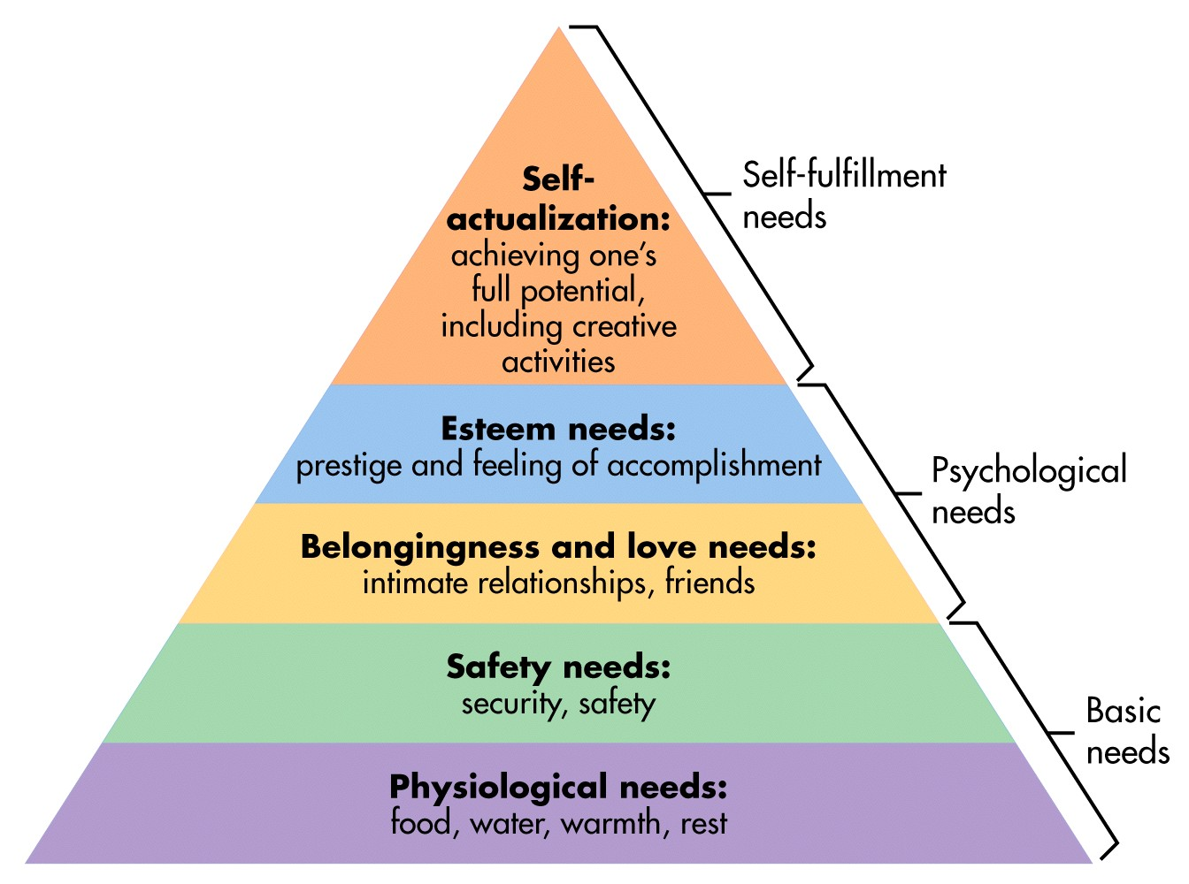

Appendix 3.
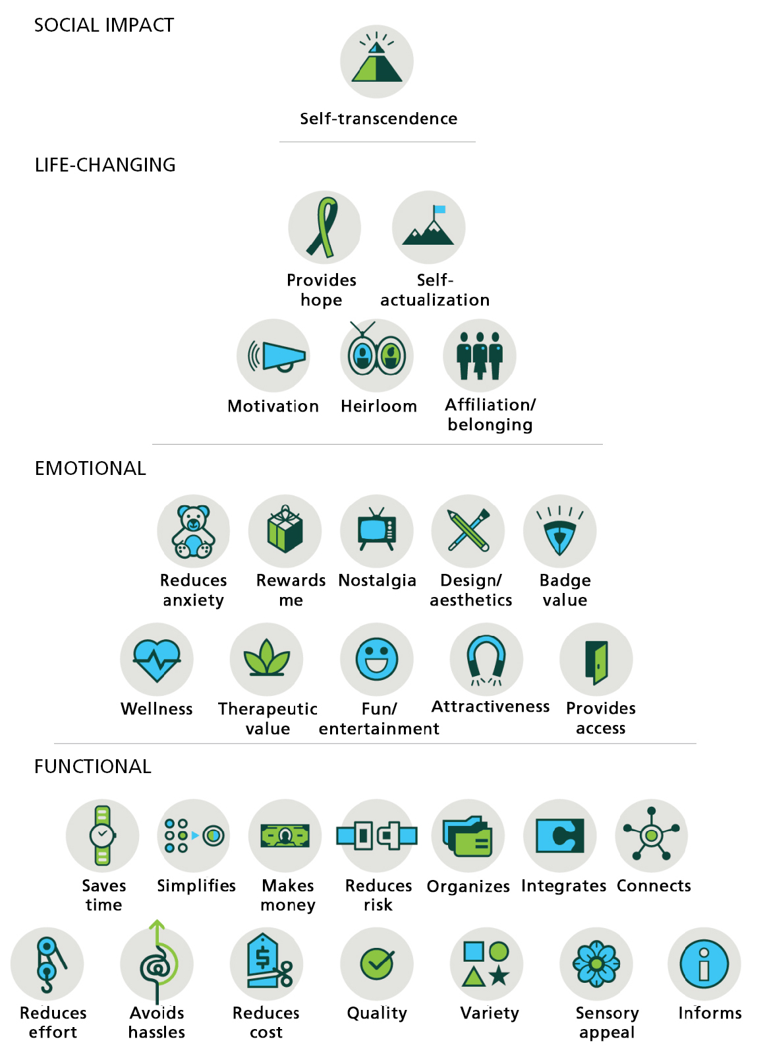

Appendix 4.

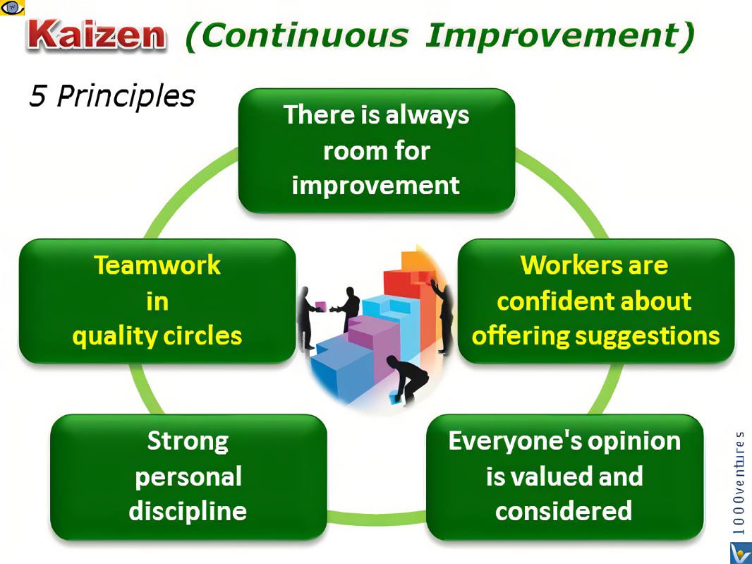

Appendix 5.

Parasocial Impact Model
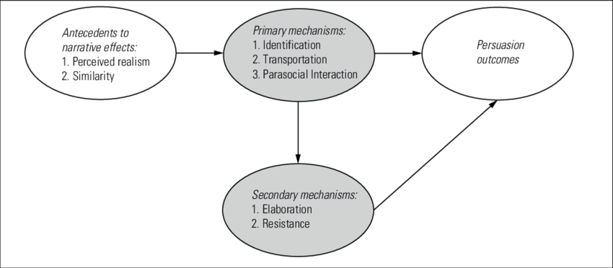

Appendix 6.

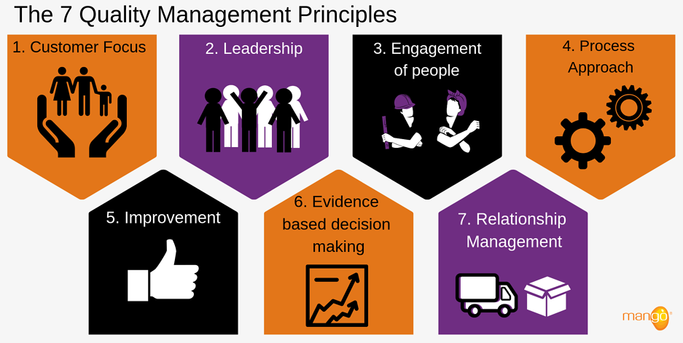

Appendix 7.

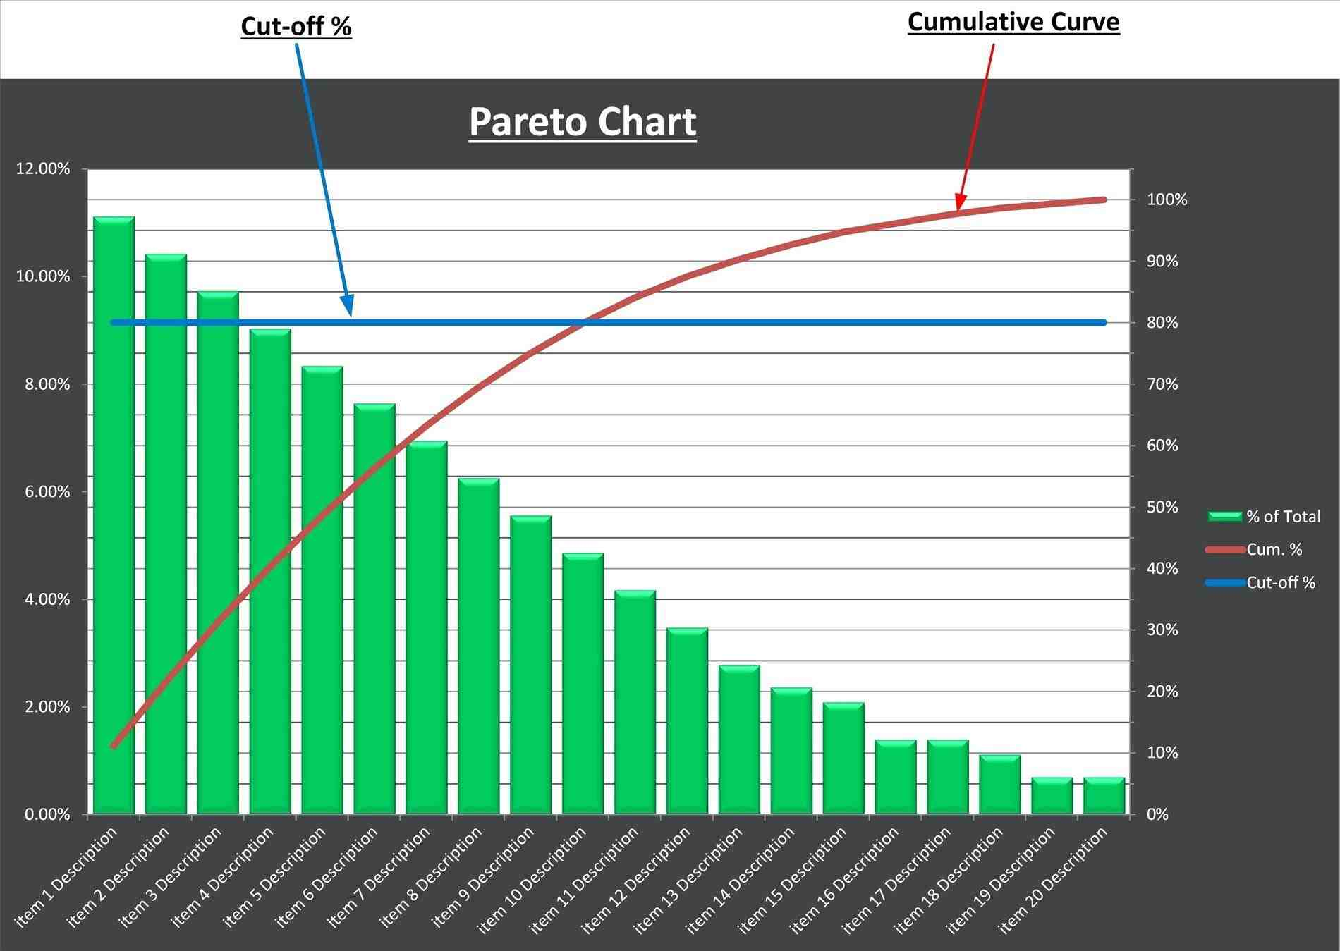

Appendix 7. 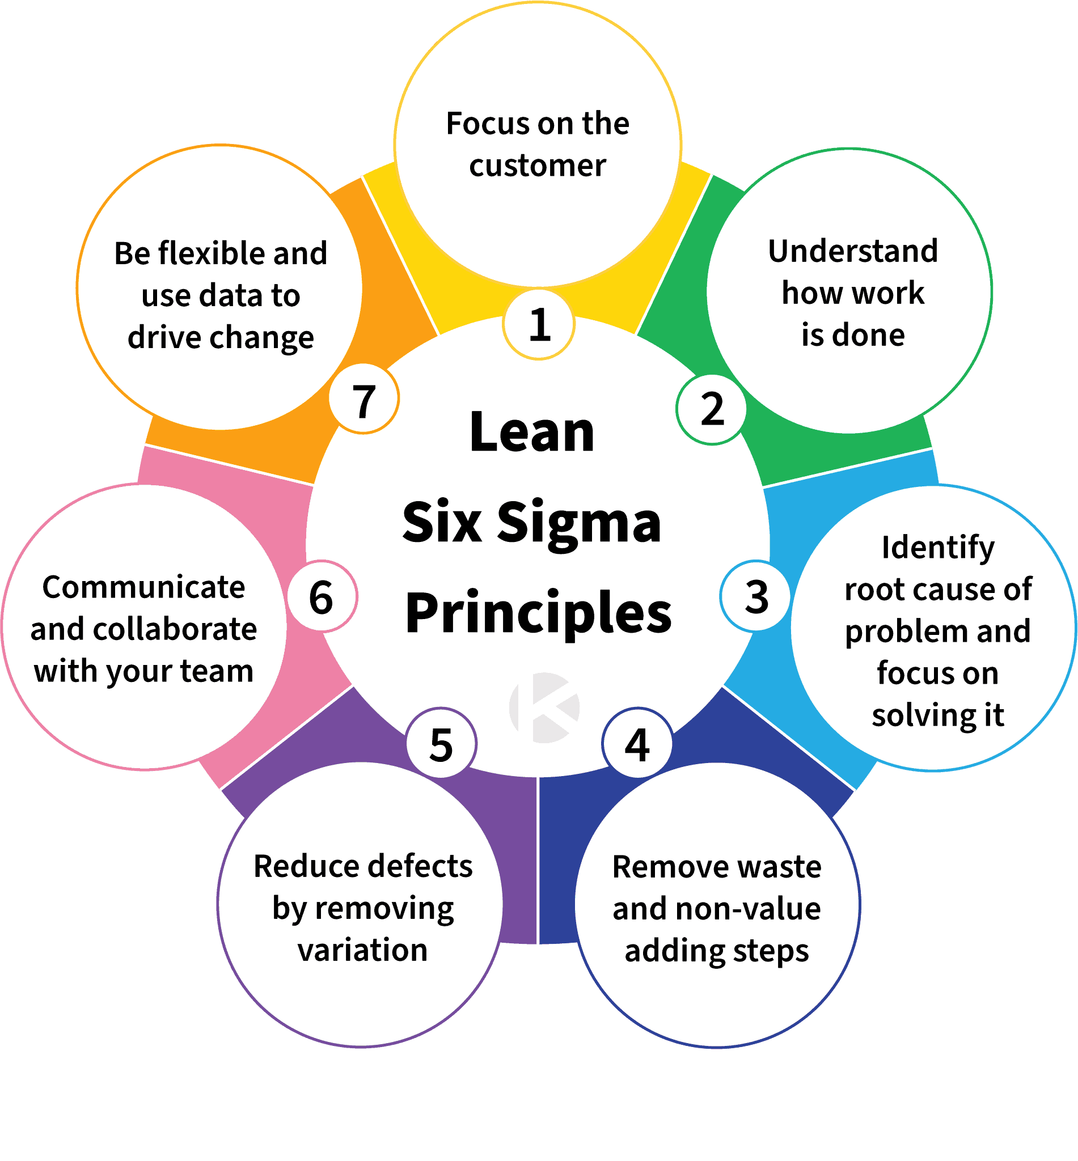

Appendix 8.



