

BA (HONS) LEADERSHIP AND MANAGEMENT SKILLS FOR THE WORKPLACE
Module name: “STRATEGIC DEVELOPMENT AND IMPLEMENTATION FOR SMEs”
BMSW6102 (JULY 2023)
TITLE:
CHOSEN ORGANISATION CLEANOL GROUP
STUDENT NAME: MARIANA GOLEMANOVA
STUDENT ID: 2030688
LECTURER NAME: FAIZU EDU

Executive Summary
The study has been provided with the business strategy of Cleenol Group to improve its position in the chemical industry of the UK. Cleenol is a well-established chemical company that provides hygiene products to customers. The report has included the strategic direction of the company in a present business scenario. It is provided with several environmental analysis tools such as “SWOT”, “PESTEL” AND “VRIN” which helped to understand the internal as well as external environment of the business. The report has proposed a new strategy with the help of “The Ansoff Matrix”, “Porter’s Generic strategy” and “Bowman’s strategic model” that will offer long-term benefits to the organisation. Stakeholder analysis has been done in this report to assess the expectations of the stakeholders of the company. Strategic recommendations have been included which will help Cleenol to achieve future development.

Table of Contents
1.0 Introduction I
2.0 "Critically appraise the organisation's current strategic direction”. I
3.0 “Using business environmental scanning tools such as PESTEL, VRIN, SWOT, provide a critical analysis of the organisations external and internal environment to identify the big picture”. II
PESTLE Analysis II
SWOT Analysis IV
VRIN analysis V
4.0 Discuss available strategic growth choices for SMEs in markets and propose a new strategy and explain why you think it is a sustainable strategy for the long-term future of the organisation”. VII
Porter’s Generic Strategies are determined in Table 3: VII
Ansoff Matrix is the next stage of analysing the Cleenol Group in Table 4: IX
Bowman’s Strategic Clock Model XI
5.0 “Do a stakeholder analysis and critically evaluate the expectations of the different stakeholders and their relative power to identify the most suitable, feasible, and acceptable strategic option/options”. XII
6.0 “Provide key strategic recommendations for the organisation for future developments and implementation, considering the challenges SMEs encounter to implement strategic direction”. XV
7.0 Conclusion XVI
References XVIII
Appendixes XXIII
Appendix 1: PESTLE Analysis XXIII
Appendix 2: Annual Profit of Cleenol XXIV
Appendix 3: Cash Flow of Cleenol in 2020 and 2021 XXV

1.0 Introduction
This report will shed light on the current strategic direction of Cleenol Group, and environmental analysis by using “PESTLE”, “SWOT”, and “VRIN frameworks”. Also will describe “Porter’s Generic Strategies”, “The Ansoff Matrix”, “Bowman’s Strategic Clock model” and “Stakeholder analysis” of the company. A recommendation and conclusion will be provided based on the findings of the report. Strategic management is referred to as a process for setting goals, objectives, and procedures. The main purpose of this management style is to make an organisation more competitive. In this study, the chosen organisation is Cleenol Group and the main aim of this report is to demonstrate effective strategies for the organisation for its sustainable growth. Cleenol is a family-owned business in the UK that offers quality cleaning and hygiene products. The company is famous for providing “top quality hand sanitisers”, “super-concentrate cleaning products”, and “British Nova floor care”. The company belongs to the Chemical industry and supplies products to the government departments and local authorities of the UK working together with the wholesalers. Cleenol exports to over 40 different countries and the company makes its worldwide recognition through its increased product quality. After the COVID-19 pandemic, the hand sanitiser market has shown huge growth. Therefore, it provides an opportunity for Cleenol Group to expand its business.

2.0 "Critically appraise the organisation's current strategic direction”.
Cleenol Group is one of the recognised suppliers, innovators, and manufacturers of hygiene and quality cleaning products in the UK (Cleenol, 2023a). The company focuses to deliver high-quality cleaning products, and floor care products to customers. The mission of the company is to provide the best products to the consumers to live germ-free life to turn them into loyal customers. The vision of Cleenol Group is to provide services and products at low prices and attract customers to enhance the sales performance of the company. The value of the company is to distribute, manufacture, and warehouse top-quality products with the help of personal and efficient service. The strategic objectives of the company are to improve performance, enhance environmental credentials and increase safety along with offering customer benefits. Cleenol has an extensive product portfolio which allows them to fulfill the personalised needs of the consumers. The company offers a wide range of cleaning products to meet the needs of the high standards in “commercial”, “domestic” and “industrial hygiene technology”.
Cleenol supplies products in different industries such as engineering, catering, and healthcare. The company supplies government, and local authorities and appointed distributors in the UK, Middle East, and Europe (Bloomberg, 2023). Cleenol is committed to enhancing hygiene across different sectors therefore development of Virabact RED to control infection of Covid-19 played a crucial part during the pandemic. Cleenol is concerned about the safety of customers therefore they offer training to the consumers about the use of chemical products. Training facilities for the consumers make Cleenol unique compared to the competitors. The main goal of Cleenol is to integrate cleanliness habits as a part of the lifestyle to contribute to a healthier and cleaner future. They celebrate "World Health Day" to promote awareness about a healthier future (Banbury Guardian, 2022). They understand the impact of chemicals on the well-being and health of people along with their environmental impact. Cleenol is evolving its product range as a strategic direction to achieve its goal of a healthier and cleaner society.

3.0 “Using business environmental scanning tools such as PESTEL, VRIN, SWOT, provide a critical analysis of the organisations external and internal environment to identify the big picture”.

PESTLE Analysis
PESTLE analysis is a framework for helping organisations to assess the external business environment through six important factors such as "political", "economic", "social", technology", "environment" and "legal" (Paul, Cadle, and Yeates, 2014, p. 43; Perera, 2017, p. 2) [Refer to Appendix 1. This framework helps the companies to achieve a competitive advantage in the specific industry.
Political
It can be said that the political condition of the UK negatively impacts Cleenol Group as a part of the chemical industry. The political state of 2022 is considered as chaotic due to the occurrence of three prime ministers, Borris Johnson, Rishi Sunak, and Liz Truss (Statista, 2023a). The country was facing difficulties to deal with the crisis of Brexit in the UK. The Russian invasion of Ukraine leads to a decline in the import of raw materials for chemical products (CIA, 2023). It all negatively impacts the chemical industry in facing issues of raw material shortage, especially as it is considered as the largest industry in the UK, which has a huge impact on the economy. The government of the UK announced that they will not maintain new restrictions in the EU (Financial Times, 2022).

Economic
People of the UK are encouraged to purchase more hygiene products to maintain a healthy lifestyle. Hence, the UK economy has a positive impact on Cleenol Group as a part of the chemical industry.
In April 2023, the GDP of the UK increased by 0.2% compared to the previous months (ONS, 2023a). It indicates that the economic condition of the UK is improving steadily. The unemployment rate has increased by 0.2% from March to May 2023 compared to the previous quarter (ONS, 2023b). However, the overall unemployment rate of the UK is low which indicates that growth in the economy is driving wage growth and improving the living standards of people.
Social
Social factors can positively impact the business of the chemical industry, especially Cleenol. The covid-19 pandemic had a substantial impact on the company as customers have shown increased demand for hygienic products as they are concerned about safety (Bahlol and Dewey 2021, p. 1888). People have started to value healthy living which increased opportunities for the businesses of the chemical industry. The clients are looking for customised products, which can be easy and convenient to use.
Technology
It can be stated that technology can positively impact the chemical industry of the UK, including Cleenol Group. Digital transformation has a positive impact on the supply chain and inventory. Incorporation of digital technology in the chemical industry can positively impact driving innovation which can improve the efficiency of chemical-producing companies. For instance, AI accelerates the R&D process to develop new products and determine their efficiency. In 2021, the expenditure of Great Britain on R&D of the chemical industry amounted to 0.87 billion pounds (Statista, 2023b).
Environment
Environmental factors will positively impact the company Cleenol as a part of the chemical industry of the UK as it is the third largest sector that contributes to CO₂ emissions. The government of the UK invests in clean energy technology to reduce carbon emissions to achieve the Net Zero scenario (IEA, 2023). Therefore, companies need to develop strategies to incorporate low-emission methods for recycling and chemical production. It can be said that chemical companies could develop processes that will help them to reduce carbon emissions and it will attract more customers to the company.
Legal
The government of the UK work closely with stakeholders and partners to manage the chemical industry therefore Cleenol Group needs to follow these regulations for business purpose.“Health and Safety Act of 1974” ensures occupational safety and health in the UK (HSE, 2023). This act allows safety at the workplace therefore companies need to work in compliance which can positively impact the employees of chemical companies. Health and safety law is essential to protect employees from risks. In the UK, businesses need to follow domestic chemical regulations to manufacture, distribute and sell chemicals (GOV, 2020).
The next tool for analysing the discussed company is SWOT analysis and it is shown in detail in Table 1 as follows:

SWOT Analysis
Strength | Weakness
- Cleenol group produces a range of cleaning and bleaching products with wide varieties in colour, appearance, and packaging.  - The company consisted of more than 250 skilled professionals capable of addressing the challenging business environment in the UK (Endole, 2023).  - The company has a strong stakeholder relation and market demand that endures annual turnover ranging from £10 to £50 million (GOV, 2023b). | - As a brand operational in the chemical industry of the UK, Cleenol Group endorses a less competitive strategy than its counterparts in the UK.  - The lack of trending technology in delivery management is reducing the scope of business expansion for the company.  - Less flexibility in business operation and a lack of skills in marketing operations is deteriorating the position of the company in the UK market.  - The company is facing a challenge in retaining their employees considering the reduction of active employees from 106 to 100 from 2020 to 2021 in the UK (Global Data Base, 2023).
Opportunity | Threat
- Enhancement of the brand image of the company with digital tools can ensure greater customer engagement.  - Improvement of operation management with flexible business culture, and a focus on research and development can ensure greater competitive advantage for the company.  - Inclusion of skilled employees, and providing training and development in AI, cloud computing technologies, and others can streamline business processes with increased transparency, authenticity, and informed decision-making. | - The demand-pull inflation of the UK market is increasing stress for the company to meet customer demands, resulting in an increased workload for the workforce (Chemical Industry Journal, 2023).  - Dramatic changes encountered in the new normal concerning employee retention might pose a threat to the company leading to a labor shortage.  - International turmoils like the Russia-Ukraine war have massively impacted on trade and foreign policies of the UK. It reduced the import of raw chemicals from the UK emerging threat for the company concerning supply chain disruption (OECD, 2022).
Table 1: SWOT Analysis
(Source: Self-created)

VRIN analysis
VRIN, often referred to as VRIO, focuses on the resources of the firm to understand the ways these resources contribute to competitive advantage (Zimmerman and Blythe, 2017, P. 44). The capability of the resources can create a competitive advantage in the market which helps to identify the position of the organisation in the country. Competitive advantage plays a pivotal role in enhancing business standards within a highly dynamic and competitive business environment which delivers higher economic value to a company compared to its rival organisations (Barney and Hesterly, 2010, p. 30). Cleenol is a cleaning company that provides the service towards people with hygiene and cleaning services maintaining sustainability and valuable resources. The resources of Cleenol are important to be analysed by the category of rare, valuable, imitable, and organised. Resources such as Human capital, technology, brand value, and finance are considered the internal resources that need to be evaluated by this framework as shown in the next Table 2 VRIO analysis.

Resources | Valuable | Rare | Imitable | Organised | Outcomes
Human capital | Yes | NO | Yes | Yes | Comparative parity
Technology | Yes | NO | Yes | Yes | Comparative parity
Brand value | Yes | Yes | No | Yes | Comparative advantage
Finance | Yes | NO | Yes | NO | Comparative parity
Table 2: VRIO analysis
(Source: Self-created)
Human capital: Employee skills and knowledge are important for the organisation to proceed with quality and efficiency. The company’s employees are skilled in logistics management with packaging, shipping, and internal work process (Cleenol, 2023f). Therefore, it is indicating that his resource is valuable and organised for the company to provide high productivity and efficiency. The skills of the employees are not rare as they can be copied by other employees by supporting them with training and can be imitated by the other top companies. The focus is on comparative parity as the outcome of this framework which is accompanied by the scope to grow in the future with better resolution.
Technology: Technological advancements help to improve the quality of the products along with improving organisational efficiency. The company uses Evolution X2 which uses a patented technology to deliver higher value to customers (Cleenol, 2023g). This indicates the technologies used in the organisation deliver competitive parity to the company.
Brand value: Brand value helps implement brand loyalty towards their customers which can increase the competitive advantage in the market. The organisation has a remarkable approach towards the people with charitable funding in the amount of £75,000 (Cleenol, 2023d). The Thames Valley Air Ambulance is another charity that is open 365 days to help people and this creates trust among customers. Hence, the brand value of Cleenol is rare, valuable inimitable, and it is used in an organised manner, thereby contributing to sustained competitive advantage for the company.
Finance: Cleenol’s financial performance is weak as per their annual report which shows the assets of the company decreased due to financial loss (GOV, 2023a). It indicates that although the financial assets of the company are valuable, it is neither rare nor inimitable, which provides competitive parity to the company.

4.0 Discuss available strategic growth choices for SMEs in markets and propose a new strategy and explain why you think it is a sustainable strategy for the long-term future of the organisation”.

Porter’s Generic Strategies are determined in Table 3:
Cost Leadership | Differentiation
The business paradigm of Cleenol is mainly driven by the idea of rebranding to develop sustainable channels for the future (Cleenol, 2023b). The organisation sets its foothold within the channels of “Antibacterial” to suppress bacterial growth by killing it (Cleenol, 2023b). It eventually sets higher standards for the organisation in creating value for its customers. Cleenol also takes various important steps in reducing the threats imposed on the environmental scenario. The UK is known as the fifth largest generator of “single-use plastic waste” in the world producing a total of 2.5 million metric tons in 2021 (Tiseo, 2023). The British government also initiated the “EdenCleen range” as a response to reduce the threats of the plastic population (GOV, 2023a). Cleenol, in this manner, incorporates the channels of “Flasks for Life” that massively reduce the total number of plastic bottles creating threats (GOV, 2023a). These insights can be interpreted in such a manner addressing the commitment of Cleenol to become more sustainable by incorporating improved packaging aspects. | Cleenol seems to be committed to developing a conscious customer base in terms of maintaining proper hygiene. The fact has emerged addressing an enormous growth within the UK’s “Hand Sanitizer Dispenser Market” acquiring £ 4.36 M in 2022 (Yahoo Finance, 2022). Cleenol, in this instance, initiates a long range of evolution to acquire higher standards of differentiation within their products. Considering this scenario, the organisation decides to expand the standards of “CrystalBrite” to cope with the higher demand metrics (Cleenol, 2023b). More precisely, the organisation has also developed a robust business paradigm by incorporating its operations within different sectors such as “catering and food processing”, “hospitality”, “laundries”, and many others. It eventually triggers a higher standard of diversification both in the products and services for Cleenol.
Focus
Cost Focus | Differentiation Focus
A cost focus can be described as a strategy that allows an organisation to attract potential customers, mainly based on pricing. Blocher et al. (2019, p. 150) have addressed the importance of cost focus strategy to target a “definite market segment”. Cleenol takes the initiative to enhance its sustainability standards driven by both price and feature. The fact has emerged reflecting nearly 3.1M adults being affected by hygiene poverty in the UK acquiring 6% of the total population in 2022 (The Hygiene Bank, 2022). Cleenol has a long range of products targeted for reducing the threats of this poverty that includes “antibacterial foaming hand soaps”, “liquid hand soap”, and others (Cleenol, 2023c). | Differentiation focus is defined as a particular strategy that allows an organisation to target a narrow section of the market for a certain product. More precisely, this particular strategy can also be a significant element in terms of improving the standards of competitive advantage for a particular brand or product. Cleenol’s business paradigm, on the contrary, is found to be evolved massively in recent years. The organisation seems to be more inclined toward the commitment of attracting a larger customer base as a total fund of £75,000 is generated through fundraising channels from their suppliers and customers (Cleenol, 2023d).
Table 3: Porter’s Generic Strategies
(Source: Self-created)
Analysis
Considering the facts illustrated in Table 1, differentiation can be interpreted as the most feasible choice for Cleenol to maintain the normalcy of their business. The organisation has a robust foundation of its business based on a long range of products along with multiple categories. On the other hand, this enormous range of Cleenol’s products also plays a pivotal role in maintaining the customer base. Moretta Tartaglione et al. (2019, p. 8) have addressed a strong relationship between brand performance and customer loyalty driven by the improvement of brand image. Cleenol, in this instance, needs to use the channels of differentiation in this manner.

Ansoff Matrix is the next stage of analysing the Cleenol Group in Table 4:
Factors | Risks | Insights
Market penetration | LOWER | It is mainly the concept of improving the sales of a certain product within an existing market. The Covid 19 pandemic seems to have imposed a landslide within the business operations of Cleenol. The organisation encountered massive damage in its overall profit, as it decreased from £ 850, 904 in 2020 to £ 91,755 in 2021 (GOV, 2023a) [Refer to Appendix 2]. This particular instance can simply affect the operations of Cleenol in terms of improving sales, especially in the existing market.
Market development | HIGHEST | Market development is mainly focused on selling a certain existing product into the new market. Cleenol faces enormous threats within the standards of their cash flows both in “operating activities” and “investing activities”. The valuation of cash flows from the operating activities of Cleenol decreased to £ 116,296 in 2021 from £ 2,164,663 in 2020 (GOV, 2023a) [Refer to Appendix 3]. On the other hand, investing activities of Cleenol also encounter a fall acquiring £ 122,969 in 2021 from £185, 144 in 2020 (GOV, 2023a). [Refer to Appendix 3]. These insights can be interpreted as the most influential in restricting the channels of expanding in a new market.
Product development | LOWEST | It is the strategy of introducing new products within an existing product. Cleenol in this instance, has a long range of products based on the dynamics of a conscious customer base. In this manner, the organisation develops a robust foundation driven by a long range of products including floor care, drain cleaners, floor polish, and many others (Cleenol, 2023e). This particular scenario can be a suitable choice for Cleenol to develop new products within its existing market. It can also be an effective choice for the organisation to maintain the standards of customer loyalty.
Diversification | MODERATE | The issues in the financial stability of Cleenol affect its ability to expand in a new market. Despite the presence of a long range of products developed by the organisation, a huge decrease in investment seems to have suppressed the opportunities for business expansion in an entirely new or unexplored market.
Table 4: Ansoff Matrix
(Source: Self-created)
Analysis
Product development seems to have higher feasibility for Cleenol in terms of enhancing the standards of their business paradigm. It links to the fact due to the presence of the stable business paradigm of the organisation within the UK market. More precisely, the organisation seems to have a higher standard of customer loyalty due to its social and environmental commitment.

Bowman’s Strategic Clock Model
“Bowman Strategic Clock” is considered as a strategic tool for market positioning comprising the most valuable and profitable business infrastructure with products. It is used with “Ansoff’s Matrix” or “Porter’s Generic Strategy” as an extension of these tools. There are eight different strategies endured in this aspect comprising two dimensions namely price and value (Bowman and Raspin, 2018, p. 63). The aspect is to evaluate Cleenol’s present business strategy and its effectiveness by analysing market data and recommending the best-suited measure to take for greater market acquaintance. It is following shown in Figure1:
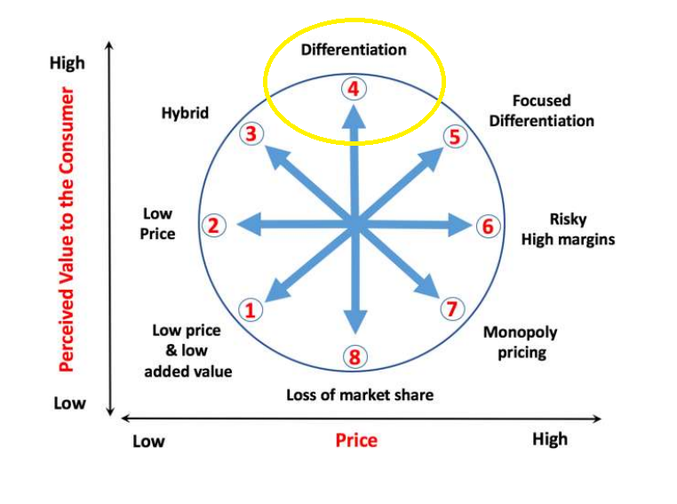
Figure 1: Bowman’s Strategic Model
(Source: Matrix and Ansoff, 2023)
“Low price and low valued” products indicated under “Bowman’s strategic clock" intends to increase sales with a competitive business advantage. As an SME, it is hard for Cleenol to accommodate the strategy due to a lack of resources. On the contrary "low price and high value” products can ensure market expansion and competitive advantage while creating immense risk for business and operation management. As observed from the annual report of Cleenol, the company encountered immense losses from 2019-2020 and 2020-2021 years respectively (GOV, 2023b). It reduces the capability of the company to take further changes by accommodating greater stress and risks on financial resources. “Hybrid strategy” endorses competitive pricing with high value (Smith, 2021, p. 26). It can accommodate profitability at a certain range but it becomes difficult for a brand to acquire reputation in the marketplace. Cleenol has less popularity in comparison to its competitors like Wightman and Parrish Ltd, Whieley Corp, ACMA Ltd, and others in the UK (Zoominfo, 2023). Therefore, taking up the “hybrid strategy” can be a risky trait for the company. “Differentiation” in “Bowman’s strategic clock” addresses unique production based on market demands. Companies focus on the improvement of product value rather focusing on competitive pricing. Cleenol Group comprises a large variety of products at a restricted or competitive price. For instance, the company sells hand sanitisers, toilet cleaners, dish wash detergent, and others either with their own brand name or subsidiaries like Osmos (Creed, 2023). Most of the products offered by Cleenol range from £10-£25 depending on the type, feature, and functionalities. It is indicating the company can focus on a differentiation strategy to grow its market share with moderate price and high value.
The purpose of Cleenol Group is to ensure competitive advantage by developing a brand reputation as well as meet the profitability expectation in the UK market. “Focused differentiation” accommodates specific features with high prices. It can be a short-term strategy but retaining it for the long term is a difficult task for a company to adhere to as there are already a significant number of competitors offering a diverse range of hand sanitisers and cleaning products catering to the personalised preferences of customers.
Despite that, the company also operates in a highly competitive market where substitute products pose a hardship for the company to retain its market share with unique production and high value. “Risky high margin” deals with increasing product price without added value. Companies opt for this strategy depending on their emotional and personal attachment to the products offered by them. In “Monopoly pricing” companies can adopt any pricing in the absence of any competition (Helmold, M. and Helmold, 2020, p. 63). “Loss of market share” indicates the urge to move to a new market due to losing grip on an existing one. Cleenol endured immense losses in the UK which reduced the company’s capacity to take up initiative for new market expansion.

5.0 “Do a stakeholder analysis and critically evaluate the expectations of the different stakeholders and their relative power to identify the most suitable, feasible, and acceptable strategic option/options”.
Stakeholder analysis
Stakeholders are the individuals who have a positive as well as negative impact on the outputs of a project. They are very important for the efficient project manager to identify effective stakeholders for the growth of a business. “Employees”, “investors”, “customers”, “government”, “suppliers”, “CEO”, “Print media” and “local community” are the main stakeholders of an organisation. Through the “Stakeholder matrix” tool, an organisation can segregate stakeholders into categories such as “keep satisfied”, “managed closely”, “monitor”, and “keep informed” (Tamam, Abdelkader and Haroun, 2022, p. 6053). Stakeholders are the central component of risk management and are engaged in the growth of a business. The stakeholder’s analysis is shown as follows in Figure2:
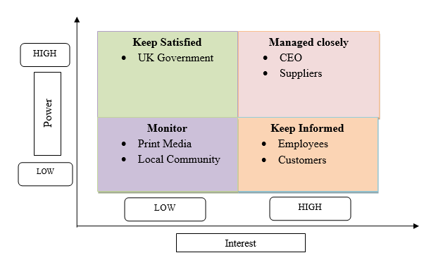
Figure 2: Stakeholders matrix
(Source: Self-created)
“Keep satisfied”
The UK government is one of the stakeholders of Cleenol, who have high power and low interest in the organisation. The government aims to ensure that the chemicals are safely managed and used in the workplace. “UK Chemicals Stakeholder Forum (UKCSF)” enables the discussion between the organisations and stakeholders in supporting effective waste management and chemicals management (GOV, 2023c). They have high power for changing the policies of production and reducing the use of harmful chemicals. The chemical industry impacts the environment such as "soil contamination", "water pollution", "greenhouse gas emission" and many more. The production and use of chemical contributions for climate change is controlled by the UK government. It can harm human health, the ecosystem, wildlife, and many more. The government provides the parameters for the organisation for protecting them from outside interference. As per the view of Chen et al. (2020, p. 136999), the UK government focuses on the use of green chemistry principles to reach their SDGs. Hence, it has been found that the UK government has a major role in the organisation for managing the business so they may be categorised as “Keep satisfied”.

“Managed closely”
The suppliers of Cleenol are major stakeholders in the business so the company provides effective recognition to them and placed them in the managed closely category. Company CEOs, directors, leaders of partner companies, and others have a high influence on decision-making for the company. They regulate product design, operational management, marketing, and customer management. They have a high interest in company operations and high power to regulate business decisions.
“Richard Greaves”, the CEO of Cleenol has a crucial role in the growth of the business (Cleenol, 2023a). The CEO has a role in managing the overall operations, making major decisions for the business, and setting the strategic directions of the business. CEOs ensure the vision and mission of a business and enhance performance in the market. Therefore, the CEO may be considered by the company as “Managed closely” who has high power and a high interest in managing business.
“Monitor”
Goodwill is one of the most essential aspects incorporated within the business paradigm of Cleenol. The fact has emerged in such a manner addressing the importance of customer loyalty to improve the fundamental standards of brand image (Naim and Kautish, 2022, p. 150). On the other hand, the presence of higher standards of customer loyalty can also be pivotal in enhancing metrics of brand-customer communication (Schultz et al. 2015, p. 150). These insights can be interpreted in such a manner addressing the importance of using local community channels to maintain a balanced customer base for their products. The overall landscape of print newspapers and magazines in the UK is found to have a user penetration of 30.0% in 2023 (Statista, 2023c). These two channels need to be monitored properly by Cleenol to improve the robustness of their entire business standards. Considering the standards of the local community, Cleenol seems to have a vibrant presence within the process of conducting several philanthropic activities. For example, “The Katharine House Hospice” and “Chipping Norton Theatre” are two big partners of Cleenol in terms of enhancing their attachment and commitment to the local community (GOV, 2023a). This particular instance is also an influential choice for Cleenol to enhance the standards of corporate identity that can be a feasible channel for attracting new investors.
“Keep informed”
About 100 employees work within the organisation and have major responsibilities for the performance of the business. Satisfied and motivated employees enhance the productivity level of the company. Through the effective skills and knowledge of the employees, the organisation reached the top level of business and met the demands of customers. Employees play an important role in deciding the culture of the workplace. Employees can manage the quality of products and level of productivity with satisfaction (Palmer, 2022, p. 9). Therefore, they may be placed in the “Keep informed” category. The company needs to focus on their motivation and satisfaction. The customers of Cleenol are important for driving revenue and enhancing the performance of organisations in the marketplace. Support and feedback from suppliers help in the growth of business and change the quality of products. Hence, it has been found that Cleenol needs to provide information about the business and upcoming activities to customers so they may be placed in the “Keep informed” category.

6.0 “Provide key strategic recommendations for the organisation for future developments and implementation, considering the challenges SMEs encounter to implement strategic direction”.
Reward policies to deal with employee turnover issue: In recent years Cleenol Group has faced employee turnover issues and it led to the declining productivity of the company. Therefore, it can be suggested that the company can adopt reward policies to resolve the issue of employee turnover. Appreciation matters a lot and it has a positive impact on the motivation of the employees (Chukwu, 2019, p. 70). Monetary rewards might be an effective way of improving employee motivation and retention. The company can also adopt a positive workplace culture and create learning and development programs to encourage employees in the workplace. It will allow the company to decrease the employee turnover issue.
Adaptation of Differentiation strategy: Cleenol Group has faced a financial asset loss and therefore it can be suggested that the organisation can adopt a Differentiation Strategy to improve this condition. The company can develop and make differentiation in the products and it will allow the company to capture more markets and develop the financial asset. The addition of more features and varieties into products helps in attracting more customers and improving customer satisfaction (Lee and Lee, p. 7). Adaptation of differentiation strategy will allow Cleenol to make variety and more features to the products and ultimately enhance its financial asset.
More investment to develop product quality: It has been seen that Cleenol did not invest much in company operations. It can be recommended that the company can focus on investing more in product development and it will help the company to deliver quality product and focuses on product hygiene. Adaptation of a long-term investment approach and diversifying the investments can minimise investment risk (SEC, 2023). Therefore, it can be said that Cleenol can focus on investing in product development. This approach will assist the organisation to satisfy the needs of the customers and achieve new customers toward the organisation.
Customer centricity: “Customer centricity” is an essential factor for Cleenol Group to focus on by analysing requirements depending upon analytics and customer activities on its website. Anticipation of customer needs and enduring them in product design and marketing can increase the profitability of a company (Gao, Melero-Polo, and Sese, 2020, p. 185). In addition, the company needs to work on suitable communication to mitigate customer issues or give them effective support before and after purchase. The data collected on Cleenol indicates the company needs to focus on a product differentiation strategy to improve its market stance as well as improve its financial stability. The company must endure good customer relations by including skilled associates and advanced technology for better communication with their targeted stakeholders.
ESG commitment: ESG endorses the idea of “environmental”, “social” and “corporate governance” by aligning business profitability, productivity, and sustainable initiatives (Becchetti et al. 2022, p. 9669). As a chemical company, Cleenol has to ensure its products are not disrupting natural stability or creating pollution due to the emission of toxic chemicals. The company also needs to ensure health and safety, suitable working conduction, diversity inclusion, and human rights under social considerations. Apart from that, ethical standards in operational management, board governance, effective stakeholder engagement, and stakeholder rights must be incorporated under the ESC commitment of the company.

7.0 Conclusion
Strategic management helps organisations to achieve its goal and remain competitive in any industry. The report discussed Cleenol Group which is a known SME in the chemical industry that offers hygiene products and top-quality cleaning to customers. The emergence of the COVID-19 pandemic provided an opportunity to expand the business in the UK as well as overseas. The objective of the company is to create a healthier society therefore they are developing some strategies such as offering training to the customers about the process to use hygiene products and it helps to boost awareness among customers. PESTLE analysis indicates that the rising demand of customers regarding health and safety can allow companies to achieve growth in the chemical industry. SWOT analysis of Cleenol group represents the opportunities to improve the brand image with the help of digital tools to promote customer engagement. Recruitment of skilled employees and offering necessary training can help the company to achieve a competitive advantage to the company/according to the discussed in class importance to get an edge to be on the top of the industry/. The above report indicates differentiation strategy of Cleenol offers benefits to the company with a huge product range. Product development strategy can offer benefits to the company in the existing market to approach better sustainability as discussed in lectures. Cleenol has the opportunity to improve its growth with the help of rewarding policies for the employees. Regarding the study cases in our class lectures we can say that as an example given, the company could carry competencies in design, information systems, and logistics management to get better results of its strategy. In addition, I can say that Cleenol is not just making an action plan/ as mentioned in lectures/ but taking action to provide a successful strategy to cover more of the chemical industry market and achieve the best possible profit!

References
Bahlol, M. and Dewey, R.S., (2021) ‘Pandemic preparedness of community pharmacies for COVID-19.’ Research in Social and Administrative Pharmacy, 17(1), pp.1888-1896.
Banbury Guardian (2022) Banbury cleaning firm boss makes a plea on World Health Day: 'Make even just modest lifestyle changes now for a cleaner world and healthier future'. Available at: https://www.banburyguardian.co.uk/health/banbury-cleaning-firm-boss-makes-plea-on-world-health-day-make-even-just-modest-lifestyle-changes-now-for-a-cleaner-world-and-healthier-future-3644840 (Accessed: 25 June 2023).
Barney, J.B. and Hesterly, W.S., (2010). Strategic management and competitive advantage: Concepts (Vol. 408). Englewood Cliffs, NJ: Prentice Hall.
Becchetti, L., Bobbio, E., Prizia, F. and Semplici, L. (2022) ‘Going deeper into the S of ESG: a relational approach to the definition of social responsibility’. Sustainability, 14(15), p.9668.
Blocher, E.J., Stout, D.E., Juras, P.E. and Smith, S., (2019). Cost Management (A Strategic Emphasis) 8e. McGraw-Hill Education.
Bloomberg (2023). Cleenol Group Ltd. Available at: https://www.bloomberg.com/profile/company/1074754Z:LN#xj4y7vzkg (Accessed: 23 June 2023).
Bowman, C. and Raspin, P.G., (2018). What's Your Competitive Advantage? Pearson UK.
Chemical Industry Journal (2023) Growth continues, but concerns remain. Available at: https://www.chemicalindustryjournal.co.uk/growth-continues-but-concerns-remain (Accessed: 18 July 2023)
Chen, T.L., Kim, H., Pan, S.Y., Tseng, P.C., Lin, Y.P. and Chiang, P.C., (2020). ‘Implementation of green chemistry principles in the circular economy system towards sustainable development goals: Challenges and perspectives’. Science of the Total Environment, 716, p.136998.
Chukwu, B.A., (2019). ‘The influence of staff promotion on employee turnover intention in food and beverage industry in Nigeria’. Journal of Asian Business Strategy, 9(2), p.66-81.
CIA (2023) Russian-Ukraine Conflict. Available at: https://www.cia.org.uk/Russian-Ukraine-Conflict (Accessed: 13 July 2023).
Cleenol (2023a) About Us. Available at: https://cleenol.com/pages/about-us (Accessed: 20 June 2023).
Cleenol (2023b) Rebrand. Available at: https://cleenol.com/pages/rebrand (Accessed: 25 June 2023).
Cleenol (2023c) World hand hygiene day. Available at: https://cleenol.com/blogs/news/world-hand-hygiene-day-1 (Accessed: 25 June 2023).
Cleenol (2023d) PROJECT 75|75|75 GOES LIVE. Available at: https://cleenol.com/blogs/news/project-75-75-75-goes-live (Accessed: 20 June 2023)
Cleenol (2023e) Products. Available at: https://cleenol.com/collections (Accessed: 28 June 2023)
Cleenol (2023f) Policies & accreditations. Available at: https://cleenol.com/pages/policies (Accessed on: 17 July 2023)
Cleenol (2023g) EVOLUTION X2. Available at: https://cleenol.com/pages/evolution-x2 (Accessed on: 17 July 2023)
Creed (2023) Cleenol Osmos Premium Dishwasher Detergent - 2x5ltr. Available at: https://www.creedfoodservice.co.uk/503540-cleenol-osmos-premium-dishwasher-detergent-2x5ltr.html (Accessed: 18 July 2023)
Indole (2023) Cleenol Group Ltd. Available at: https://suite.endole.co.uk/insight/company/00635803-cleenol-group-limited (Accessed: 18 July 2023)
Financial Times (2022) UK risks falling behind EU on hazardous chemicals standards. Available at: https://www.ft.com/content/22f0c812-3ad4-45b6-b93a-0758625fd4ab (Accessed: 23 June 2023).
Gao, L., Melero-Polo, I. and Sese, F.J. (2020) ‘Customer equity drivers, customer experience quality, and customer profitability in banking services: The moderating role of social influence’. Journal of Service Research, 23(2), pp.174-193.
Global Data Base (2023) Cleenol Holdings Limited. Available at: https://uk.globaldatabase.com/company/cleenol-holdings-limited#div_employees (Accessed: 18 July 2023)
GOV (2020) New UK chemicals regime launched. Available at: https://www.gov.uk/government/news/new-uk-chemicals-regime-launched (Accessed: 12 July 2023).
GOV (2023a) CLEENOL GROUP LIMITED. Available at: https://find-and-update.company-information.service.gov.uk/company/00635803/filing-history/MzM4MDkyNjYyMWFkaXF6a2N4/document?format=pdf&download=0 (Accessed: 29 June 2023)
GOV (2023b) Cleenol Group Limited. Available at: https://find-and-update.company-information.service.gov.uk/company/00635803/filing-history (Accessed: 18 July 2023)
GOV (2023c) UK Chemicals Stakeholder Forum (UKCSF). Available at: https://www.gov.uk/government/groups/uk-chemicals-stakeholder-forum (Accessed: 25 July 2023).
HSE (2023) Health and Safety at Work etc Act 1974. Available at: https://www.hse.gov.uk/legislation/hswa.htm#:~:text=The%20Health%20and%20Safety%20at,the%201974%20Act%20or%20HASAWA. (Accessed: 12 July 2023).
IEA (2023) Chemicals. Available at: https://www.iea.org/energy-system/industry/chemicals#overview (Accessed: 12 July 2023).
Lee, S.M. and Lee, D., (2020). ‘Untact: a new customer service strategy in the digital age’. Service Business, 14(1), pp.1-22.
Matrix, A. and Ansoff, I. (2023) Tools for Generating Strategic Operations and Strategic Management Process.. Available at: https://www.researchgate.net/profile/Rangamini-Werawatta/publication/352159498_Tools_for_Generating_Strategic_Options_in_Strategic_Management_Process/links/60bbccad299bf10dff9c6fdb/Tools-for-Generating-Strategic-Options-in-Strategic-Management-Process.pdf (Accessed: 17 July 2023)
Moretta Tartaglione, A., Cavacece, Y., Russo, G. and Granata, G., (2019). ‘A systematic mapping study on customer loyalty and brand management’. Administrative Sciences, 9(1), p.8.
Naim, A. and Kautish, S.K. eds., (2022). Building a Brand Image Through Electronic Customer Relationship Management. IGI Global.
OECD (2022) The supply of critical raw materials endangered by Russia’s war on Ukraine. Available at: https://www.oecd.org/ukraine-hub/policy-responses/the-supply-of-critical-raw-materials-endangered-by-russia-s-war-on-ukraine-e01ac7be/ (Accessed: 18 July 2023)
ONS (2023a) GDP monthly estimate, UK: April 2023. Available at: https://www.ons.gov.uk/economy/grossdomesticproductgdp/bulletins/gdpmonthlyestimateuk/april2023 (Accessed: 21 June 2023).
ONS (2023b) Unemployment. Available at: https://www.ons.gov.uk/employmentandlabourmarket/peoplenotinwork/unemployment (Accessed: 25 June 2023).
Palmer, M., (2022). What Your Employees Need and Can't Tell You: Adapting to Change with the Science of Behavioral Economics. Mango Media Inc.
Paul, D., Cadle, J. and Yeates, D. eds., (2014). Business analysis. BCS, The Chartered Institute for ITA.
Perera, R., (2017). The PESTLE analysis. Nerdynaut.
Schultz, D.E., Barnes, B.E., Schultz, H.F. and Azzaro, M., (2015). Building customer-brand relationships. Routledge.
SEC (2023) Financial Navigating in the Current Economy: Ten Things to Consider Before You Make Investing Decisions. Available at: https://www.sec.gov/investor/pubs/tenthingstoconsider.htm (Accessed: 19 July 2023)
Smith, B. D. (2021). Making Marketing Happen. United Kingdom: Taylor & Francis Group.
Statista (2023a) UK Politics - Statistics & Facts. Available at: https://www.statista.com/topics/4666/british-politics/#topicOverview (Accessed: 25 June 2023).
Statista (2023b) Chemical industry R&D investment in Europe 2021, by country. Available at: https://www.statista.com/statistics/1307562/european-chemical-industry-research-spending-by-country/ (Accessed: 10 July 2023).
Statista (2023c) Print Newspapers & Magazines - United Kingdom. Available at: https://www.statista.com/outlook/amo/media/newspapers-magazines/print-newspapers-magazines/united-kingdom?currency=GBP (Accessed: 29 June 2023)
Tamam, A., Abdelkader, H. and Haroun, A., (2022). ‘Classification Arabic Twitter User’s Insights Using Rough Set Theory’. 16(8), p.6052.
The Hygiene Bank (2022) The Hygiene Bank: Hygiene Poverty 2022 Summary Report. Available at: https://thehygienebank.com/wp-content/uploads/2022/10/Hygiene_Poverty_2022_Summary_Report-1.pdf (Accessed: 26 June 2023)
Tiseo, I., (2023) Plastic waste in the UK - statistics & facts. Available at: https://www.statista.com/topics/4918/plastic-waste-in-the-united-kingdom-uk/#topicOverview (Accessed: 29 June 2023)
Yahoo Finance (2022) The UK Hand Sanitizer Dispenser Market Expected to Reach $10.82 Million by 2027, at a CAGR of 13.91%. Available at: https://uk.finance.yahoo.com/news/uk-hand-sanitizer-dispenser-market-113800487.html (Accessed: 24 June 2023)
Zimmerman, A. and Blythe, J. (2017) Business to business marketing management: A global perspective. Routledge.
Zoominfo (2023) Cleenol Group - Business Information. Available at: https://www.zoominfo.com/c/cleenol-group-ltd/17648408 (Accessed: 18 July 2023).

Appendices

Appendix 1: PESTLE Analysis

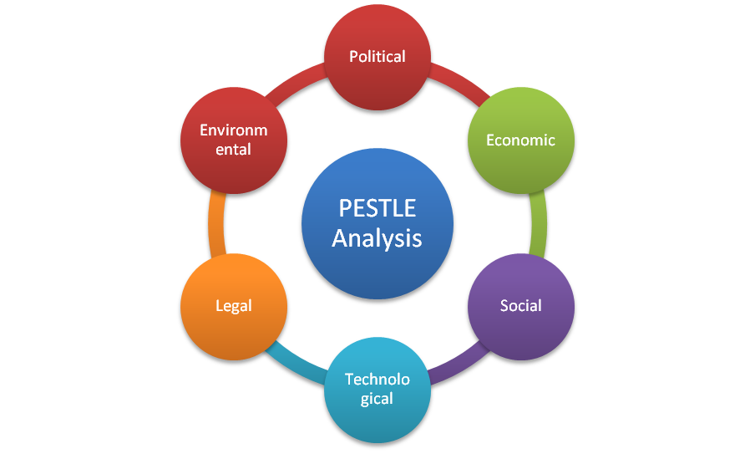
(Source: Self-created)

Appendix 2: Annual Profit of Cleenol
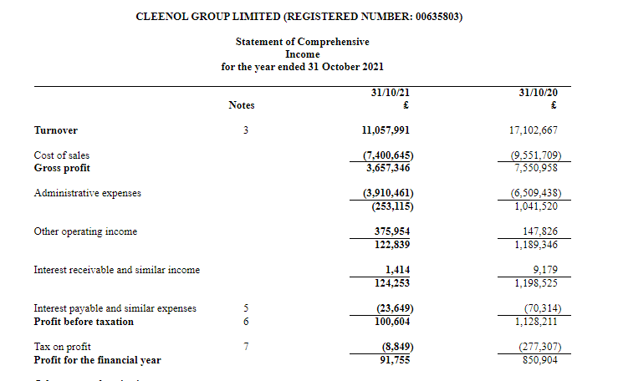
(Source: GOV, 2023a)

Appendix 3: Cash Flow of Cleenol in 2020 and 2021
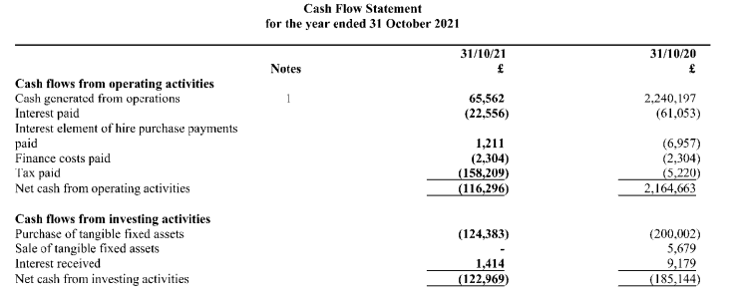
(Source: GOV, 2023a)

