

Programme: Master of Business Administration
Module: Dissertation
Module code: LCMB7035
Research Proposal On: Relationship between Sustainability supply chain management and competitive Resilience in the food retail industry
Lecturer: Shujun Xiao (Birmingham)
Student name: Pratikkumar Jagdishbhai Kevadiya
Student ID number: 2435897
Word count: 2539
Submission date: 11/06/2026

Table of Contents
1. Introduction 3
1.1 Background 3
1.2 Problem Statement 3
2. Aim, Objectives, Questions 4
3. Preliminary Literature Review 4
3.1 Sustainability Pressures Affecting Supply Chains in the Food Retail Industry 4
3.2 Retail companies’ Supply Chain Responses to Sustainability Pressures 5
3.3 Impact of Sustainability-Driven Supply Chain Strategies on Competitive Resilience 6
3.4 Theoretical Underpinning 6
3.5 Conceptual Framework 8
3.6 Literature Gap 8
4. Research Methodology 9
4.1 Research Design 9
4.2 Search Strings 9
4.3 Inclusion-Exclusion Criteria 9
4.4 Data Collection 10
4.5 Data Analysis 12
4.6 Ethical Consideration 12
5. Risks 12
6. Timeline 13
Reference List 14

1. Introduction

1.1 Background
The food retail industry has encountered greater pressure on sustainability issues for several reasons which consist of various preferences of consumers and expectations, regulations, along with the environment. Retailers need to reduce carbon emissions, minimise food waste, monitor their supply chain (SC) and be responsible. Retail companies have biggest retailers in Britain, which has a complex SC, a lot of suppliers, distribution networks as well as logistics activities. Retail companies is a part of procurement, transport, packaging as well as supplier strategy, more specifically, it has a key functional role in the strategic aspect of sustainability. However, it is very difficult for retailers to be efficient and competitive, and this is where they struggle in a very dynamic market. Meanwhile, the retailers need to be efficient and competitive in the highly dynamic market. Organizations are starting to incorporate sustainability practice into their supply chain management (SCM) to become more resilient as well as gain stakeholder trust and also effective performance in the long term to tackle sustainability pressure.

1.2 Problem Statement
Retailers are focusing on investing more in sustainable SC projects in the face of many challenges to fulfil sustainable goals and trying to maintain operational as well as financial goals. Switching to more sustainable sourcing practice and conditions, logistical approaches as well as resource management may cost and be complex (Hirth, 2025). The execution of sustainable SC is one of the main challenges for Retail companies to hold up in a very competitive food retail market. Previous research has tended to centre on the sustainability practices or SC performance, more specifically, there is little information regarding the influence of pressures for sustainability on strategic SC decisions along with SC resilience (Bani-Melhem., Aboelmaged and Alkhatib, 2025). Due to this reason, understanding the relationship between sustainability pressures, a SC strategy and competitive resilience requires to be analysed for Retail companies to remain competitive in the future in a dynamic business environment.

2. Aim, Objectives, Questions
Aim
The aim of this research is to critically evaluate how sustainability pressures influence Retail companies’ SC strategy in the food retail industry, with specific focus on how these pressures support or challenge Retail companies’ competitive resilience.
Objectives
- To identify the main sustainability pressures affecting Retail companies’ supply chain in the food retail industry.
- To analyse how Retail companies respond to these pressures through changes in sourcing, supplier management, logistics, and operational practices.
- To evaluate how these supply chain responses influence Retail companies’ competitive resilience in terms of cost control, adaptability, reputation, and long-term competitiveness.
Questions
RQ1: What are the greatest sustainability concerns of Retail companies in the food retail sector in the for their supply chain?
RQ2: How does Retail companies respond to the pressure of sustainability in the context of the changes in the sourcing, managing suppliers, logistics as well as operational transition?
RQ3: What are supply chain responses by Retail companies with regard to sustainability and how do this impact on the ability of Retail companies to control costs, adapt and sustain their reputation and competitiveness in the long-term?

3. Preliminary Literature Review

3.1 Sustainability Pressures Affecting Supply Chains in the Food Retail Industry
Sustainability pressure has a crucial function in the food chain strategies in the food retail sector. These pressures are driven by various factors which consist of policies, needs of consumers, stakeholder needs as well as a growing understanding of climate change and resource scarcity. Adams, Donovan and Topple (2023) stated that retailers need to reduce GHG emissions, use of energy along with the responsible sourcing of their SC by reducing and eliminating waste. Organisations have been forced to change their operations due to more strict regulations from governments and regulatory bodies in the sector by reducing carbon, executing better waste management, Furthermore, there is an increasing demand from consumers for retailers to be transparent as well as accountable to know which retailers are environmentally responsible as well as ethical. Nosratabadi, Mosavi and Lakner, (2020), opined that there are initiatives which provide a specific focus at organisations disclosing their sustainability performance and adopting sustainable procurement policies from investors and advocacy groups. On a specific note, the sustainability challenges in food retail SC are much more complex as food products travel through food SC as well as traverse multiple suppliers, manufacturers, distributors, and logistics companies to get to the consumers. Retail companies is facing huge pressure in terms of sustainability due to its size as well as scale, and its extensive supplier base (Hashim et al., 2021). The company needs to respect the law as well as regulations that relate to the environment by the reduction of carbon emissions, sustainable agriculture, ethical working practices, maintaining plastic waste as well as food waste.

3.2 Retail companies’ Supply Chain Responses to Sustainability Pressures
Retail companies has adopted various in its SC, which focus on enhancing the sustainability of the SC as well as boosting the confidence of its stakeholders. The SC programme of Retail companies is becoming a key element of the ' sustainable sourcing of business. Meng (2024) stated that the company is actively working on collaborating with its suppliers and driving for responsible farming, ethical practices, and sustainability standards. The supplier engagement programmes set by Retail companies encourage as well as challenge suppliers to become more resource-efficient emissions and provide transparency of environmental and social performance. In this way, the supplier relationship may be considered as cooperation between suppliers along with users by achieving sustainability goals through a shared vision. Retail companies has adopted logistics measures to minimise the implication of transport environment and to optimise the logistics process. Mc Loughlin et al., (2023) argued that investments in transportation technology which consist of the optimisation of vehicles, utilization of vehicles more efficiently along with for lower-emission modes of transport contribute to reducing the environmental impact of logistics transportation. On a broader note, Retail companies introduced programs to minimise food waste as well as improve stock management through its value chain. Furthermore, a reduction in packaging material has been executed by Retail companies and the use of recyclable packaging materials has been attempted by Retail companies. It has been also observed that the sustainability solutions of Teco also tackle social concerns such as supplier well-being, moral work practices and community involvement.

3.3 Impact of Sustainability-Driven Supply Chain Strategies on Competitive Resilience
Sustainability focused SC strategies may be treated as important in supporting competitive resilience in the food retail sector. Sharma et al., (2025) stated that Competitive resilience may be defined as an ability of an organisation to operate, respond as well as to stay competitive in an evolving market. The sustainability programmes of Retail companies are useful to build resilience with the help of optimising operations, reducing risk to long term sustainability. The energy efficiency pathway consists of any energy efficiency, reduction of waste inventory management or logistics optimization measures which may lead to better use of resources and reduced operating costs. Despite the extra expenses arising from the environmental regulations and the possible risk from the market, this growth may help to boost the profitability of Retail companies. Lai (2024) evaluated that other measures towards sustainability also have a major function in adaptability through innovation and supplier relationships. Shared supplier management as well as sustainable sourcing are useful for Retail companies to have more flexibility in the SC, more specifically, it will help Retail companies to cope with any disruption in the SC regulatory changes and consumer demand. There is also a positive effect on sustainability performance in terms of corporate reputation and trust with stakeholders (Yan et al., 2022). Sustainability and ethical positioning are one of the important points in differentiation and consumers are more sensitive in relation to the sustainability of the brands that they purchase. Pro-activity in risk management as well as regulatory compliance enhances competitiveness in the long run.

3.4 Theoretical Underpinning
This study was conducted based on Stakeholder Theory. It highlights that businesses should consider the activities they have that affect all stakeholders, not just shareholders. Stakeholders are Customers, Suppliers, Employees, Investors, Governments (Mahajan et al., 2023). This theory is applicable to this study as the pressures of sustainability in the food retail industry are driven by pressures from the stakeholders to apply more ethical sourcing practices, sustainability accounting as well as reporting in a proper manner. Its expectations will have an impact on its commercial as well as sustainability strategy with the active help of the SC of Retail companies (Bridoux and Stoelhorst, 2022). Sustainability may be interpreted as a way of achieving the interests of stakeholders along with enhancement of the performance of an organisation, from the point of view of the Stakeholder Theory. The theory also expands on the competitive value as well as competitiveness of stakeholder engagement. This includes establishing reputation, decreasing operational risk, improving supplier relations along with the fostering of sustainable long-term competitiveness in a sustainable business world.
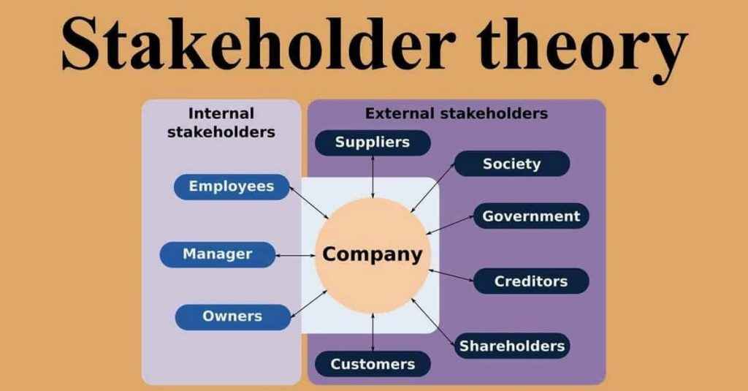
Figure 2: Stakeholder Theory
(Source: Garg, 2021)

3.5 Conceptual Framework
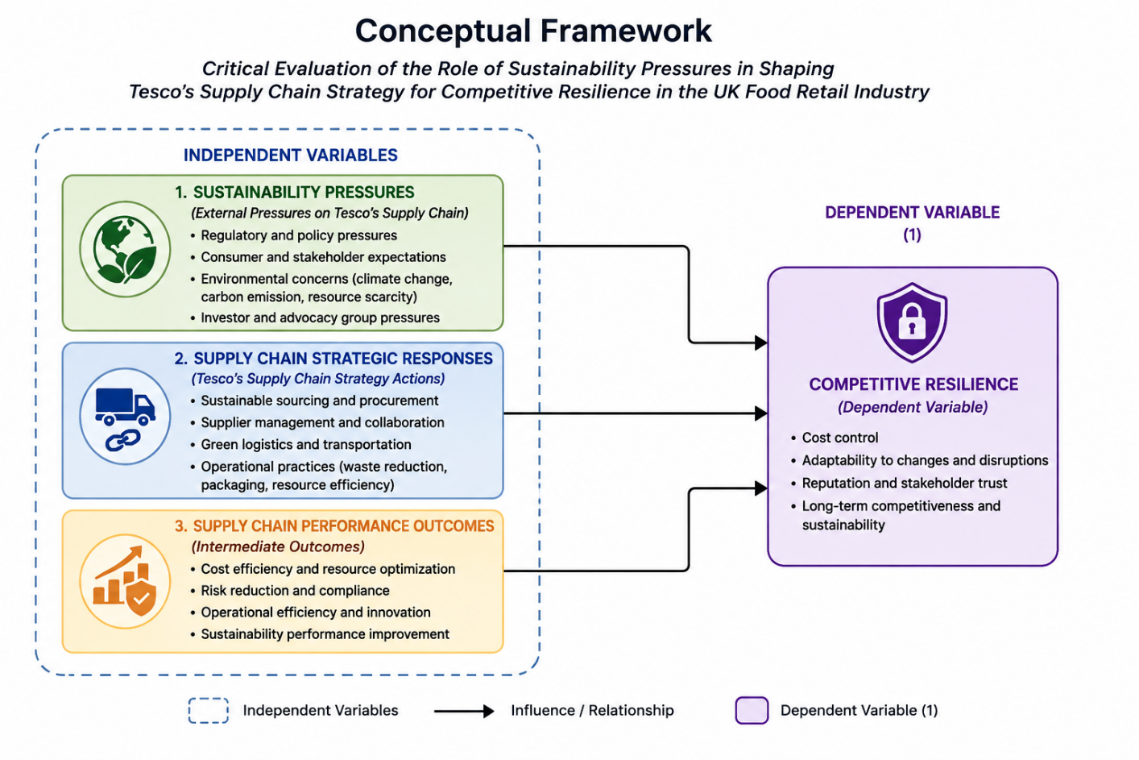
Figure 3: Conceptual Framework
(Source: Self-developed)

3.6 Literature Gap
Practice of sustainability as well as SCM have been heavily researched areas within the retail sector. However, it may be stated that a little research has been conducted on the effects that the sustainability pressures have on the SC strategy of Retail companies as well as the ways they may be able to build the competitive resilience of their SC. Moreover, it has to be stated that most studies are more concerned with the environmental impacts, and few have studied the double effects on cost control and adaptability, and long-term competitiveness.

4. Research Methodology

4.1 Research Design
The research will use the interpretivist research philosophy for the development of a deep understanding of the impact of sustainability pressures on Retail companies's SC strategy as well as competitive resilience (Verma, Verma and Abhishek, 2024). A qualitative research approach will be used as it will be helpful for the exploration as well as interpretation of the existing knowledge and findings from published sources (Sreekumar, 2023). Research strategy will be a Systematic Literature Review (SLR) which will systematically identify, screen as well as analyse academic journals, industry reports, company publications and credible secondary sources. The study will be done using an inductive approach to proper theories as well as concepts that have been previously developed with the help of theme-based analysis.

4.2 Search Strings
Keywords | Boolean Search String
Sustainability pressures, Retail companies, supply chain | ("sustainability pressures" AND Retail companies AND "supply chain")
Sustainable supply chain management | ("sustainable supply chain" OR "green supply chain") AND retail
Retail companies’ sustainability strategy | (I AND strategy)
Supplier management and sourcing | ("supplier management" OR sourcing) AND sustainability
Logistics and sustainability | (logistics AND sustainability AND retail)
Competitive resilience | ("competitive resilience" OR "supply chain resilience") AND retail
food retail industry | ("food retail" AND sustainability AND supply chain)

4.3 Inclusion-Exclusion Criteria
Criteria | Inclusion Criteria | Exclusion Criteria
Publication Period | Studies which were published between 2020 and 2025 | Studies which were published before 2020
Topic Relevance | Articles which are related to sustainability, SCM, Retail companies, food retail, along with competitive resilience | Studies which are unrelated to sustainability or supply chain strategy
Industry Focus | food retail industry as well as comparable retail sectors | Non-retail industries with limited relevance
Source Type | Peer-reviewed journal articles, reports related to industry along with companies, government publications, and credible websites | Blogs, opinion articles, magazines, as well as non-credible sources
Language | English-language publications | Non-English publications

4.4 Data Collection
The technique in collecting the data from this study is Systematic Literature Review (SLR) and primary data during the study. The sources of data will be peer-reviewed academic journals, industry reports, company publications, company sustainability reports, government documents and reputable online databases (Google Scholar, Scopus, Science Direct, Research Gate). On a broader note, data will be collected, such as identification, screening as well as selection of data sources according to inclusion and exclusion criteria (Denscombe, 2025). Using the keywords and Boolean search strings, the relevant literature will be identified in a proper manner which will be published from 2020 to 2025. The information from chosen sources will be analysed in a systematic manner for the information relevant to the research objective. This will provide comprehensive, reliable as well as relevant data that may be able to answer the research questions and support the findings of the study.

PRISMA
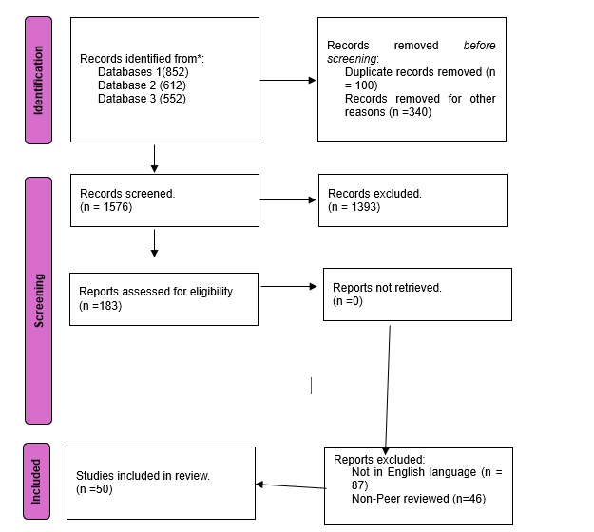
Figure 4: PRISMA Framework
(Source: self-developed)
Three databases were used for the PRISMA screening a total of 2016 records. Out of this, 100 were duplicated and 340 had been deleted for other reasons and were not the subject of screening processes as part of this screening project. This leaves 1576 to be screened. After title and abstract screening, 183 reports remained and were screened for eligibility, resulting in 1393 items being eliminated. In the later stages, 87 non-English studies along with 46 non-peer-reviewed studies were eliminated. As a result, 50 studies fulfilled the inclusion criteria and were included in the systematic literature review.

4.5 Data Analysis
Thematic analysis will be used for the identification and development of the themes as well as patterns that emerge throughout the literature that will be selected for study. This information will be systematically reviewed as well as coded after the data collection process, from academic journals, industry reports and company publications (Cheong et al., 2023). The same ideas as well as results will be clustered by themes to correspond with the research goals, such as sustainability pressures; Retail companies's SC reactions; and competitive resilience. On a specific note, the thematic analysis will be done with the help of the following steps: data familiarization, coding, developing themes, reviewing as well as interpretation of themes. This will enable systematic and detailed knowledge about the topic of research.

4.6 Ethical Consideration
In this study research processes will be carried out according to the rules as well as ethics of research. There will be no human subjects involved, and therefore no risk of privacy or consent, in the research as it will be conducted with secondary data. In addition to that, information will all be obtained from reputable sources along with public sources (Islam, Khan and Baikady, 2022). To prevent plagiarism and to give credit to the original author, appropriate referencing and citation will be used. Furthermore, the data will be objectively interpreted to guarantee accuracy, transparency, and academic integrity.

5. Risks
It has been observed that this study is based on secondary data collection with the help of a Systematic Literature Review (SLR), due to this reason, there will be no risks in this research. No human participants will be involved in the study therefore, issues related to informed consent, privacy, confidentiality as well as participant welfare do not occur. The data will be collected from credible as well as publicly available sources which consist of peer-reviewed journal articles, reports related to industry publications of company such as Retail companies and government documents. All sources will be appropriately cited along with referenced which reduces the risk of plagiarism to maintain academic integrity. Furthermore, data will be analysed with the help of sourced secondary data as well as transparently to ensure the reliability, validity along with ethical conduct of the research.

6. Timeline
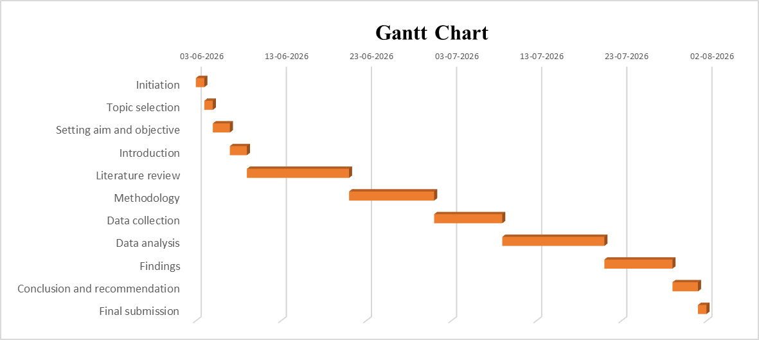
Figure 5: Research Timeline
(Source: Self-created)

Reference List
Adams, D., Donovan, J. and Topple, C., (2023). Sustainability in large food and beverage companies and their supply chains: An investigation into key drivers and barriers affecting sustainability strategies. Business Strategy and the Environment, 32(4), pp.1451-1463.https://onlinelibrary.wiley.com/doi/pdfdirect/10.1002/bse.3198
Bani-Melhem, A.J., Aboelmaged, M. and Alkhatib, S.F., (2025). Driving service performance: the interplay of innovation and resilience in food retail supply chain. Business Process Management Journal. https://www.researchgate.net/profile/Saleh-Alkhatib/publication/392625410_Driving_service_performance_the_interplay_of_innovation_and_resilience_in_food_retail_supply_chain/links/69e8dad1a33e5c006ce67cce/Driving-service-performance-the-interplay-of-innovation-and-resilience-in-food-retail-supply-chain.pdf
Bridoux, F. and Stoelhorst, J.W., (2022). Stakeholder theory, strategy, and organization: Past, present, and future. Strategic Organization, 20(4), pp.797-809. https://journals.sagepub.com/doi/pdf/10.1177/14761270221127628
Cheong, H.I., Lyons, A., Houghton, R. and Majumdar, A., (2023). Secondary qualitative research methodology using online data within the context of social sciences. International Journal of Qualitative Methods, 22, p.16094069231180160. https://journals.sagepub.com/doi/pdf/10.1177/16094069231180160
Denscombe, M., (2025). Decolonial research methodology: an assessment of the challenge to established practice. International Journal of Social Research Methodology, 28(2), pp.231-240. https://www.tandfonline.com/doi/pdf/10.1080/13645579.2024.2357558
Garg, R. (2021). All you need to know about the stakeholder theory. [online] iPleaders. Available at: https://blog.ipleaders.in/need-know-stakeholder-theory/ [Accessed 3 Jun. 2026].
Hashim, M., Nazam, M., Abrar, M., Hussain, Z., Nazim, M. and Shabbir, R., (2021). Unlocking the sustainable production indicators: a novel retail companies based fuzzy AHP approach. Cogent Business & Management, 8(1), p.1870807.https://www.tandfonline.com/doi/pdf/10.1080/23311975.2020.1870807
Hirth, S., Morgan, E., Kaptan, G., Crastes dit Sourd, R., Tallontire, A., Young, W. and Winter, M., (2025). Restoring Food System Resilience in a Turbulent World: Supply Chain Actors' Shared Responsibility. Business Strategy and the Environment, 34(5), pp.6007-6023.https://onlinelibrary.wiley.com/doi/pdf/10.1002/bse.4287
Islam, M.R., Khan, N.A. and Baikady, R. eds., (2022). Principles of social research methodology. Springer Nature. https://www.researchgate.net/profile/M-Islam-22/publication/364810712_Principles_of_Social_Research_Methodology/links/635aba2496e83c26eb5d3b8c/Principles-of-Social-Research-Methodology.pdf
Lai, Y., (2024). Innovative strategies in logistics and supply chain management: Navigating modern challenges. In SHS Web of Conferences (Vol. 183, p. 02020). EDP Sciences.https://www.shs-conferences.org/articles/shsconf/pdf/2024/03/shsconf_icpahd2024_02020.pdf
Mahajan, R., Lim, W.M., Sareen, M., Kumar, S. and Panwar, R., (2023). Stakeholder theory. Journal of Business Research, 166, p.114104. https://www.sciencedirect.com/science/article/pii/S0148296323004629
Mc Loughlin, K., Lewis, K., Lascelles, D. and Nudurupati, S., (2023). Sustainability in supply chains: reappraising business process management. Production Planning & Control, 34(1), pp.19-52.https://www.tandfonline.com/doi/pdf/10.1080/09537287.2021.1884764
Meng, S., (2024) Operation management of grocery retailer in the uk: a case of retail companies. Pacific International Journal, 7(2), pp.136-142.http://rclss.com/index.php/pij/article/download/586/391
Nosratabadi, S., Mosavi, A. and Lakner, Z., (2020). Food supply chain and business model innovation. Foods, 9(2), p.132.https://www.mdpi.com/2304-8158/9/2/132
Sharma, I., Sonar, H., Ghag, N., Belal, H.M. and Majeed, M.A., (2025). Enhancing resilience in the fresh food supply chain: a managerial perspective through interpretive analysis. British Food Journal, 127(12), pp.4715-4741.https://researchonline.ljmu.ac.uk/id/eprint/27211/3/Enhancing%20Resilience%20in%20the%20Fresh%20Food%20Supply%20Chain%20A%20Managerial%20Perspective%20Through%20Interpretive%20Analysis%20.pdf
Sreekumar, D., (2023). What is research methodology? Definition, types, and examples. Paperpal Blog-Academic Writing Guides. https://paperpal.com/blog/academic-writing-guides/what-is-research-methodology
Verma, R., Verma, S. and Abhishek, K., (2024). Research methodology. Booksclinic Publishing. https://hpuniv.ac.in/hpuniv/upload/uploadfiles/files/3_5.pdf
Yan, X., Espinosa-Cristia, J.F., Kumari, K. and Cioca, L.I., (2022). Relationship between corporate social responsibility, organizational trust, and corporate reputation for sustainable performance. Sustainability, 14(14), p.8737.https://www.mdpi.com/2071-1050/14/14/8737

