MODULE CODE/ COD Y MODIWL: BMSW4002
EFFECTIVE TEAM WORKING & COMMUNICATION

NAME: ERIK ZAJAC
STUDENT NUMBER: 1920480

Table of Contents
Introduction 3
Effective communication skills in team working 3
Different communication models and effective team working 4
Linear Model of communication 4
The interactive model of communication 5
The transactional model of communication 6
Implementation of the communication models in personal experience 7
Conclusion 8
References 10

Introduction
Teamwork is based on coordination and understanding which is gained through the implementation of effective communication (Driskell, et al., 2018). An organisation focuses on the establishment of effective teams in order to enhance their quality of work with increased productivity level in order to gain success with effective completion of tasks and crucial projects. These effective teams are to be maintained through elimination of unnecessary conflicts and facilitating the process of sharing each other’s values and culture which can only be gained through implementing necessary communication processes and methods. This would also encourage sharing of innovative ideas, learning of strengths and weaknesses of every member and thus helping each other to grow and radiate confidence. This would also enhance the rate of efficiency and facilitate cooperation in the tasks to be performed. Effective communication and support from the team can work as the motivational drive which ensures greater effort towards the achievement of the organisational goals and the set objectives in a successful manner. In this assignment, focus would be made on the distinctive types of communication models which would be efficient in facilitating communication for facilitating effective team work.

Effective communication skills in team working
An effective team work seeks an effective method of communication and in order to implement effective communication, it is necessary to implement certain skills which would support and facilitate proper communication among the members of the team to maintain coordination and efficiency in the team. Every member should maintain transparency with each other while sharing information. Incomplete sharing of data, ideas and information can give rise to unnecessary chaos and confusion among the members of the team which in turn increases the rate of errors in the task being performed in the team, thus bringing down the entire effectiveness of the team. Every team member should be logical in nature and unnecessary arguments should be eliminated (Pinto, 2019). Logical arguments help to maintain a proper working environment with positive ability of criticism among the members of the team. A clear picture about the ideas being shared would facilitate better understanding and will bring increased coordination among the team members. Also, the communication to be made should be planned and sequenced to maintain consistency and to avoid being drifted away from the original topic of discussion (Beesley, 2018). This would help to create trust and interest among the team members which would result in successful communication. Clarity brings trust and thus clear ideas with purpose would facilitate binding each member to work together. Communication is effective when there is a sense of respect for each of the members of the team. Each one’s ideas should be heard and regarded. It is only through the implementation of mutual respect that one can establish a strong connection with the other in the team. Every member should be polite and rough behaviour should be eliminated. This would also increase the level of commitment for each other in the team and would increase the rate of dedication of each member towards the performance of the team.

Different communication models and effective team working
In maintaining the effectiveness of a team, communications play a significant role. In the workplace, there are different types of models for communication that are implemented to drive effectiveness in the work. Communication models help in the identification of the involved processes in the workplace with proper visual representation of the distinct encounters of the team members regarding communication.

Linear Model of communication
There are three distinctive types of models being popularly identified for the process of communication. First one is the linear model of communication which is also known as the one-way model. It is beneficial in addressing the mass and does not entertain feedback and ideas from the other end (Kincaid, 1979). It is beneficial for setting propaganda or pursuing an audience. There is no way to ensure if the communication being maintained is effective since the understanding of the receiver would not be checked and only the message would be delivered. One such model will be the Aristotle’s Model of communication but it cannot be used for team communication and is effective for public speaking. This does not allow the feedback from the receiver and is solely about the speaker which would not ensure effective communication between the members of a team(pressbooks, 2020).
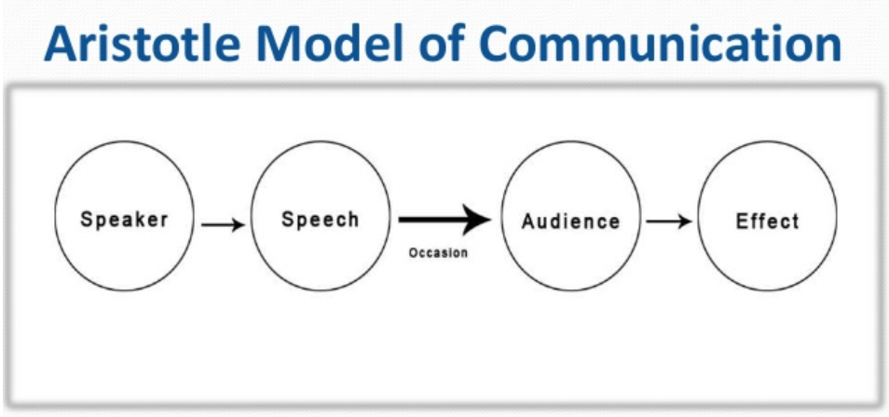
Aristotle’s Model of communication
Source: (businesstopia, 2018)

The interactive model of communication
This model is also identified as the convergence model and encourages a two-way communication. It allows exchange of different ideas and views between the sender and receiver and also encourages mass communication. It encourages a give and take idea, where the information is passed on from sender to the receiver and then again, the reply is sent back to the sender to facilitate a communication from both the ways and maintain an effective cycle. This model of communication is effective in team building as it considers the physical aspect of an individual as well as the psychological aspect(Agrawal, et al., 2016). Many a times, the behaviour of an individual can be the result of the psychological impact which can be due to increased stress, depression and even anxiety and thus it is important to identify the factors which can affect the effectiveness of the communication process among the members of the team. Also, since it is an interactive model, it allows feedback from the receiver’s end and provides a better understanding of the effectiveness of the communication.
The Schramm’s Model of communication is an effective model depicting interactive communication. This promotes the idea of exchanging ideas between two individuals for effective communication(van Ruler, 2018). This model highlights the importance of communication needing to be a two-way process where both the receiver and sender would play equally important roles. It ensures feedback from the receiver with the increased opportunity to be able to share each other’s ideas as well as opinions. The feedback mechanism in the model would ensure that the information being passed on from the sender to receiver is in a proper manner to eliminate any kind of misunderstanding and misinterpretation of the information(Sloane, 2020). This would ensure a work-friendly environment with a reduced set of conflicts and increased coordination among the members of the team.
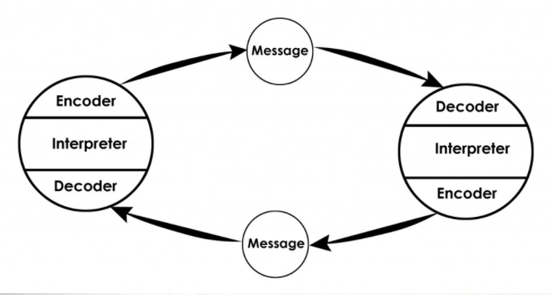
Schramm’s Model of communication
Source: (businesstopia, 2018)

The transactional model of communication
In the transactional model of communication, both the senders and the receivers are identified as communicators and both contribute equally in the role of communication. In this model the roles of the individuals are changing in a continuous manner in accordance to the environment. This model is identified to be highly effective in terms of team effectivity management since it takes into consideration the social reality, the cultural upbringing of an individual along with relational context(Mortensen, 2017). The social reality considers the norms and rules of a society. The cultural upbringing aspect would focus on relating factors like race, gender, caste, ethnicity and nationality. Under the relational context it considers the importance of maintaining the interpersonal relationship with other members. This model focuses on establishing real relationships with better understanding of the circumstances and the environment an individual belongs to(Barnlund, 2008). It believes in understanding the team members and not just communication. It facilitates the respect for every culture and identity with better recognition of strengths and weaknesses with increased coordination and efficiency at work. The transactional model of communication also takes in account the non-verbal communication which are the body languages of an individual and the gestures which are also identified as feedback in this model. This enhances the process of building a team with high effectiveness.
Barnlund’s Transactional Model of Communication is among the most recognised models in the transactional model of communication which was established in the year 1970 by Dean Barnlund. It helps in the establishment of interpersonal communication between the sender and the receiver and is a multi-layered feedback system. In this process both the sender and the receiver interchange their places and both play an important role in the process of communication in an equal manner. This is a highly effective communication model which contributes to the growing effectiveness of the team. Barnlund divided the model into three cues. One is the public cues which deal with the external environment, the physical aspects which can be man-made and artificial in nature(businesstopia, 2018). Another is the private cues which would include private and unique aspects like the sense and humour of an individual. Last one is the behavioural cues which would include the verbal communication or non-verbal communication in nature. It is a very systematic model for communication since it takes into consideration a set of aspects which can have an impact on the communication and thus facilitates a better understanding(Nicotera, 2019). The ability for the feedback ensures effective communication between the sender and the receiver, eliminates misunderstandings and enhances better communication which only increases the effectiveness of a team and thus increases the overall productivity rate of the team as well as the organisation.
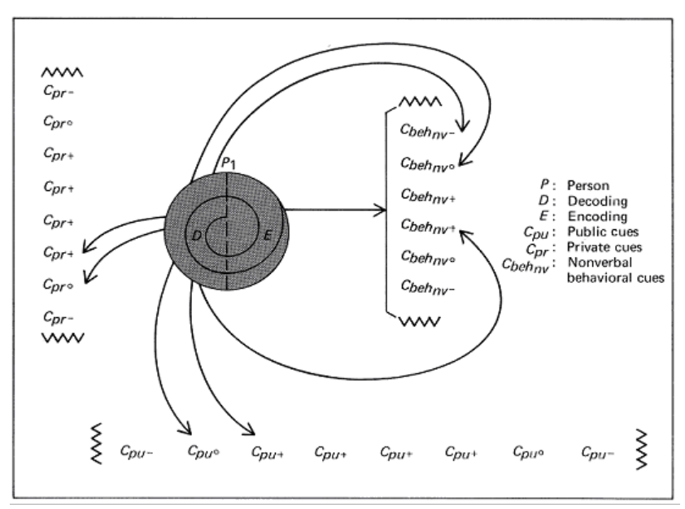
Barnlund’s Transactional Model of Communication
Source: (businesstopia, 2018)

Implementation of the communication models in personal experience
The detailed learning of the communication models provided me with the understanding that not all communication models will be ideal to facilitate effectiveness within a team and their functioning and thus it is important to implement the most effective model which would encourage team coordination with increased efficiency.
My understanding has only enhanced through this assigned task. It has enabled me to differentiate between the different models which are being implemented at different points of my daily lives. I have realised how linear models of communication are implemented when I am addressing the class on any topics or answering any gathering in public. While addressing I am keeping across my views only and hence a linear, one-way communication is maintained.
On the other hand, I understood how this effective linear model in conducting mass gathering can be severely ineffective for team management and building its effectiveness. It is important to implement either the interactive model or the transactional model in order to enhance the team coordination. Both the models of communication promote interpersonal relationships and allow communication in both ways. While being in the group work with the other members, I have realised how important it is to let the other members keep their understanding about the information being shared by me within a group. It helps in faster completion of work with limited errors and thus highlights the importance of the feedback mechanism in both the interactive and transactional models of communication. It helps us to even take in consideration about their mental state, their emotional being and their environment of upbringing. It has helped me to understand how important it is to build communication on a personal level to establish a strong understanding and identifying the strengths and weaknesses of the other members.
One of my experiences with poor communication was being a part of the team in a group task where the assigned leader to divide work properly was extremely rude with limited consideration. There was limited flexibility with limited possibility to discuss the problems regarding the topics being assigned. This pushed me to become uninterested and unmotivated in the work, and had put my least effort which had a negative impact on my marks. Thus, it is important to be open to ideas, let others speak in a team, keep across their problems and be comfortable with their task as well as the team which can be gained through an effective communication process.

Conclusion
The entire assignment focuses on highlighting the importance of communication in establishing and maintaining an effective team within an organisation. Effective communication ensures proper exchange of ideas, respect for each other and their values, increased understanding, better flow of information, increased cooperation and elimination of unnecessary chaos which leads to a work friendly environment with increased efficiency at work. The assignment works on discussing the specific set of skills which are to be implemented within a team to facilitate proper communication and to maintain effectiveness. Proper communication maintains the transparent exchange of information whereas poor communication can give rise to conflicts which reflect on the ineffective performance of the team. Hence, it is important to maintain an effective communication process in the team with the proper implementation of communication models and understanding their differences. This assignment has drawn in-depth analysis of those models in alignment with personal experiences to draw a better understanding.

References
Agrawal, S., Gelles, R. & Sahai, A., 2016. Adaptive protocols for interactive communication. In 2016 IEEE International Symposium on Information Theory (ISIT) , pp.595-99.
Barnlund, D.C., 2008. A transactional model of communication. Communication theory, 2, pp.47-57.
Beesley, P.., 2018. Developing your communication skills in social work. Los Angeles: SAGE.
businesstopia, 2018. Barnlund’s Transactional Model of Communication. [Online] Available at: HYPERLINK "https://www.businesstopia.net/communication/barnlund-transactional-model-communication” https://www.businesstopia.net/communication/barnlund-transactional-model-communication [Accessed 2020].
Driskell, J.E., Salas, E. & Driskell, T.., 2018. Foundations of teamwork and collaboration. American Psychologist, 73(4), p.334.
Kincaid, D.L.., 1979. The convergence model of communication.
Mortensen, C.D.e., 2017. Communication theory. Routledge.
Nicotera, A.M., 2019. 1 Organizing the Study of Organizational Communication. Origins and Traditions of Organizational Communication: A Comprehensive Introduction to the Field.
Pinto, P., 2019. You can always go further: STRENGTHENING LEADERSHIP SKILLS-Day 1: Coaching and communication skills build a strong team. Transpeer Trainning Activity-C3.
pressbooks, 2020. 3.2 Communication models. [Online] Available at: HYPERLINK "https://pressbooks.bccampus.ca/professionalcomms/chapter/3-2-the-communication-process-communication-in-the-real-world-an-introduction-to-communication-studies/” https://pressbooks.bccampus.ca/professionalcomms/chapter/3-2-the-communication-process-communication-in-the-real-world-an-introduction-to-communication-studies/ [Accessed 2020].
Sloane, G., 2020. Communication in Business Environment. [Online] Available at: HYPERLINK "https://www.tes.com/lessons/ELQ4kvi402w8YA/communication-in-business-environment” https://www.tes.com/lessons/ELQ4kvi402w8YA/communication-in-business-environment [Accessed 2020].
van Ruler, B., 2018. Communication Theory. The International Encyclopedia of Strategic Communication, pp.1-7.

