Introduction

A heat exchanger enables heat to pass between two or more fluids without allowing them to come into direct contact or mix. This separation is maintained by a solid surface through which thermal energy is transferred. Such equipment is used extensively in engineering applications, including electricity generation, heating, ventilation and air-conditioning systems, chemical plants, vehicle cooling systems and food-processing facilities (Cengel and Ghajar, 2020). Consequently, engineers must be able to calculate, assess and anticipate the thermal performance of heat exchangers.

The experimental work documented in this report was carried out using the TD1007 Standard 32-Tube Air–Water Heat Exchanger produced by Armfield Ltd. The unit incorporates a rectangular bank of 32 brass tubes. Water heated in a thermostatically regulated tank is circulated inside these tubes, while a fan operating at an adjustable speed draws air from the surrounding environment across their outer surfaces. As the air passes over the tube bank, it absorbs thermal energy from the hot water. The Armfield Virtual Data Acquisition System (VDAS) automatically recorded all measurements obtained during the tests. These data were then transferred into Microsoft Excel for processing, analysis and presentation in graphical form.

Two independent experiments are specified within the module requirements. In Experiment 1, the airflow is held constant by maintaining an orifice pressure difference of 250 Pa, while the water flow rate is varied to determine its influence on heat-exchanger performance. Experiment 2 reverses the variable operating condition: the water flow rate remains fixed at 0.20 L/min while the airflow rate is changed. The VDAS measurements examined in this report were collected for Experiment 2 during the laboratory session. Section 3 describes the experimental method, predicted trends and theoretical calculations associated with Experiment 1. The complete evaluation of Experiment 2, including the three specified performance graphs, is provided in Section 4.

Technical Background

- Parallel-Flow Heat Exchanger

In a parallel-flow heat exchanger, the hot and cold fluids enter from the same side and move through the unit in the same general direction. Their temperature curves gradually approach one another along the length of the exchanger without fully meeting. This behaviour restricts the highest outlet temperature that the colder fluid can attain and usually results in lower thermal efficiency than a counter-flow arrangement operating under identical conditions (Bergman et al., 2020). In the TD1007 system, heated water circulates within the tubes while surrounding air passes across their outer surfaces. Although this produces a crossflow pattern locally, the overall arrangement can be treated as an approximation of parallel flow.

- Energy Balance Equation

The heat emitted by the hot fluid (water) and the heat absorbed by the cold fluid (air) are given by (Holman, 2010):
Qᵂ = ṁᵂ × Cₚᵂ × ΔTᵂ
Qₐ = ṁₐ × Cₚₐ × ΔTₐ

ṁ = mass flow rate (kg/s)
Cₚ = specific heat capacity (J/kg·K)
ΔT = measured temperature across the exchanger for each fluid

For a perfectly insulated heat exchanger, the heat released by the water, $Q_{w}$, should equal the heat absorbed by the air, $Q_{a}$. Any difference between these values may be caused by heat escaping to the surrounding environment. In this apparatus, it may also occur because the heater tank continuously restores energy to the water circuit, meaning that the temperature change of the water, $ΔT_{w}$, across the tube bank represents only a small proportion of the total energy supplied.

- Log Mean Temperature Difference (LMTD)

As the temperature difference between the hot and cold fluids changes throughout the heat exchanger, the logarithmic mean temperature difference (LMTD) is applied as a representative average of the effective thermal driving force (Incropera et al., 2011):

LMTD = (ΔT₁ − ΔT₂) / ln(ΔT₁ / ΔT₂)

Parallel flow: ΔT₁ = Tʰᴵⁿ − Tᶜᴵⁿ (hot-inlet minus cold-inlet) and ΔT₂ = Tʰₒᵘₜ − Tᶜₒᵘₜ (hot-outlet minus cold-outlet).

- Overall Heat Transfer Coefficient, (U)
The overall heat-transfer coefficient, (U), accounts for the total opposition to heat transfer across the tube wall, including convection within the tubes on the water side and convection over the tubes on the air side. It can be determined using:
U = Q / (A × LMTD)
Here, A=0.1558 m² represents the combined external surface area of the 32 tubes (Armfield Ltd, 2019). A larger value of (U) corresponds to lower overall resistance to heat flow and therefore indicates improved heat-exchanger performance.
- Temperature Efficiency
The temperature efficiency of each fluid is expressed as the actual temperature change divided by the greatest theoretically achievable temperature change (Cengel and Ghajar, 2020). This theoretical maximum corresponds to the temperature difference between the water and air at their respective inlets:
ηᵂ = ΔTᵂ / (Tᵂ,ᴵⁿ − Tₐ,ᴵⁿ) × 100%
ηₐ = ΔTₐ / (Tᵂ,ᴵⁿ − Tₐ,ᴵⁿ) × 100%
ηₘₑₐₙ = mean efficiency.
ηᵂ = is negative because the water temperature is decreasing.
Experiment 1: Varying the Water Flow Rate
The aim is to demonstrate how different water flow rates affect the heat exchanger performance at a fixed orifice pressure drop of 250Pa and heater tank set-point of 60°C. The TD1007 apparatus was configured for parallel flow and the heater tank set to 60°C. The ambient air pressure was recorded (103 kPa) and the orifice diameter (100.11 mm) confirmed stamped on the orifice plate. The fan was activated and the slide valve adjusted until the orifice differential pressure reached 250 ± 5 Pa. The water pump was started and the hand-operated valve set to give 1.80 ± 0.01 L/min flow. After a minimum five-minute stabilisation period, all VDAS readings were recorded. The procedure was then repeated at 1.40, 1.00, 0.60, and 0.20 L/min, re-checking and adjusting the air-side pressure drop before each reading.
According to conventional heat-transfer principles, increasing the water mass flow rate is expected to produce the following effects:
- Both Qᵂ and Qₐ increase. A higher ṁᵂ circulates a greater thermal capacity per unit time, increasing the overall heat-transfer rate even though the water temperature change, ΔTᵂ becomes smaller.
- The water-side efficiency, ηᵂ decreases. As the water’s heat-capacity rate increases, its temperature reduction represents a smaller proportion of the maximum possible temperature difference, resulting in lower water-side efficiency.
- The air-side efficiency ηₐ, remains approximately constant. Since the airflow rate and inlet air temperature are maintained at fixed values, only relatively small variations in the air temperature increase are anticipated.
- The overall heat-transfer coefficient, (U), increases. Raising the water flow rate increases the internal fluid velocity and consequently improves the water-side convective heat-transfer coefficient, hᴵ. For turbulent flow inside a pipe, this relationship is described by the Dittus–Boelter correlation:
Nu = 0.023 Re⁰·⁸ Pr⁰·⁴
As the flow velocity rises, both the Reynolds number and Nusselt number increase (Holman, 2010).
- The LMTD is expected to decrease slightly. At a higher water flow rate, the water experiences less cooling, so ΔTᵂ falls and the outlet water temperature increases. This reduces the temperature difference between the two fluids at the exit of the heat exchanger.
These predicted trends demonstrate that the water-side flow rate is a significant design parameter for heat exchangers. For a specified heat-transfer requirement, engineers must balance the increased pumping power associated with higher flow rates against the reduction in the required heat-transfer surface area resulting from an increased value of (U) (Bergman et al., 2020).
Experiment 2: Varying the Air Flow Rate
The aim is to show how different air flow rates affect the performance of the heat exchanger at a fixed water flow rate of 0.20L/min and heater tank temperature of 60°C. The apparatus remained in parallel-flow configuration with the heater set to 60°C. The water flow was set and maintained at 0.20 ± 0.01 L/min throughout. The VDAS software was started to log data continuously. Beginning at an orifice pressure drop of 250 Pa, the system was allowed to reach thermal equilibrium (minimum five minutes), after which readings were logged. The slide valve was then progressively closed to reduce the air-side pressure drop in stages of approximately 50 Pa, stabilising and logging at each of 200, 150, 100, and 50 Pa. All raw sensor data were captured automatically by VDAS and the calculated performance parameters (mass flow rates, heat transfer rates, efficiencies, U, and LMTD) computed in real time and exported to Microsoft Excel for further analysis.
The following parameters were applied through Experiment 2:
PARAMETER | VALUE
Ambient pressure | 103kPa
Heater tank set-point | 60°C
Water flow rate (fixed) | 0.20 L/min (±0.01)
Heat exchanger surface area, A | 0.1558 m²
Orifice diameter | 100.11mm (7.871 × 10⁻³ m²)
Assumed Cₚₐ | 1004.8–1005 J/kg·K
Table 1: Fixed test parameters for Experiment 2
The values presented below represent the mean steady-state measurements obtained from the VDAS time-series data at each pressure drop. Several readings were combined and averaged to reduce the influence of small variations in temperature and flow rate.
ΔP (Pa) | Tᵂ₁ (°C) | Tᵂ₂ (°C) | Tᵂ₃ (°C) | Tᵂ₄ (°C) | Tₐ₁ (°C) | Tₐ₂ (°C) | Tₐ₃ (°C) | Tₐ₄ (°C) | Ṁᵂ (L/min)
250 | 34.3 | 35.3 | 58.1 | 34.3 | 23.9 | 26.8 | 23.2 | 32.6 | 0.21
200 | 34.3 | 35.4 | 57.8 | 34.3 | 23.8 | 26.8 | 23.2 | 32.7 | 0.20
150 | 34.2 | 35.7 | 57.8 | 34.3 | 23.8 | 26.9 | 23.2 | 32.7 | 0.20
100 | 34.2 | 36.5 | 57.9 | 34.3 | 23.8 | 27.3 | 23.2 | 32.8 | 0.20
50 | 34.2 | 37.7 | 58.1 | 34.3 | 24.2 | 28.2 | 23.2 | 32.8 | 0.19
Table 2: The measured steady-state temperatures and water flow rates at each air-side pressure drop. Tᵂ₁, Tᵂ₂ = water circuit temperatures; Tᵂ₃ = heater tank temperature; Tₐ₁–Tₐ₄ = air thermocouple positions.
All derived values were calculated by the VDAS software using the recorded temperatures and flow rates, together with tabulated fluid properties and the heat transfer surface area. The specific heat capacity of water was evaluated at its mean temperature, while a constant air specific heat capacity of Cₚₐ = 1004.8 J/kg·K was applied to every test, in accordance with the module instructions. The density of water was obtained from standard property tables using the average water temperature.
ΔP (Pa) | ṁₐ (kg/s) | ṁᵂ (kg/s) | Qᵂ (W) | Qₐ (W) | |ηᵂ| (%) | ηₐ (%) | LMTD (K) | U (W/m²K)
250 | 0.1153 | 0.00344 | 14.2 | 334.9 | 9.43 | 27.88 | 9.38 | 9.71
200 | 0.1031 | 0.00330 | 15.0 | 306.1 | 10.40 | 28.22 | 9.51 | 10.12
150 | 0.0892 | 0.00330 | 20.9 | 277.9 | 14.54 | 29.70 | 9.62 | 13.96
100 | 0.0729 | 0.00330 | 31.5 | 251.0 | 22.08 | 33.04 | 9.80 | 20.60
50 | 0.0518 | 0.00313 | 45.1 | 205.1 | 34.22 | 39.35 | 9.87 | 28.65
Table 3: the calculated heat transfer performance parameters for Experiment 2. |ηᵂ| = absolute value of water-side efficiency (VDAS sign convention: negative = heat released by water).
Charts 1–3 below plot the key performance parameters against air mass flow rate (ṁₐ), as required by the module specification. All x-axis values are the VDAS-calculated air mass flow rates from Table 3.
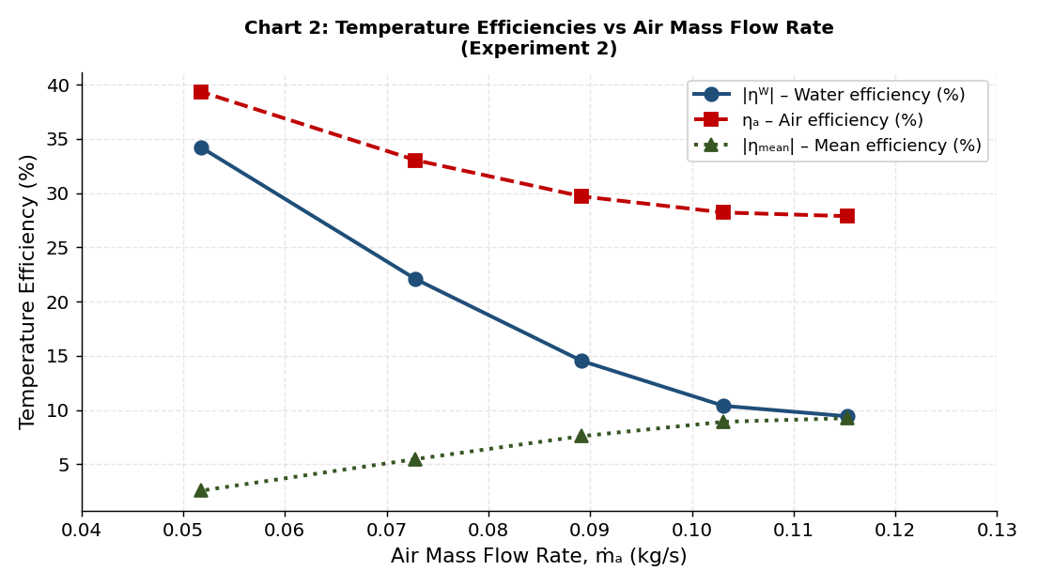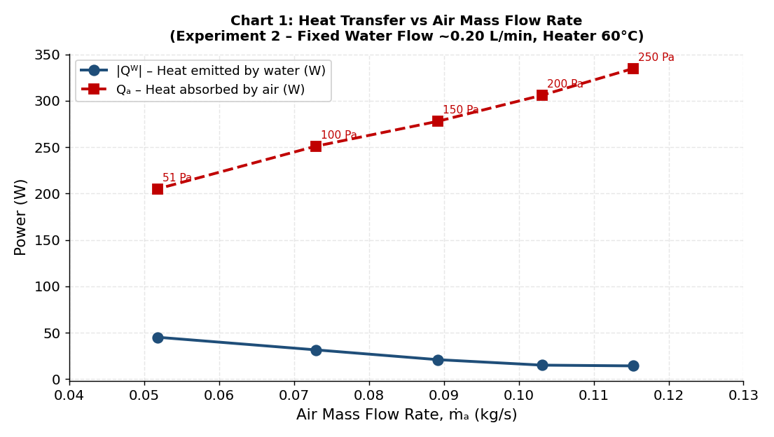
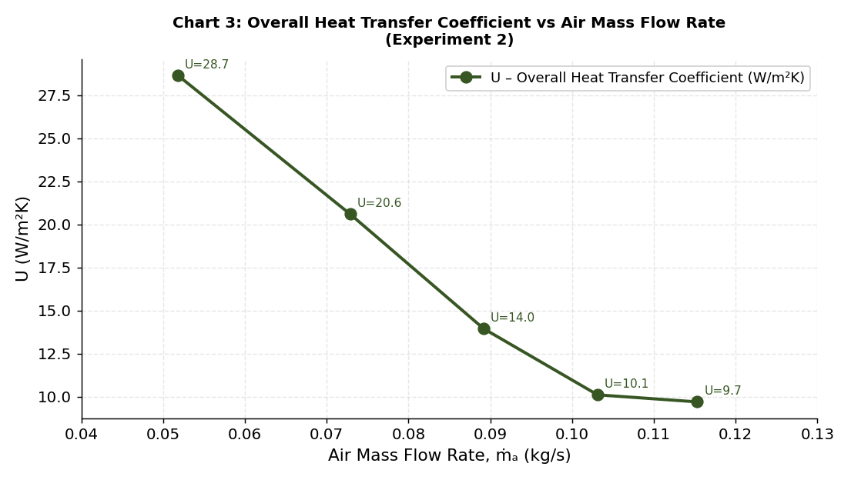

Discussion
Chart 1: Heat Transfer Rates
Chart 1 illustrates two distinct patterns in the heat transfer rates. When the air mass flow rate is reduced from 0.1153 kg/s at 250 Pa to 0.0518 kg/s at 50 Pa, the rate of heat gained by the air, (Qₐ) decreases consistently from 334.9 W to 205.1 W. This behaviour can be interpreted using the energy balance:
Qₐ = ṁₐ × Cₚₐ × ΔTₐ

Although the increase in air temperature, $ΔT_{a}$, rises slightly from ${2.89}^{∘}\text{C}$ to ${3.95}^{∘}\text{C}$, the smaller mass of air passing through the exchanger each second has a lower overall capacity to remove thermal energy. The water-side results display the opposite trend. As the airflow is reduced, the calculated heat loss from the water, $Q_{w}$, increases from 14.2 W to 45.1 W. Lower air velocities increase the time spent by the air within the heat exchanger, allowing a greater amount of heat to be transferred to each unit volume of air. This longer interaction helps sustain heat transfer from the tube wall to the surrounding air and produces a larger water-temperature reduction across the tube bank. Accordingly, $ΔT_{w}$ increases from ${0.98}^{∘}\text{C}$ to ${3.43}^{∘}\text{C}$. The considerable difference between $Q_{a}$ and $Q_{w}$ must also be considered. These quantities would theoretically be equal in a perfectly adiabatic heat exchanger. In the present results, however, $Q_{a}$ is substantially greater than $Q_{w}$. This discrepancy is attributed to the heater tank continually adding energy to the circulating water. Since the thermostat maintains the water temperature at approximately $58\text{–}{60}^{∘}\text{C}$, the measured $ΔT_{w}$ reflects only the relatively small temperature reduction occurring across the tube bank rather than the total energy supplied by the heater. This behaviour is associated with the design of the TD1007 apparatus and is identified in Armfield’s technical documentation (Armfield Ltd, 2019).

Chart 2: Temperature Efficiencies
Chart 2 indicates that the air-side efficiency, $η_{a}$, rises steadily from 27.9% to 39.4% as the airflow rate is reduced. This trend is consistent with theoretical expectations, since air moving at a lower velocity remains in contact with the heated tube surfaces for a longer period. Consequently, it achieves a greater proportion of the maximum possible temperature increase (Incropera et al., 2011).
Similarly, the magnitude of the water-side efficiency, $∣η_{w}∣$, increases from 9.4% to 34.2%. At lower airflow rates, the water circulating through the tubes undergoes a more substantial reduction in temperature, producing a larger $ΔT_{w}$. However, the VDAS mean efficiency decreases from 9.3% to 2.6%. This is because VDAS records the water-side efficiency as negative, reflecting the loss of heat from the water, and calculates the mean using the signed values of $η_{w}$and $η_{a}$. At 50 Pa, the efficiencies are more similar in magnitude but opposite in sign, so they largely cancel when averaged. Their convergence in absolute terms suggests that heat exchange between the two fluid streams becomes more balanced at the lowest airflow condition.

Chart 3: Overall Heat Transfer Coefficient
The overall heat-transfer coefficient, $U$, rises from $9.71 {\text{W/m}}^{2}\text{K}$ at 250 Pa to $28.65 {\text{W/m}}^{2}\text{K}$at 50 Pa. This represents an almost threefold increase as the airflow rate is reduced by approximately half. At first, this trend appears inconsistent with conventional convection theory. Nusselt-number correlations for external crossflow indicate that increasing air velocity should improve the air-side convective coefficient, $h_{a}$, and consequently increase $U$.
In this analysis, however, $U$ is determined using the water-side heat-transfer rate, $Q_{w}$, according to:
$$U=\frac{Q_{w}}{A×LMTD}$$
Because $Q_{w}$ increases considerably as the airflow decreases, while the LMTD changes only slightly from approximately 9.4 to 9.9 K, the calculated value of $U$ increases. The limited variation in LMTD occurs because the hot-water inlet temperature is controlled by the heater thermostat, while the cold-air inlet temperature is governed by the ambient conditions. As both inlet temperatures remain relatively constant, the overall temperature driving force changes very little across the different airflow settings.
These findings demonstrate that calculated values of $U$ and the measured heat-transfer rate may display seemingly unexpected behaviour when one fluid has a much greater thermal capacity than the other or when the temperature change of the fluid used to calculate $Q$ is very small. The observed increase in $U$ at lower airflow should therefore not be interpreted as evidence that $h_{a}$ rises when air velocity decreases, as this would be contrary to established convective heat-transfer theory.

Experimental Uncertainties and Recommended Improvements
Several factors may have affected the accuracy and reliability of the experimental results:
- Variation in water flow rate: During testing, the water flow rate fluctuated between 0.19 and 0.21 L/min rather than remaining at the intended value of 0.20 L/min. This corresponds to an uncertainty of approximately ±5% in the water mass flow rate and, consequently, in the calculated water-side heat-transfer rate, $Q_{w}$.
- Fluctuation in pressure difference: The orifice pressure difference varied by approximately ±2–3 Pa around each specified setting. These fluctuations introduced minor uncertainties into the calculated air mass flow rate.
- Insufficient time to reach steady state: Small temperature variations of approximately ±0.2°C remained visible in the VDAS time-series data after the five-minute stabilisation period. This suggests that fully steady operating conditions may not have been reached before some measurements were recorded.
- Imbalance in the calculated energy rates: A consistent difference was observed between $Q_{w}$ and $Q_{a}$, largely because of the continuous energy input from the heater tank. The calculated LMTD and $U$ values should therefore be treated carefully, as they are based on the measured water-side conditions and may not represent the total thermal duty of the heat exchanger.
Future testing could be improved by extending the stabilisation period to approximately 10–15 minutes before recording measurements. Measuring the heater’s total electrical power consumption would also enable a more complete energy balance to be established and help explain the difference between $Q_{w}$ and $Q_{a}$. Furthermore, comparing the existing parallel-flow configuration with a counter-flow arrangement would provide useful additional insight, since counter-flow typically produces a higher LMTD under the same inlet conditions (Bergman et al., 2020).
Conclusion
The TD1007 air–water heat exchanger was examined experimentally using a parallel-flow arrangement. Measurements were collected through the Armfield VDAS software and subsequently transferred to Microsoft Excel for processing and evaluation. The main findings are summarised below:
- Reducing the air mass flow rate from 0.115 to 0.052 kg/s caused the air-side heat-transfer rate, Qₐ, to decrease from 334.9 W to 205.1 W. Conversely, the water-side heat-transfer rate, Qᵂ increased from 14.2 W to 45.1 W. Although the lower airflow carried away less total energy, each unit mass of air experienced a greater temperature increase. The water also underwent a larger temperature reduction as it travelled through the tube bank.
- At the lower airflow condition, the air-side efficiency, ηₐ, increased from 27.9% to 39.4%. This indicates that the longer interaction between the air and heated tube surfaces allowed the air to absorb a greater proportion of the available thermal energy. Similarly, the magnitude of the water-side efficiency, (|ηᵂ|) rose from 9.4% to 34.2%.
- As the airflow decreased, the calculated overall heat-transfer coefficient, (U), increased from 9.71 to 28.65 W/m²K This behaviour resulted from the substantial increase in Qᵂ while the LMTD remained almost unchanged at approximately 9.4–9.9 K. The trend is therefore associated with the water-side method used to calculate (U), rather than a genuine improvement in external air-side convection.
- A consistent energy imbalance was observed, with Qₐ considerably greater than Qᵂ This difference was attributed to the heater tank continually restoring energy to the circulating water. Consequently, the measured water-temperature change across the tube bank, ΔTᵂ represents only part of the total energy supplied to the system.
- Heat-exchanger performance could potentially be enhanced by adopting a counter-flow configuration, which would provide a larger LMTD under identical inlet conditions. Further improvements could include fitting fins to the outer tube surfaces to increase the effective heat-transfer area and improve air-side convection or increasing the water flow rate to raise the internal convective coefficient, hᴵ.
- For Experiment 1, theoretical principles suggest that increasing the water flow rate should raise both Qᵂ and (U) because of greater internal turbulence and enhanced convection. At the same time, ηᵂ, is expected to decrease. These predicted relationships agree with the Dittus–Boelter correlation for turbulent flow inside tubes and can be assessed through future experimental testing.

REFERENCES
Armfield Ltd (2019) TD1007 Technical Manual: Standard 32-Tube Air-Water Heat Exchanger. Ringwood: Armfield Ltd.

Bergman, T.L., Lavine, A.S., Incropera, F.P. and Dewitt, D.P. (2020) Fundamentals of Heat and Mass Transfer. 8th edn. Hoboken: Wiley.

Cengel, Y.A. and Ghajar, A.J. (2020) Heat and Mass Transfer: Fundamentals and Applications. 6th edn. New York: McGraw-Hill Education.

Holman, J.P. (2010) Heat Transfer. 10th edn. New York: McGraw-Hill.

Incropera, F.P., Dewitt, D.P., Bergman, T.L. and Lavine, A.S. (2011) Fundamentals of Heat and Mass Transfer. 7th edn. Hoboken: Wiley.

