Peter Rees Evans (1810610)
1810610@student.uwtsd.ac.uk
Abstract
Deploying a virtual environment using a Type 2 hypervisor to include Windows Server 2019 OS and Windows 10. Configuring a virtual network and finally discussing observation highlighted during the process.
Network OPerating SYstems
Worksheet 1

Contents
Introduction 3
1. Task 1 – Creating Virtual Machines 4
1.1. Deploying virtual Machines 4
1.1.1. Steps to create the virtual machines. 4
1.1.2. Virtual Box Tweaks 4
Host System Requirements 4
1.2. Installing Windows 10 x64 Operation System 6
1.3. Windows 2019 Server Install 8
1.4. Guest Additions 9
2. Task 2 – Virtual Network Configuration 9
2.1. Virtual Network Settings 9
2.2. Connectivity 12
2.3. Firewall 15
3. TASK 3 – Observation Tasks 16
3.1. Type 1 vs Type 2 Hypervisors 16
3.1.1. Type 1 16
3.1.2. Type 2 17
3.1.3. Conclusion 17
3.2. Internet Protocol addressing scheme v4 or IPv4 for short 18
3.3. Cloud Computing 18
3.3.1. Benefits 18
3.3.2. Drawbacks 19
3.3.3. Vendors 19
3.3.4. Conclusion 19
3.4. Terminology Discussion 20
3.4.1. Storage Controllers 20
3.4.2. Conclusion 20
References 22

Introduction

Network Operating Systems come in many different forms. This report follows worksheet 1 which involves installed 4 Virtual Machines using a Type 2 Hypervisor Virtual Box. Two Windows 2019 Servers and two Windows 10 Clients are created using the recommended Virtual Box settings.
Each VM is configured with hardware settings such as CPU, RAM, Storage Devices and Network. To conclude the worksheet the author reviews observations while installing and configuring the Virtual Machines and compares different technologies available for Virtualisation.

Task 1 – Creating Virtual Machines

Deploying virtual Machines
Task 1 is to build, deploy and configuring 4 virtual machines using Virtual Box a Type 2 hypervisor. Virtual Box was downloaded from the link given in the worksheet and in this case version 6.1.18 was used.
Two virtual servers were created using the Windows Server 2019 Evaluation Edition ISO available from https://www.microsoft.com/en-us/evalcenter/evaluate-windows-server-2019.
Two virtual client machines were created using a Windows 10 x64 ISO downloaded from the module OneDrive.

Steps to create the virtual machines.

To begin with 4 Virtual Machines are created and named appropriately.
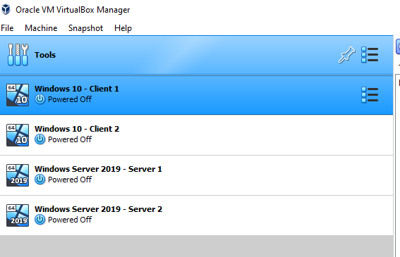
Figure 1 – Creating 4 virtual machines.
Figure 1 shows the 4 virtual machines and their naming convention. Each machine when created used the virtual box wizard to suggest the most suitable settings. These settings do require tweaking which is explained below.

Virtual Box Tweaks

Host System Requirements
To improve the performance of the Guest virtual systems a number of online sources suggest the following
- Using a SSD. Using a solid-state drive compared to a mechanical drive will provide improved read and write speeds.
- Memory. Installing more RAM (Random Access Memory) into the Host System will increase the available memory for the host but also allow additional allocation of memory to guest machines.
- CPU/Processors. Depending on what Processor is installed into the Host system it may allow the user to allocate additional processors or cores/threads. Allocating additional processors allows the Guest OS to process more simultaneous calculations.
When creating virtual machines in Virtual box, the software has a built-in wizard that suggests the minimum settings. After completing the wizard, the below changes were made.
Changing Allocated RAM from 2048 to 4096. The benefit of allocating additional RAM is that the guest devices can store more data in RAM which is a much faster method of reading and writing data than using the local hard drive.
Enabling PAE/NX
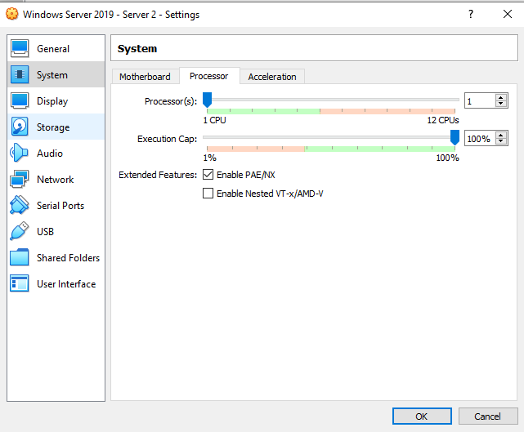
Figure 2 – enabling PAE/NX and processor allocation.
Figure 2 shows the available processors but also the extended feature PAE/NX which has been enabled. PAE/NX is Physical Address Extension. This setting allows any supported OS to overcome the memory limitation of x32 bit CPUs and allows access to more than 4GB RAM limit. Although for the purposes of this task the Host and All guests are running x64 OS version with the Host CPU being x64 compatible.
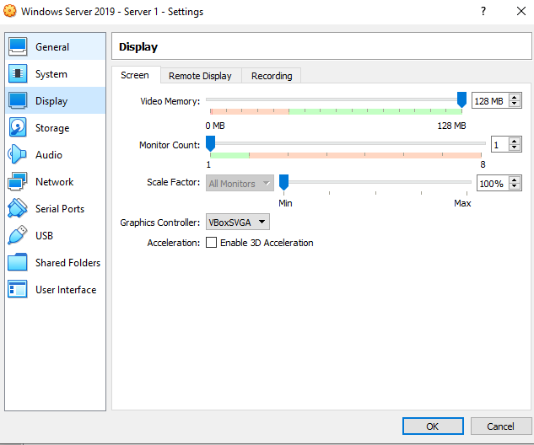
Figure 3 - Video Memory – 128MB
Figure 3 shows the video memory option. This was set to 128 MB as default by the wizard earlier and didn’t require any tweaking.

All the above settings were used for both Virtual Server and Virtual Clients. The host device was able to accommodate all devices set at 4096 MB of RAM for added performance.

Installing Windows 10 x64 Operation System
Installing Win 10 x64 Client
The steps below are relevant to both Windows 10 x64 Client 1 and Client 2. The Windows 10 ISO was loaded into Virtual Box and the Virtual Machine powered on.
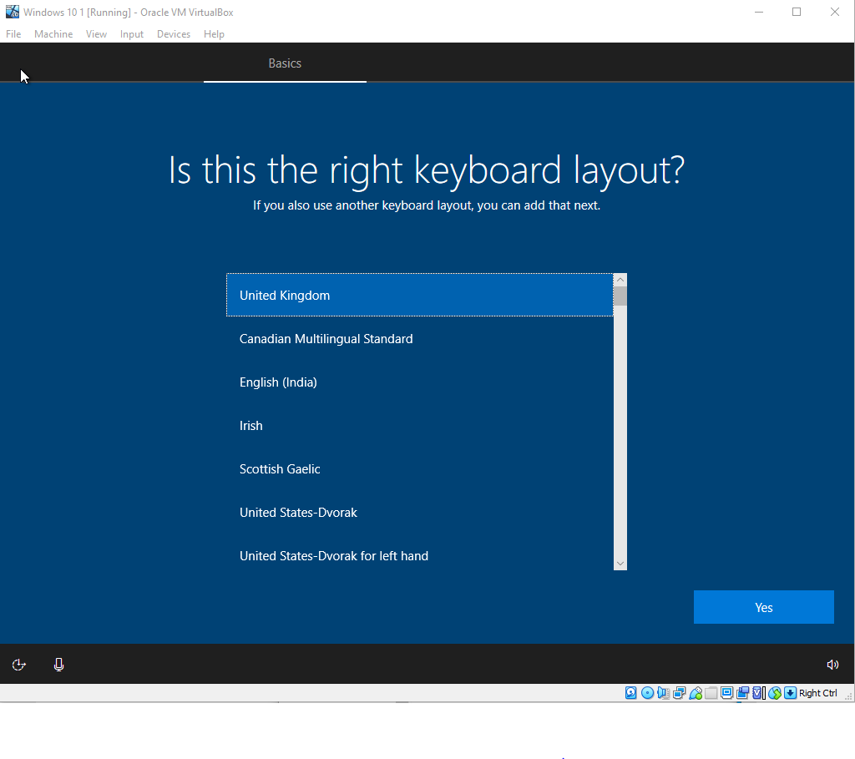
Figure 4 – Windows 10 Installation GUI
Figure 4 is showing the Windows 10 GUI setup. The user follows the prompts which in this case are choosing the keyboard layout which followed on from default language and time settings. A user account was created. Username – admin, password – P@ssw0rd.
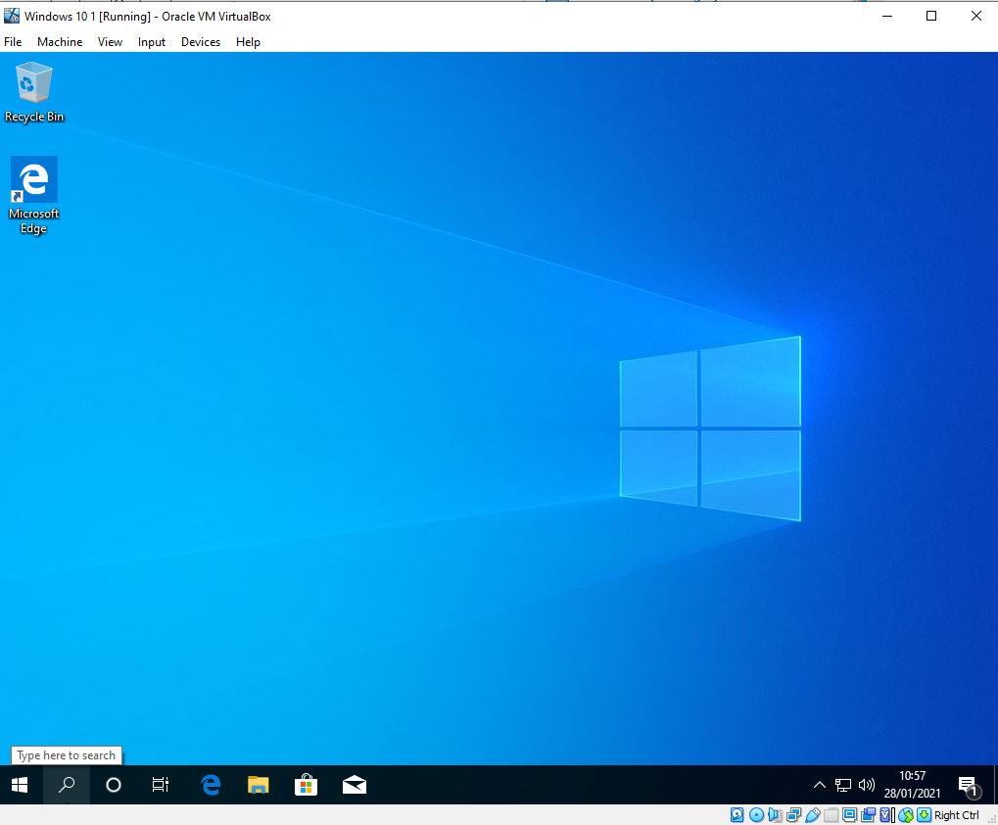
Figure 5 – Windows 10 Completed Installation showing the desktop
Finally figure 5 shows the completed install and logged into Windows.

Windows 2019 Server Install

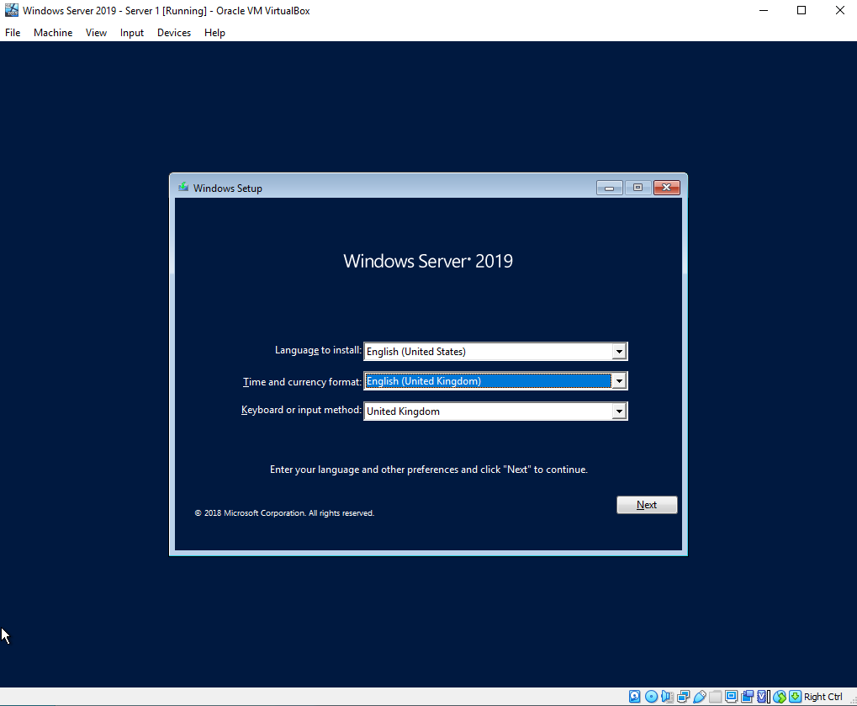
Figure 6 – Windows Server 2019 Installation GUI
Windows 2019 Server Evaluation iso was downloaded from the Microsoft website here.
Windows Server 2019 installation provides a graphic user interface wizard which guides the user through the installation process. Figure 6 shows Language, time and keyboard configuration.
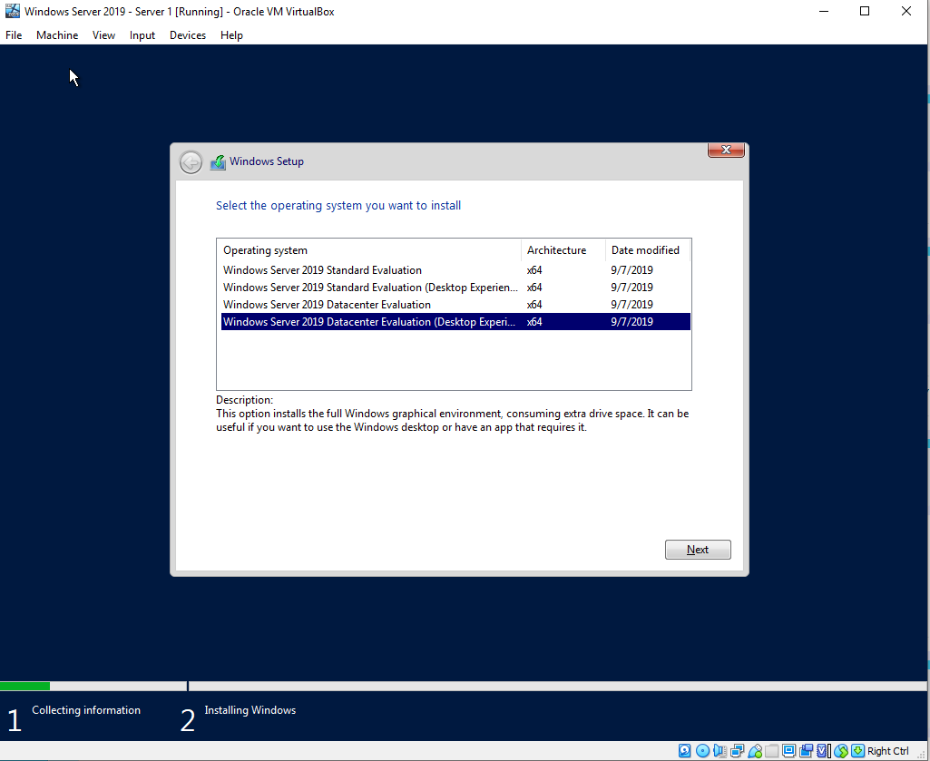
Figure 7 – Windows 2019 Server Iteration choice
Due to the installation media being an evaluation version which provides a fully functional server operating system for a 180-day trial the user must select which iteration of Windows Server 2019 to install. In this case Datacentre Evaluation (Desktop Experience) was installed as evidenced by figure 7.
A default account was created for the server.
Username – Administrator
Password – P@ssw0rd

Guest Additions
An optional step which had performance benefits is Virtual Box Guest Additions.

Task 2 – Virtual Network Configuration

Virtual Network Settings
Virtual Box provides the user with several virtual network options, they are:
- NAT (Network Address Translation)
NAT allows the Guest or VM to access the external network, however it doesn’t allow the Host system to access the Guest or VM.
- Bridged Adapter
Allows the Guest or VM to access the same network as the Host system and vis-versa.
- Internal Network
Guests share the same internal network and access each other, but no access to the host.
- Host Only Adapter
Communication between the Guest and the Host is permitted. The Host has a statically allocated IP where as the Guests are allocated a DHCP address.
- Generic Driver
For creating UDP Tunnel or Virtual Distributed Network.
- Cloud Network
Used for Oracle Cloud Infrastructure tenant.
- Not Attached
No Network connection for the Guest or VM.

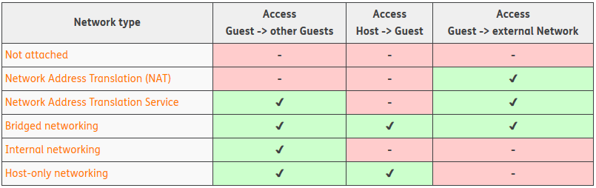
Figure 8 – Virtual Box Network Type Comparison [1].
Figure 8 compares the different network types and how each Guest VM can interact with each other or interact with the Host system.
For this task the Internal Network option was chosen for all the network adapters, 2x on each virtual server and 1x on each virtual client machine. On each Server VM the network adapters were configured with a PrivateNet and PublicNet. Figure 9 shows the 2 networks and IP address information. Figure 10 shows the option of configuring a statically allocated IP address and subnet.
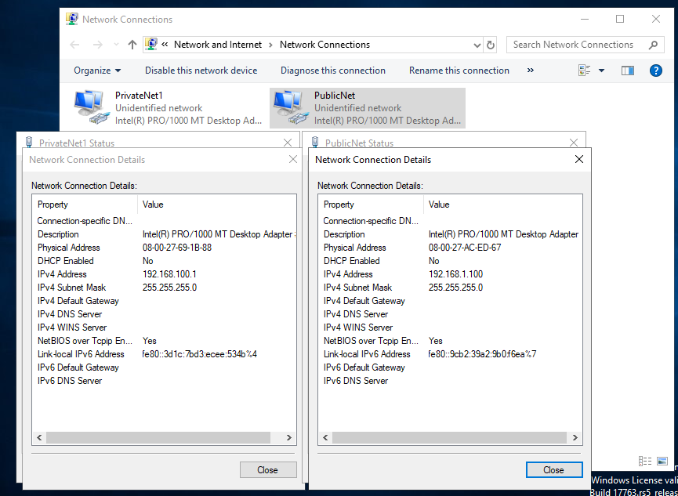
Figure 9 – PrivateNet and PublicNet configured on Server 1 VM.

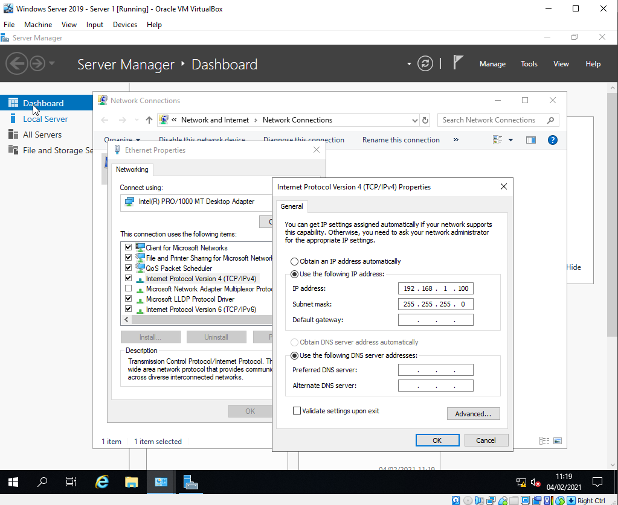
Figure 10 – Static IP management

Virtual box internal isn’t configured with DHCP (Dynamic Host Control Protocol) therefor a statically assigned IP address must be inputted to each network adapter as displayed in Figure 10. The IP addressing scheme for this task is given in Worksheet 1 – figure 1 Trial Network configuration. The same image has been copied below (figure 11). A Class C network is used for all the adapters with a /24 CIDR (Classless Inter Domain Routing) or 255.255.255.0 subnet. Oxford Dictionary of Computer Science explains a CIDR and subnet as identifying and a flexible division of a network identity and host portion of a network [2].
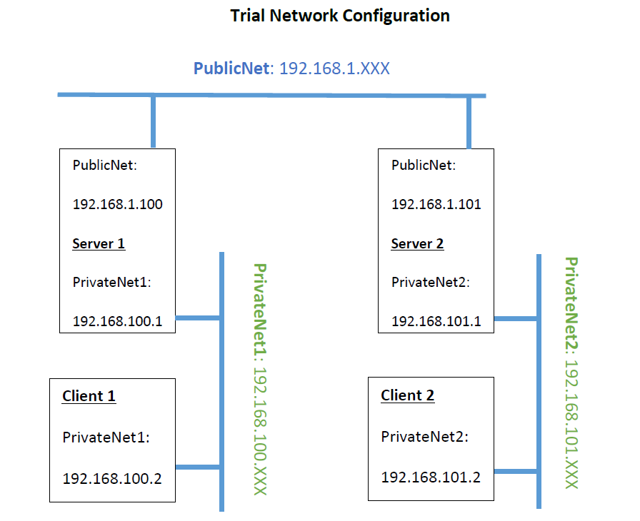
Figure 11 – Trial Network Configuration

Connectivity

Using Microsoft Windows inbuilt tools such as ipconfig and ping allows the user to check and confirm correct IP addressing and connectivity.
Once the IP configuration has been completed on all virtual machines, a quick check using Windows Command Prompt and the command ‘ipconfig’ displays the IP configuration on all network interfaces. Figure 12 shows the configuration on Server 1, returning the IP for both Network interfaces. Windows Operating systems offer a CLI (command line interface) formally known as command prompt.
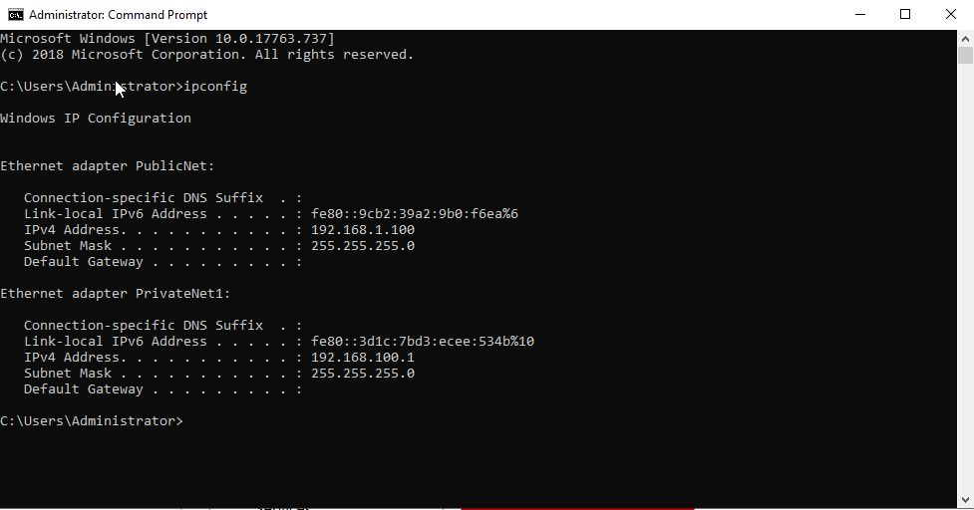
Figure 12 – Correct IP Configuration Server 1
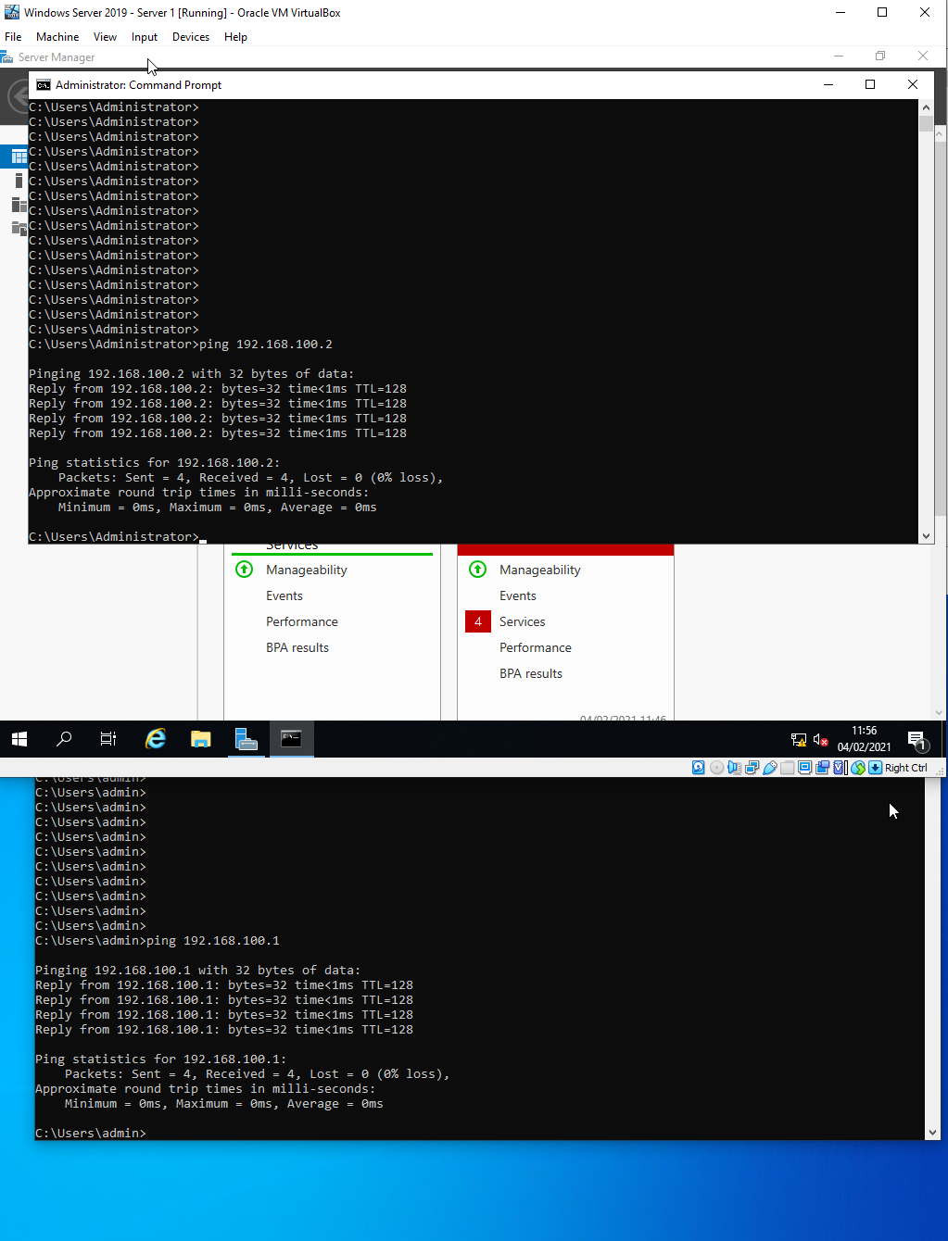
Figure 13 – ICMP Packet confirmation
Final test of connectivity was carried out using the ‘ping’ command between server 1 and client 1 as displayed in figure 13. The ping command……
Figure 14 displays the successful connection between Client 2 and Server 2.
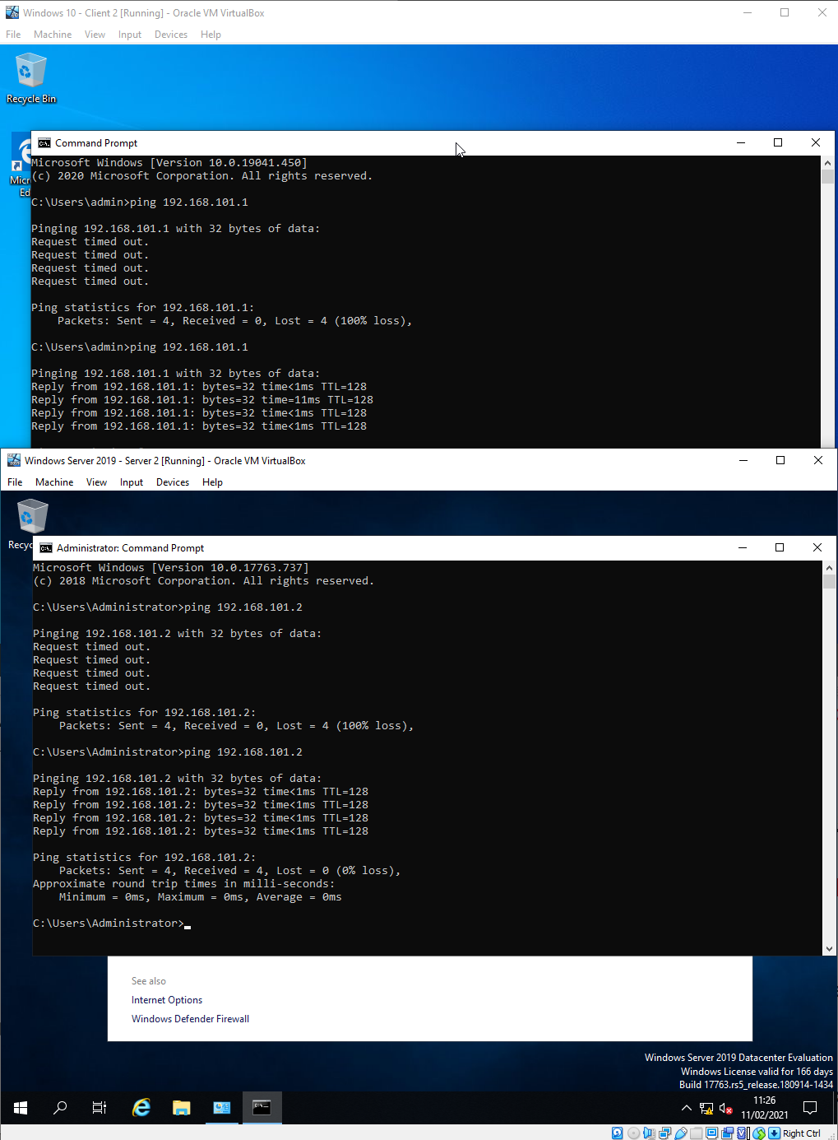
Figure 14 – Successful connection between Client 2 and Server 2.

Firewall
By default, Windows Firewall blocks ICMP packets which the ping command uses to test connectivity between devices.
There are 2 options to overcome this issue.
Option 1 – Allow ICMP through the firewall
Creating a custom Firewall rule to allows ICMPv4 and ICMPv6 as shown in Figure 15.
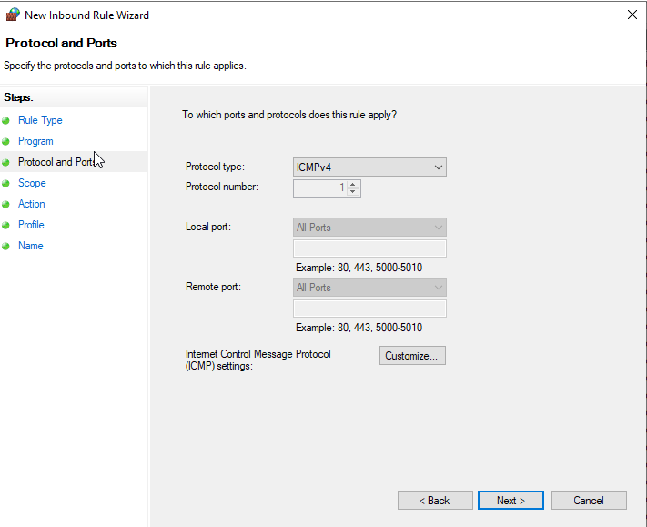
Figure 15 – Windows Firewall Rule to allow ICMP (Ping)
Option 2 – Disable Windows Firewall
This option was used for this task as per the worksheet instructions. Windows Firewall provides 3 options, Domain, Private and Public. The firewall was disabled for all 3 options on all 4 Virtual Machines as evidenced in figure 16.
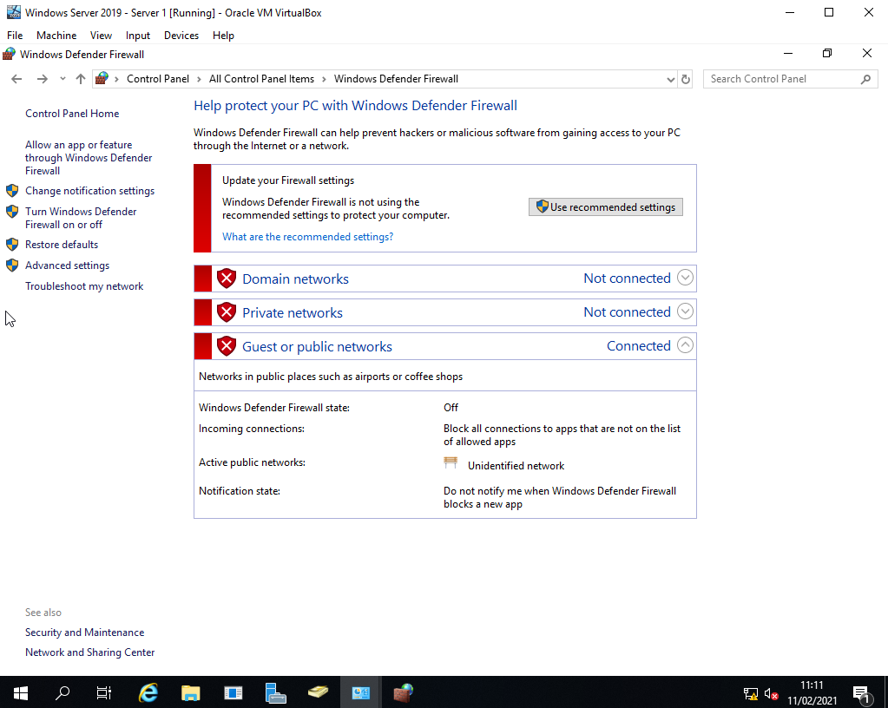
Figure 16 – Windows Firewall disabled

3. TASK 3 – Observation Tasks

3.1. Type 1 vs Type 2 Hypervisors

Hypervisors or virtualisation of operating systems is the process in which a user can use a single physical server and run multiple different operation systems. Granisezcwski and Arciszewski researched the benefits and performance gains with using hypervisors [3]. They explain that this saves on resources, provides high availability, security, and efficiency to any business or individual. The performance analysis compares the industry leaders such as VMWare ESXI, Hyper-V, Xen and Virtual Box which is discussed below when comparing the different types.

3.1.1. Type 1
Type 1 are classed as native or bare metal hypervisors. Brodkin describes type 1 as virtualisation software installed directly onto the bare metal hardware [4]. This becomes the intermediary between the hardware resources and the guest operating systems.
Security and Isolation is one of the main arguments for Type 1, Brodkin explains that greater isolation between guest operating systems and elimination of attack surface towards the host. This is beneficial because if a guest virtual machine is infected or compromised the others are isolated from it.
Reliability and Availability
There are some downsides to type 1 hypervisors. Bradbury highlights that guest machines are all competing for the host systems resources, he explains how the CPU interrupt process works and memory translation and that each guest has a schedule to access the resources [5]. This can cause issues if the host can’t keep up with the demand of the guests.

3.1.2. Type 2
Type 2 are also referred to as hosted hypervisor. This type of hypervisor is installed on top of another Host Operating system which then allows the user to run guest systems in isolation to the host.
Simplicity is a benefit of a Type 2 hypervisor. Users are accustomed to which ever Operating system they use at home or in work, therefore installing software on top of their operating system …. It takes very little knowledge of configuring and setting up hardware to configure a type 2 guest.
Security, even though security was a benefit of a type 1 hypervisor it’s also a benefit for type 2. A guest operating system can be configured and installed in a few mins and once done can be removed and deleted. This is beneficial for users to test software in isolation to their current operating system or run software designed for different manufactures operating systems such as Microsoft Windows vs a Linus distribution.
The drawbacks of using a type 2
Type 2 hypervisors have limitations. The Host Operating system consumes more hardware resources as compared to a type 1 which may result in limited resources for the guest or being limited to run less guest machines simultaneously.

3.1.3. Conclusion
There are many manufactures that offer Type 1 and Type 2 hypervisors, some even offer both.
Some examples of each both:-
Type 1 hypervisor examples – VMWare ESXI, Proxmox (KVM)
Type 2 hypervisors examples – VMWare Player, VirtualBox, Parallels Desktop.
Each type has its benefits and limitations. A Type 1 is aimed at a permeating solution with high availability and reliability. A Type 2 which runs on top of another operating system would be beneficial as a temporary solution for testing software or setting up isolation which can be disregarded and re-setup quickly and easy.
Other terminology:
Para-virtualisation – As virtualisation has become mainstream and easily accessible some operating systems have now been developed with virtualisation in mind. Enabling paravirtualization notifies the guest that it is running on a hypervisor which in turn allows the guest to omit or modify certain instructions to increase performance and elevate issues. An example of this is Windows Server 2008 which when run as a virtual guest allowed the operating system to better manage the resources available to it.
Hardware-assisted virtualisation – first appeared in 1972 by IBM, hardware-assisted virtualisation has performance benefits over paravirtualization. This…. Wasn’t available on many CPUs until recently when intel introduced VT-x and AMD with AMD-V or SVM. Therefore, virtualisation is natively available on the CPUs which allows the guests to directly communicate with the Host CPU which provides the performance benefits.

3.2. Internet Protocol addressing scheme v4 or IPv4 for short

Every connected device uses either the IPv4 or IPv6 protocol. IPv4 is a Layer 3 protocol used by devices to communicate with each other between different networks. Tanenbaum explains that the layer 3 or the network layer of the OSI models function is to forward packets from a source network to a destination [6].
An IPv4 address is made up of 3 parts, a host ID, subnet ID and a network ID. Each host on a network is assigned a unique IPv4 address. IPv4 contains 32 binary bits that are divided into four 8-bit octets however this is converted into dot decimal as its simpler for people to read and remember. The result is 4 octets ranging from 0 to 255.
A subnet mask also contains 32 binary bits the same as a IPv4 host address however it differs in that the host portion (right most) bits are all set to 0 and the network portion (left most) bits are all set to 1.
Classification. IPv4 protocol is broken down into classes ranging from A to E. For the purposes of this task only Class A to C will be discussed.
Class A addressing claims the first octet as the network portion, octets 2-4 are used for hosts and subnets, subnet mask example – 255.0.0.0.
Class B addressing claims the first 2 octets as the network portion and 2 octets for hosts and subnets, subnet mask example – 255.255.0.0.
Class C addressing claims the first 3 octets as the network position and the final octet or 8 bits for hosts and subnets, subnet mask example – 255.255.255.0.

3.3. Cloud Computing

Cloud computing is the process of deploying on demand services from an off-site location over the internet. Generally, Cloud computing is owned by a third party and offered as a pay for what you need service. The services can range from storage, applications, servers etc and access them over the internet from any location.

3.3.1. Benefits
The most prevalent benefit of cloud computing is cost. The upfront expenditure or capital required to not only purchase hardware but to house, cool and maintain it could be too high as expressed by Marston [7] who claims it being advantages to small companies. The benefits also transfer to large and enterprise companies that lack space and technical expertise instead paying for a third party to host, service, support, maintain and backup up their services without a substantial investment. Marston [7] corroborates this statement by describing it as increasing complexity and becoming more expensive than ever before to maintain on site services.
Another benefit is security, leading providers employ cyber security companies to maintain the security of their and their client’s systems which smaller companies won’t be in the position of doing themselves.
A key aspect which is often overlooked is innovation. Companies have instant access to resources that may otherwise take months to gather. This is beneficial to companies where high-performance hardware is required for artificial intelligence or high CPU cycle tasks. A study by Sun, Jiang et al [8] focuses on the advantages cloud computing has on the analysis of big medical data using artificial intelligence.

3.3.2. Drawbacks
With all the benefits offered by Cloud computing the draw backs can become obfuscated and overlooked. Hashem, Yaqoob et al [9] highlight some of the problems that using Cloud services imposes, such as data availability, data integrity, privacy and governance. Moving a service into the cloud heavily relies on both the local and remote internet connections, a problem either end could cause catastrophic damages. With the data now stored with a third party, integrity, security and privacy are a concern, the data ownership must be established prior to using any service. The Chartered Institute for IT [10] published a guide to moving IT out of the office. They have recommended solutions to the concerns such as cryptography and from their experience of cloud services data centre how security and availability are a top priority for hosting services, from physical security, man traps, secure rooms, biometrics to name a few meeting the ISO 27001 certification.

3.3.3. Vendors
There are may vendors that offer Cloud Services. Microsoft Azure, Amazons AWS, Google Cloud Platform are some of the industry giants that hold a large portion of the market. These companies offer a public platform which is pay for what you need service; and a private platform which is a flexible model that can only be accessed securely by a single organisation leading to greater control and privacy.

3.3.4. Conclusion
The services that Cloud companies offer are categorised into the following IaaS, PaaS and SaaS.
IaaS – Infrastructure as a Service is the foundation of computing. Renting equipment such as storage, network or servers which the user then configures to their requirements.
PaaS – Platform as a Service includes the tools for example operating systems, databases, backup solutions or development platforms. These would normally be an add on to IaaS but could be used independently.
SaaS – Software as a Service is becoming more popular. The hardware (IaaS) and even the behind the scene processing (PaaS) is irrelevant to the end user, all they require is the software presented to them. An example would be Microsoft Office 365, users can access Word Processor, emails etc via the internet on any device without having to deal with servers, networking, databases or backups.
From the above, companies investing in a cloud service can choose some, none or all of the services to be hosted. Weighing up the pros and cons of moving their data into the cloud will be different from business to business, however with cloud computing become more prevalent and cheaper the risks or drawbacks are still the same.

3.4. Terminology Discussion

3.4.1. Storage Controllers
Task 1 saw the creation of 4 virtual machines using Virtual box installed on Windows 10 x64. While configuring each guest a virtual hard drive is needed. Virtual Box offers a number of options, AHCI, RAID, SAS, SCSI, NVME and IDE. Virtual box provides a detailed explanation of the benefits and use cases for each [11].
IDE or ATA controllers supports up to 4 virtual storage devices. This is due to how IDE was implemented in physical machines using a ribbon cable which supported 2 physical storage devices per ribbon cable and usually limited to 2 cables thus 4 physical storage devices. By default, in virtual box the CD-ROM drive will use device 0 on the secondary IDE channel.
SATA or Serial ATA is the evolution of IDE [12]. It provides faster speeds between the storage device and controller but also allows more than the 4-device limit of IDE although virtual box limits SATA devices to 30. Another benefit of SATA in both a virtual machine and physical is that it supports adding and removing the storage device while the system is running. In Virtual Box SATA is defined as AHCI or Advanced Host Controller Interface. A drawback of using AHCI (SATA) is that not all operating systems support it, or some older operating systems require additional drivers to be installed. Nanda explains the evolution of the control and lists additional benefits [13].
SCSI and SAS. Small Computer System Interface and Serial Attached SCSI is another controller interface usually seen in high performance servers or workstations. These controllers use the LSI Logic Controller which not all operating systems support without loading additional drivers. SAS is to SCSI what SATA is to IDE, a serial connection providing faster speeds and benefits such as hot swappable. SCSI has a limit of 15 virtual storage devices whereas SAS has a limit of 255.
NVME , one final option is NVME or Non-Volatile Memory Host. This option is the evolution of the SATA controller with the benefits of 3 million IOPS (input/output operation per second) compared to the SATA limit of 150,000 IOPS. Newer hardware and Operating Systems support NVME.

3.4.2. Conclusion
The choice of Storage Controllers comes down to the choice of Operating System and use case of the Virtual Machine. By default, any Microsoft Windows operating system released after 2006 (vista) will by default support SATA. This makes SATA a good option as it provides the benefits mentioned above. NVME is a new technology which the Host and Virtual Machine OS must support. It has the benefits of faster speeds over SATA.
For CD-ROMs Virtual box defaults to IDE however this can be changed to SATA. As CD-ROMs are usually only needed for the initial installation using an ISO then changing the option is rarely needed.
There is one caveat, Virtual Box provides an option called Host Cache or I/O Cache. This setting will write and read data from a cache file stored in RAM. With this setting enabled IDE performance usually matches that of SATA. SATA still has the benefits of the hot swappable feature and a higher amount of storage devices but also has a lower virtualisation overhead.
Unless specifically needed SAS and SCSI will come second to SATA. A use case for example might be the need to have more than 30 virtual storage devices.

References

[1] “Network Configuration in VirtualBox - Thomas-Krenn-Wiki.” https://www.thomas-krenn.com/en/wiki/Network_Configuration_in_VirtualBox (accessed Feb. 11, 2021).
[2] A Dictionary of Computer Science. Oxford University Press, 2016.
[3] W. Graniszewski, “Performance analysis of selected hypervisors (Virtual Machine Monitors-VMMs),” INTL J. Electron. Telecommun., vol. 62, no. 3, pp. 231–236, 2016, doi: 10.1515/eletel-2016-0031.
[4] J. Brodkin, “A look at bare-metal hypervisor basics - ProQuest,” Netw. World, vol. 27, no. 14, Jul. 2010, Accessed: Feb. 18, 2021. [Online]. Available: https://search-proquest-com.ezproxy.uwtsd.ac.uk/docview/743887493?accountid=130472&pq-origsite=primo.
[5] D. Bradbury, “Inside a hypervisor - ProQuest,” Comput. Wkly., pp. 16–17, Feb. 2009, Accessed: Feb. 18, 2021. [Online]. Available: https://search-proquest-com.ezproxy.uwtsd.ac.uk/docview/237008043/AC1CDD8790B14331PQ/3?accountid=130472.
[6] A. Tanenbaum, Computer Networks, 5th ed. University of Washington: Pearson Education, 2013.
[7] S. Marston, Z. Li, S. Bandyopadhyay, J. Zhang, and A. Ghalsasi, “Cloud computing - The business perspective,” Decis. Support Syst., vol. 51, no. 1, pp. 176–189, Apr. 2011, doi: 10.1016/j.dss.2010.12.006.
[8] L. Sun, L. Sun, X. Jiang, H. Ren, H. Ren, and Y. Guo, “Edge-Cloud Computing and Artificial Intelligence in Internet of Medical Things: Architecture, Technology and Application,” IEEE Access, vol. 8, pp. 101079–101092, 2020, doi: 10.1109/ACCESS.2020.2997831.
[9] I. A. T. Hashem, I. Yaqoob, N. B. Anuar, S. Mokhtar, A. Gani, and S. Ullah Khan, “The rise of ‘big data’ on cloud computing: Review and open research issues,” Information Systems, vol. 47. Elsevier Ltd, pp. 98–115, Jan. 01, 2015, doi: 10.1016/j.is.2014.07.006.
[10] T. C. I. for I. BCS, Cloud Computing : Moving IT Out of the Office. 2012.
[11] U. S. B. Msd, T. Virtual, M. Manager, I. B. M. Pc, and T. Pcs, “Chapter 5 . Virtual storage,” pp. 1–12, 2016, Accessed: Mar. 04, 2021. [Online]. Available: https://www.virtualbox.org/manual/ch05.html.
[12] H. Mason, “Serial Attached SCSI and Serial ATA Seek Their Levels - ProQuest,” Comput. Technol. Rev., vol. 24, no. 2, pp. 21–22, 2004, Accessed: Mar. 04, 2021. [Online]. Available: https://search-proquest-com.ezproxy.uwtsd.ac.uk/docview/220638906?accountid=130472&pq-origsite=primo.
[13] S. Nanda, “SATA Vs. PATA - ProQuest,” Comput. Technol. Rev., vol. 22, no. 11, p. 18, Nov. 2002, Accessed: Mar. 04, 2021. [Online]. Available: https://www-proquest-com.ezproxy.uwtsd.ac.uk/docview/220627435/fulltextPDF/B39446F78BF44DBFPQ/1?accountid=130472.

