
Marketing Management
Assignment Title: Assessment component A2: Portfolio
Module Code: LCMB7024
Lecturer’s Name: Haoran Liu
Student Name: PATEL MEETKUMAR KANTILAL
Student ID: 2536671
Word Count: 2,692
Submission Date: 14 August 2026
TERM 1

GYMSHARK FUEL BRAND EXTENSION
Table of Contents
Element 1: Sustainable Brand Extension Poster Presentation 4
Element 2: Segmentation, Targeting, Differentiation, and Positioning (STDP) Analysis for Gymshark Fuel 5
2.1 Introduction 5
2.2 Market Segmentation 5
2.2.1 Geographic Segmentation 5
2.2.2 Demographic Segmentation 6
2.2.3 Psychographic Segmentation 6
2.2.4 Behavioural Segmentation 7
2.3 Target Audience 7
2.4 Differentiation 8
2.4.1 Competitor Analysis 8
2.4.2 Sustainability Credentials 8
2.4.3 Direct Retail Model 8
2.5 Positioning 8
2.5.1 Positioning Statement 8
2.5.2 Perceptual Positioning Map 9
2.5.3 Alignment of Positioning with Brand's Overall Brand Identity 10
Element 3: Marketing Mix (7Ps) for Gymshark Fuel 10
3.1 Introduction 11
3.2 Product 11
3.3 Price 12
3.4 Place 13
3.5 Promotion 13
3.6 People 14
3.7 Process 14
3.8 Physical Evidence 14
3.9 Alignment with the Sustainable Brand Extension Strategy 15
Element 4: Reflection 16
4.1 Introduction to the Reflective Process 17
4.2 Development of the Marketing Strategy 17
4.3 Poster Presentation Experience 17
4.4 Key Skills, Knowledge, and Insights Gained 17
4.5 Contribution to Personal and Professional Development 18
4.6 Areas for Future Improvement 18
Reference List 19

Element 1: Sustainable Brand Extension Poster Presentation
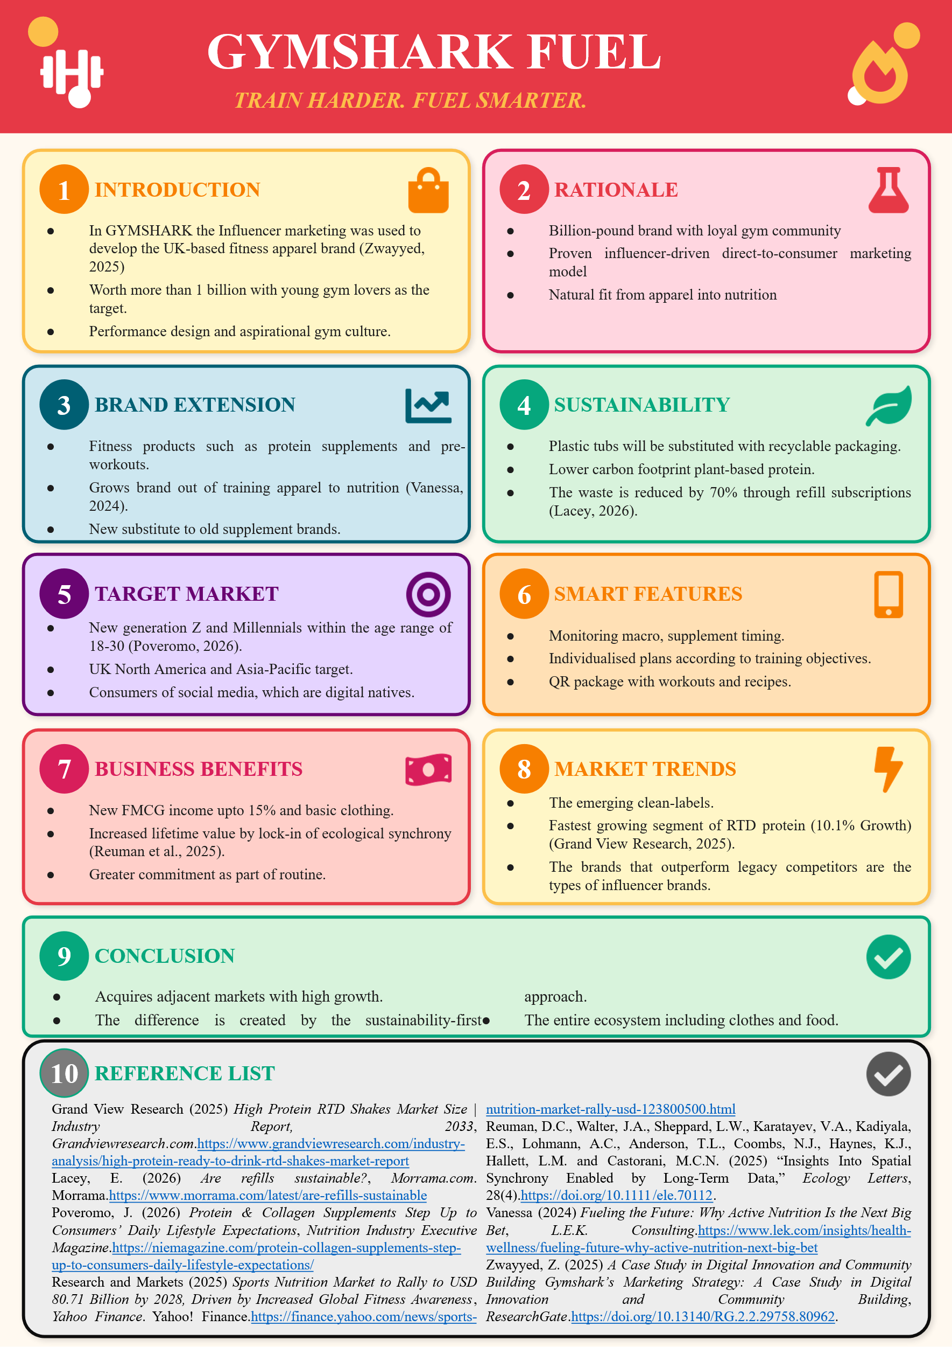

Element 2: Segmentation, Targeting, Differentiation, and Positioning (STDP) Analysis for Gymshark Fuel

2.1 Introduction
Gymshark Fuel is an eco-friendly brand that will elevate Gymshark to sports nutrition. Here, the STDP framework will be used to specify who the brand will serve, their competitive differentiation and how the brand will be positioned in a global sports nutrition market that is expected to be USD 55.71 billion in 2025 and USD 60.56 billion by the year 2026 (Stratview Research, 2026). Segmentation divides the market into specific units to enable Gymshark Fuel to use its resources effectively. There are 4 bases used.

2.2 Market Segmentation

2.2.1 Geographic Segmentation
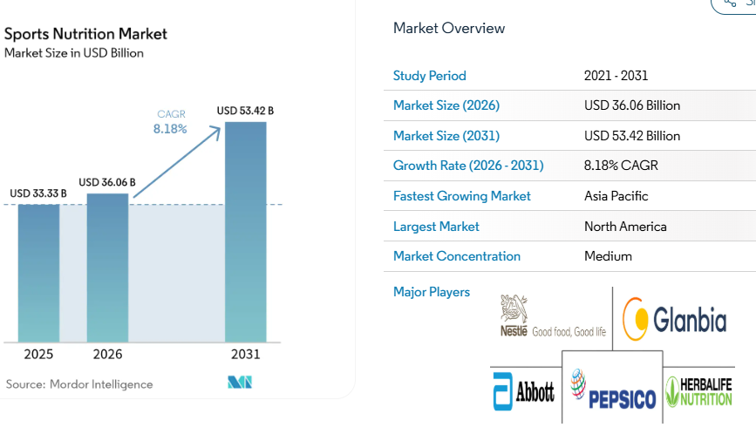
Figure 1: Sports Nutrition Market
(Source: Mordor Intelligence, 2026)
The notable geographies include the United Kingdom, North America and Asia-Pacific. In 2025, North America dominated the sports nutrition market of the world at 60.55% and Asia-Pacific is expected to grow with the highest CAGR rate of 9.56% during the period of 2031. These areas coincide with the current recipe of Gymshark stores, such as its flagship store in Manchester, London, and New York, its stores in Amsterdam and Dubai (Mordor Intelligence, 2026).

2.2.2 Demographic Segmentation
The main audience includes 18-30-year-olds who have a disposable income to spend on fitness and are divided approximately into student, personnel starting, and personal trainers. Consumers of both genders (male and female with a slight female bias) are targeted and this is due to the increasing womenswear market share by Gymshark. In 2025, protein is listed as the first nutrient of interest to Millennials and Gen Z all around the world.

2.2.3 Psychographic Segmentation
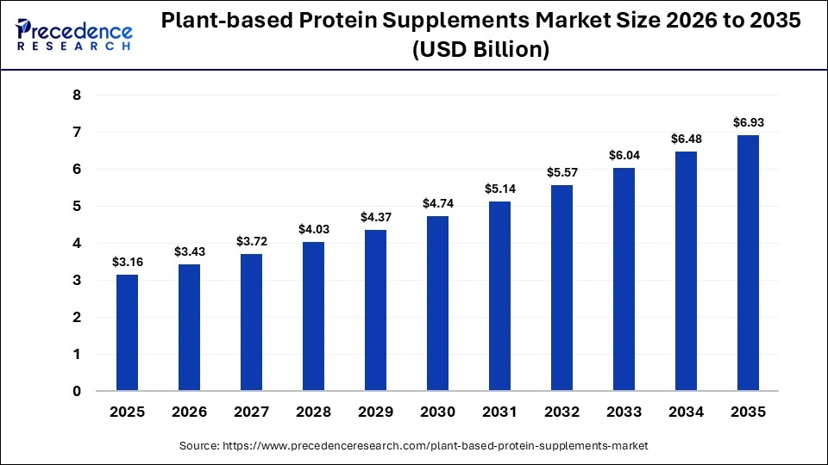
Figure 2: Plant-based Protein Supplements Market Size
(Source: Precedence Research, 2025)
Target consumers are self improvement-oriented, aesthetically influenced and value oriented towards sustainability. They treat fitness as a form of identity and not a habit and subscribe to fitness influencer culture within TikTok and Instagram. They also have a growing awareness of clean, plant-based, and ethically sourced products, and that is what propelled plant-based sports nutrition to an estimated 8.17% CAGR in 2025 (Precedence Research, 2025).

2.2.4 Behavioural Segmentation
In behavioural terms, the buyers are more frequent and perceive online channels (38.68% of the sports nutrition sales in 2025), consume protein at least three times a week, and are highly brand-loyal when the product corresponds to the training objectives. This segment is mainly dominated by subscription models and patterns of reorders with RTD protein beverages increasing 8.0% CAGR (Fortune Business Insights, 2025).

2.3 Target Audience
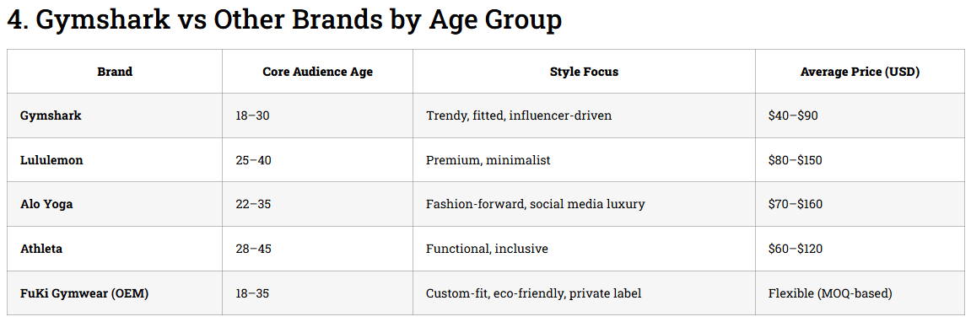
Figure 3: Gymshark vs Other Brands by Age Group
(Source: Owen, 2025)
The target market is digital native fitness consumers aged 18-30 in the UK, US, and Australia who have 4(+) workouts per week, buy supplements and use Gymshark clothes. The secondary audience consists of casual gym-goers, lifestyle fitness consumers aged 25-35, who are convenience-driven nutrition consumers (Owen, 2025). Together, these segments form the most rapidly increasing consumer groups in a market that is estimated to be USD 138.5 billion in 2033.

2.4 Differentiation

2.4.1 Competitor Analysis
The rivalry to the Gymshark Fuel includes Optimum Nutrition, Myprotein, Huel, Applied Nutrition and Grenade. Older brands control the scale but lack lifestyle, whereas newer competitors such as Huel do not have the fitness-community credibility. The 23.7 million monthly visits to the gymshark web site and the 646 million FY25 revenues are a community strength that no other supplement competitor can match at the beginning of its operations (Bottomley, 2026).

2.4.2 Sustainability Credentials
Gymshark Fuel stands out with mono-material recyclable pouches, alternatives to whey made of plants that cause a smaller environmental impact and a refill subscription that will lead to a waste reduction of 70 percent. This makes the brand stand out of Optimum Nutrition and Myprotein whose tub packaging of products is the main one in the category in 2025.

2.4.3 Direct Retail Model
In contrast to their rivals who depend on Amazon and third-party retail, Gymshark Fuel is launched via a DTC platform: gymshark.com, the Gymshark app, and its growing brick-and-mortar stores in Manchester, London, Amsterdam, Dubai, and New York (Faithfull, 2025). This is similar to the 100 percent first-party sale structure of Gymshark, which safeguards margins and consumer information.

2.5 Positioning

2.5.1 Positioning Statement
To Gen Z and Millennial consumers who are conscious of their health and fitness, Gymshark Fuel will become a more sustainable sports nutrition brand offering high-quality performance products at the customer-trusted brand, unlike traditional supplement brands that disregard design, community and environmental responsibility (Gymshark, 2026).

2.5.2 Perceptual Positioning Map
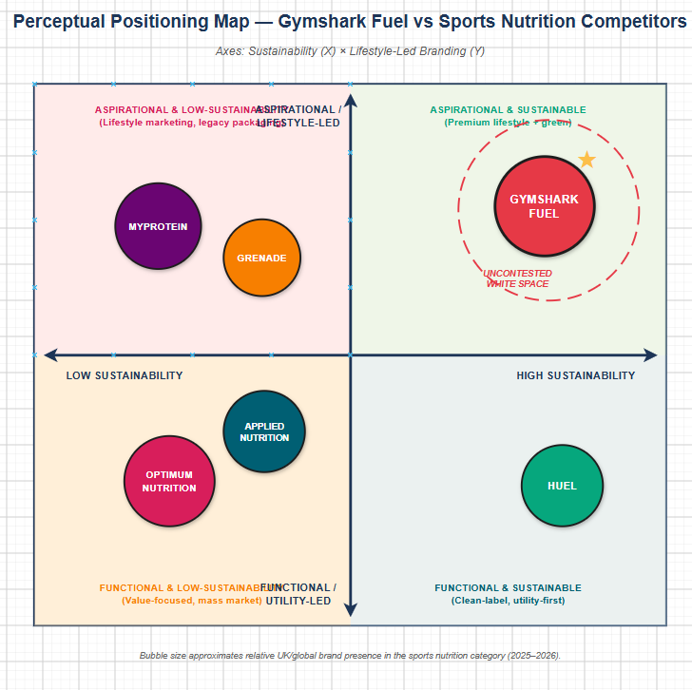
Figure 4: Perceptual Positioning Map
(Source: Self Created using Draw.io)
Located in two dimensions a sustainability (low -high) versus a lifestyle-led branding (functional -aspirational) grid, Gymshark Fuel can be placed high-sustainability and high-lifestyle. Optimum Nutrition is low-sustainability/functional; Huel is high-sustainability/functional; Myprotein is low-sustainability/aspirational. Gymshark Fuel has a white space.

2.5.3 Alignment of Positioning with Brand's Overall Brand Identity
This demarcation directly builds on the identity of Gymshark as a performance-oriented, community-focused, digitally native brand. Fuel supports the parent brand's purpose of empowering advancement in training and includes sustainability, which fortifies instead of weakening the essence of the equity of Gymshark (Zwayyed, 2025).

Element 3: Marketing Mix (7Ps) for Gymshark Fuel

3.1 Introduction
The 7Ps model translates the positioning of Gymshark Fuel into the working marketing choices. Every component is pegged to the parent brand revenue base of £646million in FY25, its digital audience of 23.7 million every month and its sustainability promises which distinguish the extension in a global market of sports nutrition expected to go up by 8.25% CAGR between 2026-2034

3.2 Product
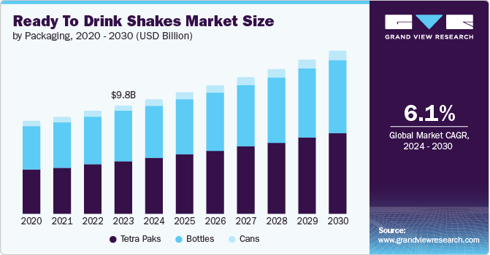
Figure 5: Ready to Drink Market
(Source: Grand View Research, 2026)
Gymshark Fuel starts with four SKU families: whey protein powder (chocolate, vanilla, salted caramel), plant-based protein (pea and fava isolate), ready-to-drink protein shake in aluminium cans, and pre-workout in single-serving packets. The protein powders indicate its largest share in the sports nutrition industry. The global ready to drink shakes market size was valued at USD 9.8 billion in 2023 and is projected to grow from USD 11.6 billion in 2026 to USD 14.8 billion by 2030, at a CAGR of 6.1% from 2024 to 2030. All products are clean-label, 3rd party tested, and contain packaging that can be fully recycled (Grand View Research, 2026). The Gymshark app offers a companion nutrition dashboard with training and macro data and reorder notices that competitors do not have a service layer.

3.3 Price
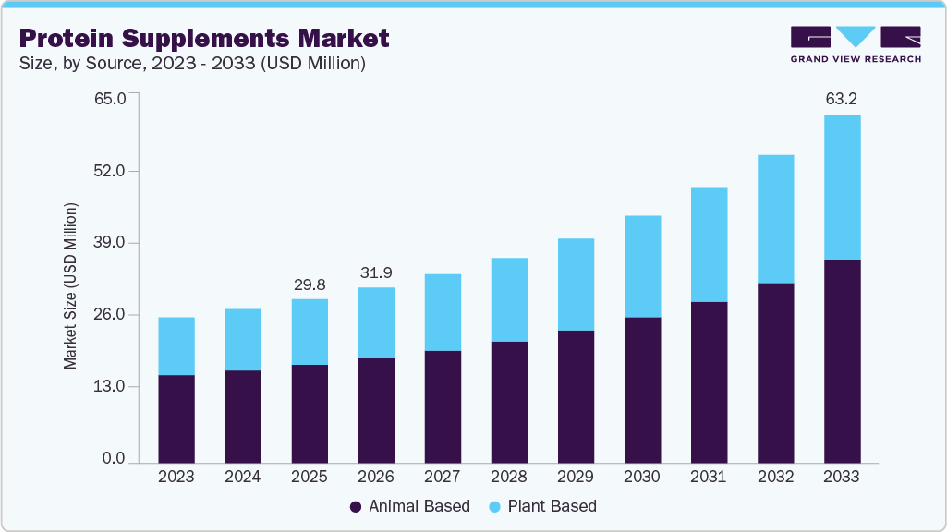
Figure 6: Protein Supplements Market
(Source: Grand View Research, 2026a)
Gymshark Fuel is priced in high value. A 1kg protein tube costs £34.99 which is above Myprotein (~22) and Optimum nutrition (~30) and below Huel Complete Protein (~38). Barebells and Grenade have the same price as RTD 330ml 0.55l can which is £2.99. A refill subscription provides 15 ounces off the usual charges to guarantee customer lifetime worth. The prices are indicative of the best practices of premium sustainability along with aspirational identity of the brand. Considering the global protein supplements market of USD 29.8 billion in 2025 and 10.3% is expected in CAGR to 2033, a premium positioning will take advantage of the existing space yet the target Gen Z women would not be pushed out by price hikes (Grand View Research, 2026a).

3.4 Place
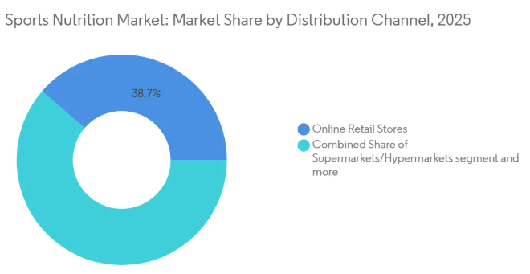
Figure 7: Sports Nutrition Market: Market Share by Distribution Channel
(Source: Mordor Intelligence, 2026)
The distribution is DTC-first, just as it is the case at Gymshark with 100% first-party e-commerce. The products will be sold via gymshark.com and the Gymshark app, with a subsequent expansion to the physical location of the stores of gymshark to Manchester, London, Amsterdam, Dubai, Long Island and its flagship of Manchester, Manhattan. In the second year, selective wholesale growth to UK high-end gyms (PureGym Plus, Third Space) and stand-alone fitness retailers occurs. The digital-first approach was valid as online sports nutrition retail had a 38.68% portion in 2025 with a 10.22% CAGR rate (Mordor Intelligence, 2026). By avoiding Amazon during the first year of operation, brand equity and margin are safeguarded.

3.5 Promotion
Advertisement is a reflection of the community approach to Gymshark. Tiered influencer partnerships on TikTok, Instagram, and YouTube will be used to launch activating the existing 200+ athlete base at Gymshark (KTPL Editor, 2026). There will be free community activity at the Manchester and NYC flagship stores including sampling events and education. Digital campaigns involve a series of content ( Fuel The Progress ) and a launch partnership with a plant nutritional scientist. Instead, paid social will target Meta and Tik Tok, where there is already a substantial global download of the Gymshark Shop Gym Clothes app. PR is interested in Men Health, Women Health, and Runner World as places to gain editorial credibility (whereby examples of fitness enthusiasts are not a strong suit) (Shastri, 2025).

3.6 People
Gymshark Fuel is engaging three pillars of human capital; sports nutritionists and food scientists to manage the product development; brand ambassadors who are recruited based on the existing athlete base of Gymshark; in-store nutrition advisors who are trained to advise on protein requirements and sustainability qualifications (Ekren, 2025). Gymshark has an established support system in the UK that has been used to create customer service. Employee culture also embodies the values of the parent brand: community, ambition, progress that internal onboarding will support with the help of a structured training (Deloitte United Kingdom, 2026). This human factor makes Fuel stand out among faceless humanless supplement competitors who sell their goods mostly via Amazon.

3.7 Process
The acquisition procedure is made to be painless. Customers will have an opportunity to order via the application, online, or in-store and have it delivered within 24 hours in the UK. Customers accessing on a monthly basis get reusable canisters and refill pouches every month on a monthly basis with skip/pause options. The companion app is able to synchronise training, nutrition, and reorder schedules (Kumar and Agrawal, 2024). The working obtainable of returns utilize the identical infrastructure as the Gymshark gear. Each touchpoint should be made to feel like a continuation of the Gymshark shopping experience instead of a supplement purchase.

3.8 Physical Evidence
The premium positioning is anchored by physical evidence. It packages in mono-materials, recyclable pouches, aluminium cans and matte-finish reusable canisters bearing the word mark of Gymshark Fuel. Gymshark flagships will have in-store areas with specific Fuel walls having digital screens and displaying sustainability information and product provenance (Gymshark, 2026b). The Gymshark app has a Fuel tab in which training-related suggestions are made. Packaging of the delivery is made of plant-based inks and is entirely recyclable cardboard. Social content run by the ambassadors, photographs of the event, and endorsements of the athletes give a 24-hour physical evidence of quality and trustworthiness in the community.

3.9 Alignment with the Sustainable Brand Extension Strategy
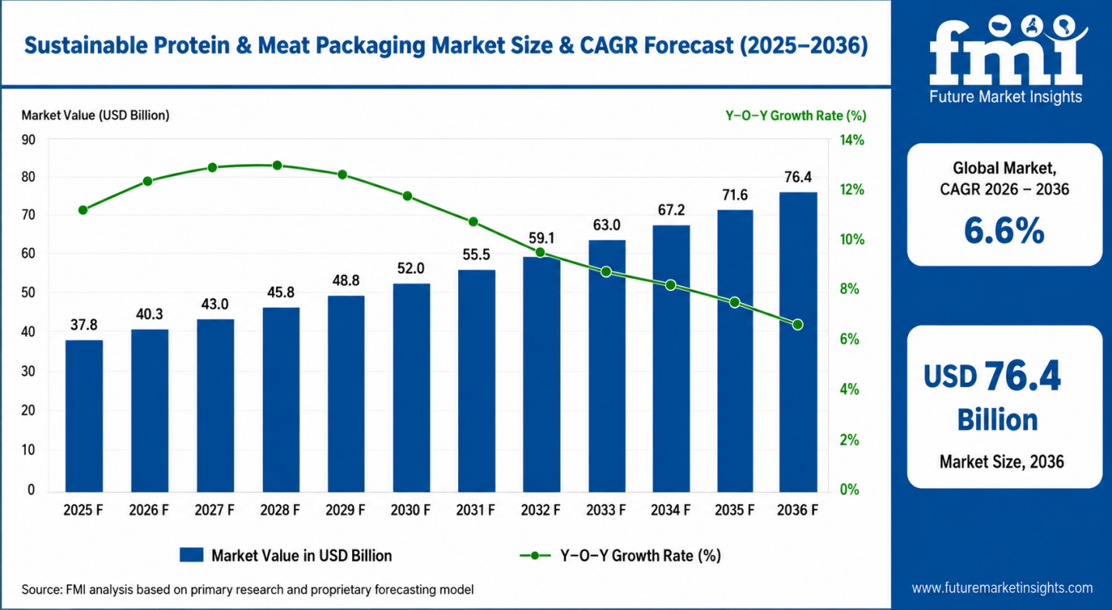
Figure 8: Sustainable Protein & Meat Packaging Market Size and CAGR Forecast (2025–2036)
(Source: Choudhury, 2026)
The 7ps all add to the sustainability brand extension strategy. Plant-based choices and recyclable packaging are incorporated into product design and packaging upfront, which is projected to have 6.6% CAGR in plant-based sports nutrition (Choudhury, 2026). Pricing holds the premium consumers could afford to pay on the aspect of sustainability without causing a split among Gen Z. DTC distribution lowers the intermediary emissions and retains control over sustainability messages. Promotion is an in-built account of sustainability, not a retrospective. People with training convey credentials uniformly, procedures minimizing waste through refills, and tangible evidence mark how sustainability looks at each touchpoint (United Nations, 2025). The combination makes Gymshark Fuel more than a product launch but a consistent sustainability-based extension to further grow the primary business of the £646 million Gymshark Companies as well as create a high-growth adjacent revenue stream.

Element 4: Reflection

4.1 Introduction to the Reflective Process
In this reflection, I have applied Gibbs reflective cycle to reflectively analyze the experience in formulating the Gymshark Fuel marketing strategy. I have been straight with the reflection, and I concentrated on what I have learned, how I have grown, and my areas of weaknesses. I did not only want to know the results of the project but also my own thought process, decision-making, and creative process all at every stage of developing the brand extension (McLeod, 2025).

4.2 Development of the Marketing Strategy
The hardest part of the project to me was formulation of the strategy. My first issue was the difficulty in selecting a brand extension that appeared to be commercially viable and, at the same time, truly sustainable (Fanzo et al., 2023). My original ideas were reviewed a couple of times, until I decided on Gymshark Fuel, as I did not want that to be a shallow line extension, but something that would sit right next to the market. Using both the STDP and 7Ps frameworks challenged me to be more analytical in understanding the segments of consumers and competitors as I tend to be in an academic context (Dally, Obsatar Sinaga and Mohd, 2021).

4.3 Poster Presentation Experience
The experience of designing the poster made me understand that visual communication is a subject on its own. I first attempted to write down everything I had to say but soon I realised how clarity on my part rested in cutting, as opposed to addition. Finding the balance between colour, visuals and readable text in an A4 layout was more difficult than I thought it would be. I acquired the importance of focusing on the most valuable knowledge, each section a message unto itself, and creating based on the attention span of the reader and not my knowledge base expectancies (Assistance Proofed, 2023).

4.4 Key Skills, Knowledge, and Insights Gained
I enhanced my skill to organise a marketing plan based on identified frameworks and translate abstract brand values into viable marketing choices. I also got much better at summarising data on the market swiftly and selecting the only numbers that help to bolster an argument, instead of including everything I discovered (Nwabekee et al., 2024). At its most heartening, I developed a better understanding of how sustainability when incorporated at the strategy level as opposed to it being deductively inserted as a marketing declaration can be a true competitive advantage.

4.5 Contribution to Personal and Professional Development
The project not only honed the skills I know will be valuable in my future career, such as my capacity to construct an argument that is consistent and supported by research but is also professional. I am more confident about working on an approach to a brief that incorporates creativity, analysis, and commercial reasoning (Pantaruk et al., 2025). This also helped me feel braver about defending decisions, as the frameworks provided me with an organized means of defending decisions, as opposed to only using intuition. My discipline was enhanced by having to work within strict word count and design constraints.

4.6 Areas for Future Improvement
In retrospect, I would dedicate more time on primary research in case I were to repeat the project since my analysis was more of secondary data. I would also work on my time management, as I did not estimate as long the poster design phase would be (Ika and Pinto, 2022). When working in the future, I would like to improve my financial modelling planning because I will be able to measure the business case of a brand expansion in a more stringent and rigorous way, as well as the strategic argument.

Reference List
Assistance Proofed (2023) Editing for concision, Proofed. Available at: https://proofed.com/knowledge-hub/editing-for-concision/
Bottomley, T. (2026) Gymshark reports record year of sales for FY25 - TheIndustry.Fashion, TheIndustry.fashion. Available at: https://www.theindustry.fashion/gymshark-reports-record-year-of-sales-growth-for-fy25/
Choudhury, N.R. (2026) Sustainable protein & meat packaging market, Future Market Insights. Available at: https://www.futuremarketinsights.com/reports/sustainable-protein-and-meat-packaging-market
Dally, D., Obsatar Sinaga and Mohd (2021) “The impact of 7p’s of marketing on the performance of the higher education institutions,” ResearchGate, pp. 235–252. Available at: https://doi.org/10.48047/rigeo.11.3.26.
Deloitte United Kingdom (2026) Strengthening Gymshark’s data-led growth strategy, Deloitte United Kingdom. Available at: https://www.deloitte.com/uk/en/Industries/consumer/case-studies/strengthening-gymsharks-data-led-growth-strategy.html
Ekren, C. (2025) Gymshark marketing strategy: Million-dollar community campaigns & DTC model, Digital Agency Network. Available at: https://digitalagencynetwork.com/gymshark-marketing-strategy/
Faithfull, M. (2025) “Gymshark and Dick’s look to each other’s virtues in store partnership,” Forbes, 23 October. Available at: https://www.forbes.com/sites/markfaithfull/2025/10/23/gymshark-and-dicks-look-to-each-others-virtues-in-store-partnership/
Fanzo, J., McLaren, R., Bellows, A. and Carducci, B. (2023) “Challenges and opportunities for increasing the effectiveness of food reformulation and fortification to improve dietary and nutrition outcomes,” Food Policy, 119(1), p. 102515. Available at: https://doi.org/10.1016/j.foodpol.2023.102515.
Fortune Business Insights (2025) RTD protein beverages market size, industry share, forecast, 2032, Fortunebusinessinsights.com. Available at: https://www.fortunebusinessinsights.com/rtd-protein-beverages-market-103179
Grand View Research (2026a) Protein supplements market size, share | industry trends report, 2025, Grandviewresearch.com. Available at: https://www.grandviewresearch.com/industry-analysis/protein-supplements-market
Grand View Research (2026b) Ready to drink shakes market size, share | industry report, 2019-2025, www.grandviewresearch.com. Available at: https://www.grandviewresearch.com/industry-analysis/ready-to-drink-rtd-shakes-market
Gymshark (2026a) Gymshark’s approach to sustainability, Gymshark.com. Gymshark Support. Available at: https://support.gymshark.com/en/articles/11215040-gymshark-s-approach-to-sustainability
Gymshark (2026b) Gymshark’s approach to sustainability, Gymshark.com. Gymshark Support. Available at: https://support.gymshark.com/en/articles/11215040-gymshark-s-approach-to-sustainability
Ika, L.A. and Pinto, J.K. (2022) “The ‘re-meaning’ of project success: Updating and recalibrating for a modern project management,” International Journal of Project Management, 40(7), pp. 835–848. Available at: https://doi.org/https://doi.org/10.1016/j.ijproman.2022.08.001.
KTPL Editor (2026) Gymshark’s influencer-first strategy explained, KTPL Blog – Branding & Marketing Ideas. Available at: https://blog.kirnanitechnologies.com/gymsharks-influencer-first-strategy-that-built-a-global-fitness-brand/
Kumar, S. and Agrawal, R. (2024) “Developing customer convenience and experience through increased competency and efficiency: A strategic approach to retail operations mastery,” Heliyon, 10(16). Available at: https://doi.org/10.1016/j.heliyon.2024.e36395.
McLeod, S. (2025) Gibbs reflective cycle, Simply Psychology. Available at: https://www.simplypsychology.org/gibbs-reflective-cycle.html
Mordor Intelligence (2026) Sports Nutrition Market Size and Share, Mordorintelligence.com. Available at: https://www.mordorintelligence.com/industry-reports/sports-nutrition-market
Nwabekee, S., Abdul-Azeez, O.Y., Ebele, E. and Ignatius, T. (2024) “Digital transformation in marketing strategies: The role of data analytics and CRM tools,” International Journal of Frontline Research in Science and Technology, 3(2), pp. 055–072. Available at: https://doi.org/10.56355/ijfrst.2024.3.2.0047.
Owen (2025) What age group does gymshark target? Demographic guide, Fukigymwear. Available at: https://fukigymwear.com/what-age-group-does-gymshark-target/
Pantaruk, S., Khuadthong, B., Imjai, N. and Aujirapongpan, S. (2025) “Fostering future-ready professionals: The impact of soft skills and internships on hospitality employability in Thailand,” Social Sciences & Humanities Open, 11, p. 101371. Available at: https://doi.org/10.1016/j.ssaho.2025.101371.
Precedence Research (2025) Plant-based protein supplements market size to hit USD 6.48 bn By 2034, Precedenceresearch.com. Precedence Research . Available at: https://www.precedenceresearch.com/plant-based-protein-supplements-market
Shastri, A. (2025) Marketing strategy of gymshark - A case study | IIDE, The Digital School. Available at: https://iide.co/case-studies/marketing-strategy-of-gymshark/
Stratview Research (2026) Sports Nutrition Market Analysis| 2026-2034, stratviewresearch.com. Stratview Research. Available at: https://www.stratviewresearch.com/market-reports/sports-nutrition-market
United Nations (2025) “Sustainability,” United Nations. Available at: https://www.un.org/en/academic-impact/sustainability
Zwayyed, Z. (2025) A case study in digital innovation and community building gymshark’s marketing strategy: A case study in digital innovation and community building, ResearchGate. Available at: https://doi.org/10.13140/RG.2.2.29758.80962.

