

Business Information Systems
  - Data Warehouse & data governance
Ben Green | P124549 | Nik Whitehead
Contents
Table of Figures 1
1. Introduction 1
2. Part One 1
2.1. Design and build a Datawarehouse prototype 1
2.2. Reports 1
2.2.1. Top five expense types by quarter and January, February, March 1
2.2.2. Top five expense areas and total amount spent on each by final quarter overall and by January, February and March 1
2.2.3. Five suppliers who received the most money from each department and the totals 1
2.3. Creation and use of Datawarehouse 1
2.3.1. Source of Data 1
2.3.2. Design Decision 1
2.3.3. ETL Process 1
2.3.4. Schema 1
1
2.3.5. Reports 1
2.3.6. Dashboard 1
3. Part Two 1
3.1. Data Governance 1
3.1.1. Policy, standards and strategy 1
3.1.2. Data Quality 1
3.1.3. Privacy, compliance and security 1
3.1.4. Data architecture and data integration 1
4. References 1
5. Appendix 1
5.1. ETL Document 1

Table of Figures
Figure 1 - Datawarehouse prototype 1
Figure 2 - Datawarehouse prototype, SQL Code linking Fact tables to dimensions 1
Figure 3 - Top 5 expenses types and the amount spent on them for the final quarter 1
Figure 4 - Top five expense types and the total amount spent on each type for January 1
Figure 5 - Top five expense types and the total amount spent on each type for February 1
Figure 6 - Top five expense types and total amount spent on each type for March 1
Figure 7 - Top five expense areas and total amount spent on each in the final quarter 1
Figure 8 -Top five expense areas and total amount spent on each for January 1
Figure 9 - Top five expense areas and total amount spent on each for February 1
Figure 10 - Top five expense areas and total amount spent on each for March 1
Figure 11 - Suppliers who received the most money from each department and the totals received for the last quarter overall 1
Figure 12 - Suppliers who received the most money from each department and the totals received for January. 1
Figure 13 - - Suppliers who received the most money from each department and the totals received for February. 1
Figure 14 - Suppliers who received the most money from each department and the totals received for March. 1
Figure 15 - DECC Finance manager dashboard 1
Figure 16 - SQL Update Query 1
Figure 17 - ETL Process, cleaning data by deleting duplicates 1
Figure 18 - ETL Process, cleaning the data by removing the comma and changing to a number 1
Figure 19 - Data Warehouse Schema Diagram 1
Figure 20 - Dashboard for DECC 1
Figure 21 - The Virtuous Cycle of Data Quality Management 1
Figure 22 - Poor quality data DECC example 1

Introduction
The purpose of this report is to create a prototype data warehouse using the data on Spend over £500 in the UK Department of Energy & Climate Change (DECC) for the final quarter of the financial year 2012-2013, months January, February and March. Techopedia define a data warehouse as “a collection of corporate information and data derived from operational systems and external data sources.”(1) Stating, they’re designed for business analytical decisions and reporting.
The first part of this document will show the schema produced with the schema diagram for the data warehouse. Provide a description of the ETL process with an ETL plan included in the appendix. An ETL is an important part in the creation of a Datawarehouse, ETL stands for Extract, Transform and Load.(2)The ETL process involves “blending” information together from multiple sources.(3) Data is extracted from a source, transformed into the right format and then loaded into a data warehouse. (4)
This report will also contain the suitable reports generated from the data warehouse and lastly a design of a dashboard, which will be inline with the needs of the DECC finance managers.
The second part of this document will include an executive summary identifying the data governance challenges that would be faced by the DECC with suggestion on how to tackle these challenges. This section will cover a range of topics including policy, standards and strategy, data quality, privacy, compliance and security and lastly data architecture and data integration.

Part One
This section will provide screenshots of the Datawarehouse created, the reports required, and the dashboard created. It will then follow with a description of how the Datawarehouse was created.

Design and build a Datawarehouse prototype
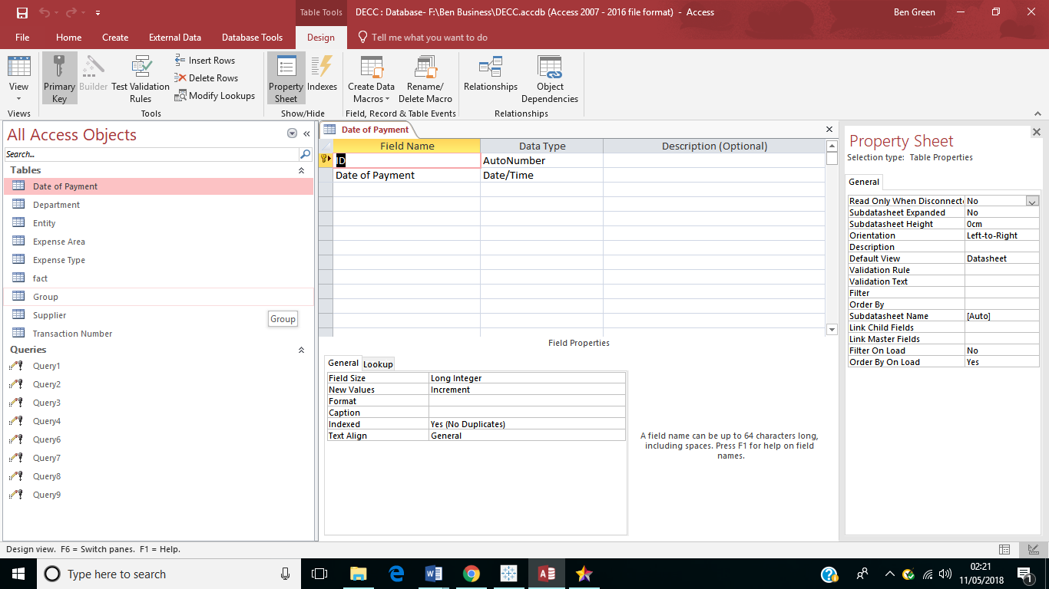
Figure 1 - Datawarehouse prototype

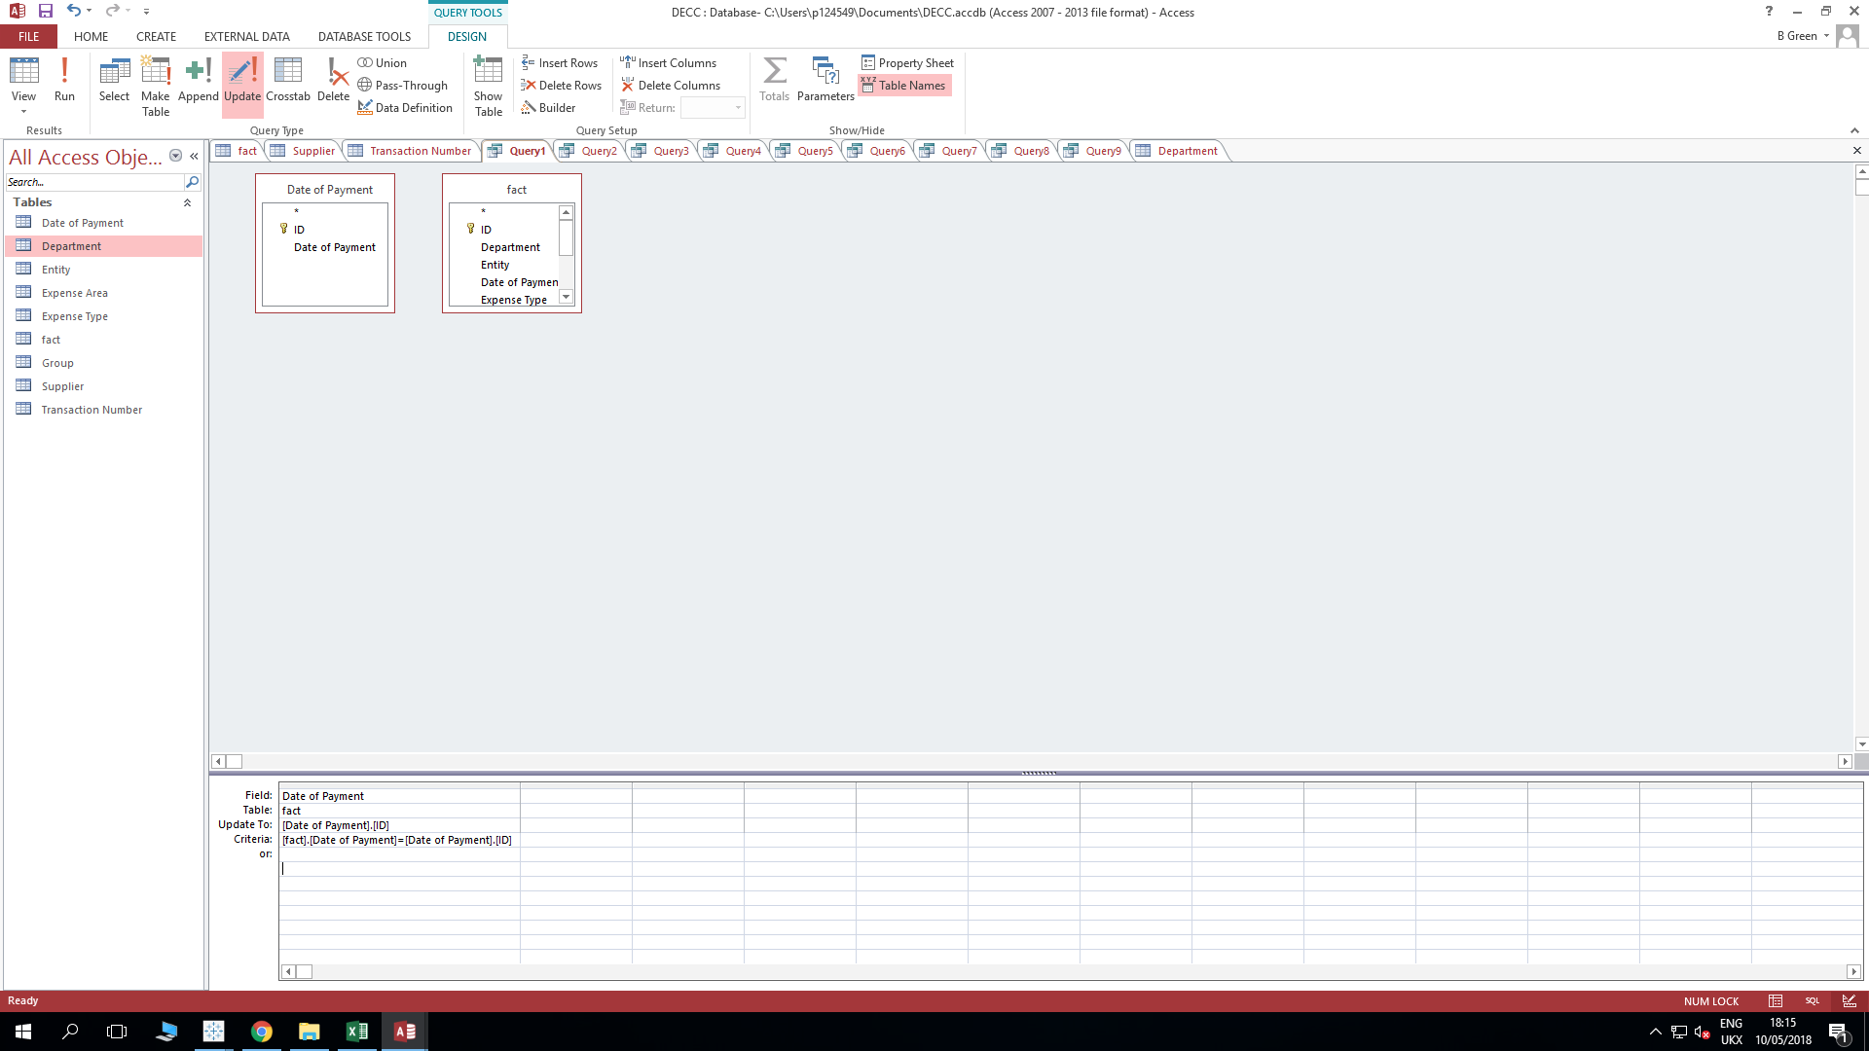
Figure 2 - Datawarehouse prototype, SQL Code linking Fact tables to dimensions

Reports

Top five expense types by quarter and January, February, March

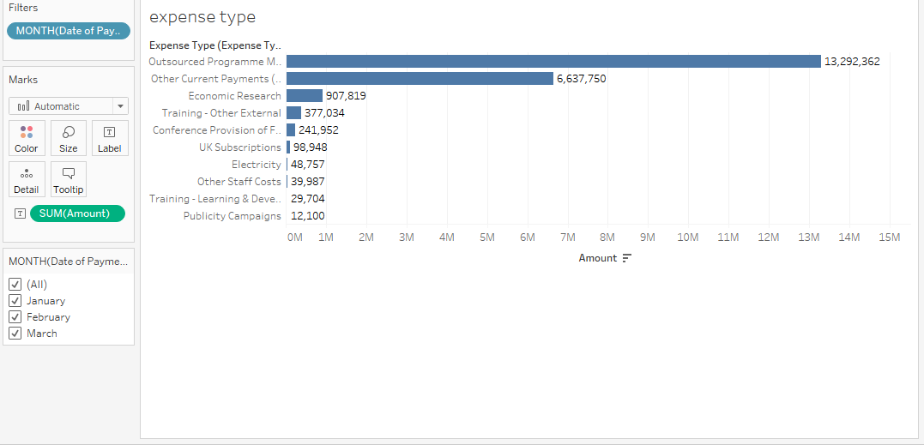
Figure 3 - Top 5 expenses types and the amount spent on them for the final quarter

The above figure shows the top five expense types for the DECC and the total amount spent on all expense types.
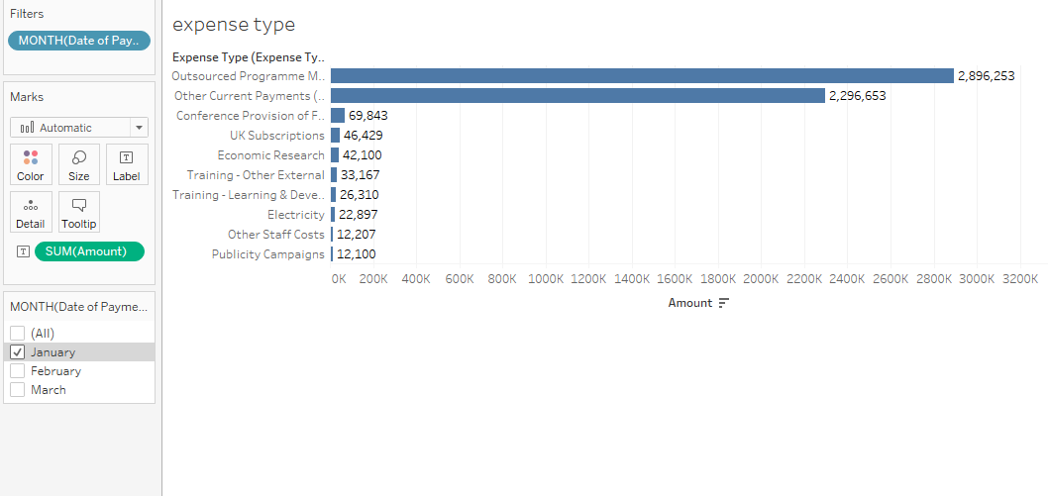
Figure 4 - Top five expense types and the total amount spent on each type for January
The above figure shows the top five expense types for the DECC and the total amount spent on each type for January.
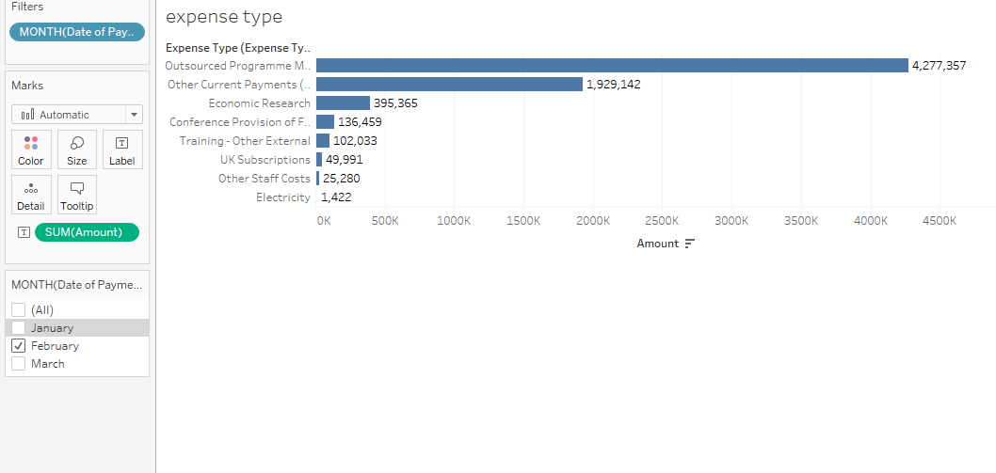
Figure 5 - Top five expense types and the total amount spent on each type for February
The above figure shows the top five expense types for the DECC and the total amount spent on each type for February.
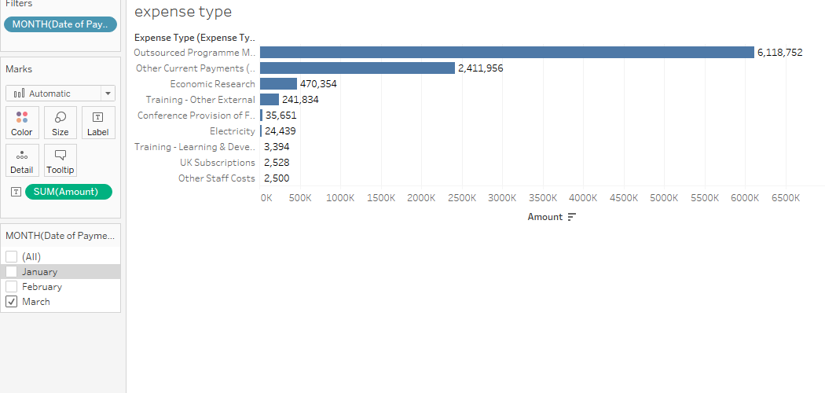
Figure 6 - Top five expense types and total amount spent on each type for March
The above figure shows the top five expense types for the DECC and the total amount spent on each type for March.

Top five expense areas and total amount spent on each by final quarter overall and by January, February and March
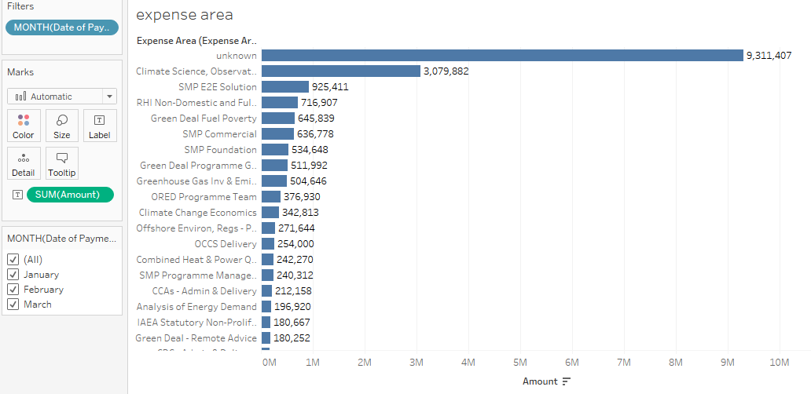
Figure 7 - Top five expense areas and total amount spent on each in the final quarter
The above figure shows the top five expense areas and total amount spent on each in the final quarter.

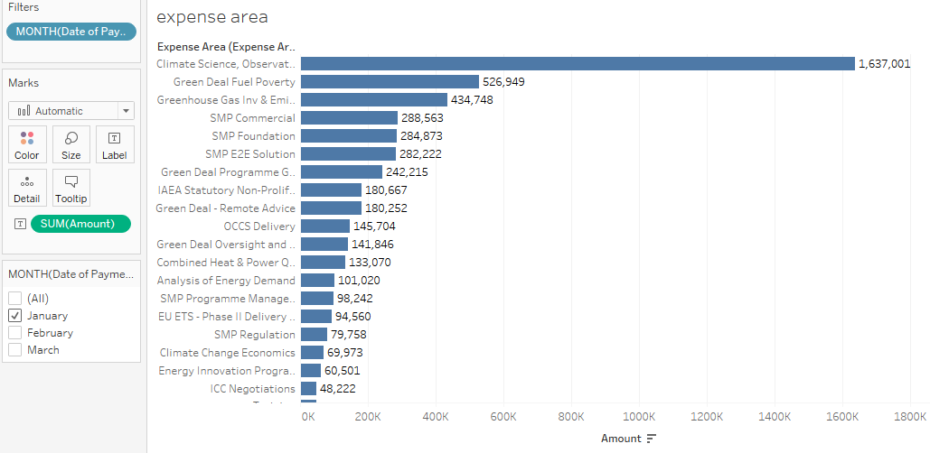
Figure 8 -Top five expense areas and total amount spent on each for January
The above figure shows the top five expense areas and total amount spent on each for January.
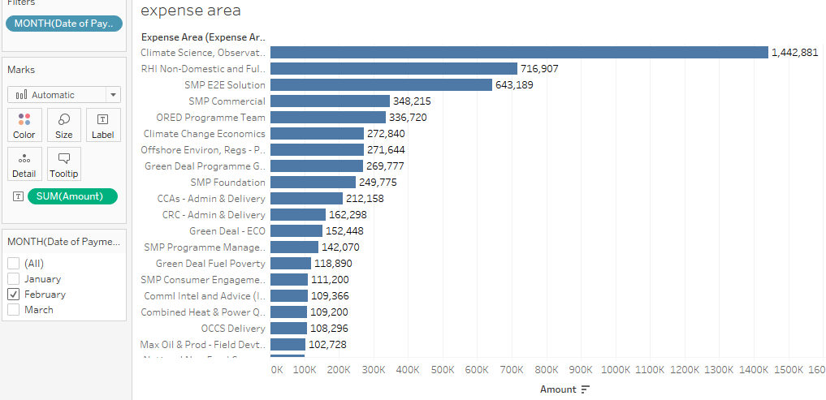
Figure 9 - Top five expense areas and total amount spent on each for February
The above figure shows the top five expense areas and total amount spent on each for February.
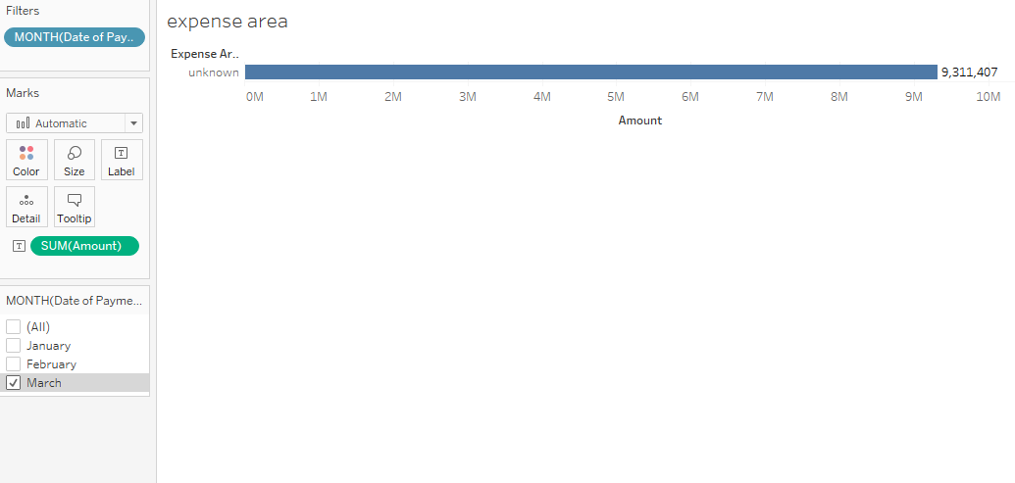
Figure 10 - Top five expense areas and total amount spent on each for March
The above figure shows the top expense area and total amount spent on it for the month of March.

Five suppliers who received the most money from each department and the totals
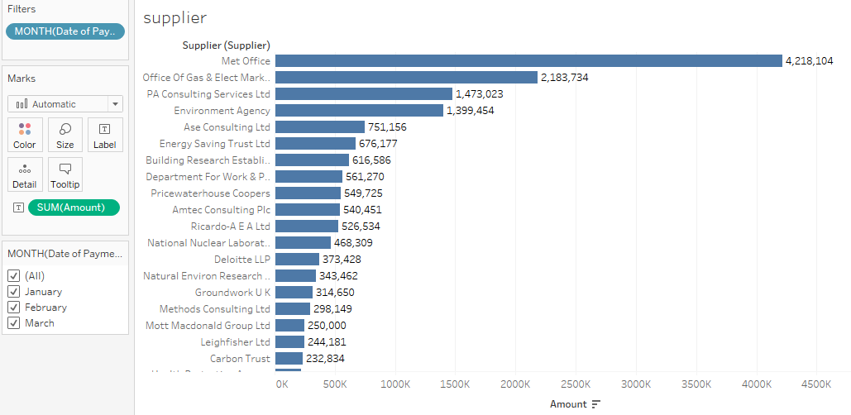
Figure 11 - Suppliers who received the most money from each department and the totals received for the last quarter overall
The above figure shows the suppliers who received the most money from each department and the total amount the received for the final quarter.
.
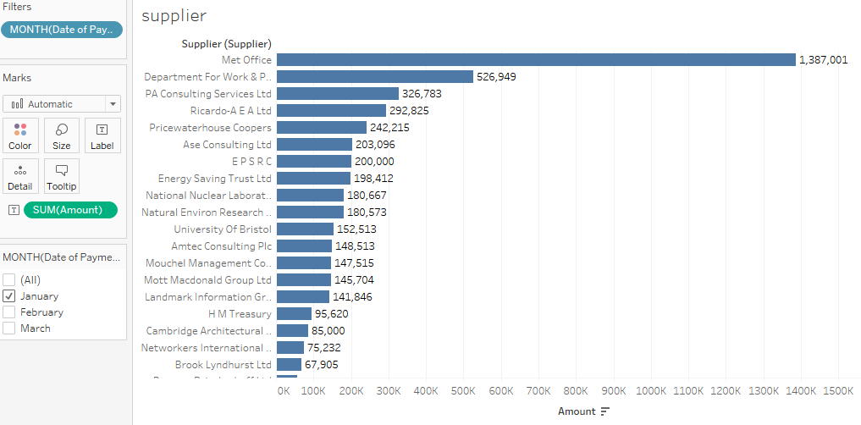
Figure 12 - Suppliers who received the most money from each department and the totals received for January.
The above figure shows the suppliers who received the most money from each department and the totals they received for the month of January.
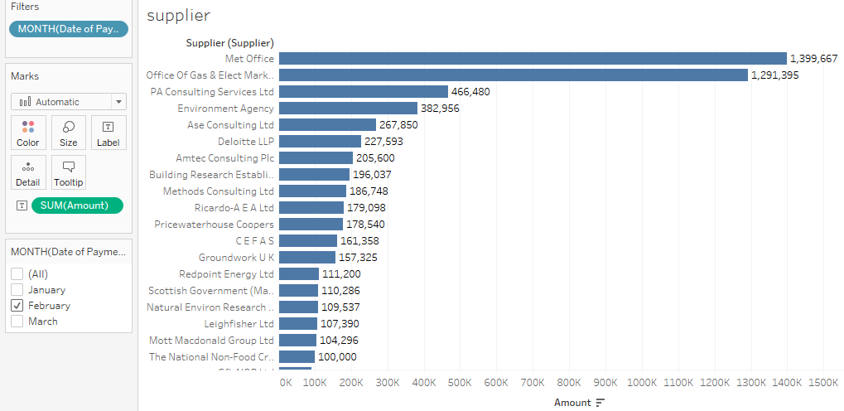
Figure 13 - - Suppliers who received the most money from each department and the totals received for February.
c
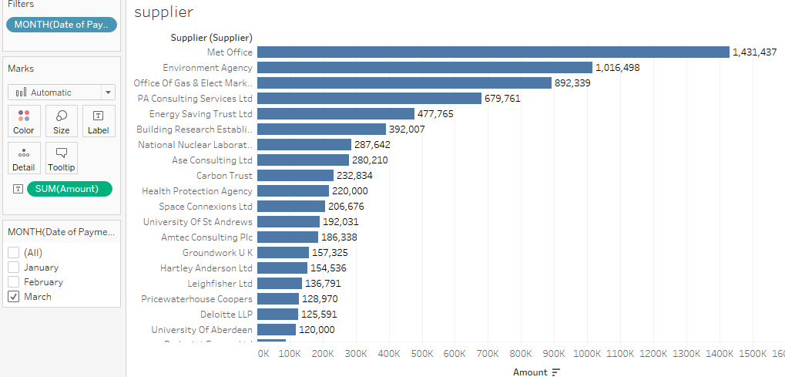
Figure 14 - Suppliers who received the most money from each department and the totals received for March.
Suppliers who received the most money from each department and the totals received for March.

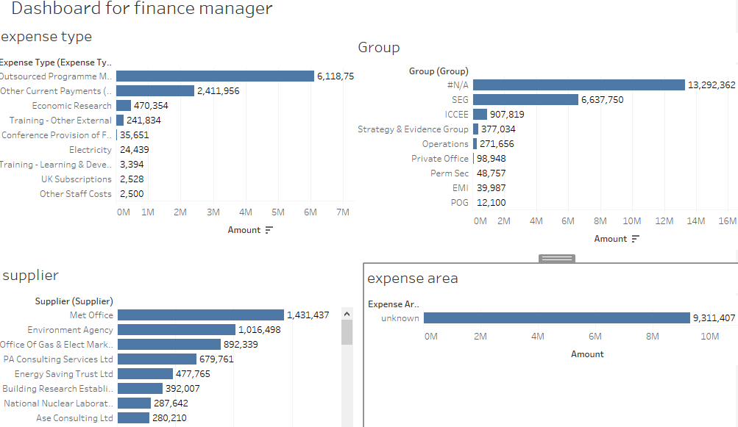
Figure 15 - DECC Finance manager dashboard

Creation and use of Datawarehouse

Source of Data
The data used for the creation of the Datawarehouse is spend over £500 in the UK Department of Energy and Climate Change (DECC) for the final quarter of the financial year of 2012-2013, months January, February and March 2013.
The data is stored in excel spreadsheet format, put through an ETL process (extract, transform and load.) The data is relational data, arranged in cells in an excel spreadsheet with each column heading contributing to a table in the data warehouse. The data contain characters, dates and integers. The file contains data fields such as Dates of purchases, the area of the expense, suppliers, type of expense, groups, transaction details, department details and amount spent.

Design Decision
An ETL document has been produced (see appendix), first designed on paper then created on a computer. It is a mapping document which contains the source, target and rules for unknown entries information. It is important in the design and development ETL process. Ideally, the mapping document would be reviewed by the end user to test(5), but the Datawarehouse has been created for the purpose of the report, with no end user.
Queries were created to change the ID numbers in the fact table, making the Datawarehouse more efficient. Also, it was important to change the ‘Date’ data type from short text to number to match the fact table, this is because the aim of creating a query is to create a relationship between the fact and dimension tables, making the process easier. One example is shown below, however, there is SQL queries for each dimension.
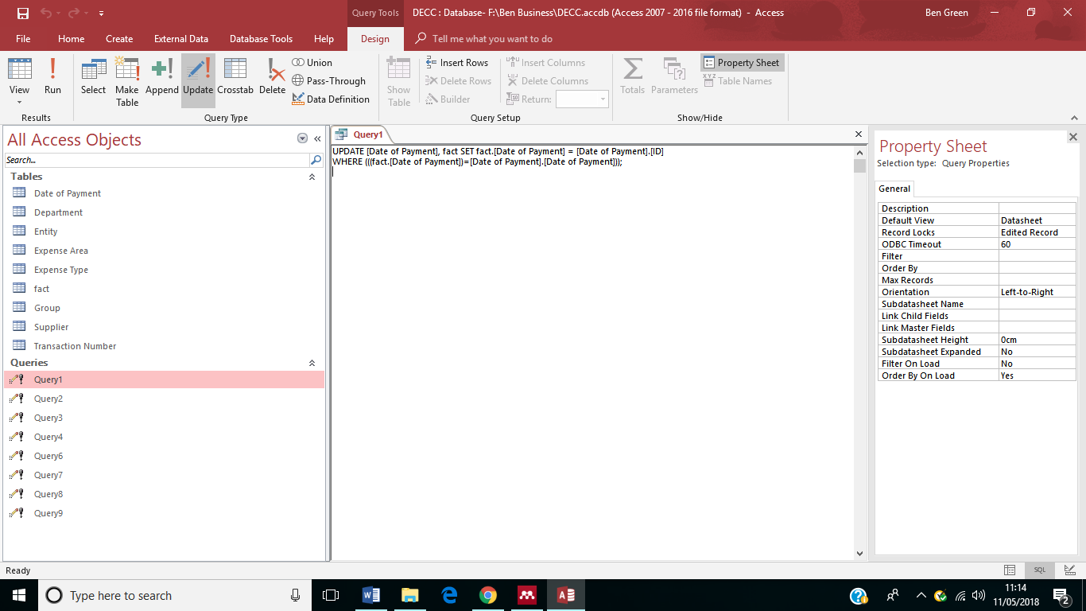
Figure 16 - SQL Update Query
The above figure shows an SQL Update Query, this query has been used to change the ID numbers in the fact table.

ETL Process
The ETL process for this Datawarehouse involved downloading three excel spreadsheets which holds data on spend over £500 for the DECC. The first part of the ETL process is to transfer all data into one work sheet, creating a fact table. The second part is to take each column of data and copy them to a new sheet creating the dimensions for the Datawarehouse. The next step is to clean the data, this involved deleting duplicate entries, filling in blanks where necessary and removing the comma from the ‘Amount’ fields and changing the field to a number.
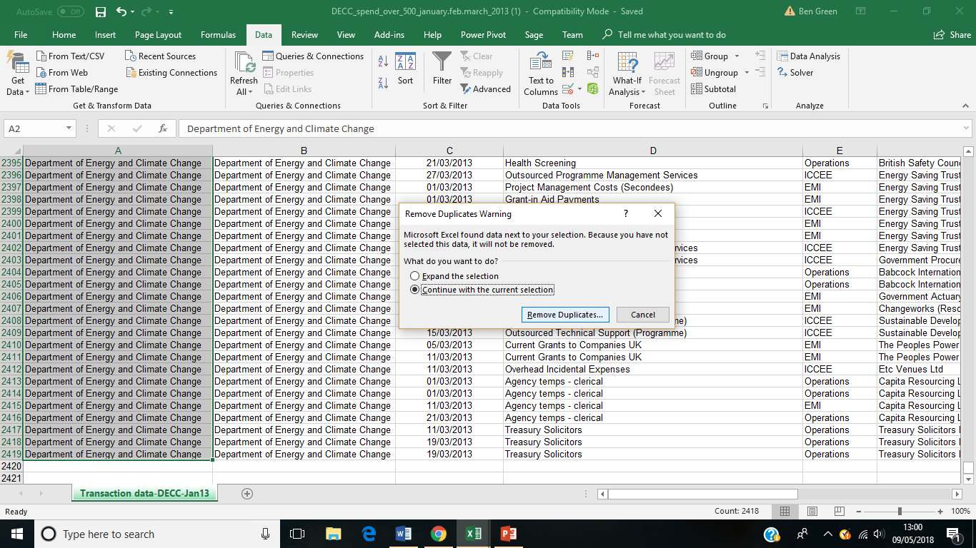
Figure 17 - ETL Process, cleaning data by deleting duplicates
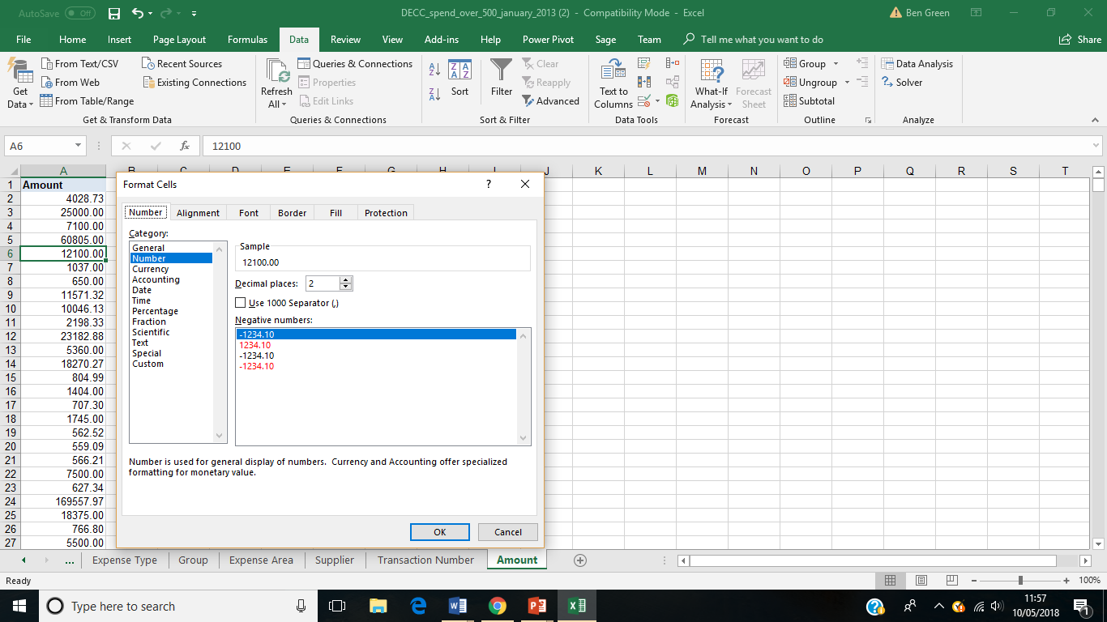
Figure 18 - ETL Process, cleaning the data by removing the comma and changing to a number

ETL Problems
A couple of problems were faced when going through the ETL process. Transferring large amounts of data was a problem, some data was transferred to the wrong columns. Along side this there as also missing data, which in line with the ETL document would be replaced with a ‘1’, ‘0’ or ‘unknown’ depending on the table.
On completion of the ETL document, the next step in the process is to design a schema. A database schema is a visual representation of a database, it represents the logical configuration of the Datawarehouse. (6) The Datawarehouse schema for this report was design in Star UML, it is a software modelling tool,(7) although it has many powerful features, it is very easy to use, hence why it was chosen for the schema.

Schema

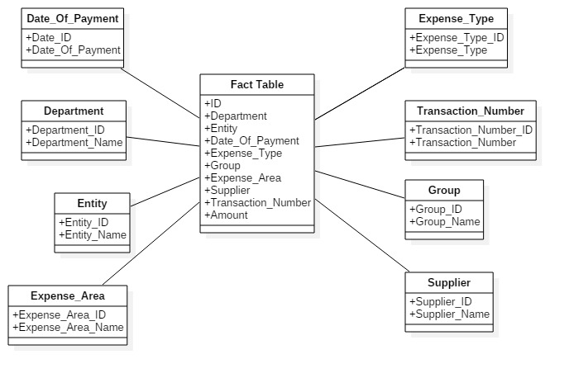
Figure 19 - Data Warehouse Schema Diagram
The above figure shows the schema produced for the DECC Datawarehouse. It shows a fact table linked to each of the eight-dimension tables.

Reports
The reports were generated using Tableau. Tableau is business intelligence software that focusses on data visualization. (8) See the above figures 3-14 for results from the analysis.

Dashboard
A business intelligence dashboard is a data visualization tool that displays “the current status of metrics and key performance indicators for an enterprise. (9) Essential features of a dashboard should have the ability to be able to pull real time data from multiple sources and be customizable.(10)
Figure 20 - Dashboard for DECC
The above figure shows the dashboard created for the DECC financial managers. The information displayed has been chosen because it is relevant to their finances, the finance manager only needs to see information relating to finances.
Reflecting on the dashboard design, if it were designed and completed with more time and consideration, more attention would be paid to the use of color. The same color makes it difficult to distinguish between information over using a red that draws the eye of the end user to potential problems or a green for showing positive trends. As well as better visualizations to show the data, could use GIS or dials, something easier on the eye.

Part Two
Part two of this report covers the data governance challenges faced by the DECC in maintaining all their financial records including suggestions on how to overcome/deal with these challenges. This section will cover data governance issues such as policy, standards and strategy, data quality, privacy, compliance and security, data architecture and data integration.

Data Governance
Data governance (DG) is the management of the availability, usability, integrity and security of data used in enterprise. (11)Data governance may involve a governing body, defined sets of rules and a plan to execute these rules. (12) Many organizations profit from data governance because it ensures data is consistent and trustworthy.(11)
The first step in incorporating data governance in an organization is to nominate or hire a data stewardship, the role of a data stewardship is to ‘take ownership of the data’ and define the objectives to maintain overall data control. (13) Once a data stewardship has been assigned the next step must be to outline how data will be stored, archived, backed up and protected. (11) Followed by the setting of standards and procedures defining how the data is to be used by personnel with access to the data as well as controls and audits to measure compliance.

Policy, standards and strategy
As stated above Data governance policy is the documented set of guidelines to ensure proper data management. Focusing on policy, standards and strategy is usually the first step in an organizations data governance efforts. (14) This part usually contains four main activities, these include:
- Identification of stakeholders
- Creation of a review approve monitor policy
- Monitor standards
- Establish enterprise data strategies (14)
So, for the DECC to create a successful policy, standards and strategy for data governance they would need to start from the bottom. Ensure their policies are well taught and well known by integrating them in the overall aims and objectives of the organization and training the workforce. Also educating the DECC employees about data governance would be helpful. As well as establishing good business processes, ensuring they build solid foundations for data capturing and modelling – regular checks in the form of audits to keep these files updated and relevant.

Data Quality
Data quality refers to the accuracy, completeness, relevance, update status, consistency, reliability, accessibility and presentation of data. (15) Good data quality practices can improve an organizations data asset, helping achieve business objectives.

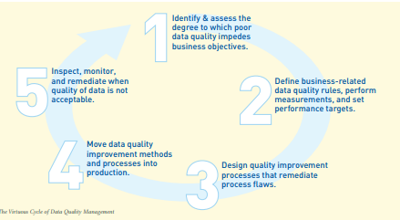(16)
Figure 21 - The Virtuous Cycle of Data Quality Management
The above figure shows the virtuous cycle of data quality management which can be applied at the DECC. It aims to express a transition from being reactive to data failures to being proactive using preventative measures. (16)
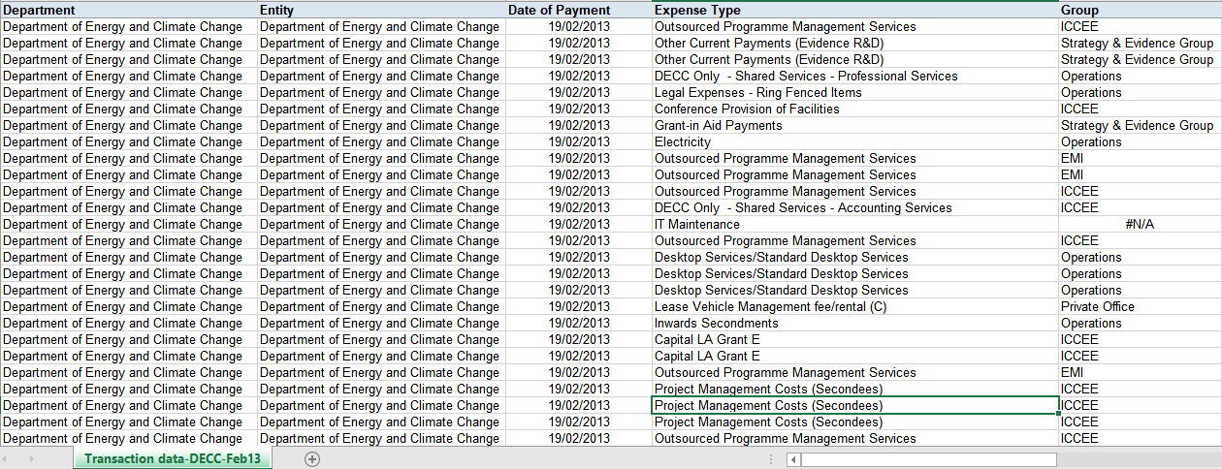
Figure 22 - Poor quality data DECC example
The above figure shows the data collected by the DECC for the month of February, showing some examples of poor quality data. For example, the many records that are duplicate and the filed with N/A. The following five bullet points are following the Virtuous Cycle of Data Management to help improve the DECC’s data quality.
- Identify & assess – The DECC can work hard to make employees aware the implications of how poor data quality affect business objectives.
- Define – The DECC should define a set of rules and measurements to be followed that can feed into management reporting. For example, defining rules for the prevention of duplicate data.
- Design quality improvement – DECC could integrate data quality into the application infrastructure.
- Move data quality – DECC could implement data stewardship procedures to manage and identify data quality rules
- Inspect, monitor and remediate – DECC could use data quality incident management tools
These five processes lay the foundations for good data quality management. Poor quality data can cost organizations money, things such as human error for example when entering an address in a form. It is imperative for companies to have accurate data to assist marketing, sales and customer service departments are accurately as possible.(18)

Privacy, compliance and security
The main objectives of Data Governance for Privacy, Confidentiality and Security are to protect the organizations data from both internal and external threats, to ensure the organization is abiding by the relevant laws and standards and to ensure the organization is proving they are compliant by producing the relevant documents. (20)
To help with privacy, compliance and security issues the DECC should limit who has access to the business data. Whilst limiting access, employees who do have access should only be allowed access with the right username and password.
The DECC should also process all their data in line with the policies laid out when first incorporating data governance as well in line with the applicable laws surrounding their industry and the capture of data. The DECC should also provide their customers notice that they are collecting their data with full disclosure on what they plan to do with any data collected.
Having the correct measure in place if there is a threat or breach from an external source, with relevant raining provided to all employees who encounter the sensitive information, as well as documenting everything.

Data architecture and data integration
Data architecture is sets of rules, policies standards and models that govern and define the type of data collected and how it is used, stored, managed and integrated within an organizations database systems.(17) Whilst data integration is about using technical and business procedures to combine data from different sources, making them useful. (19) Data architecture and Data Governance work together to increase operational efficiency. (21) Data architecture gives an understanding of what data is where and how it moves through the organizations systems. It flags changes and transformations made as data moves. (21)
The DECC could educate their employees on the data flow and data inventory diagrams, these types of diagrams help highlight business implications of improving data quality by showcasing who uses the system and for what reason.

References
1. What is a Data Warehouse (DW)? - Definition from Techopedia. [online]. [Accessed 11 May 2018]. Available from: https://www.techopedia.com/definition/1184/data-warehouse-dw
2. ETL. [online]. [Accessed 11 May 2018]. Available from: http://datawarehouse4u.info/ETL-process.html
3. Extract, transform, and load (ETL) | Microsoft Docs. [online]. [Accessed 11 May 2018]. Available from: https://docs.microsoft.com/en-us/azure/architecture/data-guide/relational-data/etl
4. WANG, Tieniu, HU, Jianhua and ZHOU, Haihe. Design and Implementation of an ETL Approach in Business Intelligence Project. In : [online]. Springer, Berlin, Heidelberg, 2011. p. 281–286. [Accessed 11 May 2018]. Available from: http://link.springer.com/10.1007/978-3-642-25658-5_35
5. What is ETL Mapping Document ?A Real Time Example « Big Data - DW &amp; BI. [online]. [Accessed 11 May 2018]. Available from: http://dwbitips.blogspot.co.uk/2012/12/what-is-etl-mapping-document-real-time.html
6. What is a Database Schema | Lucidchart. [online]. [Accessed 11 May 2018]. Available from: https://www.lucidchart.com/pages/database-diagram/database-schema
7. StarUML - Open Source UML Tool. [online]. [Accessed 11 May 2018]. Available from: http://www.methodsandtools.com/tools/staruml.php
8. What is Tableau ? |Tableau Community. [online]. [Accessed 11 May 2018]. Available from: https://community.tableau.com/thread/238491
9. What is business intelligence dashboard? - Definition from WhatIs.com. [online]. [Accessed 11 May 2018]. Available from: https://searchbusinessanalytics.techtarget.com/definition/business-intelligence-dashboard
10. Data Warehousing: Dashboards and Scorecards - dummies. [online]. [Accessed 11 May 2018]. Available from: http://www.dummies.com/programming/big-data/engineering/data-warehousing-dashboards-and-scorecards/
11. What is data governance (DG)? - Definition from WhatIs.com. [online]. [Accessed 11 May 2018]. Available from: https://searchdatamanagement.techtarget.com/definition/data-governance
12. Defining Data Governance - The Data Governance Institute. [online]. [Accessed 11 May 2018]. Available from: http://www.datagovernance.com/defining-data-governance/
13. What is a Data Steward? | Experian. [online]. [Accessed 11 May 2018]. Available from: https://www.edq.com/uk/glossary/data-steward/
14. SUN, Helen and CORPORATION, Oracle. Enterprise Information Management: Best Practices in Data Governance. [online]. [Accessed 11 May 2018]. Available from: http://egovstandards.gov.in/sites/default/files/oea-best-practices-data-gov-400760.pdf
15. What is data quality? - Definition from WhatIs.com. [online]. [Accessed 11 May 2018]. Available from: https://searchdatamanagement.techtarget.com/definition/data-quality
16. LOSHIN, David. Five Fundamental Data Quality Practices DATA QUALITY &amp; DATA INTEGRATION THIS CYCLE TURNS ON THE EXECUTION OF FIVE FUNDAMENTAL DATA QUALITY MANAGEMENT PRACTICES, WHICH ARE ULTIMATELY IMPLEMENTED USING A COMBINATION OF CORE DATA SERVICES. THOSE PRACTICE. [online]. Available from: http://www.pbinsight.com/files/resource-library/resource-files/five_fundamental_data_quality_practices_WP.pdf
17. What is Data Architecture? - Definition from Techopedia. [online]. [Accessed 11 May 2018]. Available from: https://www.techopedia.com/definition/6730/data-architecture
18. The consequences of poor data quality for a business | Experian. [online]. [Accessed 11 May 2018]. Available from: https://www.edq.com/blog/the-consequences-of-poor-data-quality-for-a-business/
19. Data Integration | IBM Analytics. [online]. [Accessed 11 May 2018]. Available from: https://www.ibm.com/analytics/data-integration
20. SALIDO, Javier and VOON, Patrick. A Guide to Data Governance for Privacy, Confidentiality, and Compliance Part 1: The Case for Data Governance. [online]. 2010. [Accessed 11 May 2018]. Available from: https://iapp.org/media/pdf/knowledge_center/Guide_to_Data_Governance_Part1_The_Case_for_Data_Governance_whitepaper.pdfThe information contained in this document represents the current view of Microsoft Corp. on the issues discussed as of the date of publication. Because Microsoft must respond to changing market conditions, it should not be interpreted to be a commitment on the part of Microsoft, and Microsoft cannot guarantee the accuracy of any information presented after the date of publication.
21. What Is the Relationship between Data Architecture and Data Governance? - Blog: Kelle O’Neal - BeyeNETWORK. [online]. [Accessed 11 May 2018]. Available from: http://www.b-eye-network.com/blogs/oneal/archives/2014/03/what_is_the_rel.php

Appendix

ETL Document
ETL Plan – UK Department of Energy and Climate Change (DECC) Analyst(s): Ben Green
Database to data warehouse table mapping:
DATABASE TABLES | DATA WAREHOUSE TABLE
Spreadsheet | Entity
Spreadsheet | Expense Area
Spreadsheet | Dates
Spreadsheet | Fact
Spreadsheet | Suppliers
Spreadsheet | Expense Type
Spreadsheet | Group
Spreadsheet | Transaction

Database to data warehouse attribute mapping
Fact Table
TARGET ATTRIBUTE | SOURCE(S) | PROCESSING REQUIRED | MISSING VALUE? | INCORRECT VALUE?
Fact_ID | PK | Automatically generated
Entity_ID | Spreadsheet Entity | Linked to entity dimension PK | 1(=unknown)
Expense_Area_ID | Spreadsheet Expense Area | Linked to expense area dimension PK | 1(=unknown)
Date_ID | Spreadsheet date | Linked to Date dimension PK | 1(=unknown)
Supplier_ID | Spreadsheet supplier | Linked to supplier dimension PK | 1(=unknown)
Expense_Type_ID | Spreadsheet expense type | Linked to expense type dimension PK | 1(=unknown)
Group_ID | Spreadsheet group | Linked to group dimension PK | 1(=unknown)
Transaction_Number | Spreadsheet Transaction | Linked to Transaction PK | 1(=unknown)
Amount | Spreadsheet Amount | Linked to amount PK | 0(=unknown)

Entity
TARGET ATTRIBUTE | SOURCE(S) | PROCESSING REQUIRED | MISSING VALUE? | INCORRECT VALUE?
Entity_ID | PK | Automatically Generated
Entity_Name | Spreadsheet Entity | None | “Unknown”

Expense Area
TARGET ATTRIBUTE | SOURCE(S) | PROCESSING REQUIRED | MISSING VALUE? | INCORRECT VALUE?
Eexpense_Area_ID | PK | Automatically Generated
Expense_Area_Name | Spreadsheet Entity | None | “Unknown”

Date
TARGET ATTRIBUTE | SOURCE(S) | PROCESSING REQUIRED | MISSING VALUE? | INCORRECT VALUE?
Date_ID | PK | Automatically Generated
Day | Spreadsheet Date | Full Date | Set to last day of the current accounting period
Week | Spreadsheet Date | Calculate financial week number | Set to week of current financial period
Month | Spreadsheet Date | Month | Set to month of current financial accounting period
Quarter | Spreadsheet Date | Month | Set to quarter of current accounting period
Year | Spreadsheet Date | Year | Set to year of current accounting period

Suppliers
TARGET ATTRIBUTE | SOURCE(S) | PROCESSING REQUIRED | MISSING VALUE? | INCORRECT VALUE?
Supplier_ID | PK | Automatically Generated
Supplier_Name | Spreadsheet Supplier | None | “Unknown”

Expense Type
TARGET ATTRIBUTE | SOURCE(S) | PROCESSING REQUIRED | MISSING VALUE? | INCORRECT VALUE?
Expense_Type_ID | PK | Automatically Generated
Expense_Type_Name | Spreadsheet Expense Type | None | “Unknown”

Group
TARGET ATTRIBUTE | SOURCE(S) | PROCESSING REQUIRED | MISSING VALUE? | INCORRECT VALUE?
Group_ID | PK | Automatically Generated
Group_Name | Spreadsheet Group | None | “Unknown”

Transaction Number
TARGET ATTRIBUTE | SOURCE(S) | PROCESSING REQUIRED | MISSING VALUE? | INCORRECT VALUE?
Transaction_Number_ID | PK | Automatically Generated
Transaction_Number | Spreadsheet Transaction Number | None | “Unknown”

Amount
TARGET ATTRIBUTE | SOURCE(S) | PROCESSING REQUIRED | MISSING VALUE? | INCORRECT VALUE?
Amount_ID | PK | Automatically Generated
Amount | Spreadsheet Amount | None | “Unknown”

