Academic and employability skill
Student Name: Suma Aktar
Student ID: 1707402
Lecturer: Peter Allen

This module introduces the employability skills to me and helps me to understand how I improve my skills by performance evaluation. The feedback evaluation is helped to performance appraisal. This module helps me in the long run for developing my quality.
Individual resources include personal responsibilities, performance appraisal, objectives and emphasize on the motivational tools application for development of performance. This module helps me to develop my own responsibilities and self-management objectives. As I desire to be marketing manager in future that need to responsible in the jobs including into the marketing committee and growth of brand (Bartetzko, A 2014). The organization’s strategic development can be also possible by the employability skill. .
This module helps me to identify my responsibilities and duties as well as performance objectives that are given below –
Responsibilities and duties | Performance Objectives
As a Tesco marketing manager I am responsible for the following duties and responsibilities –  - Outlining and implementing Tesco marketing strategies.  - Exploring ideas that improve the existing service.  - Identify the innovative marketing campaigns.  - Maintaining regular communication with the committee members.  - Analyzing performance and tracking  - Improving strategic decision making. | For this module I also prepare my SMERT objectives for developing my performance -  - I will prepare for new opportunities, new lead and new customer’s information generation in every month.  - I will use the indirect channels for providing brand massage. I regularly monitor and arranging enforcement and training program.  - I will outline the department budget and use the content marketing for updating and execute to the team.  - I will manage and lead the training session for improves the closing deals.
This module helps me to understand the personal effectiveness evaluation that need to organizational betterment. By this module I responsible to my jobs and encourage to quality work and adopt the organizational policies (Burris, A 2015). It helps me to understand the quality measurement methods that develop my job and periodically measure my progress in workplace. This module helps me to mange self jobs by the following process –
- I understand pre-determine manner and evaluate the quality of jobs as well as the accepted jobs range.
- I can measure the jobs and allocate time limit.
- I can assign my jobs that help me to evaluate my better performance in future.
By this module I understand my responsibilities and knowledge application as follow –
- I share my views and opinion with the other stuff for maintaining the relationship
- I also help to understand the duties and responsibilities of the other stuff on the basis of organizational policies.
In an organization human resources is the main strength and they provide high attention to human resources (Williams, C. 2015). This module helps me to improve by concentrating area like – goodwill improvement, minimization of cost and best service provide to the customers. In various scenarios I collect the recommendation that helpful for my performance improvement that are –
- I should practice the proper measurement and work reflection in the workplace that helps to outline better performance.
- I should evaluate the organizational development idea that helps to collect the data in various ways. I should maintain regular communication with other stud through better relationship.
- I should also need to maintain proper engagement program with the co-workers. For this I need to maintain a smooth communication and share my views and knowledge with them.
- I should also try to collect the management review that helps me to adopt with the changing situation by understanding policy of the organization. I should review the overall situation and timely inform my subordinate about the changing situation.
By this module I also learn about the Maslow Hierarchical needs theory that helps me to achieve the appropriate way of my demand or need (Lawrence. T., 2012). Needs are differents for different indivituals. The lower level employees are more focus in the physiological needs.

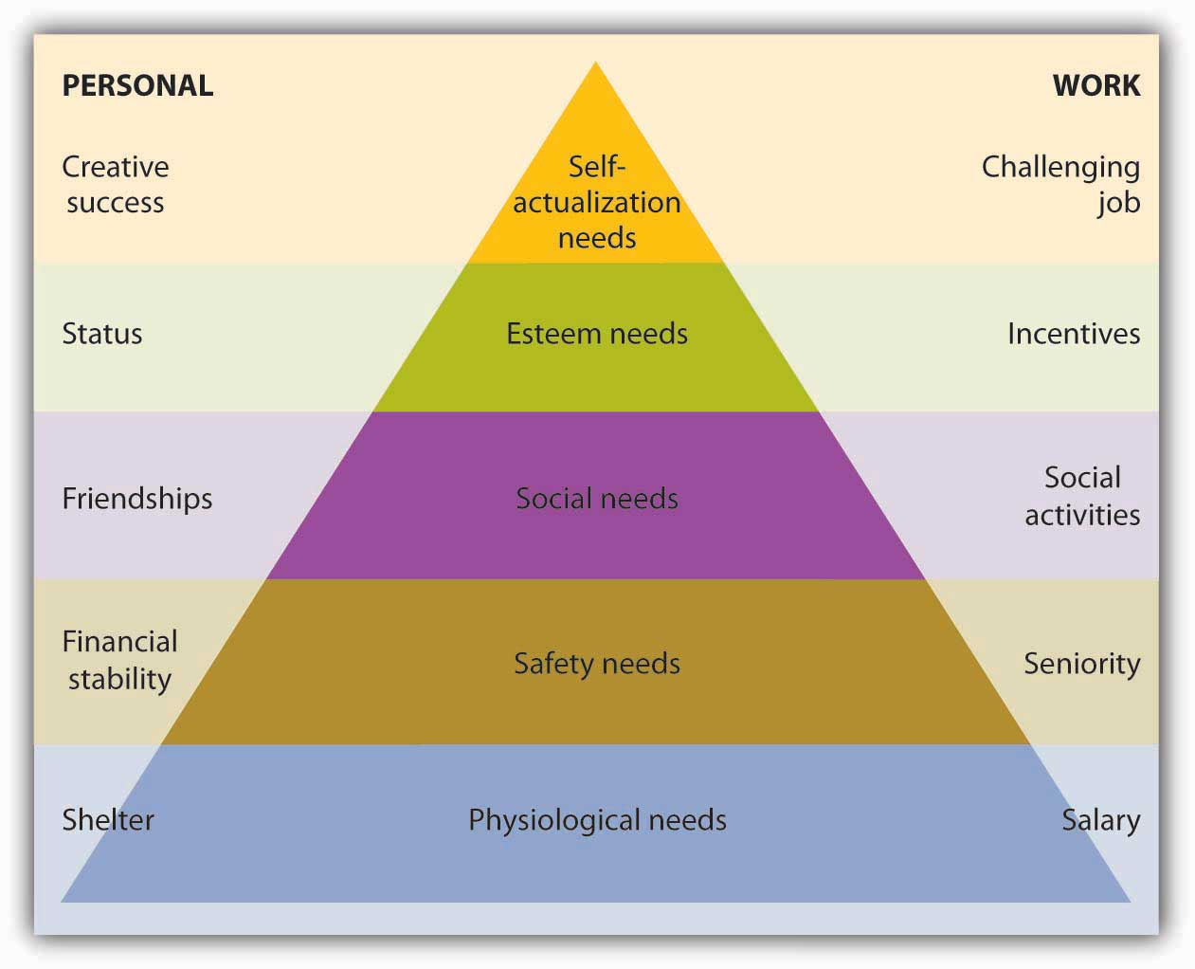
Figure: Maslow hierarchical needs theory
My hierarchical needs like physiological, safety and belongingness can achieve through enough salary, jobs security and co-workers relationship (Curtis, D 2014). But my esteem needs can’t fulfill yet that can achieve through promotion.
This module also helps me to learn how to use Herzberg Two factors theory that helps me to motivate my subordinate’s workers motivation in the working area (TW, S 2013). I learn that in which area the employees like to work and which area hamper their work quality.

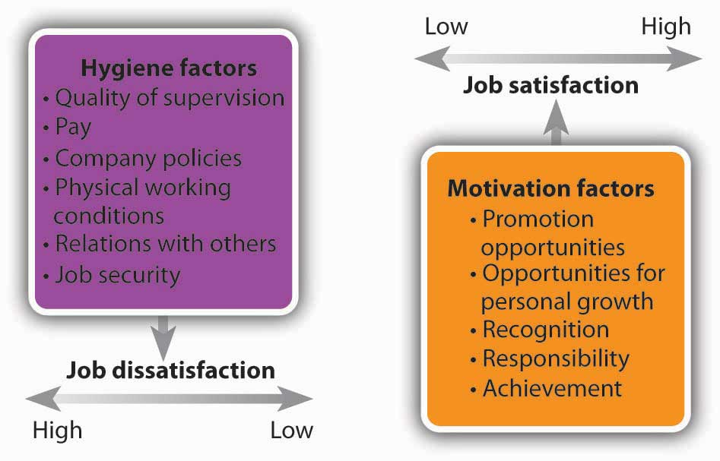
Figure: Herzberg two factors theory
The flexible work schedule that I learn to prepare through this module is helped to improve the performance as well as the quality of work. I can motivate my subordinate by the following process as –
- I can provide reward to the best team performer and recognize them to everyone for encouraging in work.
- I can identify the available facilities and try to provide the subordinate to motivate them in the work area.
This module develops my communication process and helps me to identify the effective communication process, managing time and problem solution. In the business organization every time we face challenge. This module help me to handle this critical situation by highlighting the problem area though quality measurement. I learn that taking initiatives is very effective for problem solving (Williams, 2015). In the workplace I can use several problem solving methods. This module discusses about the equipment checking and maintains them in the appropriate way. Employees can solve the problem at the use of time contingency (Down, C, Fechner, S & Purcell, R 2016). Consumers can get the service to check and recheck the service. By the help of this module I take part in the planning, resources allocation and resolution of contingency situation.
In my job area I can face critical marketing situation when I need to solve the problem. My communication skill that I learn from this module help to solve the problem. It also helps me increase the problem solving capacity through enhancing performance. This module learn me the following area –
- For smooth communication channels it is important to ensure the problem solving. For this reason, I use the two way communication for minimizing the problem.
- We can express any things by using body language. The body language in workplace is also highlight in this module.
- The problem minimization can be possible by quick response. This module discusses the response process in the various stages.
Communication is necessary in every area of organization. In the organizational development and cycle process it is very important to connect with each other. In the workplace I need to communicate with the supervisors, co-workers and other stuffs in the organizational process and cycle. For smooth communication I use the following way –
- For meeting communication I shape document and it provides all the information about the policies and practices of jobs. For the multifaceted tender I explain in the documents the modus and policy qualification (T.W. 2013).
- For informal communication I use social media that helps me to communicate with my subordinate. I can easily maintain the network.
- The non-verbal communication style is also help to understand my situation related to subordinate. It also helps me to understand the problem area.
For employability skill time management is necessary. For this reason this module discusses about the time management strategies. For this reason I can effectively use my time by the management strategies that helpful in the planning and organizing sectors. This module use some effective tools and techniques for time management that are –
- Work sequence maintain
- Decentralization of task
- Priorities segmentation
- Task measurement
- Time distraction.
I use the following process for effective time management –
- I take quick note and use diary management for time management that also helps to segment the task on the priorities basis.
- For time management I avoid procrastination and schedule my times as well as take note after task completion that helps me to schedule my time in future.
This module discusses about the team roles that plays by the member of the team and reach the team in the successful area. The employability skill needs to focus on the team role to achieve the target goal. I play the following role in the team work –
- We allocate the resource from the team management for ensuring its availability. We allocate on the basis of requirement of the team demand (Lawrence, T 2012).
- We outline the specific job’s features and rules and classified the risk for effectively handle it.
- A smooth communication is maintained among the group and group members. It also helps us to complete the task in time.
- Training area is very important so we follow the rules and regulation in the learning process to make it effective.
This module discuss about the significant affiliations of team work and how it forms. We all together work for ensuring the best performance among the team. This module talks about the team dynamics that are necessary for our success. A team maintains various difficulties that rising with the team service and available resources. The group members provide the joint effectors for completing the multi tasking within the team. Among the team several members are committed to work under requirements (Smith, E & Comyn, P 2016). The team supervisors have several responsibilities to maintain the team. The mutual contribution of team members can possibly solve the problem. All members properly deal with the arguments with the affiliations of supervisors. Team can easily achieve their goal by outlining their objectives. In the alternative way the specialized terms are suggested. The team members are achieve the specific area that area that are specialized. The time segmentation is very important to complete the assign task equally among the group members.
Philosophical ideologies is also help to segment the team for achieving the target goal because same psychological people have good understanding to each other and they can effectively maintain the smooth communication to reduce the possible conflict.
This module also helps me to understand the problem specification and possible outcomes identification. The planning and evaluation techniques are also discussing tools in this area. For problem solving certain strategies are necessary. Most of the organization faces increasing number of turnover that creates the problem (Webster, F.E., 2015). The problem can solve by the suitable tools and techniques. Mathematics is the important tools are the important tools for algorithms problem solving. Mathematical overview is given the information that helps to take the decision in problem solving. It sometimes consumes time but it’s very effective way for problem solving.
Heuristics is the way of problem solving that focus on experience, innovating new ideas and learning. In the market place this technique is very effective for problem solving. In the market I use my experience to understand the situation and solve it (Porter, M.E., 2016). A trial and error method is also use in several situation of problem solving. By these techniques I use alternative strategies in the market place.
This module is overall helped me to develop my employability skill that help me in future. This module guides me by clarifying the problem area and identifies major roles and responsibilities in the workplace. This module also helps me to given the idea about the critical situation and how I can overcome challenge in the work place in long run. This development helps me in the long run. I also use the experience for handling the problem in the long run.

References
Bartetzko, A 2014, Key Competencies, Employability Skills and the new training organisation.
Burris, A 2015, Understanding the Math You Teach., Merrill Prentice Hall.
Curtis, D 2014, '‘International perspectives on generic skills’', Generic Skills in vocational education and training, NCVER, Adelaide, pp. 19-37.
Down, C, Fechner, S & Purcell, R 2016, 'Maximising Learning, Department of Employment, Education,', Training and Youth.
Lawrence, T 2012, 'Teaching and assessing employability skills through SkillsUSA', Annual Quality Congress, vol 56, pp. 285-95.
Smith, E & Comyn, P 2016, The development of Employability Skills in novice workers, , viewed 27 January 2006, NCVER, viewed 5 July 2012,<.>.
TW, S 2013, '‘Teaching and assessing employability skills through Skills USA’', Annual Quality Congress, vol 56, pp. 265-75.
Williams, C 2015, ' ‘The discursive construction of the “competent” ', ‘Employability Skills’, Studies in Continuing Education, vol 27, no. 1, pp.. 33-49.
Webster, F.E., 2015. The rediscovery of the marketing concept.Business horizons, 31(3), pp.29-39.
Porter, M.E., 2016. Competitive advantage: Creating and sustaining superior performance. Simon and Schuster

