

Cloud computing administration

Sigitas Dobrovolskis
BSc Cloud computing student
University of Wales: Trinity Saint David
London, United Kingdom
2019925@student.uwtsd.ac.uk

Abstract – This document will illustrate how companies could benefit from moving their services onto the cloud, rather than running their services on-premises. It will include a calculation and pictured example of projected savings by switching from an on-premises service to the cloud. This specific document is aimed to help directly to a medium-sized educational institution called GLI (Global Learning Institute). It will include an evaluation of Azure’s total cost of ownership calculation, storage account usage on the cloud and its security, data backup options, site recovery capabilities, and Azure SQL database implementation.
Keywords – Azure SQL database, security, storage, backup.
- Introduction
Not that long ago businesses and institutions were hosting their services from their infrastructure based on premises, which is a costly and time-consuming process. To make life easier, cloud providers introduced cloud services, where all the physical infrastructure can be merged into the cloud.
Cloud migration refers to the process of transferring local applications, data, and infrastructure to the cloud [1]. The cloud offers computing resources that can be accessed on demand, without the need for active management from users. This is because required software, hardware, and network components can be stored and accessed on the cloud. With its 24/7 availability, users have the ability to request the services they need through the On-demand self-service feature, eliminating the need to contact IT support and saving time typically wasted waiting for a response. Additionally, many cloud services offer automatic software updates and upgrades, allowing users to easily access what they need on the platform.
One of the most notable benefits of cloud computing is the On-demand self-service model. This provides users with access to computing resources whenever they need it, as long as there is an internet connection available. Offline work is also an option for some applications, such as additional storage space and database access [2]. While some cloud providers may schedule downtime for maintenance, Private Cloud users have more control over system upgrades and maintenance cycles, allowing them to keep systems running smoothly and prevent outages.
This document will analyze and evaluate some aspects of why would companies consider moving to the cloud rather than running their services on-premises.
Firstly, most of the companies would be lured to transfer their services to the cloud by comparing running costs. Sometimes it might be difficult to estimate the total price of running services on the cloud, but thankfully cloud providers, like Azure, are providing the Total Cost of Ownership calculators [3]. By using this tool enterprises can visualize their projected costs if they would decide to move to the cloud and decide if that satisfies them.
Further on, businesses would appreciate cloud infrastructure security. Some would argue that in-house infrastructure is way safer than the cloud, but that has been proven to be false [4]. To be clear, this depends on an individual enterprise's needs, as some cannot use third-party clouds and others can.
Security depends on the manpower and resources available. Most companies don’t have the financial or staffing resources to build the strongest security out there, which is why using cloud providers makes a huge sense. These providers are concentrated on providing the best service for the customers, so they have to keep improving their reliability and security to compare with other providers.
Another useful service offered by cloud providers is storage. This paper will go more in-depth discussion on why file storage on the cloud could be more efficient and beneficial than running on-site.
As mentioned earlier, this document is aimed at advising the specific institution on how they could benefit from merging their services to the cloud. This advice will include all the above points and cover some benefits of cloud-based databases, as well as infrastructure recovery and backup services.

- Cloud service cost

Firstly, to get started with the calculation of the cost difference between on-premises and cloud infrastructure it is important to understand the difference between these two and bear in mind some key differences.
Starting with on-premises services, which means that all resources are based within the company, so they could manage it locally. Companies using an on-premises method usually have their in-house IT teams to manage their infrastructure. Also, this method provides more flexibility to the personal business approach regarding setup or security [5]. But all that comes at a cost, which is very high. One of the biggest drawbacks of running services from in-house servers is the cost of it. To have reliable on-premises infrastructure companies have to invest colossal amounts of money, plus to keep it running smoothly and securely they do have to hire IT specialists, so they can monitor and update the service if needed. Another point to consider is that scalability is very difficult with on-premises infrastructure. Once again, the cost would be very high and there would be no guarantee that extended infrastructure would be needed all the time.
That is where cloud infrastructure comes in handy. Firstly, cloud infrastructure refers to services accessible through the internet. These services include virtual storage, virtual machines, virtual databases, and so on. Cloud computing services are highly cost-effective to the consumer, as most of the cloud providers charge only for the services used [6]. Also, cloud providers offer a huge selection of services, which can be implemented in every company. One more advantage cloud computing has is that it is scalable at any angle and at any time. For example, virtual machines can be created in a matter of minutes, and the same can be done with virtual databases [7]. But what would happen if the companies' demand dropped, and they needed to scale down their services on the cloud? Same as before, just the other way around. Services are scalable both ways, so they could be scaled up or down, depending on the enterprise's needs in a matter of minutes [7].
As the above information suggests, cloud services should save businesses some hassle and money, by opting to run their services on the cloud rather than on-premises. This is where Azure's Total Cost of Ownership calculator has a use.
This paper is aimed at helping the Global Learning Institute to visualize and analyze its potential savings by moving its services to the cloud.
Firstly, Azure’s TCO calculator is asking to provide some initial information about what they currently use in-house, such as how much storage they use, what database they run, etc. After all necessary information is provided, the calculator will display a breakdown of current on-premises costs and the same level of service cost running on the cloud.
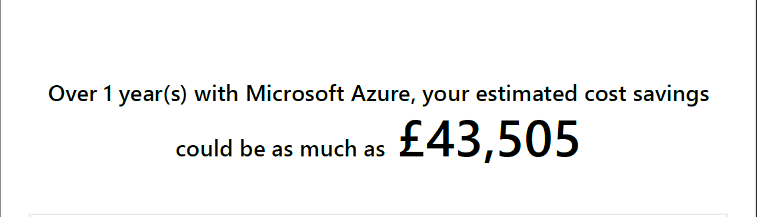[3]

Azure estimates that in this instance GLI could save up to 43,500 £ over one year. By examining the price breakdown, it is clear to see where all the costs could be cut down. 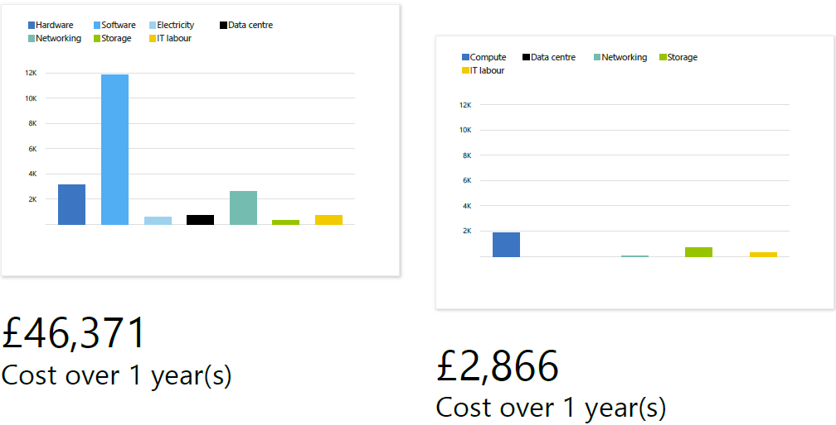[3]
Without a doubt, the biggest saving comes from hardware and software, meaning that Azure provides virtual tools, such as virtual machines and all necessary software. Another important point to note when calculating cloud computing costs is that the institution won’t need to pay for electricity to run these services, and that saves a lot of resources.
One more very important point to note is that if a company or in this instance institution is paying for an SQL database, they can apply the option “Azure hybrid benefit”. This option allows users to save on their license costs, as Azure won’t ask to buy a new license. Instead, they will ask to provide proof of a current license, making the process much easier and cost-efficient [8]. The below image demonstrates how much SQL database license costs for on-premises use, and the savings if Azure’s hybrid benefit is applied.
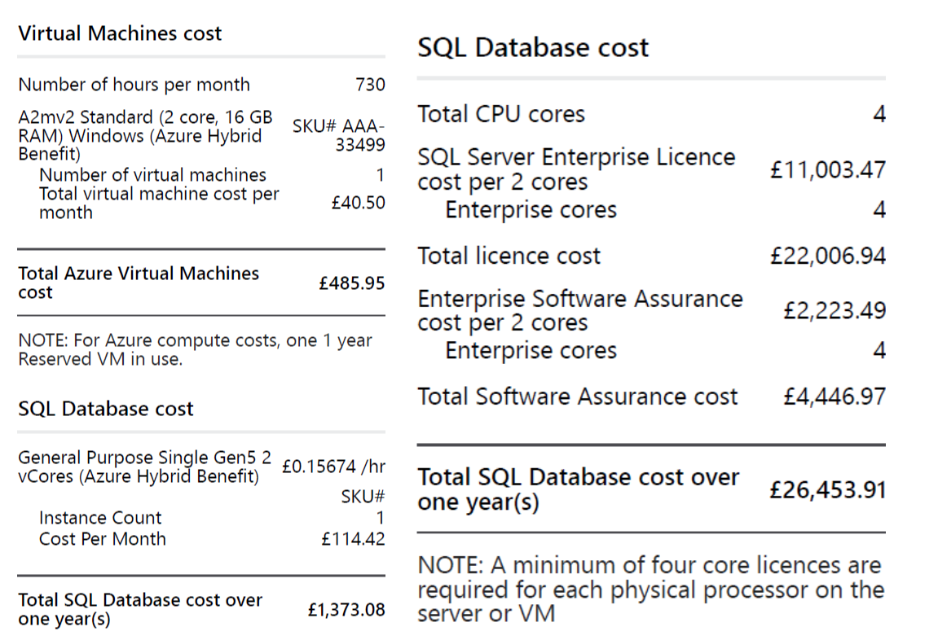 [3]

All in all, this calculation demonstrates how GLI could benefit by switching to cloud services, this includes not only huge cost savings, but it provides endless capabilities to expand their required services at any time, hassle-free IT support, different backup options, and more.

Azure file storage

Azure File Storage is a cloud-based file storage service provided by Microsoft that allows users to create highly available, scalable file shares in the cloud that can be accessed by multiple users. Their storage capacity is almost unlimited, maxed at 500TB [9].
Azure storage feature provides multiple benefits, including:
- Scalability - users can scale up or down at any time, depending on their needs, also optimizing the cost of the file storage.
- Availability – file storage can be accessed anytime, as long as the user has access to the internet. Also, data is stored in multiple storage nods, to protect from data loss.
- Integration – data stored on Azure file storage can be easily used in any other Azure-provided service, such as virtual machines or databases.

As well as the above benefits, Azure provides enhanced security features to protect the data, including:
- Encryption – the data is encrypted while being transferred to the cloud storage, and also when resting in the storage account.
- Azure Active Directory - this feature provides administrators with extensive control over who and how storage account users can access the data.
- Network security – Azure offers a virtual network feature to enhance the security while accessing the data.
- Disaster recovery – this feature is useful to protect important data from loss or system failure, as all data would be backed up safely in different storage locations or even regions [9].

As the Global Learning Institution is debating between keeping their services on-premises or moving to the cloud, this document will provide critical information regarding cloud storage and how could they benefit from it.
Firstly, as GLI deals with multiple student applications, it is important to have enough storage to be able to store all the data and expand storage if demand is bigger than usual. That is where Azure cloud storage takes a top trump as it can be increased depending on the needs, or decreased if demand is lower, resulting in optimized costs. The same can’t be said about on-premises storage, which needs to be planned carefully. If an institution runs out of storage space, they would need to purchase extra storage hardware, which would cost significantly and installation is not instant, so the service of the institution can be disturbed. Furthermore, if the demand drops and all the added storage is not needed anymore it is possible to disable it, but money spent on the hardware would be wasted.
One more critical point for storing data is data redundancy. When storing data on-premises without duplication the institution is at risk of losing it in case of hardware failure or any natural disaster. To avoid this, they would need to have a copy of all the data stored in different locations, which could be very costly, and still, not all data would be protected as new data can be added to the storage every second. In this case, Azure’s cloud storage offers multiple options to have data protected.

When creating a storage account on Azure, presents multiple options on how the data can be protected in case of system failure or natural disaster.
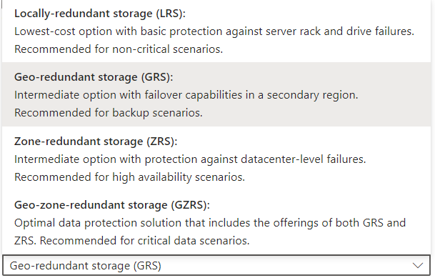[9]

Since GLI would use cloud storage to store some applications and old files, it is suggested to have locally redundant storage, so the data will be duplicated locally. If GLI decides to store more important information, such as bank details, it would be useful to switch to Geo-redundant storage, as the data would be backed up in different data centres.
Lastly, accidental file deletion caused by human error is still a huge problem in every company or institution. To be precise, up to 75% of data loss is caused by human error [10]. GlI is no exception, that is why Azure offers a function called soft delete. When creating file storage, Azure provides some options for specific files on how long a user would want to keep file copies after deletion. As default, it is set to keep file copies for 7 days after deletion, whether it’s intended deletion or accidental.
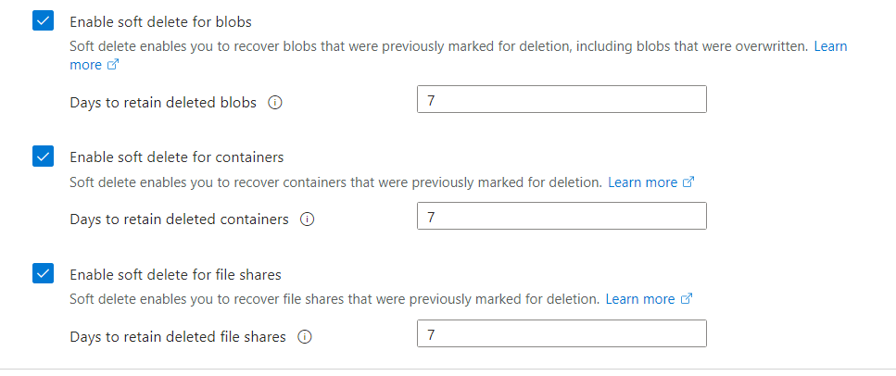[9]

Microsoft Azure databases

Azure database is a fully managed cloud-based database that offers users easy creation, managing, and scalability without worrying about underlying infrastructure [11].
Microsoft Azure offers different options when it comes to databases. The selection is wide, so users have to choose their preferred option before purchasing. Also, it is important to understand that database options provide different levels of customisation and different cost levels.
Some of the Azure database options include:
- Azure SQL database – fully managed, typically built on a relational database management system. Efficient, fully scalable, and cost-friendly.
- Azure Database for MySQL – mostly similar to the Azure SQL database, but it is open-source software, offering programmability and customization.
- Azure database for PostgreSQL – advanced object-relational database, that stores and scales workloads that are too complex for everyday systems. Offers support from the PostgreSQL open-source community [12].

To offer GLI the most efficient and cost-friendly option isn’t difficult, as their institution is using simple relational tables, it has to be an Azure SQL database. If their institution decides to move on and start using more complex data, they could switch to Azure Database for PostgreSQL, as the migration process on Azure is very simple. But at this moment Azure SQL database is a very desirable option for the GLI.
As with every Azure service, creation starts at the Azure portal and searching for a needed service, in this case, Azure SQL. After hitting the create button Azure will ask to choose the required option of how the user will intend to use their SQL database. This includes simple database creation or the option included with migration tools. 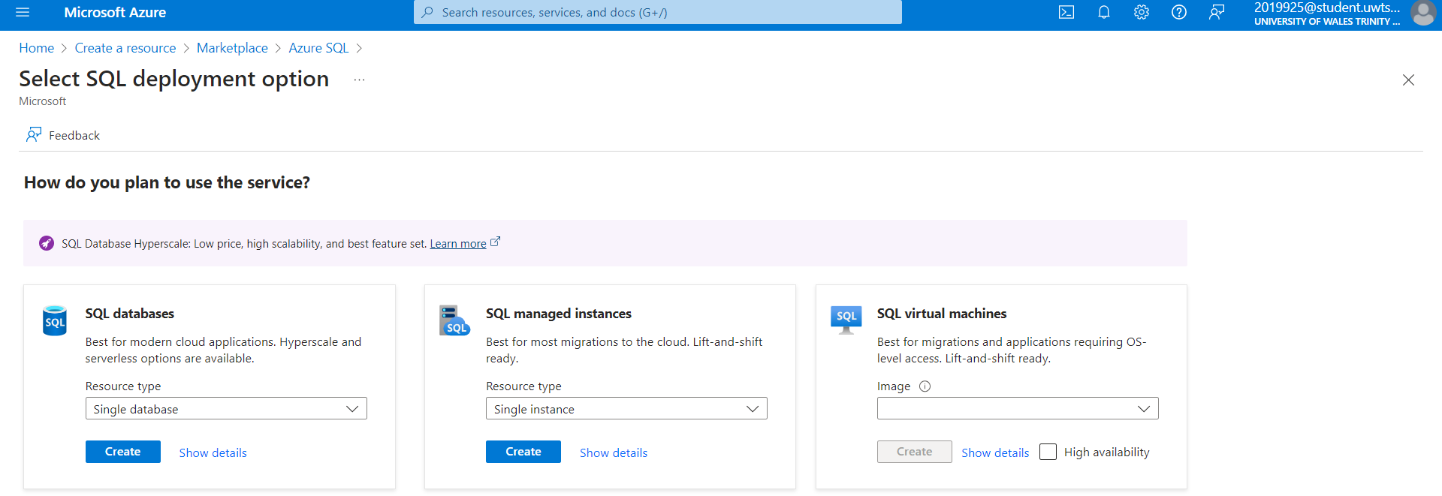[12]

After choosing a preferred option, Azure will ask to provide some basic information for database creation, such as resource group and database name. Also, Azure will prompt to create a server, where the database will be running. The server will need a name, location, and method of authentication. Azure offers few options for how users can authenticate before using the database, this includes manual creation of server admin login name and password or using Azure’s secure Microsoft-Entra authentication.
Furthermore, Azure will ask to choose an appropriate option for the backup storage redundancy. This purely depends on the needs of an enterprise. In this case, one of the GLI’s requirements was to keep the costs as low as possible, which is why locally redundant backup storage has to be selected.
One more important point to note before creating the database is how users will access the database. Azure provides multiple options for this instance, including no access at all, or accessing from public IP addresses.
To maximize database security, Azure offers additional security measures, such as Microsoft Defender for SQL and Encryption. These extra services ensure top security for the database, but they do increase the overall cost of it, so it all depends on the needs of the institution.
After all of the above are selected and configured, Azure will display the actual cost of the database and any extras that were selected.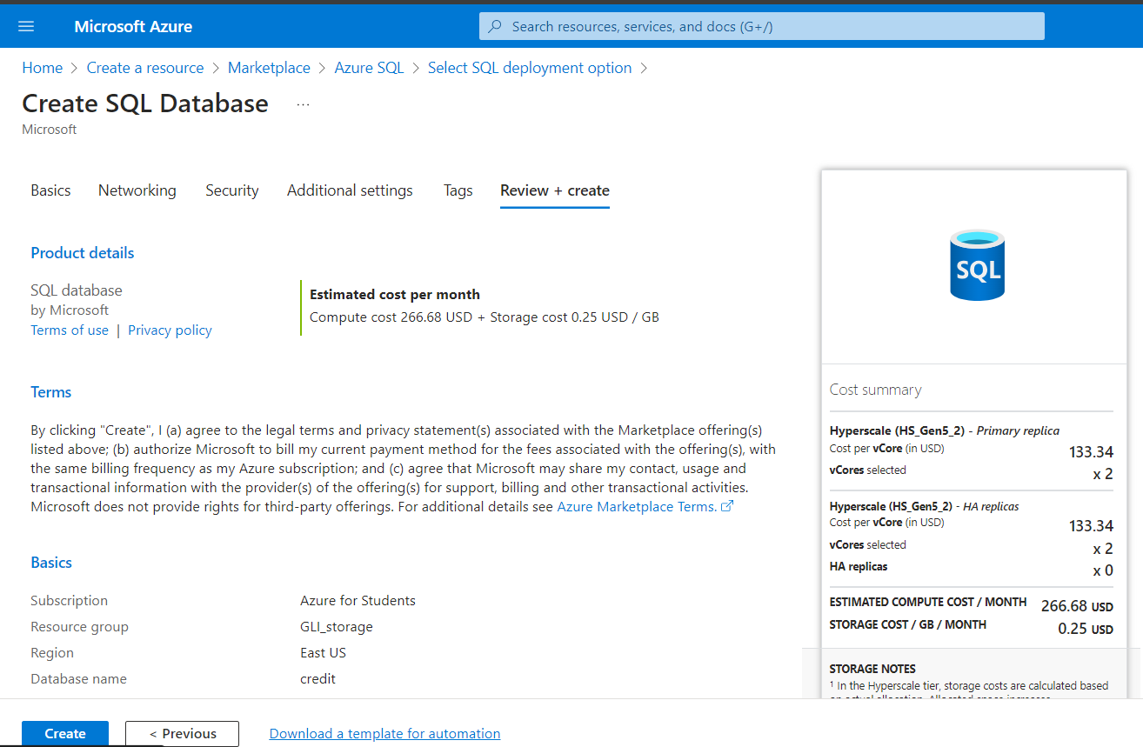[12]

Azure backup

Azure Backup, a service from Microsoft, provides a cloud-based backup solution. It ensures the security and scalability needed to safeguard data, applications, and workloads. Its purpose is to assist businesses in defending crucial data against various risks like accidental deletion, hardware issues, ransomware attacks, and unforeseen disasters [13].
Also, Azure provides many other features with their backup service, such as:
- Flexibility – Azure provides options on what to back up. This can include all infrastructure, or separate parts, like VMs or file storage.
- Automation – this option allows enterprises to set their preferred time intervals for backup to commence. Azure will initiate backups automatically, without user input.
- Incremental backups – this means that only the modified data will be backed up. Companies benefit from this by saving on storage costs and shortening backup time.
- Retention – Microsoft provides different options when it comes to retention. This can be set to a minimum of 7 days and can be increased to months or even a year. This feature ensures that no data is lost if any error happens during the storing process.
- Security – Azure encrypts all the data while it’s in transit or at the storage. Also, it provides access options, so the backup admin can set who can access the data [13].

As GLI decided to merge their infrastructure to the cloud, it should consider opting for Azure’s backup service. This feature will provide the institution with assurance that their files and the database are safely stored in different data centres and can be retrieved at any time if needed.
To get started, the Azure website needs to be accessed and search for Backup and Site Recovery. After hitting the create button, Azure will prompt to enter some basic details, such as the resource group name and the name of the vault.
Moving on, the website will ask to choose the redundancy option, which could be local, zone, or geo. This option provides the GLI institution with a choice of how far apart would they want to keep their backup in case of data loss or natural disaster.
Furthermore, under the encryption tab, Azure will ask to choose the type of encryption, which could be managed by Microsoft or users, depending on personal needs.
Lastly, the networking tab provides a choice of how backup service users would access the database, this can be done through any network or set to private network only.
After all the above has been selected, the backup and site recovery can be created.
To start using the backup service, the user has to upload some files and initiate manual backup or wait until the scheduled automatic backup. This YouTube video explains and demonstrates more about storage, database, and backup service creation and usage, it also provides the process of restoring files from the backup vault: https://youtu.be/_3shjRGpSxU.

Azure Site Recovery

Microsoft’s disaster recovery-as-a-service provides users with an assurance that their services can be up and running in a minimal time if any unexpected error or disaster happens [14]. This feature is widely used by enterprises to minimise the company's downtime and provide the best service for their customers.
Some key features provided by Azure Site Recovery:
- Simplicity – this service is built into Azure, so it can be managed easily from a single location.
- Security – data is backed up inside Azure storage, therefore they do provide the strongest security possible to prevent any data leaks.
- RTO and RPO – recovery time objective and recovery point objective depend on the user needs and budget available. Azure provides multiple options with different price ranges to enterprises, so they can meet their requirements. Downtime can be minimised to a staggering 30 seconds, so the everyday user wouldn’t notice that the service is down.
- Cost-effectiveness – to save costs, Azure Site Recovery service backs up only the data which has been modified since the last backup, saving time and storage space [14].

GLI, as any other Azure user, could benefit from this recovery service. To serve their customers efficiently, GLI could set their preferences when setting up site recovery, so their service would be highly available. A study shows [15] that an alarming 62% of web users are not willing to wait for a website to load more than 5 seconds. That shows how important is to have a highly available website.

- Conclusion

In conclusion, the analysis of Microsoft Azure's cost structure, storage accounts, SQL database services, Azure Backup, and Site Recovery solutions reveals a comprehensive ecosystem designed to meet GLI’s needs with scalability and efficiency.
This report explored the balance between cost-effectiveness and performance optimization inherent in Azure's offerings. From the flexibility of storage accounts to the robust capabilities of SQL databases, Azure provides a spectrum of solutions adaptable to varying workloads and organizational requirements.
Moreover, the integration of Azure Backup and Site Recovery underscores Microsoft's commitment to data protection, business continuity, and availability. These services not only safeguard critical assets but also ensure minimal downtime in the face of unforeseen disruptions, bolstering the resilience of Azure-powered environments.
As the GLI will navigate the complexities of cloud adoption, understanding the variation of Azure's cost models and service functionalities becomes paramount. By leveraging the insights provided in this report, GLI can make informed decisions to maximize the value derived from their Azure investments while mitigating potential financial risks.
Essentially, Microsoft Azure emerges as a versatile platform equipped with a variety of tools and services to empower businesses in their digital transformation journey. Whether optimizing costs, managing data storage, or bracing disaster recovery strategies, Azure remains a competitive choice for enterprises seeking innovation, reliability, and scalability in the cloud.

- References

[1] Google Cloud, “What is cloud migration?, GoogleCloud, 2024. [Online]. Available: https://cloud.google.com/learn/cloud-migration. [Accessed Apr. 19, 2024].
[2] M. Muchmore, “The best cloud storage and file-sharing services”, PCmag, Feb. 29, 2024. [Online]. Available: https://uk.pcmag.com/file-syncing-and-backup/3682/the-best-cloud-storage-and-file-sharing-services-for-2020. [Accessed Apr. 19, 2024].
[3] Microsoft, “Total cost of ownership calculator”, Microsoft, 2024. [Online]. Available: https://azure.microsoft.com/en-gb/pricing/tco/calculator/. [Accessed Apr. 20, 2024].
[4] T. Montgomery, “Why your data is safer in the cloud than on-premises”, TeachBeacon, 2024. [Online]. Available: https://techbeacon.com/security/why-your-data-safer-cloud-premises. [Accessed Apr. 20, 2024].
[5] N. Hazdun, “Cloud versus on-premises: advantages and disadvantages of both models”, Forbes, Mar. 27, 2023. [Online]. Available: https://www.forbes.com/sites/forbestechcouncil/2023/03/27/cloud-versus-on-premises-advantages-and-disadvantages-of-both-models/. [Accessed Apr. 20, 2024].
[6] S. Bigelow, “Pay as you go cloud computing”, TechTarget, 2024. [Online]. Available: https://www.techtarget.com/searchstorage/definition/pay-as-you-go-cloud-computing-PAYG-cloud-computing. [Accessed Apr. 21, 2024].
[7] Hewlett Packard Enterprise, “What is cloud scalability”, HPE, 2024. [Online]. Available: https://www.hpe.com/uk/en/what-is/cloud-scalability.html. [Accessed Apr. 21, 2024].
[8] Azure, “Azure hybrid benefit”, Microsoft, 2024. [Online]. Available: https://azure.microsoft.com/en-gb/pricing/hybrid-benefit/. [Accessed Apr. 22, 2024].
[9] Azure, “Azure files”, Microsoft, 2024. [Online]. Available: https://azure.microsoft.com/en-gb/products/storage/files. [Accessed Apr. 22, 2024].
[10] T. Rock, “75% of data loss is from human error. Here’s how to deal with it.” Invenioit, Dec. 20, 2020. [Online]. Available: https://invenioit.com/continuity/data-loss-from-human-error/. [Accessed Apr. 22, 2024].
[11] Azure, “Azure SQL Database”, Microsoft, 2024. [Online]. Available: https://azure.microsoft.com/en-us/products/azure-sql/database/#Features. [Accessed Apr. 22, 2024].
[12] Azure, “Databases on Azure”, Microsoft, 2024. [Online]. Available: https://azure.microsoft.com/en-us/products/category/databases. [Accessed Apr. 23, 2024].
[13] K. Chauhan, “What is Azure backup?”, K21Academy, Dec. 8, 2023. [Online]. Available: https://k21academy.com/microsoft-azure/az-500/what-is-azure-backup-features-benefitstools-real-life-examples/. [Accessed Apr. 23, 2024].
[14] V. Vladimiskiy, “Microsoft Azure site recovery”, Nerdio, Aug. 31, 2023. [Online]. Available: https://getnerdio.com/resources/demystifying-azure-site-recovery/. [Accessed Apr. 23, 2024].
[15] P. Dughi, “How long will customers wait for your website to load?”, Medium, May 16, 2016. [Online]. Available: https://medium.com/stronger-content/how-long-will-customers-wait-for-your-site-to-load-we-put-top-sites-to-the-test-545862be62c. [Accessed Apr. 23, 2024].

