

Faculty of Applied Design and Engineering/Cyfadran Dylunio Cymhwysol a Pheirianneg
School of Applied Computing/Ysgol Cyfrifiadureg Gymhwysol

Local Area Networks
BEng (Hons) Computer Network Technology (M2X8521)
BSc Computer Networks (M2X8625)
HND Computer Networks (M5X8930)

Practical Lab Assessment 2013-14

Name :

Student ID :

Date & Time :

This is an individual practical lab-test, held under examination conditions. You will be assigned three Switches and a Router; you should configure these devices based on the given specifications.

This paper is marked out of 100.

You will have 2 hours to complete this task.

TOPOLOGY DIAGRAM

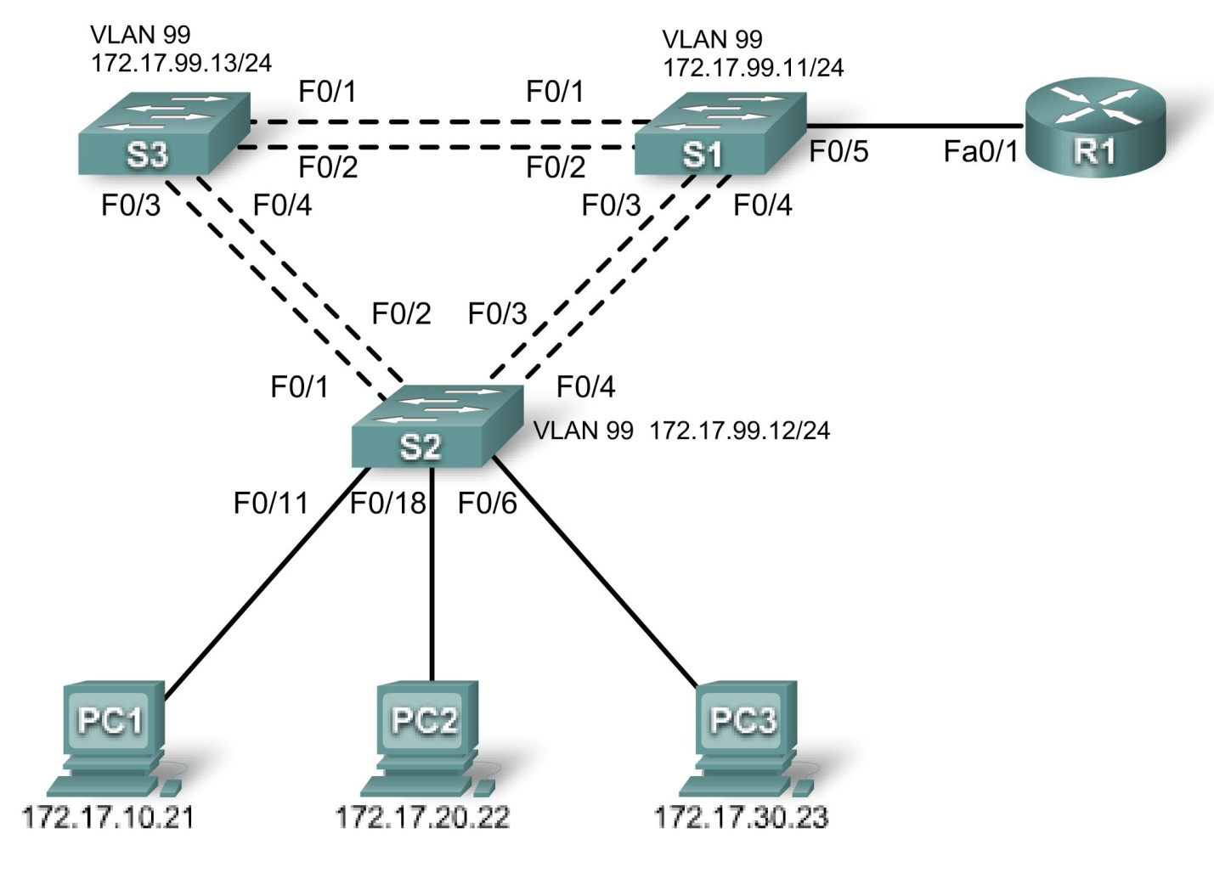

Addressing Table
Device | Interface | IP Address | Subnet Mask | Default Gateway
R1 | Fa0/1 | N/A | N/A | N/A
R1 | F0/1.10 | 172.17.10.1 | 255.255.255.0 | N/A
R1 | F0/1.20 | 172.17.20.1 | 255.255.255.0 | N/A
R1 | F0/1.30 | 172.17.30.1 | 255.255.255.0 | N/A
R1 | F0/1.99 | 172.17.99.1 | 255.255.255.0 | N/A
S1 | VLAN99 | 172.17.99.11 | 255.255.255.0 | 172.17.99.1
S2 | VLAN99 | 172.17.99.12 | 255.255.255.0 | 172.17.99.1
S3 | VLAN99 | 172.17.99.13 | 255.255.255.0 | 172.17.99.1
PC1 | NIC | 172.17.10.21 | 255.255.255.0 | 172.17.10.1
PC2 | NIC | 172.17.20.22 | 255.255.255.0 | 172.17.20.1
PC3 | NIC | 172.17.30.23 | 255.255.255.0 | 172.17.30.1

Port Assignments

Switch 2
Ports | Assignment | Network
Fa0/1 – 0/4 | 802.1q Trunks (Native VLAN 99) | 172.17.99.0 /24
Fa0/6 – 0/10 | VLAN 30 – Guest (Default) | 172.17.30.0 /24
Fa0/11 – 0/17 | VLAN 10 – Faculty | 172.17.10.0 /24
Fa0/18 – 0/24 | VLAN 20 – Students | 172.17.20.0 /24

Switch 1
Ports | Assignment | Network
Fa0/1 – 0/4 | 802.1q Trunks (Native VLAN 99) | 172.17.99.0 /24
Fa0/5 | 802.1q Trunks | 172.17.99.0 /24

Switch 3
Ports | Assignment | Network
Fa0/1 – 0/4 | 802.1q Trunks (Native VLAN 99) | 172.17.99.0 /24
Task 1: Prepare the Network (5 marks)
Step 1: Cable a network that is similar to the one in the topology diagram.
Step 2: Clear any existing configurations on the devices.
Step 3: Disable all ports using the shutdown command.
Step 4: Re-enable the active user ports on S2 in access mode.

Task 2: Perform Basic Device Configurations (10 marks)
Configure the S1, S2, and S3 switches and R1 router according to the following guidelines:
- Configure the hostname.
- Disable DNS lookup.
- Configure an EXEC mode password.
- Configure a message-of-the-day banner.
- Configure a password for console connections.
- Configure synchronous logging.
- Configure a password for vty connections.
Task 3: Configure and Activate Network Addresses (10 marks)
Step 1: Configure the Management VLAN interface and default gateway on S1, S2, and S3.
Step 2: Configure the PC1, PC2, and PC3 Ethernet interfaces.
Task 4: Configure VTP (15 marks)
Step 1: Configure S1 as the VTP server, with domain name cisco and password cisco.
Step 2: Configure S2 and S3 as VTP clients, with domain name and password.
Step 3: Configure all trunks. All trunks should allow only traffic for VLANs 10, 20, 30, and 99.
Task 5: Configure VLANs (15 marks)
Step 1: Configure the VLANs on the VTP server. (Note: Remember to assign the appropriate ports to the VLANS as described in the Port Assignments table on page 3)
Configure the VLANs in the table below on the VTP server.
VLAN | VLAN Name
VLAN 99 | management
VLAN 10 | faculty
VLAN 20 | students
VLAN 30 | guest
Step 2: Verify that the VTP clients are receiving VLAN configurations from the server.
Task 6: Configure STP (15 marks)
Step 1: Configure S1 to be the root for all VLANs.
Step 2: Configure Rapid PVST+.
Step 3: Configure PortFast and BPDU Guard on the interface connected to PC1, PC2, and PC3.
Step 4: Verify that STP is running correctly.
Task 7: Configure an LACP EtherChannel between S1 and S3 (10 marks)
Step 1: On S1, Configure a LACP EtherChannel on interface connected to S3. Use group 1 and enable LACP unconditionally.
Step 2: On S3, Configure a LACP EtherChannel on interface connected to S1. Use group 1 and enable LACP only if a LACP device is detected.

Task 8: Configure Inter-VLAN routing (15 marks)
Step 1: Create a basic configuration on the router.
Step 2: Configure the trunking interface on R1.
Step 3: Verify Inter-VLAN routing.
Ping from each host to every other host.
Task 9: Document the Configurations (5 marks)
All documentation for your solution should be submitted. Your name should be clearly printed on the documents.

At the end of the test a flash memory will be given to you, the configuration files for all routers should be copied to the media and handed in to your instructor. It is you responsibility that you copy the files correctly.

On each device, issue the
show run
sh vlan
sh ip int brief
sh int trunk
sh vtp status
commands and capture the configurations. Save the file as devicename_surname_Pno.txt.

