Component 2
Written Report
Student Name: Kim Merson
Student Number: 2127725
Lecturer Name: Dr. Fahad Khan
LCHS4004_BIRM
Introduction to Public Health

Report on the major health issue - Asthma

Introduction

This report looks into the causes, symptoms, and treatments of asthma, a non-infectious respiratory lung disease that can be fatal in some severe cases. The disease mainly causes breathing difficulties, wheezing, shortness of breath, and chest tightness in people of all ages. Asthma is a common chronic childhood disease that can persist into adulthood. In the United Kingdom, 1 million children are now receiving asthma treatment. In the years 2017/2018, there were 174 emergency hospital admissions for asthma among children under the age of 19. (National Health Service,2018).
The report will include statistics on disease incidence and severity in the United Kingdom and around the world, as well as strategies for measuring, monitoring, and controlling the disease. According to NICE, approximately 12% of the population in the UK, more than 8 million people, have asthma, though some may have grown out of the condition during childhood. (NICE,2022).
To treat the symptoms of an asthma attack, an inhaler and a small breathing device are commonly used. If breathing cannot be improved using these treatments, a GP appointment or, in severe cases, an urgent hospital visit is required. Some of the triggers that can cause asthma include exercise, pollen, smoke, and even dust causing irritation of the airways making them irritated and swollen causing a build-up of mucus in the lungs and airways resulting in an asthma attack. Furthermore, the report will further look at how to prevent the disease. Although asthma can be controlled with medications and inhalers, there is no known cure; however, doctors and healthcare professionals can devise a plan for how to live with the condition this would be personal to the individual depending on the type of asthma and its severity.

Public Health Measures

Asthma is one of the leading causes of respiratory lung disease which often results in the need for emergency care or even hospitalization. This can affect the number of days missed from school or employment. Public Health England is the core of protecting and improving the health of people with asthma and preventing risks of an attack before they happen. An action plan is normally given by health professionals to the individual with Asthma this personal and differs from person to person depending on risk factors and environmental determinants that may trigger a possible asthma attack. Preventions for the individual can be avoiding pets such as cats and dogs, animals can also cause asthma to develop at any stage of life.
Promoting awareness of triggers for members of the public that might not be aware of the outcome for the individual with Asthma, is a positive and effective way to prevent an attack. For example, smoke inhalation is one of the main triggers for asthma sufferers this is due to the smoke irritating the airways causing an asthma flare-up. Promotion of the cigarette packet is not only to promote quitting smoking but to make people aware of health issues such as asthma. To protect children and young adults it was made illegal on 1 October 2015 to smoke in a car with anyone under the age of 18 this is to protect from the dangers of second-hand smoke. (GOV,2015).
The chart below illustrates the mortality rates for people aged 10 to 24 between 1998 and 2019. The number of deaths during this time period did decrease, but it is unclear in recent years, and in older people, this may vary dramatically due to health problems and other health issues.
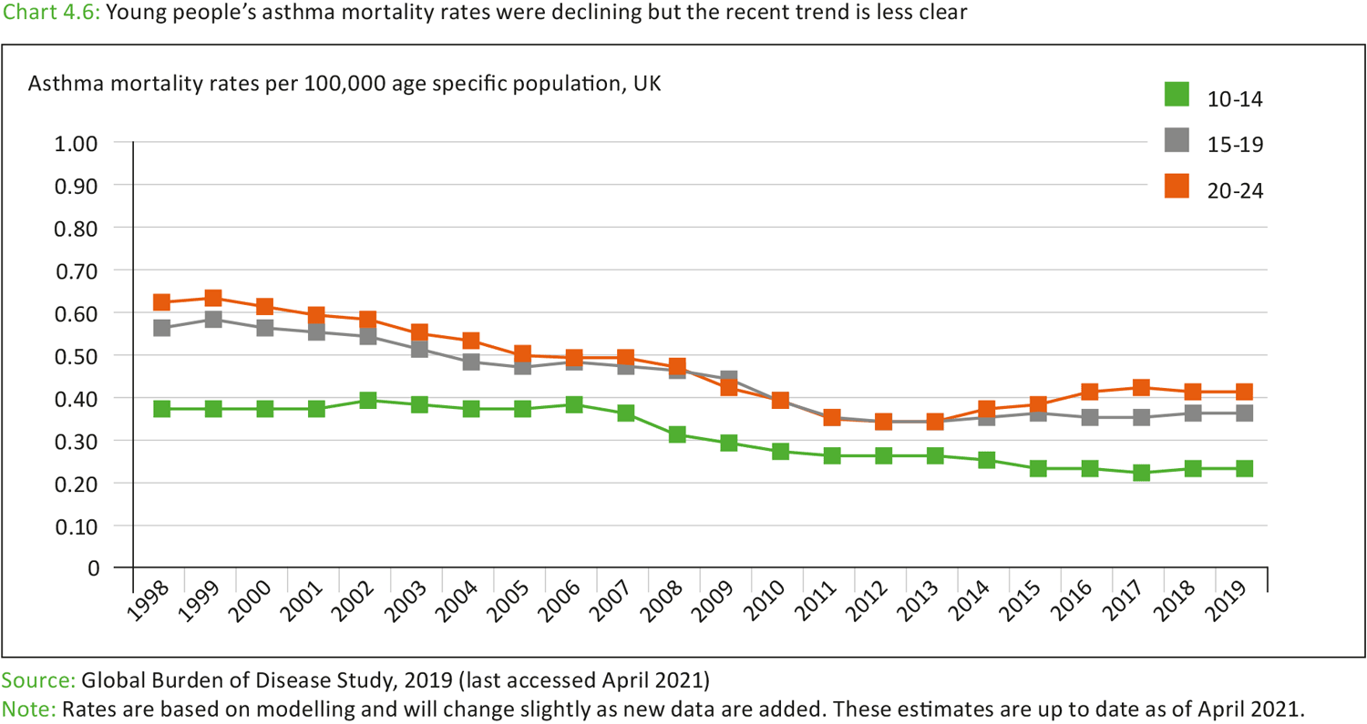
(source: - Public Health England. (Youth Health Data, 2021)
However, if a mother smokes during pregnancy it is not the law but only advised by health professionals as it could impact health conditions when the baby is born. this could trigger an ongoing asthma diagnosis in the early stages of life. “Additional risks include an increased incidence of upper and lower respiratory illnesses, increased hospitalization and visits to the doctor, and an increased use of asthma medication.” (Stocks and Dezateux 2003, p.226).
Promoting a healthy balanced diet will improve the quality of life and may reduce symptoms of asthma this would also improve obesity rates which do impact asthma sufferers as it’s harder to manage due to extra strain put on the lungs leading to repertory problems and high BMI. Globally According to the World Health Organisation (2016), 2 billion adults are overweight and 650 million are considered to be affected by obesity. (WHO,2016).
Diagram one shows that both obesity and asthma cases are dramatically increasing but yet is it not critically proven that obesity is related to causing asthma but can increase risks and worsen a pre-diagnosed case.
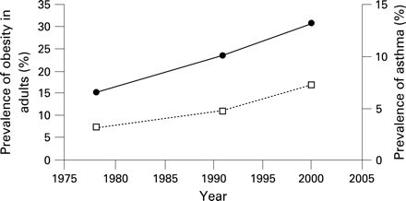
(source: - prevalence of obesity in adults and asthma in the USA) (Sutherland, 2007)
To enable medical professionals to protect people diagnosed with asthma two vaccines are available to the public the first being the Influenza (Flu Vaccine) this is available yearly to NHS patients who have health issues such as asthma, the elderly, pregnant women, and people at risk with weakened immune systems. The flu vaccine is safe and effective and in recent years been strongly promoted to NHS patients.
The Pneumococcal Vaccine is also available this Is given every 5 years to people with long-term health issues and as a baby and to people over the age of 65 to prevent fatal pneumococcal infections. The World Health Organisation considers asthma a need for pneumococcal vaccination although is rarely given. (WHO,2018).
However, the most common protection against Asthma is Corticosteroids also known as steroid inhalers these are given to the patient to prevent an attack before it occurs.

The key determinants/risk factors of Asthma

If a close family member, such as a parent or sibling, has asthma, it may be due to genetics or the home environment. It is quite common for asthma to be passed on to a child if both parents have asthma. If a mother carries the Asthma genes, her child is more likely to inherit them. Epidemiological studies on the risk factors for this disease have revealed that maternal asthma has a higher risk in their children than paternal asthma. This could be because of post-natal factors like breastfeeding. (NIH,2010).
Another great risk factor determinant is the environment this could be several things in either a household environment which could be dust, vacuuming carpets, and dusting furniture can disturb dust particles or dust mites around the house and aggravate an asthma attack.
Asthma symptoms can be triggered by hot or cold temperatures because they cause the airway to narrow. The best temperature for people with asthma is room temperature because it does not irritate the airways this includes weather changes.
Families that are from lower income backgrounds and deprived areas that have Asthma are more likely to need hospital treatment this is due to being exposed to more triggers such as mould, smoke, and air pollution. Asthma is also caused by high levels of air pollution. Asthma UK is campaigning for cleaner air to improve and reduce the risk of asthma attacks. Because of bonfires, barbeques, and wood-burning stoves, air pollution levels can vary throughout the year. There is a pollution forecast, and sufferers can check it daily to help track and note symptoms or avoid certain outdoor conditions. (Asthma Lung UK, 2020).

The results on the bar chart below show the hospital admissions for asthma for people aged 10-18 living in deprived areas in the United Kingdom. Hospital admissions almost doubled in 2019/2020 in the lowest-class areas.

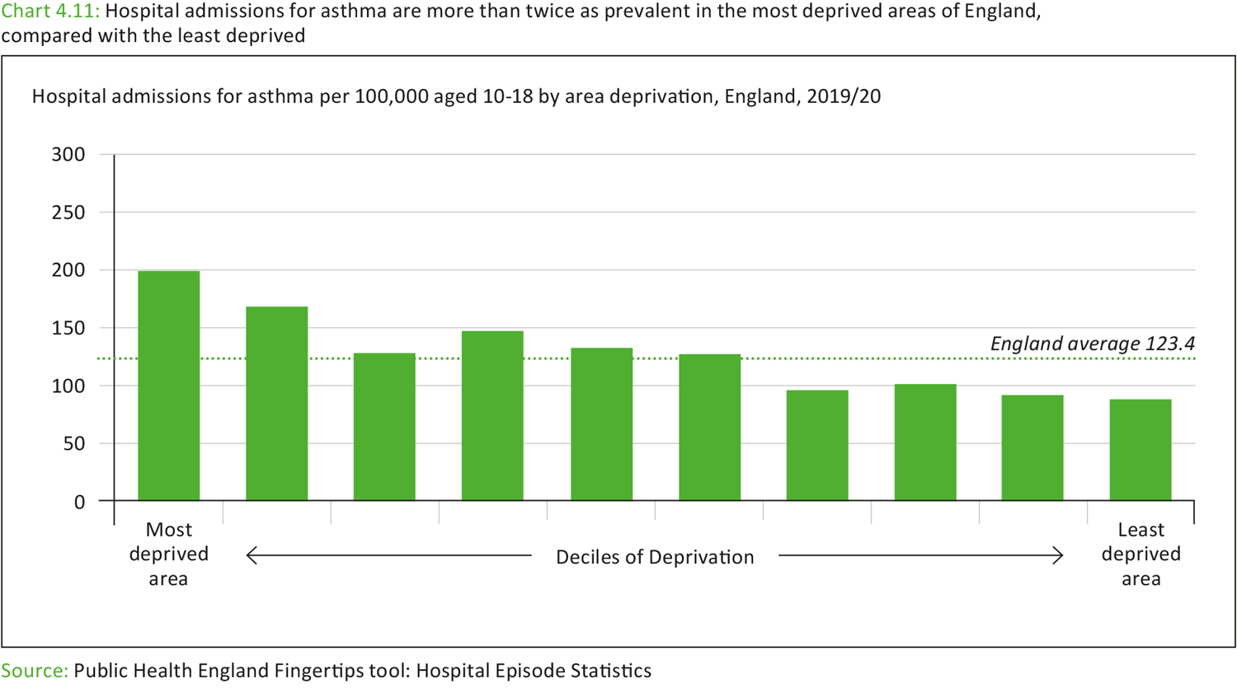
(source: - Public Health England. (Youth Health Data, 2021)

Short-term public health consequences

Short-term public health consequences of asthma include tightness of the airways and chest, resulting in shortness of breath and a continuous cough; an inhaler would be required to relieve symptoms. Sleep deprivation as a result of symptoms developing during the night can result in a lack of concentration at work or school.
Asthma can prevent physical activity due to shortness of breath, resulting in weight gain and depression, which must be treated separately because asthma is the causative agent.
This can in some cases lead to high blood pressure and would need to be monitored by a health professional. Causing extra pressure and cost to the NHS, If the short-term consequences can be monitored and prevented the risks would be lower. This could be done by banning smoking in public spaces and allowing certain dates or times for bonfires to enable asthma sufferers to isolate.
More advertisements could be used to promote Asthma so the general public can gain more knowledge and awareness of this disease and save lives.

Long-term public health consequences

There is no current cure for asthma so it is itself a long-term consequence. This can cause growth and puberty delays in children if untreated this can be approximately 1.5 years. A fully grown adult’s height can be affected in severe asthma cases. (Doull, 2014).
People who have had severe asthma for a long time are more likely to develop bronchiectasis, lung scarring, inflammation, and excess mucus, which can lead to more asthma attacks and hospitalizations. To reduce the risk of bronchiectasis, quit smoking and avoid places where smoking is permitted. The flu vaccine reduces the risks, and breathing exercises can help reduce the amount of mucus in the airways.
Long-term use of steroids for asthma can alleviate symptoms, but it can also result in diabetes 2, osteoporosis, and other complications. Chronic airway inflammation can result in permanent changes such as chronic coughing, airway wall thickening, loss of lung function, and increased mucus production.
Patients suffering from severe asthma are at risk of respiratory failure. This occurs when there is insufficient oxygen in the bloodstream; it is uncommon, and symptoms worsen over time.

Conclusion

To summarise Asthma is one of the most serious and widespread respiratory diseases in the world. There is no cure, but in some cases, children can grow out of the disease. The vast majority of cases are mild, requiring the use of an inhaler in the event of an asthma attack or flare-up. In more severe cases of asthma, hospitalization would be required, as well as the implementation of a prevention plan. Many factors can contribute to flare-ups, but they can also be avoided. There are a few potential causes, such as smoking during pregnancy, that could be prohibited to reduce childhood cases, but this has yet to be proven. Measures in public health are in place to promote, protect, and protect people from attacks. Asthma currently has no cure, but there are treatments and it can be prevented by managing symptoms, so many people have control over the disease. There is hope for a complete cure in the coming years, which can be aided by measures put in place to prevent it.

References

Doull J.M (2004) The effect of asthma and its treatment on growth
Archives of Disease in Childhood.

Gov.UK (2017) Smoking in Vehicles. Available at: https://www.gov.uk/government/news/smoking-in-vehicles (Accessed: 17 November 2022).
National Health Service (2018) Childhood Asthma. Available at: https://www.england.nhs.uk/childhood-asthma (Accessed: 17 November 2022).
NICE (2022) What is the Prevalence of Asthma? Available at: https://cks.nice.org.uk/topics/asthma/background-information/prevalence (Accessed: 17 November 2022).

NIH (2010) Risk for Asthma in offspring of Asthmatic Mothers Versus Fathers. https://www.ncbi.nlm.nih.gov/pmc/articles/PMC2853568/ (Accessed: 27 November 2022).
Stocks, J. and Dezateux, C. (2003). The effect of parental smoking on lung function and development during infancy. Respirology.
WHO(2016) Obesity and overweight. Available at: https://www.who.int/news-room/fact-sheets/detail/obesity-and-overweight (Accessed:17 November 2022).
WHO(2018) Asthma deaths. Available at: https://www.cdc.gov/asthma/asthma_stats/asthma_underlying_death.html (Accessed: 26 November 2022)
Sutherland, E.(2007) Obesity and the lung: Obesity and asthma. (Accessed:17 November 2022).
Centers for Disease Control and Prevention (2018) Asthma underlying deaths. https://www.cdc.gov/asthma/asthma_stats/asthma_underlying_death.html (Accessed:26 November 2022)

