
Student Name: | Darshan Pansuriya | Student ID: | 2526084
Programme: | Master of Business Administration
Module: | Human Capital Management
Module Code: | LCMB7023
Assignment Title: | Assessment component 1: Individual report – HR strategy
Lecturer Name: | Gladius Kulothungan Ejike Udeogu
Word Count: | 2475(Excluding Refernces, Tables, Appendix) | Submission Date: | 20th March, 2026

Table of Contents
Part 1: Re-Engineering Performance and Job Design 1
1. Introduction 1
2. Critical Analysis of Current Performance Appraisal Practices 1
3. Proposed Modern Performance Management System 2
3.1 Objectives & Key Results (OKRs) 2
3.2 360-Degree Feedback 3
3.3 Integration and Benefits 4
4. Job Design and Analysis on Key Jobs 4
4.1 CEO (Chief Executive Officer) 5
4.2 CFO (Chief Financial Officer) 5
4.3 CTO (Chief Technology Officer) 5
4.4 CIO (Chief Innovation Officer) 5
4.5 HR Director 5
4.6 Head of R&D 5
4.7 Skills-Based Job Design 6
5. Integration: Building a Performance-Driven Culture 6
6. Conclusion 6
Part 2: Reflective Analysis and Development in the Future 6
2.1 Reflection Using Gibbs Reflective Cycle 6
2.2 Staying Relevant in the Age of Artificial Intelligence 8
References 9
Appendix 10

Executive Summary
Aether Innovations, a fast-growing technology organisation with 300 employees, is presently experiencing a sluggish growth, high levels of employee turnover, and declining levels of customer satisfaction. These challenges suggest a mismatch between organisational strategy and human capital practices. This report proposes a cohesive human capital blueprint that is focused on re-engineering performance management systems and job design to create a high performance, innovation-driven culture.
The report offers a critical analysis of traditional performance appraisal methods used in technology firms, and points out their limitations in dynamic and knowledge-intensive environments. It suggests the introduction of a modern and continuous performance management system based on Objectives and Key Results (OKRs) and 360-degree feedback mechanisms. These approaches focus on alignment, transparency and on-going development instead of looking back.
In parallel, the report redesigns job roles based on Job Characteristics Model (Hackman and Oldham, 76) and skills-based job design principles to increase autonomy, task significance, skill variety, and feedback. Six key leadership roles (CEO, CFO, CTO, CIO, HR Director, and Head of R&D) are redefined to encourage innovation, accountability and cross-functional collaboration.
The report contends that integration of performance management and job design systems is critical to creating a performance-based culture. By ensuring that individual roles are aligned with strategic objectives and has a continuous feedback loop and development, Aether Innovations can help improve employee engagement, reduce turnovers and improve organisational performance. This integrated approach ultimately supports both employee excellence and customer satisfaction putting the organisation in a position for sustainable growth.

Part 1: Re-Engineering Performance and Job Design

1. Introduction
In modern technology organisations, human capital is an essential element of innovation, competitiveness and long-term success. However, many firms find it difficult to align their people management practices with the changing business environments that are proliferating at an accelerated pace. Aether Innovations is a good example of this challenge as reflected in the dropping performance indicators, employee turnover, customer dissatisfaction. These problems are frequently caused by aging performance management systems and inflexible job designs that do not support agility and innovation.
This section critically reviews current practices in the areas of performance appraisal and job design in technology firms and offers an integrated framework suited to Aether Innovations. By using modern performance management approaches in conjunction with enhanced job design, the organisation can create a culture of continuous improvement and innovation.

2. Critical Analysis of Current Performance Appraisal Practices
Traditional performance appraisal systems in many organisations are typically annual, top down and heavily focused on past performance. While such systems offer administrative control, they are increasingly criticised as being ineffective in dynamic environments (DeNisi and Murphy, 2017). In technology companies, where innovation and fast iterations are critical, such systems often do not deliver timely feedback to the organization or enable the development of the employees.
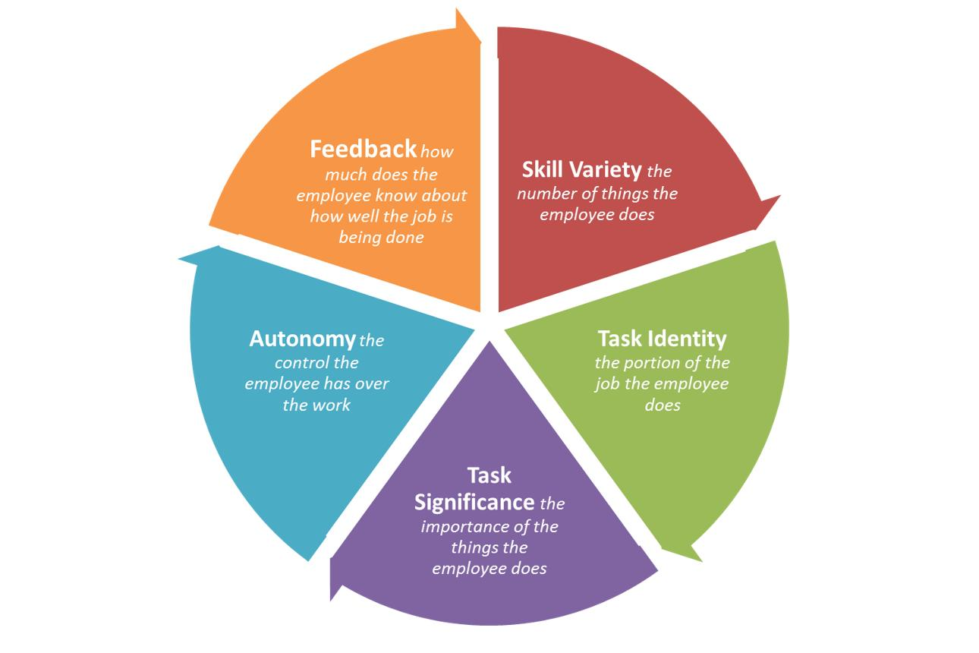
Moreover, traditional appraisals usually focus on individual performance measures and ignore collaboration and team-based results, which are important in knowledge-intensive industries (Cappelli and Tavis, 2016). This misalignment can result in disengagement, lack of motivation, and higher turnover rates.
Another limitation is the lack of participation of employees in the process of goal-setting. When employees believe performance evaluations are unfair or far removed from their day-to-day efforts at work, this destroys trust and organisational commitment (Aguinis, 2019). Therefore, there is increasing demand for more flexible, transparent and development-oriented performance management systems.

3. Proposed Modern Performance Management System
To overcome these limitations, Aether Innovations should implement a continuous performance management system that combines Objectives and Key Results (OKRs) and 360-degree feedback.

3.1 Objectives & Key Results (OKRs)
OKRs are a goal-setting framework that brings together individual, team and organisational goals by means of measurable results. Widely used by leading technology companies like Google, OKRs foster transparency, accountability and strategic alignment (Doerr, 2018).
The implementation of OKRs at Aether Innovations would involve having ambitious but achievable objectives at all organisational levels with clearly defined key results. This approach motivates employees to focus on outcomes, rather than activities, to encourage a results-oriented culture.
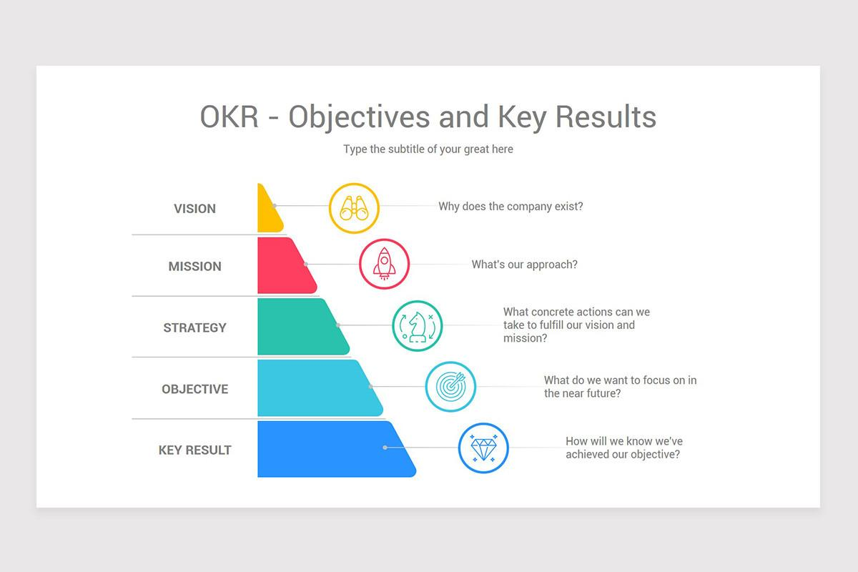
Critically, OKRs are reviewed often - usually quarterly, which means there is agility and adaptability to adjust to changing business conditions. This is in contrast to traditional annual appraisals which can often be too rigid and out of date by the time feedback is given.

3.2 360-Degree Feedback
Complementing OKRs, 360-degree feedback is gathering feedback on an individual's performance from a variety of sources such as peers, subordinates and supervisors. This is a more holistic and balanced approach towards the employee performance (London and Smither, 2015).
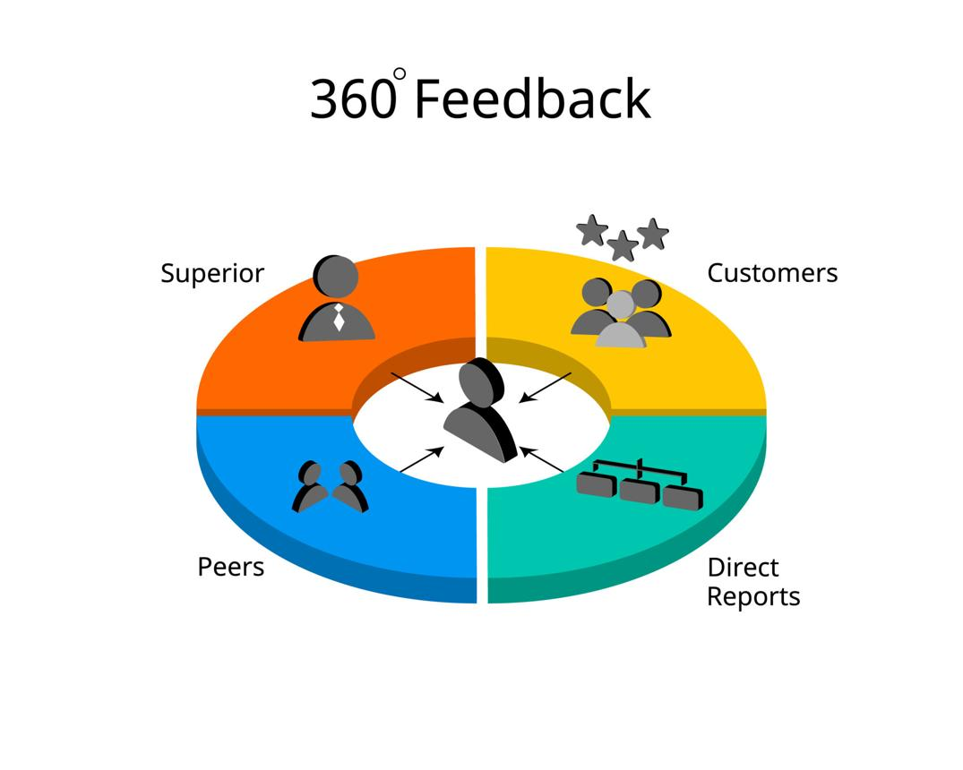
In the context of Aether Innovations, 360 degree feedback may be used to improve collaboration and accountability recognition of contributions beyond formal job roles. It also aids in developing leadership skills through insights on interpersonal and managerial skills.
However, it is imperative to implement this system carefully so as not to introduce biases and ensure constructive feedback. Providing training to employees on how to provide and receive feedback is very important to the success of feedback.

3.3 Integration and Benefits
The combination of OKRs and 360 degree feedback forms a continuous, development-focused system of performance management. This approach ensures that employees are more engaged, their individual contribution is aligned with organisational goals, and it also helps to foster a culture of continuous learning and improvement.

4. Job Design and Analysis on Key Jobs
Effective job design is very important in order to maximise the motivation and performance of the employees. The Job Characteristics Model (Hackman and Oldham, 1976) describes five fundamental dimensions that affect job satisfaction and performance (i.e. skill variety, task identity, task significance, autonomy, feedback).
Applying this model, Aether Innovations should craft key roles to increase intrinsic motivation and innovation.

4.1 CEO (Chief Executive Officer)
- Job Description: Strategic leadership, vision setting, stakeholder management.
- Enhancements: Increased autonomy in decision-making and cross-functional collaboration.
- Skills Required: Strategic thinking, leadership, adaptability.

4.2 CFO (Chief Financial Officer)
- Job Description: Financial planning, risk management, investment decisions.
- Enhancements: Integration with innovation initiatives to support strategic investments.
- Skills Required: Analytical skills, financial expertise, strategic alignment.

4.3 CTO (Chief Technology Officer)
- Job Description: Technology strategy, product development, infrastructure management.
- Enhancements: Greater autonomy in experimentation and adoption of emerging technologies.
- Skills Required: Technical expertise, innovation capability, leadership.

4.4 CIO (Chief Innovation Officer)
- Job Description: Driving innovation, managing R&D initiatives, fostering creativity.
- Enhancements: High task significance and autonomy to lead innovation programs.
- Skills Required: Creativity, strategic vision, change management.

4.5 HR Director
- Job Description: Talent management, organisational development, employee engagement.
- Enhancements: Expanded role in shaping organisational culture and learning strategies.
- Skills Required: Interpersonal skills, strategic HRM, leadership.

4.6 Head of R&D
- Job Description: Research and development, product innovation, team leadership.
- Enhancements: Increased skill variety and feedback mechanisms through cross-functional projects.
- Skills Required: Technical expertise, creativity, collaboration.

4.7 Skills-Based Job Design
In addition to role redesign, Aether Innovations should adopt a skills-based approach, where employees are valued for their competencies rather than fixed job titles (Cappelli, 2020). This allows for greater flexibility, adaptability, and career development opportunities.

5. Integration: Building a Performance-Driven Culture
The integration of modern performance management systems and enhanced job design is the key to establishing a performance-driven culture. While performance management helps set direction and accountability, job design helps ensure that employees are motivated and able to accomplish their goals.
At Aether Innovations, the alignment between OKRs and redesigned job roles ensures that the employees understand the contribution of their work towards organisational success. Continuous feedback mechanisms provide further support to learning and improvement and job characteristics add to intrinsic motivation.
This integrated approach deals with the causes of the challenges faced by the organisation - low engagement, high turnover, and declining performance - by developing a system in which employees are both empowered and accountable.

6. Conclusion
In conclusion, the importance of re-engineering performance management and job design is critical to Aether Innovations in order to gain its competitive edge back. By replacing traditional appraisal systems with continuous, development-focused approaches and redesigning jobs to increase motivation and innovation, the organisation can develop a high performing culture. The integration of these systems ensures that there is an alignment of individual and organisational goals to ultimately drive sustainable growth and customer satisfaction.

Part 2: Reflective Analysis and Development in the Future

2.1 Reflection Using Gibbs Reflective Cycle
Reflective practice is an essential aspect of professional development, specifically in the field of Human Resource Management (HRM) in which continuous learning and adaptation are key. This section uses Gibbs Reflective Cycle (1988) to reflect on my learning journey throughout the Human Capital Management module and how it impacts on my professional development.
Description
Throughout this module, I was introduced to a wide range of concepts of HRM, such as performance management, job design, talent management, and organisational culture. Initially, my knowledge base of HR was more administrative in nature - recruitment and basic employee management. However, the module gave more in depth knowledge about the role of HR to perform strategic functions for people to be aligned with organisational goals.
A key learning experience was the understanding of the role that integrated Human resource practices such as performance management systems and job design play in influencing organisational outcomes. The case of Aether Innovations emphasised the need for HR strategies to be aligned with business strategies in order to solve problems such as employee disengagement and falling performance.

Feelings
At the start of the module I was unsure about my ability to think critically about the theories in the field of HR and apply them to a real-life situation. The complexity of models like the Job Characteristics Model and the modern performance management frameworks appeared at first to be overwhelming.
However, as I delved deeper into the material, I gained more and more confidence. I started to value the relevance of HRM in driving organisational success. The process of applying theoretical concepts to practical scenarios was especially rewarding as it helped me see the implications of HR strategies in a real world setting.

Evaluation
The module was of helped me a lot to increase my knowledge about strategic HRM. One of the most beneficial aspects was the focus on integrating different HR practices as opposed to thinking about them in isolation. This holistic view is important in terms of designing effective human resource strategies.
But what I struggled with was that I had to do more than just describe existing practices, but that I had to be critical of them. Developing a critical mindset meant being more in-depth with the academic literature and challenging accepted approaches. This was at first hard but it eventually improved my analytical skills.
Additionally, the use of case-based learning was helpful for bridging the gap between theory and practice. It allowed me to apply some concepts such as OKRs and job design models to realistic organisational issues and improve my working knowledge.

Analysis
This learning experience can be related to Kolb's Experiential Learning Theory (1984) which emphasises learning by experience, reflection, conceptualisation and experimentation. By doing things that relate to the real world I was able to transition from theoretical understanding to practical application.
Furthermore, the module emphasised on the importance of motivation and engagement of employees in the success of organisations. The Job Characteristics Model showed the impact of job design in intrinsic motivation and performance management systems like OKRs focused on alignment and continuous improvement.
Critically I have come to realise that HRM is not just a support function, but a strategic partner in organisational achievement. This correspond to Ulrich's (1997) model of HR as a strategic business partner which emphasises the role of HR in creating value for the organisation.

Conclusion
In conclusion, this module has made a great difference to my understanding of HRM from an administrative function to a strategic discipline. I have gained the skill to critically evaluate HR practices and have been able to apply theoretical models to real-life situations.
The important lesson in this learning journey should be the importance of integration in HR practices. Effective performance management and job design must work together, in order to create a motivated and high-performing workforce.

Action Plan
Moving forward, I plan to further develop my skills in the field of strategic HRM by:
- Keeping up with current research and industry trends to keep up with new HR practices
- Developing my analytical and critical thinking skills through constant practice
- Potential graduate related to HR strategy
- Improving my communication and leadership skills in implementing HR initiatives
Additionally, I strive to have a growth mindset and be open to learning and adapting to stay relevant in a fast-changing work environment.

2.2 Staying Relevant in the Age of Artificial Intelligence
The accelerated growth of Artificial Intelligence (AI) is changing the nature of work in industries, including HRM. AI technologies are increasingly able to do such routine and data-driven tasks as recruitment screening, performance analytics, and employee engagement tracking (Brynjolfsson and McAfee, 2017). While this offers opportunities for efficiency, there are also a number of concerns for job displacement.
To be relevant in this changing landscape it is important to concentrate on the skills that AI cannot replicate easily. These are critical thinking, emotional intelligence, creativity, and strategic decision-making. In the context of HRM, the human element is still important in areas like leadership, employee engagement, and organisational culture.
Instead of seeing AI as a threat, I am going to use it as a tool to be more effective. For instance, AI may be used to analyse employee data and spot trends, to make more informed decisions. It can also be used to automate administrative tasks, freeing up HR professionals to work on more strategic tasks.
However, it is important to strike a balance between adopting technology and using human judgment. Over-reliance on AI could bring certain ethical concerns, such as bias in decision-making and a decreased human interaction. Therefore, HR professionals must ensure that AI is used responsibly and ethically.
To strike this balance, I aim to grow digitally literate and familiar with AI tools applicable for HRM. At the same time, I will continue to build on my interpersonal and leadership skills, which are crucial for building trust and fostering a positive organisational culture.
In conclusion, the future of work will demand a mix of technological abilities and human-centered abilities. With the help of AI, I can bring out the best of my skills and stay competitive in the changing job market by adopting an AI as a supportive tool, not a replacement.

References
Aguinis, H. (2019) Performance Management. 4th edn. Chicago: University of Chicago Press.
Armstrong, M. and Taylor, S. (2023) Armstrong’s Handbook of Human Resource Management Practice. 16th edn. London: Kogan Page.
Cappelli, P. (2020) Talent on Demand: Managing Talent in an Age of Uncertainty. Boston: Harvard Business School Press.
Doerr, J. (2018) Measure What Matters: OKRs – The Simple Idea that Drives 10x Growth. London: Portfolio Penguin.
Hackman, J.R. and Oldham, G.R. (1976) ‘Motivation through the design of work’, Organizational Behavior and Human Performance, 16(2), pp. 250–279.
Ulrich, D. (1997) Human Resource Champions. Boston: Harvard Business School Press.
Cappelli, P. and Tavis, A. (2016) ‘The performance management revolution’, Harvard Business Review, 94(10), pp. 58–67.
DeNisi, A. and Murphy, K.R. (2017) ‘Performance appraisal and performance management: 100 years of progress?’, Journal of Applied Psychology, 102(3), pp. 421–433.
London, M. and Smither, J.W. (2015) ‘Feedback orientation, feedback culture, and the longitudinal performance management process’, Human Resource Management Review, 25(2), pp. 164–184.
Pulakos, E.D., Hanson, R.M., Arad, S. and Moye, N. (2019) ‘Performance management can be fixed: An evidence-based approach’, Industrial and Organizational Psychology, 12(3), pp. 303–326.

Appendix
Appendix : OKRs Framework for Aether Innovations
Organisational Objective | Key Results (Measurable Outcomes) | Responsible Role
Improve customer satisfaction | Increase customer satisfaction score by 20% within 6 months | CEO / HR Director
Enhance innovation output | Launch 3 new innovative products annually | CTO / CIO / Head of R&D
Reduce employee turnover | Decrease turnover rate by 15% within 1 year | HR Director
Improve employee engagement | Achieve 85% engagement score in internal surveys | HR Director
Increase revenue growth | Achieve 25% annual revenue growth | CEO / CFO

Appendix : 360-Degree Feedback Structure
Feedback Source | Focus Area | Purpose
Supervisors | Performance outcomes, goal achievement | Evaluate strategic alignment
Peers | Teamwork, collaboration, communication | Enhance team effectiveness
Subordinates | Leadership, support, communication | Improve leadership quality
Self-assessment | Personal reflection, strengths, weaknesses | Encourage self-development

