Applied Computing
(data & information systems):
Introduction to web and database concepts
Assignment 1: html & css web development
November 15, 2025
Chris Powell (2508868)
2508868@student.uwtsd.ac.uk

Table of Contents
Introduction 3
Requirements 3
Website Purpose 3
Target Audience 4
Implementation 5
Page Content 5
Home 5
About Us 7
Contact Us 8
Website Validation 9
HTML Validation 9
CSS Validation 10
Evaluation 10
Usability 10
Terminology Research 10
Site Usability Evaluation 10
Accessibility 10
Terminology Research 10
Site Accessibility Evaluation 10
Search Engine Optimisation (SEO) 10
Terminology Research 10
Site SEO Evaluation 10
Similar Website Comparison 11
Site A 11
Site B 11
Conclusion 11
References 11
Appendices 11

Introduction
This report will try to critically assess the development process of a multi-page static website; with a critical evaluation of its functionality vs it’s intended purpose. It will assess factors including the below, as well as describing their importance in web development:
- Usefulness
- Accessibility
- Search Engine Optimisation (SEO)
There will also be a comparison of my created website against several other websites that have a similar intended purpose.

Requirements

Website Purpose
This website was built to be an information repository, and front door enabling customers to contact, a fictional IT consultancy company called ‘DataSage’.
To effectively promote such a company there are several elements that are needed:
- Company overview
- Product offering
- Pricing structure
- Method for clients to contact
Given the subject matter covered by the company services, the website needs to be an immediate showcase of technical ability, with clean visuals and simple but impressive touches that make a website seem professional, making the company seem reputable and capable.
There finally needs to be frequent calls-to-action for prospective clients to be able to contact the company from anywhere on the site.

Target Audience
This website it is targeting individuals, as well as small to medium sized businesses that are looking for support with any IT related issue/project they may have. To this end, the SEO must enable high discoverability for this audience.
A professional, clean, and polished looking site is key to attracting the business of these potential clients. Succinct, relevant information as well as regular calls-to-action will make it easy for the target audience to progress through the sales funnel.

Implementation

Page Content

Home
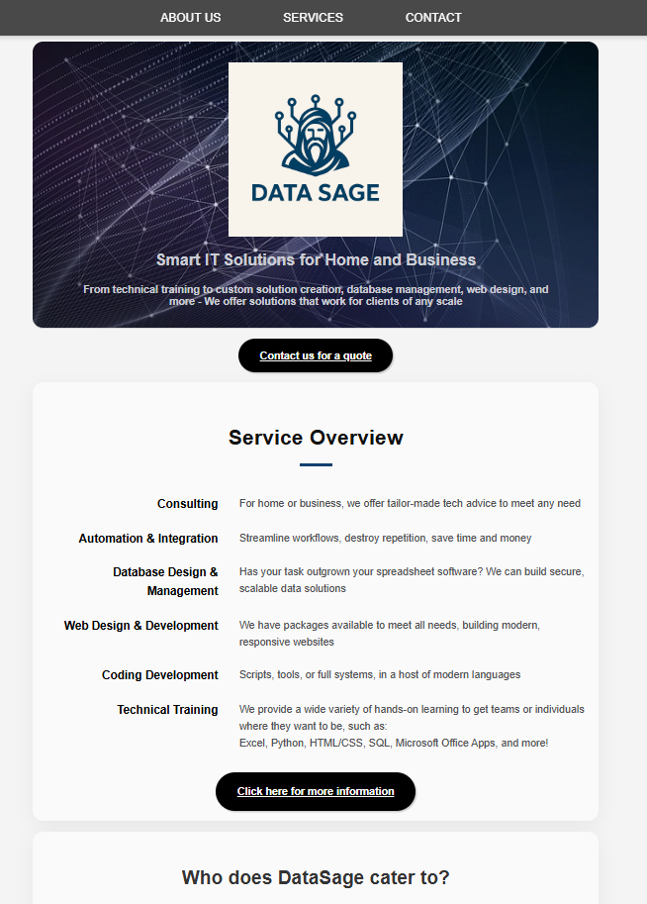
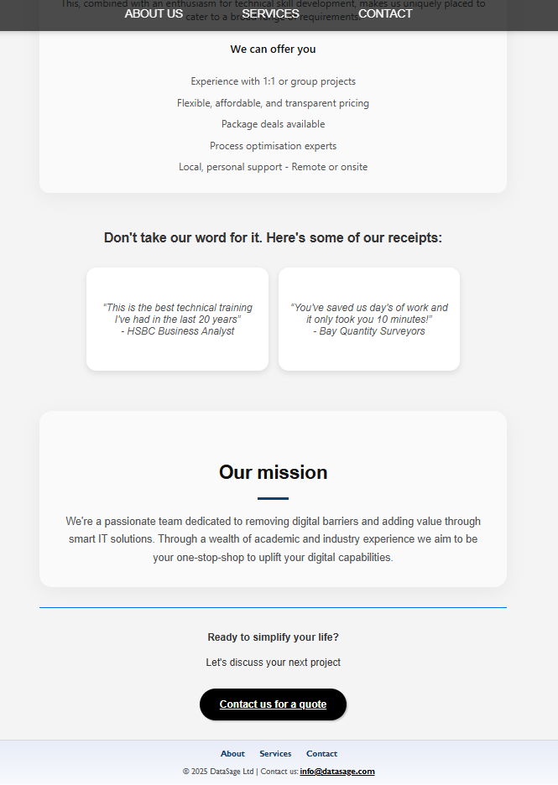

About Us
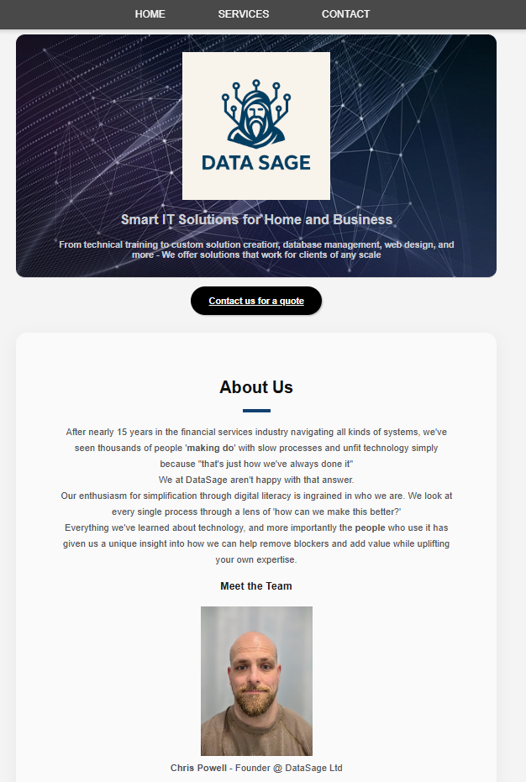

Contact Us
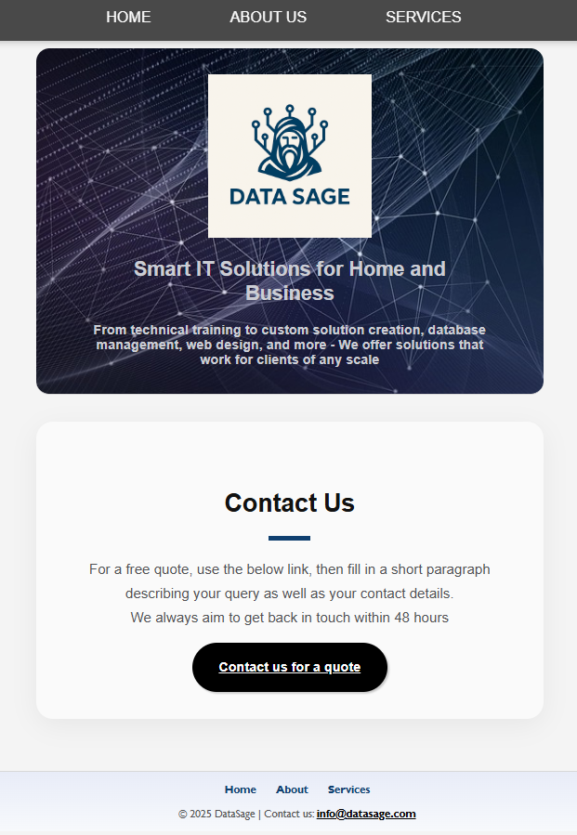

Website Validation
When creating websites, it is critical to ensure that your code has the correct syntax and adheres to the correct development standards. This will ensure that your site will be able to work not only in your development environment, but also a variety of other browsers and browser versions, ensuring the maximum possible reachable audience. It also contributes to better SEO, improving site discoverability.
There are various validators that developers can use to check that their HTML & CSS code are correct and compliant; we will use W3 to check the DataSage site, before correcting any potential errors that may be identified.

HTML Validation
On first assessment, the validator identified several errors that needed to be corrected for full compliance. As seen in the below screenshot, I used backslashes instead of forward slashes when referencing images, and I also had spaces in a filename.
While my website seemed to work correctly for me in my development environment, these issues may have caused compatibility issues on other machines/browsers.
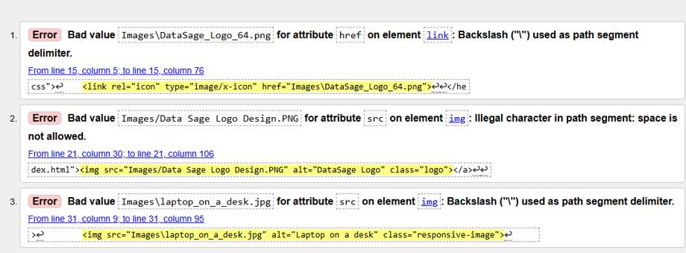

Once these errors were corrected, I received the below confirmation that there were no more errors found.
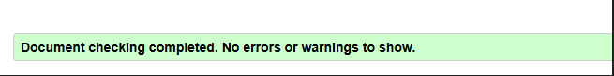

CSS Validation
On evaluation, no errors were identified with my CSS code, meaning it is syntactically correct and compliant.
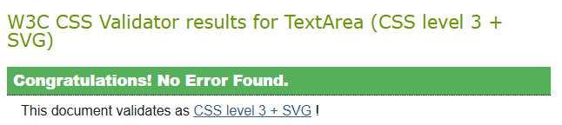

Evaluation

Terminology Research

Usability
How easily a visitor to a website can navigate its content, and find the information/service they’re looking for, is very closely linked to visitor satisfaction, as well as higher site traffic and repeat visits [1]. How ‘usable’ a website is depends on several factors:
- Navigation – How quickly and easily a visitor can access what they’re looking for
- Response time – how quickly a page loads.
- Content – information relevance, quality, and quantity, with the most relevant information viewable early.
- Interactivity and responsiveness – supporting simple and valuable interactions with content via means such as familiar icons and links.
Usability is arguably the most key consideration of web design, as if a site isn’t usable for it’s intended audience, then it considerably more likely to fail in its intended purpose.

Accessibility
To put it simply, an accessible website is one that allows people with disabilities to use the web [2] in the same manner that able people are. There is also a secondary benefit in that it even increases usability for non-disabled by giving flexibility according to individual preferences.
Accessible websites cater to users with impairments like physical mobility, hearing loss, vision impairment, or even neurological deficiencies.
To retrofit a website with accessibility in mind can be costly and time consuming, so designing for it up front is something that every web developer should keep in mind.

Search Engine Optimisation (SEO)
Search Engine Optimisation is a key marketing technique used to improve a website’s findability to potential visitors, therefore increasing user traffic and saving a company money that would have been otherwise spent on expensive marketing campaigns [3]. Proper SEO also moves a website higher in search results, which can build visitor credibility and trust [4].
SEO involves adequate on-page content, keywords, and metadata to allow it to show up in search results, technical best practises (e.g. site responsiveness, mobile compatibility, etc) to allow search engines to index effectively, and what’s known as ‘off-page SEO’ to build website credibility, such as other sites linking back to yours. Adequate image labelling with descriptive alt text is also important so that they would show up in image searches.
To summarise, if we want a website to succeed, it is in our best interest to optimise for SEO as every opportunity.

Evaluation of my Website

Usefulness
For my website ‘DataSage’ showcases a simple but strong design, intended to make navigation to relevant information as simple as possible with ample opportunities to do so no matter where you are on the website. This is done with several different ‘calls-to-action’ placed strategically around each different content section, as well as a floating navigation bar that is always visible at the top of the screen no matter what page you’re on.
Each page has consistent visual design, being very mindful to keep it professional and aesthetic, using lots of negative space and neutral colours to not overwhelm visitors with ‘clutter’.
There are several simple but powerful design choices used to showcase technical ability, such as the ‘on-hover’ expanding underline. Given the intended website purpose, this will give users confidence in the credibility of the services that the site is promoting.
The content of the site has been consciously ordered from most important to least important, ensuring that visitors need to spend only the minimum possible time finding what they need. The detailed information on each topic is then separated out from the main homepage into various sub-pages, allowing easy browsing on first site visit with more detail available only when a visitor wants it.
Improvement Suggestions
- Build out a rolling testimonial bar that is live linked to a review website such as google reviews. This would prevent the need to update testimonials manually
- Enhance the ‘contact us’ functionality so that instead of just opening a user’s email provider of choice, I could build a web form linked to a database. This would allow building of a contact list for additional marketing opportunities.
- Add more detailed content, such as an FAQ section or more dynamic service pricing information.

Accessibility
The website has been designed with several accessibility features in mind according to the WCAG accessibility principles. The browser extension ‘Wave’ has been used to assess the accessibility of the home page according to these principles, and returned with a score of 8.4/10, meaning it is highly accessible, with some areas that could be improved. The below screenshot showcases the only accessibility ‘errors’ that the tool highlighted; the contrast between the header image and the text overlaid on top.
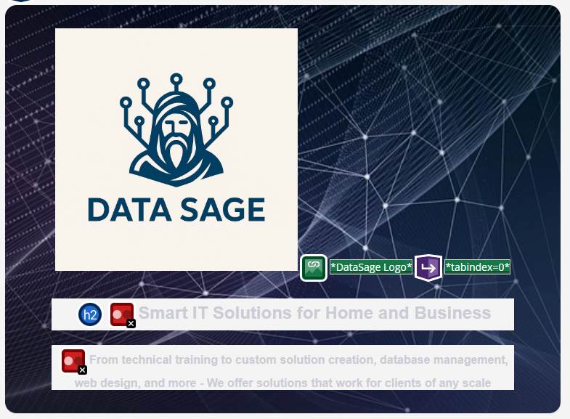
[Screenshot of ‘Wave’ accessibility assessment]

Outside of the above example, the remaining areas highlighted for improvement were classed as ‘Alerts’. While they don’t strictly impact accessibility they should still be addressed to ensure maximum compatibility.
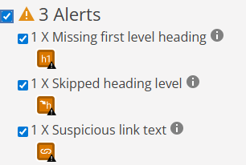
[Screenshot of ‘Wave’ Alerts]
Other areas considered in the design according to WCAG were:
- Perceivability: colour scheme and text contrast ensures users can adequately read the content, with alt text added to images so users of screen readers can understand the content
- Operability: Easily navigable with intuitive interface. Use of tabindex enables keyboard navigation of all key links. Floating navbar ensures navigation is easy from any part of any page.
- Understandability: Content is highly structured, with most important information being higher up on each page. The language used is simply to understand for people of many abilities.
- Robustness: Dynamic page sizing ensures the page is usable across multiple screen sizes/device types. The HTML and CSS has been assessed to ensure compliancy between multiple browsers & browser versions.
Overall, I’m comfortable that with some very minor tweaks, the site will be fully accessible.
Improvement Suggestions
- Adjust contrast of header image, perhaps even add a text background to enable
- Address ‘alerts’ by changing the heading levels used
- Perhaps add even more detail to alt text to further support screen readers

Search Engine Optimisation (SEO)
Significant effort has been made to apply SEO techniques to the site so that it can reach the widest possible audience organically without additional marketing budget. Given the intended purpose of the website is to be a front door for business clients, getting high volumes of high-quality traffic is essential for it to meet its intended function.
Some of the techniques applied are:
- Detailed meta tags, including relevant keywords and the viewport tag for mobile compatibility.
- Clear HTML & CSS structure that has been thoroughly validated for compatibility
- Descriptive titles to optimise the content for search engines, instead of generic titles.
- Images contain descriptive alt text
- Page URLs are simple and structured with relevant titles.
Improvement Suggestions
- Further metadata keyword optimisation
- Dynamic pages that make use of cookies so that the site would appear in location specific searches.
- Further enhance the information on page structure available to search engines

Similar Website Comparison
The two websites I will be comparing are ‘BCG Platinion’ (https://www.bcgplatinion.com/) and ‘Morgan&Morgan Business and Technology’ (https://www.mmbt.co.uk/). They are both IT consultancy businesses catering to a wide variety of clients, so serve the same intended purpose.

Comparison

Usability

BCGPlatinion
Information layout seems a bit scattered, with it not being very clear of the relevance of the information on screen. Examples like section titles and content not lined up, and moving text making it harder to read.
Navigation can be frustrating when scrolling down the page, primarily due to page delays. Initially on first page load while an animation plays, and then while moving down the page it seems to ‘stop’ for further animated images to progress through their cycle.
A combination of the above leads to, in my opinion, sacrificing user experience for the sake of ‘showing off’ technical ability.

MMBT
Layout is simple and intuitive, with no unnecessary bells and whistles. It’s not too text heavy or cluttered. Navigation is in line with the current industry standard, so is intuitive to user, leading to a consistent and pleasant user experience.

Accessibility

BCGPlatinion
Score of 2.5 / 10 with over 120 ‘Wave’ errors and 460 additional alerts.
Darker background colours hinder contrast and therefore readability.

MMBT
Score of 5 / 10 with just under 20 errors and 101 additional alerts.

SEO
Compare meta tags, titles, alt attributes, and heading structures

BCGPlatinion
Page appears to load without delays (i.e. responsive).
Significant quantity of alt text is missing, and a significant unbalanced ratio of heading levels 3 present when compared to heading level 2, indicating poor page structure.
Lots of ‘content’ meta tags present to adequately describe the site elements. No ‘viewport’ tag apparent. No ‘keywords’ meta tag is apparent.

MMBT
Page appears to load without delays (i.e. responsive).
No missing alt text, page structure seems ordered and easy to follow.
Lots of ‘content’ meta tags present to adequately describe the site elements. ‘Viewport’ tag is present to scale for mobile. No ‘keywords’ meta tag is apparent.

Mobile Friendliness

BCGPlatinion
Page appears to adjust content dynamically when on mobile devices. This makes some content easier to follow when compared to the desktop site. It does have the same frustrating navigation elements as the desktop site, however.

MMBT
Page appears to also adjust content dynamically on mobile devices. No detrimental effects on usability or user experience were apparent

Comparison Conclusion
Overall, MMBT gives a cleaner website experience that more effectively caters to the modern internet user by keeping things simple and responsive. While BCGPlatinion provides a more advanced technical showcase, they come to the detriment of overall user experience and accessibility. Given the target audience this could lead to reduced engagement rates in the long term, working against the overall website goal.
MMBT seems to prioritise user experience over the ‘flashy’ animations, keeping navigation intuitive and considering accessibility.
Both sites are mobile responsive, and both seem to adequately consider meta tags to try to optimise SEO performance.

References

[1] | J. Palmer, “Designing for Web site usability,” Computer (Long Beach, Calif.), vol. vol. 35, no. no. 7, pp. 102-103, 2002.
[2] | J. Thatcher, Web accessibility : web standards and regulatory compliance, 1st ed., Berkeley: FriendsofED, 2006.
[3] | J. M. a. N. A. B. U. F. Ahmad, “Search engine optimisation (SEO) strategy as determinants to enhance the online brand positioning,” F1000 research, vol. vol. 11, p. 714, 2022.
[4] | “Brand authority: The role of SEO in establishing and maintaining it,” BusinessCloud, 3 Jul 2024. [Online]. Available: https://businesscloud.co.uk/news/brand-authority-the-role-of-seo-in-establishing-and-maintaining-it/. [Accessed 17 Nov 2025].

Appendices

index.html
<!DOCTYPE html>
<html lang="en">

<!-- Metadata, Title information, and stylesheet link -->
<head>
<meta charset="UTF-8">
<meta name="viewport" content="width=device-width, initial-scale=1.0">
<meta name="description" content="Home page for DataSage IT Solutions.">
<meta name="keywords" content="DataSage, Tech, Innovation, Data, Automation, IT, Home, Business,
Consulting, Simplification, Web Design, Databases, Database,
Programming, Training, Python, Cyber Security, Home">
<meta name="author" content="Chris L Powell (2508868)">
<meta name="viewport" content="width=device-width, initial-scale=1.0">
<title>DataSage IT Solutions - Home</title>
<link rel="stylesheet" href="style.css">
<link rel="icon" type="image/x-icon" href="Images/DataSage_Logo_64.png">

</head>

<body>
<!-- Moving top navigation bar -->
<header>
<nav class="navbar">
<ul>
<li><a tabindex="0" href="about.html">About Us</a></li>
<li><a tabindex="0" href="services.html">Services</a></li>
<li><a tabindex="0" href="contact.html">Contact</a></li>
</ul>
</nav>
</header>

<!-- Main content -->
<main>
<div class="main-head"><a tabindex="0" href="index.html"><img src="Images/Data_Sage_Logo.PNG" alt="DataSage Logo" class="logo"></a>

<h2>Smart IT Solutions for Home and Business</h2>
<p>From technical training to custom solution creation, database management, web design, and more - We offer
solutions that work for clients of any scale</p>
</div>
<div class="button-wrapper">
<a class="button cta-button" tabindex="0" href="contact.html">Contact us for a quote</a>
</div>

<section id="offering">
<h4>Service Overview</h4>

<dl>
<dt>Consulting</dt>
<dd>For home or business, we offer tailor-made tech advice to meet any need</dd>
<dt>Automation & Integration</dt>
<dd>Streamline workflows, destroy repetition, save time and money</dd>
<dt>Database Design & Management</dt>
<dd>Has your task outgrown your spreadsheet software? We can build secure, scalable data solutions
</dd>
<dt>Web Design & Development</dt>
<dd>We have packages available to meet all needs, building modern, responsive websites</dd>
<dt>Coding Development</dt>
<dd>Scripts, tools, or full systems, in a host of modern languages</dd>
<dt>Technical Training</dt>
<dd>We provide a wide variety of hands-on learning to get teams or individuals where they want to be, such as:
<br>
Excel, Python, HTML/CSS, SQL, Microsoft Office Apps, and more!
</dd>
</dl>
<div class="button-wrapper">
<a class="button cta-button" tabindex="0" href="services.html">Click here to find out more about our services</a>
</div>
</section>
<section id="clients">
<h4>Who does DataSage cater to?</h4>

<h5>For Businesses</h5>
<p>We offer a range of services for businesses of all sizes, from single person operations up to
multinational organisations.</p>
<dl>
<dt>IT Strategy Design</dt>
<dd>Is your business growing? We can guide and design your IT to scale with you</dd>
<dt>Process simplification / Automation</dt>
<dd>Save time to dedicate to your flagship deliverables</dd>
<dt>Technical Training</dt>
<dd>Improve your workforce and employee engagement/retention</dd>
<dt>Data Systems</dt>
<dd>Let us enhance your software for you</dd>
</dl>
<h5>For Home Users</h5>
<p>No usecase too small, we can provide Sage advice even on an individual level.</p>
<dl>
<dt>Tech Set-up</dt>
<dd>We can help get you started for education, work, or personal projects</dd>
<dt>Automation</dt>
<dd>Our personal time is valuable, why not remove admin?</dd>
<dt>Smart Home Integration</dt>
<dd>Design and build a home of the future</dd>
<dt>Tutoring</dt>
<dd>Learning new skills or just a little rusty? We can help</dd>
</dl>
</section>
<section id="value_proposition">
<h4>Why choose DataSage?</h4>
<p>We have over a decade of enterprise experience in both hands-on and strategic roles, delivering millions
of £'s worth of value in that time.</p>
<p>This, combined with an enthusiasm for technical skill development, makes us uniquely
placed to cater to a broad range of requirements.</p>
<h5>We can offer you</h5>
<ul>
<li>Experience with 1:1 or group projects</li>
<li>Flexible, affordable, and transparent pricing</li>
<li>Package deals available</li>
<li>Process optimisation experts</li>
<li>Local, personal support - Remote or onsite</li>
</ul>
</section>
<section id="testimonials">
<h4>Don't take our word for it. Here's some of our receipts:</h4>
<p><q>This is the best technical training I've had in the last 20 years</q> - HSBC Business Analyst</p>
<p><q>You've saved us day's of work and it only took you 10 minutes!</q> - Bay Quantity Surveyors</p>
</section>
<section id="info_section">
<h4>Our mission</h4>
<p>We're a passionate team dedicated to removing digital barriers and adding value through smart IT
solutions. Through a wealth of academic and industry experience we aim to be your one-stop-shop
to uplift your digital capabilities.</p>
</section>
<section id="call_to_action">
<h4>Ready to simplify your life?</h4>
<p>Let's discuss your next project</p>
<div class="button-wrapper">
<a class="button cta-button" tabindex="0" href="contact.html">Contact us for a quote</a>
</div>
</section>
</main>

<footer>
<nav>
<ul>
<li><a tabindex="0" href="about.html">About</a></li>
<li><a tabindex="0" href="services.html">Services</a></li>
<li><a tabindex="0" href="contact.html">Contact</a></li>
</ul>
</nav>
<p>&copy; 2025 DataSage Ltd |
Contact us: <a tabindex="0" href="mailto:info@datasage.com">info@datasage.com</a></p>
</footer>
</body>

</html>

about.html
<!DOCTYPE html>
<html lang="en">

<head>
<meta charset="UTF-8">
<meta name="viewport" content="width=device-width, initial-scale=1.0">
<meta name="description" content="About page for DataSage IT Solutions.">
<meta name="keywords" content="DataSage, Tech, Innovation, Data, Automation, IT, Home, Business,
Consulting, Simplification, Web Design, Databases, Database,
Programming, Training, Python, Cyber Security, About">
<meta name="author" content="Chris L Powell (2508868)">
<meta name="viewport" content="width=device-width, initial-scale=1.0">
<title>DataSage IT Solutions - About Us</title>
<link rel="stylesheet" href="style.css">
<link rel="icon" type="image/x-icon" href="Images/DataSage_Logo_64.png">
</head>

<body>
<header>
<nav class="navbar">
<ul>
<li><a tabindex="0" href="index.html">Home</a></li>
<li><a tabindex="0" href="services.html">Services</a></li>
<li><a tabindex="0" href="contact.html">Contact</a></li>
</ul>
</nav>
</header>

<main>
<div class="main-head"><a tabindex="0" href="index.html"><img src="Images/Data_Sage_Logo.PNG" alt="DataSage Logo" class="logo"></a>

<h2>Smart IT Solutions for Home and Business</h2>
<p>From technical training to custom solution creation, database management, web design, and more - We offer
solutions that work for clients of any scale</p>
</div>
<div class="button-wrapper">
<a class="button cta-button" tabindex="0" href="contact.html">Contact us for a quote</a>
</div>
<section id="info_section">
<h4>About Us</h4>
<p>After nearly 15 years in the financial services industry navigating all kinds of systems, we've seen
thousands of people '<b>making do</b>'
with slow processes and unfit technology simply because "that's just how we've always done it"</p>
<p>We at DataSage aren't happy with that answer.</p>
<p>Our enthusiasm for simplification through digital literacy is ingrained in who we are. We look at every
single process through a lens of 'how can we make this better?'</p>
<p>Everything we've learned about technology, and more importantly the <b>people</b> who use it has given us
a unique insight into how we can help remove blockers and add value while uplifting your own expertise.
</p>
<h3>Meet the Team</h3>
<div>
<img src="Images\Chris_Powell_Image.PNG" alt="Chris Powell - Founder of DataSage">
<p><b>Chris Powell</b> - Founder @ DataSage Ltd</p>
</div>
</section>
</main>

<footer>
<nav>
<ul>
<li><a tabindex="0" href="index.html">Home</a></li>
<li><a tabindex="0" href="services.html">Services</a></li>
<li><a tabindex="0" href="contact.html">Contact</a></li>
</ul>
</nav>
<p>&copy; 2025 DataSage |
Contact us: <a tabindex="0" href="mailto:info@datasage.com">info@datasage.com</a></p>
</footer>

</body>

</html>

services.html
<!DOCTYPE html>
<html lang="en">

<head>
<meta charset="UTF-8">
<meta name="viewport" content="width=device-width, initial-scale=1.0">
<meta name="description" content="About page for DataSage IT Solutions.">
<meta name="keywords" content="DataSage, Tech, Innovation, Data, Automation, IT, Home, Business,
Consulting, Simplification, Web Design, Databases, Database,
Programming, Training, Python, Cyber Security, About">
<meta name="author" content="Chris L Powell (2508868)">
<meta name="viewport" content="width=device-width, initial-scale=1.0">
<title>DataSage IT Solutions - About Us</title>
<link rel="stylesheet" href="style.css">
<link rel="icon" type="image/x-icon" href="Images/DataSage_Logo_64.png">
</head>

<body>
<header>
<nav class="navbar">
<ul>
<li><a tabindex="0" href="index.html">Home</a></li>
<li><a tabindex="0" href="about.html">About Us</a></li>
<li><a tabindex="0" href="contact.html">Contact</a></li>
</ul>
</nav>
</header>

<main>
<div class="main-head"><a tabindex="0" href="index.html"><img src="Images/Data_Sage_Logo.PNG" alt="DataSage Logo" class="logo"></a>

<h2>Smart IT Solutions for Home and Business</h2>
<p>From technical training to custom solution creation, database management, web design, and more - We offer
solutions that work for clients of any scale</p>
</div>
<div class="button-wrapper">
<a class="button cta-button" tabindex="0" href="contact.html">Contact us for a quote</a>
</div>
<section id="info_section">
<h4>Pricing</h4>
<p>We customise the pricing for each project to suit your needs. For a quote, you can contact us via the above link.</p>
<p><strong>All</strong> quotations are free</p>
<p>Minimum service booking is for 30 minutes @ £100</p>
<p>Technical Training minimum booking starts at 5 hours, with length varying depending on the training in question and your requested training level.</p>

</section>
<section id="offering">
<h4>Services</h4>
<dl>
<dt>IT Consulting</dt>
<dd>For home or business, we offer tailor-made tech advice to meet any need</dd>
<dt>Automation & Integration</dt>
<dd>Streamline workflows, destroy repetition, save time and money</dd>
<dt>Database Design & Management</dt>
<dd>Has your task outgrown your spreadsheet software? We can build secure, scalable data solutions</dd>
<dt>Web Design & Development</dt>
<dd>We have packages available to meet all needs, building modern, responsive websites</dd>
<dt>Coding Development</dt>
<dd>Scripts, tools, or full systems, in a host of modern languages</dd>
<dt>Technical Training</dt>
<dd>We provide a wide variety of hands-on learning to get teams or individuals where they want to be
<br>
Excel, Python, HTML/CSS, SQL, Microsoft Office Apps,
</dd>
</dl>
<div class="button-wrapper">
<a class="button cta-button" tabindex="0" href="contact.html">Contact us for a quote</a>
</div>
</section>

</main>

<footer>
<nav>
<ul>
<li><a tabindex="0" href="index.html">Home</a></li>
<li><a tabindex="0" href="about.html">About</a></li>
<li><a tabindex="0" href="contact.html">Contact</a></li>
</ul>
</nav>
<p>&copy; 2025 DataSage |
Contact us: <a tabindex="0" href="mailto:info@datasage.com">info@datasage.com</a></p>
</footer>

</body>

</html>

contact.html
<!DOCTYPE html>
<html lang="en">

<head>
<meta charset="UTF-8">
<meta name="viewport" content="width=device-width, initial-scale=1.0">
<meta name="description" content="About page for DataSage IT Solutions.">
<meta name="keywords" content="DataSage, Tech, Innovation, Data, Automation, IT, Home, Business,
Consulting, Simplification, Web Design, Databases, Database,
Programming, Training, Python, Cyber Security, About">
<meta name="author" content="Chris L Powell (2508868)">
<meta name="viewport" content="width=device-width, initial-scale=1.0">
<title>DataSage IT Solutions - About Us</title>
<link rel="stylesheet" href="style.css">
<link rel="icon" type="image/x-icon" href="Images/DataSage_Logo_64.png">
</head>

<body>
<header>
<nav class="navbar">
<ul>
<li><a tabindex="0" href="index.html">Home</a></li>
<li><a tabindex="0" href="about.html">About Us</a></li>
<li><a tabindex="0" href="services.html">Services</a></li>
</ul>
</nav>
</header>

<main>
<div class="main-head"><a tabindex="0" href="index.html"><img src="Images/Data_Sage_Logo.PNG" alt="DataSage Logo" class="logo"></a>

<h2>Smart IT Solutions for Home and Business</h2>
<p>From technical training to custom solution creation, database management, web design, and more - We offer
solutions that work for clients of any scale</p>
</div>

<section id="info_section">
<h4>Contact Us</h4>
<p>For a free quote, use the below link, then fill in a short paragraph describing your query as well as your contact details.</p>
<p>We always aim to get back in touch within 48 hours</p>
<div class="button-wrapper">
<a class="button cta-button" tabindex="0" href="mailto:info@datasage.com">Contact us for a quote</a>
</div>
</section>

</main>

<footer>
<nav>
<ul>
<li><a tabindex="0" href="index.html">Home</a></li>
<li><a tabindex="0" href="about.html">About</a></li>
<li><a tabindex="0" href="services.html">Services</a></li>
</ul>
</nav>
<p>&copy; 2025 DataSage |
Contact us: <a tabindex="0" href="mailto:info@datasage.com">info@datasage.com</a></p>
</footer>

</body>

</html>

style.css
/* Page settings */
html {
scroll-behavior: smooth;
font-size: 16px;
}

/* CTA Classes */
.button-wrapper {
display: block;
text-align: center;
padding-top: 1rem;
}

.button {
border: none;
border-radius: 3em;
box-shadow: 2px 2px 2px rgba(0, 0, 0, 0.2);
display: inline-block;
font-size: 1em;
padding: 1em 2em;
width: auto;
}

.cta-button {
background-color: #1d1d1f;
color: #fff !important;
}

.cta-button:hover {
background-color: #777;
transform: scale(1.03); /* slightly enlarges button */
box-shadow: 0 4px 8px rgba(0, 0, 0, 0.2); /* adds shadow */
}

#call_to_action {
padding-top: 1rem;
border-top: 0.1rem solid #0071e3;
text-align: center;
}

/* Default body */
body {
font-family: Arial, sans-serif;
background-color: #f4f4f4;
color: #333;
margin: 0;
}

body main {
padding-top: 4rem;
padding-left: 5rem;
padding-right: 6rem;
}

a {
color: black;
font-weight: bold;
}

a:hover {
color: #007BFF;
}

/* Header */
.main-head {
background-image: url(Images/header_image.png);
background-size: cover;
background-position: center;
background-repeat: no-repeat;
border-radius: 1rem;
padding: 2rem 4rem 1rem;
position: relative;
text-align: center;
font-weight: 700;
font-size: large;
color: white;
}

.main-head::before {
content: "";
position: absolute;
top: 0; left: 0;
width: 100%; height: 100%;
z-index: 0;
}

/* Keep logo above background image so that it's clickable/hoverable*/
.main-head * {
position: relative;
z-index: 1;
}

/* Floating Navbar */
.navbar {
background-color: rgba(0, 0, 0, 0.7);
position: fixed;
top: 0;
width: 100%;
z-index: 100;
padding: 1px 0;
text-align: center;
box-shadow: 0 2px 8px rgba(0, 0, 0, 0.2);
}
.navbar ul {
list-style: none;
}
.navbar ul li {
display: inline-block;
margin-right: 40px;
}
.navbar ul li a {
color: white;
font-size: 18px;
font-weight: 500;
text-transform: uppercase;
padding: 10px 20px;
transition: color 0.3s ease;
}
.navbar ul li a:hover {
color: #9abada;
}

body img.logo {
width: 25vw;
max-width: 40vh;
max-height: 40vh;
}

body img.logo:hover {
box-shadow: 0 4px 8px rgba(0, 0, 0, 0.2);
transform: scale(1.02);
}

/* Dynamic Re-sizing for mobile */
@media (max-width: 768px) {
body img.logo {
width: 25vw;
max-width: 150px;
}
#clients {
padding: 1.5rem 1rem;
}

#clients h4 {
font-size: 1.5rem;
}

#clients h5 {
font-size: 1.15rem;
}
}

main img {
width: 20vw;
max-width: 200px
}

/* Generic Nav menu */
nav ul {
list-style-type: none;
padding: 0px;
}

nav ul li {
display: inline;
margin: 0 10px;
}

nav ul li a {
color: white;
text-decoration: none;
}

/* Main styling */
main {
padding: 30px;
min-height: 100%;
/* margin-bottom: -100px */
}

/* Generic Info Section */
#info_section {
max-width: 800px;
margin: 2rem auto;
padding: 2rem;
background: #fafafa;
border-radius: 20px;
box-shadow: 0 8px 30px rgba(0, 0, 0, 0.05);
color: #1c1c1e;
text-align: center;
line-height: 1.7;
}

/* Section Title */
#info_section h4 {
font-size: 1.9rem;
font-weight: 600;
letter-spacing: -0.4px;
margin-bottom: 1.3rem;
color: #1d1d1f;
}

/* Main Text */
#info_section p {
font-size: 1.05rem;
color: #515154;
transition: color 0.3s ease;
}

/* Accent underline on hover */
#info_section h4::after {
content: "";
display: block;
width: 50px;
height: 5px;
background: #104070;
margin: 0.8rem auto 0;
transition: width 0.5s ease;
}

#info_section:hover h4::after {
width: 90px;
}

/* Service Overview Section */
#offering {
max-width: 850px;
margin: 1rem auto;
padding: 1rem;
background: #fafafa;
border-radius: 16px;
box-shadow: 0 8px 30px rgba(0, 0, 0, 0.05);
line-height: 1.6;
}

/* Section Heading */
#offering h4 {
text-align: center;
font-size: 2rem;
color: #1d1d1f;
}

/* Accent underline on hover */
#offering h4::after {
content: "";
display: block;
width: 50px;
height: 5px;
background: #104070;
margin: 0.8rem auto 0;
transition: width 0.5s ease;
}

#offering:hover h4::after {
width: 90px;
}

/* Definition List Layout */
#offering dl {
display: grid;
grid-template-columns: 1fr 2fr;
column-gap: 2rem;
row-gap: 1.5rem;
align-items: start;
}

/* Service Names */
#offering dt {
font-weight: 600;
font-size: 1.1rem;
color: #1d1d1f;
text-align: right;
transition: color 0.3s ease;
}

/* Service Descriptions */
#offering dd {
margin: 0;
color: #515154;
font-size: 1rem;
}

/* Subtle hover highlight */
#offering dt:hover {
color: #104070; /* Apple's blue */
}

/* Client Section */
#clients {
max-width: 850px;
margin: 1rem auto;
padding: 1rem;
background: #fafafa;
border-radius: 16px;
box-shadow: 0 8px 30px rgba(0, 0, 0, 0.05);
}

#clients:hover {
box-shadow: 0 12px 36px rgba(0, 0, 0, 0.08);
}

#clients h4 {
font-size: 1.8rem;
font-weight: 600;
text-align: center;
margin-bottom: 2rem;
}

#clients h5 {
font-size: 1.3rem;
font-weight: 600;
color: #104070;
margin-top: 2.5rem;
margin-bottom: 0.5rem;
}

#clients p {
color: #515154;
font-size: 1rem;
margin-bottom: 1.5rem;
}

#clients dl {
display: flex;
flex-flow: row wrap;
margin: 0;
padding: 0;
}

#clients dt {
flex-basis: 20%;
padding: 2px 4px;
text-align: right;
font-weight: 600;
color: #1d1d1f;
margin: 0.25rem 0 0.75rem 0;
font-size: 1.05rem;
}

#clients dd {
margin: 0.25rem 0 0.75rem 0;
padding-left: 1rem;
flex-basis: 70%;
border-bottom: 1px solid #333;
color: #515154;
border-left: 2px solid #e0e0e0;
transition: all 0.2s ease;
}

#clients dd:hover {
border-left-color: #0071e3;
color: #1d1d1f;
}

/* Value Proposition Section */
#value_proposition {
max-width: 850px;
margin: 1rem auto;
padding: 1rem;
background: #fafafa;
border-radius: 16px;
box-shadow: 0 8px 30px rgba(0, 0, 0, 0.05);
color: #515154;
text-align: center;
}

#value_proposition h4 {
font-size: 1.8rem;
font-weight: 600;
margin-bottom: 1.5rem;
color: #1d1d1f;
letter-spacing: -0.3px;
}

#value_proposition h5 {
font-size: 1.1rem;
font-weight: 600;
color: #1d1d1f;
}

#value_proposition ul {
list-style: none;
padding: 0;
display: flex;
flex-direction: column;
gap: 0.8rem;
align-items: center;
}

#value_proposition li {
position: relative;
font-size: 1rem;
color: #515154;
max-width: 500px;
text-align: center;
transition: transform 0.2s ease, color 0.3s ease;
}

#value_proposition li:hover {
transform: translateX(4px);
color: #104070;
}

#testimonials {
display: flex;
justify-content: center;
align-items: stretch;
gap: 1rem; /* spacing between boxes */
flex-wrap: wrap; /* wrap on smaller screens */
padding: 1rem;
text-align: center;
}

#testimonials h4 {
flex-basis: 100%;
text-align: center;
font-size: 1.3rem;
margin-bottom: 0.2rem;
}

#testimonials p {
flex: 1 1 200px;
max-width: 250px;
aspect-ratio: 1 / 0.5; /* box size */
background: white;
border-radius: 1rem;
box-shadow: 0 4px 10px rgba(0,0,0,0.1);
padding: 1.2rem;
display: flex;
flex-direction: column;
justify-content: center;
font-style: italic;
color: #515154;
transition: transform 0.2s ease, box-shadow 0.2s ease;
}

/* Footer styling */
footer {
background: linear-gradient(180deg, #e8ecf8 0%, #f7f9fc 100%);
font-size: small;
font-family: 'Gill Sans', 'Gill Sans MT', Calibri, 'Trebuchet MS', sans-serif;
color: #555;
text-align: center;
padding: 1px;
position: relative;
bottom: 0;
/* height: 100px; */
width: 100%;
border-top: 1px solid #d8d8d8;
}

/* Footer Navigation menu */
footer nav ul {
list-style-type: none;
padding: 0px;
}

footer nav ul li {
display: inline;
margin: 0 10px;
}

footer nav ul li a {
color: #104070;
text-decoration: none;
}

footer nav ul li a:hover {
text-decoration: underline;
}

