
COMPANY RISK INTELLIGENCE PLATFORM
An End-to-End Databricks Lakehouse and AI Solution
Master’s Project Report
MSc Data and Artificial Intelligence

Module: ACFA7003 – Master’s Project
University of Wales Trinity Saint David
Submitted by
Shivam Sanjivkumar Patel
Student ID: 2435900
Supervisor: Dr Aliyu Sambo
Submission date: 28 August 2026

Abstract

The fundamental problem with this project was originally practical; trying to review a company is not straightforward when there's lots of related information which isn't together, in one form. The source data came from Companies Houses registration and officer data plus Yahoo Finances business and financials data, accordingly, I designed and built a platform that was a Company Risk Intelligence platform hosted in Databricks, combining together all the sources mentioned previously.PySpark and SQL used Delta Lake to establish a clean three layered Bronze-Silver-Gold system which captured initial data, processed domains and formed coherent company level financial, share price and risk information which removed the need to process API calls on an ongoing basis.

The AI part of the project developed in parallel to the data pipelines; after the clean news text had been established along with the unambiguous identifiers of the companies,TF-IDF ngrams were used to represent the text as numeric data and these new inputs were fed in, in unison with the held-out training and test sets, to a Linear Support Vector Machine and compare it to Logistic Regression.

The model selected, wrote a prediction for each one along with the company identifier, source data, model name, decision margin and date and so instead of the output sitting inside a training notebook, it became directly reviewable. Jobs were set to manage all process stages in sequence and a completed AI/BI dashboard gave a overview of 20 companies, of the 197 cleaned data items; company coverage, average financial score, company-wide sentiment, comparison between companies, time trends and a functional company search are represented by separate panels,. The prototype demonstrated how the two data inputs could be constantly iterated through from the initial pipeline to the end product; the Linear SV Machine resulted in 82.33% accurate and 81.84% weighted F1 scores on the held out test set, which was far greater than the 78.86% accurate and 78.25% weighted F1 score of Logistic Regression, yet, class specific precision varies far more. Neutral information is being identified the most effectively while negative recall remains considerably lower,.

Coverage is also obviously affected by the number of companies in scope.

The poor news data coverage and the fact that there are now 317 items on the hold-out set explain why I present the output as a screening and not decision tool. The main innovation, is this link between: the raw data; the engineering principles used and the output the business consumer receives.
Table of Contents
Contents
INTRODUCTION 8
1.1 Introduction 8
1.2 Background of the Study 8
1.3 Problem Statement 9
1.4 Project Aim 10
1.5 Project Objectives 10
1.6 Research Questions 10
1.7 Overview of the Proposed Solution 11
1.8 Project Scope 13
1.9 Project Limitations 14
1.10 Significance of the Project 14
1.11 Structure of the Report 15
1.12 Chapter Summary 15
LITERATURE REVIEW 16
2.1 Introduction 16
2.2 Traditional Data Warehouses 16
2.3 Data Lakes and Their Challenges 17
2.4 Data Lakehouse Architecture 17
2.5 Medallion Architecture 18
2.6 Apache Spark, PySpark and Delta Lake 19
2.7 Data Ingestion from REST APIs 20
2.8 Data Quality, Governance and Lineage 20
2.9 Financial and Corporate Data Integration 21
2.10 Sentiment Analysis of Financial News 21
2.11 TF-IDF for Text Feature Extraction 21
2.12 Linear SVM and Logistic Regression 22
2.13 Model Evaluation Methods 23
2.14 Workflow Orchestration and Monitoring 23
2.15 Business Intelligence Dashboards 24
2.16 Research Gap 24
2.17 Conceptual Framework 25
2.18 Chapter Summary 25
RESEARCH METHODOLOGY 27
3.1 Introduction 27
3.2 Research Philosophy 27
3.3 Research Approach 28
3.4 Research Design 28
3.5 System Development Methodology 29
3.6 Data Sources and Data Collection 30
3.7 Platform Architecture and Technologies 30
3.8 Data-Ingestion Method 31
3.9 Bronze, Silver and Gold Processing 31
3.10 Data-Quality Methods 32
3.11 AI and Sentiment-Analysis Method 32
3.12 Model Training and Evaluation 33
3.13 Dashboard Development 34
3.14 Workflow Orchestration and Monitoring 34
3.15 Ethical, Privacy and Security Considerations 36
3.16 Reliability and Validity 37
3.17 Methodological Limitations 37
3.18 Chapter Summary 38
SYSTEM DESIGN AND IMPLEMENTATION 39
4.1 Introduction 39
4.2 System Requirements and Design Decisions 39
4.3 Overall Platform Architecture 41
4.4 Data Sources and API Ingestion 42
4.4.1 Companies House ingestion 42
4.4.2 Yahoo Finance ingestion 43
4.5 Bronze Layer Implementation 43
4.6 Silver Layer Implementation 43
4.7 Gold Layer and Risk Data Products 44
4.8 AI Sentiment-Analysis Implementation 45
4.9 Workflow Orchestration and Monitoring 46
4.10 AI/BI Dashboard Implementation 47
4.11 Security, Governance and Data Lineage 48
4.12 Implementation Challenges and Solutions 48
4.13 Chapter Summary 49
RESULTS, EVALUATION AND DISCUSSION 51
5.1 Introduction 51
5.2 Evaluation Approach 51
5.3 Data-Pipeline Results 53
5.4 AI Sentiment Results 54
5.5 Dashboard Results and Business Interpretation 57
5.6 Time-Trend and Filter Evaluation 58
5.7 Reliability, Traceability and Reproducibility 59
5.8 Research Questions Revisited 59
5.9 Critical Discussion 60
5.10 Chapter Summary 61
CONCLUSIONS, RECOMMENDATIONS AND REFLECTION 62
6.1 Introduction 62
6.2 Overall Project Conclusion 62
6.3 Achievement of the Project Objectives 63
6.4 How the Coding Work Solved the Main Problems 63
6.4.1 API ingestion and source handling 63
6.4.2 Bronze and Silver processing 64
6.4.3 Gold data products and risk measures 64
6.4.4 AI sentiment pipeline 65
6.4.5 Orchestration and dashboard coding 65
6.5 Answers to the Research Questions 66
6.6 Project Limitations 67
6.7 Recommendations and Future Work 67
6.8 Personal Reflection and Skills Developed 68
6.9 Final Conclusion 69
References 70

List of Figures
Figure 1.1. High-Level Architecture of the Company Risk Intelligence Platform. 12
Figure 2.1. Medallion Architecture for the Company Risk Intelligence Platform. 18
Figure 2.2. Conceptual framework for the Company Risk Intelligence Platform. 23
Figure 3.1. Research and development process used in the project. 27
Figure 3.2. AI sentiment-analysis method used for training, comparison and prediction. 31
Figure 3.3. Databricks workflow orchestration used for the end-to-end platform. 32
Figure 3.4. End-to-end data and AI development flowchart. 33
Figure 4.1. UML component and requirements view of the implemented platfor……………………38
Figure 4.2. Implemented Databricks workflow and task dependencies. 39
Figure 4.3. Successful task-level runs of the implemented pipeline. 43
Figure 4.4. Implemented Company Risk Intelligence dashboard. 44
Figure 5.1. Distribution of stored sentiment predictions across the project news data. 50
Figure 5.2. Linear SVM confusion matrix on the held-out test set……………………………………51
Figure 5.3. Published dashboard results for company coverage, average score and sentiment. 52
Figure 5.4. Company-filtered news sentiment trend for PSN_L. 53

List of Tables
Table 2.1. Comparison of common analytical data architectures 17
Table 3.1. Main machine-learning configuration 30
Table 4.1. Project requirements and implementation traceability 37
Table 4.2. Implemented data products across the platform 41
Table 4.3. AI implementation configuration 42
Table 4.4. Project implementation challenges and solutions 45
Table 5.1. Summary of evaluated project outputs 48
Table 5.2. Quantitative pipeline, quality and reconciliation evidence………………………………..48
Table 5.3. Published sentiment results 50
Table 5.4. Held-out model comparison from the saved notebook…………………………………….51
Table 5.5. Evaluation against the research questions 54
Table 6.1. Final evaluation of the project objectives 58
Table 6.2. Recommended next steps for the platform 61

CHAPTER 1

INTRODUCTION
Company Risk Intelligence Platform

1.1 Introduction
The first question in a company review is often as simple as “What?” and then turns into a data-integration problem. Official records, stock information, financial values and news articles did not come in the same format or with a common identifier in this project. Manual checking would involve downloading them repeatedly and then cleaning the spreadsheet and subjectively reading the news. I created the platform to take out that disjointed process, and create a repeatable route from source collection to dashboard output.
This project aims to create a Company Risk Intelligence Platform that integrates with Databricks. The platform gathers company data from Companies House and Yahoo Finance financial and news data. Data collected is passed through the Bronze, Silver and Gold layers of a Medallion Architecture.
The project also utilizes AI for financial news. The comparison between two machine-learning models is made: Linear Support Vector Machine (Linear SVM) and Logistic Regression which are used to classify news as positive, neutral or negative. The final information is delivered via a pair of interactive Databricks AI/BI dashboards.
The platform has been created in an integrated manner, not as single notebooks. The task was clearly defined in each stage as follows; gathering source evidence, keeping evidence, cleaning evidence, developing business measures, categorizing news and presenting the outcome. This provided a way to follow the value of the dashboard down through the Gold and Silver tables to its source record.

1.2 Background of the Study
There is a lot of regulatory, financial and textual data generated by companies. The information that may be included in the regulatory data might include the company's registration information, business status, filing history, and information about company officers. Financial data can comprise of stock prices, financial statements, market data and business news. This information can be helpful but it's not typically in one location. Companies House makes official company information available via a REST API [1]. Yahoo Finance offers market information, company profiles, financial information and business news [2]. While they all have different analyses they support, they all have different structures and identifiers.
If the data is sourced from a number of different sources, there are a number of issues that may arise. A single company can be referred to by various names in different sources. There are possibilities that some fields are missing, dates may be in various formats and the same record could be repeated. Raw data is not always immediately appropriate for analysis.
The aforementioned traditional data warehouses are primarily created for structured and organised data. Data lakes are capable of holding structured, semi-structured and unstructured data, but can become difficult to control if not managed appropriately. The lakehouse approach is the unification of the flexibility of a data lake with the reliability and management of a data warehouse [3].
Databricks has been working on technologies like Apache Spark and Delta Lake, which enable the lakehouse approach. Apache Spark offers a single engine for large-scale data processing [4] and Delta Lake offers reliable tables, schema controls and transactional updates. These technologies enable developers to create data pipelines that are more maintainable and reproducible. [24], [25], [45]-[48], [55]
The Medallion Architecture involved in this project organizes data into three layers:
- Bronze: Raw data collected from the sources
- Silver: Cleaned, standardised, validated and deduplicated data
- Gold: Business ready tables for reporting, machine learning and analysis.
This layered approach enhances data quality and helps to trace back the source of an error. It also enables the storage of raw data for auditing, troubleshooting and reprocessing.
This is the architecture that is employed by the project to integrate Companies House and Yahoo Finance information. It then uses sentiment analysis on financial news. Sentiment analysis is a natural language processing technique that determines the sentiment of written text as being positive, neutral or negative [5].

1.3 Problem Statement
There's no single data source to get a proper understanding of company risk. While official company information is a valuable indicator of the company's legal and regulatory situation, it is not an accurate reflection of actual market activity or public opinion. Financial information includes market and performance indicators and may not contain detailed regulatory information.
The news articles can narrate the recent happenings but if there is a lot of articles to read and classify then it will take a lot of time. This is because these various kinds of information are separated into different sources. They have different structures, update frequencies and data-quality issues. Data to inform decision-making needs to be gathered and ready to be processed.
This manual solution is complex and has several problems:
- Collecting information from different sources is time-consuming.
- Source data may contain missing values, inconsistent types or duplicate records.
- Company names, company numbers and ticker symbols may not match across sources.
- Transformation rules may be applied differently during separate analysis runs.
- Manual news classification may be influenced by personal judgement.
Thus, there is a need for an integrated platform that automatically gathers, stores, cleans and merges corporate, financial and news data. Machine learning should also be used to analyze news information and displayed in a useful and readable manner on the platform.

1.4 Project Aim
The primary objectives of this project include: Designing and deploying an End-to-End Company Risk Intelligence Platform in Databricks, connecting Companies House and Yahoo Finance information via a Medallick Lakehouse Architecture, leveraging machine learning to categorize financial news sentiment, and providing interactive company level insights via a dashboard.

1.5 Project Objectives
- Get company-profile, filing-history and officer data from the Companies House API.
- Collect stock, financial, company and news information from Yahoo Finance.
- Keep the original source data in Bronze Delta tables, with valuable audit data.
- Standardize, clean, validate and deduplicate data in the Silver layer.
- Create Gold tables containing business-ready company, financial, stock and risk information.
- Create a universal company dimension which can be matched to Companies House records and financial ticker symbols.
- Prepare financial news text for machine-learning analysis.
- Train and compare sentiment-classification models (Linear SVM and Logistic Regression).
- Classify company news as positive, neutral or negative and store the predictions in a Delta table.
- Create a Databricks workflow that runs ingestion, transformation, Gold loading and AI tasks in the correct order.
- Create an interactive Databricks AI/BI dashboard showing company statistics, news sentiment and time-based trends.
- Evaluate the completed platform in terms of data quality, model performance, reliability and usefulness.

1.6 Research Questions
RQ1: How can company, financial and news data from different sources be integrated into a reliable Databricks Lakehouse platform?
RQ2: How can the Bronze, Silver and Gold layers improve the organisation, quality and usability of company data?
RQ3: How effectively can Linear SVM and Logistic Regression classify financial news as positive, neutral or negative?
RQ4: How can workflow orchestration and an interactive dashboard support the monitoring and communication of company-risk information?

1.7 Overview of the Proposed Solution
The proposed solution begins by collecting information from two sources. The Companies House API provides official UK company information, while Yahoo Finance provides stock, financial and news information. Figure 1.1 presents the complete design of the platform.

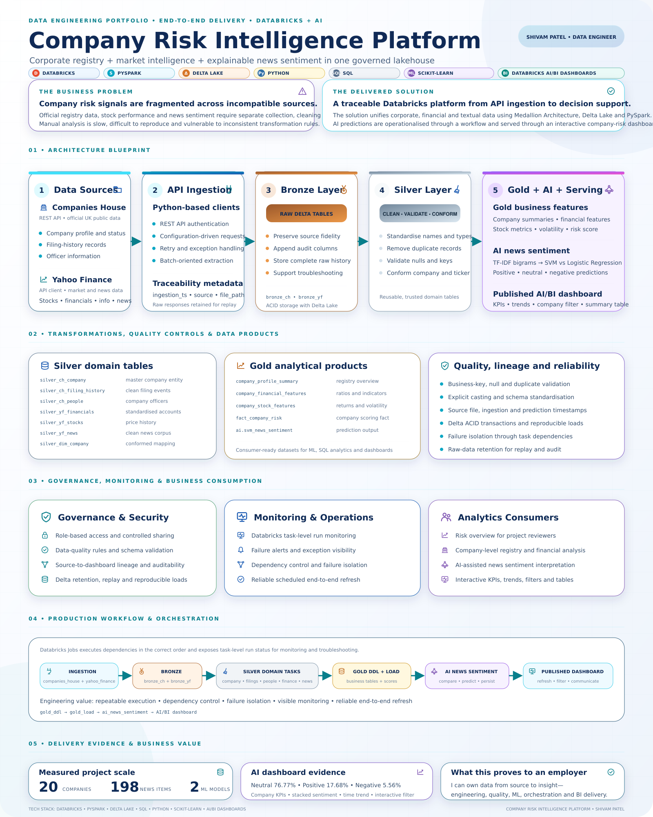
Figure 1.1. High-Level Architecture of the Company Risk Intelligence Platform.
Source: Author's own work (2026).

As shown in Figure 1.1, data is collected from Companies House and Yahoo Finance before being processed through the Bronze, Silver and Gold layers. The platform includes data-quality, lineage and monitoring controls.
The source data is retrieved by ingestion clients written in Python.The ingestion clients written in Python collect the source data. Ingestion logic is implemented via API request, values in configuration, exception handling and ingestion timestamps. Data gathered is kept in the Bronze layer, which does not remove the original source information from the data.
The Silver layer enhances the data by applying type conversions, normalising column names, validating critical columns and deduplicating records. It also establishes a common company mapping to enable Companies House records to be connected to Yahoo Finance ticker symbols.
Analytical data products are found on the Gold layer. The tables offer company summaries, financial indicators, details on stocks, sentiment results, and company level risk information. They are made for machine learning, SQL analysis and dashboard reporting.
For the AI part, the financial news text is converted using the Term Frequency-Inverse Document Frequency (TF-IDF). This converts text into numerical features that can be used by machine-learning models. Unigrams and bigrams are included so that the models can learn from individual words and two-word combinations. [26], [35]
Linear SVM and Logistic Regression are trained using the same TF-IDF process. The dataset is divided using an 80/20 stratified split so that each sentiment class remains represented in both the training and testing data. The models are compared using accuracy, precision, recall and F1-score. Scikit-learn provides the machine-learning implementation used in this project [6]. [27]-[29], [33], [34]
The selected model is used to predict the sentiment of company news. Predictions are stored in the ai.svm_news_sentiment Delta table with the predicted class, prediction margin, sentiment score, model name and prediction timestamp.
A Databricks workflow runs the main tasks in the following order: ingestion, Bronze processing, Silver transformation, Gold loading, AI sentiment prediction and dashboard delivery. This dependency-based workflow supports repeatable execution, failure isolation and task-level monitoring.

1.8 Project Scope
The project focuses on selected UK-listed companies that can be connected across Companies House and Yahoo Finance. It includes:
- Companies House company-profile, filing-history and officer data.
- Yahoo Finance company, financial, stock and news data.
- Bronze, Silver and Gold Delta tables.
- Data cleaning, validation, standardisation and deduplication.
- News sentiment classification using Linear SVM and Logistic Regression.
- Databricks workflow orchestration and monitoring.
- An interactive Databricks AI/BI dashboard.
The dashboard that is currently in place includes 20 companies and 197 financial news records that have been prepared. The values are provided as data available at the time of the project's completion and may be updated when the pipeline is updated.

1.9 Project Limitations
There are some limitations of the project. Firstly, because it has a small sample of companies, the results will reflect the design of the platform but not all UK companies. Secondly, the project has to rely on external data sources. Ingestion may be impacted by API changes, missing records, or access limitations/transient source problems.
Third, the quality of the sentiment model depends on the labelled training data. Financial language can be difficult to classify because an article may contain mixed opinions or require wider business knowledge. Fourth, batch processing means that new information does not appear immediately after it becomes available at the source.
Finally, news sentiment is only one possible risk indicator. Negative news does not always mean that a company is financially unstable, and neutral news does not guarantee low risk. The sentiment results should therefore be considered alongside regulatory, financial and market information. The dashboard is a decision-support tool and is not a replacement for professional financial or investment advice.

1.10 Significance of the Project
This project is significant because it demonstrates how data engineering, artificial intelligence and business intelligence can be combined to address a realistic business problem.
From a data-engineering perspective, the project demonstrates API ingestion, Delta Lake storage, data cleaning, validation, layered transformation and workflow orchestration. From an AI perspective, it demonstrates text preparation, TF-IDF feature engineering, model comparison, evaluation and prediction storage.
Reproducibility is also a goal of the project. Raw source information is kept, transformation logic is broken into layers and tasks are clearly dependent. The features make the platform more accessible to monitoring, explaining and maintaining.
The solution can be the basis for an expanded company-risk platform. Newer releases may feature additional companies, data sources, real-time data processing, sophisticated language models, anomaly detection, and more sophisticated risk-scoring techniques.

1.11 Structure of the Report
Chapter 2 - Literature Review: Reviews research on data warehouses, data lakes, lakehouse architecture, Medallion Architecture, data quality, financial data integration, sentiment analysis and machine-learning classification.
Chapter 3 - Methodology: Explains the research approach, system design, data sources, collection process, transformations, machine-learning methods and evaluation strategy.
Chapter 4 - System Design and Implementation: Describes the implementation of ingestion, Bronze, Silver and Gold processing, AI development, orchestration and dashboard creation in Databricks.
Chapter 5 - Results, Evaluation and Discussion: Presents pipeline results, data-quality outcomes, model-performance results and dashboard findings.
Chapter 6 - Conclusions, Recommendations and Reflection: Summarises the completed project, answers the research questions, identifies limitations and recommends future improvements.

1.12 Chapter Summary
This chapter introduced the Company Risk Intelligence Platform and explained the problem addressed by the project. Regulatory, financial and news data is available from different sources, but it is difficult to combine and analyse manually.
The project addresses this problem by using Databricks, PySpark and Delta Lake to build an end-to-end lakehouse platform. Companies House and Yahoo Finance data is processed through Bronze, Silver and Gold layers. Machine learning is applied to classify financial news, and the results are presented through an interactive dashboard.
The chapter also presented the project aim, objectives, research questions, scope, limitations and significance. The next chapter reviews the academic and technical literature that supports the platform design.

CHAPTER 2

LITERATURE REVIEW
Company Risk Intelligence Platform

2.1 Introduction
A detailed account of the technical concepts that were incorporated into the design of the platform are discussed in this chapter and the appropriateness of these concepts to the context of this project are explored. It goes beyond data warehouses, data lakes, lakehouses, Spark, Delta Lake, text classification and dashboards. It takes into account the usefulness of each option, where each option can add unnecessary complexity and why the technologies chosen were appropriate for Companies House records, Yahoo Finance data and financial news text.
The literature was surveyed with respect to four primary project needs: evidence retention from the original APIs, data quality enhancement, entity matching of companies, and machine learning & dashboard outputs. Some of these requirements may be met in a traditional reporting system, but not all of them easily. The lakehouse approach was selected because all of the source data can be stored in one governing environment, all transformations can be performed using PySpark and SQL, and all of the data can be used to prepare features for the model and serve the final analytical tables [3].

2.2 Traditional Data Warehouses
It is its ability to use agreed schemas and measures, typically structured as fact and dimension tables [7] that makes it most significant. This would be suitable for the Gold layer company summary and risk measures at the end. It would not be as well suited to be used for storing changing JSON responses or financial-news text until they were well understood in terms of their structure and quality.
The core advantages of a warehouse are consistency, well-defined schemas and reliable SQL analysis. Useful when the organisation requires a standard definition for a measure, like revenue or profit, or the number of customers. A warehouse may also isolate reporting functions from day-to-day operational systems, so that complicated analytical queries do not impact day-to-day business transactions.
But, a conventional warehouse has its drawbacks. Typically, data has to be designed, cleaned and transformed prior to loading. Stable and structured records are fine, but when dealing with changing API fields, JSON responses, documents, news articles, etc., it's not really flexible. Resources for storage and computing can also be tightly coupled, and different tools might be needed for machine learning. If the only platform that was used in this project was a warehouse, it would have been harder to keep the complete API responses and process the financial-news text in the same platform.

2.3 Data Lakes and Their Challenges
A data lake solves the raw data problem by allowing structured records, semi-structured JSON, and unstructured text to be stored, without having to fit some reporting model before it can be stored. This flexibility was suitable to the ingestion requirements of the project. But saving all of the API responses as files would not have yielded consistent data for the dashboard. If the data wasn't named, had no metadata, and was not checked, or controlled moved from one data area to another, the outcome might have been a big bucket of data that was hard to make sense of and hard to validate.
The flexibility of a data lake, therefore, can be the biggest risk. When files are uploaded without clear ownership, naming conventions, and metadata or quality control, users may not be aware of what data contains or if it is reliable. This is often referred to as a "data swamp. Data lakes that are created from files alone can also lack transaction control, lack reliable updates, and have limited SQL performance.
A zone-based architecture can help avert these issues by segmenting raw, cleaned and consumer-ready data. Based on the research on enterprise data lake, implementation of zones and rules of movement allows to increase efficiency in data management and make the purpose of each data set more understandable [8]. This concept is very similar to the Bronze, Silver and Gold layers that are being developed in this project.

2.4 Data Lakehouse Architecture
The lakehouse model was a practical alternative to the warehouse and data-lake models. It maintained the flexibility requirements for API responses and news text, and implemented managed tables, transaction support and SQL access [3]. I could prepare the Delta data in Python/PySpark, use SQL to analyze the data, and finally use the Dashboard to present the results using the same Delta data. This minimized the need to make copies of the data, and allowed an output to be followed through its processing stages.
This project was ideal for a lakehouse because the corporate records, financial data, stock information, and news articles could be stored in a single managed environment. The data can be transformed using Python or PySpark, be queried via SQL, used to train models and be displayed in a dashboard. This enhanced the traceability as each final product would be able to trace back to its source and transformation point.
But, a lakehouse will not solve all problems. Even with poorly designed tables, there can be confusing tables, unnecessary computing costs and weak governance. Data Engineering, SQL, Distributed Processing, Security are also known skills that development teams require. The clarity and management of the data layers, quality rules, access permissions and workflows make the value of a lakehouse.
Table 2.1. Comparison of common analytical data architectures
Area | Data warehouse | Data lake | Data lakehouse
Main data | Structured, modelled | Any format, often raw | Any format with managed tables
Strength | Reliable SQL and BI | Flexible, scalable storage | One platform for BI, data and ML
Weakness | Less flexible for raw text | May become a data swamp | Needs careful design and skills
Project fit | Useful for Gold reporting | Useful for Bronze retention | Supports the full solution
Source: Author's comparison based on [3], [7], [8].
All warehouses and lakehouses are not created equal. When the primary workload is the same as SQL reporting on structured data, a warehouse can be a good solution as its schemas and performance controls have already been tested and established. For instance, Snowflake is a cloud-based data warehouse that offers scalable, flexible storage and computing services [56]. But the project also required to retain raw API responses, process semi-structured news textual data, apply transformations using PySpark and prepare data for machine learning. The primary reason for doing these things in a separate Data Lake and Data Warehouse is because it would have added more connections to the system and would have created extra copies of the data. Therefore one of the lakehouses was chosen to enable the storage of raw source evidence, Delta tables, SQL analysis and AI processing. The primary drawback was the added complexity of the platform over a small, warehouse-only solution [3, 11].

2.5 Medallion Architecture
To have a clear purpose for each stage of data, I applied the Medallion pattern. The Bronze layer contained Companies House and Yahoo Finance information in a form that was similar to the original source, along with data related to their ingestion. The Silver layer comprised a lot of the primary cleaning tasks such as data type corrections, date standardisation, deduplication and linking company numbers to ticker symbols. The Gold layer contained fewer business-ready features and risk measures required for the dashboard. This is done following Databricks best practices about incrementally enhancing data with Bronze, Silver and Gold layers [9].
This design supports traceability. The AI model was not offered as a fourth Medallion layer, but definitely consumed prepared data. If there was a result that seemed to be incorrect, a developer might be able to compare the Gold output with the corresponding Silver and Bronze outputs. The Bronze stage enabled the original data to be processed again, whenever transformation and/or quality rules were changed.
This project was using the Bronze tables to store data from Companies House and Yahoo Finance. Data areas were cleaned and organized by the Silver tables and financial features, stock features, company-risk facts and datasets prepared for sentiment analysis were created by the Gold tables. The information can be stored in multiple layers and each new layer needs processing time and maintenance. Using too many layers could make a small project unnecessarily complicated. This three-layer design was warranted here due to varying source systems, need for clean text in the AI model and stable business fields in the dashboard.
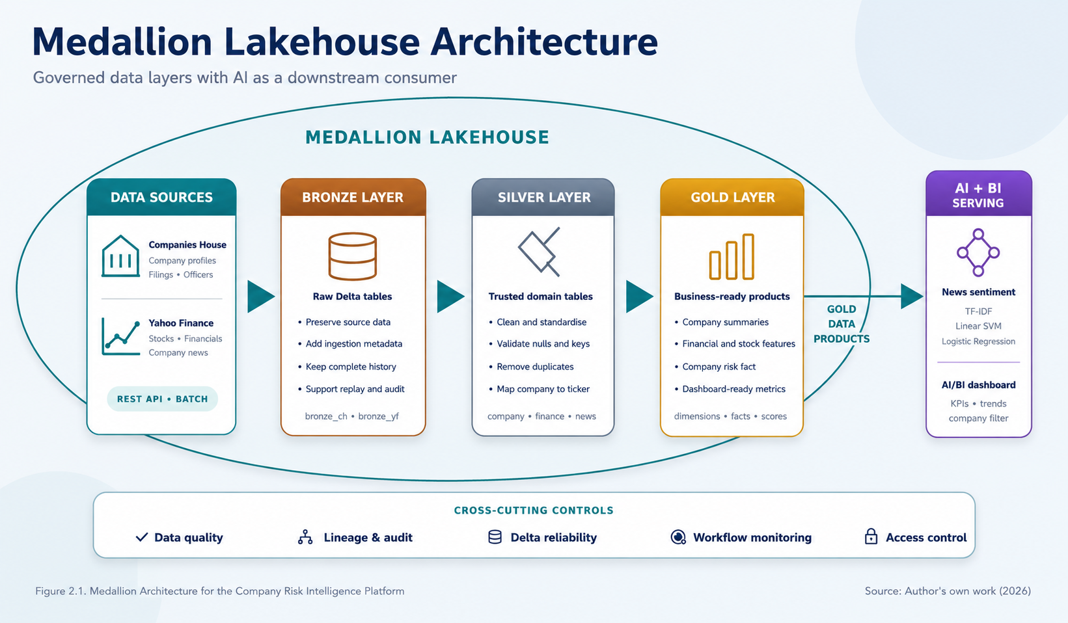
Figure 2.1. Medallion Architecture for the Company Risk Intelligence Platform.
Source: Author's own work (2026).

2.6 Apache Spark, PySpark and Delta Lake
The DataFrame transformations implemented in the project were mainly using Apache Spark as the main processing engine [4]. I performed common operations like select, cast, filter, join, and aggregation on company profiles, filings, officers, financial statements, stock records and news articles using PySpark [10]. The data set used was sufficiently small to be processed using regular Python. Spark was initially kept as the goal was to build a pipeline that would eventually be able to accommodate additional companies and data for a longer duration without any additional redesign work.
When the data pipeline might grow in size or complexity, Spark is useful. This coding pattern can handle a small demonstration data set and then be applied to a much larger number of companies and records. Databricks notebooks, Jobs and SQL are also integrated tightly with Spark. Distributed processing does come with setup, scheduling and computing overhead, however. Ordinary python could be faster and easier for just 197 prepared news articles. Spark was selected for the project since it was important to show an end-to-end platform, not just one small calculation.
A transaction layer is added to data files in cloud storage, such as Delta Lake. It has the ability to execute ACID operations, to run schema controls, time travel and reliable updates [11]. ACID properties help prevent inconsistent states for tables and incomplete writes. Time travel and table history also aid in debugging and reproducing the history since previous versions can be examined when a problem arises. These features were best suited for the Bronze, Silver, Gold, and AI outputs generated in this project [46] as opposed to an unmanaged CSV file.
Spark and Snowflake are designed to serve different components of a data platform and are not interchangeable. Spark is a distributed processing engine to provide granular control on transformations to developers. It also integrates seamlessly with data and machine learning pipelines [4] using files and Python. Snowflake is primarily a data storage and SQL-based data warehouse and data analysis cloud data platform. The best solution then depends on what type of data is involved, the kind of processing needed and the prime purpose of the platform.

2.7 Data Ingestion from REST APIs
API ingestion offers consistency and automation in data collection, but also presents some practical challenges. Authentication keys need to be secured, limits might be imposed on requests, network connections can drop and an endpoint might return an unexpected status code. The format of the source data may also change over time. A proper API client must utilize configuration settings, timeouts, retries, exception handling and logging. It should also log the ingestion time and source information so that all the logs can be tracked back to the source and time it was ingested.
This project used batch ingestion due to the lack of requirements for changes to company files, financial statements, or risk dashboards occurring every second. Streaming would allow for data in less time, however it would also cost more and would be more complicated to operate. To ensure a balance of data freshness, simplicity and reproducibility for the project, the batch approach was adopted.

2.8 Data Quality, Governance and Lineage
Data quality refers to the appropriateness of the data for the purpose for which it is used. Key areas are Accuracy, Completeness, Consistency, Validity and Timeliness. The model ISO/IEC 25012 is a recognised set of data-quality characteristics [13]. This project involved converting data types, checking for nulls, business keys, duplicate records and standardising Company Identifiers, among other quality rules. Governance is about who can access the data, how it is secured and the management of change. Track the source of data and modifications to the data while it is being processed. The following ideas are relevant to company-risk analysis in that a user should be able to discern the rationale for the presentation of a given value on the dashboard. This traceability included ingestion timestamps, source file paths, table names and prediction timestamps [49] [50] [52].
.

2.9 Financial and Corporate Data Integration
By combining corporate and financial data, a broader picture of company risk is provided. Market sources offer stock prices and financial measures and news, and Companies House offers official legal and filing records. These sources provide a formal indication of a company's standing, as well as its recent market transactions.
The primary difficulty is to match the same firm from various sources. Companies House has an official company number, and Yahoo Finance typically has a ticker symbol. The names of companies can include abbreviations, punctuation or legal endings and one business group can have multiple companies listed. Joining records by controlled company dimension is thus a safer option than joining by name. The dimension created in this project connects company numbers, company names and safe ticker values.
A filing relates to a reporting period, a share price belongs to a trading date and a news article has a publication time. Don't assume these records were all obtained at the same time.

2.10 Sentiment Analysis of Financial News
Natural language processing (NLP) is a tool used in sentiment analysis to determine the opinion or emotional tone of text. There are common classes of positive, neutral and negative. According to Liu [5] sentiment analysis can be conducted on document, sentence or aspect level. This project adopts document-level classification as each news article is assigned one label for the whole document. News sentiment can give some information which is missing in a financial table.
A decline in performance can be associated with a warning, legal matter or market event included in an article, for instance. Automated classification also can provide a summary of many articles that is more consistent than manual reading. Previous research in machine-learning found that sentiment classification is possible based on word-based features [14].
Financial terminology is hard to master, however. A negative word in a phrase may convey an improvement, e.g., "losses narrowed". Articles can also include divergent views, quotes and predictions of future events. It's possible that neutral articles are more generally found, making for class imbalance.

2.11 TF-IDF for Text Feature Extraction
TF-IDF (and so-called TF-IDF) transforms documents into numerical vectors. The more that a word occurs in one document, the more weight it will have in the TF. IDF ignores words that occur in a lot of documents as they are not useful in separating classes. Salton and Buckley demonstrated the use of term weighting techniques in information retrieval [15, 36]. The TF-IDF was appropriate for this project because it is efficient, easy to explain and it's suitable for linear classifiers. Unigrams are single words and bigrams are phrases that are a minimum of two words in length, like “profit warning” or “strong growth.” Both were used in the project and the number of features was reduced to 10,000. This helped to keep the model manageable without losing any useful phrases.
The biggest problem is that TF-IDF doesn't know what a modern language model knows—the meaning. Produces sparse vectors, and is somewhat confused about word order, context and sarcasm. It gives a baseline for this size of data which is strong and repeatable though. More data, computing resources, and evaluation controls would be needed for a large model of a transformer.
TF-IDF was chosen to be a clear baseline over BERT. It exhibits the words and word pairs that a linear classifier is using, is easily trained on a small labeled dataset, and can be easily reproduced [15, 26]. BERT reads text in both directions to generate contextual representations, which enables it to grasp the meaning that can be lost by a bag-of-words model [57]. This can help if the meaning of a financial term is influenced by the context. Training and explaining a transformer, however, will need more computing power, better control over experiments and careful attention to the difference between general and financial language. Given that this project was a proof of concept and involved experiment - from writing code to uploading to a dashboard, TF-IDF was a good option. A finance-specific transformer would be more helpful in comparing the performance in the future, but it shouldn't be taken for granted.

2.12 Linear SVM and Logistic Regression
Linear Support Vector Machine and Logistic Regression are frequently used in text classification. Linear SVM determine decision boundaries which maximise the margin between classes. It has been demonstrated that support vector machines are successful in high dimensional text data by Joachims [16]. Thus, sparse TF-IDF vectors are good for this kind of model. Logistic Regression estimates the probabilities of a class by fitting a linear relationship between the features and the log odds of a class. It's efficient, user friendly and works well with sparse text. Both models are provided by scikit-learn in consistent versions, allowing to make a fair comparison [6].
Linear SVM may be very good when the data has a lot of features, and Logistic Regression may yield probability-like outputs which would be simpler to incorporate into subsequent risk computations. But both models don't directly comprehend the context of the language. They have a reliance on feature selection and regularisation, and the ratio of classes. Both models were trained on the same TF-IDF pipeline and with an 80/20 split of the data, keeping the same percentile for each class. Thus, differences in data preparation were not considered and the comparison was targeted at the classifiers [28].
Linear SVM was also selected as the other model to compare with Random Forest for the main comparison. The high dimensional and sparse feature space of TF-IDF together with the large number of relevant features that are found in text classification by linear SVM make this the right choice for the specific problem at hand. Random forest can detect non-linear relationship and can give the feature-importance values. But its splits on trees are not as natural for thousands of sparse word features. A set of decision trees is also more difficult to explain as a direct weighted decision boundary [58]. Random Forest may be helpful if the features have clear numerical interpretations in a structured financial data and if they have non-linear relationships. Financial news classification is a more suitable and controlled task to be used as baseline for Linear SVM and Logistic Regression.

2.13 Model Evaluation Methods
Accuracy indicates the percentage of the total predictions that were correctly predicted. Easy to understand, but can give a false impression if one class is much larger than another. For instance, a model that can forecast the largest class in most cases can be very accurate but not be able to detect important negative news.
Precision is the number of times that the model is correct in predicting a specific class. Recall is the proportion of the real examples that the model correctly classifies. F1 score is a single measure that integrates precision and recall scores. Different parts of model performance are measured by classification measures; as such, these measures must be carefully selected to assess the model performance [17]. Macro averages assign equal weight to each class whereas weighted averages weigh the number of examples in each class [30]–[32].
In this project, one should look at accuracy, precision, recall, F1-score and confusion matrix simultaneously. The confusion matrix depicts the misclassification of the classes, for instance, negative articles misclassified as neutral. Using a stratified data split allows for identical class proportions in training and test sets. Due to limited data size, results presented should be interpreted as indicative of the performance of models in this project. They do not guarantee the same level of performance on all future financial-news articles [29]–[32].

2.14 Workflow Orchestration and Monitoring
A data product must execute the tasks in the right order to operate reliably. Workflow Orchestration controls the connections between data ingestion, data transformation, data loading, model predictions and reporting. Databricks Jobs provides a support for tasks that can be scheduled, dependency graphs, retry and monitoring for individual tasks [18].
This project starts with two ingest jobs: Companies House and Yahoo Finance. The Bronze tables are set up prior to the Silver transformations. The gold loading waits for the necessary trusted silver outputs, and the AI prediction task relies on the news data that have been prepared. This will ensure that any task that requires missing or incomplete data from a previous task will not be able to use that data. It also helps to make it easier to find out if a task has failed in the script than when searching through one big script.
Tracking should document the state and time taken for each task, error information, and data-quality information. Retries should be used to recover from temporary network issues, but not an effective way to mask permanent network issues. Also, the schedule will need to consider platform dependence, computing costs involved in workflow orchestration, and the actual need for the business. A daily batch refresh -- or planned -- is a better approach than continuous pipeline operation for this project.

2.15 Business Intelligence Dashboards
A dashboard transforms prepared data into information that users can explore and comprehend. A good dashboard should include a few simple business metrics, easy-to-read charts and filters to answer specific business questions. For company-risk analysis, helpful views include the total number of companies, financial scores, overall sentiment distribution, sentiment by company, changes over time and a detailed summary table.
The Databricks AI/BI dashboard brings the analysis directly to the Gold and AI tables. This minimizes unwanted data transfers and enables the dashboard to refresh off controlled and prepared outputs. The company filter lets you go from the overall results to the details of one organisation. Published access also enables access to the shared data by authorised users within the allowed Databricks workspace or account.
But dashboard design can also pose dangers. Uncertainty may be confused in one financial score, colours may sway the user too much and aggregated sentiment may obscure the information in individual news articles. The dashboard should thus display counts of articles as well as time trends in scores. It should also have clear titles and not give the results as financial advice. Such access should be kept restricted as the sharing of a link doesn't eliminate the need for workspace permission.

2.16 Research Gap
Existing studies provide detailed information on data warehouses, data lakes, lakehouses and machine-learning methods. There are numerous studies that have been conducted on data architecture, and on sentiment classification. API ingestion, Delta tables, workflows and dashboards are also available as separate guidance from technology providers. But there is not as much practical proof that all these elements can be integrated into a single small and traceable and repeatable company-risk platform.
There is a specific area for the full integration of official UK company records and market and financial-news data. Companies House refer to businesses by their company numbers and the financial platforms primarily by their ticker symbols. Before getting information from the final dashboard, many things have to be addressed, such as the company-matching problem, the data-quality rules and the machine-learning outputs.
The platform includes Bronze, Silver and Gold Delta tables, a managed company dimension, two sentiment-classification models, a workflow-driven dependency process and filters in the interactive dashboard. This project is not intended to be a new classification algorithm. What it brings is a design and implementation of a comprehensive and digestible solution that demonstrates the ability to synergize data engineering and applied AI.

2.17 Conceptual Framework
This study has a conceptual framework comprising of six interconnected phases: source data, ingestion, layered data processing, business features, AI analysis and decision support. Data governance, quality, lineage and monitoring is applicable throughout all phases. The framework was elaborated on the basis of literature researched in this chapter and then directly used in platform implementation.
Sources  Companies House  Yahoo Finance | Ingestion  REST APIs  Batch metadata | Medallion  Bronze → Silver  → Gold | Features  Company, finance  stock and news | Applied AI  TF-IDF  SVM and LR | Decision support  Risk tables  AI/BI dashboard
Figure 2.2. Conceptual framework for the Company Risk Intelligence Platform. Source: Author's own work (2026).
Companies House and Yahoo Finance are the main data sources. These sources are used by python clients to gather the information and append traceability metadata. The Medallion layers then ensure the preservation of the original records, enhances the quality and generates business-ready data products. Financial-news text is converted to sentiment predictions using the TF-IDF and the linear classification models. Lastly, the Gold and AI tables contain the data that is prepped for the dashboard. This structure establishes the linkage between the literature, the platform design and the final project evaluation.

2.18 Chapter Summary
The key concepts outlined in this chapter were the concepts that underpin the Company Risk Intelligence Platform. Traditional data warehouses can be used to report on structured data, and data lakes can be used for storage of various types of data. A lakehouse combines these strengths, but it must also have well-defined data layers, rules for governance, and monitoring. The Medallion Architecture offers a useful approach to transforming data from its raw state to trusted and business-ready data.
Apache Spark and PySpark enable scalable data transformation and Delta Lake enables reliable table updates and version history. While REST APIs can be used for automated data collection, failures, limits on the number of requests, and changes in the schema data source need to be managed with care. Other aspects that are relevant when joining official company data with data from the financial markets are data quality, data governance, data lineage and controlled company matching.
The review revealed that TF-IDF, Linear SVM and Logistic Regression are clear and practical approaches to sentiment classification. They should be judged on multiple criteria especially if the sentiment classes are imbalanced. Workflow orchestration allows the entire workflow to be repeated and the dashboard provides the user with the end result. The identified research gap helps to develop an all-encompassing Databricks solution that will incorporate all of these in a single end-to-end platform. Chapter 3 details the methodology applied to design, development and evaluation of the platform.

CHAPTER 3

RESEARCH METHODOLOGY
Company Risk Intelligence Platform

3.1 Introduction
The chapter describes the design, construction and testing of the Company Risk Intelligence Platform. It describes the research philosophy, research approach, data sources, technical methods, AI model development, dashboard creation and ethical controls.
The intent is to write the project process in a way that is clear to a different developer or researcher, and could be repeated. The project is practical because it provides a go/no-go solution with Databricks. It is also analytical, as the end product platform is tested with data quality checks, machine learning tests and dashboard data.
A design-science method was thus chosen for the approach to be taken. This is appropriate if the research is addressing a real problem and creating and testing an artefact like a model, method or information system [19, 20].

3.2 Research Philosophy
Research philosophy is a set of assumptions regarding the determination of what is considered useful knowledge. This project mainly follows a pragmatic philosophy. Pragmatism emphasizes techniques that can be used to address the research question and solve the problem but do not mandate that all components of the research study use one type of evidence [21].
This attitude is appropriate because multiple types of evidence are employed in this project. Technical evidence includes successful pipeline runs, table schemas, row counts and data-quality results. The accuracy, precision, recall and F1-score are quantitative evidence.
The research design is a development-based case study of selected group of companies listed in UK stock exchanges. The project is processing data from Companies House and Yahoo Finance in the Databricks workspace. It is batch-processing and based on Medallion Lakehouse Architecture.
The business problem, and the data needs were identified first. Secondly, the source data was obtained via Python clients. Lastly, raw data was captured in Bronze tables. Fourth, the data were cleaned and standardised by Silver transformations. Fifth, Gold tables had business-ready features. Lastly, the results have been broken down into a workflow and dashboard. Figure 3.1 summarises. the research and development process. The stages are linked but iterative work was done. For instance, the improvement of text preparation required as a result of dashboard requirements resulted in the upgrading of the Gold-table fields or the improvement of model testing required as a result of which led to the upgrading of text preparation. [21].

3.3 Research Approach
The study takes a constructive approach to the research with design-science principles. Constructive research is the research that aims at solving a real problem through the development of something useful and its testing [19]. Typically, design-science research (DSR) consists of three phases: problem identification, design and development, and demonstration and evaluation and communication [20].
This project aims to tackle the issue of fragmented company risk information. The companies house, financial information and stock information and news are all provided by different sources, with differing structures and identifiers. The goal was to develop a single platform which would gather, wash, combine and analyze this information.
The artefact is not just the Sentiment Model, but the entire Company Risk Intelligence Platform. It includes API ingestion, Bronze/Silver/Gold Delta tables, a company dimension, analytical Gold products, AI predictions, a Databricks workflow and a published dashboard. Successful end-to-end runs were performed and technical checks and model measures conducted to demonstrate the artefact.
An alternative was a study of just a comparison of classifiers, which was purely experimental and aimed at gaining a better understanding of the concept. That would provide detailed model results but not provide answers to data-integration and operational questions. So this project would best be assessed using the constructive approach as it checks to see if everything is working together.
The constructive approach was more powerful than an observational or survey design in terms of it being able to investigate the research problem in full by creating an artefact. The platform itself enabled the testing of integration of two APIs, keeping lineage and getting models to a dashboard [19]. A survey could ask for feedback on what features would be great to have, but not prove that the workflow worked perfectly or that the Gold and AI tables matched up.

3.4 Research Design
The research design is an exploratory case study of a case selected from the companies listed on the UK Stock Exchange, focusing on developing the research. It processes data from Companies House and Yahoo Finance in a Databricks workspace. It is a batch process system with Medallion Lakehouse Architecture.
It was produced in an integrated way. The business problem and data needs were identified. Secondly, Python clients were used to gather source data. Thirdly, raw data was stored in Bronze tables. Fourth, the data were cleaned and standardised in Silver transformations. Fifth, Gold tables were used to produce features that were ready for business. Sixth, financial news were employed to train and compare sentiment models. Lastly, a workflow and dashboard were created to operationalise the results.
The research and development process are summarised in Figure 3.1. For instance, because of the dashboard requirements, changes were made to Gold-table fields; and due to model testing, improvements were made with the text preparation.
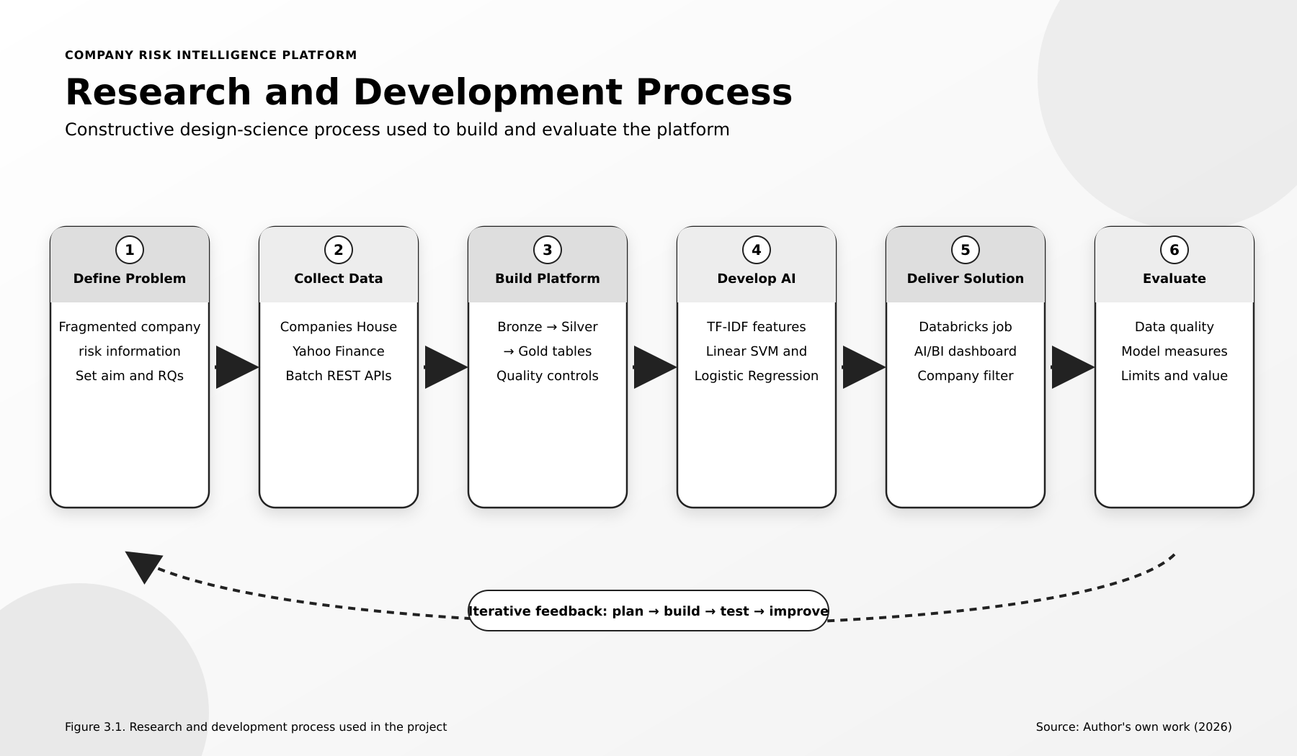
Figure 3.1. Research and development process used in the project. Source: Author's own work (2026).
This construction was organised using Design Science as it was used to create and evaluate the artefact that addresses the identified problem [20]. Its problem identification, design, development, demonstration and evaluation process is directly applicable to this project. It also expects design decisions to be explained and assessment to be made of the artefact in relation to its design goals. This is better than just using these as coding drills – the benefit comes from the full working platform and from lessons drawn from its merits and deficiencies.

3.5 System Development Methodology
Every major layer has been built and tested prior to the next layer. This helped to minimise the potential for developing a full solution on bad source information. The plan, build, test and improve cycle was used as the main cycle.
The necessary source endpoints, the table names, business keys and outputs were determined during the planning stage. When building, one task at a time notebooks and SQL statement were made. Schema, row, null, duplicate, sample record were tested. If a problem was identified, the program code or configuration was changed and the program was then rerun.
This approach facilitated the learning process as the development proceeds. It was not always possible to know at the start of the program the type of API responses or the financial fields, so it would be too limiting to have a fixed one pass method. Iteration facilitated responding to the missing values, inconsistent identifiers and dashboard requirementsTo minimize this risk, table responsibilities and workflow dependencies were kept to a minimum.

3.6 Data Sources and Data Collection
Two leading external sources were utilized. Companies House is an official source for information on companies that are registered in the United Kingdom. The chosen endpoints provided company profiles, filing history and company officers. Yahoo Finance provided company information, financial measures, stock-price history and financial news.
The companies were chosen because they could be represented in both sources. A business required a Companies House record and a financial ticker to be used with Yahoo Finance. This is a "purposive" selection rather than a random selection. It is appropriate for a technical development project because they are interested in testing integration between two source systems, but not interested in estimating the characteristics of all companies in the UK.
The dashboard has a total of 20 companies, and 197 ready-to-use news items from the project run. These are a representation of project data available and should not be considered a statistically representative sample of the overall market. Content of sources and time may vary with the updating of the pipeline.
The source services responded with structured responses to requests sent by python-based clients. Other information like provider name, canonical URL and publication date was also preserved in news records. These fields enable a traceability to be maintained and the source of the result to be verified.

3.7 Platform Architecture and Technologies
The development and execution environment was Databricks. Data preparation was supported by PySpark, table queries and data for the dashboards were supported by SQL, and Delta Lake offered a managed data storage solution. The selection of Delta Lake was made due to the following features of the transaction log: reliable writes, schema management and table history [11].
The platform is based on the lakehouse design. Although news and structured corporate and financial records are distinct types of records, they can be processed together without being transferred into other analytical systems. Based on the guidance of Databricks, a layered architecture is suggested where raw data will be stored and quality will be improved as one moves to subsequent layers [9].
The AI component was implemented with scikit-learn due to tested functions it offers such as TF-IDF, Linear Support Vector Machine, Logistic Regression and evaluation measures [6]. The presentation used Databricks AI/BI dashboards which can receive queries from prepared tables on the platform, and offer interactive filters.
The technologies chosen are suitable for an end-to-end demonstration but have more capabilities than are currently needed with the limited volume of data. A smaller local Python solution was able to process 197 prepared news records.

3.8 Data-Ingestion Method
The project is based on a batch API ingestion. A batch process gathers a set of records at a predetermined time, and a stream process continuously processes events. Batch ingestion is chosen for the following reason: company filings, financial statements and this project dashboard do not need to be updated in seconds. It is easier to manage, replicate and track for the range of possibilities available.
An ingestion client performs the following steps: read, request data, check response, convert the returned data to a consistent record structure, audit data, and write. Requests are authenticated as appropriate. Errors are dealt with in a way that would not cause a failure to go unnoticed while producing incomplete data.
All ingestion clients share the following structure: read configuration, ask for data, check the response, transform it into a uniform record structure, add audit information, write the output. Requests are authenticated as necessary. Errors are dealt with in a manner that allows failure to be detected without leaving partially complete data.
API ingestion has a dependency on external services. This risk can be mitigated through schema checks and source metadata, but can not be eliminated.

3.9 Bronze, Silver and Gold Processing
The Bronze layer is intended for storing source data in a less altered form. It is intended to maintain the fidelity of the source and give a recoverable history. The ingestion metadata is added to bronze tables to enable records to be associated with a collection run. This layer is not directly used to make a business conclusion.
Data from Companies House and Yahoo Finance tables are logically distinct, but are named and typed consistently.
The link between company numbers, names and ticker values is a company dimension. This is a controlled mapping, since a company name only may lead to false mapping. The ticker_safe field will return a consistent ticker form that can be used for analytical and sentiment data.
On the Gold layer, the data is used to create data products for analysis. These comprise company summaries, financial features, stock features, the company-risk fact and news-sentiment dataset. Gold tables contain stable names and measures which make it easier to work with them for machine-learning and dashboard operations without relying on complex raw structures.
This design comes at the cost of extra storage and processing. Validity checks were performed to ensure that expected types and allowed values were adhered to. Repeated records were eliminated using appropriate business keys, in a uniqueness check. Timeliness was facilitated using ingestion time and load time.The layers are useful for establishing a clear line of quality and allowing easy detection of errors, however. The benefits of the added traceability and maintainability outweigh the slight extra storage cost for this project.

3.10 Data-Quality Methods
Data quality was performed along the way through the platform. The checks were on completeness, validity, consistency, uniqueness and timeliness. These dimensions are comparable to the ones identified in the data quality models [13].
Completeness checks were used to discover missing business keys and key fields for analytical operations. Validity checks were done to ensure that the expected types and allowed values were met. Consistency check Standardise dates, names and ticker formats. Repeated records were deduplicated with appropriate business keys in uniqueness checks. Timeliness was assisted using ingestion and load timestamps.
The difference in counts, both row and grouped counts, was compared across stages. If the Silver count has been reduced, it may be expected in conjunction with the removal of the duplicates; but if the count has been dropped unexpectedly and significantly, there could be a problem in the filter. Major joins and transformations were also applied to sample data and displayed. This mix of automated checks and manual checks is useful because a technically valid record doesn't necessarily have to be logically valid.
The quality rules increase the confidence level, but do not guarantee the truth of all the external values. For instance, a source might give a correct numeric value that is no longer current. The project, therefore, captures source and time data and quality as fitness for the intended dashboard and model tasks.

3.11 AI and Sentiment-Analysis Method
The AI categorizes financial news into positive, neutral and negative sentiment. The input is the text of the news that is retrieved from Yahoo Finance. If there is no text, the records are filled with an empty value before the processing pipeline is run, to avoid failure.
The news text is transformed into numeric features by TF-IDF. Words are lowercase and common stop words are precluded. The vectoriser uses unigrams and bigrams, a minimum document frequency of two, a maximum of 10,000 features and sublinear term frequency. Certain phrases like ‘profit warning' might be more useful than each individual word and can be represented using the bigrams.
Linear SVM and Log. Regression were considered as the two classifiers. They work well with both sparse TFIDF features. Class weights are balanced to decrease the impact of unequal sentiment classes. This is because the same text preparation is used for both models, enabling a fair comparison.
No deep-learning language model was chosen to be the prime implementation. This type of model could be better at understanding context, but would need more compute, more training data, and more complicated explanation. Linear models offer an appropriate repeatable starting point for scope of the project.

3.12 Model Training and Evaluation
The labelled dataset was split into training and testing data with 80/20 ratio. Both sets were stratified to ensure that the proportion of sentiment classes was preserved. Fixed random state allows for reproducibility.
Only training set was used to train each candidate model. Then it was used a pipeline to predict the test set. The model comparison is executed by accuracy, precision, recall, F1 score, classification report and confusion matrix.
Precision measures the rate of correctness in the prediction of the class, recall measures the number of items in that class that are found, and F1-score is a trade-off between Precision and Recall [17]. The confusion matrix presents the detailed information about each class confused [31].
Table 3.1. Main machine-learning configuration
Component | Setting | Reason
Data split | 80% train / 20% test, stratified | Keeps sentiment classes represented
Text features | TF-IDF, unigrams and bigrams | Efficient features for short news text
Feature limit | Maximum 10,000 | Controls size and processing cost
Classifiers | Linear SVM and Logistic Regression | Strong baselines for sparse text
Class handling | Balanced class weights | Reduces majority-class dominance
Measures | Accuracy, precision, recall and F1 | Provides a balanced evaluation
Source: Author's own work (2026).
After comparison, the selected SVM pipeline was used to generate project predictions. The outputs were stored in ai.svm_news_sentiment. Stored fields include news ID, ticker, text, provider, URL, publication time, predicted sentiment, prediction margin, sentiment score, model name and prediction timestamp. Keeping both inputs and outputs supports later review.
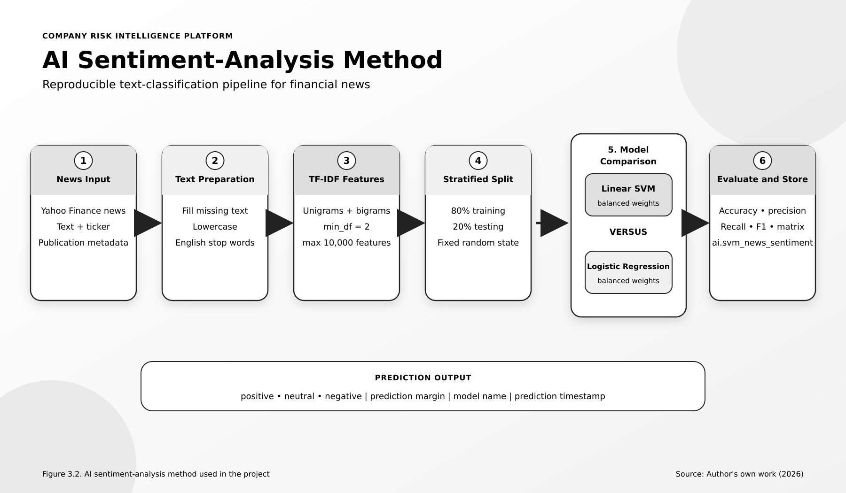
Figure 3.2. AI sentiment-analysis method used for training, comparison and prediction. Source: Author's own work (2026).

3.13 Dashboard Development
The dashboard was constructed using pre-prepared Gold and AI datasets. The initial questions were the main user questions: How many companies are there in the design, What is the average financial score, What is the overall sentiment for the news, What is the sentiment by company, and What is the sentiment over time?
The total companies and average financial score are shown in counter visualisations. A donut chart shows how the overall sentiment is distributed. A stacked chart is a chart in which the sentiment count of each ticker is shown on a stacked vertical bar chart. A line chart displays the sentiment trend over time, while a table displays sentiment for a given company. The single value company filter has only one value that the user can select which will filter a single ticker.
Companies were selected and dashboard updated to make sure that matching visualisations updated correctly. The format of labels, title and chart types were selected to ensure that the results are understandable to a non-technical reviewer. Then, the dashboard is published and shared using access controls in Databricks.
It is possible to make a dashboard too simple. The design therefore includes counts and trends in addition to scores and not provides investment advice in terms of sentiment.

3.14 Workflow Orchestration and Monitoring
An end-to-end process has been implemented in a databricks workflow to execute the process in proper sequence. Companies House and Yahoo Finance ingestion, Bronze processing, Silver transformations, Gold DDL and loading, AI sentiment prediction, and dashboard refresh are the key components of the main sequence.
Where branches do not depend on one another parallel tasks are used. Task level status is visible proof of the successful/correct or unsuccessful/incorrect completion of a task. The finished job graph revealed successful execution of the tasks implemented.
Monitoring focuses on run status, duration and failed task details. If a task fails, it doesn't force the re-execution of not very relevant successful steps. Retries are okay if the API is temporarily down, but if they're happening over and over again, it needs fixing, not thrown over again and again. Databricks Jobs allows for dependency-driven and scheduled runs and operational monitoring [18].
The project is manually or planned batch executed. The additions are not a part of the current scope but are in line with the architecture.
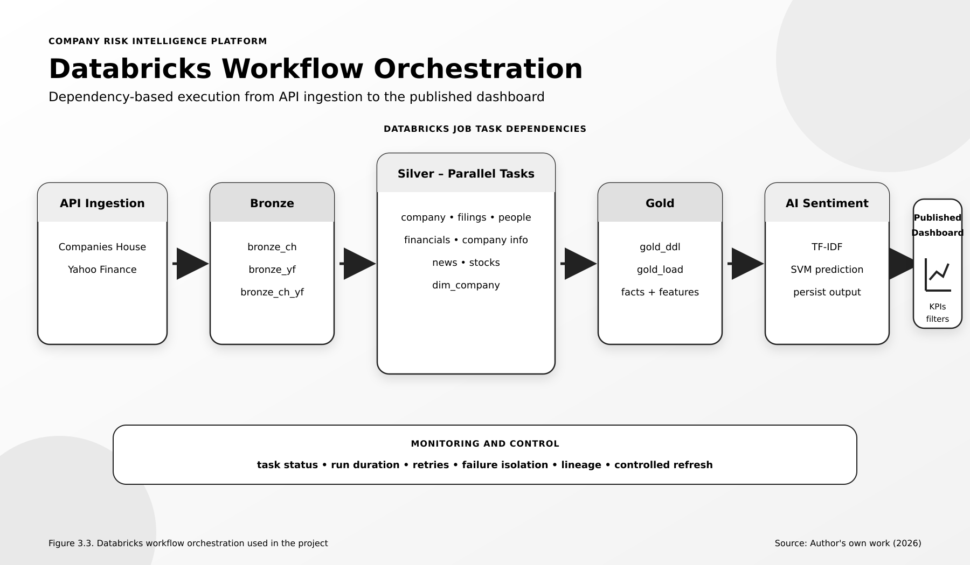
Figure 3.3. Databricks workflow orchestration used for the end-to-end platform. Source: Author's own work (2026).
Figure 3.4 combines all the development method in one flow. I started by cleaning up the company scope, the company source keys and gathered the two API datasets and kept the records in Bronze. Silver has cleaned all the domains and made the controlled company mapping. This trusted point then branched into the Gold analytical products as well as the AI sentiment output, which was then used by the dashboard.
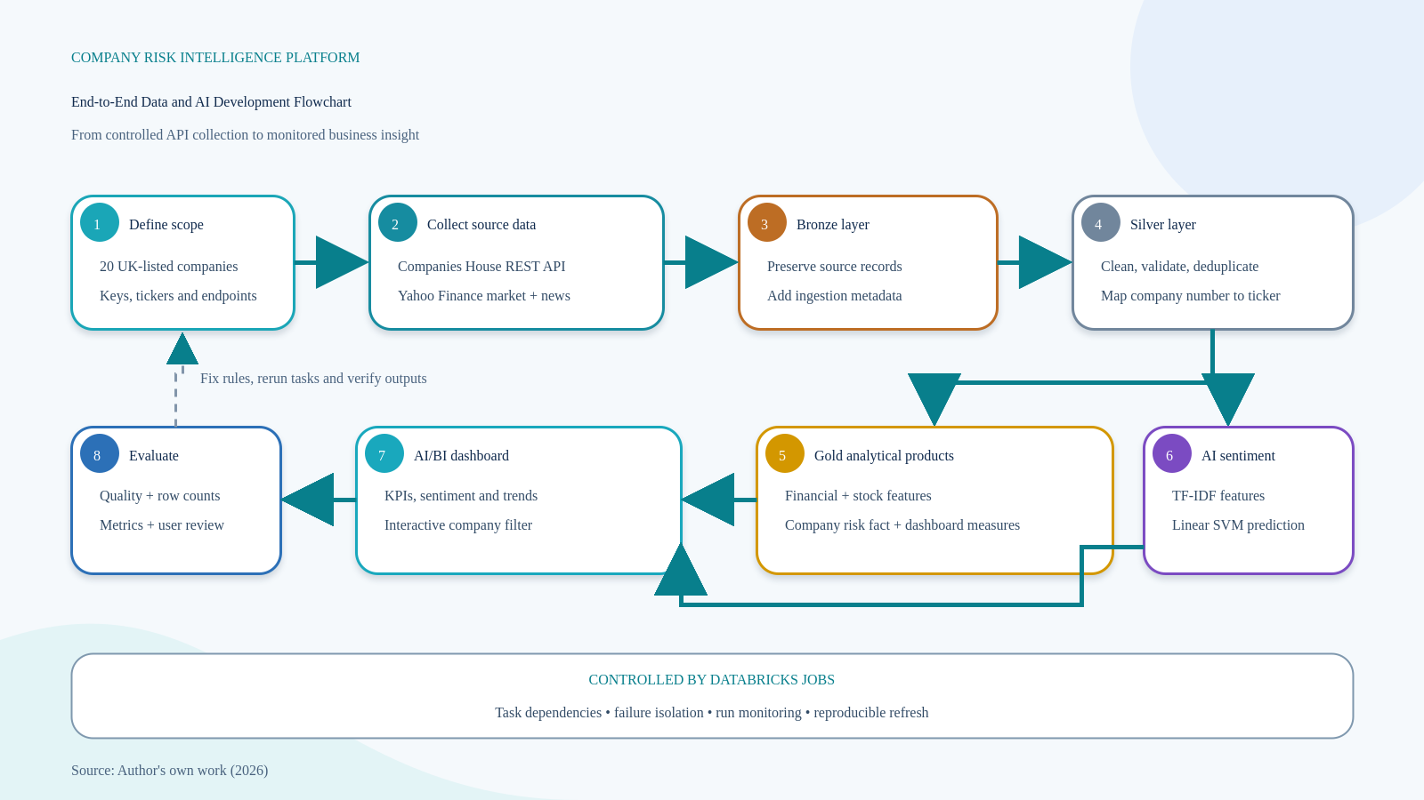
Figure 3.4. End-to-end data and AI development flowchart for the Company Risk Intelligence Platform.
Source: Author's own work (2026).
The return arrow from evaluation to scope indicates how I've worked on implementation. Once these requirements were identified, I replaced the appropriate Silver or Gold logic and ran the tasks which depended on it. The flowchart, then, illustrates an iterative build-and-check process, and not necessarily one in which each of the decisions was made correct on the first try.

3.15 Ethical, Privacy and Security Considerations
The project relies on information that is available to the public from companies and the financial market. Does not gather survey responses or medical information or private customer records. Companies House officer information can still be connected to people who can be identified. The project is then designed to take advantage of only the necessary fields for the company risk purpose and to prevent unnecessary personal analysis.
In the UK, the principles of GDPR are based on lawfulness, fairness and transparency, purpose limitation, data minimisation, accuracy, storage limitation, security and accountability [22]. These principles were used to inform the project by reducing the number of data fields included, ensuring source information was included, and limiting the number of conclusions that were drawn by the project and not supported by the data. [39]-[42] [40], [41]
Do not include API credentials in published notebooks or in the report. Platform settings should be used to manage access permissions and secrets. Only intended users can have access to the dashboard. Data in transit is secured through the secure web connections of the source services and stored tables are secured by the Databricks workspace controls.
The sentiment model may give wrong or skewed results. Predictions can be misinterpreted due to financial language and class imbalance. This is why the output is provided as a decision support and not an automatic judgement on a company. The results should be considered in conjunction with the evidence of the corporate and financial affairs.

3.16 Reliability and Validity
Reliability: The method should be consistent when repeated under the same conditions. Fixed transformation rules, Delta tables, recorded timestamps, fixed model random state and orchestrated workflow provide the project with support for reliability. The raw data is saved for reconstruction at later stages.
Internal validity relates to the validity of the evaluation for making the conclusions. The same training/test split and the use of pipeline, making the training more fair. Multiple performance measures used, rather than just accuracy. Data checks also validate that dashboard values are derived from prepared data.
The issue of external validity has to do with generalizability of results to the project sample. This is restricted as there are 20 companies and 197 prepared news items from selected sources in the project. Although the observed model scores may not be assumed to represent all companies, news provider or time periods, the architecture can be extended.
The working artefact testifies to the practical validity. The platform is able to move the data from the data collection site to the published dashboard. A larger production trial is required to test the performance, user satisfaction, cost and behaviour of high data volume, however.

3.17 Methodological Limitations
Firstly, the size of the samples. The chosen companies/news records are adequate to illustrate the method, but do not allow for broad statistical conclusions. The second is source dependence. Results may be influenced by missing data, source errors, rate limits or schema changes.
The third is sentiment labelling. The information in a news item may present multiple opinions, and the label may not fully represent the financial significance. TF-IDF also lacks of context understanding. The fourth restriction is batch processing, where it takes time for the source to change and the dashboard to be available.
The fifth restriction is the scope of the evaluation. The project does not have a formal user study with risk analysts; however, technical success and classifier performance is measured. Functional test and reasoning about design are used to gauge the usefulness of the dashboard, not via a large-scale user survey.
While these limitations restrict this study, they do not detract from the usefulness of this study. They determine the conclusions that can reasonably be made. The project provides a repeatable and repeatable approach to integrating company, financial and news data, but there is still more work to be done before a platform could be used for high-stakes financial decisions.

3.18 Chapter Summary
The methodology for the construction and assessment of the Company Risk Intelligence Platform was described in this chapter. A pragmatic philosophy and constructive design-science approach was chosen since the study results in a working technical artefact for the solution of a practical problem. The development process was an iterative plan, build, test and improve process.
Data from Companies House and Yahoo Finance were gathered via a batch API client and various Bronze, Silver and Gold Delta tables. Data quality checks included completeness, validity, consistency, uniqueness and timeliness. A company was controlled by having a company dimension that contained company numbers and ticker values.
TF-IDF, Linear SVM, and Logistic Regression were used in the AI technique. We applied a 80/20 split and multiple evaluation measures to models for comparison. The predictions were saved in a traceable AI table. Finally, the data sets were shared using an interactive dashboard and orchestrated Databricks workflow.
Ethical and security measures encompassed data minimisation, protection of credentials, restricted access and data interpretation of model outcomes. Repeatable code, Delta storage and workflow dependencies assisted reliability and limitations were identified. The results of the main technical solutions and the implementation of the system will be presented in Chapter 4. [37], [38], [51]

CHAPTER 4

SYSTEM DESIGN AND IMPLEMENTATION
Company Risk Intelligence Platform

4.1 Introduction
This chapter provides an overview of how the Company Risk Intelligence Platform was designed and constructed in Databricks. It emphasizes the system that has been developed, and not a general description of lakehouse technology. The platform integrated corporate data from Companies House with data from Yahoo Finance regarding companies, financial data, stock prices and news. The data went through Bronze, Silver and Gold Delta tables. It was then enhanced by leveraging an AI model for news sentiment analysis and displayed in a published Databricks AI/BI dashboard.
A major issue was that Companies House and Yahoo Finance have different company names. Official company numbers and registered names are used by Companies House, while Yahoo Finance primarily use stock market ticker symbols. The sources also include information at various levels. For instance, if one company has multiple filings, officers, stock price, news articles, etc. The final workflow utilized a common dimension of the company and the ticker_safe field, eliminating the need to rely on display names to link financial and news data to the proper company, as display names can change or be inconsistent.
It then details each of these steps, starting with data ingestion, Bronze storage, Silver transformation, Gold data products, AI sentiment prediction, workflow orchestration, and the delivery to a dashboard. The results of detailed data quality are discussed in Chapter 5 along with the model performance. Only when they need to be included to indicate a successful completion of a specific portion of the system are they included in this chapter.

4.2 System Requirements and Design Decisions
The requirements were created based on the primary project goal, and the four research questions introduced in Chapter 1. The system had to collect data and more. It needed to retain data from the original API responses and generate consistent company-level datasets for every pipeline run, which meant it had to ensure that the same transformation rules were applied. It also required to be able to store predictions generated by AI algorithms alongside information about the AI model employed and clearly present the resulting predictions to a non-technical reviewer. These needs were turned into the functional and non-functional requirements presented in Table 4.1.
Table 4.1. Project requirements and implementation traceability
ID | Project requirement | Implemented evidence
FR1 | Collect corporate, market and news data | Separate Python API clients for Companies House and Yahoo Finance; raw responses retained with source metadata.
FR2 | Prepare reusable company datasets | Bronze, Silver and Gold Delta tables with cleaning, type conversion, deduplication and conformed company mapping.
FR3 | Create company-risk features | Gold financial and stock feature tables plus fact_company_risk for company-level analytical measures.
FR4 | Classify financial-news sentiment | TF-IDF pipeline comparing Linear SVM and Logistic Regression; selected predictions stored in ai.svm_news_sentiment.
FR5 | Provide interactive analysis | Databricks AI/BI dashboard with KPIs, sentiment charts, trend chart, company filter and summary table.
NFR1 | Traceability and reproducibility | File path, ingestion timestamp, prediction timestamp, model name and workflow dependencies recorded.
NFR2 | Data quality and reliability | Null, duplicate, type and business-key checks; Delta ACID tables; failures isolated at task level.
NFR3 | Controlled access | Databricks workspace permissions and dashboard sharing restricted to authorised users.
Source: Author's own work (2026).
A layered structure was selected to gain access to previous versions of data should problems arise in the APIs or AI model. For instance, when a score in the Gold layer was flawed I had to work backwards to the corresponding Silver score and then back to the corresponding Bronze score. For this reason, the responsibilities of the Bronze, Silver and Gold layers were kept separate, following the Medallion pattern discussed in Chapter 2 [9]. All managed layers were stored in Delta Lake, as it provided better support for transactions and table history for frequent pipeline runs than unmanaged files [11].
Figure 4.1 shows the functional and non-functional requirements using UML style component diagram. It encompasses the external data services, controlled ingestion process, three lakehouse layers, AI component, dashboard, orchestration and governance activities. The diagram also shows the project reviewer as a system user and links the dashboard to the back-end governed data products. It therefore helps to complete Table 4.1 indicating which parts of the system fulfill each requirement..
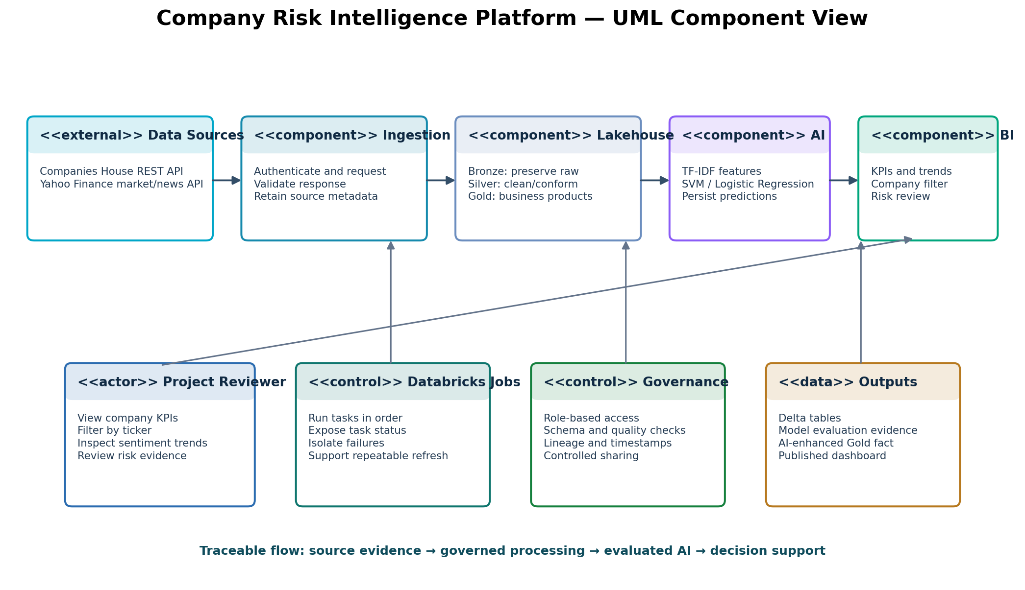
Figure 4.1. UML component and requirements view of the implemented platform. Source: Author's own work (2026).

4.3 Overall Platform Architecture
The platform was designed as a single Databricks job, company_risk_intelligence_pipeline, where tasks are managed using their dependencies. Data from Companies House and Yahoo Finance is gathered by 2 ingestion branches. The Silver outputs are collected in silver_dim_company which supplies common company mapping to the Gold layer and the AI component. The Gold DDL task creates the tables required in the target if necessary, before loading data. These tables are then populated with the prepared records by the gold_load task. Finally, the ai_news_sentiment task reads the cleaned news data, applies the selected sentiment model and saves the prediction results.
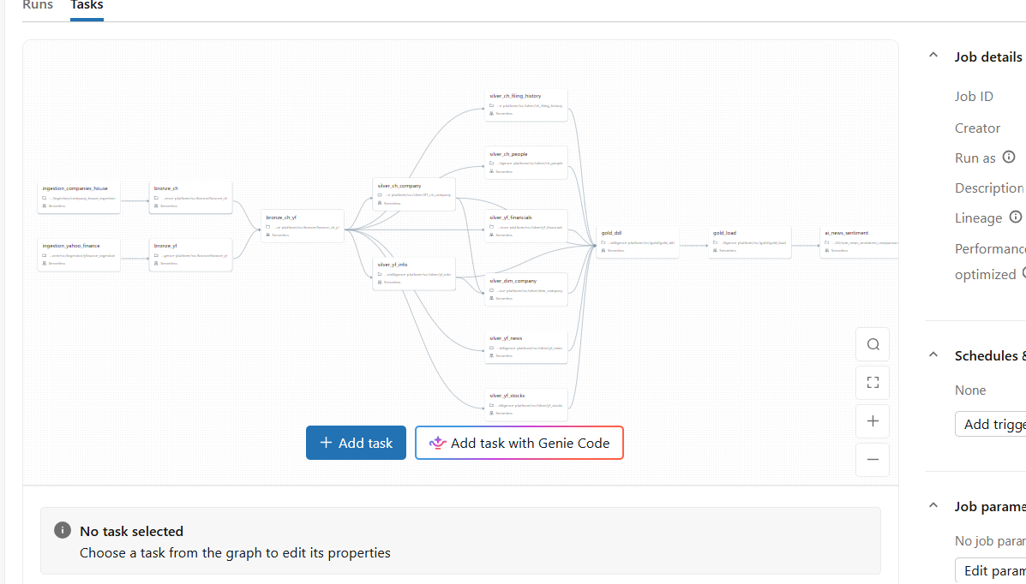
Figure 4.2. Implemented Databricks workflow and task dependencies. Source: Author's own work (2026).
Figure 4.2 is significant because it not only shows the general architecture, but also shows the order in which the features have been implemented. For instance, gold_load cannot start until the Gold table structures are created, and all the necessary Silver outputs are available. The AI task is run after the Gold loading, to maintain the same company identifiers and dashboard structure as with the overall analytical model. When silver tasks were not mutually dependent, then they were allowed to run concurrently. This minimised the need to wait for unnecessary tasks, while ensuring tasks were kept separate and failure easier to spot and deal with.

4.4 Data Sources and API Ingestion

4.4.1 Companies House ingestion
The Companies House client gathered the official company profiles, filings history and officer information for the companies listed in the UK. The company number was used as the primary source key as it is not as likely to change as the company name. The requests were managed in the same way by using configuration settings so that the same ingestion code can gather data for multiple companies, but yet not repeat the code. The client has documented the company, API end point, ingestion time, and the path of the file coming from the client. This information enabled investigation of failed/partial responses in the subsequent stages.
The company profile endpoint was used to return one record per company; the filing history and officer endpoints were used to return multiple records. These data sets were kept separate and not linked into a large table. Incorporation of them would have duplicated company information for all filings and officers thus creating a more difficult management situation. Separation also ensured that if one endpoint failed data that were successfully collected at the remaining endpoints could be used.

4.4.2 Yahoo Finance ingestion
Yahoo Finance branch gathered general information on the company, all financial statements, historical stock prices and financial news. Before further processing, the ticker was converted into a standard field called ticker_safe. This was required as punctuation and exchange suffixes in ticker symbols might form invalid or inconsistent table names and joins. News data consisted of the text of the article, the name of the provider, the original URL for the article and the time of the publication. The sentiment prediction would not be easily verifiable without the provider and URL.
The ingestion branches were batch type, as this was the scope of the project and the frequency with which the demonstration dashboard needed to be updated. The academic goals and the limited amount of data were not conducive to implementing streaming. This platform can be expanded in the future by adjusting the time table or ingestion approach. The current batch approach does simplify the repeat, examination and comparison of every pipeline run, though.

4.5 Bronze Layer Implementation
The Bronze layer was used to store data that was not transformed much and kept near its original sources. Bronze_ch and bronze_yf were the primary tables for Companies House and Yahoo Finance, respectively. These were followed by bronze_ch_yf where records from both sources were available to be processed later. In this point, I retained the original source fields and values if possible. This was helpful during development because some of the optional fields were not always returned in the API responses, and some of the returned data was not in an appropriate data type. I was able to correct a Silver transformation rule, and run it again without another API request, thanks to having the original records still in Bronze. It also prevented a wrong cleaning decision being made before the date of the original copy from altering the single remaining record of a source. Thus the Bronze layer was used as both the ingestion boundary and a good point to reprocess the data.

4.6 Silver Layer Implementation
The Silver layer cleans and trusted the source-based records to form domain tables. I've made separate tasks for silver_ch_company, silver_ch_filing_history and silver_ch_people. A few more tasks were also created: silver_yf_financials, silver_yf_info, silver_yf_news and silver_yf_stocks. Each task used rules specific to the detail level found in each of its datasets. Typical transformations involved were trimming the unnecessary space, ensuring all column names were standardised, changing date and numeric data to the correct column data type, deletion of duplicate business keys, and verification of column identifiers.
The most important Silver output was silver_dim_company. If you have a company number and legal name from Companies House, that table also matched them with the Yahoo Finance ticker values and ticker_safe. I wanted to make it a sort of controlled mapping table, rather than having to join the sources again and again by company name. Names may vary due to legal endings, punctuation or abbreviation as used by each source. A reviewed mapping was thus more reliable for this project and more easily understood and explained in the later joins.
Records were processed through data quality checks prior to being moved to the Gold layer. These checks included completeness of company numbers, ticker values, data types (date and numeric), and also duplicate removal and relationships among the datasets. These checks were linked to the data-quality aspects that were enunciated in Chapter 2 [13] but they were used as project "rules". For instance, if the provider name is missing, it may not be an impediment to the storage of a news record. If this article did not include a ticker_safe value, however, it would not be able to be linked to the right company. Thus, this had to be resolved prior to the dashboard using the data.
Table 4.2. Implemented data products across the platform
Layer | Main tables | Project-specific content | Primary use
Bronze | bronze_ch; bronze_yf; bronze_ch_yf | Source-aligned API data plus ingestion metadata | Replay and troubleshooting
Silver - Companies House | silver_ch_company; silver_ch_filing_history; silver_ch_people | Clean company, filing and officer entities | Trusted corporate records
Silver - Yahoo Finance | silver_yf_financials; silver_yf_info; silver_yf_news; silver_yf_stocks | Typed financial, company, news and stock records | Reusable analytical domains
Conformed Silver | silver_dim_company | Company number, name, ticker and ticker_safe mapping | Cross-source identity
Gold | company_profile_summary; company_financial_features; company_stock_features; fact_company_risk | Business features and company-risk measures | Dashboard-ready analytics
AI | ai.svm_news_sentiment | News text, prediction, margin, score, model and timestamps | Traceable sentiment output
Source: Author's own work (2026).

4.7 Gold Layer and Risk Data Products
The Gold layer was created to align to the information needed by the dashboard, not the original structure of the APIs. The company_profile_summary table will contain one record for every company with registry and descriptive information. The company_financial_features table is used to save standardised financial figures, and the company_stock_features table is used to save market-related financial figures like the returns on stock and stock volatility. The fact_company_risk table is a combination of the main company-level measures and allows companies to be reported and compared.
The gold_ddl and gold_load tasks are separated in the workflow. These tasks were separated out because if one of the target tables isn't found there should be no data loaded. This allowed development to be made safer for changes to table definitions to be reviewed separately from the transformations that were used to insert records.
The financial risk score was not a definitive indicator that a company was safe or unsafe, but rather a tool to assist in the decision-making process. The Gold tables maintained the individual features that were used to generate the score, to explain its meaning. This was significant due to the way one combined score could mask the underlying source of the highest risk indicator, which could have been financial performance, stock behaviour or news sentiment. That's why the overall score isn't displayed on the dashboard alone, but along with sentiment totals and detailed company information.

4.8 AI Sentiment-Analysis Implementation
News articles from the Yahoo Finance Silver layer have been processed and used as the source for the AI component. If there is no text in the record, it was made empty before vectorisation, otherwise the pipeline would crash. The TF-IDF technique was used to process the text of the article in order to transform it into numerical features. The settings included English stop words, unigrams, bigrams, min_df=2, a maximum of 10,000 features and sublinear term frequency. Bigrams were added since phrases like “profit warning” can offer more meaningful context than the individual words.
I repeated the same data split, set random state and made the same feature settings and used the same class weights when training my Linear SVM and Logistic Regression. The same data and settings were used to allow the models to be fairly compared. The model evaluation in Chapter 5 indicated that linear SVM was the best model for the final prediction table. Rather, its goal was to find a repeatable baseline that was suitable for the project data set and the few numerical features that were produced by TF-IDF.
Predictions were stored in a table instead of being computed only in a notebook. The table of news_sentiment is created by news_sentiment in the Artificial Intelligence folder. Each of the results for the dashboard can be tracked down to the article, company, model, and prediction time. This also helps to prevent the need to retrain the model whenever the data is updated.
Table 4.3. AI implementation configuration
Component | Implemented setting | Reason in this project
Input | Clean Yahoo Finance news text | Uses ticker_safe and source metadata from Silver
Feature extraction | TF-IDF; unigrams + bigrams; min_df=2; max_features=10,000 | Compact, reproducible text representation
Candidate models | Linear SVM and Logistic Regression | Compared under the same conditions
Class handling | Balanced class weights | Reduces dominance of the largest sentiment class
Evaluation split | 80% train / 20% test; stratified; fixed random state | Preserves class proportions and repeatability
Operational output | ai.svm_news_sentiment | Persists sentiment, margin, score, model and timestamps
Source: Author's own work (2026).

4.9 Workflow Orchestration and Monitoring
The final components were not run manually as notebooks, rather, they were run as a Databricks job. All tasks were dependant of each other and therefore, if later tables were to be created based on missing or incomplete data, the dependency was added. The ingestion tasks for Companies House and Yahoo Finance can run independently, and multiple Silver tasks can run concurrently. The Gold and AI tasks wait until the necessary data for them is available. The dependency structure leverages the operational capabilities of Databricks Jobs [18] but the task dependency was tailored for this project.
One could easily see and handle errors in the individual tasks when they were being monitored separately. For instance, if silver_yf_news was not successful, the finished Companies House jobs might not have to be executed once more. The status and length of these runs also indicated that some of the complete workflows could be repeated. It assisted to distinguish between data issues and workflow issues during development. There was a red task indicating the failed stage and a green task indicating successful completion of previous stages and the availability of their outputs.
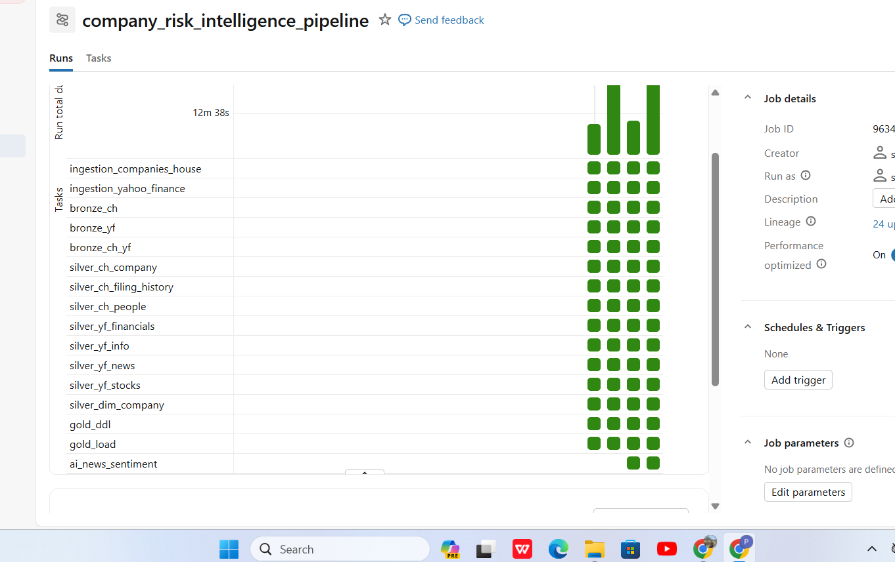
Figure 4.3. Successful task-level runs of the implemented pipeline. Source: Author's own work (2026).
Figure 4.3 shows the repeated successful runs on the tasks implemented. Data quality is not guaranteed with successful execution, but is checked independently. It does, however, confirm that the task dependencies, notebooks and target tables were part of one single workflow. The dashboard was only updated once the needed Gold tables and AI predictions were available. This decreased the chance of showing information generated from various or incomplete pipeline runs.

4.10 AI/BI Dashboard Implementation
The dashboard has been developed using the planned Gold and AI data sets. It was designed to answer the questions a project reviewer may have: What is the number of companies included? What is the mean value of the financial scores? What is the most common sentiment for news? What do companies differ in in terms of sentiment? What is the trend of sentiment with time? Each visual was selected to address one of these questions as opposed to adding to the quantity of charts.
The number of companies is shown on two counter cards, as is the average of the financial scores. The overall distribution of positive, neutral and negative news is illustrated in a donut chart. A stacked bar chart compares the sentiment totals for each ticker_safe, a line chart shows the sentiment levels over time of articles that were published. A detailed table offers company level totals and percentages. Lastly, the Select Company filter lets the user select one ticker and then use that selection for all applicable dashboard data sets.
The implementation used aggregated fields such as news_count because the prediction table contains one row per article. For the sentiment charts, predicted_sentiment defines the colour or series and the count measure defines the size. This small design decision prevented article-level rows from being displayed as repeated labels and made the relationship between the visual and the AI output easy to verify. The dashboard was published using Databricks dashboard functionality [23] and shared through workspace access controls.
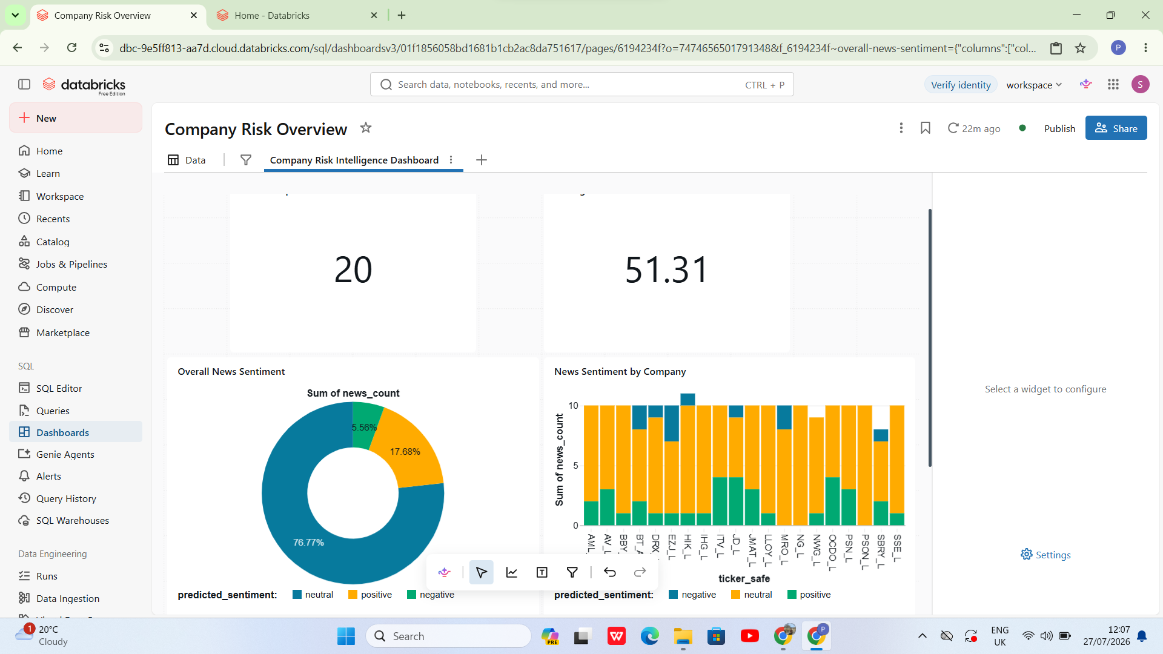
Figure 4.4. Implemented Company Risk Intelligence dashboard. Source: Author's own work (2026).
The working dashboard appears when developing an application. This is shown in figure 4.4. It displays 20 companies, an average financial score of 51.31 and sentiment charts created from the saved prediction results. These values have been added here to detect and validate completion of the dashboard items. The meaning of these and the restrictions of the data are explored further in Chapter 5.

4.11 Security, Governance and Data Lineage
Publicly available corporate and financial information was used in the project. API credentials were not published with outputs, and no dashboard was published as a public dataset, but rather access to the dashboard was managed by Databricks permissions. Those fields that are required for the company risk analysis were only migrated to the reporting layer. Records were maintained by the officer, with no specific effort to process or profile individuals, from a corporate source.
Data lineage was handled via separate tables, workflow dependencies and audit columns. The Gold level outputs can be followed to their named tables of Silver and Bronze. The model_name and prediction_ts are other attributes included in the AI prediction records. This does not offer all of the capabilities of an enterprise data catalogue. It does give enough information to recreate and track the project's data path from the response from the API to the end value in the dashboard.

4.12 Implementation Challenges and Solutions
The platform development was fraught with several problems; some influenced the final design. They have been included as they provide an explanation of the changes in the system during implementation. The primary problems were the lack of consistency in company identification between the two sources, optional API fields, duplicate records, schema and data type differences, and choosing appropriate dashboard metrics, as well as class imbalances in the AI. Table 4.4 provides a summary of each problem along with details on how each one was solved.
Table 4.4. Project implementation challenges and solutions
Challenge | Effect on this project | Implemented response
Different company identifiers | Company names and ticker symbols did not match reliably across sources. | Created silver_dim_company and used company_number plus ticker_safe as controlled keys.
Changing or optional API fields | Some responses lacked fields or returned different nested structures. | Retained Bronze responses and applied entity-specific Silver rules instead of one rigid schema.
Duplicate repeated records | Filings, prices and news could be repeated across requests. | Applied grain-specific business keys and duplicate checks before Gold loading.
Data-type inconsistency | Dates and financial values arrived as strings or nullable fields. | Applied explicit Silver casting and validity checks; preserved raw values in Bronze for replay.
Unequal sentiment classes | The labelled text was not evenly distributed across positive, neutral and negative classes. | Used stratification, balanced class weights and several evaluation measures.
Dashboard count not available | Article-level data did not initially expose the required visual measure. | Created news_count aggregation and used predicted_sentiment as the visual series/colour.
Task failure diagnosis | A failed downstream step could make a manual run difficult to interpret. | Used explicit Databricks dependencies and task-level status to isolate the failing component.
Source: Author's own work (2026).
The solutions chosen were suitable in terms of size and requirements of the project. For instance, a controlled company mapping was easier and more transparent to review and was simpler than building an automated company-matching model for just 20 companies. In the same way, the linear classification models and TF-IDF models were more easily reproduced, tested and explained than a large language model. These decisions cut down on the complexity while ensuring the project goal of creating a full fledged and traceable platform was achieved.

4.13 Chapter Summary
In this chapter, the design and implementation of the Company Risk Intelligence Platform were explained. Information from Companies House and Yahoo Finance was obtained via separate batch API clients, and stored in Data Lakes in the Bronze Delta format for processing again when needed. Silver data areas were cleaned and normalised for a shared company mapping. The Gold tables subsequently converted the trusted information into company profiles, financial features, stock features and company-risk measures.
The same TF-IDF features were used to train and compare Linear SVM and Logistic Regression. Information regarding the original source, model and prediction time was recorded along with predictions from the selected model. Databricks Jobs handled the order of jobs and even monitored tasks. The AI/BI Dashboard provides company KPIs, overall sentiment distribution, company comparisons, sentiment trends and detailed records.
It is a seamless data product with source tracking, re-usable data layers, AI predictions stored, workflow management and a published dashboard. In Chapter 5, the finished datasets and the performance of the models and dashboard are assessed. It also analyzes the effectiveness of the platform in providing the answers to the research questions.

CHAPTER 5

RESULTS, EVALUATION AND DISCUSSION
Company Risk Intelligence Platform

5.1 Introduction
In this chapter, the results obtained from the Company Risk Intelligence Platform are analysed and the relevance of the results to the project aim and research questions are explained. The evaluation will be based on the finalized Databricks pipeline, generated datasets in the Bronze, Silver and Gold layers, stored AI predictions, and published dashboard. The intent is not just to ensure that every part executed successfully. It is also to establish whether the system generated "useful", "understandable" and "traceable" results and to acknowledge the gaps in the available evidence.
The project processed two different types of information about UK-listed companies. Company profiles, filing history and officer records from Companies House. Yahoo Finance provided company, financial, stock market and news data. A total of 20 companies and 197 ready-made financial-news articles were included in the final project. This volume of data proved to be enough to show the whole platform but it is not a total market sample. As such, the outcomes are not reflected as generalisations of the likely performance of all companies in the UK or of the future performance of companies investing in the platform.
It then analyzes the predictions of sentiment, dashboard, usability, reliability and research questions. The completed platform is also compared to the ideas discussed in Chapter 2. This is particularly significant in regard to the accuracy and the F1 score. Comparisons between Linear SVM and Logistic Regression were made throughout the project, but the obtained performance numbers should be only be added to the final report if it's possible to directly retrieve them from the saved model evaluation results.

5.2 Evaluation Approach
Four types of evidence were used for the evaluation. In the first step, the Databricks tasks (ingestion, transformation, Gold loading and AI prediction) were checked to ensure that they were able to be executed in the proper sequence. Second, output tables were examined to ensure the table was at the appropriate level of detail, included identifiers, metadata and calculated measures. Third, the published dashboard was checked to ensure that it made appropriate use of the prepared data in its counters, sentiment charts, trend view, company filter and summary table. Finally, the results were related to the four research questions presented in Chapter 1.
This was a combination of technical checks and usefulness. A green task gives evidence that a process has been run but does not guarantee that all the values returned by the process are correct. Hence the assessment will take into account several areas at the same time. These include workflow completion, consistency with company identifiers, traceability from the result of the dashboard to the source records, repeatability of pipeline runs, clarity of the output and the limited data set restrictions.
Table 5.1. Summary of evaluated project outputs
Area | Observed project result | Evaluation meaning
Source integration | Companies House and Yahoo Finance branches completed | Corporate, financial, stock and news evidence became available in one platform.
Company coverage | 20 companies in the published dashboard | A consistent company-level view was produced for the selected project cohort.
News coverage | 197 final prepared and classified news items | The final notebook retained 99.49% of the earlier 198-item dashboard snapshot and produced traceable article-level outputs.
Layered data products | Bronze, Silver, Gold and AI tables created | Raw evidence, trusted entities, business measures and predictions remained separately traceable.
Orchestration | Dependency-controlled tasks with repeated successful runs | The solution operated as an end-to-end workflow rather than as isolated notebooks.
Business delivery | Published AI/BI dashboard with KPIs, charts, filter and table | Technical outputs were communicated through a non-technical analytical interface.
Source: Author's own work (2026).
Table 5.2 summarises the measurable evidence retained by the notebook and workflow screens. The final preparation produced 197 usable records from the earlier 198-record dashboard snapshot, a retention rate of 99.49%. Because text availability, ticker extraction and duplicate removal were applied in one preparation chain, the saved output does not prove which individual rule excluded the single record. The important reconciliation is that all 197 prepared records were saved as predictions, all 20 company tickers matched Gold, and the AI-enhanced Gold fact preserved all 20 rows.
Table 5.2. Quantitative pipeline, quality and reconciliation evidence
Measure | Observed result | Evaluation
Earlier dashboard snapshot | 198 news items | Baseline before final preparation
Final prepared news | 197 items (99.49% retained) | One item excluded by the combined preparation rules
Prediction reconciliation | 197 saved / 197 prepared (100%) | No prediction rows lost
Company coverage | 20 company summaries | All selected companies represented
Cross-source matching | 20 matched / 20 (100%); 0 unmatched | Ticker mapping fully reconciled
AI-enhanced Gold fact | 20 saved / 20 source rows (100%) | Gold grain preserved
Observed workflow duration | 12 min 38 sec (758 sec) | Successful monitored end-to-end run
Held-out ML test set | 317 labelled sentences | Stratified 80/20 evaluation

Source: Author's calculation from saved Databricks notebook and workflow evidence (2026).
Project notebooks did not record any of the following null counts before and after transformation, nor did they record any of the number of records that were rejected by the quality rules: It would, therefore, not be accurate to give artificial percentages for completeness, validity or for the sake of duplicate reduction. The prototype illustrates how you can compare and match rows between associated records. A production version should also store null rates, duplicate totals and quality-rule pass rates and reasons for rejecting records on each pipeline run.

5.3 Data-Pipeline Results
The first big success has been the integration of the Companies House and Yahoo Finance data branches. Companies House branch held, stored and provided official company numbers, company details, filing history and officer information. The Yahoo Finance branch was responsible for holding company details, financial statements, past stock prices and news articles related to companies by ticker. These records were NOT merged into one giant source table. Rather, the level of detail for each data set remained intact. It eliminated redundant data and enabled quality rules to be applied based on the interpretation of each record.
The Bronze layer was used to deliver a stable reference point which the data could be reprocessed from. While developing, optional API fields and data types could be explored without needing to re-request all the data from the outside services. This was consistent with the Medallion concept that preservation of data source evidence should be maintained in early data layers and later layers should work to structure and improve data quality [9]. It was also helpful in practice since the original API response was maintained so the Silver transformation rule could be fixed and re-run without losing the original data.
Main issue in company identity, not in data storage and retrieval emphasized from the Silver results. Companies House uses company numbers and legal names to identify a company, while Yahoo Finance primarily uses ticker symbols. It would have been unnecessary risk to repeatedly connect with the sources by display names, as punctuation and legal endings and abbreviations may differ from system to system. It was therefore decided that one of the most important outputs from the platform would be the controlled mapping of silver_dim_company. This provided a stable reference for the later tables for Gold and AI, and it linked the company number, company name, ticker and ticker_safe.
The Gold layer took the technical source records and made them into datasets which the dashboard could then use. A registry-level view was generated for each company in the company_profile_summary table. Company_financial_features and company_stock_features tables contained financial and market measures that were reused. The main fields needed for reporting were then put together in the fact_company_risk table. This structure was more user friendly than directly accessing nested API responses. It also helped to support the legacy of research in the literature that a lakehouse can be used to store flexible data as well as control analytical tables [3, 11].
One constraint is that the formal automated quality score was not computed for each field. The checks that were implemented included required keys, duplicate key checks, and checks of data types as well as relationships between tables. But from the screenshots alone it's not possible to say that the datasets were error free. A much more robust future evaluation would store the number of records passed and failed per quality rule, and the number of input and output records for each run. This evidence will facilitate data quality comparisons between refreshes, and allow for continued service-level monitoring.

5.4 AI Sentiment Results
The AI pipeline labelled each prepared news article as neutral, positive or negative and added it to ai.svm_news_sentiment. This was used to join the experimental model to the working platform. Each prediction contained the ID of the news, the ticker, the article text, the source of the news, the URL, the time of when the article was published, the expected sentiment of the news, the margin of error, and the name of the model, as well as the time the prediction was made. Thus, each percentage displayed on the dashboard would be able to be tracked back to the original article and original model run.
Out of 197 prepared news records, 151 were neutral, 35 were positive and 11 were negative. This translates to neutral news making up a whopping 76.65%, with positive and negative news making up 17.77% and 5.58%, respectively. This difference is clearly illustrated in Figure 5.1. The large number of neutral articles is fairly expected as the company news feed can have regular updates. But it does not indicate that the companies that were chosen were low in risk. Collection period, news providers, labelling process and the action of the classifier could also have had an impact on the result.
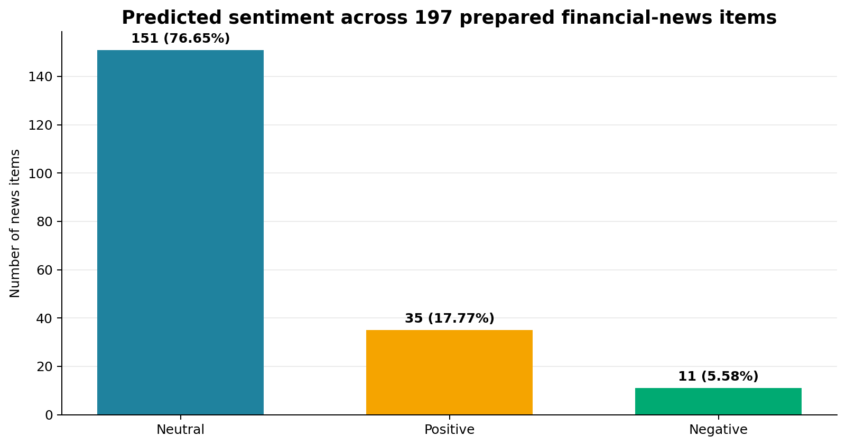
Figure 5.1. Distribution of stored sentiment predictions across the project news data. Source: Author's own work (2026).
Table 5.3. Published sentiment results
Predicted class | News items | Share | Project interpretation
Neutral | 151 | 76.65% | Largest class; routine or mixed news dominates the collected output.
Positive | 35 | 17.77% | A smaller group of items was identified as favourable.
Negative | 11 | 5.58% | The smallest class; important for review but vulnerable to low-sample uncertainty.
Total | 197 | 100.00% | Complete published news set used by the dashboard.
Source: Author's own work (2026).
Imbalance class issues were taken into account in the development of models. A stratified 80/20 class weight (balanced class weights) was used to avoid a skewed training and testing data set in favor of the neutral class. This gave a good baseline for the few TF-IDF features that were available, which tend to work well with linear classifiers [15] and [16]. There were only 11 records in the negative class, however. Thus, a single or perhaps two wrong predictions might have a significant impact on its recall and F1 scores. Overall accuracy per se would not give an adequate measure of the model [17].
Linear SVM and Logistic Regression were trained using the same stratified 80/20 split and identical TF-IDF settings, so the comparison isolated the effect of the classifier. Linear SVM achieved 82.33% accuracy, 81.80% weighted precision, 82.33% weighted recall and 81.84% weighted F1. Logistic Regression achieved 78.86% accuracy, 77.95% weighted precision, 78.86% weighted recall and 78.25% weighted F1. Linear SVM was therefore selected because its weighted F1 was 3.59 percentage points higher. Training time was similar—0.0711 seconds for SVM and 0.0806 seconds for Logistic Regression—so performance, not runtime, determined the selection [27]-[32].
Table 5.4. Held-out model comparison from the saved notebook
Model | Accuracy | Weighted precision | Weighted recall | Weighted F1 | Training time
Linear SVM | 0.8233 | 0.8180 | 0.8233 | 0.8184 | 0.0711 s
Logistic Regression | 0.7886 | 0.7795 | 0.7886 | 0.7825 | 0.0806 s

Source: Saved output from the author's svm_news_sentiment_comparison notebook (2026).
Figure 5.2 gives the Linear SVM confusion matrix in the label order negative, neutral and positive. Of 44 actual negative sentences, 24 were classified correctly, six were labelled neutral and 14 were labelled positive. Of 193 neutral sentences, 180 were correct. Of 80 positive sentences, 57 were correct. This explains why neutral recall (0.93) was much stronger than negative recall (0.55).
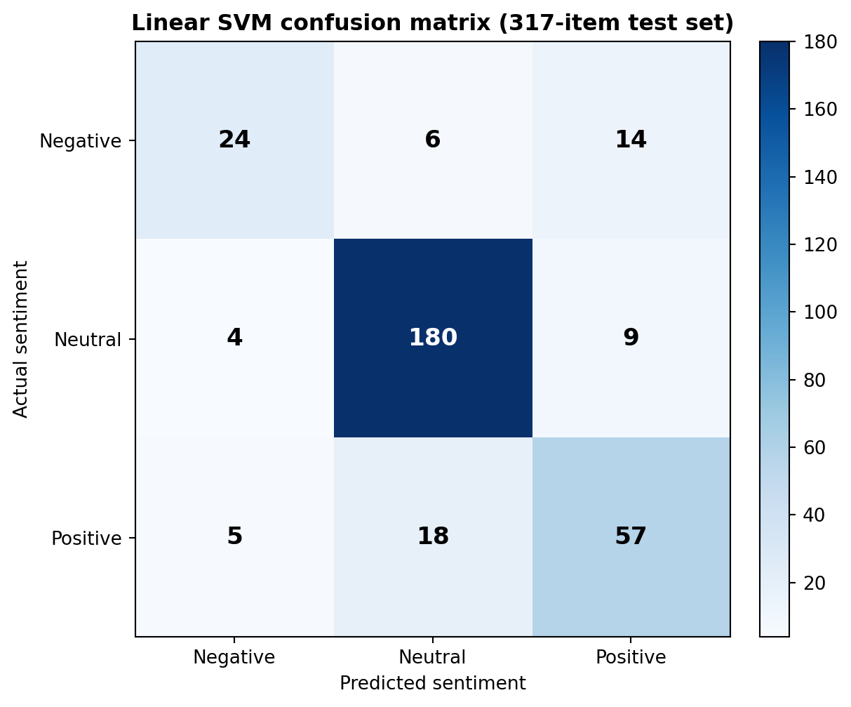
Figure 5.2. Linear SVM confusion matrix on the 317-item held-out test set. Source: Author's saved notebook output (2026).
The sentiment model should be used to assist in rather than making decisions. An experienced analyst will be able to better understand the sarcasm, hidden meaning, or the financial significance of an event than TF-IDF. In other words, the term 'profit fell less than expected' has negative language but can mean a better market outcome. The prediction margin reflects the model's ability to distinguish between classes and not a calibrated probability. Any negative prediction with potentially serious consequences should thus always be verified against the source article and the source URL prior to the use thereof as a basis for a business decision.

5.5 Dashboard Results and Business Interpretation
The entire financial and AI results were amalgamated into the dashboard. During the finished project run it had 20 companies with an average financial score of 51.31. The counters provided a user with a quick overview of the dataset, and the sentiment donut chart and stacked company chart provided a user with a visual representation of the distribution of the news predictions. The company filter also enabled an individual user to navigate from a portfolio view to a single ticker without having to open a notebook or write a SQL code.
Figure 5.3. Published dashboard results for company coverage, average score and sentiment. Source: Author's own work (2026).
The following figure, 5.3, indicates that the Gold and AI datasets might be suitable for a business application. The dashboard has been designed to provide users with more than just some technical row counts; instead, it is designed to answer practical questions, such as: How many companies are included? What is the mean financial rating? What is the mode of the class of sentiments? What is the balance of sentiments in companies? This aligns with the project goal of converting source data to decision support.
The average financial score of 51.31 only refers to the 20 companies that are part of the current project run. It has to be considered with caution and should not be used as a market indicator as it is influenced by the choice of companies, data, calculation rules and refresh time. When considering the score in relation to company-level results, and underlying financial and stock characteristics, the score is more useful. While a single score simplifies comparison, it can fail to reveal the importance of the outcome from financial ratios, volatility in the stock or missing values.
The sentiment chart stacked showed that the companies were not all the same type of news. In some tickers there were only neutral articles in the sample of collected articles, in others there are positive or negative records as well. The chart is helpful for preliminary evaluation. Companies with more articles, however, will have larger totals of course. The dashboard should display both the absolute number of articles and percentages in the future. It should also explicitly make mention of the time of observation. These changes would help minimize the chance that users would mix up increased news coverage with increased company risk.

5.6 Time-Trend and Filter Evaluation
The news trend chart had a new view feature that was not included in the overall sentiment totals, which is the time based view. It bucketed (grouped) articles by their publication time and forecasted sentiment. This enabled users to pinpoint times when a specific sentiment class had risen. They would then be able to use the company filter to determine if the change was from the one or multiple companies.
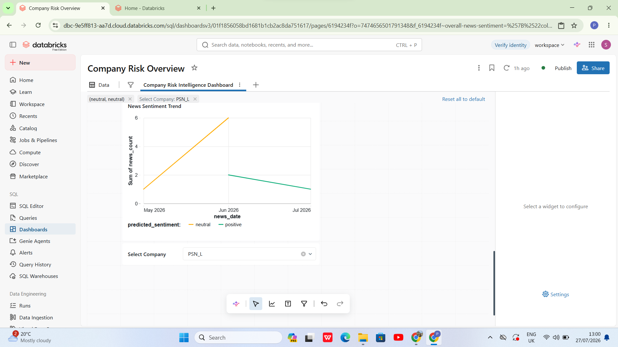
Figure 5.4. Company-filtered news sentiment trend for PSN_L. Source: Author's own work (2026).
The dashboard for PSN_L has been filtered and is shown in figure 5.4. For the filtered view, the filtered articles were a mix of neutral and positive articles, and there were no negative articles to appear since there were no negative articles on that company during the period selected. This verified the filter is properly connected to the trend data set. It also showed a potential usability problem in that users might think that a "line" is a technical error and not a "no records" result. For non-technical users, it would be better if it was explained in a short note or zero-value legend.
The trend chart provides a good way of exploring the data, but does not explain the cause of the change. For instance, if the neutral news volume goes up in one month, then it does not show why. There are also a few articles that can help make an individual company's changes seem more profound than they really are. Users should consult the detailed article table before drawing a conclusion, taking into account the times of publication, providers and source text. This is a typical feature of the platform, as it is meant to assist in further research before making investment decisions.

5.7 Reliability, Traceability and Reproducibility
The entire workflow was able to run multiple times successfully when repeated green task results to Databricks. The two ingestion tasks ran independently, the two Silver tasks worked on their own data areas, and the two Gold tasks waited for the required data to be ready. When the prepared data was available, the AI task was run. This decreased the likelihood of data being loaded onto the dashboard from a part complete pipeline run. It also demonstrated the benefit of establishing task dependencies [18].
Cleaned data for each business entity was stored in a Silver table, and a Bronze table was where file paths and ingestion details were stored. The business datasets identified by the gold tables were clearly indicated and the AI records contained the model name and prediction time. The result is that you could get to a dashboard without implementing a full enterprise data catalogue from an original API response. This helped to fulfill the project's requirement that results be explainable and reproducible.
But there are still some restrictions on the platform. It was batch based and were only covering a small group of companies. The project did not establish a Production SLA, develop automatic retry procedures for all potential API failure cases, constantly monitor API data quality or identify shifts in model performance. Access to workspace was managed, however the dashboard was not tested with many users using it concurrently. These restrictions are not negative at all, as the prototype was not a failure. Rather, they demonstrate the steps that would go into making it a "production ready" service.

5.8 Research Questions Revisited
Table 5.5. Evaluation against the research questions
RQ | Question focus | Project evidence | Evaluation
RQ1 | How can company, financial and news data be integrated? | Separate API branches, Bronze/Silver/Gold Delta tables and silver_dim_company connected company numbers with ticker_safe. | Achieved for the selected 20-company cohort; wider automated entity resolution remains future work.
RQ2 | How can the platform improve data quality and usability? | Entity-specific cleaning, type conversion, deduplication, key checks and dashboard-ready Gold tables. | Substantially achieved; formal rule-level pass rates should be added.
RQ3 | How effectively can linear models classify financial news? | TF-IDF with Linear SVM and Logistic Regression produced stored three-class predictions. | Answered: Linear SVM 82.33% accuracy and 81.84% weighted F1; stronger than Logistic Regression, with weaker recall for negative news.
RQ4 | How can results be monitored and communicated? | Dependency-controlled Databricks runs and a published dashboard with KPIs, charts, filter and detail. | Achieved as a working project interface, subject to workspace access and small-sample limits.
Source: Author's own work (2026).
As illustrated in Table 5.5, the project is directly relevant to all four research questions. The test-set comparison is the answer to RQ3. The accuracy of linear SVM was 82.33% with a weighted F1-score of 81.84%. Logistic Regression performed best accuracy of 78.86% and weighted F1 score of 78.25%. The results can be seen in more detail in the confusion matrix, though. For negative news, the model attained 0.55 for recall while for neutral news it attained 0.93. As a result, in this experiment, Linear SVM is the best model, but this does not necessarily mean that it would be the best model for all financial-news datasets.
In general, the objective of the project has been fulfilled at prototype level. This platform integrated official corporate information, market data and financial news within a single traceable workflow within the lakehouse. It created business-focused Gold datasets, put a text-classification model into operation and presented the results through an interactive dashboard. The implementation also highlighted realistic issues such as company identity matching, changing API structures, imbalanced sentiment classes and access to the dashboard. It was these challenges that provided the project with practical value, other than proving the single technologies feasibility.

5.9 Critical Discussion
With Databricks, more technical capacity was used than needed to process the data. These 197 news articles were prepared in a local Python script, which would have been more quickly and with less setup. The project goal was not just to create sentiment labels, however, but to show a whole knowledge engineering and AI system. The use of it was therefore justified because of the integration and operational experience it provided, rather than the size of the dataset.
The Medallion architecture needed more storage and development for related information, as it was stored in multiple layers. The cost was not an issue because the two sources differed in structure and, when problems occurred in development, there was a need to access the original records. But, a production system should have appropriate retention policies and the data should not be unnecessarily stored for an indefinite time. Each layer should be assessed based on the quality and usability that it adds.
TF-IDF and linear classification models were selected for ease of interpretation, speed and reproducibility. A language model based on a transformer may have more capacity to learn the meaning of finance, but it would also need more labelled data, more computational resources, more controls for tuning the model to the subject, and more controls for giving explanations. The simpler was a good option for a small academic project. Its main drawback is that financial terms may be used in different ways in different contexts, and it only had a handful of negative examples in the data set. It should also contain a report of the calibration of the model in addition to the primary measures for classification.
The dashboard proved to be a good way to communicate since it enabled a non-technical reviewer to switch between the overall portfolio and the results by company. The biggest problem with it, however, is that it can give an outcome that is more convincing than it really is. This would make the uncertainty apparent in the dashboard, rather than in the text report.

5.10 Chapter Summary
The outcomes of the pipeline, data tables, and AI model and dashboard were used as evidence in the evaluation of the completion of the Company Risk Intelligence Platform in this chapter. The project involved putting together a dataset from Companies House and Yahoo Finance data for 20 companies and preparing 197 news articles. It generated outputs that were traceable in the Bronze, Silver, Gold and AI levels. A total of 151 neutral, 35 positive and 11 negative predictions were saved. Average financial scores were also found on the dashboard for the selected companies, which were 51.31.

The best results were the controlled company mapping between the two sources, full row-count reconciliation, dependency-based workflow, published dashboard and recorded comparison between models. Linear SVM achieved higher accuracy and weighted F1-score compared to Logistic Regression. But the results of the confusion matrix indicated that the chosen model was less effective in recognizing negative news.
CHAPTER 6

CONCLUSIONS, RECOMMENDATIONS AND REFLECTION
Company Risk Intelligence Platform

6.1 Introduction
The chapter gathers all the knowledge gained during construction and testing of the platform. It brings back the same issue as the original one: carrying information about the company across various sources and then evaluating how the ingestion process, lakehouse tables, sentiment model, workflow and dashboard solved this problem at prototype scale. It also defines which are working and which are still needed for a production service, especially when it comes to controls and data coverage.
Created a connected data pipeline that has a distinct set of stages. The source data was retrieved via Python API clients and source-aligned records and audit information was stored in Bronze Delta tables. Silver tasks took care of cleaning each entity and the challenge of matching entities from different sources. Gold tables were then created to generate valuable financial, stock and risk data. The AI task determined the sentiment of news articles—positive, neutral or negative—and the Databricks Jobs specified the order of the tasks. This chapter outlines the results of the project, how it addressed the research questions, areas for future improvement and lessons learned while developing the project.

6.2 Overall Project Conclusion
The main aim of the project was achieved at prototype scale. Designed an end-to-end lakehouse platform that pulled corporate, financial, market and news data for a subset of the UK-listed companies. 20 companies were included in the published dashboard and 197 classified news items. It had company coverage, an average financial score, overall sentiment, sentiment by company, sentiment changes over time and a company filter. This demonstrated that raw responses from the API could be converted to information that could be understood by a project reviewer without having to review the engineering notebooks.
The primary finding was the entire data pipeline from the source to the dashboard. For instance, a sentiment score on the dashboard could be linked to `ai.svm_news_sentiment`, the cleaned Silver news table, and finally to source information like provider, URL, date published, ingestion time and file path. Policies at company level might also go back to the Companies House data or Yahoo Finance data, through the Silver tables. This traceability facilitated the easier testability, understandability and explainability of this platform.
It was also evident in the final solution that data engineering and AI must be designed together and as part of the same ecosystem. The dashboard needed to be summarized on a per-day basis, e.g. news_count, but not each individual article. The process also needed to be designed in such a way that the Gold and AI tables were available prior to the dashboard update. Taking these factors into account resulted in a more robust solution than creating the model, data pipeline and dashboard independently.

6.3 Achievement of the Project Objectives
Table 6.1. Final evaluation of the project objectives
No. | Objective | Evidence from the implemented code and platform | Outcome
1 | Collect company data | Python clients collected Companies House profiles, filings and officers and Yahoo Finance information, financials, stocks and news. | Achieved
2 | Preserve raw evidence | bronze_ch, bronze_yf and bronze_ch_yf retained source-aligned records with ingestion metadata. | Achieved
3 | Create trusted data | Silver tasks cleaned types, names, dates, duplicates and required identifiers for each entity. | Achieved
4 | Connect both sources | silver_dim_company mapped company number, company name, ticker and ticker_safe. | Achieved for selected companies
5 | Create analytical products | Gold tables produced company profiles, financial features, stock features and company-risk measures. | Achieved
6 | Apply AI to news | TF-IDF, Linear SVM and Logistic Regression were implemented; selected predictions were stored. | Achieved; final metrics still required
7 | Automate the workflow | Databricks task dependencies controlled ingestion, Bronze, Silver, Gold and AI execution. | Achieved
8 | Communicate results | A published AI/BI dashboard provided KPIs, charts, a detail table and company filter. | Achieved
Source: Author's own work (2026).
Table 6.1 shows that the technical objectives planned were achieved. The held-out evaluation results, which were missing, are also available as a saved notebook. Linear SVM got an accuracy of 82.33% and weighted F1 score of 81.84%. Logistic Regression had an accuracy of 78.86% and weighted F1 score of 78.25%. The confusion matrix was given to classify 24 of 44 negative records correctly, 180 of 193 neutral records and 57 of 80 positive records. These evaluation results should automatically be saved together with the model version, the dataset version and run identifier in a production version.

6.4 How the Coding Work Solved the Main Problems

6.4.1 API ingestion and source handling
In the first coding challenge, they had to gather data from two different APIs, one providing information in a different structure. The company number was the primary key used with the Companies House code and a separate endpoint was provided for company profiles, filing history and officers. The Yahoo Finance code for this work had been ticker symbols and gathered company details, financial statements, stock history and news. Separating the endpoints proved helpful because there is one company profile for each company, and there could be a lot of the things listed above for each one. If all of this was in a single flattened table, then company information would be duplicated in numerous rows and duplicate management would be more complex.
Some fields like `ingestion_ts` and `file_path` were captured when a record was added to the platform and where it was put. The following fields were also preserved in the news records: provider_name, canonical_url and pub_date. These fields were not directly involved with the end result of the game, but were used to ensure the results were auditable. If there was a record that was wrong, I could validate its source, collection time, rather than assuming it was an incorrect result and taking the dashboard value as the truth.

6.4.2 Bronze and Silver processing
The Bronze layer simply saved the original data without applying any business rules. The tables like bronze_ch and bronze_yf are used to store the source aligned values with metadata to ensure monitoring and control. This proved very handy if optional API fields were missing or when a value was received as a string rather than as a number. I could edit the Silver transformation to run it again without losing the original response or hitting the API again.
The Silver code had rules to clean each table based on its grain. The table, silver_ch_company, contained company information, the table, silver_ch_filing_history, contained repeated filing information, and the table, silver_ch_people, contained the officers information. On the Yahoo Finance side, there were separate tasks for creating the `silver_yf_financials`, `silver_yf_info`, `silver_yf_news`, and `silver_yf_stocks`. These activities shortened text data, transformed data types, normalized dates, checked vital keys and deleted duplicate data.
Making the transformations into smaller domain tasks also enhanced error handling. For instance, if there was a problem processing the news, the company, financial and stock tasks were not restarted. The most difficult integration problem was in identifying the same company in both sources. Company names were not good join keys since "suffixes", punctuation and abbreviations of the names could differ. My solution to this issue is to work around it by creating a table called `silver_dim_company` as a controlled company-mapping table. It mapped between Companies House company number and Yahoo Finance ticker and the normalised value of the ticker safe. This provided a consistent company reference for the Gold and AI task, thereby eliminating the need to match names for each of the notebooks.

6.4.3 Gold data products and risk measures
The Gold layer had converted the technical tables to a file of data suitable for analysis at a company level, the company_profile_summary layer; company_financial_features layer had provided a comparable set of financial measures; and company_stock_features layer had provided a set of market-based measures, including returns and volatility. The fact_company_risk table consolidated the main measures and allowed for them to be used in the dashboard. Gold_ddl and gold_load were left as separate tasks in the workflow. Prior to the first data being inserted by the gold_load task, table structures were created or checked with the gold_ddl task. This allowed any errors to be identified easier, since if the target table was missing, it could be identified prior to attempting any transformation loads.
The financial score was applied as an initial screening instrument and not as a judgement on a company. The Gold tables included supporting features so that users would be able to understand how this score had been created. This was significant because one score does not necessarily display the cause of the score. The financial values, stock behavior, lack of information, or calculation rules used could impact a company's score. The dashboard, for this reason, didn't imply that a company was safe or risky based on the score alone, but rather showed the financial score along with the company information and news sentiment.

6.4.4 AI sentiment pipeline
News articles from the Yahoo Finance website were cleaned using AI code and used on the Silver layer. The pipeline was not halted when there were missing text values, these were replaced. The text of the article was then converted into numerical features using TF-IDF. Lower case text and English stop words, unigrams and bigrams, min_df=2, sublinear term frequency, 10000 max features were used. Two words were introduced because there are combinations of words, such as profit warning, that can mean more than the sum of their parts.
The same Stratified 80/20 split, fixed random state, TF-IDF Pipeline, and class weights were used when training the model with Linear SVM and Logistic Regression. The models could be fairly compared by maintaining these settings. The chosen SVM pipeline then stored the results of the predictions in ai.svm_news_sentiment. The news_id, ticker_safe, article text, provider, URL, publication time, predicted_sentiment, prediction_margin, sentiment_score, model_name and prediction_ts were part of each record. By preserving this information, the model became an output for the platform and could be saved and reused for other parts of the platform.
One hundred and fifty-one (151) predictions were neutral, 35 were positive, and 11 were negative.One hundred and fifty one (151) predictions were neutral, 35 were positive and 11 were negative. The number of neutral results indicated the need for balanced class weights and class-level evaluation. It also pointed out a deficiency in the data set. There were 11 negative outputs so even a few false negative predications can significantly impact negative recall or F1-score. The model should thus be able to be reviewed by humans, especially articles with potentially significant negative consequences, not to automatically make investment decisions.

6.4.5 Orchestration and dashboard coding
The company_risk_intelligence_pipeline Databricks job was used to connect the notebooks. Ingestion tasks (Companies House, Yahoo Finance) might run independently. Some Silver transformations were able to run concurrently, and the tasks in the Bronze category were ran after related ingestion tasks. Gold tasks didn't start until the trusted tables were present, and the last task was an AI task that only started when its prepared inputs were present.
There was also additional data preparation to be done when building the dashboard. The prediction table had one entry per article, while the dashboard's charts required totals of the predictions by company and sentiment. I designed and picked an aggregated news_count measure and used the predicted_sentiment as the category or colour in the charts. The Select Company filter applied ticker_safe to enable the same company identifier to be applied to compatible datasets. These minor problems were worthy of solving because, even if the backend table is technically correct, it may not be ready to be used for a meaningful dashboard.

6.5 Answers to the Research Questions
RQ1 was concerned with how information from the various companies, financial and news sources could be integrated. The project had different API clients, multiple Delta tables and a common company mapping. The picked companies adopted this method. A larger platform, though, would need to be able to handle entity matching and more robust rules for changes in company names in an automated way.
RQ2 was what would be the benefit of a lakehouse architecture on data quality and usability. Separating these responsibilities facilitated testing the pipeline, correcting and rerunning it. Pre-prepared datasets of company, financial-feature, risk and sentiment data made the dashboard's API responses simple and non-nested. The outcome was technical control and access improved for non-technical users.
RQ3 investigated the capability of Linear SVM and Logistic Regression to classify financial news. Linear SVM was able to reach an accuracy of 82.33% and a weighted F1 score of 81.84% on the held-out test set of 317 records. Logistic Regression had an accuracy of 78.86% and a weighted F1-score of 78.25%. Hence, linear SVM achieved better results on both measures. A more detailed display of its performance was given in the SVM classification report. The precision, recall, and F1-score for negative: 0.73, 0.55, and 0.62. Precision for neutral news: 0.88, Recall for neutral news: 0.93 and F1-score for neutral news: 0.91. The positive news, precision, recall and f1 score were all 0.71. These results indicate that in this experiment the SVM model is the more powerful model. But, its recall of negative news was lower, which could lead to some missing articles being about risk. There is therefore a need for human review when the model identifies or fails to identify important negative news.
RQ4 was how the company-risk information can be monitored and communicated. Technical monitoring was enabled by Databricks task statuses, which indicated if each pipeline stage was successful or not. The AI/BI dashboard took the results in a form that a non-technical reviewer could understand. It features counters, a donut chart, a stacked company chart, a time-based trend, and a summary table and company filter that enabled users to drill down into the details of one ticker from the overall results. Access permissions of workspaces also provided that the dashboard link could only be opened by authorised users.

6.6 Project Limitations
The dashboard included information for 20 companies and 197 prepared news articles. This is sufficient to prove the design, but not the entire UK market. Also, there was variability in the number of articles among the different companies and different time periods. The higher the proportion of negative news a company had, the higher its ranking on the news count charts, even if the company received little news coverage.
The second condition is related to the AI dataset. The language used in financial terms can be confusing, for instance a negative word can be used to describe a positive outcome, such as a loss that is less than anticipated. TF-IDF is not capable of interpreting this context, sarcasm or the deeper meaning of a new event. The classes were also imbalanced, with some classes having much fewer samples than others.
The pipeline lacked full service-level agreements, automatic alerts for data model drift, performance testing with many users, or a full enterprise data catalogue. Data-quality checks were performed and a detailed score for each rule was not saved during each run for the final platform. Such restrictions are justifiable if it's an academic prototype, but they need to be resolved before the platform can be used for critical business decisions.

6.7 Recommendations and Future Work
Table 6.2. Recommended next steps for the platform
Priority | Recommended change | Practical implementation | Expected benefit
1 | Expand data coverage | Add more UK companies, longer financial history and several trusted news providers. | Reduces small-sample bias and improves comparison.
2 | Strengthen data quality | Store input, accepted, rejected and duplicate counts for every entity and run. | Creates measurable quality evidence and easier alerts.
3 | Improve entity matching | Add rule-based and fuzzy matching with a reviewed exception queue. | Supports a larger company set without unsafe name joins.
4 | Improve AI evaluation | Save model metrics, confusion matrices and class-level results as governed tables. | Makes model selection reproducible and auditable.
5 | Test advanced language models | Compare the baseline with a finance-specific transformer on more labelled data. | May improve context handling while keeping the baseline for comparison.
6 | Add model monitoring | Track prediction distribution, confidence, drift and low-margin records by run. | Identifies when the model may need review or retraining.
7 | Improve dashboard context | Show refresh date, observation period, article totals, percentages and clear score definitions. | Prevents users from treating small or old samples as precise facts.
8 | Production controls | Add retry policies, secure secret management, CI/CD tests, catalogue lineage and service targets. | Moves the prototype toward a reliable managed service.
Source: Author's own work (2026).
The suggestions should be implemented gradually. Saving exact model results and detailed data-quality measures are a top priority. This would do a great deal to strengthen the evidence without having to make significant changes to the architecture. The second is to expand the data coverage and to enhance the explanations displayed on the dashboard. More sophisticated models should be used later, when the training labels and evaluation system are robust enough to assure that the added complexity is worthwhile. In the future, SHAP and LIME will be tested as methods for explaining, allowing the reviewers to understand which words or features had an impact on each prediction [53, 54]. Delta MERGE might be used if the platform shifts to incremental processing, to apply controlled inserts and updates upon the managed-table design [47] remains unchanged. Monitoring in a model should also indicate a need for model review or retraining.

6.8 Personal Reflection and Skills Developed
I gained a better understanding of how to take the concept of data-engineering and put it into fruition through this project. I wanted to start off by just sending data from one layer to another. I had learned that the more difficult questions were related to data grain, identifiers, failure handling and how another person would interpret the results as they were being developed.
The key to silver_dim_company was to use a controlled business-key rather than using “good enough” company-name match. Also worked on my debugging skills. I was able to determine the exact pipeline stage, source path, schema, required key and the output of the preceding task when a particular task failed, without rerunning the entire pipeline. This helped to be easier with the Bronze data and having task dependencies. As part of dashboard development, I learned how to identify the grain of a data set, as well as how to make the proper aggregation. The source table for the news_count problem had one row for each article, and the chart required a measure aggregated. A solution to this issue showed that a valid back end table does not automatically exist and can be used for the dashboard.
The AI skill made comparing models more easily done. The same text preparation, TF-IDF settings, data split and class weights were used for Linear SVM and Logistic Regression. Also, I was made aware that the prediction was not all the process. The output must contain information about the model, times, source fields and explicit restrictions so that another person could check what the model has produced. When I thought of this, I thought of the role of AI as a part of a broader data platform instead of something that's merely an experiment.
Last but not least, the project helped me develop my communication abilities. The notebooks and table names helped with the technical development, another kind of explanation, the dashboard and report. A Data Engineer will need to have a Production Pipeline that can be relied upon to work with and is also clear for Data Analysts, Managers and others to use and directly applicable to this role.

6.9 Final Conclusion
The Company Risk Intelligence Platform illustrates a full chain of public API data to a monitored and published analytical product. It compiled Companies House and Yahoo Finance data, stored the data on the source, created an authoritative domain table, matched domain names, created Gold features, added AI sentiment classification and displayed the results on a Databricks dashboard.
Real problems with optional API fields, duplicate records, class imbalance, unmatched identifiers, task failures, and aggregations in the dashboard had an impact on the technical options. This finished platform should be considered as an academic prototype instead of a finished investment system. It provides important screening information and a good scientific foundation, but must also be evaluated by a person. The same architecture could be further developed to provide more comprehensive and more powerful company-risk service by adding other companies, more reliable tagged information, saved quality measures, model monitoring, and production monitoring. The project thus had two main goals: (1) to attain its primary goal and (2) to offer a clear direction for future development.

References
[1] Companies House, 'Companies House REST API,' GOV.UK. [Online]. Available: https://developer.company-information.service.gov.uk/overview. [Accessed: Aug. 4, 2026].
[2] Yahoo, 'Yahoo Finance: Stock market, financial and business news.' [Online]. Available: https://finance.yahoo.com/. [Accessed: Aug. 4, 2026].
[3] M. Armbrust, A. Ghodsi, R. Xin, and M. Zaharia, 'Lakehouse: A new generation of open platforms that unify data warehousing and advanced analytics,' in Proc. 11th Annu. Conf. Innov. Data Syst. Res. (CIDR), 2021.
[4] M. Zaharia et al., 'Apache Spark: A unified engine for big data processing,' Commun. ACM, vol. 59, no. 11, pp. 56-65, Nov. 2016.
[5] B. Liu, Sentiment Analysis and Opinion Mining. San Rafael, CA, USA: Morgan & Claypool, 2012.
[6] F. Pedregosa et al., 'Scikit-learn: Machine learning in Python,' J. Mach. Learn. Res., vol. 12, pp. 2825-2830, 2011.
[7] R. Kimball and M. Ross, The Data Warehouse Toolkit: The Definitive Guide to Dimensional Modeling, 3rd ed. Indianapolis, IN, USA: Wiley, 2013.
[8] C. Giebler, C. Gröger, E. Hoos, H. Schwarz, and B. Mitschang, ‘A zone reference model for enterprise-grade data lake management,’ in Proc. IEEE 24th Int. Enterprise Distributed Object Computing Workshop (EDOCW), 2020, pp. 57–66.
[9] Databricks, ‘What is a medallion architecture?’ Databricks Documentation. [Online]. Available: https://docs.databricks.com/aws/en/lakehouse/medallion. [Accessed: Aug. 4, 2026].
[10] Apache Software Foundation, ‘PySpark documentation.’ [Online]. Available: https://spark.apache.org/docs/latest/api/python/. [Accessed: Aug. 4, 2026].
[11] M. Armbrust et al., ‘Delta Lake: High-performance ACID table storage over cloud object stores,’ Proc. VLDB Endow., vol. 13, no. 12, pp. 3411–3424, 2020, doi: 10.14778/3415478.3415560.
[12] R. T. Fielding, ‘Architectural styles and the design of network-based software architectures,’ Ph.D. dissertation, Univ. California, Irvine, CA, USA, 2000.
[13] ISO/IEC 25012:2008, Software Engineering—Software Product Quality Requirements and Evaluation (SQuaRE)—Data Quality Model, ISO, Geneva, Switzerland, 2008.
[14] B. Pang, L. Lee, and S. Vaithyanathan, ‘Thumbs up? Sentiment classification using machine learning techniques,’ in Proc. Conf. Empirical Methods in Natural Language Processing (EMNLP), 2002, pp. 79–86.
[15] G. Salton and C. Buckley, ‘Term-weighting approaches in automatic text retrieval,’ Inf. Process. Manage., vol. 24, no. 5, pp. 513–523, 1988.
[16] T. Joachims, ‘Text categorization with support vector machines: Learning with many relevant features,’ in Machine Learning: ECML-98. Berlin, Germany: Springer, 1998, pp. 137–142.
[17] M. Sokolova and G. Lapalme, ‘A systematic analysis of performance measures for classification tasks,’ Inf. Process. Manage., vol. 45, no. 4, pp. 427–437, 2009.
[18] Databricks, ‘Lakeflow Jobs.’ Databricks Documentation. [Online]. Available: https://docs.databricks.com/aws/en/jobs/. [Accessed: Aug. 4, 2026].
[19] E. Kasanen, K. Lukka, and A. Siitonen, ‘The constructive approach in management accounting research,’ J. Manage. Accounting Res., vol. 5, pp. 243–264, 1993.
[20] K. Peffers, T. Tuunanen, M. A. Rothenberger, and S. Chatterjee, ‘A design science research methodology for information systems research,’ J. Manage. Inf. Syst., vol. 24, no. 3, pp. 45–77, 2007, doi: 10.2753/MIS0742-1222240302.
[21] M. Saunders, P. Lewis, and A. Thornhill, Research Methods for Business Students, 8th ed. Harlow, U.K.: Pearson, 2019.
[22] Information Commissioner's Office, ‘A guide to the data protection principles.’ [Online]. Available: https://ico.org.uk/for-organisations/uk-gdpr-guidance-and-resources/data-protection-principles/a-guide-to-the-data-protection-principles/. [Accessed: Aug. 4, 2026].
[23] Databricks, ‘Dashboards.’ Databricks Documentation. [Online]. Available: https://docs.databricks.com/aws/en/dashboards/. [Accessed: Aug. 4, 2026].
[24] Apache Software Foundation, 'Spark SQL, DataFrames and Datasets Guide,' Apache Spark Documentation. [Online]. Available: https://spark.apache.org/docs/latest/sql-programming-guide/. [Accessed: Aug. 17, 2026].
[25] Apache Software Foundation, 'Machine Learning Library (MLlib) Guide,' Apache Spark Documentation. [Online]. Available: https://spark.apache.org/docs/latest/ml-guide.html. [Accessed: Aug. 17, 2026].
[26] Scikit-learn Developers, 'TfidfVectorizer,' Scikit-learn Documentation. [Online]. Available: https://scikit-learn.org/stable/modules/generated/sklearn.feature_extraction.text.TfidfVectorizer.html. [Accessed: Aug. 17, 2026].
[27] Scikit-learn Developers, 'LinearSVC,' Scikit-learn Documentation. [Online]. Available: https://scikit-learn.org/stable/modules/generated/sklearn.svm.LinearSVC.html. [Accessed: Aug. 17, 2026].
[28] Scikit-learn Developers, 'LogisticRegression,' Scikit-learn Documentation. [Online]. Available: https://scikit-learn.org/stable/modules/generated/sklearn.linear_model.LogisticRegression.html. [Accessed: Aug. 17, 2026].
[29] Scikit-learn Developers, 'train_test_split,' Scikit-learn Documentation. [Online]. Available: https://scikit-learn.org/stable/modules/generated/sklearn.model_selection.train_test_split.html. [Accessed: Aug. 17, 2026].
[30] Scikit-learn Developers, 'classification_report,' Scikit-learn Documentation. [Online]. Available: https://scikit-learn.org/stable/modules/generated/sklearn.metrics.classification_report.html. [Accessed: Aug. 17, 2026].
[31] Scikit-learn Developers, 'confusion_matrix,' Scikit-learn Documentation. [Online]. Available: https://scikit-learn.org/stable/modules/generated/sklearn.metrics.confusion_matrix.html. [Accessed: Aug. 17, 2026].
[32] Scikit-learn Developers, 'precision_recall_fscore_support,' Scikit-learn Documentation. [Online]. Available: https://scikit-learn.org/stable/modules/generated/sklearn.metrics.precision_recall_fscore_support.html. [Accessed: Aug. 17, 2026].
[33] C. Cortes and V. Vapnik, 'Support-vector networks,' Mach. Learn., vol. 20, pp. 273-297, 1995, doi: 10.1007/BF00994018.
[34] D. R. Cox, 'The regression analysis of binary sequences,' J. Roy. Stat. Soc. B, vol. 20, no. 2, pp. 215-242, 1958.
[35] C. D. Manning, P. Raghavan, and H. Schuetze, Introduction to Information Retrieval. Cambridge, U.K.: Cambridge Univ. Press, 2008.
[36] F. Sebastiani, 'Machine learning in automated text categorization,' ACM Comput. Surv., vol. 34, no. 1, pp. 1-47, Mar. 2002, doi: 10.1145/505282.505283.
[37] D. Sculley et al., 'Hidden technical debt in machine learning systems,' in Advances in Neural Information Processing Systems 28, 2015, pp. 2503-2511.
[38] E. Breck et al., 'The ML test score: A rubric for ML production readiness and technical debt reduction,' in Proc. IEEE Int. Conf. Big Data, 2017, pp. 1123-1132, doi: 10.1109/BigData.2017.8258038.
[39] E. Tabassi, Artificial Intelligence Risk Management Framework (AI RMF 1.0), NIST AI 100-1. Gaithersburg, MD, USA: National Institute of Standards and Technology, 2023, doi: 10.6028/NIST.AI.100-1.
[40] Information Commissioner's Office, 'Guidance on AI and data protection.' [Online]. Available: https://ico.org.uk/for-organisations/uk-gdpr-guidance-and-resources/artificial-intelligence/guidance-on-ai-and-data-protection/. [Accessed: Aug. 17, 2026].
[41] Data Protection Act 2018, c. 12, U.K. Public General Acts, 2018. [Online]. Available: https://www.legislation.gov.uk/ukpga/2018/12/contents. [Accessed: Aug. 17, 2026].
[42] Regulation (EU) 2016/679 of the European Parliament and of the Council (General Data Protection Regulation), Apr. 27, 2016. [Online]. Available: https://eur-lex.europa.eu/eli/reg/2016/679/oj. [Accessed: Aug. 17, 2026].
[43] OWASP Foundation, OWASP API Security Top 10 - 2023. [Online]. Available: https://owasp.org/API-Security/editions/2023/en/0x11-t10/. [Accessed: Aug. 17, 2026].
[44] R. Fielding, M. Nottingham, and J. Reschke, 'HTTP Semantics,' RFC 9110, Internet Engineering Task Force, Jun. 2022, doi: 10.17487/RFC9110.
[45] Apache Software Foundation, 'Apache Parquet Documentation.' [Online]. Available: https://parquet.apache.org/docs/. [Accessed: Aug. 17, 2026].
[46] Delta Lake Project, 'Schema enforcement,' Delta Lake Documentation. [Online]. Available: https://docs.delta.io/latest/delta-batch.html#schema-validation. [Accessed: Aug. 17, 2026].
[47] Delta Lake Project, 'Upsert into a table using merge,' Delta Lake Documentation. [Online]. Available: https://docs.delta.io/latest/delta-update.html#upsert-into-a-table-using-merge. [Accessed: Aug. 17, 2026].
[48] Delta Lake Project, 'Query an older snapshot of a table (time travel),' Delta Lake Documentation. [Online]. Available: https://docs.delta.io/latest/delta-batch.html#query-an-older-snapshot-of-a-table-time-travel. [Accessed: Aug. 17, 2026].
[49] Databricks, 'Data and AI governance with Unity Catalog,' Databricks Documentation. [Online]. Available: https://docs.databricks.com/aws/en/data-governance/. [Accessed: Aug. 17, 2026].
[50] Databricks, 'Capture and view data lineage using Unity Catalog,' Databricks Documentation. [Online]. Available: https://docs.databricks.com/aws/en/data-governance/unity-catalog/data-lineage.html. [Accessed: Aug. 17, 2026].
[51] Databricks, 'Monitor and manage Lakeflow Jobs,' Databricks Documentation. [Online]. Available: https://docs.databricks.com/aws/en/jobs/monitor.html. [Accessed: Aug. 17, 2026].
[52] T. Lebo et al., 'PROV-O: The PROV Ontology,' W3C Recommendation, World Wide Web Consortium, Apr. 30, 2013. [Online]. Available: https://www.w3.org/TR/prov-o/. [Accessed: Aug. 17, 2026].
[53] S. M. Lundberg and S.-I. Lee, 'A unified approach to interpreting model predictions,' in Advances in Neural Information Processing Systems 30, 2017, pp. 4765-4774.
[54] M. T. Ribeiro, S. Singh, and C. Guestrin, 'Why should I trust you?: Explaining the predictions of any classifier,' in Proc. 22nd ACM SIGKDD Int. Conf. Knowl. Discovery Data Mining, 2016, pp. 1135-1144, doi: 10.1145/2939672.2939778.
[55] M. Kleppmann, Designing Data-Intensive Applications. Sebastopol, CA, USA: O'Reilly Media, 2017.
[56] B. Dageville et al., 'The Snowflake elastic data warehouse,' in Proc. ACM SIGMOD Int. Conf. Management of Data, 2016, pp. 215–226, doi: 10.1145/2882903.2903741.
[57] J. Devlin, M.-W. Chang, K. Lee, and K. Toutanova, 'BERT: Pre-training of deep bidirectional transformers for language understanding,' in Proc. NAACL-HLT, 2019, pp. 4171–4186, doi: 10.18653/v1/N19-1423.
[58] L. Breiman, 'Random forests,' Mach. Learn., vol. 45, no. 1, pp. 5–32, 2001, doi: 10.1023/A:1010933404324.

