- Write down the units for the following:

a) Time
(s) Second

b) Speed
(m/s) Meter/second

c) Acceleration
(m/s²) Meter per second per second
d) Weight
(n) Newton
e) Mass
(k) Kilogram

- Given that the equation for density can be written as;

Density=mass
Volume

D = m/v or D = m
V
D= density
M= mass
V= volume

Write down the units of density

(Kg/m³) Kilogram per cubic meter
Density/SI units

- A body of weight 1200N rests on a rough inclined plane which is at an angle of 25⁰ to the horizontal.

a) Draw a free body diagram in your answer booklet showing the weight, normal reaction, friction and the component of weight that acts down the slope

b) Calculate the magnitude of frictional force
c) Calculate the magnitude of the normal reaction to the surface.

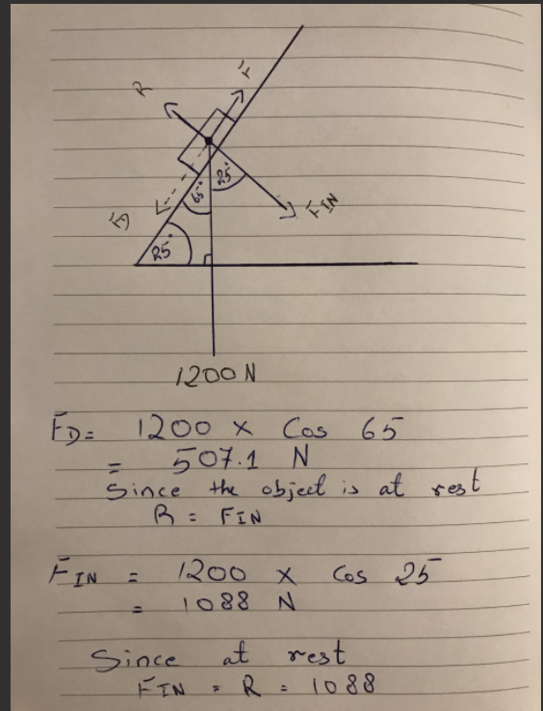

Friction = 507.1 N
F_{IN =} R = 1088 N

- By considering figure 1
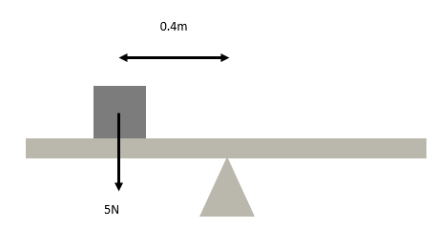
Figure 1

- Calculate the anticlockwise moment experienced on the see-saw

Moment = F x d = 5 x 0.4 = 2Nm (ACW)

- A 3N weight is placed on the right hand side of the see-saw to balance it. How far from the pivot should it be placed?

(3) D = (5) (0.4)

D = 5 x 0.4 = 0.67m
3

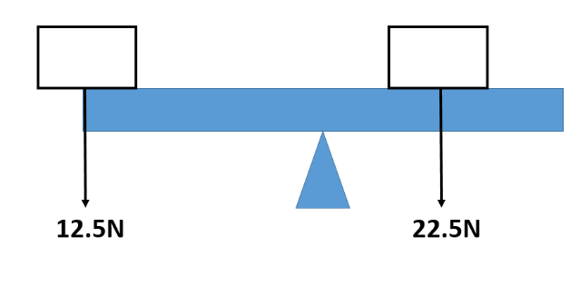
c) Figure 2 consists of a 5m plank that rests on a pivot. A 22.5N weight is added to the right hand side of the pivot. Determine the distance that the 22.5N weight needs to be from the centre in order to balance the plank.

Figure 2

Wight 22.5N
Half of 5m is 2.5m

22.5 x 2.5 = 56.25 Nm

- Figure 3 shows a 10m uniform beam of weight 5.5KN which is at rest. The beam is supported by two pillars. Pillar X is positioned 1.2m from the left hand side of the beam, pillar Y is positioned 2.5m from the right hand side of the beam.
X
Y
Figure 3

- Copy this diagram on your answer booklet, showing all forces.
- Determine both support forces.
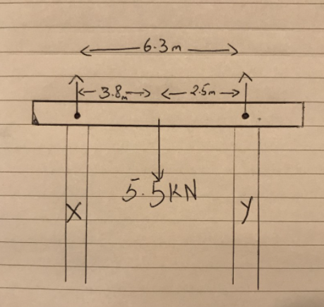

*Taking a moment about Rx * Taking a moment about Ry

(5.5) (3.8) = Ry = (6.3)  20.9 = 6.3 Ry  20.9 = Ry = Ry 3.317 N  6.3 | Rx (6.3) = (5.5) (2.5)  6.3 Rx = 13.75  13.75 = Rx = 2.182 N  6.3

Ry = 2.182 – 3.317
Ry = – 1.135

6. Solve the following by factorising:

- $x^{2}+6x+8=0$
Ans. ($x$ + 4) ($x$ + 2) = 0

- $x^{2}+4x+3=0$
Ans. ($x+3$) ($x+1$) = 0

- $x^{2}+3x=4$
Ans. $x^{2}+$3𝑥 – 4 = 0
(𝑥 − 1) (𝑥 + 4) = 0

- $x^{2}+3x-10=0$
Ans. ($x+$5) ($x-2$) = 0

- $x^{2}-5x+6=0$
Ans. ($x-3$) ($x-2$) = 0

7. Solve the following by using the quadratic formula:

- $7x^{2}+5x-10=0$

$x$ = -b ± √b^{2 _} 4ac
$2a$

a = 7
b = 5
c = 10

$x$ = -5 ± √5^{2 _} 4.7 (-10)
$2.7$

$x$= - 5 ± √25 _ 4.7 (-10) $2.7$

$x$= -5 ± √25 ⁺ 280
$2.7$

$x$= -5 ± √305
$2.7$

$x$= - 5 ± √305
𝟏4

$x$= - 5 + √305  𝟏4 | $x$= - 5 - √305  𝟏4
$x$= - 5 + 17.464  $$14$$ | $x$= - 5 – 17.464  𝟏4
$x$= 12.464  𝟏4 | $x$= - 22.464  𝟏4
$x$= 0.89 | $x$= – 1.605

- $12x^{2}+5x-4=0$

$x$ = -b ± √b^{2 _} 4ac
$2a$

a = 12
b = 5
c = 4

$x$ = -5 ± √5^{2 _} 4.12 (-4)
$2.12$

$x$= - 5 ± √25 _ 4.12 (-4) $2.12$

$x$= -5 ± √25 ⁺ 192
$2.12$

$x$= -5 ± √217
$2.12$

$x$= - 5 ± √217
24

$x$= - 5 - √217
24

$x$= - 5 + √217
24

$x$= - 5 ± √217
24

8. Solve the following linear equations:
- $\frac{5x}{2}=\frac{3x+1}{3}$

3 x 5$x$ = 2 (3$x$ + 1)
15$x=2 \left(3x+1\right)$
15$x=6x+2$
15$x- 6x=2$
9$x=2$
$x=2$/9
$$x=0.2$$

- $\left(x+5\right)\left(x+1\right)=(x+10)(x+2$)

$x$² $+ 6x$+ 5 = ($x$ + 10) ($x$ + 2)
$x$² + 6$x$ + 5 = $x$² + 12$x$ + 20
$x$² + 6$x$ + 5 $-x$² = 12$x$ + 20
6$x$ + 5 = 12$x$ + 20
6$x$ + 5 $-$12$x$= 20
$-$6$x+5=20$
$-$6$x=20-5$
$-$6$x=15$
$x$ = 15
$-$6
$x=-$ $5$
2
$$x=-2.5$$

