Reflection on Study Skills

Author: Joshua Luke Evans

Course: BSc Ordnance, Munitions, and Explosives – Level 4 Study Skills

Faculty of Architecture, Computing and Engineering

Date of Submission: 21st April 2021

4586 Words (not including appendices or reference list)

Declaration
The work of this report completed under the supervision of Gareth Jones. I declare that this report is the product of my own work and is not being submitted for any other degree etc.

Signed: Joshua Evans (electronically on 20th April 2021)

Abstract
The Study Skills module at the University of Wales – Trinity Saint David (UWTSD) teaches essential methods and principles to be successful within higher academia, as well as throughout one’s personal and professional life. The Author herein has identified and applied these principles through various class exercises and individual research, identifying key values and goals, and understanding their personality traits to distinguish strengths as well as weaknesses. The Author has then implemented the self-improvement techniques taught in the module to begin working on areas of concern. By applying and demonstrating these skills and behaviours throughout university, the Author hopes to achieve their desired grades as well as improve in other aspects of life.

Contents

Declaration 2
Abstract 3
Contents 4
List of Figures 5
List of Tables 6
1. Presentation 7
1.1. Presentation Techniques 8
1.2. Presentation Feedback and Evaluation 10
2. Skills Evaluation 11
2.1. Skills for Success 11
2.1.1. Higher Education 11
2.1.2. Transferrable Skills 11
2.2. Self-Evaluation 12
2.3. Self-Improvement 14
3. Application 15
3.1. Data Protection 15
3.2. Time Management and Self-Organisation 16
4. Conclusion & Evaluation 19
References 20
Appendices 22
Appendix A – “Creating Your Horizon” Activity 22
Appendix B – The Guardian: “What job would make you happiest?” [19] results. 24
Appendix C – Jungian/Myers-Briggs Personality Test [7] Results. 25
Appendix D – Big 5 Test [20] Results 26
Appendix E – Jung Personality Test [8] Results 27
Appendix F – Career Test [10] Results 29
Appendix G – Big Five Personality Test [12] Results 32
Appendix H – Team Role Test [11] Results 34
Appendix I – The Quiet Personality Test [9] Results 36
Appendix J – Self Evaluation of Academic Skills 37
Appendix K – Personal Development Plan 39
Appendix L – CryptoWall Ransomware Report 41

List of Figures
Figure 1 - "Likes" slide from class presentation. 7
Figure 2 - "My Personality" slide from class presentation. 7
Figure 3 - "Strengths and Weaknesses" slide from class presentation. 8
Figure 4 - "My Hopes for the Future" slide from class presentation. 8
Figure 5 - Jungian/Myers-Briggs Results Scale 12
Figure 6 - Screengrab of Google Calendar schedule 17
Figure 7 - Screengrab of E-Portfolio File Tree 18

List of Tables
Table 1 - Personal and Professional Goals 14

Presentation
In the second week of the study skills module, the class were asked to present a five-minute introduction on themselves outlining hobbies & interests (Figure 1), personality traits (Figure 2), strengths & weaknesses (Figure 3) and hopes for the future (Figure 4). The class were asked to refrain from using personality evaluation tests at this stage, to encourage self-reflection. One of the later exercises in Section 2.2, was to then compare the personal assessment against the results of online personality tests.
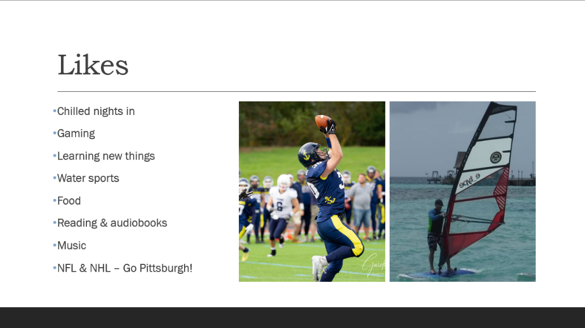
Figure 1 - "Likes" slide from class presentation.
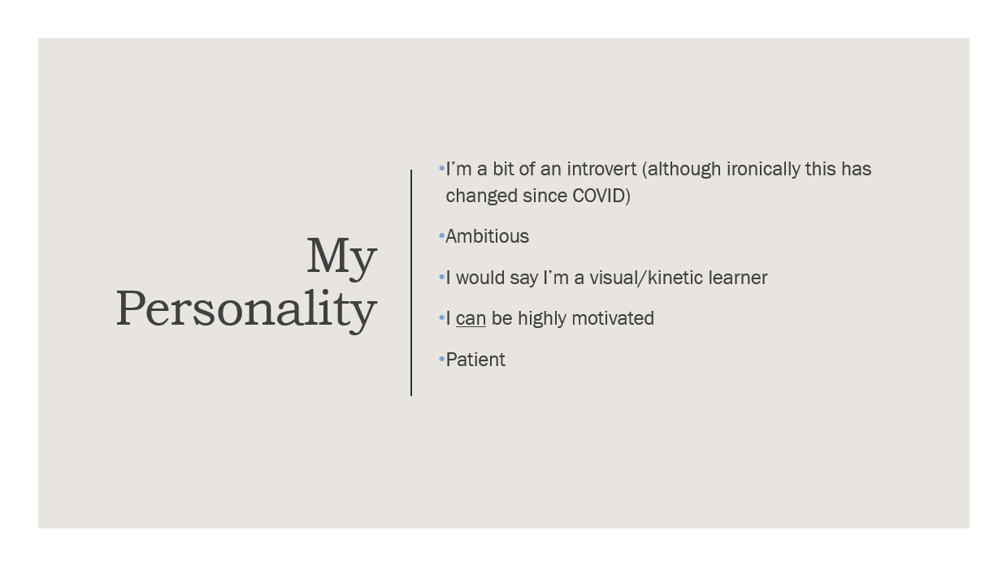
Figure 2 - "My Personality" slide from class presentation.
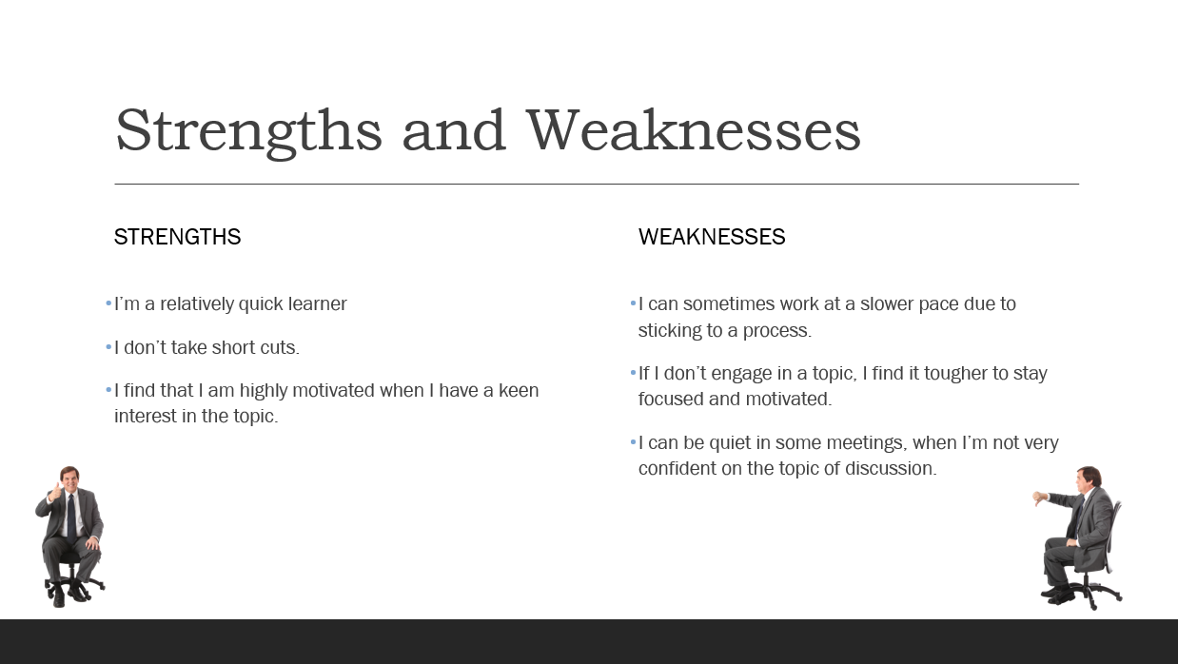
Figure 3 - "Strengths and Weaknesses" slide from class presentation.

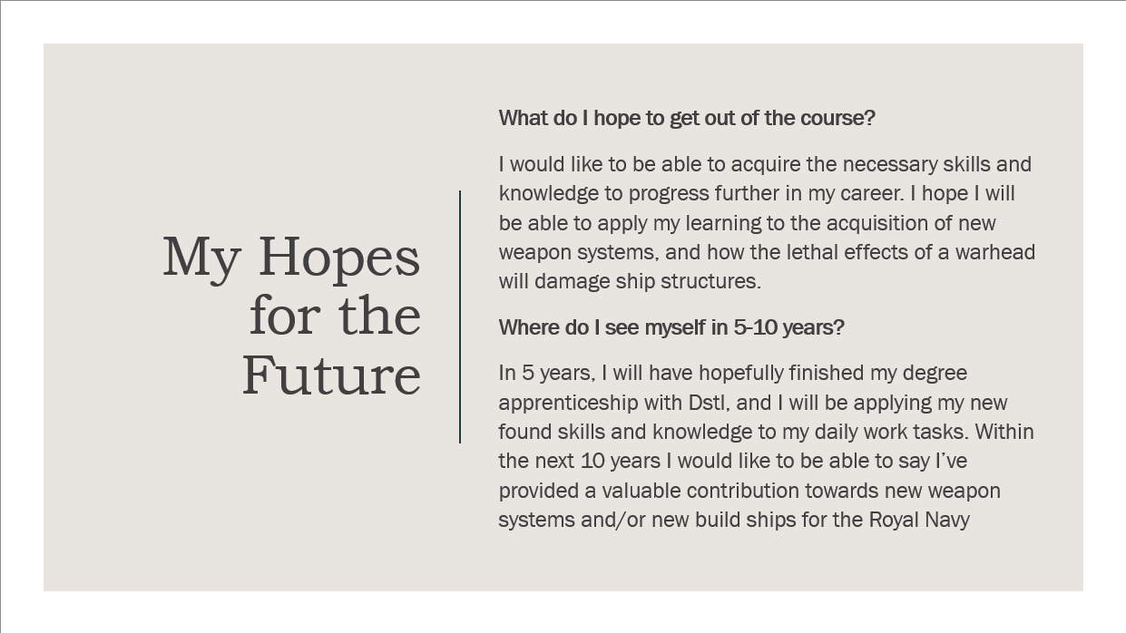
Figure 4 - "My Hopes for the Future" slide from class presentation.

Presentation Techniques
Ahead of the presentation, the class were asked to research presentation techniques and implement these in the delivery of their talk. Gareth Jones [1] [2] gave tips on general presentation design (e.g., font standards, structure, use of imagery and videos), what to expect when presenting a talk for university modules, and some key “do’s and don’ts” for giving a successful talk. One of the main points to come out of this lecture was the term “POWER:P”, which stands for:
- Prepare
- Organise
- Write
- Edit
- Refine
- Practice, Practice, Practice
By following these steps, one could ensure that an appropriate amount of preparation has gone into the talk, which should translate into a more confident and competent delivery.
Nancy Duarte [3] identified a common structure in some of history’s most memorable speeches, including the “I have a dream” speech and Steve Jobs’ iPhone launch. The structure involves going back and forth between the status quo and the possible future once your idea has been adopted. As demonstrated in the particular use cases identified by Nancy, using this type of structure for university talks could be very impactful when putting across results and findings from assignments and projects.
Chris Anderson [4] gave his thoughts on what makes a great talk great, and it focused on how to bring your audience with you on a journey to the idea you are presenting and outlined potential obstacles that may prevent the audience from connecting with your idea. Chris advised that to successfully deliver a concept, it needs to be built upon a firm foundation. The speaker is more likely to have success if they “build a concept step by step”, “use accessible language”, “avoid jargon” and “give examples”.
From the research carried out and from previous experience, some key tips to delivering a successful talk are:
- Focus on the topic of the presentation and try not to stray away from it. Time limits are often given and so time is wasted when irrelevant points are discussed.
- Pitch the presentation to the correct audience. If there is too much detail the audience may lose interest – not enough, and your presentation may lose the desired impact.
- Do not overload slides with too many words. Firstly, it can be tempting to rely on the information in the slides as a prompt, which can come across as being unprepared. Secondly, the audience can lose interest if there is too much written detail on each slide. Instead, the use of visual aids to communicate key points is more effective.
- Practice. It is easier to give a talk when you have suitably prepared and in turn this helps to come across more confidently.
- Prepare for any questions you might be asked. You will come across as more professional if you can answer questions without hesitation.

Presentation Feedback and Evaluation
Following the presentation, the lecturer provided individual feedback to the class, highlighting strengths and areas for improvement. The following feedback was given to the Author following their presentation:
- Excellent incorporation of visuals/images/photos to help convey the story and to keep the audience engaged.
- Good choice of a clear, professional looking template.
- Appropriate layout, use of fonts and text size.
- Make sure the screen is full-size.
- Clear, easy to understand.
- A professional delivery, seemed confident and well prepared.
- Be careful saying “umm”, “err” etc too many times… it is bad practice and can be avoided.
- Ran a little over time at 6:20. Practice with a stopwatch beforehand and edit if required.
- Good to see all areas requested in the brief were covered.
In addition to the feedback provided by the lecturer, the Author has also provided their thoughts on how the presentation went:
Overall, I felt that the presentation went well. I was suitably prepared for the talk and felt confident in what I was presenting. I had an issue at the start when attempting to screen share on a monitor that was positioned in portrait mode, which meant the slides were too small for the audience to read. After fixing the issue I felt slightly flustered, which may have contributed to me using “umm” and “err” more frequently, but despite this I still think I recovered well and delivered a good talk. In future presentations I will test the hardware and software I am using beforehand (where possible) so I can identify and fix any issues.

Skills Evaluation

Skills for Success
This section identifies valuable skills for success in higher education as well as skills that can be acquired through university that are transferrable throughout one’s career.

Higher Education
When starting out in further education, it is important to identify the skills and behaviours that are needed along the way to achieving desired grades. From the first day of Fresher’s week there are many new challenges that students face, and it is important to confront these effectively to help settle nerves and gain in confidence. Smale and Fowlie [5] highlight the “culture shock” that many are faced with when starting off in higher education. Being positive, inquisitive, and social in the first few weeks can help new students to settle in.
[5] also draws attention to students recognising their own motivation to learn and develop. By identifying what you wish to achieve throughout your time at university (similarly applicable to your career), and your reasons for wanting to achieve these goals can help to motivate you during more difficult periods.
One recurring theme by Smale and Fowlie [5] is the importance placed upon reflection. In Essence, the “three-stage model of reflection” they outlined in Figure 5.2 of their book is the same as any system, in that it has an input, a process, and an output. The input is all the learning material gathered through lectures and research; the process stage is the key to generating an effective output. Smale and Fowlie refer to the terms “surface learning” and “deep learning” which distinguishes how people interact with and comprehend source material. When a deeper understanding of a topic and its underlying premises is achieved, one can creatively examine and interpret the data for their own purposes, whether that be a written report, an oral presentation, or in an exam.
Furthermore, [6] identifies techniques for “mastering the art of studying”. Note taking is vital for remembering lecture material and recording thoughts when reading through data sources for an assignment. It is recommended that students review their notes from class at the end of the day while the topic is still fresh in the memory. This helps to form a firmer understanding of the subject matter and any areas that need further attention. Everyone has their own preferred methods of learning, and for some, reading notes aloud can be a more effective way of retaining information. Finally, [6] suggests that teaching friends the course material is a good way of cementing comprehension of a particular subject as this demonstrates understanding and applies knowledge in a different way.

Transferrable Skills
Transferrable skills are general competencies and behaviours that are developed over time throughout your career. Maturing these skills will increase your effectiveness at work, regardless of role and responsibilities. University courses provide opportunities to practice and develop these skills through various mediums encountered in academic study (e.g., carrying out group/individual projects, revising for and taking exams, writing assignments, conducting research, etc.). Employers will look for applicants to provide evidence where transferrable skills have been demonstrated, however there is no definitive list of what skills they may be looking for. [6] outlines the main employability skills students should try to develop whilst at university:
- Numeracy / IT skills – As well as showing an understanding of numbers and other mathematical concepts, high numeracy skills can demonstrate that a person has the ability to think logically. There are a large range of job roles that involve maths to some degree and is often a key requirement that employers seek. IT skills refer to the ability to understand and effectively employ software to achieve daily tasks of the prospective job role. For a data scientist, proficient knowledge of programming is likely required. For a management role, a good understanding of the Microsoft Office suite would be beneficial.
- Communication skills – In many job roles, an employee will likely spend more time conversing with colleagues and customers, than reading or writing. The ability to effectively talk and listen is valuable for generating meaningful discussions that can benefit the tasks you are undertaking. It is also useful to be able to communicate effectively at different levels. For instance, when giving a presentation, will your audience understand the technical concepts behind the talk you are giving, or are they more interested in understanding the high-level results and conclusions?
- Team-working skills – effective team-workers can coordinate and balance tasks amongst other team members and provide motivational support to the team. Group work requires cooperation, sharing of knowledge, direction, and leadership to generate effective outputs.
- Research/critical thinking skills – The ability to locate, identify, dissect, and analyse relevant source material for use in generating reports, as well as being able to critique others’ work is necessary in many job roles. It enables you to identify if similar work to your current tasking has previously been conducted, which can save you time, effort, and money, whilst good critical thinking skills may be demonstrated through giving constructive feedback on colleague’s work or analysing source material to identify if there are possible errors in the methods used or results gathered.
- Creativity/problem-solving skills – These skills refer to the ability to solve various challenges through logical and creative thinking. people with these abilities can adapt to new and shifting environments, whilst in the workplace, these skills can improve performance, troubleshoot problematic procedures, and complete research tasks.
- Organisational skills – Good organisation is required at all job levels to maximise efficiency in a company. Employers will expect job candidates to be able to independently plan and manage their own workloads.
- Commercial awareness – Commercial awareness requires prospective job candidates to have knowledge of the job sector and wider environment in which companies operate. This includes understanding an organisation’s strategic direction, policies, and processes. Having a solid grounding in commercial awareness is useful regardless of job level, but greater understanding and application is required at more senior levels.

Self-Evaluation
One of the class activities conducted in the Study Skills module was to carry out online personality tests. All the tests consisted of similar question sets that looked to identify personality characteristics and associated strengths and weaknesses. an example from [7], assessed the following pairs of personality traits:
- Introversion (I) / Extroversion (E)
- Sensing (S) / Intuition (N)
- Feeling (F) / Thinking (T)
- Judging (J) / Perceiving (P)
There were two tests [7] [8] that used the same metrics yet gave slightly different results. [7] assessed the Author as INTJ, whilst [8] assessed Joshua as INTP. When taking a further look into the results, [7] gives a scale which displays how firmly one sits on either side (Figure 5).
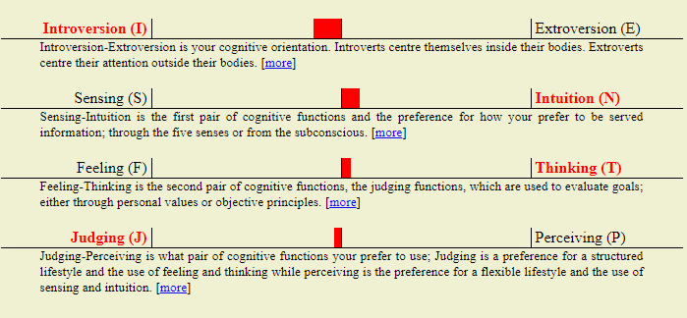
Figure 5 - Jungian/Myers-Briggs Results Scale
From this scale, it is noticeable that the Author lies very close to the boundary for “Judging/Perceiving”. “Sensing/Intuition” and “Feeling/Thinking” are also close to the margin, which explains previous results that the Author attained from personality tests conducted in 2020 that described the Author as ISFP.
Throughout many tests completed, there was a consistent trend that the Author is introverted. This aligns with the Author’s self-assessment of his personality, where in Figure 2 the first point states, “I’m a bit of an introvert (although ironically this has changed since COVID)”. This viewpoint is further supported by the personality tests carried out, as [9] assessed the Author as being “ambivert”, where one is able to tap into the strengths of both introverts and extroverts as required.
Two of the personality tests assessed suitable career paths [10] and job roles [11]. The Career Test gave promising results that aligned to the Author’s career path to date. There were several occupations that came out with an 85% suitability score, and of them, the Author has experience both in electrical and mechanical engineering. The Ordnance, Munitions and Explosives BSc Course has strong links to electrical and mechanical engineering principles which is an encouraging sign for later modules.
The Team Role Test [11] recommended Joshua as being a suitable Chairperson. Joshua has had previous experience in this role but has felt uncomfortable on occasions when there are difficulties making progress on agenda items. One of the responsibilities of a Chairperson is to keep meetings on track, and this can be difficult when discussions take tangents and become irrelevant to the original program. This can take valuable time away from discussing more important matters that may be further down on the meeting schedule. Conversely, the second most appropriate role was Innovator. This is more attuned to the Author’s current job role and is a closer personality match to how the Author would describe themselves.
The Big Five Personality Test [12] measures five major factors of personality:
- Openness to experience
- Conscientiousness
- Extraversion
- Agreeableness
- Natural reactions
For each of these aspects the Author was provided a score. Accompanying this was a table of personality traits associated with high and low scorers. Joshua scored “low” in “openness to experience” and “extraversion”. The personality traits are neither a strength nor weakness until context is applied. For example, the Author works in research and development and has an engineering background. Therefore, being “traditionalist” and “conservative” rather than “imaginative” and “open-minded” could possibly limit success in their current career path if they are not open to or accepting of new ideas and technologies. Having identified potential areas of weakness, further investigation is needed to ascertain which descriptors genuinely apply and look to improve on traits that could hinder future development and progress.

Self-Improvement
In this section the Author explores two methods that can be employed to stimulate self-improvement: Goalsetting and Personal Development Plans (PDPs).
Goalsetting is a valuable exercise for identifying and achieving long-term targets. This exercise can be undertaken to recognise both professional and personal objectives to strengthen aspects in all areas of life – not just work. Short-term objectives can be useful for measuring progress against long-term goals. For instance, in Table 1, the Author would like to achieve chartered status in a professional institute. To help accomplish this, attaining incorporated professional status first will provide a suitable steppingstone for becoming chartered later in their career. However, it should be noted that if short-term goals could take too long or are too difficult to achieve, this can be demoralising as it is harder to track progress. Therefore, it is pragmatic to list more short-term targets so that growth can be monitored more closely, and achievement of short-term goals can also generate inspiration to keep working towards long-term aims.
Personal |  | Professional
Short-term | Long-term | Short-term | Long-term
Miscellaneous – go on honeymoon | Golf – achieve a score of 100 or less | Personal development – improve organisation skills | Professional institute – gain chartered status
Windsurfing – learn how to tack/jibe at faster speeds. Get more confident using a harness. | House renovation – buy new kitchen and conservatory | Personal development – learn how to motivate myself more effectively | University - finish my degree with at least 2.1 (stretch – get a 1st)
Roller skating – get more confident |  | University - pass year 1 modules (Stretch – get at least a 2.1 average) | At work – gain a promotion
Golf – take part in a tournament and do not finish last. |  | Professional institute – gain incorporated status
Golf – get a handicap |  | Personal development – read at least one article/report a week
 |  | Coding – become more proficient.
Table 1 - Personal and Professional Goals
Another key skill for promoting self-improvement is to put a PDP in place [5]. This should be a live document – in that it is a continuous cycle of identifying, improving, and managing areas of weakness. Multiple sources [5] [13] refer to using SMART targets, when setting out a PDP. SMART stands for:
S = Specific
M = Measurable
A = Achievable
R = Realistic
T = Timed
By following this format, PDPs are likely to be more effective, generating noticeable improvements. Appendix K – Personal Development Plan provides an example PDP that the Author generated throughout the Study Skills module.

Application

Data Protection
Throughout a higher education course, students will generate large amounts of data that needs to be kept secure, as any loss of data could significantly impact the quality of an assignment, or the ability to submit it on time. The class were taught the “in 3 different places” rule [14] to provide robust protection against possible disaster scenarios. The three different places that the Author has identified for their university studies are:
- Cloud-based storage.
- Internal/external hard drives.
- Work servers.
Cloud-based storage allows for remote access to files from any device, which means that if your laptop/PC unexpectedly breaks down, you can still access the files from another electronic device (if you have an internet connection). Many cloud storage solutions allow you to back up local files from electronic devices so that they can be recovered if, for example, your PC gets a virus, or your hard drive breaks. One limitation of cloud-based storage is that you require an internet connection to access it. Therefore, if there is no Wi-Fi or cellular connection the files will be unavailable. Cloud storage could also suffer outages if maintenance or updates are required, therefore 24/7 access cannot always be guaranteed.
Internal and external hard disks allow for instant access to your files, and unlike cloud-based storage, do not require an internet connection. Internal hard drives on a laptop/PC are tailorable for various data requirements (e.g., read/write speeds and limits, storage capacity, budgets, etc.). By installing multiple hard disks, copies of the drive images can be stored so that if one hard drive malfunctions, it can be restored once the broken disk has been fixed/replaced.
The third option is to save copies of university files on work servers. This can be a useful way of protecting data, as it is often the case that companies will have a lower risk appetite when it comes to data protection, and so they will have robust mitigation in place to ensure data is still accessible/recoverable following a disaster scenario.
By using the three storage options in parallel, a multi-layer protection method can be maintained, minimising the risk of important files being inaccessible at the required time following a data loss incident. For instance, if the internet cannot be accessed, there are offline copies of documents available on internal/external hard disks. If one hard disk happens to be malfunctioning at the same time, then copies are stored on the cloned drive image which can be recovered.
If an electronic device gets infected with malware and access to documents has been restricted (in the case of ransomware, for instance), then there are still copies of the documents available on the work servers or on cloud storage. However, it is worth investigating how the malware was contracted onto the electronic device, in case there is an infected document that has been downloaded from a website or an email. For more information on ransomware, please refer to Appendix L.

Time Management and Self-Organisation
Time management and self-organisation are key skills to master for being successful in higher education and are very useful transferrable skills that employers look for in job applicants. In order to improve these skills, the Author has outlined steps they have taken, or intend to take, which will improve productivity and organisation, and reduce stress levels.
One recent step taken that coincided with the start of the Ordnance, Munitions and Explosives Degree course was to adopt a plant-based diet. Veganism can have a positive impact on your physical and mental health in a chemical and biological way [15]. Many vegans report that “plant power” helps increase your brain function thanks to the additional intake of essential vitamins and nutrients. Higher carbohydrate consumption also helps to keep energy levels up throughout the day. Vegan diets have also been linked to lowering stress, as plant-based foods can lower cortisol levels [16].
Another method of improving organisation is to keep an up-to-date calendar [17]. Calendars are useful for recording key dates (e.g., assignment deadlines, birthdays, anniversaries, etc.) and for blocking out times for daily tasks such as driving to work, going for a run, or dedicating time for revision/study. This can help you to prioritise workloads appropriately and create a good work-life balance. Figure 6 shows the Author’s typical weekly schedule within Google Calendar. This schedule has flexibility over the weekends which means there’s available time to socialise with friends and family, but also to carry out extra study if deadlines are close, or if study/revision sessions in the week have been disrupted by other events.
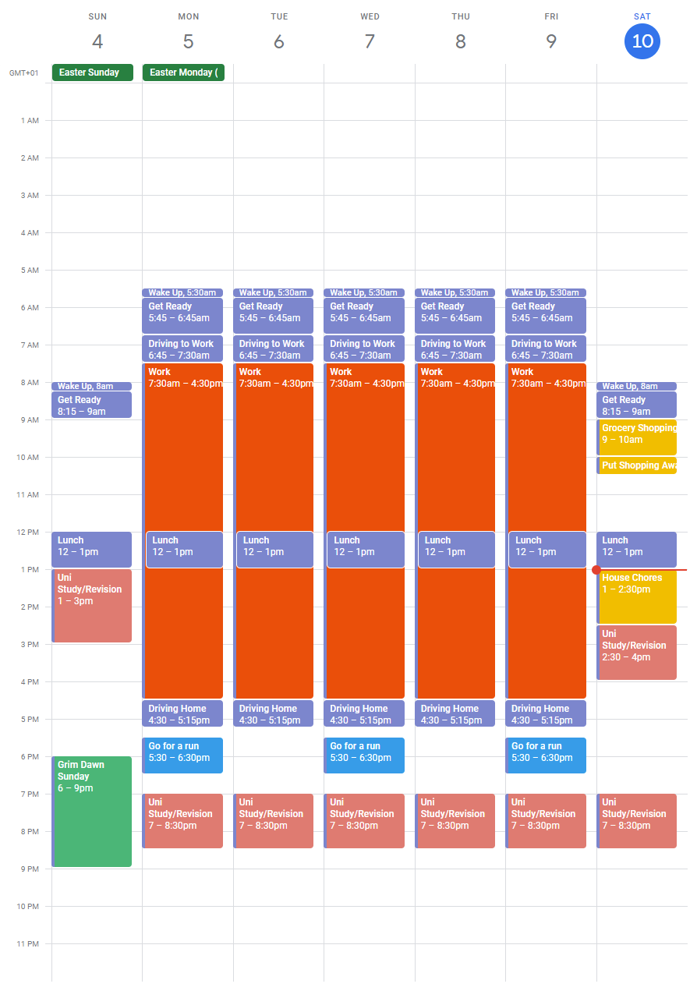
Figure 6 - Screengrab of Google Calendar schedule
Figure 6 also displays the Author’s weekly fitness routine. Keeping fitness levels up can have a positive effect on improving concentration and mental health. Ben Martynoga [18] linked various findings that support this, including a 2010 study where participants carrying out daily yoga and meditation over an 8-week period reported lower stress levels. Brain scans later showed shrinkage to a part of the amygdala that is responsible for processing stress, fear, and anxiety.
As part of the Study Skills module, Gareth Jones [19] highlighted the importance of organising files. It was recommended that students create an e-portfolio to manage both personal and professional files that are generated. An example of the Author’s e-portfolio is provided in Figure 7.
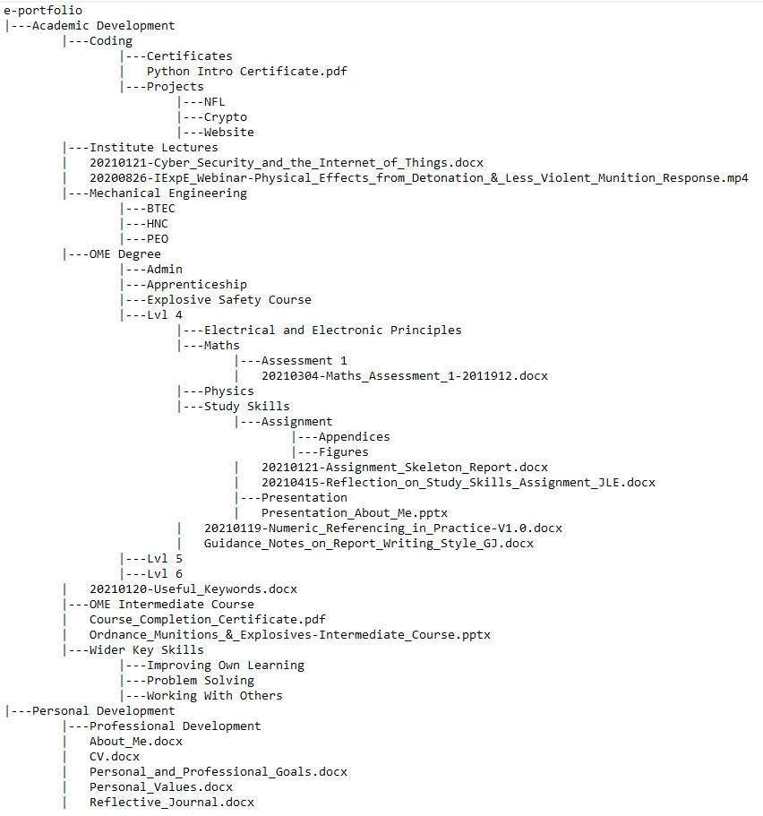
Figure 7 - Screengrab of E-Portfolio File Tree
In the “Academic Development” folder, the Author has multiple subfolders that contain documents from the OME BSc course and other previous training courses. Having the ability to refer to content from previous training courses and is valuable as these can still be used as a training aid if knowledge needs refreshing on certain topics.
The “Personal Development” folder contains data that relates to other areas of the Author’s life. For instance, the “Personal and Professional Goals” document is a live version of Table 1 that documents short-term and long-term targets. The “reflective journal” can be used to record daily events with introspective musings on what the Author did well and can also help identify areas for weakness. Keeping a journal can be an effective tool for personal development as well as a suitable referencing aid (e.g., when gathering evidence of competencies for chartered status with a professional institute).

Conclusion & Evaluation
The Study Skills module has provided a useful introduction into the techniques and skills required for success throughout the Ordnance, Munitions and Explosives BSc Degree course, as well as success in one’s future professional career and personal life. The methods for preparing and generating technical talks, producing reports, and correctly referencing various sources of information will be beneficial in ensuring maximum marks can be achieved in subsequent modules, whilst methods for identifying areas of strengths and weaknesses allow for continual improvement and development in all aspects of life.
The PDP as shown in Section 2.3 and Appendix K – Personal Development Plan will continue, and results will be monitored to identify where improvements have been made. Action plans that are found to be ineffective, shall be reinvestigated to consider alternative approaches. Additionally, regular self-evaluation exercises will be conducted to identify any emerging weaknesses so that action plans can be established as soon as possible.
Another aspect that will require continual monitoring and management is the data storage requirements outlined in Section 3.1. As technology advances, so does the threat to data security (i.e., cyber criminals), and so what may now be considered as a safe method of storage, may not be in the future. It is therefore necessary to ensure that files are continually backed up to all storage locations identified so that the “in 3 different places” rule is maintained to minimise risk of data loss. There may be more appropriate data storage methods that are identified if working with larger files (e.g., big data or engineering models), so storage methods should be reassessed to ensure the most efficient and cost-effective solutions are being utilised.

References

[1] | G. Jones, “ACDA4010: Presentation Design Tips,” UWTSD, 10 October 2013. [Online]. Available: https://moodle.uwtsd.ac.uk/mod/page/view.php?id=203069&inpopup=1. [Accessed 14 January 2021].
[2] | G. Jones, “e-Handout - Presentation Tips,” UWTSD, Swansea, 2013.
[3] | N. Duarte, “The Secret Structure of Great Talks,” in TEDxEast, New York, 2011.
[4] | C. Anderson, “What Makes a Great Talk... Great,” in TEDGlobal, Edinburgh, 2013.
[5] | B. Smale and J. Fowlie, How to Succeed at University - An Essential Guide to Academic Skills and Personal Development, London: SAGE Publications, 2009.
[6] | University of the People, “How to Succeed as a Student,” University of the People, [Online]. Available: https://www.uopeople.edu/blog/how-to-succeed-as-a-student/. [Accessed 18 04 2021].
[7] | University of Kent, “Employability Skills,” University of Kent, 21 August 2020. [Online]. Available: https://www.kent.ac.uk/ces/student/skills.html. [Accessed 13 04 2021].
[8] | Open Psychometrics, “Open Extended Jungian Type Scales 1.2,” [Online]. Available: https://openpsychometrics.org/tests/OEJTS/. [Accessed 24 February 2021].
[9] | 123 Test, “Jung Personality Test,” [Online]. Available: https://www.123test.com/jung-personality-test/. [Accessed 24 February 2021].
[10] | S. Cain, “The Quiet Personality Test,” Quiet Revolution, [Online]. Available: https://www.quietrev.com/the-introvert-test/. [Accessed 24 February 2021].
[11] | 123 Test, “Career Aptitude Test,” [Online]. Available: https://www.123test.com/career-test/. [Accessed 24 February 2021].
[12] | 123 Test, “Team Roles Test,” 123 Test, [Online]. Available: https://www.123test.com/team-roles-test/. [Accessed 24 February 2021].
[13] | 123 Test, “Big Five Personality Test,” 123 Test, 25 January 2021. [Online]. Available: https://www.123test.com/personality-test/. [Accessed 24 February 2021].
[14] | G. Jones and C. Carpenter, “Goals, Aims, and Objectives 2019,” UWTSD, Swansea, 2019.
[15] | G. Rees-Evans and G. Jones, “Backing Up Data GJ AES,” UWTSD, Swansea, 2014.
[16] | J. Landis, “Does Being Vegan Help Your Mental Health? 5 Benefits You'll Notice When Making the Switch,” Vegan Food and Living, 22 September 2020. [Online]. Available: https://www.veganfoodandliving.com/vegan-lifestyle/mental-health-benefits-going-vegan/#:~:text=Eating%20a%20healthy%20diet%20and,a%20chemical%20and%20biological%20level.. [Accessed 10 April 2021].
[17] | C. Debret, “Understanding How a Plant-Based Whole Foods Diet and Exercise Improvces Cortisol Levels,” One Green Planet, 2019. [Online]. Available: https://www.onegreenplanet.org/natural-health/understanding-how-a-plant-based-whole-foods-diet-and-exercise-improves-cortisol-levels/. [Accessed 10 04 2021].
[18] | G. Jones and G. Rees-Evans, “Time Management,” UWTSD, Swansea, 2019.
[19] | B. Martynoga, “How Physical Exercise Makes Your Brain Work Better,” The Guardian, 18 June 2016. [Online]. Available: https://www.theguardian.com/education/2016/jun/18/how-physical-exercise-makes-your-brain-work-better. [Accessed 10 April 2021].
[20] | G. Jones, “Creating Your PDP and E-Portfolio,” UWTSD, 20 January 2021. [Online]. Available: https://moodle.uwtsd.ac.uk/mod/page/view.php?id=203098&inpopup=1. [Accessed 20 January 2021].
[21] | J. Lees, “Personality test: What job would make you happiest?,” The Guardian, 11 November 2014. [Online]. Available: https://www.theguardian.com/lifeandstyle/2014/nov/11/-sp-questionnaire-what-job-would-make-you-happiest. [Accessed 24 February 2021].
[22] | Open Psychometrics, “Big Five Personality Test,” 2 August 2019. [Online]. Available: https://openpsychometrics.org/tests/IPIP-BFFM/. [Accessed 24 February 2021].

Appendices

Appendix A – “Creating Your Horizon” Activity
You:
- What you truly Love & Enjoy?
I enjoy the company of friends and family.
I love food, and since going vegan in January 2021 I am enjoying food even more, as I am feeling healthier and discovering new tastes in the process.
I love living near the beach. I like to go on walks at my local beach (even in the winter months), and in the summer it is great to be able to do different water sports that are another passion of mine e.g., kayaking, paddle-boarding, windsurfing, etc.
- What you enjoy doing?
  - Spending time with friends and family
  - Going on holidays
  - Reading
  - Golf
  - Windsurfing
  - Walking
  - PC gaming
  - Watching sports
  - Going to the cinema
  - Learning
- What kind of person do you want to be?
- With your family?
With my family, I want to be reliable. I want them to know that they can always count on me to be there to support them whenever they need it. Times have been difficult over the last year with COVID, as family members have struggled, and being unable to see them and provide support to them has been difficult for me to accept.
- With your friends?
As is the case with my family, I would like to be reliable to my friends. As work and other life commitments have got in the way, I have lost touch with old friends from the past. Going forward, I would like to stay in touch more often and be more involved in my friends’ lives.
- at work?
At work I want to be respected, not just generally, but also in my specific field I would like to be noticed by the community as an expert and know that my work is truly valued.
I want to be approachable and helpful to my colleagues. I want them to know that they can talk to me about their work, and that I am willing to pass on my knowledge, as well as learn from them.
Your Profession:
- What you would truly love to do as a Career?
When I first got into engineering, it was my dream role to get into research and development, and I am grateful that I have been able to get into that field so early on in my career. Going forward, I would love to be more hands on in my work, organising and carrying out trials and assisting in design and manufacturing of new, impactful technology.
- What would be your Dream job?
As stated above, I am already in my dream job, but I would like to be involved in more practical work in the future. I started my career in a craft apprenticeship and worked for 5 years on my tools, so I would be grateful to be able to apply those skills to my current role.
- How could you achieve it?
There are a lot of internal opportunities for getting involved in trials work, and there are customers whose projects are usually more hands-on. I will look to make contacts in these areas and declare my interest to get involved. By making a good name for myself on these types of projects I can hopefully get more involvement as time progresses.
- How would you feel doing that job?
I would feel more comfortable, having had a lot of practical experience in the past. I would also get more satisfaction seeing the results of the work I am carrying out, which is something I do not see in my current work role.
- What would be your daily activities?
- Designing and manufacturing prototypes
- Organising, managing and conducting trials
- Working with industry
- Collaborating with other teams
- Liaising with customers to determine their requirements.
- What would you love most about your job?
The satisfaction of seeing results from my work would be the thing I would love most about this job role. Bringing new products into service that have a meaningful impact to way things are done would provide personal assurance that I am an effective member of my team.
Your Life:
- What would your ideal life be like? consider what different aspects of your life would be like.
I would ideally have a good work-life balance where I am able to spend time with family and friends, as well doing some of the hobbies I enjoy in my spare time. I would also like to have the opportunity to travel – both for business and pleasure.
I hope to have a wider friendship group that shares similar interests and hobbies, including having a friendship group inside of work that I can discuss work-related matters with (being a civil servant means I cannot talk to my friends outside of work about these things).
- What would you love most about your life?
The thing I would love most about my life is the variety: The variety of location, the variety of friendship groups that have different interests and yet all resonate with my personality and pastimes. The difficulty with this would be balancing work and home life, and then splitting time between friends and family.

Appendix B – The Guardian: “What job would make you happiest?” [20] results.
1. Hands-on: 15
Your ideal work is mainly about engaging with the physical world, for example building, cooking, craft, DIY, working with animals, plants and machines, sports and hands-on therapy. Example jobs include: sports coach, physiotherapist, engineer, LGV driver, builder, mechanic, veterinary nurse.
2. Information and research, processes and systems: 12
Your ideal work is mainly about researching or managing information. This will include analysis, cataloguing and database management, but may include investigating topics in depth, IT, science, maths, quality control, systems, and regulations. Example jobs include: accountant, scientific researcher, investigative journalist, legal assistant, book-keeper, health and safety officer, purchasing professional.
3. Influencing, negotiating, communicating: 12
Your ideal work is mainly about persuading other people to do something, buy something or believe in your cause. This includes driving others, influencing, persuading, lobbying, motivating, selling. Example jobs include: salesperson, recruiter, fundraiser, event manager, estate agent, public speaker.
4. Creative use of ideas, materials or situations: 14
Your ideal work is mainly about working imaginatively with ideas or designs. This includes jobs in the arts, performing, creative writing, and also visual design, lateral thinking, business creativity, adapting or coming up with new ideas, working in situations where no rulebook exists. Example jobs include: graphic designer, training consultant, wedding planner, public relations.
5. Supporting people: 9
Your ideal work is mainly about working with people, with their wellbeing and development as the main focus of your work. Example jobs include: teacher, life coach, therapist, nurse, learning and development, career coach.
6. Making new things happen: 11
Your ideal work is mainly about achieving things with and through other people. This may involve organisational change, planning, managing projects, leadership, creating a new business, shaping teams, getting results. Example jobs include: project manager, team leader, operations manager, sales manager, business developer.

Appendix C – Jungian/Myers-Briggs Personality Test [7] Results.
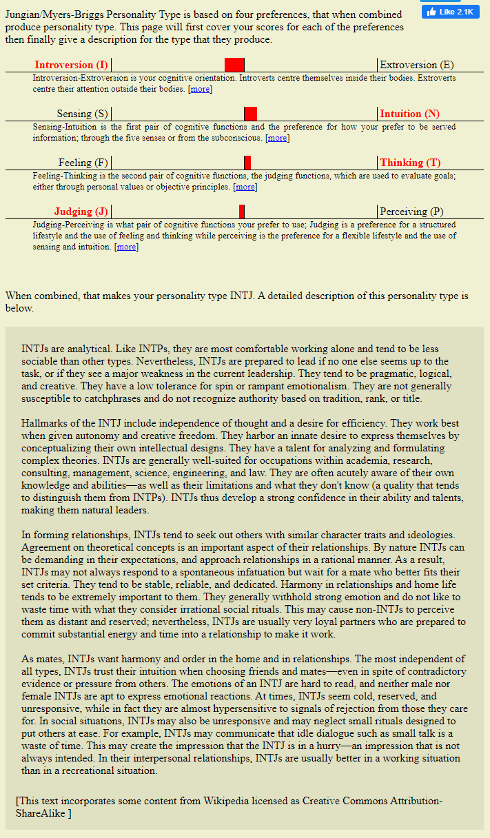

Appendix D – Big 5 Test [21] Results

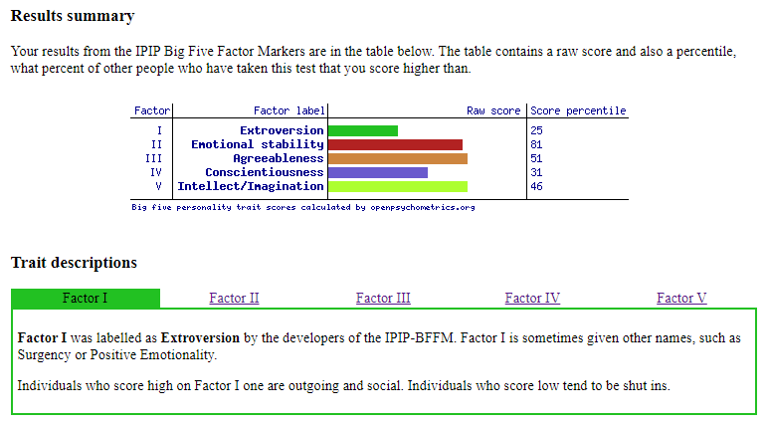
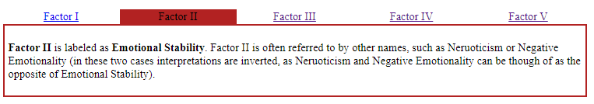
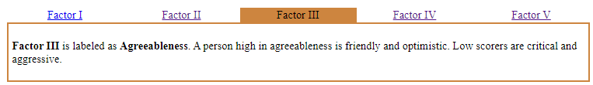
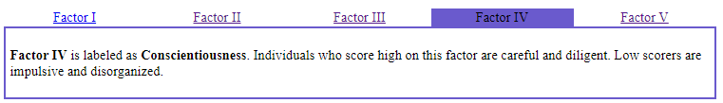
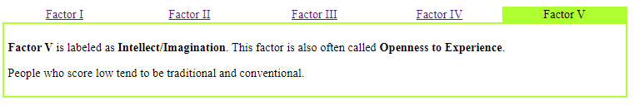

Appendix E – Jung Personality Test [8] Results
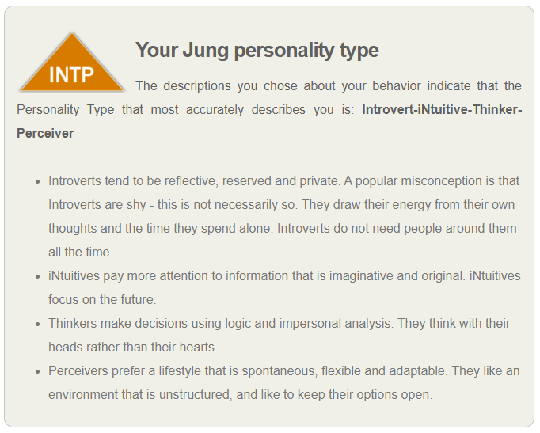
An INTP at-a-glance
You are perhaps the most intellectually thoughtful of all the Personality Types. People who know INTPs well describe them as innovative and ingenious. You live in a rich internal world in your mind, which is full of imagination and excitement. As a consequence, you may sometimes find the external world less interesting. This may lead some people to see you as being rather understated and reserved.
Your distinguishing characteristics are imagination, originality, perceptiveness, creativity and a delight in tackling the complex. You are interested in theorizing, analysing and learning. You thrive on exploring, understanding and explaining how the world works.
Your logical, rational mind means that you are frequently one step ahead of others and are usually considered to be intellectually superior. You are strongly motivated to challenge yourself to pursue and acquire excellence. You tend to be somewhat sceptical and are orientated towards the future rather than the past. Every Jung Personality type has one or two specific nicknames that concisely describe your Jung personality type, e.g. Inventor, Strategist, Protector and others.
Your probable contributions to an organisation
Each Personality Type has a different set of skills, talents and attributes that they bring to an organisation, group or relationship. Here is a list of those most commonly associated with Personality Types like you - INTP.
- Seeks to continually acquire new knowledge and competencies.
- Uses systematic intellectual precision and expertise to tackle problems.
- Has strongly defined interests and enjoys working on a technical level.
- Is strong in strategy.
- Prefers the world of ideas and analysis and enjoys designing complex systems.
On a team
Some people work well on teams, others work best on their own. Understanding the personality types of team members provides information about how individuals are likely to carry out their work and interact with each other. Given your personality preferences, the following are the strengths (and possible weaknesses!) you will most likely bring to a team:
- Naturally becomes the expert resource on a problem that others consult with.
- Works alone to achieve the group project and goals.
- Brings both a critical vision and precise rational understanding to the team.
- Uses logic and reason to support conclusions.
- Offers insightful conclusions that result from an intense, internal rational process.

Appendix F – Career Test [10] Results
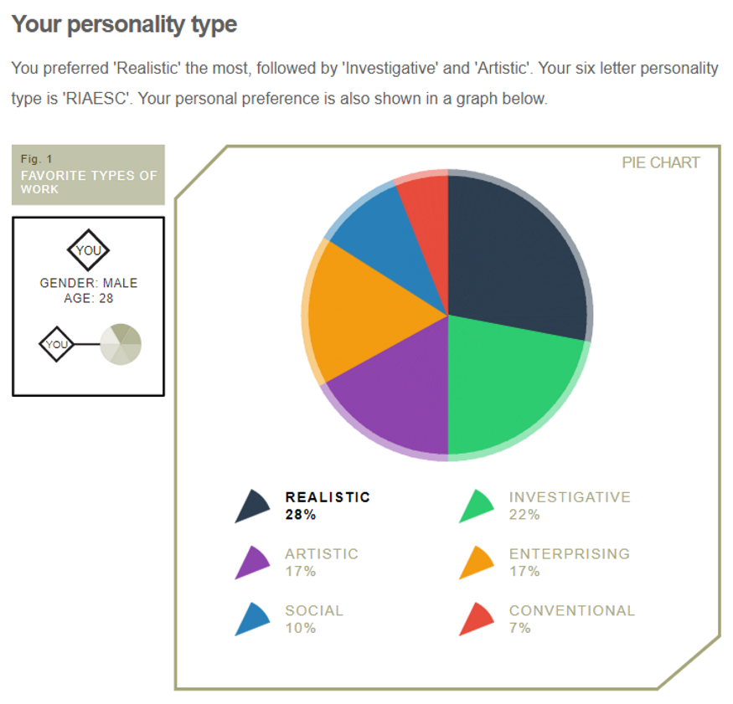

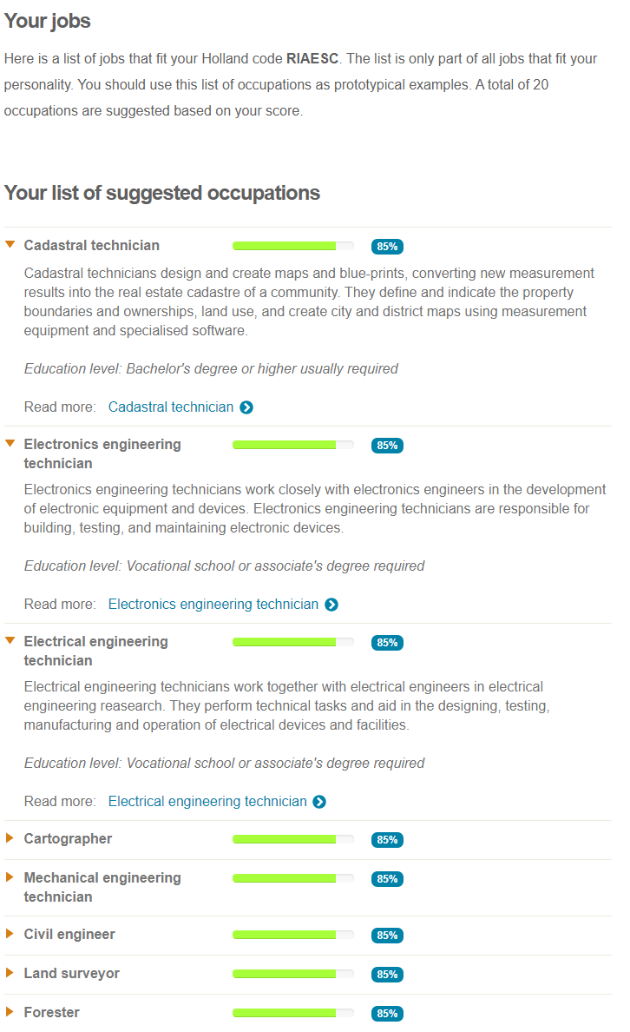
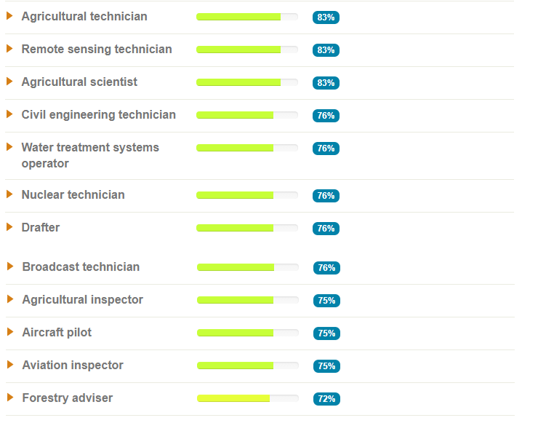

Appendix G – Big Five Personality Test [12] Results

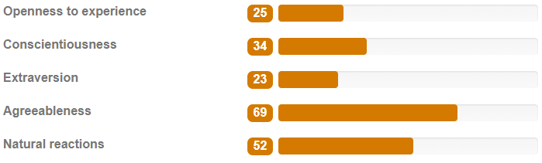
The Big Five Factors | Describing a low range scoring person… | Percentile | Range | Describing a high range scoring person…
Openness to experience | Traditionalist, down-to-earth, practical, conservative, prefers traditional outlooks and technical problem-solving | 25 | Low | Imaginative, open-minded, experimental, prefers creative conceptual problem-solving
Conscientiousness (work ethic) | Spontaneous, disorganised, prefers flexible plans, dislikes precise details | 34 | Middle | Conscientious, disciplined, efficient, well organised, likes precise detail, strong sense of duty, (very high scorers could be described as workaholics)
Extraversion | Reserved, formal, serious, quiet, prefers working alone, avoids direct leadership roles | 23 | Low | Outgoing, friendly, assertive, likes working with others, enjoys direct leadership roles
Agreeableness | Hard-headed, sceptical, competitive, proud, prefers competition over co-operation | 69 | Middle | Compassionate, eager to please, good natured, prefers co-operation over competition and conflict
Natural reactions | Not easily upset in stressful situations, relaxed, resilient, calm | 52 | Middle | Experiences negative emotional reactions and feelings of anxiety, prone to worry, easily upset

Appendix H – Team Role Test [11] Results
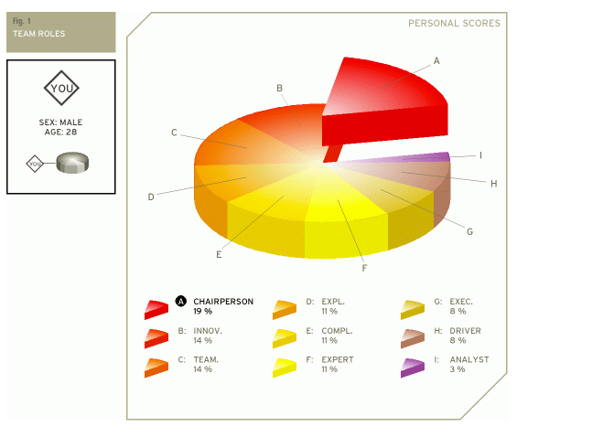
Chairperson
The chairperson has a strong coordinating role. With an emphasis on procedures, the chairperson will try to bring and keep the team together. He or she is communicative and deals with the members of the team in a respectful and open-minded way.
Innovator
The innovator is often the creative generator of a team. He or she has a strong imagination and a desire to be original. The innovator prefers to be independent and tends to approach tasks in a scientific way. As a creative individual the innovator may play a crucial role in the way a team approaches tasks and solves problems.
Team player
The team player is caring, avoids conflicts, and fosters harmony. Being someone who likes to help other people, the team player is generally considered agreeable and friendly. He or she is diplomatic and emphasizes solidarity and team cohesion.
Explorer
The explorer is generally an extrovert by nature. He or she is cheerful, gregarious. The explorer is also investigative, interested and curious about things. Because explorers like to improvise and communicate with others, they will have little problem presenting ideas to the team and developing new contacts.
Completer
The completer is very conscientious and feels responsible for the team's achievements. Completers are concerned when errors are made and they tend to worry because of their controlling nature. The completer is also known as the finisher because they are most effectively used at the end of a task, to polish and scrutinize the work for errors, subjecting it to the highest standards of quality control.
Expert
The expert has the skills and expertise required for the specific task at hand. He or she has a strong focus on the task and may get defensive when others interfere with his or her work. The expert prefers to work alone and team members often have a great deal of trust and confidence in him or her.
Executive
The executive is sometimes also referred to as the organizer. The executive is generally disciplined and eager to get the job done. He or she is efficient, practical, and systematic. Executives are well organized and diligent, and quickly turn the ideas of a team into concrete actions and practical plans.
Driver
The driver is generally very ambitious and energetic. He or she may appear as impatient and impulsive. The driver is a strong motivator and will challenge others at crucial times. Although the actions of the driver may sometimes seem somewhat emotional, they do play a crucial role in pushing the team forward to succeed.
Analyst
The analyst has a tendency to be reserved and critical. The analyst will also react to plans and ideas in a rational and sensible way. He or she will favour a prudent approach to matters and will evaluate them according to their accuracy before acting.

Appendix I – The Quiet Personality Test [9] Results
Based on your responses, you’re an ambivert. That means you fall smack in the middle of the introvert-extrovert spectrum. In many ways, ambiverts have the best of both worlds, able to tap into the strengths of both introverts and extroverts as needed.
Introverts
Given the choice, introverts will devote their social energy to a small group of people they care about most, preferring a glass of wine with a close friend to a party full of strangers. Introverts think before they speak, have a more deliberate approach to risk, and enjoy solitude. They feel energised when focusing deeply on a subject or activity that really interests them. When they’re in overly stimulating environments (too loud, too crowded, etc.), they tend to feel overwhelmed. They seek out environments of peace, sanctuary, and beauty; they have an active inner life and are at their best when they tap into its riches.
Extroverts
Extroverts relish social life and are energised by interacting with friends and strangers alike. They’re typically assertive, go-getting, and able to seize the day. Extroverts are great at thinking on their feet; they’re relatively comfortable with conflict. Given the choice, extroverts usually prefer more stimulating environments that give them frequent opportunities to see and speak with others. When they’re in quiet environments, they’re prone to feeling bored and restless. They are actively engaged in the world around them and at their best when tapping into its energy.
Why does it matter?
It matters because introversion and extroversion lie at the heart of human nature. One scientist refers to them as “the north and south of temperament.” When you make life choices that are congruent with your temperament – and allow others to do the same – you unleash vast stores of energy.
Conversely, when you spend too much time battling your own nature, the opposite happens: you deplete yourself.
Is it really that simple?
No one’s personality can be completely described in 10 questions – we’re all gloriously complex beings. But the test does provide an accurate indicator of where you fall on the introvert/extrovert spectrum.

Appendix J – Self Evaluation of Academic Skills
Self-Evaluation of Academic Skills

Thinking about yourself, read and mark each statement out of 5, with 5 being 'Totally Agree' and 1 being 'Totally Disagree'. If a statement doesn’t apply to you, leave it blank.

Skill
 | 5 | 4 | 3 | 2 | 1
I have the confidence to try new things and express my ideas |  |  | x
I am self motivated and will persevere with difficult tasks |  |  |  | x
I am organised and can meet set deadlines |  |  | x
I am able to find information from different resources easily |  | x
I can read complicated texts and understand the general meaning |  | x
I am able to select what is relevant and what is irrelevant in text |  | x
I can compare different opinions and decide what are the best grounds for deciding who is right |  | x
I can write things in my own words |  |  |  | x
I am able to reflect and evaluate my own work |  |  | x
I have good strategies for starting a new task/assignment |  |  |  | x
I have good time management skills and can organise my workload effectively |  |  |  | x
I am able to make, store and find my notes |  |  | x
I am able to manage a range of writing skills appropriately |  |  | x
I am able to think critically and analytically, and evaluate arguments |  | x
I have good memory strategies |  |  | x
I know how to use IT to help academic study |  | x
I am confident at preparing and delivering oral presentations |  | x

Appendix K – Personal Development Plan
Personal Development Plan

Go back over your answers to the self-evaluation forms you have just completed.
Focus on the different areas and identify your current strengths, the areas you wish to develop, and the areas that are a priority in aiding you in your future learning.

Strengths, skills and qualities
1. Dissecting source material to support and shape arguments
2. Critical and analytical thinking
3. Effective use of IT
4. Confident delivery in giving talks (on familiar topics)

What I need to work on, develop or improve
1. Creative and original writing
2. Report/assignment plans
3. Time management
4. Organisation
5. Self-motivation
6. Focus

My Priorities: What I am going to do, When and How
What? | When? | How?
1. Improve self-motivation to remain focused on tasks | Over the next 2-3 months | Identify motivation techniques and practice. Try each technique for a couple of weeks to see if motivation and focus improves.
2. Improve creative and original writing | Over the next year | Practice writing things in my own words from various sources. Look at articles on the internet or other sources and practice rewriting them in my own words.
3. Improve time management and organising workload more effectively | Over the next 2-3 months | Identify techniques for time management and prioritising and managing workload. Try each method for a few weeks.
4. Report/assignment plans | Over next 2-3 months | Identify and practice different methods for writing plans. Try a new method for each task.

How will I measure if I have improved?
1. personal judgement as to whether I am feeling more motivated following implementation of new techniques. Am I getting more work done during times where I am trying to focus and study? Am I feeling more comfortable/confident when undertaking tasks?
2. Get my peers to provide constructive feedback on my writing.
3. Personal judgement. Am I finding that I am able to get more done in the day, and am I working more effectively as a result? Do I feel rushed to fit things in, or am I finding a better balance?
4. Personal judgement and feedback from report/assignment. Are grades and/or feedback improving? Do I find writing assignments easier using new plan techniques?

Appendix L – CryptoWall Ransomware Report

Ransomware: A Brief on the Practice and its Impact on Effected Parties

Author: Joshua Luke Evans
Course: BSc Ordnance, Munitions, and Explosives – Level 4 Study Skills
Faculty of Architecture, Computing and Engineering
Date of Submission: 22nd February 2021

Abstract
Cybercrime is highly lucrative, and cases are on the rise as more of us are connected to the internet and use it to control our finances, our social lives, and our work. Malware is a persistent threat that looks to exploit and extort the sensitive data that is stored on our internet-connected devices, and without the proper protection methods in place, passwords, finances, and other important files are at risk of being used as leverage against victims of malware.
CryptoWall is a type of ransomware attack that can encrypt files of an infected system and demands payment in return for the decryption key. If the user has not taken appropriate methods to protect themselves by installing anti-virus software or backing up important files in other locations, then they may face the difficult choice of having to pay the criminals or lose their files for good. This can cost a significant amount of money, not only through ransom fees, but also through downtime, loss of intellectual property or online finance accounts (e.g. cryptocurrency wallets).
It is therefore vital to adopt safe-working practices when using the internet to avoid cyberattacks. Think before opening a link or an attachment in an email – “Was I expecting this email?”, “Do I know the sender?”. Ensure that operating systems and other software are updated to avoid any security vulnerabilities that may be present in older versions of software, and make sure that anti-virus protection is installed so that any malware is identified, before it has a chance to act.
Contents
Abstract 2
1. Introduction 4
2. Computer Viruses 4
2.1. Overview 4
2.2. Infection Methods 5
3. Ransomware 6
4. CryptoWall 7
5. Protection Methods 7
6. Conclusion 8
7. References 8

Introduction
In the modern-day era, businesses and individuals are becoming more reliant on Information and Communication Technology (ICT) and the Internet of Things (IoT). Although this has helped to increase efficiency and quality of life, it also comes with heightened security concerns as hostile actors attempt to exploit the large amounts of sensitive data that are generated and stored by businesses and individuals alike. In 2018, it was estimated that there were 22 billion devices connected to the IoT, and by 2030 it is projected to rise to around 50 billion [1]. Having all these devices interconnected to one-another increases the opportunity of attack for cybercriminals to exploit and extort the sensitive information these devices are gathering, and one weakness can provide access to your entire network.
Malware attacks come in many forms, including ransomware that looks to encrypt victims’ information and demands payment for the decryption key. one of the most common ransomware campaigns experienced by internet users today is CryptoWall. It is currently predicted that by 2025, cybercrime damages will total $10.5 trillion annually [2]. It is therefore vital to understand how hostile actors attempt to infect networks and systems, and how companies and individuals can protect themselves from attack.

Computer Viruses

Overview
The earliest recorded malware attacks appeared in the early 1970s [3]. The “Creeper Worm”, would replicate itself on an infected system and displayed a message to the user: “I’m the creeper, catch me if you can!” – A relatively harmless attack in comparison to what cybercriminals are capable of now. Other types of malware that exist today include: [4]
- Ransomware – form of malware that encrypts victims’ information and demands payment in return for the decryption key.
- Botnet software – infects large numbers of internet-connected devices. Botnets are not always malicious, and in fact are beneficial to smooth running of the internet. Those that are malicious will attempt to use computer’s processing power to carry out other malicious activities.
- Remote-access Trojans (RATs) – These install backdoors on targeted systems which allow remote-access to hostile actors.
- Spyware – this type of malware will look to monitor user activity, gathering sensitive personal information in the process.
- Trojan – These are disguised as legitimate software but perform malicious activity when executed.
- Viruses and worms – A virus is a piece of malicious code that is installed without the victims’ knowledge. This can replicate and spread to other computers by attaching themselves to other computer files. Worms are like viruses, but do not need to attach themselves to other programs/files in order to replicate and spread.
- Rootkits and bootkits – Rootkits usually comprise of several malicious payloads, allowing attackers remote access to targeted machines. Bootkits are a type of rootkit that can infect start-up code.
These malicious attacks are employed for various effects ranging from monetary gain and blackmail of businesses or individuals, to sabotage of national infrastructure (as was witnessed by the events of the Iranian Stuxnet attack in 2010, and the NHS cyberattack in 2017). Cyberattacks are carried out by several types of actors, ranging in sophistication:
- Script Kiddies: These are wannabe hackers that often use malicious code that has been made available on the internet, rather than having the knowledge to generate their own. They often target weakly-secured systems.
- Insider Threat: Insider attack is a big threat to cybersecurity, as these actors may have high level access to restricted information on your network and can often go undetected. They may look to leak information to a company’s competitor in return for financial rewards.
- Hacktivists: These groups of anonymous hackers, usually follow their own code of ethics, and are perceived by some as vigilante groups. Instead of pursuing personal gain from cyberattacks, they look to target companies, governments or individuals who they deem to be unethical.
- State actors: These are individuals or groups that are consciously – or in some cases unconsciously – funded by a state nation to carry out targeted attacks. The Stuxnet attack in Iran has been linked to US and Israeli governments.

Infection Methods
There are numerous attack vectors to be aware of and ignorance of any one of these could lead to a successful attack on your systems. The most common form that people are aware of are phishing attacks. These are emails/SMS/social media messages that attempt to trick the reader into clicking a link to a website or opening an attachment. Since the rollout of COVID-19 vaccines began in the UK, there have been phishing attacks circulating, stating that the reader is eligible for their vaccination, and directs them to an online form where they are asked to fill out personal information, including bank details (Figure 1) [5].
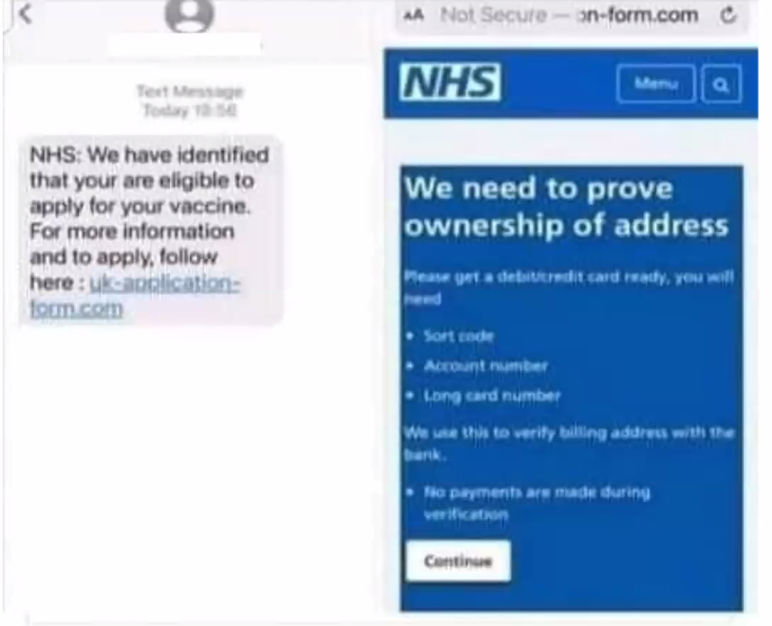
Figure 1 - COVID-19 vaccine phishing attack circulating in January 2021. [5]
A more sophisticated and targeted type of phishing attack is a spear-phishing attack. These are aimed at individual targets or groups, and often require some level of social engineering to elicit the victim’s interest to click on the link/attachment. For instance, attackers may pose as conference organisers, looking to attract new attendees. These conferences may be related to the target’s work or perhaps a personal interest or hobby. The target may be redirected to a malicious website and asked for their personal information or asked to download a file which contains malicious code.
Waterhole attacks are another form of phishing that do not require the use of an email/SMS [6]. Attackers will attempt to hack popular websites and implant a malicious script. When the target clicks on the specific object, they are redirected to install new software or firmware. For example, a video streaming website may redirect the user to another website recommending certain software to view the content. This download however will contain malware, rather than the advertised program.
Another possible method of attack is through insider threat. These hostile actors could deploy a malware attack in a variety of ways, some unbeknownst to them. For instance, the insider may be asked to download sensitive information onto a USB drive that has been handed to them. The insider may only believe that they are retrieving information off the system, but the USB drive may have pre-installed malware that instantly infects the system it is plugged into. At which point, the attacker has access to more than the insider may have originally wished to handover.
Another method of insider attack could be through a company’s logistics chain. It is very difficult for organisations/companies to have full control and sight of the procurement process from design to deployment, and with computer/network systems there are potential opportunities for sophisticated attackers to infiltrate the logistics chain and install malware on a system before it is deployed for use. It is equally possible for maintenance activities to be a possible attack vector if a contractor needs to access a network via their own device. A company/individual’s security could be state-of-the-art, but if your contractors are not meeting the same standards, then this presents possible vulnerabilities to your network.

Ransomware
As mentioned in 2.1, ransomware is a form of malware that looks to encrypt victims’ sensitive information and then demands payment for the release a decryption key. There are three main types of ransomware, that range in severity: [7]
- Scareware: often in the form of rogue security software and tech support scams, these types of ransomware do not actually access or encrypt any of the user’s information but displays messages that the user’s computer has been infected with malware and prompts payment to have the malicious files removed. This is the least severe type of ransomware and can be removed using a security program (e.g. Malwarebytes) without the loss of any files.
- Screen lockers: this type of ransomware will open a full-size window with an FBI or US Department of Justice seal stating that illegal activity has been detected on your system, and you must pay a fine in order to access your computer. In order to remove this type of ransomware, you need to perform a full system recovery to a date where the malware was not on the system, and this may mean you lose some recent files if they have not been backed up.
- Encrypting ransomware – this will gather the files from your system/network and encrypt them, demanding payment for them to be released. It is possible to try and decrypt the files yourself as free decryption keys have been released over time in order to try and counter the ransomware threat. However, if you do not use the correct decryption key you can further encrypt your files likely meaning they are unrecoverable.
If you are ever affected by any type of ransomware, the FBI-endorsed response is to not give into the cybercriminal’s ransom demands. By paying for the release of your files, you encourage hackers to continue this practice. [6] cites numerous sources that show many victims of ransomware attacks do pay for the release of their files. Money is often requested to cryptocurrency addresses where the transactions cannot by traced back to the hacker. It is difficult to know for sure how much money is made through ransomware attacks due to its covert nature, and there is also the cost of downtime to the victim, whilst they are unable to access or recover their files, but [8] estimates the global cost of ransomware attacks anywhere up to $169.8 billion annually.

CryptoWall
CryptoWall is one of the most common ransomware campaigns witnessed by internet users today. As with other types of encrypting ransomware, CryptoWall encodes a victim’s files and then demands payment for the decryption key. [9] states that CryptoWall is one of many ransomware families (others include, TorrentLocker, TeslaCrypt, and CTB-Locker). It was first found in 2013 and has since released other variants of which version 5.1 is the latest [10]. In addition to encrypting files, it will make it difficult for you to restore your data and can also try to extract your passwords and cryptocurrency wallets that are stored on your system in the attempt to receive more financial gain from the attack.
CryptoWall uses similar infection methods to other ransomware examples, and can infect devices using: [10]
- Phishing emails: As covered in 2.2, phishing emails try to trick users into clicking links or downloading attachments which contain malware.
- Exploit kits: These are used to detect security vulnerabilities that can exist in your operating systems, applications, or websites. CryptoWall will try to exploit these vulnerabilities to install malware if/when found.
- Malicious ads: Hostile actors will purchase or hack advertisements on the internet to deliver malware via your web browser. These ads will try to run javascript in your browser to download the malware covertly.
Once CryptoWall has successfully been installed on a system, it communicates with a command-and-control server to send the encryption key that will be used to encrypt the victim’s files. It will then search through all files, not only on your system but also on other network connected devices, and encrypts your documents, photos, and your music. There are many file types that are vulnerable to this attack and so the damage can be widespread.
Once the encryption is finished, the victim receives a ransom note with instructions on how to make payment. Payment is usually requested to a Bitcoin account, where the transaction cannot be traced back to the source of the attack. Once this ransom note has been issued, the malware deletes itself from the system. Even if the victim pays the ransom fee, there is no guarantee that the hacker will release the decryption key. [10] cites a Forbes article by Lee Mathews which reports that 19% of those that pay the ransom fee get the decryption key in return, and so users must look to methods they can employ to prevent these types of attacks from happening in the first place.

Protection Methods
In the following list of protection methods, all are as important as one another and to ensure the best protection, internet users should employ a layered defence to protect themselves from multiple attack vectors.
As phishing attacks are one of the most experienced forms of cyberattacks, it is vital that internet users take a cautious approach when managing emails. Ensure that a spam filter is turned on to filter out most scam emails, and for those that still get through, always ask yourself – “am I expecting this email?”, “do I know who the sender is?”. If the answer is “no” to either of those questions it is safer to ignore and delete.
Always ensure that your computer is patched and up to date. Developers will often bring out new versions of their programs when security issues have been identified, and hackers can be very quick to take advantage of these vulnerabilities. Therefore, by leaving programs unpatched it is possible the user is leaving a back-door open into their system or network for cybercriminals to exploit.
Another important method to prevent malware attacks is to have anti-virus software installed and for it to be up to date. There are many paid and free examples of anti-virus packages that can protect you from numerous kinds of malware attacks. When they detect malware, they quarantine the malware files which prevents them from executing and infecting other files.
Firewalls should also be used to stop malware from communicating with the command-and-control server. By restricting the connection, it is not able to execute further stages of the attack, protecting files from harm.
Data backup is important, even when not considering malware attacks. There are multiple scenarios where data backup may be required to enable access to files. For instance:
- If a device has been stolen/lost
- Following physical damage to a data drive (e.g. fire, flood, dropped, etc.)
- After forgetting a USB-drive/CD with important work
- If connection to cloud-based servers is lost.
To ensure files can be recovered following a disaster, it is good practice to have multiple backups to protect important files. When considering malware attacks, it is important to hold a copy of important documents offline from the rest of the network. As previously stated, Ransomware such as CryptoWall can infect multiple devices that are connected to the same network, and so if the victim has files located on a server, there is a risk that all files on the server could be encrypted during the attack. For small amounts of data, backup CDs/USBs could be used to store important files. For larger amounts of data, one potential mitigation would be to have remote storage that is kept in a different location to the rest of the network.

Conclusion
For anyone accessing the internet, it is important to take precautions where possible to mitigate the risk of falling victim to malware. Whether you are an individual using a PC for online banking, or a company storing important data on a network, there are steps that can be taken to limit your exposure to cybercriminals. Be wary of unfamiliar emails, ensure system/network operating systems are patched, use an up-to-date anti-virus system, and make sure your most important files are backed up to multiple locations so that even if you do fall victim to ransomware, you do not need to consider paying the ransom fees.

References

[1] | S. R. Department, “Number of internet of things (IOT) connected devices worldwide in 2018, 2025 and 2030 (in billions),” Statista, May 2019. [Online]. Available: https://www.statista.com/statistics/802690/worldwide-connected-devices-by-access-technology/#:~:text=By%20the%20end%20of%202018,in%20use%20around%20the%20world.. [Accessed 22 02 2021].
[2] | C. Ventures, “Cybercrime to cost the world $10.5 trillion annually by 2025,” PR Newswire, 13 November 2020. [Online]. Available: https://www.prnewswire.com/news-releases/cybercrime-to-cost-the-world-10-5-trillion-annually-by-2025--301172786.html. [Accessed 22 February 2021].
[3] | J. Love, “A brief history of malware - its evolution and impact,” lastline, 5 April 2018. [Online]. Available: https://www.lastline.com/blog/history-of-malware-its-evolution-and-impact/#:~:text=The%20earliest%20documented%20viruses%20began,with%20being%20the%20first%20virus.. [Accessed 22 February 2021].
[4] | IT Governance, “Types of Cyber Threat in 2021,” IT Governance, [Online]. Available: https://www.itgovernance.co.uk/cyber-threats. [Accessed 22 February 2021].
[5] | D. C. Campbell, Cyber Security and the Internet of Things, Swansea: The Institute of Engineering and Technology , 2021.
[6] | P. O'Kane, S. Sezer and D. Carlin, “Evolution of Ransomware,” IET, 1 September 2018. [Online]. Available: https://ietresearch.onlinelibrary.wiley.com/doi/10.1049/iet-net.2017.0207. [Accessed 22 February 2021].
[7] | Malwarebytes, “Ransomware,” Malwarebytes, [Online]. Available: https://www.malwarebytes.com/ransomware/. [Accessed 22 February 2021].
[8] | D. H. Kass, “Ransomware Demands: $170B Worldwide Forecast in 2020, Report,” MSSP Alert, 13 February 2020. [Online]. Available: https://www.msspalert.com/cybersecurity-breaches-and-attacks/ransomware/demand-costs-2020-research/. [Accessed 22 February 2021].
[9] | Cyber Threat Alliance, “Lucrative Ransomware Attacks: Analysis of the CryptoWall Version 3 Threat,” Cyber Threat Alliance, 2015.
[10] |  | J. Petters, “The State of CryptoWall in 2018,” Varonis, 6 June 2020. [Online]. Available: https://www.varonis.com/blog/cryptowall/. [Accessed 22 February 2021].

