Evangeline May O’kelly
Student no. – 1702749
University of Wales Trinity Saint David

Abstract
This research report will show the results involving the recognition of faces between black and white races following a distractor task. To test the hypothesis, there will be a recall study carried out to see how many participants from both races can identify each photo and identify which ethnic group the image shown belongs to. This was split over two sections of the study and was timed by approximately 2 seconds per image to gain a recognition of which race the image showed belonged to. Overall, we found out that our hypothesis tested was not supported but rejected. This is because we found participants seemed to recall more black faces than white which we did not think would the case, so there for, the hypothesis was rejected in a way we unexpected and in result, gave a different outcome than predicted.

Introduction
Own-race bias, known as ORB is the tendency to identify and separate between faces of our own race more easily than faces who are from another race. In addition, this gives us the explanation to why an individual may think that members of another ethnic group all look very similar. (Own-race bias) brings issues for eyewitness identification as individuals are less correct when having to identify members from another race. There has been research found to show that when both witness and the other individual are from different ethnic groups, the witness has an estimated 50% chance of making the wrong identification.
This can be due to lack of exposure to people from different ethnic groups or even down to the lack of knowledge when it comes to perceiving that race’s features. Own-race bias is linked within this study in terms of providing evidence to support our theory that own-race bias is automatically going to affect our pre judgement when separating both black and white races. The hypothesis with this study is to carry out an experiment reported within this research paper which will explain an investigation involving the recall of both black and white faces. This study will involve a debate which is fairly balanced with a variety of primary resources to conduct the research which will be given out. The hypothesis will predict that the white race will have more recognition than the black race.
Another factor that there had been found to influence facial recognition which other studies have talked about is emotional expressions. Fox, (2004) explains that recognition of emotional expressions in faces is known to be a complex issue with no direct answer to why. However, it may appear that getting the understanding of emotions is an automatic personal instinct from the beginning of life; there are many other individuals without this ability to do so. However, there are said to be types of components of the face that attract our attention as an individual when understanding the emotion present, even if we are not consciously aware of them. This review concentrates on the recent studies that have helped paint a clearer picture of these perspectives for us.
Humans perceive and start to understand all types of emotions within faces from a young age. This is what triggers this early development in life. One particular factor which may play part in young individuals recognising emotions is the familiarity of a face. A study by Kahana-Kalman and Walker-Andrews (2001) involved the testing of the “looking preferences” of infants as young as 12 weeks old. The study concluded that infants who looked the longest and were most excited when watching video recordings of their mothers showed a more positive affect through facial expression, rather than an unfamiliar person displaying emotions in the same way. When both mothers and unfamiliar individuals displayed negative effects, the infants looked significantly longer at their mothers which could be linked to confusion. This indicates a discrimination of emotions based on person familiarity.
In result, the same effect was not produced when other emotions were demonstrated for the infants. These emotions being such as scared, fearful, surprised and so on. The researchers made the conclusion that infants are prone to be sensitive to contextual information, which in this case is person familiarity that potentially facilitates the meaning of emotional expressions within individuals. Going from the young age of the participants, this sensitivity to person familiarity appears to occur in the early stages of development of life.

Method
Participants:
A group of 29 white race participants were involved in this study. A total of 7 males and 22 females ageing from 18 to 60 years old were asked to take part in a recall study. We decided to mix the range of ages from 18 to 60 years old so we could gather information from a variety of different ages which would reflect on the results we would receive and would also explain their own personal perception on the images they were going to be shown.
Design:
The design that was used within this study was a paired sampled t-test. The independent variable involved in this study was the individuals own recognition between both black and white faces and what they thought the images showed. Again, this is all down to their personal perception. The dependent variable was the outcome of the decision made between the participants when choosing between black and white race images.
Materials:
For the first part of the study, participants were shown a power point providing images of 12 faces on a slideshow on a screen in front of them. Each face shown was a mixture of both black and white faces and they were presented on screen for approximately 2 seconds each. With this, every face was a different gender, race and age. For the second part of the study, participants were shown 6 pages of images containing 6 faces per page. As well as this, a demographical set of questions were given out to each participant to complete which again involved age, gender and ethnicity. Along with this, the participants were provided with a separate box on the sheet given to record their own personal results and state which number box they remembered seeing. With this, there was a collection of results gained and looked at after the study had taken place.
Procedure:
The procedure was fairly straight forward and the instructions handed out were simple and easy to follow. Each and every participant that was involved was asked to remain silent during the study. There were 12 faces on the power point slide shown; each picture was on the screen in front of the participants for approximately 2 seconds long in section 1. Each image shown was either between black or white ethnic groups, varying on age and gender. Section 2 showed 6 faces, some which had been shown prior to section 1 and some which weren’t. These faces were a mixture of races, gender and age on 6 separate slides and each participant was asked to state how many faces they could either remember or thought they could remember seeing in the first section. This was part of the study that would be testing their memory and recognition when looking at images of individuals. However, there was a consent form given out prior to this study which each participant had to fill in which involved confidentiality of their results and that they were happy to take part in the study. After the study had been completed, a descriptive sheet for the t-test study was handed out to each participant to be given the option to discuss the outcome with the researcher and any feedback they wished to share.
Results:
A paired-samples t-test was carried out to determine whether participants were able to remember more white faces than black faces by following an involvement of distraction. The results show that participants recalled significantly more black faces (M = 3.34, SD = 2.42) than white faces (M = 2.67, SD = 1.97); t (29) = 3.12, p < .05. The original hypothesis is rejected for this study as participants would recall significantly more black faces than white faces.
Discussion:
The main aim of this study was to find out whether people are better at recalling and identifying faces which are in the same ethnicity as them, known as in their “ethnic group”. For this study, we specifically hypothesised that participants would be able to recall a lot more faces that belonged to their own personal ethnic group than their outer group. Describing the outcome of my research, my hypothesis again was rejected. This is because participants recalled more black faces than white which we did not think would the case, so there for, the hypothesis was rejected and had a different outcome than predicted.
One limitation identified within this study was that all participants were belonging to the white race group and that made the study unfair as there were no participants who were from the black ethnic group. In further future, if we were to carry out this study again, we would make sure that there was an even amount of participants from both races involved. However, again for future studies, recognition between both ethnic groups may help change results if there was another study to carry out next time as participants would have some grounded knowledge on both races as well as not going from what they see or an educated guess.
Another limitation that more or less would of affected the study carried out would have been the equality between both male and female gender participation. With this, I believe that we gathered more of the female identification towards ethnicity groups than we did with the male identification when looking at both black and white races. For future studies, we would again try and make the participants involved equal in terms of gender and race. In result, this may give a completely different result to what we would have collected before, or it may not.

Reference list:
Own Race Bias. (n.d.). In Alleydog.com's online glossary. Retrieved from: https://www.alleydog.com/glossary/definition-cit.php?term=Own+Race+Bias
(Fox, Psychological & Social Sciences, 2004). Retrieved from: http://legacy.jyi.org/volumes/volume10/issue3/articles/fox2.html

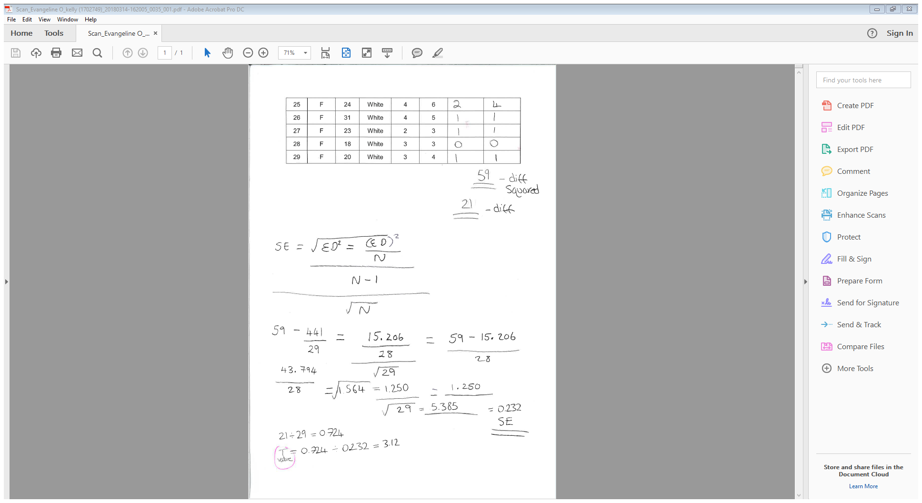
Appendices:

Research Methods Data Collection Study

Please specify your gender:
- Male
- Female
- Other
- Prefer not to say

Please state your age: _______________________________

Please state your ethnicity: ___________________________
Please use the space below to record your responses to Part Two of this study.

Study Consent Form

I understand that taking part in this research study will involve me viewing a number of faces and attempting to recall the faces I have already seen.
I understand that this study consists of two parts. Part one will take approximately two minutes and will consists of me viewing a number of faces. For part two, I understand that I need to pay attention to the faces being presented and record which faces were shown in part one.
I understand that participation in this study is entirely voluntary and I am free to withdraw at any time without giving a reason. I am aware that if I have concerns about the study I can discuss these concerns with the researcher at any time during or after the study.
I understand that the information provided by me will be used for the purpose of providing data for analysis, but that this data will be held confidentially and anonymously, with a code assigned in place of my name. These data will be stored in accordance with the Data Protection Act.
I also understand that at the end of the study I will be provided with a debrief form and the opportunity to discuss any issues with the researcher.

I, ___________________________________( NAME) consent to participate in the study conducted by Stacey Coleman, School of Psychology, University of Wales Trinity Saint David, Swansea.

Participant Signature:________________________________________________

Date:___________________

Name and signature of researcher taking consent:
Stacey Coleman

