KNOWLEDGE AND INFORMATION MANAGEMENT SKILLS FOR THE WORKPLACE
BMSK5006
IASH ALI
1708765
BUDDHI PATHAK

CONTENTS:
PART 1….
INTRODUCTION….
Q1.0: DATA INFORMATION….
Q2.0: KNOWLEDGE AND DIFFERENCES WITH DATA INFORMATION….
Q3.0: CARD GAME / TACIT OR EXPLICIT KNOWLEDGE….
Q4.0: FIVE DECISIONS MADE….
Q5.0: NEW INVENTION OF A PRODUCT….
REFERENCES….
APENDIX 1….
APENDIX 2….
PART 2, CASE STUDY….
Q1: AMERICAN AIRLINES COST LEADERSHIP AND PRODUCT DIFFERENCES….
Q2: SABRE ADVANTAGE ON AMERICAN AIRLINE….
Q3: AMERICAN AIRLINES AND COMPETITORS….
INFORMATION SYSTEMS….
Q1: DEFINE THE INFORMATION….
Q2: COMPUTER BASED INFORMATION SYSTEMS….
Q3: COMPUTER BASED INFORMATION SYSTEMS SUPPORT MANAGERS….
REFERENCES….

PART 1:

INTRODUCTION

At this report, we are engaged in discussing about data, where, we will discuss if it is useful or not as there are certain people needs that they require this and some don’t, the knowledge that comes in to it and how it makes that difference with data, we will be looking at information’s that are provided to access certain amount of data and look at various different ways in how we use our knowledge to an extent in talking about the data that we use commonly in when we are doing some daily activity and will be doing a case study at part 2.

Q1.0 DATA INFORMATION

Data are a useful source for most companies as these are good for making better decisions, a lot of places keep data information confidential to protect their own staff, for an example uber taxi firm, keep their drivers information on their uber app, which is only can be seen by the company and the driver, when they log in to the app, this makes the company to use data efficiently and keep it private.
Organisations can keep their industry running smoothly with the right amount of information that’s needed at the company to process improvements to the business and make effective decisions, which can lead to good future for the business, these can save a lot of money and time.
Company like amazon, makes data useful as customers purchase from them and amazon collects that data and hold it at their business, amazon tracks customers purchases and the items they view, they use this data to recommend the items that the customer are interested in. The thing is amazon started betting on data for earlier than its competitors did. This is what made the difference for amazon (Williams 2018).
Some data’s can be not useful for others, as this can be poor data which can lead to delays and costs may vary, errors made towards the data will costs organisations more money and also the efficiency will go down, leading to loss in confidence and losing customers and also productivity loss. For example, Uber taxis keep track of the distance or on the miles the driver covers in a week or a day to measure the productivity, that some data would be useless to the customers as this information can’t be of no use to the customers. Useless data becomes magnified into poor interpretation and misinformed decisions, (Ambisense 2020).
In another example, we might want to know how windy it is outside, but the data might only show us the temperatures, which is useless to us as we don’t know the wind speed outside but only know the temperature.
Being working for uber taxi firm, the data that they provide turns in to knowledge for us and this information is important because of having the right information, the accuracy of the knowledge leads us to doing the work properly, as in an example they have given us a trip with the information about the customer and where they are going and how much its costing them, this information that’s given becomes knowledge for us, as this is processed in an manner that is unique for us.
It is important to understand the differences between data, information, knowledge especially when capturing knowledge (Hammer, 2016).

The information given that are organised, can be a part of knowledge, as we interpret that information, than capture that to allow in our knowledge system, which the information has to be clear and not clear information is not of our use as it is wrong data given.
In an example uber has all the information on the app system, the data they hold become released through the app and this is how, we interpret that data and capture it through our knowledge and then play the part using that in our role at work, we get information about the customers, including where they are going and where their pick up location are, we take that in to our knowledge to do our task, as the information are presented in a good form, it makes it easier for us to process it. Uber creates the data that is raw with the appropriate information that we need, leads us in our knowledge and makes our wisdom effective.
Discovering knowledge in data is a well-structured standard process to present to those involved in giving the results (Larose and Larose, 2020).
Relationship of the information are data that are processed like something is happening and organised by correct information given with the right structure and having that useful information to present it.

Q2.0 KNOWLEDGE AND DIFFERENCES WITH DATA INFORMATION

Knowledge is like a mixture of data and beliefs. Data is materials you gather which is a primary source. There are two types of data, quantitative research and qualitative research and is data collected in person. For example, quantitative is when the data is close-ended and can be quantified into numbers and percentages. Qualitative data for example is open-ended data such as a questionnaire, where the respondents can give any their views and opinions. This type of data is more open to analysis and interpretation.

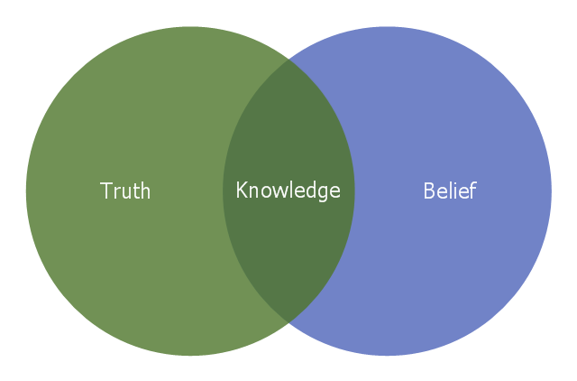
Figure 1 Knowledge- Venn diagram 2020 (ref….)The concept justified true belief states that in order to know truth, one must not only believe in the truth but justify it, (Knowledge 2020).

Knowledge is what we have in our brains which is in our belief, the belief is what we are thinking in our brains and we use this to get information, which gives us in more experience, this builds our knowledge, which then we have the accurate information and then the truth is the facts, as in what we looked at based on evidence, knowledge can be facts that can support information that is in our belief.
The pyramid below figure 2, shows how knowledge is important as data and information makes the knowledge and this is how we value the data and knowledge, is not done by information that are not relevant, but information that are important and knowledge helps us to make better decisions.

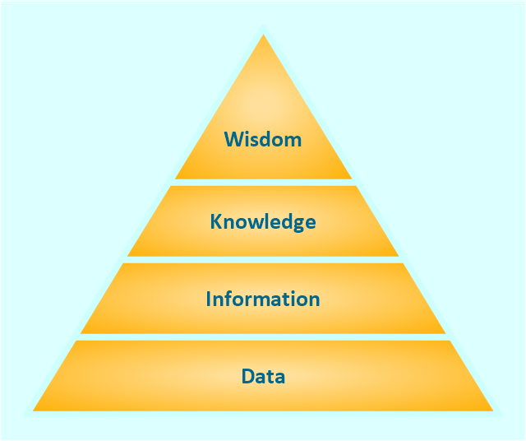
Figure 2 knowledge pyramid, 2020

Knowledge is defined in terms of information and the term wisdom in terms of knowledge, (Knowledge pyramid, 2020).

Information is refined data form, it means nothing, but it helps to understand the meaning of it and knowledge comes in after to understanding the information that’s when you can draw conclusion from their judgement of information. Data are few facts, which don’t mean anything because its without relevant insuffiency.
We capture the data information, which we then take into our knowledge of information that really matters, this in our knowledge, how we make the decisions of the correct information we get.

Knowledge is what we know, it contains our belief and expectations (Infogineering, 2020).

Q3.0 CARD GAME / TACIT OR EXPLICIT KNOWLEDGE

A player in a card game use tacit knowledge, as this is on his knowledge to analyse the game, this makes him feel in what he is doing and the outcome that will follow, in his experience he knows the game and what he needs to do as this is his personal experience, the player needs to focus in what he is doing and has to be patience and make the decisions that are best in his knowledge with all the information that is there to take. In an example poker, each player has two cards and five cards are drawn, but you don’t know what cards each player has and you don’t know which cards will be drawn, only the player knows himself which cards he has, as in his experience he knows what he is going to play and the other players won’t know that but only know their cards that they are playing and a good player can be bluffing as he can take advantages of someone’s weakness and outplay that person.
3.1 Tacit- Tacit knowledge is your own knowledge, this is something we have from our personal experience, which is only with us that we know this, and this is hard to transfer to another person.
In an example, am on the motorway going to my sister’s place, which is a long journey, it is in my knowledge that I don’t need maps to go the place, as I know my way there, so the other motorist don’t know the destination am going to, this is where I only know where I’m going to as this is in my knowledge and I cannot transfer that to someone else.

Tacit knowledge is knowledge that are difficult to quantify or get to another person through verbal or written communication (HRZONE 2020).

3.2 EXPLICIT KNOWLEDGE- This knowledge can be given to anyone with ease, a person can speak easily and transfer knowledge to someone else and express their feelings towards others. Technology can help transfer knowledge from one place to another place, as they are stored in databases which they are in form of organized explicit knowledge, like in an example my doctors surgery holds my information about me in their database, which has my NHS number and date of birth and address, if I wanted my NHS number they can transfer that to me through email and the information is of me, hold by the surgery is coded.

Explicit knowledge is codified information and data that is written down and can be easily understood and decoded by the recipient (Explicit knowledge 2020).

Q4.0 FIVE DECISIONS MADE

4.1 While we were driving, we were using google maps and was turning right in a road, which using the map information it showed the road was clear to turn in to it, as it had no, no entry signs and there was no road works, looking at the data of the map made us the decision that the road was clear and it is legal to turn in, this information also helped us on our knowledge of speed that we, was taking to turning in that road, as this is an explicit knowledge that the technology information helped our cause.

4.2 Went to Asda to do some shopping, this is where we took our shopping list with us, this had all the items we need on it, the information of the items made it more in accuracy for us to do the shopping and not to miss anything out, however when something was out of stock, we phoned home for any alternative, the decision to take our shopping list with us helped us to gain efficiency through using that information. Explicit knowledge was used to do our shopping as the list was the information which gave us the actual reading of what we needed.

4.3 We went to collect our son from school at home time, this is our normal routine we do, as we pick our son from school at 3.15, this is in our knowledge that we have to pick him up at this time, as the school is nearby we go to pick him up walking and we always check the weather for the day and check the information on it, for an example if it’s going to rain than we have to prepare and take an umbrella with us. This is our tacit knowledge as this where we always collect our son from school at home time and some explicit knowledge is there as well, like checking the weather.

4.4 At work being a taxi driver, using our driver App which gives us information on the trips that we are going to do, as we went online on the App, the company sent us the trip details, as this data comes to our system, we looked at the information that’s been sent, this shows me where we need to go for pick up, as soon as we accept it, the whole thing then gets processed for us as we take that information in our knowledge to complete the trip, so the data that’s been provided is the information I used to do my work.

4.5 Made an order on eBay, through our eBay account where our information is
Stored as we have an account with eBay and our data is there, we have looked at item that we are ordering and placed the order, after it
was processed we investigated the delivery date when the order is going to be
delivered, as this was on our account the data provided us with the new order
details and tracking information, this information gives us the knowledge in
when the order will arrive, this is where the information given by eBay for the
order is very relevant as it shows we have ordered the correct item and the seller
is genuine, this is an explicit knowledge as we are transferring information to
another.

Q5 NEW INVENTION OF A PRODUCT

The product that I have invented is a drink that’s with ginger and has got no sugar and sweeteners.
I will be using samples to test my product out, as samples I can find out from different people how my product is like. When doing samples, you are finding a group or a part of the population which you do by generation, people representing a larger population.
The whole idea is doing a generalisation research is that it’s not time consuming, I can pick people in an area where there are colleagues/ universities and also pick another location like social clubs where I would find older generation, I would use a questionnaire and find out from location of Birmingham, what are the people that would enjoy my product. I am going to use hypothesis and the data is not bias, questionnaire will be the same for the young and the older generation. This way, I will find out that the results are in validity conductor and can be firmed looking at demography is how much death rates there are in the area and birth rates and overall, what is the population, see Appendix 1 of population of Birmingham.
If I open my organisation of soft drinks (ginger) and mortality rates are high, I know for sure my business will not be successful. The energy drinks have natural ingredients which will boost people’s health and having a good diet they can live longer. I as a business, I must take care of social footprint in the area where I am doing business.
And to get the best out of my product, I would advertise through social media like Facebook and put it online as a ginger drink with all the ingredients that I have put in to make this product, which is new in the market. However, after trying out samples of my product, people’s word of mouth can promote my product more in the local community and beyond and I believe especially social media will be more effective way to boost my product.
The key is to arm yourself with some solid pointers to get you started and move forward, (Thrive Hive 2020).
I will be using a questionnaire with a Likert scale which where people can rate my product, this will be private and confidential and anonymous, it can’t be shared. The Likert scale use, will be showing me how my product is doing as it is new, this has the advantage of not expecting a yes or no.
Liker scale is a five or (seven) point scale which is used to allow individual to express how much they agree or disagree on a statement, (Mcleod 2019).

REFERENCES
Ambisense, (2020) Why useless data is worse than no data [online] Available at: https://ambisense.net/why-useless-data-is-worse-than-no-data/#our-blogs [Accessed on 15 Feb 2020]
Explicit knowledge (2020) Computer business research [online] Available at: http://www.computerbusinessresearch.com/Home/enterprise-resource-planning-and-collabrative-systems/explicit-knowledge/ [Accessed on 09 March 2020]

Hammer, L. (2020). Data, Information, knowledge - why is it so important? - Dezide. [online] Available at: https://www.dezide.com/data-information-knowledge-why-important/ [Accessed on 16 Feb. 2020].
HRZONE (2020) What is Tacit Knowledge? [online] Available at: https://www.hrzone.com/hr-glossary/what-is-tacit-knowledge [Accessed on 01 March 2020]
Infogineering. (2020) The differences between data information and knowledge [online] Available at: http://www.infogineering.net/data-information-knowledge.htm [Accessed on 27 Feb. 2020]
Knowledge (2020) Venn diagram, [online] Available at: https://conceptdraw.com/a205663/preview [Accessed on 11 March 2020]
Knowledge pyramid , (2020) [online] Available at: https://www.conceptdraw.com/How-to-guide/knowledge-pyramid-triangle-diagram [Accessed on 11 March 2020]

Larose, D. and Larose, C. (n.d.). Discovering knowledge in data.
Mcleod, (2019) S.A. (2019) Likert scale, simply psychology [online] Available at: https://www.simplypsychology.orscale.html [Accessed on 12 March 2020]
Thrive Hive (2020) [online] Available at: https://www.google.com/amp/s/thrivehive.com/how-to-promote-a-product-on-social-media/amp/ [Accessed on 13 March]
Planning & Growth strategy. (2019) [online] Available at: www.birmingham.gov.uk/census [Accessed on 18 March 2020]
Planning & Regeneration. (2019) [online] Available at: population.census@birmingham.gov.uk [Accessed on 18 March 2020]

Williams, j. (2018). How amazon started betting on data has helped them transform their business. [online] Available at: https://www.promptcloud.com/blog/how-amazon-focus-data-business-transformation [Accessed on 15 Feb 2020]

APENDIX 1

APENDIX 2
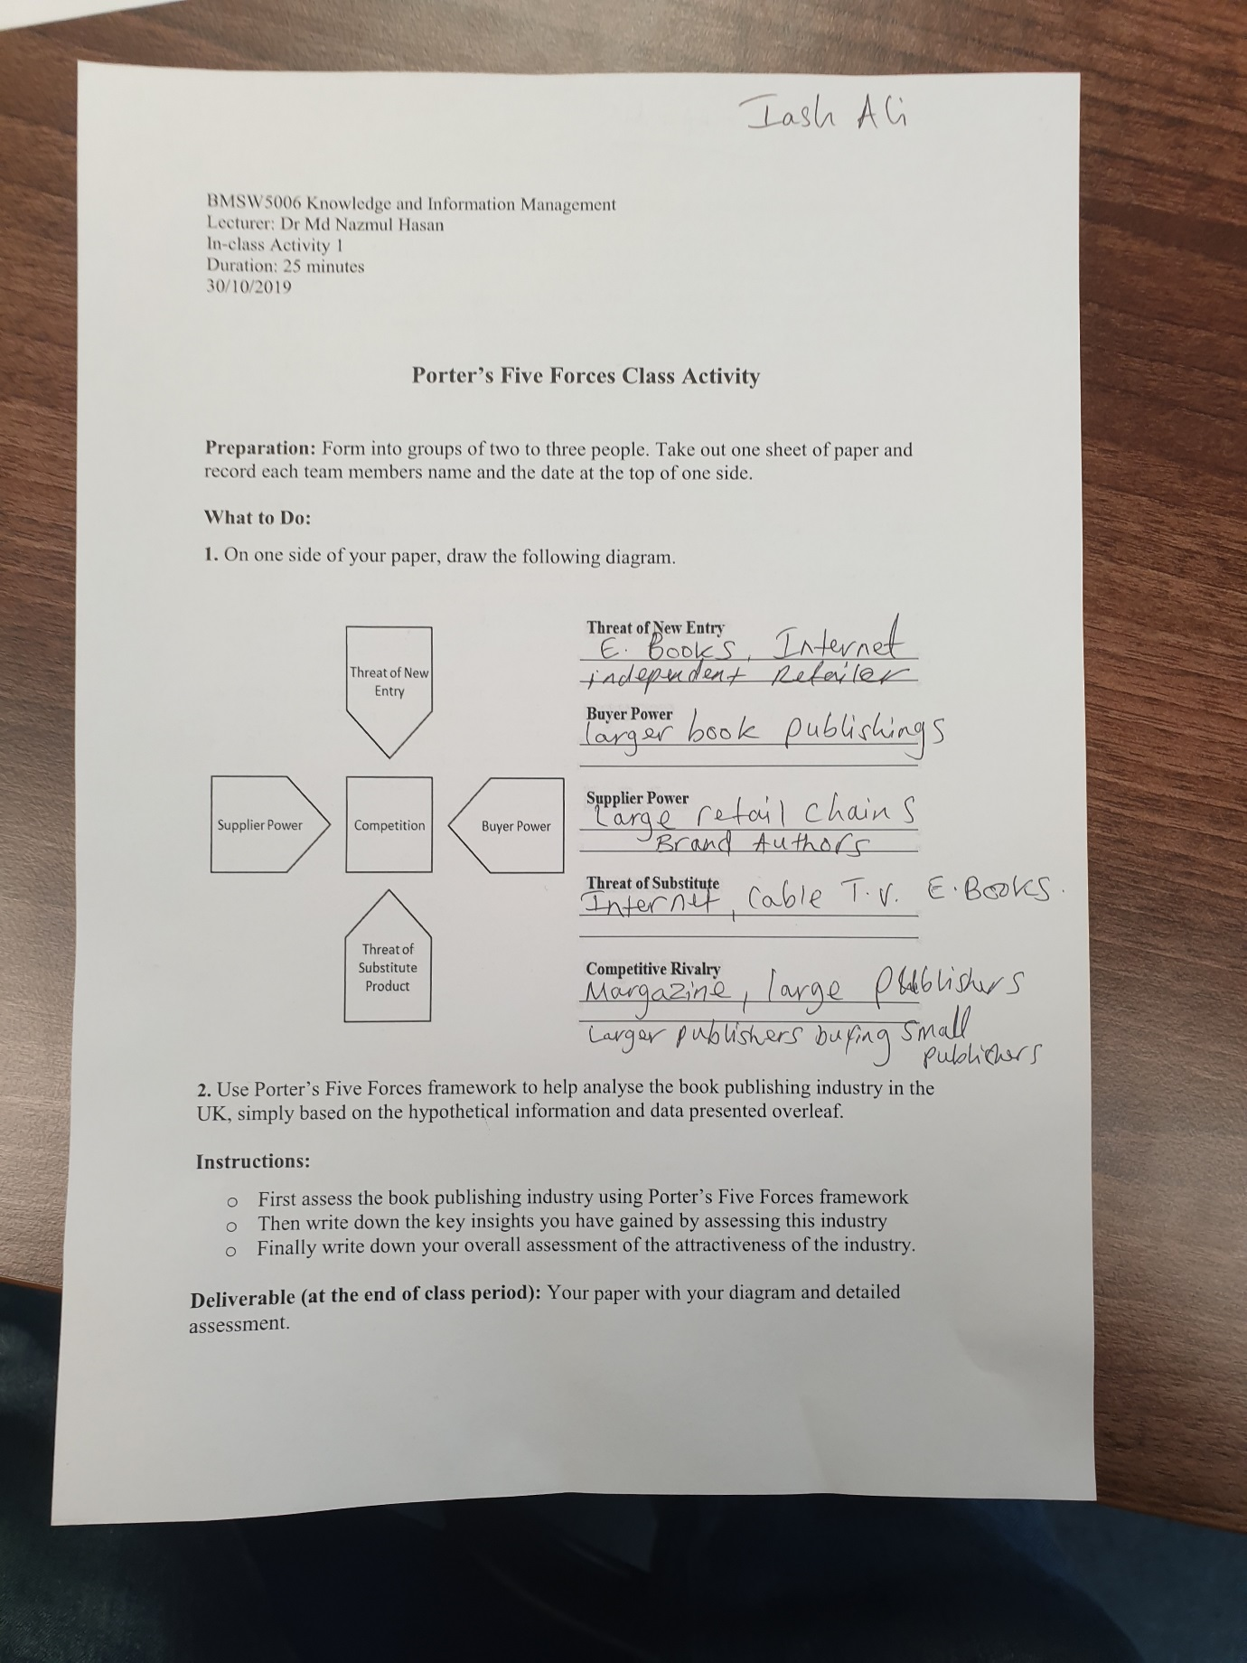

PART 2, CASE STUDY
Q1: AMERICAN AIRLINES COST LEADERSHIP AND PRODUCT DIFFERENCES

American airlines is a leading firm of airline, they the airlines adopted porters five forces to analyse the strategies in how it is cost leadership, the airline went digital after it got rid of hand written system which was of the 1950s, becoming digital it has been cost leadership, this works for them as this will reduce the number of employees and becoming automated, these things helps saving the cost, the booking are more efficient and will be accurate, all this is allowed them to offer better and competitive pricing strategy to their customers.
Third party bookings like from then travel agents can book easily as the booking facility is easier and having gone digital the travel agent can book through their office system which will give them to see what bookings are available as well as seat reservation that are available, so they can confirm when booked.
American airline can understand their strategic management through porters five forces and by looking at the porters five forces the airline can put this in their favour.
The bargaining powers of buyers from the porters five forces can lead customers in getting discounts on the airline as the airlines customers are higher in numbers and this can take them to seek extra offers, this will help the airline build on larger scale of customers from the population they already have.
By analysing all five competitive forces American Airline group can see the picture of the impact it has made on profit, (Fern fort university 2020).
American airlines group attract new customers with their new products, which also the old customers are always interested in their new products, the airline intend to build differentiation that is sustainable, adding seats that are more comfortable and internet that are high in speed, also extra benefit of leg room.
Substitute products are low on American airline and the main of a threat comes from brands that are competing, American airline are strong as they have strength in customer satisfaction and having large scale of customers, they also have the brand image.

The overall threat from substitute products remains moderate for the airline, (Pratap 2018).

Q2: SABRE ADVANTAGE ON AMERICAN AIRLINE

Sabre helped the airline in reducing the cost of reservation, the sabre company is so advanced as it can store so many airfares, this sabre system gave the airline advantage as travel agents and other companies to make bookings, check the prices and they can compare the prices, this system allowed them to do that directly with sabre having other functions which the airline task are made easy.
This system made American airline bookings easier and made the airline a passenger experience, as people can trust the system and look at the flights that are in their need, this makes trust grow with the system for the passenger which gives the airline benefit and also there is information on their which allow customers to understand better with saving a lot of time.
Referring to porters five forces customers are the power of the airline as American airline introduced the sabre system customers increased, the database of sabre is easy to use and has a lot of features that is need of the customer satisfaction.
It provides a fast booking experience through online, mobile and other services that makes the traveller journey great, (SIENAcollege 2015).
This gave the airline opportunity to change the hand written reservation and replace with sabre which can manage the reservation really fast and accurately through computer system, the sabre system made the American airline main part of their process as a business and turns the business as automated on reservations.

Sabre gave America airlines a competitive edge and delivered a lot of benefits, (The American airlines sabre reservation system essay 2020).

Q3: AMERICAN AIRLINES AND COMPETITORS

American airlines enjoyed unprecedented success after implementing Sabre, however they struggled to maintain that competitive edge beyond the 1980s as we will outline further.
As the market was beginning to saturate with other airlines getting introduced, they had caught up with American Airlines. This gave consumers several alternatives with similar or better services to choose from as the change in the market happened it allowed those airlines to reduce their cost to match with other airlines. For example, American Airlines having their prices matched and beaten by new competitors entering the market enabled them to expand quickly. Customers flying competitor airlines were seeing their needs met on a budget as flights were cheaper and more affordable to book. This made the rise of the middle-class people travelling by air increase. These budget airlines were making an impact as there were restrictions and regulations that had been there, but were removed in the aviation industry, this made flying not only for rich to afford but for everyone with a more affordable budget.
Following deregulation introduced by President Jimmy Carter in 1978, it made it easier for start-up airlines to join the industry. This increased competition to American Airlines and took away a large portion of the airlines market share and decreased their dominance on the industry.
Those airlines have the freedom policies at the expense of customers, (Rehal 2019).

To turn the airlines fortunes around American Airlines began by relocating their headquarters from New York to Dallas. This allowed them to accommodate the flight academy, the learning centre, the pilot training facility, and the southern reservation office. In 1980 the newly elected CEO, Robert Crandall, identify that the airlines Boeing 707 fleet had souring fuel costs. Consequently, Crandall over saw the retirement of the whole fleet.
In the 1990s, new routes were made for flying to Europe and other international routes were taken into consideration with making new establishment for maintenance that will facilitate the upcoming routes. The airline made a new route which was going to Tokyo, Japan, with that increased the population of travellers and the expansion of routes was continuing to grow to countries like China, Argentina, Russia. American airlines gave advantage of great deals for their customers, for their needs, like example flexibility and fairness.
The airline added onboard entertainment in flight video (DVD) to attract more customers, more leg room was created through expansion for customer comfort. The airline also went to paperless document of their boarding pass and took it on digitally to the mobile system, which is a quick and easy way for customers to check in, and to further to satisfy the customers they have introduced online experience in which customers can book their flight online.
To make the airline more attractive consumers, travel rewards were implemented as part of the airline marketing program, (Wesner, Brostoff, Zhang 2011).

INFORMATION SYSTEMS

Q1: DEFINE THE INFORMATION

Information system is a system that collects, stores, then process the information, this leads to the information getting distributed and this system can give important information to an business or to society, however the system is based on components like hardware on a computer, it also has the software which combines with hardware, this helps a lot of organizations to gather, pass, process, bring and then distribute that data of information out, as this system coverts the data in to information, this can be make use of people resources and data resources. This system is defined as when the data is organised and then examined, which is helped by the software, and the main priority of the information system is using the raw data material to make it into important data as for data relates to fact.
Information and communication technology are the needs of an organization and the way the process of business, it is supported by the interaction of people, (Information system 2020).
The role of the systems is to turn the data in to information and the possess that to knowledge, and with advance technology these days these role has gained success in business, from years ago till now it has been improving the system with technology, businesses find competitive advantage from information systems, nowadays business have several computers to have that advantage.
Information systems bringing more productivity and better control, (Bourgeois, Bourgeois 2020).
In our work experience, working for Uber taxi firm, the information system works in a simple format, basically to order a taxi with the firm you require a I phone or an android to register were the firm will collect your information and then when you order your taxi they process it and it will show how long your taxi going to be by using the app via text message, after the ride is finished your information will be stored and the firm will distribute your price that’s been deducted from the credit or debit card.

Q2: COMPUTER BASED INFORMATION SYSTEMS

Computer based system is an organised hardware and software that work together, and the people element are needed to design the information in making decisions that are accurate and important, the computer plays an important role in this. The system carries out tasks that are due to be done, this system takes benefit from information systems were there are some categories that we will discuss.

In an example of an computer based information system, there are transaction processing system (TPS), this system captures information and then process the information, example our bank account can track our money when we take out cash, it would appear how much I have taken and the balance left, when we pay bills through our account or put in a deposit it would appear on the account after it has been processed and as transferring to other accounts it will show activity on the account straight away.
Transaction processing are important as records in a company are updated to new, (Study.com 2020).
Decision support system (DSS) is another system that supports companies, this system looks at the revenues, sales of the company and also can track older sales and revenues, the function of this is to collect data, this can be done through the computer or through people and can be done together, companies can solve their problems out after identifying it and this tool is useful for them to make better decisions, this system can also be done through mobile devices as there are people who travel a lot for their work.
Analysing the information to make decisions for the people in using the DSS system, (Segal 2019).
Management information system (MIS) is a database through the computer, this carries reports on operations on the organization from the management and makes things to attain easily, as in managing and accessing data to have it in a simple way. Management can control the whole organization through this system, the system can show data that are correct and have records of previous data, which are received from functions or units. Some data’s can be received automatically from their computers which are in a form of check-out counters.
This MIS can also allow keeping records of employees in the organization and invoicing and customer relations, it can also produce sales report were management can see where it had made profit and what section needs improving. Even small businesses can run the management information system with just one computer regarding its equipped well.
Upgrading the information system usually begins by identifying problem and then finding the right solution, (Management information system 2020).

Executive support system (ESS) also known as executive information system (EIS) is used by organizations to allow their data to be useful and to make it in to reports, all the information that this system give out is about the organization, this is where big management can make decisions that are good for the organization. This system improves the personal efficiency as the speed helps the system get the goals. The system is unique for management as looking at the internal information and external information that this can provide. This system is also connected with the management information system and decision support system, which forms to support the management at their level, and this has provided the management with general computing and relay of information. This system gives the management in a position to get the relevant data information summaries that were used by the management information system and the decision support systems, which are a lower system, this saves a lot of time for the management.
One striking features of ESS is the advanced software that are employed, (Business Report on Executive Support Systems 2020).

Q3: COMPUTER BASED INFORMATION SYSTEMS SUPPORT MANAGERS

Information is received to managers through the computer-based information system as in a formal way. This is supported by technology that uses electronic computing, however computers are used everywhere nowadays, and this plays a part in an organisation, where managers solution to problems are eased and having the computer-based information system makes things easier.
Managers can increase their effectiveness in their organisations using the system, (Alter 1976).

Management information systems are another way that gives managers to make decision on a running business, this system can refer to computer-based information system, this is where it can allow the management to set well to run a department. The computer-based information system can carry out some or all tasks that are planned by the management.
People and project management applications and any computerized processes can make department to run efficiently, (Hasan 2018).

Management in 1980s, say the new i.t development would increase morale for important managers, who can take bigger proportion, this will lead them to planning and creative functions than it was back in the days, managers can be routine technicians and not just thinkers.
Providing better quality and more timely information to aid the decision-making process, (Levitt, Whisler 1958).

Over the time businesses have developed systems, use to process and manage information in their industry. This computer-based information system helped management with data that process fast into information and this made no delay, this made organisations to get better in making decisions. Management control the stocks with efficiency with improved inventory control and this gives organisations not to go low on stock. And if managers are authorised, they can renew and audit records of the organisation from any part of the world.
CBIS is always up to date provided that all electronic information is integrated, (Akaenyi 2013)

REFERENCES
Akaenyi, W. I (2013) The Relevance of computer Based Information System in an Organisation, The Journal of Technical Education Research and Development Vol.4 No.2
Alter S L, (1976) How effective managers use information systems [online] Available at: https://hbr.org/1976/11/how-effective-managers-use-information-systems [Accessed on 25 March 2020]
Bourgeois D, Bourgeois T, (2020) Chapter 1: What is an information system? [online] Available at: https://bus206.pressbooks.com/chapter/chapter-1/#navigation [Accessed on 22 March]
Business Report Executive Support Systems, (2020) [online] Available at: https://businessays.net/business-report-on-executive-support-systems/ [Accessed on 24 March 2020]
Fern fort university, (2020) [online] Available at: http://fernfortuniversity.com/term-papers/porter5/analysis/2528-american-airlines-group-inc-php [Accessed on 12 March 2020]
Hasan A, (2018) Management information systems [online] Available at: https://medium.com/@AbdulHasan0021/management-information-systems-b46c19f952a9 [Accessed on 26 March 2020]
Information system, (2020) [online] Available at: https://en.m.wikipedia.org/wki/information-system [Accessed on 19 March 2020]
Levitt, H.J. & Whisler, T.L (1958) Management in the 1980s, Harvard Business Review. Vol 36, No6, pp 41- 48
Management information system, (2020) [online] Available at: https://www.inc.com/encyclopedia/management-information-systems-mis.html [Accessed on 23 March 2020]
Rehal S, (2019) Simple flying [online] Available at: https://simpleflying.com/major-airline-decline-1980s/ [accessed on 18 March 2020]
SIENAcollege (2015) Sabre corporation [online] Available at: https://sienastudentfund.weebly.com> [Accessed on 13 March 2020]
Segal T, Decision support system-DSS [online] Available at: https://www.investopedia.com/terms/d/decision-support-system-asp [Accessed on 19 March 2020]
Study.com, (2020) [online] Available at: https://study.com/academy/lesson/transaction-processing-systems-tps-manual-and-automated-systems.html [Accessed on 18 March 2020]
The American airlines sabre reservation system essay (2020). [online] Available at: https://studymoose.com/the-american-airlines-sabre-reservation-system-essay [Accessed on 14 March 2020]
Pratap A, (2018) The overall threat from substitute product remains moderate for the airline [online] Available at: https://notesmatic.com/2017/11/five-forces-analysis-american-airlines/ [Accessed on 13 March 2020]
Wesner M, Brostoff B, Zhang S, (2011) American Airlines, 2011, History of AMR and American Airlines.

