A critical evaluation and the identification of next teaching and learning steps focussing on a case study of an individual learner or a group of learners, based on an observed critical incident.

Lev Vygotsky, Jean Piaget and Ivan Pavlov all created the ideals for teaching that have been taught and followed for generations; what people see and hear in a classroom has more often than not originated from these educational psychologists. A critical incident is created by the way in which an individual observer looks into and evaluates a situation, therefore, the interpretation someone makes over the significance of an event in either a positive or negative way (Tripp, 2012). It is vital to remember that when looking at a critical incident, it is not technically critical but instead ‘typical’. With that in mind, this assignment will provide a critical evaluation of a typical incident witnessed within a classroom during a school placement, following a class that had not yet been observed by myself. The assignment will look into reflective practices, behaviour and classroom management, scaffolding and differentiation, questioning each of the methods and reasoning for the individual psychologist, teachers, or educational writers I will be looking at. Doing this will help towards the future of teaching and Donaldson’s existing and new curriculum; Donaldson wants to ensure that all teachers have knowledge, not just on their specialised subject but also on how children learn and should be taught (Donaldson, 2012).
For the purpose of the assignment I will be referring to the school I observed at as ‘school x’; This will be done in line with the guidelines from the British Educational Research Association (BERA, 2018). While at the school, I followed a year 7 class which was made up of mixed ability pupils, this is the school’s procedure for all classes and subjects as the school promotes fair opportunities for every pupil to aid their development regardless of their numeracy or literacy level. School x is a yellow support category school with 482 pupils, 27.2% of which have free school meals, and 5.8% are of a minority ethnic group. 1.2% of the pupils have English as an additional language, and a further 12.9% are seen as having special education needs (My Local School, 2018). The last Estyn inspection the school had left them with an overall good; with neighbouring schools’ having excellence in their recent inspections leaving school x suffering with their pupil numbers. To put this into perspective they went from 760 pupils in 2007 to 482 in 2018 (Estyn, 2008). The class I observed was a French class with a ratio of 14 boys to 8 girls, which challenged the teacher to try and enforce a boy-girl-boy seating plan as much as possible with the unequal numbers. This class was the first of the morning for the pupils which did reflect by their determination and concentration throughout the lesson, actively wanting to learn and listen to the teacher.
Methodology
As specified in the requirements for the assignment, the research method chosen was observation within the classroom in order to see pupils in a natural school environment and to see what positive or negative incidents would take place. This was part of an overall case study methodology, this purpose is explained as to explore a phenomenon and look into not just how and why but also what (Arthur et al, 2012). During the lesson, I acted as a non-participant observer which could have potentially caused the teachers relations with the pupils to have differed; the lesson itself could have also been approached differently by the teacher knowing there was a presence of two student teachers. Being a non-participant compared to a participant would have made the information less distorted as I was not involved in the teaching and learning at any stage. However, as mentioned it is still a factor that could have altered the teaching and learning process from its normality (Payne and Payne, 2004). As highlighted above, there will be no mention of any institutes, teachers, or pupils’ names throughout the essay to ensure the BERA (2018) guidelines are being followed to uphold complete anonymity. Due to this and school rules, the observation was not able to be recorded by a video camera which is unfortunate due to the help that the material would have brought to the further analysis of the incident itself, as remembering everything that happened once being logged on the record sheets can be difficult, and information could have been missed. Prior to the observation I read over the schools safeguarding policy and had a talk with the Safeguarding Officer in order to make sure I am remaining in line with not just BERA (2018) policies but also with those of the school whether they differed or not. Also, the teacher made all of the pupils aware that there would be an observation carried out during the class to make sure they were all comfortable with it as well as the teacher themselves providing consent. The research that has been carried out for this has been done in a qualitative method rather than quantitative, this is because qualitative data allows for open ended observations. This does however mean that there were a number of considerations that may influence the outcome which have been highlighted above by the non-participant involvement and the lack of recorded footage (Kumar, 2014). These considerations also include moral and ethical codes that could affect the qualitative research according to Vignette’s research (Barter and Renold, 1999). This observation required by myself as the researcher ensured that I had to look at what pupils’ actions and speech meant, as well as self-questioning through the Grounded Theory (Payne and Payne, 2004), meaning that the eventual achievement of the observation would be a clear and processed account of the critical incident itself with a confident analysis. Although, it has to be remembered the negatives are there due to the lack of video recording to look back on. Even though the observation sheets have got much detail to them as you can see in the appendices, it is still inevitable that parts of the incident or other incidents throughout the teaching and learning process were missed while information was being handwritten onto the document.
As mentioned, I observed a year 7 French class complete with a mixed ability of pupils ranging from low to high numeracy and literacy levels. As soon as the pupils walked into the room there was a starter task ready for them on the interactive whiteboard (IWB). The rest of the tasks for the lesson were split up into three parts of easy, medium and hard levels; the teacher did not explicitly announce to the class that the task varied in difficulty the, instead just let each student get on with it but eased the pressure at the end. When it came to the last task a specific pupil who suffers with low literacy levels tried his hardest to compete the last task (hardest of them all), however, when he missed one of the recordings which was giving the answer they needed, he got frustrated. Up to this point the pupil had been doing well, getting the answers to all of the questions while being fidgety due to potential ALN. The teacher never once raised their voice at the pupil but when he asked to go back to listen to one of the recordings again so he could get 8/8 in the final task, the teacher refused. Subsequently, this made the pupil upset and caused lack of motivation for the rest of the day. For the critical incident I will be looking in depth further on in the essay into the reasons why the teacher would not replay the second-long tape to allow the pupil to get the answer, was it for behaviour management? Could it have been due to differentiation and scaffolding of the tasks that the teacher already prepared for before the class to present it to different abilities? This critical incident would fit in well with Donaldson’s idea of an ambitious and capable learner, which will be looked at during further investigation and reflection stages later. The pupil did fit the criteria of having high standards and proceeded to seek and enjoy the challenge of attempting the harder levelled tasks in the lesson, when the teacher possibly put him in the category of only completing the easy and medium intensity level tasks prior to the class. The pupil also proceeded through the lesson to ask questions and showed clear willing for learning throughout, regardless of his twitchy behaviour at stages. It was clear the pupil tried their hardest to use information surrounding him and activating prior knowledge (APK) to be able to answer questions in the harder task as the information was too hard to remain in his long-term memory (Donaldson, 2015).
Literature Review
Jean Piaget, a leading constructivist in learning theories advocates cognitive development as being vital for the growth and development of young people from birth to adulthood. Piaget recommends for all to adopt an active, mentoring role towards young people and act as a sharer in the learning experience instead of pushing information at them, even though this information Piaget accumulated was never actively linked to education, it is easily done so in the stages of cognitive development (Piaget and Inhelder, 1972). Similarly, the Ginott Model continues the point that Piaget enforced that behaviour improvement comes with positive teacher communication and interaction, alongside the use of positive language of acceptance not rejection meaning the pupils are invited to cooperate and learn together as a unit rather than demanded by the teacher (Ginott, 1972). This is how those who follow the Piaget method and Ginott Model in teaching limit their need for behaviour and classroom management. By implementing respect, sensitivity and
thoughtfulness for one another in the classroom, this almost banishes any temptation for poor behaviour a pupil may have, although Piaget did believe in immanent justice if necessary (Simply Psychology, 2015). Unlike those two examples, Burrhus Skinner never believed in punishment as a method of changing behaviour but, instead thought that the environment alone would advocate as a prevention of poor behaviour. The use of rewards inside of a protecting classroom environment can influence student behaviour massively compared to shouting and punishment which Skinner viewed as ineffective (Skinner, 1954). It is important to recognise that all of these methods of behaviour management have their restraints, both Piaget (1972) and Ginott (1972) did not give any enlightenment to what should be done for serious behaviour problems that could perhaps be ongoing, as well as them both not being helpful for teachers who have a traditional way of dealing with bad behaviour, meaning punishment like Skinner (1954) supports. Looking through relevant literature from recent years, some have adopted Skinner’s approach, whereas others have adopted Piaget’s approach. Tom Bennett (2010) recognises in his top 10 tips for maintaining classroom management that one, teachers must set out behaviour expectations from the moment they meet the students. And two, if this is broken then the pupil must pay a penalty, all while reminding that the final tip is ‘be a teacher, not their chum’. Sue Crowley in her clever book ‘Get the Buggers to Behave 2’ outlines the need to stress the positive which is about not just praising students but, having a positive outlook during your time with them, noticing that you need to be flexible on times and focus on time management as that is key for preventing poor behaviour. Crowley explains that time management is executed well in the classroom leaves no space for bad behaviour, however if the tasks are rushed then the pupils are more likely to lose attention and misbehave (Crowley, 2001). Crowley (2001) backs up Piaget (1972) in the sense that a positive learning environment, good relationships, and differentiation in the pupil’s levels of learning is the best way to solve any behavioural issues. For this to be successful mistakes will need to be made by the teacher, so they learn what is right and what is wrong for their pupils (Syed, 2018). Tim O’Brien looks into the reasons why pupils misbehave in a teaching and learning and setting, he concluded that it comes down to one of the four points: the pupil wants attention, they want to get out of the classroom, it makes them feel good when they are misbehaving, or finally they want a reward (McGill, 2017). Looking at gender specifics, some recognise behaviour of the two sexes to be for different reasons; when a girl misbehaves then teachers focus on the emotional consequences such as arguments between friends, whereas when it is a boy that has misbehaved in class then it is put down to their inability to stay still for the lesson and their naturally disruptive attributes (Pinkett and Roberts, 2019). Roberts (2019) wants to get away from this, relaying the importance that all teachers should have the same attitude towards boys and girls learning and behaviour, ensuring high expectations, high challenge, no gimmicks and no shortcuts are used for either in any lesson. This equality in class should help prevent behaviour issues as both the male and female pupils should be busy, engaged and focussed on the task.
Scaffolding is the help and structure given to pupils by an adult (parent or teacher) with the hope that it used successfully to assist in the teaching and learning, and subsequently will allow that pupil to achieve the end goal, whether that is an exam or end of lesson target. The breakdown of scaffolding is seen as, simplifying the task or idea, motivating and encouraging the child, highlighting important task elements or errors, and giving models that can be imitated (Simply Psychology, 2019). Vygotsky’s definition of the Zone of Proximal Development (ZPD) is
The distance between the actual development level as determined by independent problem solving and the level of potential development as determined through problem- solving under adult guidance, or in collaboration with more capable peers (Vygotsky, 1978, p.86).
One could interpret this as the distinction of what a learner can do without any help and what they can do with scaffolding through their teaching and learning. Similarly, Bruner’s interpretation on scaffolding through teaching and learning is how steps are followed in order to reduce independence when carrying out a task, the reason for this is so the pupil can focus on the difficult skill they are trying to learn (Simply Psychology, 2019). Overall, Bruner’s aim is to make sure that the important skills are taught properly with the right level of support given where necessary which is followed by the constructivist approach to teaching and learning. Both Bruner and Vygotsky have been known for their emphasis on the pupil and their teaching and learning environments and how this has been scaffolded by adults. Cognitive development according to Vygotsky comes from the social interactions that a being has throughout their lives, and this is then the background for their accomplishments in learning due to its effect on their ZPD. Vygotsky admits that adults are the stem importance of transferring this cultural background into their ability to succeed in education; for example, if a pupil has a good relationship with their teacher, parents or tutor then they are more likely to succeed due to them thriving in the social aspect of the teaching and learning process (Vygotsky, 1978).
Another advocate for pupils’ continuing ability to thrive and succeed throughout their lives in education and outside is Carol Dweck. Dweck highlights in her book ‘Mindset’ the key terms: growth mindset and fixed mindset, but what does this mean? An individual with a growth mindset thrives with motivation and achievement and are explained as people who believe they can get smarter with hard work, if they just put in enough time and effort. Whereas, an individual with a fixed mindset believes that their qualities are traits that cannot be changed or altered with time and experience, as well as talent is what leads you to succeed, not effort (Dweck, 2006). These findings allowed Dweck to change the face of education for the better; teachers alone began to believe in those pupils who were not as academic to someday, with hard work, have the ability to catch up with those who were succeeding well in their classes. As a teacher, it is vital that mistakes and gaps in learning are recognised in order to be in a stronger teaching and learning position as writing these wrongs, or taking a step back, can help prevent low value learning in the future (O’Brien and Guiney, 2001). It can also allow these pupils to remain or move into an area of a growth mindset. Many schools have since established mixed ability classrooms which would only work for academic schooling systems that believe in equal opportunities for all due to their growth mindset, all that is needed to allow these individuals to thrive is scaffolding and differentiation. This is supported further by Piaget and the stages of cognitive development, with the interpretation by John Hattie being that the teacher needs to recognise and understand where the pupil is to be able to then go on to challenge their learning to ensure cognitive acceleration (Hattie, 2012). In order to perform successfully and attempt tasks that are at a higher level than perhaps the pupil is at, they must maintain access to large amounts of knowledge by doing activities in lessons such as, text comprehension and skills performance practices, all made possible by teachers scaffolding techniques (Sprenger, 2005). To do this and to ensure that pupils are stretched away from the idea of a fixed mindset, teachers must give clear explanations, they must challenge pupils using the success criteria and lesson aim, they must be adaptive and use a range of learning strategies, know when to back it up and provide a differed range of scaffolding if a pupil is not progressing, and finally provide valuable feedback to promote next learning steps (Hattie, 2012). Skinner (1954) displays great emphasis on this, being an influential theorist in Sprenger and Hattie’s reasoning. He advocated the use of instructional strategies for teaching and learning, recognising that scaffolding, small but important tasks, repetition, feedback, and review of lesson objectives against success criteria, were all vital to the success of pupils.
Reflection and Next Steps
Brookfield’s reflection process of the four lenses within teaching and learning is to help teachers examine their performance. The four lenses include: reflection on own teaching, reflection from the eyes of the student, reflection of colleague experiences in their classroom, and reflection of educational literature (Brookfield, 1995). When reflecting on behaviour and classroom management in particular, catch them being good to reinforce positive behaviour is the main underlying behaviour model that is being adopted by many new teachers, and some experienced. The way to get this to work is to make sure you remind pupils of the rules before an activity takes place, using tokens and points to award positive behaviour (Education Support, 2018). In school x they follow Rosenshine’s Principles of Instruction as a key aspect of developing the new standards of teaching and learning; the school enforces rewards for effort rather than achievement due to the deprived area the majority of the students are from (Rosenshine, 2012). Alongside a merit scheme on classroom charts where teachers can give pupils positive points for positive behaviour. The teachers and I provide mild behaviour management when needed during teaching and learning, but it is all about being consistent and fair when it comes to punishment, unemotional and confident not hostile or aggressive. Ginott Model’s idea of praising behaviour rather than ability would have worked really well for the pupil in the critical incident I have recorded, rewarding his willingness rather than punishing his low literacy ability. Teachers need to use this now most schools are introducing mixed ability classes from years 7 through to 11 (Ginott, 1972). The idea that praise is given for strive and effort is the best route for maintaining good behaviour. Crowley (2001) addresses the known task teachers have when new year 7 classes get introduced to the school each year. Teachers have to build relationships with their pupils, especially teachers for Modern Foreign Languages (MFL) as they are only taught 2-3 times a fortnight. As shown in appendices observation sheets 3, the behaviour of the pupils never got out of control. Although, I think it would be important for all teachers to remember, old and new, going from a year 6 class where you have the same teacher for every lesson to going to having a different teacher for each of the subjects. This can be a huge shock for pupils; having to learn new behaviour and class management strategies can be difficult (Crowley, 2001). McGill (2017) suggests scaffolding for MFL oracy tasks and writing frames for students with different abilities in the class can help achieve successful improvements in their learning over a course of time, if it is monitored correctly and feedback is given appropriately. This will eventually allow independent work to take place. Rosenshine’s 17 principles of effective instruction helps guide this differentiation by guiding students as they begin practice, providing examples, providing systematic feedback and corrections, preparing students for independent practice and checking response of all students’ understanding (Rosenshine, 2012).
My next steps as a trainee teacher will be to ensure I am following Rosenshine’s principles for both behavioural and scaffolding reasons to maintain a fun, educational, and safe learning environment for my pupils. Therefore, I will also be looking at William Glasser’s five needs in reality therapy to make sure this happens, along with each pupil being given a fair and equal opportunity in their teaching and learning. The five needs are as follows: love, every child needs to feel that they are loved by another person or persons. Power, every child needs to feel that they are achieving through worthwhile means. Freedom, every child deserves to have the opportunity for independent learning where able to. Fun, every child deserves to seek enjoyment out of their learning. Finally, survival, to be able safe in their environment, home and school. If we follow this in our schools along with behaviour management and scaffolding then each teacher will not be doing too bad at all.
Conclusion
To conclude, the learning event that took place at school x allowed me to acknowledge that as a trainee teacher I need to always listen to the pupils as the learning is for them, not me. By looking deeply into the different behaviour management strategies and ways to differentiate successfully, it will allow me to understand for my own teaching practice what needs to be done when and if it is necessary to bend rules. This will be done by adopting Bruner’s form of scaffolding for children where necessary in order for there to be no gaps remaining in their knowledge at the end of each scheme of work (Simply Psychology, 2019). By adopting a non-participant observation method and following Vignette’s interpretation on successful qualitative research, I was able to successfully undertake observations which have shaped teaching and learning for my own practices in future by looking through the microscope of what makes successful pupils, putting in great effort regardless of grades or their academic level (Social Research, 1999). Ultimately, the purpose of the assignment, observations, and intense research was all to make sure I employ the teaching and learning practices that are both in line with the school and my preferred methods in order to make myself a prosperous teacher for my entire career.

Reference List

Arthur, J. et al. (2012) Research Methods & Methodologies in Education. London: SAGE.

Barter, C. and Renold, E. (1999) The use of Vignettes in Qualitative Research. Surrey: University of Surrey.

Bennett, T. (2010) The Behaviour Guru: Behaviour Management Solutions for Teachers. Continuum Publishing Solutions.

BERA (2018) Ethical Guidelines for Educational Research. Available at: https://www.bera.ac.uk/publication/ethical-guidelines-for-educational-research-2018 (Accessed: 26th October 2019)

Brookfield, S. (1995) Becoming a Critically Reflective Teacher. San Francisco: Jossey – Bass.

Crowley, S. (2001) Get the buggers to behave 2. London: Continuum.

Donaldson, G. (2015) Successful Futures. Available at: https://www.nasuwt.org.uk/asset (Accessed: 26th October 2019)

Dweck, C.S. (2006) Mindset. The New Psychology of Success. Random House.

Education Support (2018) Managing Pupil Behaviour. Available at: https://www.educationsupportpartnership.org.uk/resources/life-guides/managing-pupil-behaviour (Accessed: 28th October 2019)

Estyn (2008) Inspection Report. Available at: https://www.estyn.gov.wales/provider/6704075 (Accessed: 15th October 2019)

Ginott, H. (1972) Teacher and Child. New York: Macmillan.

Gov Wales (2018) My Local School. Available at: http://mylocalschool.gov.wales/School/6704075?lang=en (Accessed: 15th October 2019)

Hattie, J. (2012) Visible Learning for Teachers. London: Routledge.

Hwb (2017) Professional Standards. Available at: https://hwb.gov.wales/professional-development/professional-standards (Accessed: 28th October 2019)

Kumar, R. (2014) Research Methodology, a step by step guide for beginners. London: SAGE.

McGill, R.M. (2017) Mark. Plan. Teach. London: Bloomsbury.

O’Brien, T. and Guiney, D. (2001) Differentiation in Teaching and Learning. London: Continuum.

Payne, G. and Payne, J. (2004) Key Concepts in Social Research. London: Sage Publications.

Piaget, J. and Inhelder, B. (1966) The Psychology of the Child. Basic Books.

Pinkett, M. and Roberts, M. (2019) Boys Don’t Try? Rethinking Masculinity in Schools. London: Routledge.

Rosenshine, B. (2012) Principles of Instruction. American Educator.

Simply Psychology (2019) Bruner. Available at: https://www.simplypsychology.org/bruner (Accessed: 28th October 2019)

Simply Psychology (2015) Piaget’s Theory of Moral Development. Available at: https://www.simplypsychology.org/piaget-moral.html (Accessed: 28th October 2019)

Skinner, B.F. (1954) The Science of Learning and the Art of Teaching. Cambridge: Cambridge Mass.

Sprenger, M. (2005) How to Teach so Students Remember. Virginia: Association for Supervision and Curriculum Development.

Syed, M. (2018) You are Awe Some. Wren & Rook.

Tripp, D. (2012) Critical Incidents in Teaching. London: Routledge.

Vygotsky, L. (1978) Mind in Society. Harvard: Harvard University Press.

Appendices

Observation and Arc Sheets 1:




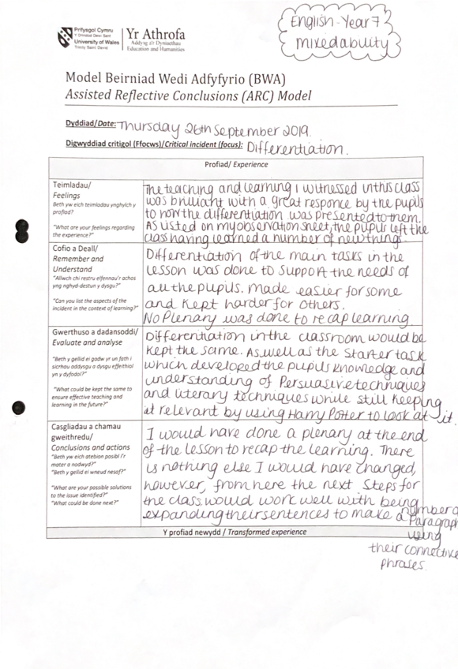

Observation and Arc Sheets 2:


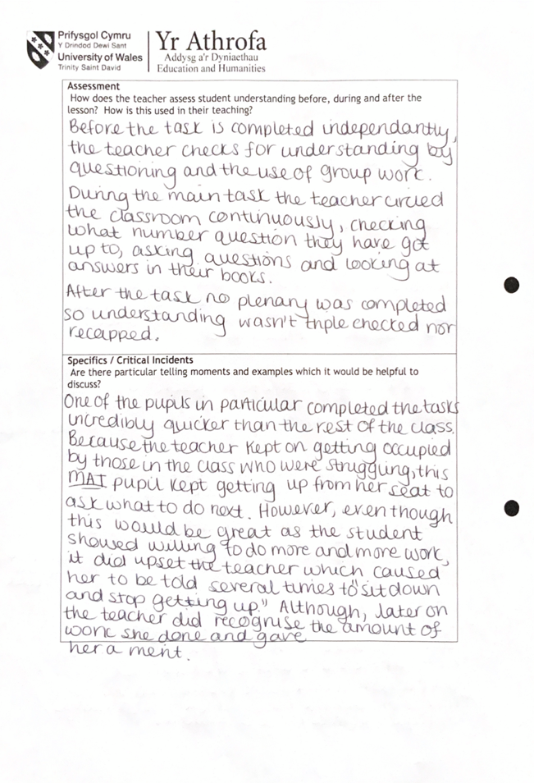

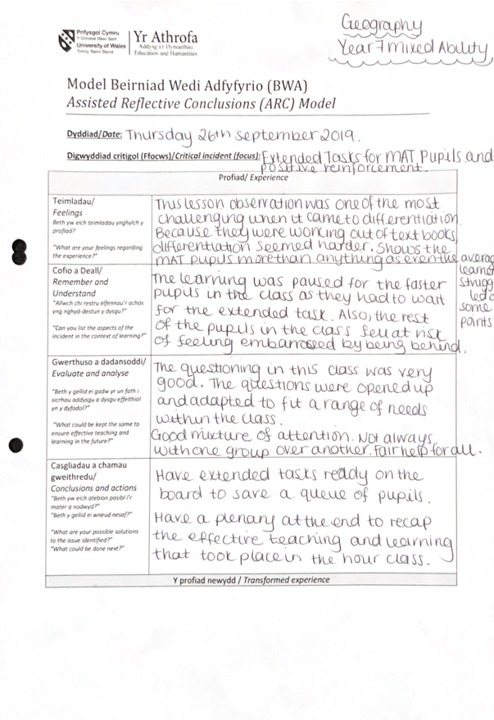

Observation and Arc Sheets 3:


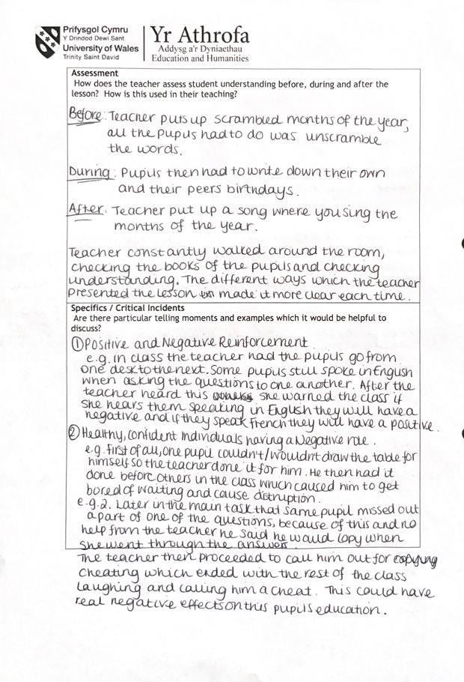




Observation and Arc Sheets 4:



