November 18, 2019
Lorna Jones
NAissance Trading

Major environmental trends within Naissance 1302640
Pestel Analysis - Word count: 1,965
Executive summary
The aim of this report is to analyse HRM/HRD trends in the environment that could affect Naissance Trading. Specifically using the PESTEL tool to isolate the effect of major trends on the environment.
After a basic pestel analysis was undertaken it was seen that the main issues affecting us are Managing mental health, the implementation of AI and the role of HR with regards to environmental sustainability. A critical analysis of these isolates that mental health is a key trend, ACAS, (2019), notes Mental Health as understanding emotional, psychological and social wellbeing, which affects how we think, feel and act.
The benefit of using techonology noted by managers percieves organisational and financial sense (Jones, 2019). Specifically for HR AI can improve processes such as recruitment, employee wellbeing and retension. We are entering a new understanding of how AI will change wellbeing, cost analysis and employee and organisational productivity (Jones, 2019). Naissance are with this trend with their current strategies however the gap between AI and recruitment shows correlation between CIPD, (2019) & Jones, (2019) and Naissance, (2019)
Ethical and environmental sustainability in the current climate is difficult to manage noting there is always room for improvement. Naissance are looking to include a volunteering scheme in the future to improve learning and development of employees but also their benefits and engagement (Rochester, et al., 2019). However there is a danger that this will not be done correctly and cause problems long term, it is paramount this is set up by HR and managers combined to ensure effectiveness (Volunteering, 2019).
Overall the consensus gained is the necessity to undertake a full PESTEL and SWOT analysis on the organisation to ensure the organisation needs and HR are working towards the same best practice strategy and goal. Currently Naissance are working towards these factors and in the VUCA environment noting and understanding changing legislation and trends will benefit the organisation long term.
Contents page

1.0 Introduction 3
2.0 Top Trends 4
3.1 How to Manage Mental Health – The Social Trend 4
2.1.1 A Current Issue 5
2.2 Is the implementation of AI in HR a threat? - Technology Trends 5
2.2.1 A Current issue 6
2.3 Environmental Stability – The role of HR. 6
2.3.1 Current Situation 7
3.0 Conclusion 8
3.1 Conclusion Mental Health 8
3.2 Conclusion AI 9
3.3 Conclusion Environmental Sustainability 9
3.4 Overall Conclusion 10
4.0 Recommendations and Action Plan for Naissance 10
6.0 References 11

Major environmental trends within Naissance (PESTEL)

1.0 Introduction

The aim of this report is to analyse HRM/HRD trends in the environment that could affect Naissance Trading. Specifically using the PESTEL tool to isolate the effect of major trends on the environment.
Naissance trading is an SME based in south wales specialising in the manufacturing and distribution of natural organic products. We operate on a multinational bases distributing products globally from our depots in the UK, Germany and America. Operating with a best practice strategy, the HR department within Naissance are keen to ensure that the business needs are met by corelating the business and HR strategies and aligning them with shareholder/stakeholder needs.
  - PESTEL
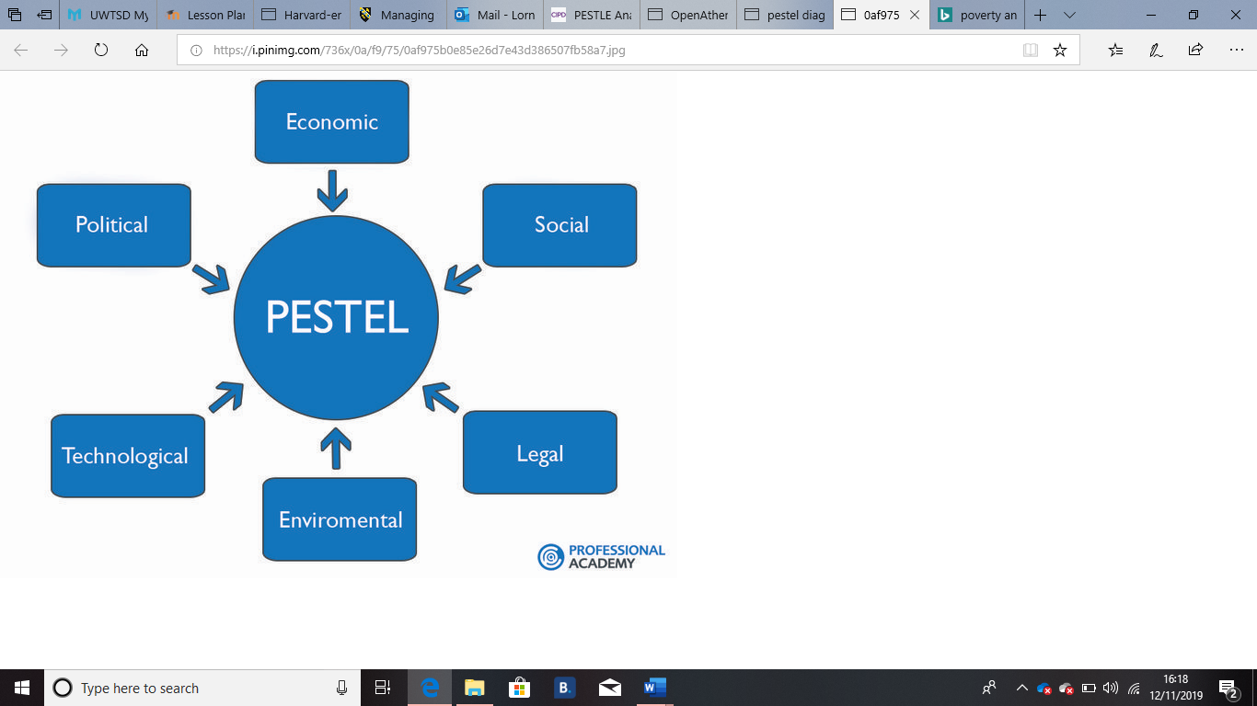
A pestel analysis was undertaken to understand the environment in which Naissance operate within. Diagram 1 shows the key factors a PESTEL considers.

Diagram 1 – PESTEL factors
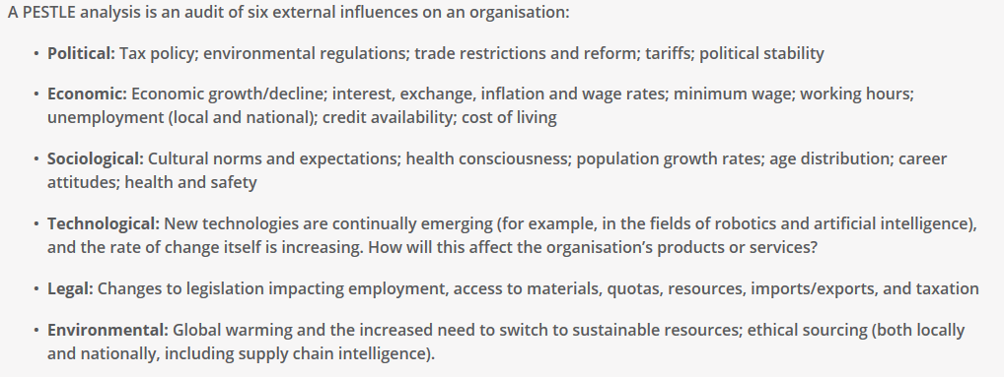
Diagram 1 – Pestel explanation -CIPD 2019.
A Pestel is used to examine external in internal factors that may affect the organisational strategy (CIPD,2019). Its purpose is to mitigate risk by outlining and understanding political, economic, social, technological, legal and environmental factors. For a full analysis of the environment it is clearer to use multiple internal and external analysis tools, for example SWOT and Porters 5 forces in conjunction with Pestel and Steeple. A criticism of Pestel is the limited knowledge it gives, it isolates issues but does not explain them in detail (Perera, 2017). Another criticism of pestel is the changing VUCA environment, for pestel to be fully effective they should be flexible and constantly under scrutiny by the organisation. A pestel is a long analysis technique and the correct time and resources need to be given in order to give a clear picture of the environment. Information can be misinterpreted or collected incorrectly this also needs to be taken into consideration, this report acknowledges this.

2.0 Top Trends

After a basic pestel analysis was undertaken it was seen that the main issues affecting us are Managing mental health, the implementation of AI and the role of HR with regards to environmental sustainability. A critical analysis of these is below.

3.1 How to Manage Mental Health – The Social Trend

ACAS, (2019), notes Mental Health as understanding emotional, psychological and social wellbeing, which affects how we think, feel and act. Work can cause or aid poor mental health. 57% of UK employees have suffered from mental health within employment (Dentith, 2019).

2.1.1 A Current Issue

In 2018 20% of company sicknesses (74.5 days) were linked to mental health, 2019 so far showed 48 days (Naissance, 2018; Naissance, Sickness monitor, 2019). Giving the need to prioritise further into mental health and how Naissance can manage employees effectively.
The UK workforce showed 64.9% of employees had a long-term health condition or illness whilst employed (ONS, 2016). Its noted that mental wellbeing was in the top 10 of workplace trends for 2018 and 2019 (Schawbel, 2018 & Schawbel, 2019).
In response to this, employers need to understand discrimination and stigma surrounding mental health and how it affects employees (CIPD, 2019). The Equality Act 2010 includes mental health impairments and classifies them as a disability, protecting employees against disability discrimination. However, clinical diagnosis needs to take place to qualify mental health as a disability. Employers need to be mindful of claims under the Protection from Harassment Act 1997 and the Mental Health Act 1983 (Mind, 2018; Scott, 2017). Mental health has directly affected Naissance strategy and direction by exacerbating manager workload. HR have recently overhauled policies and procedures linking to mental health due to the dramatic growth witnessed. The critique of this system would be the lack of diagnosis the system is open to be abused.

2.2 Is the implementation of AI in HR a threat? - Technology Trends

In 2019 HR was noted as the affected sector when it comes to AI. Transactional HR roles could be under threat from AI technologies; however, will they allow for progression and training or job insecurity and redundancies (Hamilton, 2018; CIPD, 2019).
AI has the ability to simulate human functions specifically problem solving, learning and perception therefore improving efficiency and workflow (Min, 2017). 38% of organisations are noted as already using AI, 33% of the workforce believe their roles will be affected by the implementation of AI (Bersin, 2017; Min, 2017).

2.2.1 A Current issue

A survey of HR executives showed 46% of them thought AI would improve their talent acquisition capabilities whereas 49% expect it to improve their payroll and benefits administration process (Bersin, 2017). HR is usually a function that needs to be employee facing, however Hamilton, (2018) noted that on a normal week the HR department spends less that 20% of their time with employees. This is true for Naissance.
Same as most HR departments Naissance use email, phone and other digital platforms to communicate with employees (Min, 2017). The platform BreatheHR allows the HR Administrator to spend less time organising personal documents, holiday requests and sicknesses (BreatheHR, 2019). This allows them to undertake other strategies which arguably may be above their current pay grade but allows for progression and experience.
AI can anticipate user interface, make suggestions and provide quick and reasonable responses to employees. Adapting this to HR where AI would give advice on policies, procedures, holiday entitlement and employment law (Hearn, 2018; Min, 2017). Talent acquisition, HR decision making though employee wellbeing and the data collected, Talent development through L&D processes are all processes in question from AI.
However according to CIPD, (2019) the ethical implications surrounding AI need to be considered, for example the GDPR implications or the impact on employee wellbeing. The use of AI systems increases risk to the employee and further research needs to be done (Lawrence, et al., 2017).

2.3 Environmental Stability – The role of HR.

The environment has become a hot topic with regards to stability, sustainability and ethical work (CIPD, 2019). Naissance have aligned their business and HR strategies around the environment. As a family business that originated in south Africa the quality and lifecycle of the product is key to business success. Delivery and shipment of goods must be sustainable and environmentally friendly as possible.

2.3.1 Current Situation

Naissance values underpin the importance of sustainability, actively taking a role in partnerships such as Soil association organic, Leaping Bunny and Vegan. In an attempt to stop exploitation of the environment and animals (Naissance, 2019). Corporate social responsibility is important for organisations to understand the effect the workplace has on society, environment and economy (CIPDa, 2019) and minimising any negative effects. The role of HR is to build and maintain ethical culture and practice, in Naissance case this is included in their ‘Best Practice’ strategy. By having reward and performance management processes aids in development and knowledge of the workforce with regards to CSR.
Areas of corporate responsibility are usually linked to:
- Workplace – Focusing on rights and wellbeing of employees.
- Marketplace – Impact of products or services, supply chain issues, fair trading, corporate taxes and anti-bribery.
- Environment – the company’s environmental impact.
- Community – is the organisations activities positively or negatively affecting society.
Specifically, HR act to ensure the best employment and people management practices are in place including recruitment, development, diversity, terms and conditions etc. They support a broad corporate sustainability strategy aiding in communicating and training employees on their social and environmental responsibility. Volunteering schemes are also considered. Overall HR are there to gauge, understand and change organisational culture, specifically their ability to ask whether things can be ethically better.
Naissance is top of the field with regards to CSR and the environment however there is room for improvement. The role of HR is changing, organisations are becoming aware of the benefit of including HR in decisions for the overall organisational interest.
There are some critics that say CR is a publicity ploy to push a company’s brand (Institute of CSR, 2019) however notably consensus gained is that the good it does in the long run outweighs this view (CIPDa, 2019 & WBCSD, 2019).
Taking into account the above social, technological and environmental trends it is key to point the link between all six of the PESTEL sections as previously outlined in the above PESTEL on Naissance.

3.0 Conclusion

Overall the following points were concluded from the PESTEL analysis undertaken.

3.1 Conclusion Mental Health
Promoting mental health and wellbeing in the workplace is key, showing the need for a positive culture, a level of awareness and training around mental health (CIPD, 2019), more for Naissance considering the growth of cases. Stress has been placed on departments with colleagues off work, HR have an increased workload and managers increased responsibility of trying to resolve the issue. Performance and time are key costs with managing mental health. On average the HR department 12 hours a week chasing employees with mental health issues (Naissance, 2018). Early intervention and support will improve attendance, promote work-left balance and address any possible negative outcome and prevent common conditions such as anxiety and depression (Race & Furnham, 2014 & Mental Health Network, 2016). It is the employer’s responsibility to make reasonable adjustments even if undiagnosed its seen as best practice to accommodate accordingly (ACAS, 2019; CIPD, 2019).
The consensus gained shows employees are fearful to speak about mental illness (Baska, 2019). 23% of the workforce stating their reason was embarrassment, 24% didn’t think their employer could help and 19% because they feared for their career (CIPD, 2019; Farmer & Stevenson , 2017; Mind, 2018, ONS, 2016 & Dentith, 2019). Naissance have implemented a ‘champion’ scheme so employees can discuss concerns with a colleague.

3.2 Conclusion AI

Consensus gained is AI will be used within every industry. The benefit of using techonology noted by managers percieves organisational and financial sense (Jones, 2019). Specifically for HR AI can improve processes such as recruitment, employee wellbeing and retension. This can be done by improving planning, giving completely unbiased recruitment, enhance workplaces by allowing data collection and admin to be completed by AI, complex human work can be completed by humans adding to employee growth and progression. Furthermore AI can improve employee wellbeing for example by monitoring and analysing employee stress. AI can demonstrate the value of the workforce. Jones, (2019) quoted that “In 2019 AI will change the workplace for the better by helping to upskill and empower rather than replace employees”. We are entering a new understanding of how AI will change wellbeing, cost analysis and employee and organisational productivity (Jones, 2019).

3.3 Conclusion Environmental Sustainability

Naissance have a good bases for ethical and environmental sustainability however in the current climate there is always room for improvement. Naissance are looking to include a volunteering scheme in the future to improve learning and development of employees but also their benefits and engagement (Rochester, et al., 2019). By supporting volunteering during working hours can improve the way the organisation interacts with the community, the different options on how to offer volunteering gives flexibility to organisation and the outcome increases company profile. However there is a danger that this will not be done correctly and cause problems long term, it is paramount this is set up by HR and managers combined to ensure effectiveness (Volunteering, 2019).

3.4 Overall Conclusion

As these are the key issues currently under review within Naissance it is key to understand the overall affect they have on the organisation. Overall the consensus gained is the necessity to undertake a full PESTEL and SWOT analysis on the organisation to ensure the organisation needs and HR are working towards the same best practice strategy and goal. Currently Naissance are working towards these factors and in the VUCA environment noting and understanding changing legislation and trends will benefit the organisation long term.

4.0 Recommendations and Action Plan for Naissance

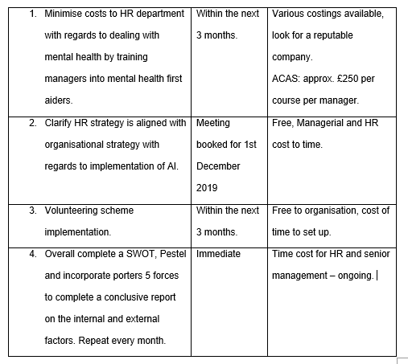
In order of priority for the organisation the follow points are the recommendations of this report.

6.0 References

ACAS. (2019). Promoting Positive Mental Health in the Workplace. London : ACAS.
Baska, M., (2019). Employees still scared to open up about mental health, says survey. People Managment, 13 8, p. 1.
Bersin, J., (2017). AI, Robotics, and Cognitive Computing Are Changing Business Faster Than You Thought. [Online] Available at: http://joshbersin.com/2017/03/ai-robotics-and-cognitive-computing-are-changing-business-faster-than-you-thought/ [Accessed 19 10 18].
BreatheHR, (2019). Naissance Profile. [Online] Available at: https://www.breathehr.com/ [Accessed 18.10.19].
CIPD, (2019). Artificial intelligence and automation in the workplace. [Online]
Available at: https://www.cipd.co.uk/knowledge/work/technology/emerging-future-work-factsheet
[Accessed 18.10.19].
CIPD, (2019). MegaTrends: The trends shaping work and working lives , London : CIPD.
CIPD, (2019). Mental health in the workplace. [Online]
Available at: https://www.cipd.co.uk/knowledge/culture/well-being/mental-health-factsheet
[Accessed 17.10.19].
CIPDa, (2019). CSR. [Online]
Available at: https://www.cipd.co.uk/knowledge/strategy/corporate-responsibility/factsheet
Dentith, L., (2019). Mental Health in the Workplace: A Worrying Trend. [Online]
Available at: https://www.nowgp.com/blog/mental-health-in-workplace/
[Accessed 17.10.19].
Farmer, P., & Stevenson , D. (2017). Thriving at work The Stevenson / Farmer review of mental health and employers. London : Gov.uk.
Hamilton, M., (2018). Three HR trends to watch for in 2019. [Online]
Available at: https://www.linkedin.com/pulse/three-hr-trends-watch-2019-matthew-hamilton/
[Accessed 18.10.19].
Hearn, S., (2018). Preformance Managment Trends of 2019.. [Online]
Available at: https://www.clearreview.com/performance-management-trends-of-2019/
[Accessed 18.10.19].
Institute of CSR, (2019). Business Ethics. [Online] Available at: https://icrs.info/
Jones, I., 2019. Will 2019 be the year HR fully adopts AI?People Management. People Managment, 09 01.
Lawrence, M., Roberts, C. & King , L., (2017). Managing automation: employment, inequality and ethics in the digital age. IPPR: The Progressive Policy Think Tank
Min, J.-A., (2017). Ten ways HR tech leaders can make the most of artificial intelligence. [Online]
Available at: https://www.personneltoday.com/hr/ten-ways-hr-tech-leaders-can-make-artificial-intelligence/
Mental Health at work. (2019). Your first stop for better mental health at work. Retrieved 17.10.19, from Mental health at work - MIND: https://www.mentalhealthatwork.org.uk/
Mental Health Network. (2016). Key Facts and Trends in Mental Health . England : Mind: For better mental health .
Mind. (2018). Mental Health Act 1983. Retrieved 17.10.19, from Mind: https://www.mind.org.uk/information-support/legal-rights/mental-health-act-1983/#.XahArW5FyuU
Naissance. (2018). HR Annual Report. Neath: Naissance Limited.
Naissance. (2019). Sickness monitor. Neath : Naissance Trading .
Naissance, (2019a). Oc Health reports, Neath: Naissance.
Naissance, (2019). Introduction of AI into HR , Neath : Naissance .
Naissance, (2019). Our partnerships. [Online] Available at: https://naissance.com/pages/about-us
ONS, (2016). NOMIS Database, London : Office for National Statistics .
Perera, R., (2017). The Pestel Analysis. 2 ed. No city : Nerdynaut .
Rochester, C., Paine , A. & Howlett , S., (2019). Volunteering and society in the 21st century. London: Palgrave Macmillan.
Race, M. C., & Furnham, A. (2014). Mental illness at work: a manager’s guide to identifying, managing and preventing psychological problems in the workplace. Basingstoke: Palgrave Macmillan.
Rowthorn, P. R. & Coutts, P. K., (2013). De-industrialisation and the balance of payments in advanced economies, Cambridge : Future of Manufacturing Project: Evidence Paper 31.
Schawbel, D. (2017). 10 Workplace Trends You'll See In 2018 . accessed 17.10.19, from Forbes : https://www.forbes.com/sites/danschawbel/2017/11/01/10-workplace-trends-youll-see-in-2018/#1771e2664bf2, 11 1
Schawbel, D. (2018). The Top 10 Workplace Trends For 2019. accessed 17.10.19, from DS: Dan Schwabel Blog : https://danschawbel.com/blog/the-top-10-workplace-trends-for-2019/ 11 1.
Scott, K. (2017). The law and mental health in the workplace. accessed 17.10.19, from Personnel Today CIPD: https://www.personneltoday.com/hr/the-law-and-mental-health-in-the-workplace,
Volunteering, E. (2019). What do we do?. [Online] Available at: http://www.employeevolunteering.co.uk/
WBCSD, (2019). Food and Nature. [Online] Available at: https://www.wbcsd.org/Programs/Food-Land-Water

