Effective Team Working and Communication

Student Name: Andrei Eugen Campian
Student number: 1816178
Lecturer’s name: Christopher Mafuva

- Introduction
Teamwork represents the collaboration between a group of people working together towards achieving a common goal. This skill is always useful to have when you find yourself in a social environment, whether that is at school or at work. Through teamwork you can share your other skill and improve upon them by gathering knowledge from the respective group of people, get to know them better and they you. Often great things are achieved through teamwork and that is why, in the present, it is so solicited and important to have this skill wherever you go.
Another crucial skill that I was taught in the class room is communication which is the transferring of information from one person to another. Communication can be verbal such as conveying a message or expressing feelings through spoken words, and nonverbal which is the opposite of verbal communication, it is when you send or receive information without the use of words such as body language expressing physical behavior and often this type of communication speaks the loudest.
But, in my opinion, the most important type of communication at the work place is verbal communication, and I can say so through my experience at my workplace, Amazon.
Amazon is the largest online retailer in the world, it is a communication based environment, everything and everyone works collectively and thus, at work my colleagues do not expect me to relay information based on emotional expressions but through verbal communication, they want a precise and clear transfer of information to avoid confusion so that we can work efficiently do our best to “deliver smiles” (Amazon 2019) in time.

- Types of Communication
There are multiple ways of communicating when trying to relay a message, depending on the type of situation that you are finding yourself in, you can choose what type of communication to approach, whether you are sending an email or sustaining a business presentation, the type of communication that you use will determine the outcome of your intended message.
There are four main types of communication and these include verbal, non-verbal, written and visual communication.

2.1 Verbal Communication
Verbal communication is the type of language that ca be use to transmit information through speaking and it is known as the most common and the most used type of communication at the present time. The reason for this is that it can be easily and efficiently used to deliver any kind of message, it encourages you to use active listening skills by listening and hearing others.
2.2 Non-verbal Communication
This type of communication implies the use of body language, gestures and facial expressions to transmit information to others around you. Non-verbal communication is a transmitter of thought and feelings such as the simple fact of crossing your arms around you giving the impression of coldness or gesticulating when you are explaining a subject, trying to make the listener to understand it better. All of these body languages can help to understand each other’s feelings, to relate to one another, after all expressing feelings is part of what makes us human.

2.3 Written Communication
Written communication is the conveying of information through the act of writing such as letters, essays or reports like the one I am writing here. This skill is useful when you have to come to a certain agreement or conclusion, to send a precise, verified and concrete message. It is also the most formal and permanent method of communication that can be used today, it allows us to better study the information and to make future references. When information is offered to a person via this method, it should be as clear and simple as possible so that it can be easily understood. Written communication allows you one aspect that no other method of communication can and that is the ability to identify mistakes in your message and correct them or the opportunity to say something differently.

2.4 Visual Communication
This type of communication is based on description of information in forms that can be looked upon. It is in and of itself the very world that I am trying to explain. This method can relay messages in a more emotional and evocative way, it helps to express feelings, more than a written word. A good example would be photographs, drawings, illustrations and graphic design. It relates to the idea that a visual message introduced alongside a text has a greater power to inform and educate the reader
Visual information also includes non-verbal communication that was mentioned above, body language and gestures can be classified as such.
To draw a conclusion to this type of communication by saying that visual communication is the easiest way to send information and to relate to others.

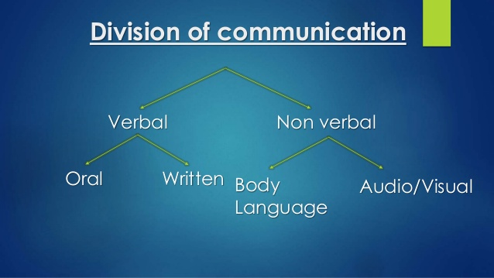
https://www.slideshare.net/SahilSB97/types-of-communication-53518724

3.0 Theories of Communication
According to in-class exercises there are three main models of communication that can help us understand how communication works at a fundamental level, explained through scientific methods and those are: The Shannon Weaver Model of Communication, Berlo’s Model of Communication and Schramm’s Model of Communication.

3.1 The Shannon Weaver Model of Communication
This model represents the effective communication between a sender and a receiver. Shannon, a mathematician joined Weaver who was a scientist to share their knowledge and to come up with “A Mathematical Theory of Communication” more commonly known as “The Shannon Weaver Model of Communication”.
It was intended to improve the technical communication in the field of communication.
The concept of this model shows us how the sender sends the information through an encoder that coverts the message into a signal or binary numbers then the signal is transported via a channel, the medium that the message goes through, for example a wire or wireless waves. The message then reaches a decoder also known as the receiver that in turn converts the signal or binary numbers back into the original message so that it can be understood and finally it reaches its destination which is the receiver.
But this model is not without flaw, one factor was discovered that could affect the process of communication called noise. Noise is the physical disturbance which can interfere with the message and as a result the message does not reach the receiver as it was intended by the sender.
A real life scenario of this model would be as follows, I am the sender and I write into my phone a message after which I send that message through the same medium and then it arrives at my friend’s phone who is the receiver and he decodes the very same massage that I have sent and at this point communication has occurred. According to this model communication has occurred when a message has been sent and received. The other aspect of this is the noise factor that can interfere with the massage and cause it to not reach my friend.
There are limitation to this model as well, like the notion of feedback, it is implied in the model but is not directly part of it. Another limitation in that this model does not include non-verbal communications.

A graphical representation of The Shannon Weaver Communication Model


3.2 Berlo’s Model of Communication
This model is the most famous and most used model of communication, it was developed from Shannon and Weaver’s model of Communication and it has only four components that describe the model through focusing on encoding and decoding the information and they are sender, message, channel, receiver.
It has the same basic communication aspects as the model mentioned above with the exception that this model includes verbal and non-verbal communication, unlike the Shannon Weaver’s model and also it considers the emotional aspect of the message.
Some of the criticisms of this models are the lack of feedback, the fact that it does not mention any barriers to communication, it does not explain the implication of the noise aspect and it is a linear model of communication and a complex model.

https://www.businesstopia.net/communication/berlo-model-communication

3.3 Schramm’s Model of Communication
Schramm’s model of communication is a two way circular communication between a sender and a receiver. It emphasizes on encoding and decoding of the message and that the message is only sent when encoded by the sender and decoded after it has been received by the receiver.
This model is not a traditional model of communication, the sender is the person who sends the message through a channel, the encoder is the person who converts the message to be sent into codes, the decoder is the person who receives it and the interpreter is the person trying to understand the message.
This communication model is sometimes affected by semantic noise in the sense that a message can be misunderstood and interpreted differently than what the sender intended to say.
Some of the advantages that this model has are:
- dynamic model showing how the situation might change
- the sender and the receiver are not different persons they are the same person
- this model is a circular communication
- it offers feedback

The disadvantages of this model are:
- It mentions semantic noise but it does not explain it in detail what it is or how it affects the model
- It assumes the moment of encoding and decoding

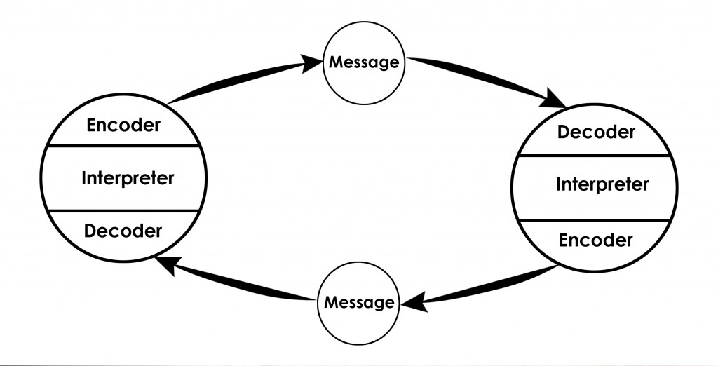https://www.communicationtheory.org/osgood-schramm-model-of-communication/
Conclusion
Communication and team work in essence, is what binds us together, it makes us connect to one and other, to express our feelings and to understand each other. Communication encourages collaboration regardless of what type of communication it is and therefor by work in teams we can achieve so much more than we ca as an individual.
The information and knowledge that I have gathered from this past term at the university was surprisingly useful. The information that I possessed in regard to communication and team work had room to improve upon and by taking this course it undoubtedly did so.

References

Maund, A., Schriek, M. and Tinkler, P. K., (2017). Certificat in Higher Education: Skills for the Workplace Student Yearbook. Sage Press

Morgan, P., (2017). The Business Student’s Guide to Study and Employability. Saga Press

Available at:
http://www.open.ac.uk/choose/unison/develop/my-skills/team-working (Accessed: 29 August 2019)
Available at:
https://www.indeed.com/career-advice/career-development/types-of-communication (Accessed: 29 August 2019)
Available at:
https://www.communicationtheory.org/shannon-and-weaver-model-of-communication/ (Accessed: 29 August 2019)
Available at:
https://www.businesstopia.net/communication/berlo-model-communication (Accessed:29 August 2019)

Appendix



