.

Does the diet of violent images we are being fed via the media of newspapers and film affect our wellbeing as individuals, both morally and psychologically, and should this exposure be controlled?

By Richard Lloyd Harding
P145369

Tutor: Paul Duerinckx

Submitted in partial fulfilment of the requirements for the degree BA(Hons)
Photojournalism University of Wales Trinity Saint David. December 2017

Table of Contents

- List of Illustrations – Page 3

- Introduction – Page 4 - 5

- Chapter One – Pages 6 - 9

- Chapter Two – Pages 10 – 15

- Chapter Three – Pages 16 – 22

- Chapter Four – Pages 23 – 24

- Conclusion – Pages 25 – 27

- Bibliography – Page 28

- Internet References – Pages 29 – 30

Dissertation Word Count – 5020

(Inc. Bibliography, Internet
References and Illustrations) (5761)

List of Illustrations
Page No.

9.Ritual beheading – Photographer, Location and Date unknown – Accessed Nov.5th 2017 14:20 Ritual beheading – Photographer, Location and Date

10.D-Day Photo of a soldier in the surf on Omaha Beach– FRANCE. Normandy. June 6th, 1944.
Robert Capa—© International Center of Photography/Magnum Photos

12.Raising the Flag February 23, 1945 Joe Rosenthal - Copyright The Associated Press

13.The raising of the 1st Flag on Mount Suribachi, Iwo Jima February 23, 1945 Sgt. Louis Lowery, a Marine photographer for Leatherneck magazine
As work of the United States Marine Corps and the U.S. federal government, the image is in the public domain.

15.Napalm Girl – Nick Ut Original 35mmContact

15. Napalm Girl – Trang Bang – AP IMages

17.Graffitti Hashtag, Kursky Raiway Station, Moscow Mladen Antonov: Getty Images.

19.Texas Lone Star 11th November 2017

20.London Bridge Terrorist attack March 2017 Lorriman, Jaimie – REX Shutterstock

21.Photoshopped image depicting Bennett burning the American flag, September 2017

21.What do you do in the victory locker room? You victory dance 5:52 pm - 3 Jan 2016

24.Rwanda 1994 – James Nachtway

Introduction

This dissertation will discuss how one’s perception of reality has always been shaped by narratives, normally by either word of mouth, TV and Film broadcast or the written analogue media. But in our post modern/post truth society social media platforms such as Facebook, Twitter, Instagram and Snapchat, are being used especially by the youth as alternative means of communication for the battle to continue with competing narratives.

There are various understandings of what post modernity is but I see it as where we are involved in questioning the modernist epistemology, or the investigation into the nature of knowledge itself, based on a clear distinction between subject and object,
and how we can differentiate between truth and falsehood.

Modern epistemology generally involves a debate between rationalism, i.e. knowledge acquired through the reasoning, and empiricism, i.e. the knowledge that is gained through experience. However this is being conflicted with our post truth politics where the debate is framed largely by what you want to believe, which is disconnected by details of policy, and by the repeated assertion of talking points to which the rebuttal of facts are consistently ignored.

I have used research from a variety of theorists such as Berger and Benjamin, Baudrillard and Barthes, Sontag and Wells, and images from the last seventy five years. I have used both articles, and research from the internet

In Chapter One I wish to show the internet and the world wide web is being used to disseminate violent images that destabilise our society

In chapter Two I will explore how images were used on a more political and propagandist view in the Modernist, industrialised society where the recognition of consciousness becomes a force in its own right

Chapter Three moves towards the age of the Gulf wars and how the role of reporting changed through the embedding of journalists, and the emerging digital technologies which has changed the way and the speed of how information is being relayed, as we move into the world of fake news, memes and fabrication of events.

Finally I will pull all the questions and answers to answer if the diet of violent images we are being fed via the media of newspapers and film affect our wellbeing as individuals, both morally and psychologically, and should this exposure be controlled?

Chapter One

In Britain we generally believe that we live in a free society where the public have a general consensus in our society that because of our right of free speech we reject censorship of any kind, especially censorship of the media and of the tv/film industry, but while we indulge ourselves in ever disturbing images are we rejecting the responsibility that comes hand in hand with freedom of speech.

Roland Barthes in Camera Lucida said:

‘The Photograph is violent: not because it shows violent things, but because on each occasion it fills the sight by force, and because in it nothing can be refused or transformed (that we can sometimes call it mild does not contradict its violence: many say that sugar is mild, but to me sugar is violent, and I call it so). (p91)

As we surround ourselves with like-minded contacts we are polarising our beliefs and prejudices, leaving the door wide open to be manipulated by the more savvy internet users, especially as we gradually close the door on anyone who expresses an alternative view, believing their version is nothing but lies and fake news
No longer can we rely on impartial advice being offered by professional journalists, working for independent media organisations. Russia has offered us a glimpse of the future, by exploiting these media platforms, both in the run up to the US Presidential elections, and in the conflict affecting Syria, Yemen and the Middle East. The dream offered to us by Tim Berners-Lee of a world wide web that we would enjoy a utopian dream of unlimited information have been usurped by states and organisations with their own political agenda, as their tendrils stifle the flow of free knowledge, and imposing their ideological narratives into the minds of the masses.
During the last Presidential election in the US numerous stories surfaced regarding Hilton Clinton to the point that her supporters saying it was an orchestrated campaign by Donald Trump, her rival, supporters. This is not unique to the US, as in the UK prior to the Brexit Referendum, Robert Booth of the Guardian stated
‘UK academics have already established that at least 419 Twitter accounts operating from the Kremlin-linked Russian Internet Research Agency (IRA) tweeted about Brexit and that thousands of other Russia-based Twitter accounts posted more than 45,000 messages about Brexit in just 48 hours during last year’s referendum’.

In July 2016 Russian Culture Minister Vladimir Medinsky accused the US that Netflix was a CIA conspiracy, where they were using the online streaming service to 'creep into our heads'. There is an element of truth in this but it is combination of Medinsky using the CIA to increase funding for Russian cinema in order to combat the increasing dominance of Hollywood, and that the CIA did in fact fund cultural projects during the Cold War,such as Hollywood films and also art exhibitions and musicians.

Facebook former vice-president for user growth, Chamath Palihapitiya, said recently on the Verge website: “The short-term, dopamine-driven feedback loops that we have created are destroying how society works. No civil discourse, no cooperation, misinformation, mistruth.”

His comments were not only aimed at Facebook but all online media platforms, highlighting that the internet is in danger of becoming a modern day version of Jeremy Bentham’s Panoptican, where a large number of people are under invisible surveillance by a small number of people, and controlled accordingly.

“No civil discourse, no cooperation; misinformation, mistruth. And it’s not an American problem — this is not about Russians ads. This is a global problem.”.
He went on to say-“And imagine taking that to the extreme, where bad actors can now manipulate large swathes of people to do anything you want”.

Carl Von Clausewitz, stated in his book On War that:
‘War is a mere continuation of policy by other means. We see, therefore, that War is not merely a political act, but also a real political instrument, a continuation of political commerce, a carrying out of the same by other means’
Conversely Michel Foucault explains this in terms of the inversion of Clausewitz’s dictum that war is diplomacy by other means into the claim that “politics is war by other means.”

But how do you fight an organisation that will outlast its physical territorial hold, as its surviving fighters disperse back into the general population that it was recruited from? According to Gilles De Kerchove , the EU Counterterrorism terrorism coordinator, we must invest even more in prevention, try to reduce the propaganda on the internet and develop a counterdiscourse. (Saim Saeed, 2017

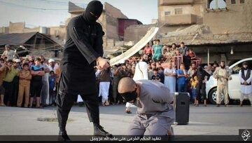
https://goo.gl/images/zigqma Photographer and location unknown.

The violence inherent in this digital photographic image is in what is inferred, other than that of what is apparent.

In relation to the world of photography of political trauma and witness responding to the radical changes of how war is made and what it is made for, Susie Linfield’s
book ‘The Cruel Radiance’ raises questions on why people look and also why some don’t. She went on to say that “When it comes to photography the opposite is also true”

Walter Benjamin commented that “to ask for the ‘authentic’ print makes no sense.
He was talking about multiple prints being made from a single negative, but the same situation exists today with digital technology being able to copy, transmit and alter in a moment.
“But the instant the criterion of authenticity ceases to be applicable to artistic production, the total function of art is reversed. Instead of being based on ritual, it begins to be based on another practice – politics”. (1968)
Chapter Two
Robert Capa framed the violence in his images of war from a moral and political point of view, not with an indulgence of self-gratifying exaggerated violence, but with an inherent sense of patriotism and political principle.
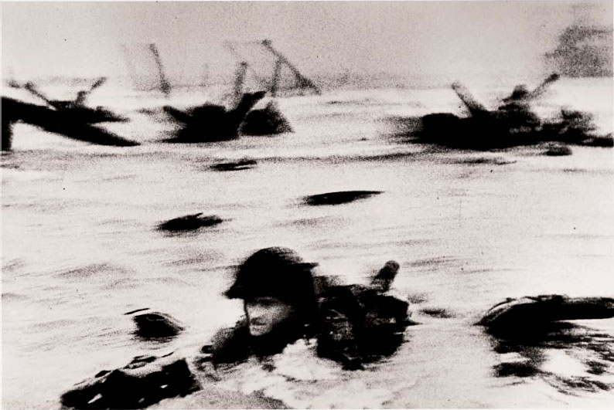
D-Day Photo of a soldier in the surf on Omaha Beach– FRANCE. Normandy. June 6th, 1944. Robert Capa—© International Center of Photography/Magnum Photos

Western society, meaning Europe and English speaking countries, tends to speak to the world from its point of view, detailing the stand point of the west, whilst considering the remainder as the rest of the world, and their history being almost static, or slowly catching up with the west’s dynamic and rapidly changing history.
Whereas traditional photojournalists had the ethical and moral guidelines to ensure to try to record the truth as they saw it, the rewards of false news, and digitally enhanced images are far too easily available to be exploited for political and ideological ends.
John Berger (1982:99) stated,
‘the camera was invented in 1839. Auguste Comte was just finishing his Cours de Philosophie Positive and the camera and sociology grew up together. What sustained them all as practices was the belief that quantifiable facts, recorded by scientists and experts, would one day offer man such total knowledge about nature and society that he would be able to order them both’
He went on to state that it was always that the photograph couldn’t be just considered as scientific evidence , but was only a “proposal that was ( and is) that when something is visible, it is a fact, and that facts only contain the truth” (1982:100)
Walter Benjamin stated ‘to ask for the “authentic” print makes no sense. But the instant the criterion of authenticity ceases to be applicable to artistic production, the total function of art is reversed. Instead of being based on ritual, it begins to be based on another practice – politics.’ (Liz Wells 2003: p45)
The authenticity of an image is paramount, since once this is threatened then its historical importance no longer carries the authority it possesses as an object of truth
Conversely Umberto Eco says ‘To speak of things that one wants to connote as real, these things must seem real’ and that things must be offered as ‘a sign, that will be forgotten as such: The sign aims to be the thing, to abolish the distinction of the reference, the mechanism of replacement. Not the image of the thing, but its plaster cast. Its double in other words.’ (1986, p6)
One of the most famous images of WW11 is Joe Rosenthal’s ‘Raising the flag on Iwo Jima’, which won the Pullitzer Prize, and it could be argued this simple photo helped win World War II.
It was not enough for the public back home just to be told of the victory, as ironically the island was only included in the Americans invasion plans due to the early fall of the Phillipines, and what was needed was a symbol that America was invincible, and the blood of its nearly 7000 of its troops was spilt in defence of their land. This and symbolic iconic image created a wave of national hope that peace was inevitable as Japanese forces would soon be crushed, subsequently raising millions of dollars in the sale of war bonds, helping to keep the nation stabilised financially.
But Rosenthal was just one of several cameramen on the island's Mount Suribachi that day, and on reaching the top, Rosenthal spotted a group of Marines holding a second flag. as they'd been ordered to replace the first flag, that had been raised 90 minutes earlier, with a bigger one so more people could see it below.
. 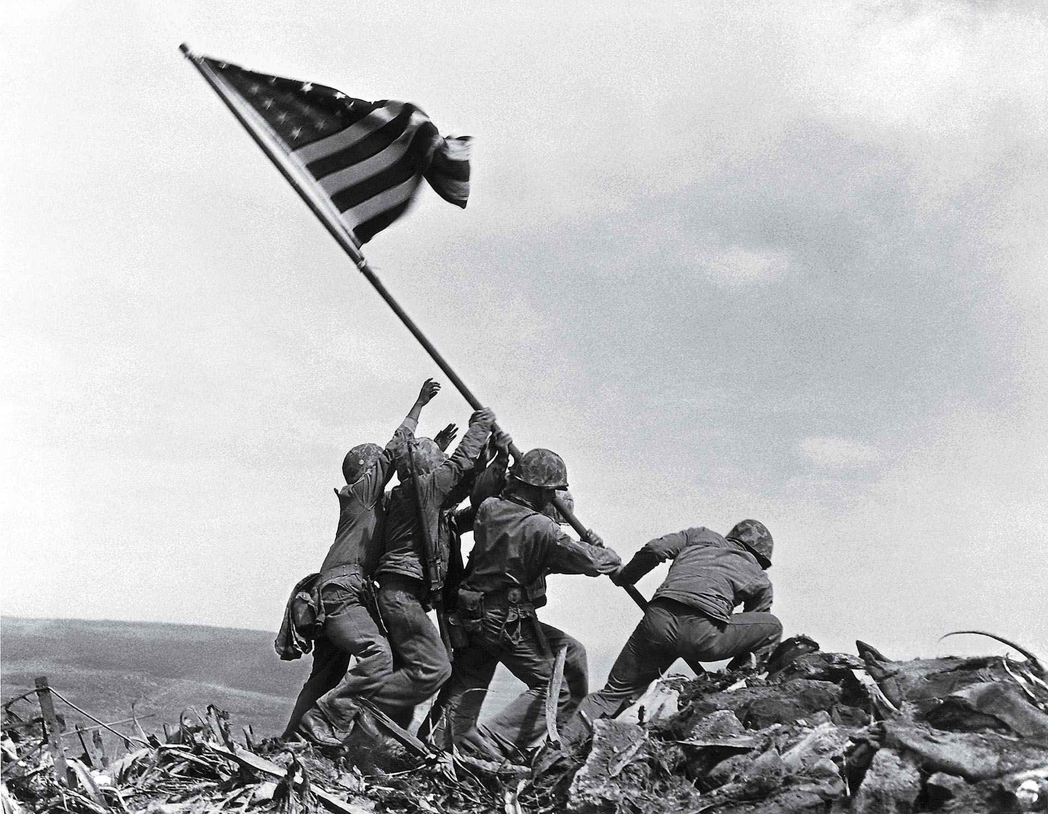
Raising the Flag February 23, 1945 Joe Rosenthal - Copyright The Associated Press

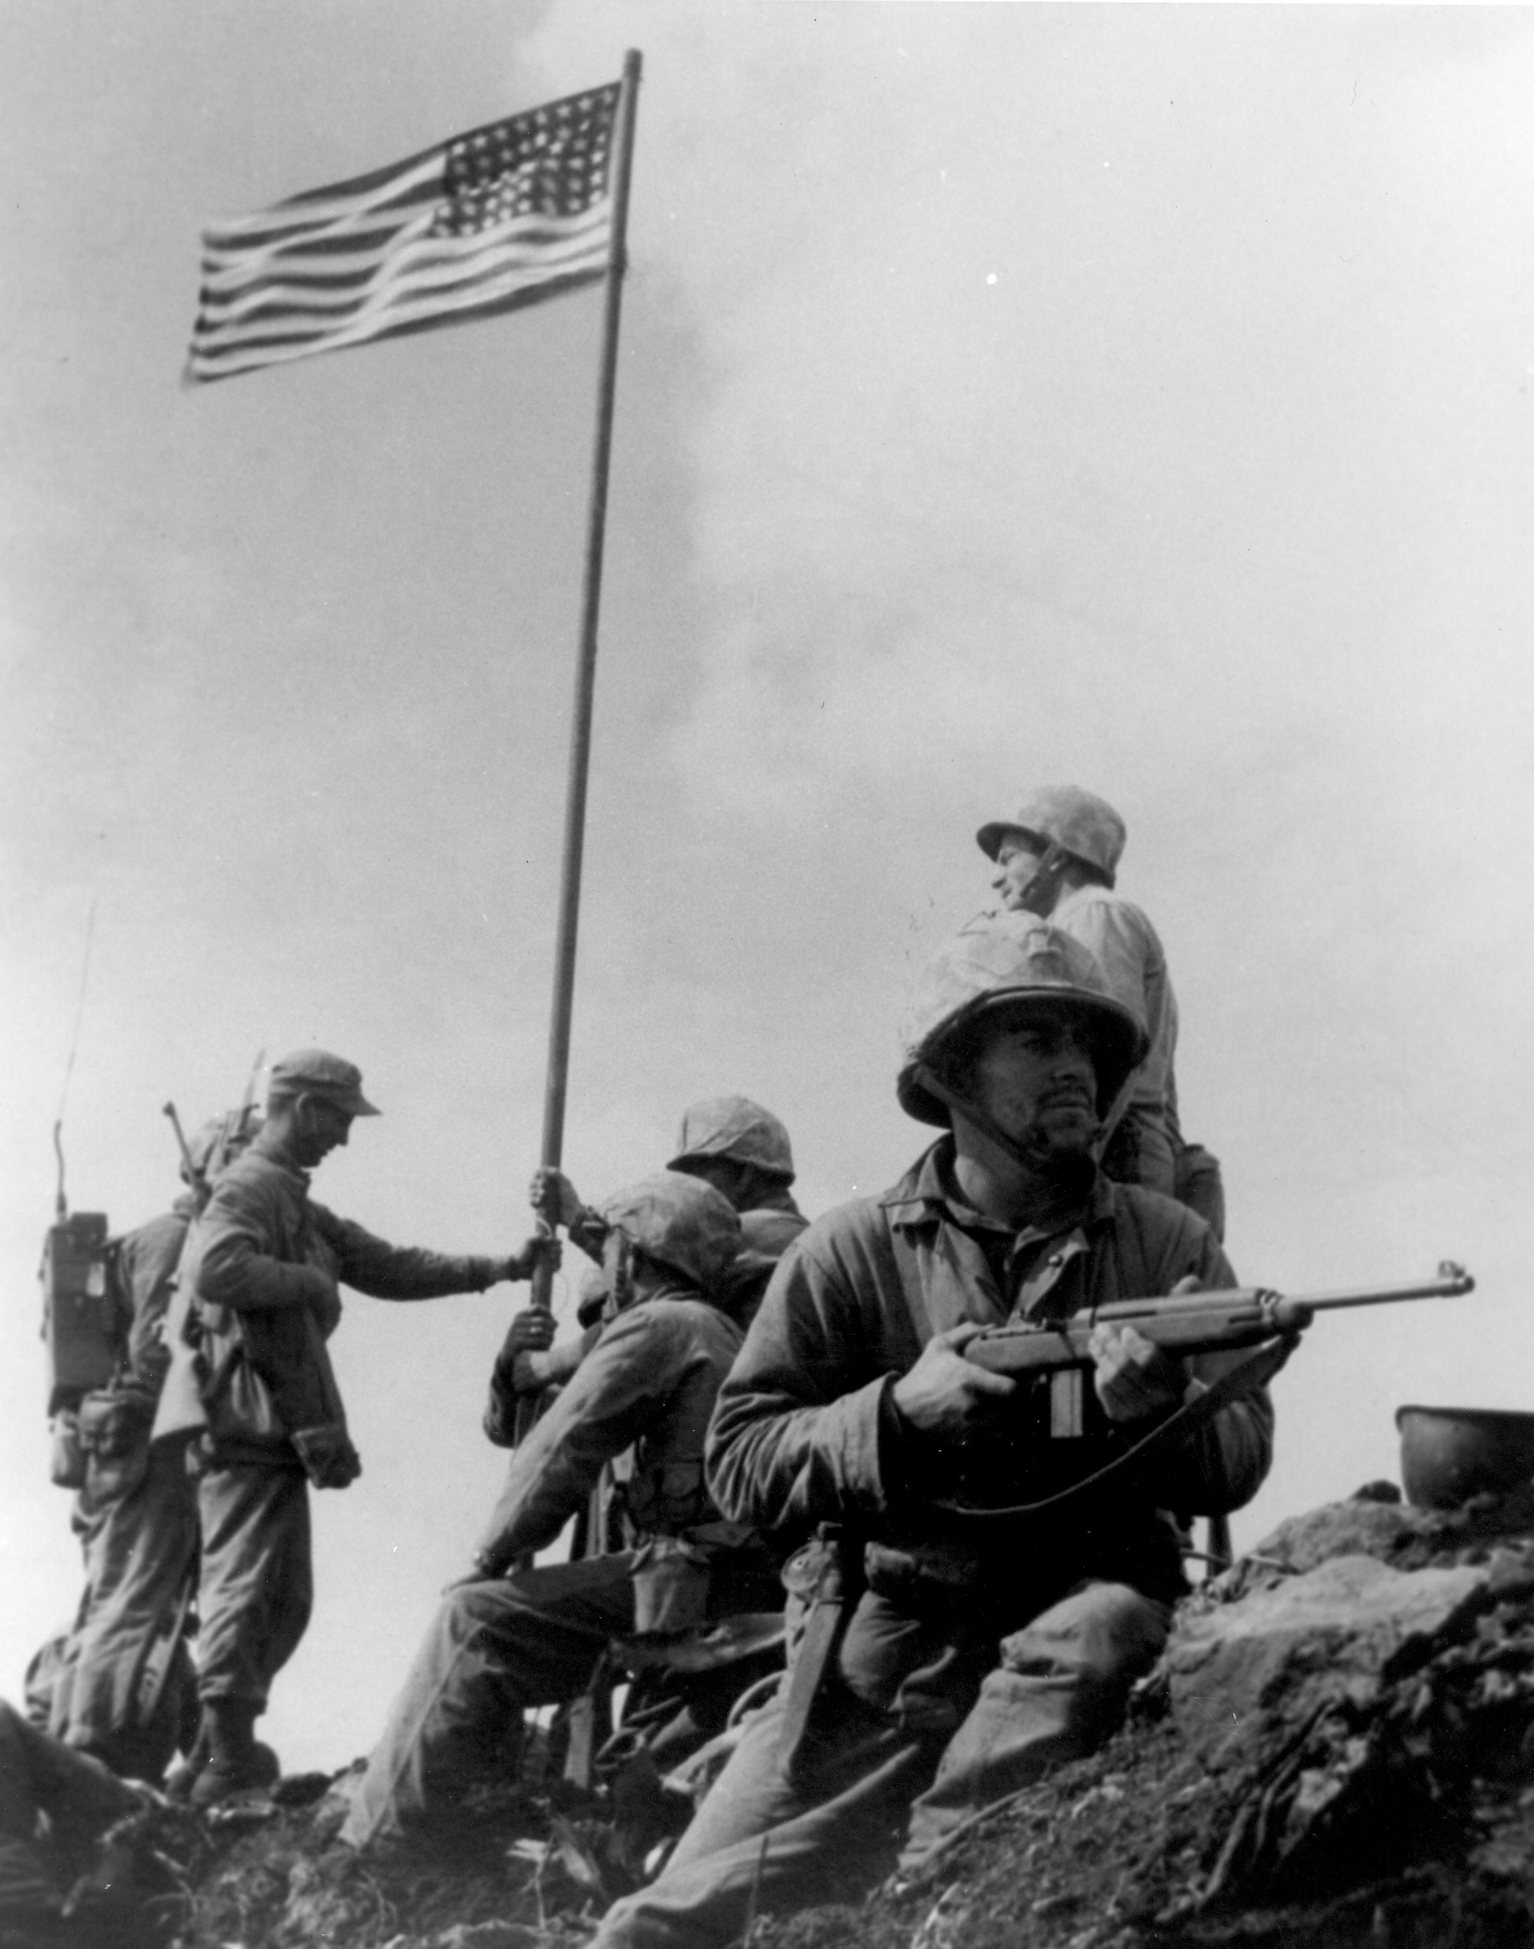

The raising of the 1st Flag on Mount Suribachi, Iwo Jima February 23, 1945
Taken by Sgt. Louis Lowery, a Marine photographer for Leatherneck magazine.

This image or file is in the public domain because it contains materials that originally came from the United States Marine Corps. As a work of the U.S. federal government, the image is in the public domain.

Whichever image you consider to be the real deal they are both signs for the public to reinforce their beliefs , whether pro or anti-war. It is well known that photography is primarily ‘indexical’. Rosenthal’s image in semiotic terms is primarily symbolic. It doesn’t matter who the people were raising the flag, not even that they were 5 marines and a sailor, but that they were members of American armed forces, that were enforcing the aims and wishes of the American public. Even the colours of the flag are symbolic as red often represents courage, revolution, hardiness, blood, and or valour, white often represents peace, purity, and/or innocence and blue often represents freedom, vigilance, perseverance, justice, prosperity, peace, and/or patriotism. And these values overspan the connected desires of all the people in the vast continent of America under one symbol, subtly reinforcing the words of the star spangled banner where :

‘the rockets’ red glare, the bombs bursting in air,
gave proof through the night that our flag was still there.
Oh say! does that star spangled banner yet wave,
o’er the land of the free and the home of the brave’.

But every conflict will bring an image that makes us question not only what is happening at that moment in that particular armed conflict, but why the whole thing has come about, whether it is happening to an individual, such as Che Guevera tortured body after being captured, or to a nation, Nick Ut’s napalm girl, crying as she ran down the road escaping her village, became a symbol for America’s shift in consciousness. The image was unprecedented at the time for the Associated Press news wire, due to full frontal nudity depicted of the bombing victims. Pictures of nudes of all ages and sexes, and especially frontal views were an absolute no-no at the Associated Press in 1972. Horst Faas argued by telex with the New York head-office that an exception must be made, with the compromise that no close-up of the girl Kim Phuc alone would be transmitted. The New York photo editor, Hal Buell, agreed that the news value of the photograph overrode any reservations about nudity. (Faas & Fulton:2206)

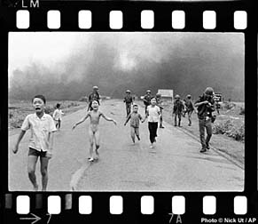 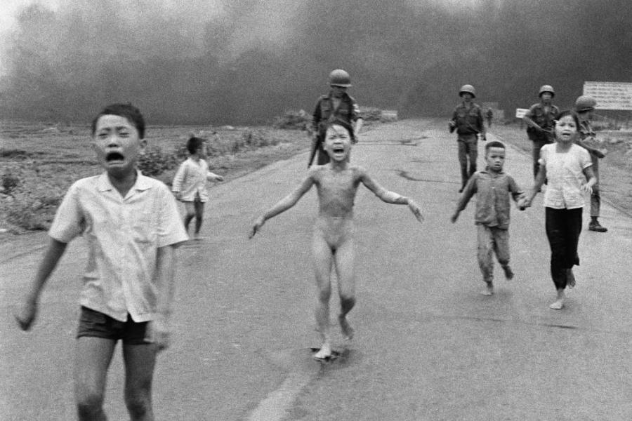 http://digitaljournalist.org/issue0008/ng4.htm Nick Ut:AP Images
(accessed 9/12/2017, 23:58)

In reality at the time of the napalm bombing there were only 2 US soldiers in the area,
and the whole incident was due to an ARVN (Southern Vietnamese) military operation.

According to http://all-that-is-interesting.com/napalm-girl, at the time of the battle, there
were exactly two American servicemen in Tay Ninh Province, one of whom was miles
away and another who arrived at Trang Bang as an observer with zero authority over air
and ground forces.
Nobody, except for the NVA, ever attacked the village and no Americans within radio range range had the power to issue such an order. From start to finish, Trang Bang was a Vietnamese operation.
After Vietnam the way photographers had access to frontline war stories started to chnge and there were to have no longer the same access to the warfare as before.

Chapter Three

The embedding of journalists with the Armed forces, especially with the Royal Navy during the Falklands war meant lessons were learnt by all sides on how the press could be controlled, and this was taken up enthusiastically by military planners in both Washington and London for the First Gulf War in 1991.

The Iraq conflict of 2003, a much more contentious war in its objectives, was rather different, and embedding became increasingly controversial. Technology had moved on and clips of military action, occurring far away from the front line of action was carefully released to the public via videos, being far more controlled by the Military forces and the debate over the Iraq War still rages too intensely to make a judgment on whether journalism or self-censorship and military management of the media triumphed.
With the rise in the world of the so called Islamic state, and the threat of a new cold war in Eastern Europe, famine and conflict in the sub-Sahara, and an ever increasing destabilisation of the regions in the far east Western armed forces are having to play a new role in a deeply unstable world. And just as the armed forces have adapted to the changing face of warfare so has the role of the photojournalist in areas of armed conflict. Over twenty five years ago it was identified by Wombell on the emergence of photovideo that ‘It is not overstating it to say that the advent of this new technology is by changing the very nature of photography as we have known it.’(1991)
Not just photojournalism is in the process of a dramatic sea change but the whole media industry as we know it today, as newspapers ironically themselves use information gathered from social media to fight the remorseless march of Facebook, Twitter, Flickr and Instagram news feed.
It is not just a case of journalists carrying the latest equipment suitable for both high quality photographs and high definition video, or being in the correct placed to record events, but the fact that smart phones have developed to the point of broadcast quality that can be sent by satellite from anywhere in the world, resulting in a dramatic change in the way journalism is used to garner information, and how traditional photojournalism is affected.
Jonathan Crary said of new image technologies ‘Most of the historically important functions of the human eye are being supplanted by practices in which visual images no longer have any reference to the position of an observer in a real” optically perceived world (Crary 1993:2)
Social Media is transforming the way that wars are waged, covered and consumed by an ever avaricious public. The traditional way of waging a war will always be by major institutions and states, but as the face to face war disintegrates the balance of power is shifting to the internet, where someone not in a traditional military role is able to wield capabilities of influencing people way above their normal position in society.
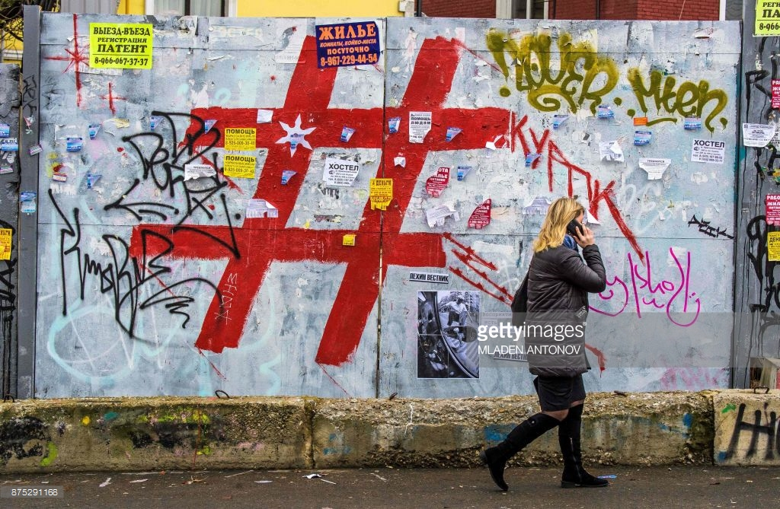 Mladen Antonov: Getty Images. 07/12/17
In previous times, such as the ‘Cold War” Russia at one time relied on having agents on the ground spreading disinformation to de-stabilise governments through the beliefs and the will of the people, but now a new form of information warfare is being waged against the west using the technology of Social Media platforms.
Propaganda has always run hand in hand with war itself, being used to support a case for, a case for continuing or a case for justifying the conflict itself after the event. ISIS, has shifted its emphasis from a physical presence which tried to establish the Caliphate in Syria and beyond, to a virtual caliphate in cyberspace where individuals and lone wolves carry out attacks on the western world, sometimes in its name, and sometimes where the ideological link is not so clearly established. Gilles De Kerchove reported in June of this year that tens of thousands of websites are circulating radical islamist content. (Newsweek 07/06/2017)
In the recent terrorist incident in London where an individual drove down Westminster Bridge in March 2017 injuring members of the public who were walking on the pavements, a photograph was taken of a woman in a Hijab appearing to walk past the injured lying prone on the pavement, completely ignoring what had happened. This image subsequently went viral on the internet justifying the black arts of the Russian propaganda team, especially as the image was accredited to a Texan tourist who happened to be on the Bridge.
The impact of these images can be even more disturbing as one wasn’t expecting to be confronted with violence. People when watching the 9/11 attack had difficulty initially in believing it wasn’t some form of Hollywood trailer for a forthcoming Hollywood movie .
The sights seen on the internet are nothing compared to what soldiers, or members of the essential services see on a daily basis. But a 2015 study at the University of Toronto found that extended exposure to violent or disturbing material can have a severe effect on journalists mental health.
On social media there is no warning, and with the way images are being retweeted, pinterested and snapscanned, we are increasingly encountering images this way: without any warning and no chance to prepare ourselves for the sudden shock of reality..
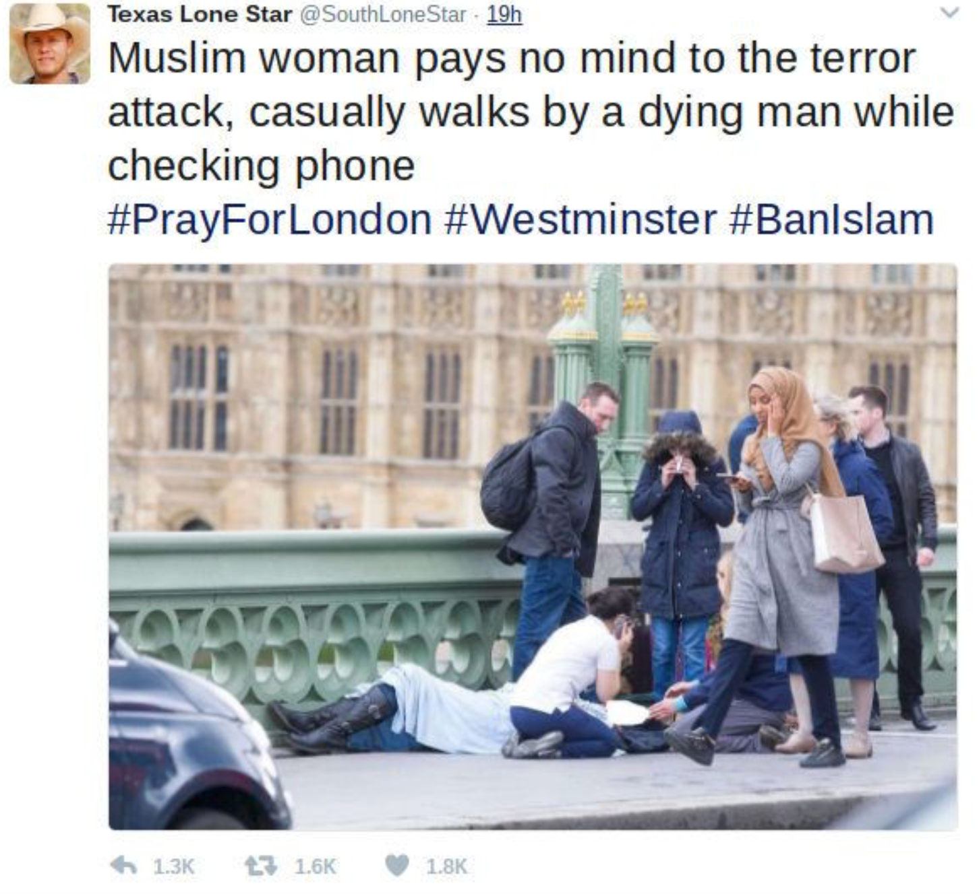
Whilst no one is denying that the photo is real, the claims that the woman was not empathetic to the attack was simply an interpretation of a single image, determined by previously established beliefs about Muslims.

Looking at the second image from Rex Images which was taken a second before the above image shows the woman captured in the picture being “visibly distressed” as she passes the victim:
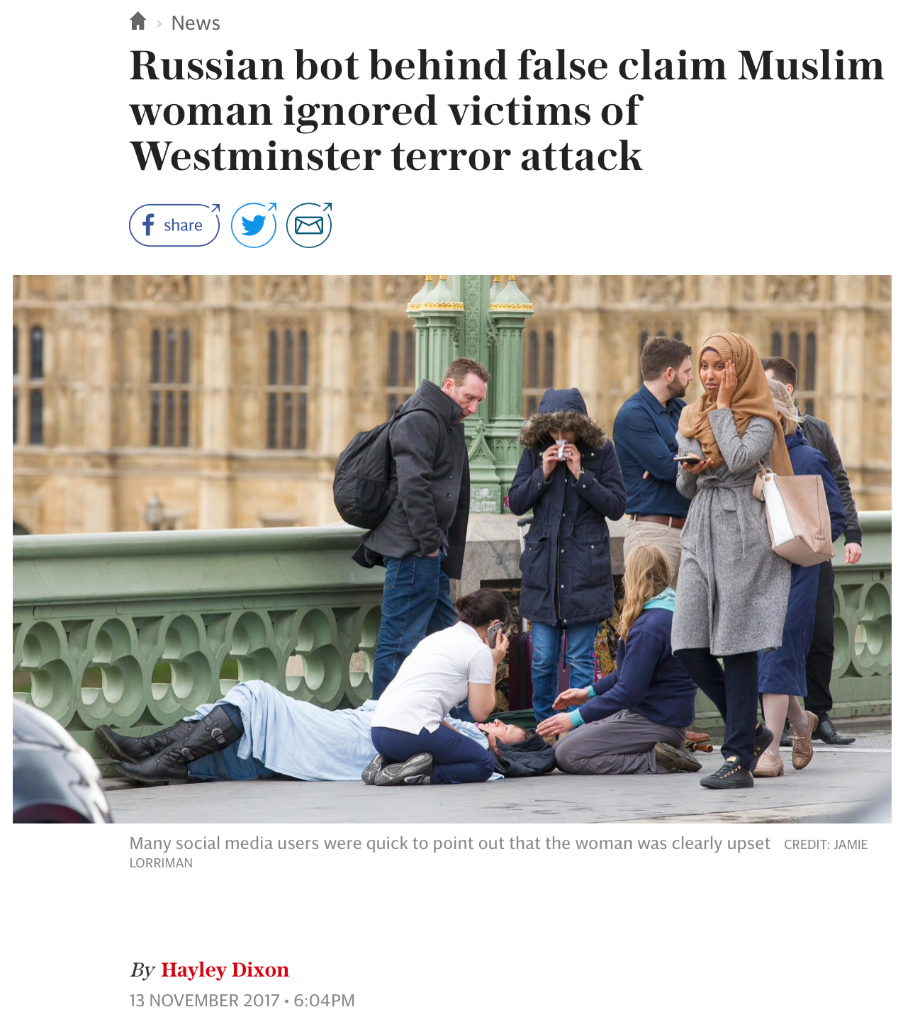
Freelance photographer Jamie Lorriman, who captured the events on the bridge said woman in reality was “distressed and horrified”.

The Guardian Researchers at the University of Edinburgh have identified over 400 accounts operating from the Russian Internet Research Agency attempting to influence UK politics, with further a statement by Ciaran Martin, Head of the UK’s National Cyber Security Centre says Russia is ‘seeking to undermine the international system’, and that ‘International order as we know it is in danger of being eroded. (Alex Hern).

A good example of how new image technologies are being subverted for ideological aims is the doctored photograph which has been has been shared thousands of times on social media Twitter, of an image of an NFL american football player burning the American flag in a locker room, whilst his teammates and coach enthusiastically cheer him on, whilst in reality the original image had no flag, and the player was doing a victory dance after a hard fought match.
Meanwhile Conservative social media accounts are sharing the viral image and accusing NFL players of disrespect
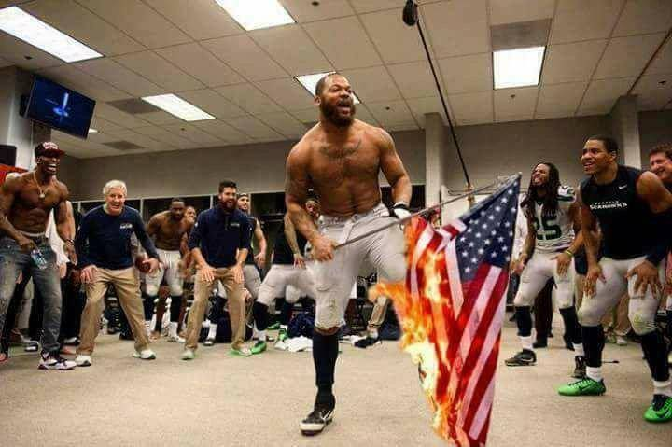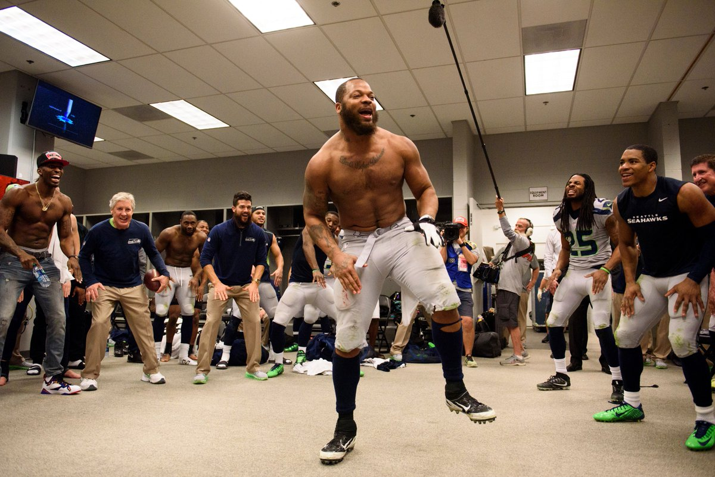
Photoshopped image depicting Bennett What do you do in the victory locker room? You
burning the American flag, September 2017 victory dance 5:52 pm - 3 Jan 2016
While most of the scene in the image is real, the flame has been superimposed on the original photo which was shared from the American football team's official Twitter account in January ₂₀₁₆.

Technically this action isn’t classed as “Fake News’ but as a meme, but still
Conservative social media accounts shared the Photoshopped image and used it to accuse the athletes of disrespect and argue they should be sacked. But should there be a reciprocal law where people deliberately incite racial hatred and diversity by the deliberate manipulation of images that they should be accountable for their actions.

The authenticity of an image is paramount, since once this is threatened then its historical importance no longer carries the authority it possesses as an object of truth.
On studying the top twenty ‘fake news’ stories regarding the 2016 Clinton /Trump Presidential election, an analysis by Buzzfeed an American Internet media company based in New York, received more hits i.e. interest on Facebook than the top 20 news stories on the election from 19 major media outlets. Paul Callan, a reporter for CNN News says it is far harder to prosecute sites and sources of fake news, because of the laws of libel in the US and that under existing law such lawsuits are practically impossible, and because of this the relevance of fake news has increased in post-truth politics.

Chapter Four
But what does it mean to look at photographs of violence and suffering? Are we creating a situation to justify the act of violence, and does that mean that looking at them is it voyeuristic, exploitative or even pornographic?
By looking at them we at least acknowledge the suffering they have endured as it is almost impossible to let them know how we truly feel.

Alternatively if we refused to look at the images are we just ignoring the fact that an atrocity has occurred, and letting the world know that we don’t care or by refusing to do so are we demonstrating a means of respect for the victim?

And finally if we censored all visual recordings of acts of violence and suffering would the world be a better place if it was an imageless one?

Mirazon Lahr of the Smithsonian Institute in the US talks about the earliest recorded act of barbarism, and possibly warfare, which is of a group of African hunter gatherers in Nataruk, Kenya, approximately 10,000 years ago where they had their skulls crushed and their bodies had suffered from multiple projectile points. Whilst at that time there are no recorded settled human societies this gives an indication that violence and warfare has always been an inherent part of man’s nature, and flouts the idea that warfare is more associated with sedentary societies and the control of resources.

Photography has often being charged with being pornographic, not only for the act of recording acts of sexual desire or of fetish and fantasy, but for dwelling on the suffering and degradation of others. Whilst it is easy to pigeon hole photography as (sexual) porn or war porn, it can be said that the sexual pornography is the recording of something between two individuals which should be kept private, whereas as war porn is the recording of something which should not be private, but is a statement of an act of wrongdoing for all to see.

The Walter Benjamin quote from the Task of the Translator of ‘There is no document of civilization which is not at the same time a document of barbarism’ seems apt.

James Nachtway vision of the world is maybe influencing what images are becoming acceptable on the internet, or maybe he is ahead of the curve in reacting to what is being displayed. People have described him as a ‘grim reaper’ or as a ‘sniper’, but his work makes you address issues you wouldn’t out of choice

What is wrong with bringing the atrocities of war, and images of starvation to the worlds attention? Each and every image of barbarism and suffering is telling this event has happened, and we or someone should have prevented it from happening.
It is a statement that we have failed in our duty of care for a fellow human being, and its practice must stop.
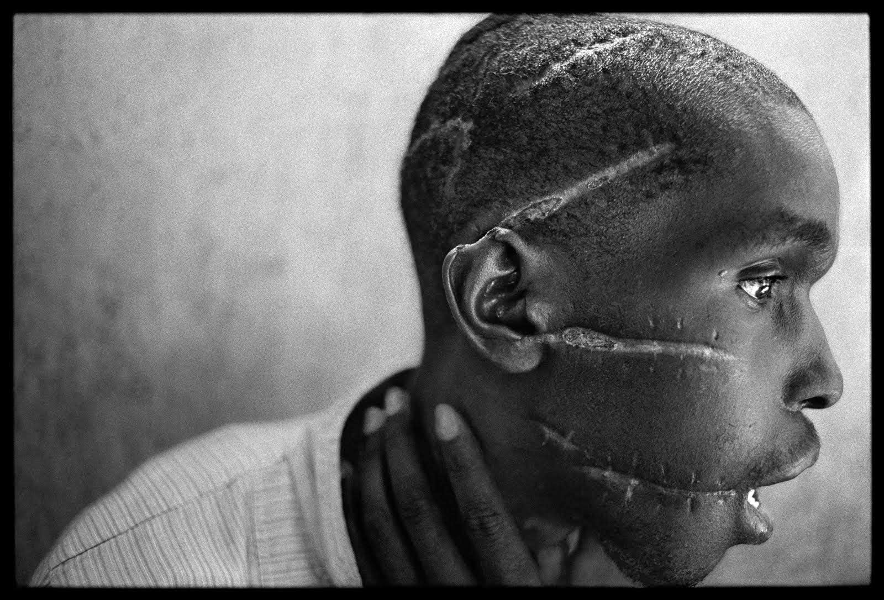 James Nachtway – Rwanda 1994

Conclusion
I asked at the beginning of this dissertation that does the diet of violent images we are being fed via the media of newspapers and film affect our wellbeing as individuals, both morally and psychologically, and should this exposure be controlled?

There is no doubt that our behaviour with social media and the internet is a symbiotic relationship, where we both need each other, and feed off the emerging technologies in ways we never envisaged even a few years ago. It is worrying that somebody deeply involved in its creation is advising us to walk away from it to prevent us from becoming more and more isolated, living in a state of fragmented concentration, and less productive as a human being..

There is a definite trend that people who have more exposure to social media are more deeply hooked on it, especially when a basic tenet of a social platform is to enhance the short term dopamine being delivered to their brain.

Social Media must be viewed objectively that it is not essential for it to exist for mankind to communicate, let alone survive. It is basically a source of entertainment that has an inbuilt trait of trying to make itself addictive to its user, with a side effect of reduction in civil discourse with others, less co-operation and collaboration, and a constant flow of misinformation and mistruth. The psychological damage of viewing distressing and violent images to the general public is hard to assess, as not enough research has been carried out. The effects of PTSD on the armed forces, and the essential services are well documented, so it would be naïve to dismiss the accumulated effect on Journalists, would not be have a lesser effect on prolific social media users.

The internet was set up to be used as a utility to find essential and necessary information for us, and to help us communicate efficiently, but somehow things have flipped where the internet is using actually using us to justify its own existence.

As a photographer we hope to explore the envelope of human experience to show others what is happening in the world, or how we see the world, and to get some form of validation in what we do.

We should not censor the images we put on the internet as we would be just burying our head in the sand. The world would still be going on, and we would back in Plato’s Cave. But we should be aware of how we are being controlled by either the state or by people who are using social media to influence us and learn to read between the lines, by questioning the facts and images we are being bombarded with every second of the day and not just accept them at face value.

You could consider that the problem is that the existing system of news paper media had reliable tried and tested methods for revbiewing sources of information. With the newer technology of social media it is not that it is a less reliable source of information which is supplying false truths, butit is that the newer and less reliable sources of information are less likely to want to conform to engage public scrutiny, especially if they are being eloquent with the truth.

I will leave the last comment to John Berger, who was expanding the discourse on Walter Benjamin’s essay of cultural criticism The Work of Art in the Age of Mechanical Reproduction and the effect of photography on art, just as the internet and social media is having an effect in regards to post truth politics:

“For the first time ever, images of art have become ephemeral, ubiquitous, insubstantial, available, valueless, free, for lacking the aura of the original work of art”. (pp. 32–34).

Bibliography

Barthes, Roland (1984) Camera Lucida, New York: Hill and Wang, republished in London by Vantage, 2000

Benjamin, Walter (1940) Theses on the Philosophy of History

Benjamin, Walter (1968). Hannah Arendt, ed. “The Work of Art in the Age of Mechanical Reproduction”, Illuminations. London: Fontana.

Berger, John. (1972) Ways of Seeing. London : Penguin Books.

Berger, John and Mohr, Jean (1982) Another Way of Telling: A Possible Theory of Photography, New York: Bloomsbury

Crary, Jonathan (New Ed edition (8 April 1992) Techniques of the Observer - On vision and modernity on the nineteenth century, Massachusssets: MIT Press

Eco, Umberto (1986) Travels in hyper reality: essays. San Diego: Harcourt Brace Jovanovich

Faas, Horst and Fulton, Marianne(1972) “Napalm Girl. How the Picture Reached the World". Retrieved 2007-06-02. New York: Associated Press

Hall, Stuart (1992) The West and the Rest: Discourse and Power, Cambridge: Polity Press in association with Blackwell and the Open University

Lechte, John ( 1994) Fifty Key Contemporary Thinkers.From Structuralism to Post Modernity, London and New York: Routledge

Linfield, Susie ( 2010) The Cruel Radiance : Photography and Political Violence. Chicago and London: The University of Chicago Press Ltd.

Rancieres, Jacques (2003) Dissensus: On Politics and Aesthetics
London: Continuum

Von Clausewitz, Carl (1993) On War: New York: Random House USA Inc.

Wells, Liz (2nd edition, 2000) Photography: A Critical Introduction, London: Routledge

Wombell, Paul (ed.)(1991) PhotoVideo: Photography in the Age of the Computer, London: RiverOram Press

Internet References

Robert Booth, Matthew Weaver, Alex Hern and Shaun Walker in Moscow
https://www.theguardian.com/world/2017/nov/14/how-400-russia-run-fake-accounts-posted-bogus-brexit-tweets
Tuesday 14 November 2017 20.52 GM Accessed 15/11/17 13.43

Callan , Paul. "Sue over fake news? Not so fast". CNN. Retrieved January 15, 2017
http://edition.cnn.com/2016/12/05/opinions/suing-fake-news-not-so-fast-callan/index.html
Accessed 13/12/1706:30.

Hilary Clinton Conspiracies
http://www.theweek.co.uk/us-election-2016/78433/weirdest-hillary-clinton-conspiracy-theories
Accessed 12/12/2017 22.35

Chang, Juju; Lefferman, Jake; Pedersen, Claire; Martz, Geoff (November 29, 2016). "When Fake News Stories Make Real News Headlines". Nightline.
http://abcnews.go.com/Technology/fake-news-stories-make-real-news-headlines/story?id=43845383
Accessed 13/12/17 06:00

Dixon, Hayley – theguardian.com ,
http://www.telegraph.co.uk/news/2017/11/13/russian-bot-behind-false-claim-muslim-woman-ignored-victims/
Accessed 14/11/17 18:42

Huffington Post 28/05/15 18:59 BST
http://www.huffingtonpost.co.uk/entry/secondhand-trauma-journalists_n_7305992
Accessed 13/12/17 07:00

Lorriman, Jaimie – REX Shutterstock
http://www.news.com.au/technology/online/social/what-was-really-going-on-when-this-photo-was-taken/news-story/c0e04f739dfd1312acd241cc770f4e07
Accessed 14/11/17 18:51

Marr, Rod – Seattle Seahawks’https://www.wired.com/story/that-flag-burning-nfl-photo-isnt-fake-news-its-a-meme/Saturday 30 September 2017 12:26 BST.
Accessed 15/11/17 13.12

Mladen Antonov: Getty Images.
http://www.gettyimages.co.uk/detail/news-photo/woman-speaks-on-a-mobile-phone-as-she-walks-past-a-graffiti-news-photo/875291168#woman-speaks-on-a-mobile-phone-as-she-walks-past-a-graffiti-covered-picture-id875291168
Accessed 07/12/2017 19.56

Moore, Jack (2017) Newsweek ISIS on the web 07/06/2017
http://www.newsweek.com/authors/jack-moore?page=7&wptouch_preview_theme=enabled
Accessed 09/12/17 21:28

Nachtway, James at TED 2007
https://www.ted.com/talks/james_nachtwey_s_searing_pictures_of_war
Accessed 07/12/17 21:00

Netflix a CIA Conspiracy
http://www.theweek.co.uk/73902/netflix-is-a-cia-conspiracy-claims-kremlin
Accessed 12/12/2017 22.15

Saeed, Saim, 7/4/17, 8:36 AM CET
https://www.politico.eu/article/eu-anti-terror-chief-warns-of-virtual-caliphate/
Accessed 11/12/2017 16:00

Stockton, Richard - November 20, 2017
http://all-that-is-interesting.com/napalm-girl
Accessed 10/12/2017 11:00

Unknown Photographer Ritual beheading, Location and Date unknown https://qph.ec.quoracdn.net/main-qimg-1f6058629a97689cd000a045150c3062-c?convert_to_webp=true
Accessed 15/11/2017 14:20

Ut, Nick – AP Images
http://all-that-is-interesting.com/napalm-girl
Accessed 20/11/2017, 21:12

Nick Ut – AP Images
http://digitaljournalist.org/issue0008/ng4.htm
Accessed 9/12/2017, 23:58

Vincent, James. The Verge Dec 11, 2017, 6:07am EST
https://www.theverge.com/2017/12/11/16761016/former-facebook-exec-ripping-apart-society
Accessed 13/12/17 01:55

