Tutor: SUJEEWA HERATH
student: Daniel G. Rosales
DATE:11/11/2022

Project Management Plan

managing projects in the workplace
BMSW5014
Table of Contents
Introduction 2
Elements of the project management plan 2
Definition of project 2
Project group and organization 4
Project planning, arrangement, and control 5
The Work Breakdown Structure 5
The Critical Path Method (CPM) 6
Program Evaluation Review Technique (PERT) 6
Higher management examination and control 6
Gantt chart 7
The Causes and Scope of WBS 8
Stakeholder analysis 9
Identify stakeholder 9
Scope of a stakeholder grid 10
Risk Assessment 12
Conclusion 13
References 14

Introduction
Project management is the tool of categorizing and supervising resources in such a way that the project is accomplished within described scope, duration, cost, and quality restrictions. A project is a momentary venture carries out to create an exclusive goods or service launch. The report will focus on the usefulness of tools and techniques of project management for achieving desirable project objectives. This report demonstrates the understanding of essentials of the venture management map by taking the example of a pharmaceutical project. This project aims for a successful launch of the multivitamin brand by company XYZ.
Managers face many challenges while performing project management for launching a new product or service. There are two major challenges of project management; the first one is to take care that a project is completed inside prescribed restrictions. The second is a more determined challenge which is the optimized distribution and assimilation of inputs to achieve pre-defined goals. A venture is a vigilantly clear set of actions that use people, finance, materials, space, power, provisions, and communication to achieve specified goals.

Elements of the project management plan
A project management plan for launching a new product of a pharmaceutical company includes five elements
- Defining the project
- Project group and association
- Venture planning, arrangement, and control
- solving problems and making decisions
- higher management assessment and control

Definition of project
The Project manager makes the project management plan after the inputs received from the project group and the important stakeholders (Heagney, 2016). A Project management plan is an official, permitted document that identifies how a project will be executed, controlled, and controlled. The plan may be in form of a summary or a featured document and include baselines, stakeholder analysis, work breakdown structure, auxiliary management plans, and other related documents. This deed is used to describe the process; the project group takes to carry out the aimed project management scope of the project.
This initial component of a project management outline is used to describe the capacity and objectives of the project. It sketch out what is inside as well as what is outside of the project limits including the company’s problem and market want, and the types of equipment to be accustomed to resolve that big business problem (Walker, 2015). Project aims describe goal status at the closing stages of the project, accomplishment which is measured as essential for the attainment of intended profit. The pharmaceutical company XYZ is planning to launch a new brand of multivitamins into the market. The company had tried to achieve its target by launching new products in the past but did not get success. So it’s very important to set clear scope and objectives this time, the main focus of this project management plan is to gain traction with new customers, hospitals, and stores. This can be achieved by developing the goods and then induction it in the marketplace within the given constraints.
In Pharma, business goals are depending on some items such as management, supply chain, patent, and parallel duration & expenses. Management should try to focus on improving supply chain management for a smooth flow of multivitamins products in the market (Sharonand Dori, 2017). The supply chain should help in filling the gap between market supply and demand. The supply chain division will supply unrefined materials essential for the progress of the multivitamin product through vigorous and recipient sourcing. The development department develops new brand’s multivitamin products through analytical and clinical study being in the pharmacy Industry Company XYZ needs to register its product before launching with the respective department. Company XYZ needed to patent its new brand products for business purposes and to create brand dominance. This plan also takes care of all the stakeholders of the multivitamin brand to be successful in this product category.

Project group and organization
A project panel is a tiny quantity of persons with harmonizing skills, who are dedicated towards a general intention, quality in performance, and methods for which they are jointly responsible. A project panel may be separated into two components that are core group and the support group. First group persons belong to diverse functions of the companies who have important power & accountability in the company. They have every skills including technical & management skills which are required to perform various activities in the new brand launch (Mazlumand, 2015). Support group members belong to diverse functions, an associate of the core group can be a manager of the support group.
In the team of project management, each person has a particular work. To manage the new launch proficiently, all members are required to have precise accountability & proper power to perform the assigned task (Connor, et.al, 2018). The project panel must have a diagram that envisages wherever each team member is positioned in the system of the project. It indicate importance of group affiliates and other associations .every associate-
• Make sure functional skill required for the project
• characterize a functional point of view on the project
• Make certain that the functional results are achieved
• Practically elevate functional problems that impact the project team.
A Skills Matrix can be used to display people's ability in particular ability and knowledge, with their interest in performing task by using specified expertise and knowledge

Project planning, arrangement, and control
There are many different methods available for planning of project management like Work Breakdown Structure (WBS), Project Evaluation, and Review Technique (PERT) and Critical Path method.
The Work Breakdown Structure - A work breakdown structure (WBS) is a project management technique that involves a series of steps to complete big assignment with various moving sections. By dividing the assignment into smaller tasks, a WBS combine cost, range, and desired result into one tool (Jaberidoost, et.al, 2015). The WBS might be product, hardware, process oriented. In a project of launching a new product, the work down structure is created by beginning with goals and sequentially dividing it into a convenient task in conditions of duration, amount, and accountability. The chart below explains the steps involve while launching the new product through the work break down structure.

The Critical Path Method (CPM) is an investigation tool accustomed to forecast assignment duration by studying which order of actions or path is best in terms of lowest amount of float and flexibility. The critical path finds out the most primitive way of completing the assignment (Schuhmacher, et.al, 2021).CPM helps in discovering the best timeline of task involved in the project and also identifying dependency of task on one another.
Program Evaluation Review Technique (PERT) is the most used project management planning technique; it is used to determine the total time required to practically complete a assignment. PERT involves charts and this are used to map tasks inside a project to make scheduling easy as well as coordination among team members. The main difference between CPM and PERT is the CPM depended on a single approximation for the time of a task, while PERT considers two approximations. These are worst-case and best-case approximations.

Higher management examination and control
Top management grants the support and money for the growth of multivitamins products in XYZ pharmaceutical company. Top-level manager needs are involved in the business's new project strategy and growth, the risks and issues involved in the project, and the position of the project (Vogler, et.al 2017). This communication is essential the whole time of a project mainly at the beginning of the project.
Project evaluations with top management are an important component of the new product launch process. A hierarchy of reviews is essential for a well-timed and continual flow of project status and issues-related information. Senior management at company XYZ should be involved in these reviews process to secure that the multivitamin product launch achieves desired sales target and product launch meet the overall goals. Top management examination should evaluate:
• The big business problems and aims of the assignment
• Problems related to the consumers’ needs and expectation
• Management of resources
• Corporate and business unit director and product line fit
• Sales target and reimbursement potential
• Schedule of project
• Time to launch
• Technology for meeting quality and expense goals of multivitamins

Gantt chart

The basic Gantt chart shows the duration, start, and completion of activities on a horizontal bar. This tool presents a graphical analog of the activity length and reflects relationship between activities and time duration. A baseline plan is made in the form of a Gantt chart schedule. After the establishment of a Gantt schedule for assignment, development must be designed alongside the baseline timetable periodically (Chung and Crawford, 2016). If diverse functional regions are engaged in assignment, every region may require detailed timetable to completion the project prime schedule.

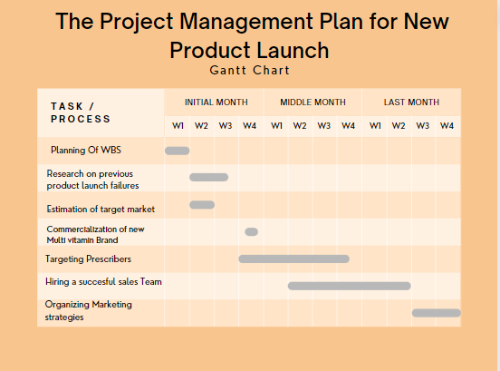
Figure 1 Gantt chart for project management plan

The Causes and Scope of WBS
Pharmaceutical company’s projects consist of diverse stages, technology shift procedures, and target and concerns related to solving problems. For the company, XYZ's main problem is in gaining traction with new consumers, hospitals, and stores.
The above Gantt chart is made for the project management plan for multivitamin product launch of XYZ pharmaceutical company. This is designed to achieve project management goals related to sales and other aspects. After creating WBS, proper research on previous launch will be done and to figure out why company failed to achieve its target. This is going to be help the company to avoid the mistake done previously, in which research will be complete at the end of 3rd week. Managers will work with cross-functional teams such as medicinal affairs, learning and development team, R & D team. For this purpose meetings will be conducted, scientific symposia will be prepared to make sure that brand is visible to the target audience section of the pharmacy company, which are healthcare certifiers and hospitals.
According to decided timeline this task will run simultaneously with research of previous launch. Week 4 commercialization of new product will be done with the target of increasing sales, attracting more consumers, etc. This consists of forecasting of product, pipeline strategy for new multivitamin product, and launch strategy and new plans for product growth strategy. In the meantime, the task will follow up with targeting prescribers, this is most important task because prescribers are the main stakeholder of a pharmaceutical company which can help more sales. Next task will be hiring a good sales team and this task will be completed by end of middle month, it involves Providing training, clearing path to the field, sales team to make sure that they are well prepared with technical and communication knowledge and skills. Last task is organizing marketing strategy, marketing is important it increase brand awareness of multivitamin in the market. This involves Developing brand plans for the range of product, market penetration strategy, research of market with analyses of competition.

Stakeholder analysis

Identify stakeholder
Stakeholder analysis is very important for a successful product launch in every Industry including the pharmaceutical industry. The main stakeholder of pharmaceutical companies like XYZ Company are the patients, they are the final consumer of multivitamins products. But this industry's organizations are forming relationships with new stakeholders such as doctors, retailers, and stockiest. Doctors prescribe multivitamins and other medicines of the specific company while the retailer and the stockiest a key part of the supply chain of the company (Ometlic, 2017). They can give a boost to the sale of multivitamins by communicating the information to the doctors and recommending company XYZ’s new multivitamin brand as a substitute for a few prescriptions.
The actual stakeholder of pharmaceutical organizations can be segregated into prescribers and non-prescribers. The prescriber's group of stakeholders mostly consists of general practitioners and specialists. The other stakeholder group includes those parties which do not write a prescription but have an indirect influence on the process of prescription. The pharmaceutical market is different from m traditional consumer goods market, in this market buyer, consumer, and decision market are not the same. Doctors who are prescribing the medicines are the decision maker and the health insurance funds are payers by performing reimburses. The stakeholder of XYZ pharmaceutical consists of pharmacists, patients, healthcare policymaker, health insurance fund, and pharmaceutical wholesaler. There are three main consumer categories for XYZ pharmaceutical company; these three categories are patients, payers, and physicians (Jandhyala, 2021).
This stakeholder analysis of XYZ pharmaceutical company says that the company needs to put sales efforts towards the three consumer groups, first one is physicians, second are hospitals, pharmacies, and wholesalers. The third one is patients, the end consumers of multivitamins.

Scope of a stakeholder grid
A stakeholder grid is a project management tool for analyzing the stakeholders of the project. The list of people and organizations that affect XYZ pharmaceutical company has the power to influence the company's new multivitamin brand launch. Understanding and prioritizing the power of stakeholders. Stakeholder's Power-Interest grid is useful (Worsley, 2022). By plotting stakeholders on this grid, a company can identify the power and interest of stakeholders in the new launch. With the help of the Power Grid Company can determine high-low power stakeholders which affect the company's new multivitamin launch.

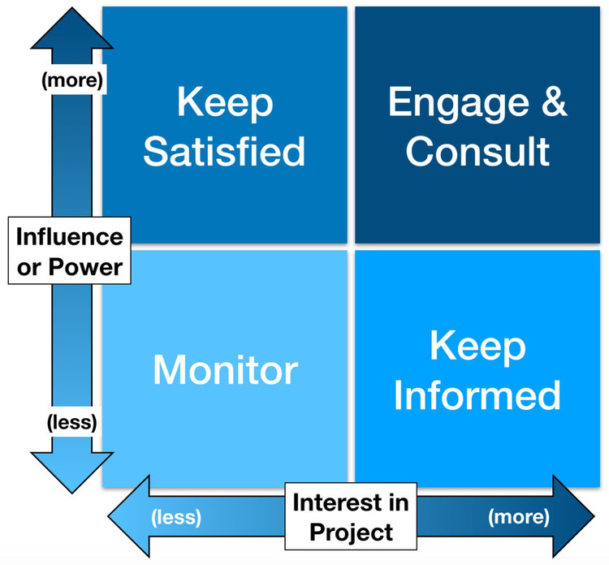
Figure2 Stakeholder's Grid
(Source: Guthrie, 2021)

The above figure clarifies the diverse approach a company should have for the divided stakeholders.
- High power - High interest: the stakeholders who are decision-takers and have the largest influence on the project accomplishment therefore a company must intensely manage their hopes (Paterek, 2019). In the case of XYZ pharmaceutical, physicians and prescribers’ group of stakeholders consist part of this segment.
- High power - Low Interest: the stakeholder needed to be kept in the circle; these stakeholders need to be satisfied even though they aren’t concerned because they have power. These kinds of stakeholders should be handled with caution because they have the power to influence the success of the project.
- Low Power – High interest: keep these stakeholders effectively informed, and continuously communicate with them to make sure that no main issues are arising. This segment of stakeholders can be very helpful with the detail for a new launch. In the case of XYZ pharmaceutical company retailers and the stockiest is the part of this segment (Glukhov,Ilinand Levina, 2015).
- Low power - low interest: monitor this segment of stakeholders but do not tire them with too much information.

Risk Assessment
Risk assessment is an important part of a project management plan for launching a new pharmaceutical product like multivitamins. Risks related to the launch should be identified, evaluate and deal with accordingly. Research assessment helps in assessing organizations' risk associated before launching and re-launching products and services. At least 25 percent of total income and earnings across the pharma industry comes from the launch of new products like the multivitamin brand, so commence of a new product is vital to XYZ organization (Siami-Irdemoosa, Dindarloo and Sharifzadeh, 2015). Even though the organization has a brilliant product still this will not ensure the success of the product and is reliant on several factors such as:
- Targeting the right audience
- The selling objective of the product and consumers' needs should match.
- The organization needs to position products properly in the marketplace.
- Product prices are on point.
In the case of company XYZ, the target audience can be every age group of people for its new multivitamin brand. Nowadays everyone is getting more conscious about their health and vitamin intake, so the company needs to attract every generation of consumers. As the last launch was not successful the company needs to find out the gap between the product objectives and the consumer's needs to make the new launch successful (Al-Kasasbeh, Abudayyeh and Liu, 2021). XYZ organization should get feedback from the consumers and make changes accordingly.
They are four ways to deal with the risk involved in the launch of a multivitamins brand:
- Accept: accept the chances of a pessimistic impact
- Avoid: acclimatize plans to evade the problem
- Mitigate: decrease the impact by execution of actions
- Transfer: subcontract the risk to a third party that is an expert in managing the outcome

Conclusion

In the research project, the project management of a pharma company is discussed while focusing on assignment planning and assessment. The 1950s is noticeable as the start of the current project management period. In the 1950s, the Gantt chart and work breakdown structure are included in the project management structure. Project management within the pharmaceutical ground play’s important role in conveying groups together, integrating solutions across functions, and providing a generalist view of projects to balance the more scientific/technical perspective.

References

Heagney, J., 2016. Fundamentals of project management. Amacom.
Walker, A., 2015. Project management in construction. John Wiley &amp; Sons.
Sharon, A. and Dori, D., 2017. Model‐Based Project‐Product Lifecycle Management and Gantt
Chart Models: A Comparative Study. Systems engineering, 20(5), pp.447-466.
Mazlum, M. and Güneri, A.F., 2015. CPM, PERT and project management with fuzzy logic
technique and implementation on a business. Procedia-Social and Behavioral Sciences, 210,
pp.348-357.
Connor, P.M., Axon, C.J., Xenias, D. and Balta-Ozkan, N., 2018. Sources of risk and uncertainty
in UK smart grid deployment: An expert stakeholder analysis. Energy, 161, pp.1-9.
Jaberidoost, M., Olfat, L., Hosseini, A., Kebriaeezadeh, A., Abdollahi, M., Alaeddini, M. and
Dinarvand, R., 2015. Pharmaceutical supply chain risk assessment in Iran using analytic
hierarchy process (AHP) and simple additive weighting (SAW) methods. Journal of
pharmaceutical policy and practice, 8(1), pp.1-10.
Schuhmacher, A., Brieke, C., Gassmann, O., Hinder, M. and Hartl, D., 2021. Systematic risk
identification and assessment using a new risk map in pharmaceutical R&amp;D. Drug discovery
today, 26(12), pp.2786-2793.
Chung, K.S.K. and Crawford, L., 2016. The role of social networks theory and methodology for
project stakeholder management. Procedia-Social and Behavioral Sciences, 226, pp.372-380.
Vogler, D., Macey, S. and Sigouin, A., 2017. Stakeholder analysis in environmental and
conservation planning. Lessons in conservation, 7(7), pp.5-16.
Worsley, L., 2022. Stakeholder-led business case development.
Jandhyala, R., 2021. The multiple stakeholder approach to real-world evidence (RWE)
generation: observing multidisciplinary expert consensus on quality indicators of rare disease
patient registries (RDRs). Current Medical Research and Opinion, 37(7), pp.1249-1257.
Ometlic, D., 2017. The importance of interviewing CEOs and higher management when writing
case studies.
Paterek, P., 2019. Agile transformation changes from the perspective of project team values.
Glukhov, V.V., Ilin, I.V. and Levina, A.I., 2015. Project management team structure for internet
providing companies. In Internet of Things, Smart Spaces, and Next Generation Networks and
Systems (pp. 543-553). Springer, Cham.
Schachel, H., Lachmann, M., Endenich, C. and Breucker, O., 2021. The importance of
management control systems for startup funding–empirical evidence from external
financiers. Journal of Accounting &amp; Organizational Change.
Siami-Irdemoosa, E., Dindarloo, S.R. and Sharifzadeh, M., 2015. Work breakdown structure
(WBS) development for underground construction. Automation in construction, 58, pp.85-94.
Al-Kasasbeh, M., Abudayyeh, O. and Liu, H., 2021. An integrated decision support system for
building asset management based on BIM and Work Breakdown Structure. Journal of Building
Engineering, 34, p.101959.
Guthrie, G. (2021) Manage your stakeholders like a pro with a power/interest grid, Nulab. Available at: https://nulab.com/learn/strategy-and-planning/manage-your-stakeholders-like-a-pro-with-a-power-interest-grid/ (Accessed: November 1, 2022).

