  PROfessional CAREER DEVELOPMENT  BMSW4005_LON | STUDENT ID: 2128948  Student name: janina-eveline oros  LECTURER: Husam Helmi Alharahseh

Table of Contents
Introduction 3
Reflection on role play 4
Interviewer perspective 4
Interviewee perspective 4
Self-evaluation review 5
Personal development planning 6
SWOT analysis 6
SMART objectives 6
My understanding 7
Career ambition and aspiration 8
Personal development plan 8
Conclusion 10
References 11
Appendices 12
Questions and answer 12
Job application form 14


Introduction

When I look back on my life, I can see how my time at the University of Wales have influenced who I am today.
My time at the University of Wales was innovative in many ways. I was encouraged to exercise my analytical and imaginative skills while learning from some of the greatest lecturers in my field of study. Furthermore, I had the chance to form enduring connections with other students who shared my passion for development and education (Zwozdiak-Myers, 2018). These experiences allowed me to develop a strong base of skills and knowledge that I still practise today. I was able to gain valuable skills in communication, project management, and problem-solving from these experiences. They encouraged me to work with different kinds of people and adapting to new circumstances. These experiences gave me a reason to become very interested in digital marketing. I found that I was drawn to work at the intersection of technology and marketing.
They not only gave me the knowledge and abilities I need to succeed in my future career, as a digital marketing professional, but they also inspired me to dedicate myself to lifelong development and education.
In the end, I believe that my experience at the University of Wales as well as the various jobs I've worked have helped me develop into a competent and all-around professional (York-Barr et al., 2016). They helped me develop a love for lifelong learning and growth in addition to providing me with the knowledge and abilities I need to succeed in my current role as a digital marketing professional.


Reflection on role play

Interviewer perspective

My role-playing as an interviewer for the senior digital marketing skilled position was interesting and instructive for me. The most essential lesson I learned from this role-playing exercise was the need of asking open-ended questions to give interviewees the opportunity to speak on their expertise and skills. The person doing the interview must have a thorough understanding of the specific job requirements and the ability to formulate questions that offer a precise evaluation of the candidate's capacity to meet those criteria (Mann and Walsh, 2017).

One of the challenges of doing a role play is the potential for the candidate to perform worse in the simulated scenario than they would in the real thing. This might be due to anxiety, a lack of experience with this situation, or another factor. This must be known, and instead of focusing too much attention on any one specific example, look for general patterns in the candidates reacts.

One of the most crucial lessons I learned from the role play was the value of paying close consideration when communicating to the candidate. Understanding the candidate's body language, tone of voice, and other nonverbal signals during an interview is helpful for getting a better understanding of their past experiences and skills.

Interviewee perspective

Participating in a role-play in which I was applying for the position of senior digital marketing expert was an interesting challenge for me. The most important thing I learned from this role play was the value of being well-prepared and having trust in their knowledge and abilities (Amzat and Padilla-Valdez, 2017).

For me to be given a chance at the position, I must be able demonstrate how my skills and experience match the specific needs of the job.

While the role play had no time limit, one of the challenges was attempting to understand the specific situation and the goals.

However, I found that spending a minute to discuss any questions or issues with the interviewer may help to better understand the problem and give solutions that are more specific. It is important to show that you have excellent communication skills, especially regarding the way you express knowledge to the interviewer and in terms of your capacity to take the interviewer's comments in part.

In general, the Senior Digital Marketing Specialist role play was helpful for providing information about the skills and attributes necessary to succeed in this role. I found that spending a minute with the interviewer to clear up any doubts or confusion might help me better understand the situation and provide solutions that are more specific.

Self-evaluation review
People must regularly evaluate themself to be able to think about their personal and professional growth. I'm very self-motivated when it comes to choosing a career path. I've always known that I want to work in marketing, so I've made efforts so that I'm moving in the correct direction. I am also persistent in looking for professional.

opportunities that meet my career objectives, such as voluntary work and scholarships in sectors related to marketing.
I've found that practical, visual learning is the way I learn fastest. For instance, I like using mental pictures along with other visual organisers to simplify complicated ideas. I have worked very hard to develop a strong work ethic and to always act professionally. Furthermore, I look for feedback and helpful critique to improve my work and improve the direction of my career. It's helped me to realise that visual and hands-on learning are my favourites. I find that I retain information best when I apply it to my own experiences and when I use visual aids like charts, graphs, and movies (Zwozdiak-Myers, 2018).
In conclusion, self-evaluation is an important process that allows people to think about their personal and professional progress. I've learned that I have a strong sense of improve regarding my profession, that I learn better visually and experientially, and that I never fail to conduct myself properly (York-Barr et al., 2016). Periodic self-evaluation has helped me identify issues that still need work, such as improving my time management skills and seeking out new learning opportunities.

Personal development planning

SWOT analysis
Strengths | Weaknesses | Opportunities | Threats
Excellent communication skills | Tendency to procrastinate | Growing demand for digital marketing expertise | Intense competition in the industry
Attention to detail | Lack of experience in certain areas | Increasing use of social media for marketing | Constantly changing technology and platforms
Creative problem-solving | Limited knowledge of data analytics | Potential for career advancement | Economic downturns affecting marketing budgets

SMART objectives
Objective | Specific | Measurable | Achievable | Relevant | Time-bound
Develop expertise in SEO | Yes | Yes | Yes | Yes | Within 6 months
Increase email open rates | Yes | Yes | Yes | Yes | Within 3 months
Create and implement a successful social media advertising campaign | Yes | Yes | Yes | Yes | Within 9 months
Attend at least two industry conferences or events to expand your knowledge and network | Yes | Yes | Yes | Yes | Within 12 months

The completion of a personal SWOT analysis and the development of SMART objectives have all proven to be extremely beneficial exercises in the process of planning for my future career in marketing (Mann and Walsh, 2017). By doing a SWOT analysis, I was able to identify my marketing business's potential, threats, and strengths as well as imperfections. I was able to concentrate on developing skills like data analytics and digital marketing that would improve my edge in the job market because of my efforts. The SMART targets I developed will help me stay on track to achieving my long-term goals since they are specific, measurable, achievable, relevant, and period-bound. By setting targets for SEO, email marketing, social media advertising, and business events, I am certain that I am moving closer to achieving my objectives.

My understanding

I have certain assumptions and understandings about what the world of work in this field will involve because I'm interested in pursuing a career in marketing (Fourali, 2019). I plan to continue my formal studies and training to gain more and extend my knowledge base. I am aware that the marketing industry is always changing, and that success depends on being current with trends and standards. I understand that effective teamwork and customer interaction are crucial for marketing professionals to reach their goals (Somers, Finch, and Birnbaum, 2010).

In addition to using my skills and expertise to make the world a better place, I wish to be happy and content in my career. I understand that the marketing sector may be challenging, but I am confident in my ability to overcome these challenges and achieve my goals. I hope to be happy and fulfilled in my profession and to be able to use my knowledge and abilities to positively influence the world. My desire to learn, grow, and have a positive impact defines both my knowledge and expectations of the marketing field. I am excited about the opportunities waiting forward and hope to develop a successful career in this area.

Career ambition and aspiration

I've always had an immense passion in the field of marketing, and I've always hoped to have a very successful career. In the next five years, I anticipate myself as a top marketing professional working for a well-known organisation on challenging projects that require both my mind and imagination (Fourali, 2019). I have faith in my ability to achieve my professional goals, and I'm working hard to become a marketer who is very productive and has a favourable influence on the company I work for.

Personal development plan
Area of Development | SMART Objective | Resources Needed | Timeline
Leadership Skills | Attend a leadership training course and apply what is learned to lead a marketing project (Somers, Finch and Birnbaum, 2010). | Budget for training, time for application | Within the next 12 months
Communication Skills | Attend a communication training course and participate in public speaking opportunities to build confidence. | Budget for training, opportunities for public speaking | Within the next 6 months
Marketing Knowledge | Enrol in a digital marketing course to gain knowledge on emerging marketing trends. | Budget for the course, time for studying | Within the next 6 months
Networking | Attend industry conferences and events to meet other professionals in the field and expand my network (Fourali, 2019). | Budget for attendance, time for attending | Within the next 12 months
Project Management | Complete a project management certification course to develop skills in managing complex marketing projects. | Budget for the course, time for studying | Within the next 18 months

I am aware that continuing personal development will be necessary if I am to achieve my career objective of working as a senior marketing expert for a trustworthy organisation (Jain, 2019). These objectives have been designated as specific areas of development. Using the table above, I have created SMART objectives that are measurable, achievable, relevant, and time bound. My career ambitions involve becoming a successful senior marketing professional, and I feel that if I pursue these growth opportunities fully, I will be better positioned to achieve those goals and succeed.

Conclusion
Reflecting on the past is essential for both personal and professional growth. I was able to identify my advantages, disadvantages, opportunities, and threats through this process. It helps me with goal setting, career planning, and self-awareness growth. I am more capable to understand who I am, my career prospects, and what I must do to achieve our goals by using a variety of models, such as SWOT analysis and SMART targets. I can get better as a person, a worker, and a member of society through reflecting.

References

Amzat and Padilla-Valdez, N. (2017). Teacher Professional Knowledge and Development for Reflective and Inclusive Practices. Taylor & Francis.
Fourali, C. (2019). Developing World-Class Social Marketing Standards: A Step in the Right Direction for a More Socially Responsible Marketing Profession. Social Marketing Quarterly, 15(2), pp.14–24.
Jain, T.K. (2019). From Marketing to Digital Marketing: The Evergreen Profession for Executives. SSRN Electronic Journal.
Mann, S. and Walsh, S. (2017). Reflective Practice in English Language Teaching. Taylor & Francis.
Somers, M.J., Finch, L. and Birnbaum, D. (2010). Marketing Nursing as a Profession: Integrated Marketing Strategies to Address the Nursing Shortage. Health Marketing Quarterly, 27(3), pp.291–306.
York-Barr, J., Sommers, W.A., Ghere, G.S., Montie, J. and Costa, A.L. (2016). Reflective practice for renewing schools: an action guide for educators. Thousand Oaks, California: Corwin.
Zwozdiak-Myers, P. (2018). The Teacher’s Reflective Practice Handbook. Routledge.

Appendixes
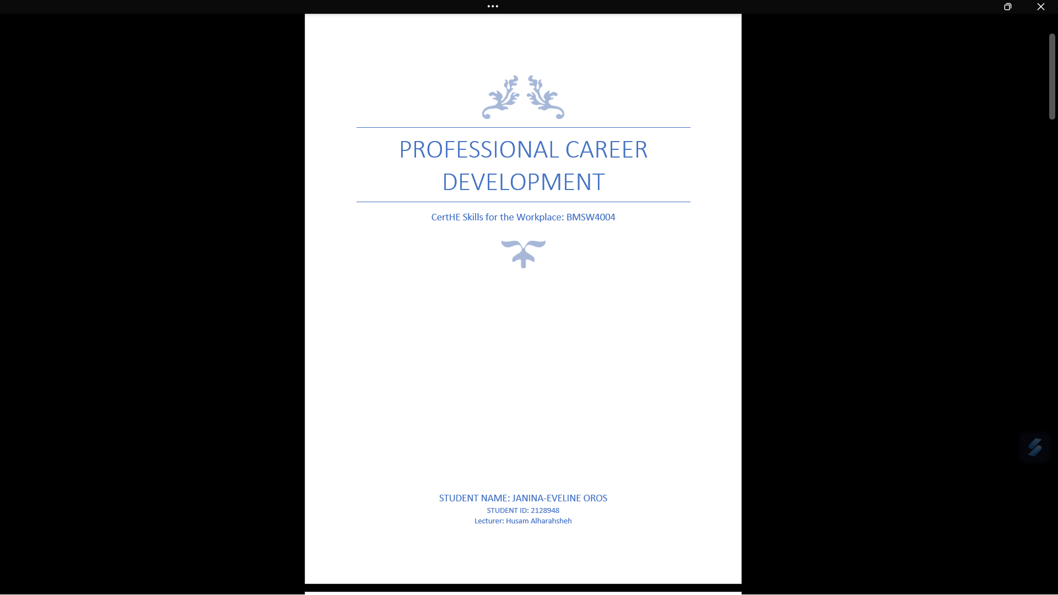
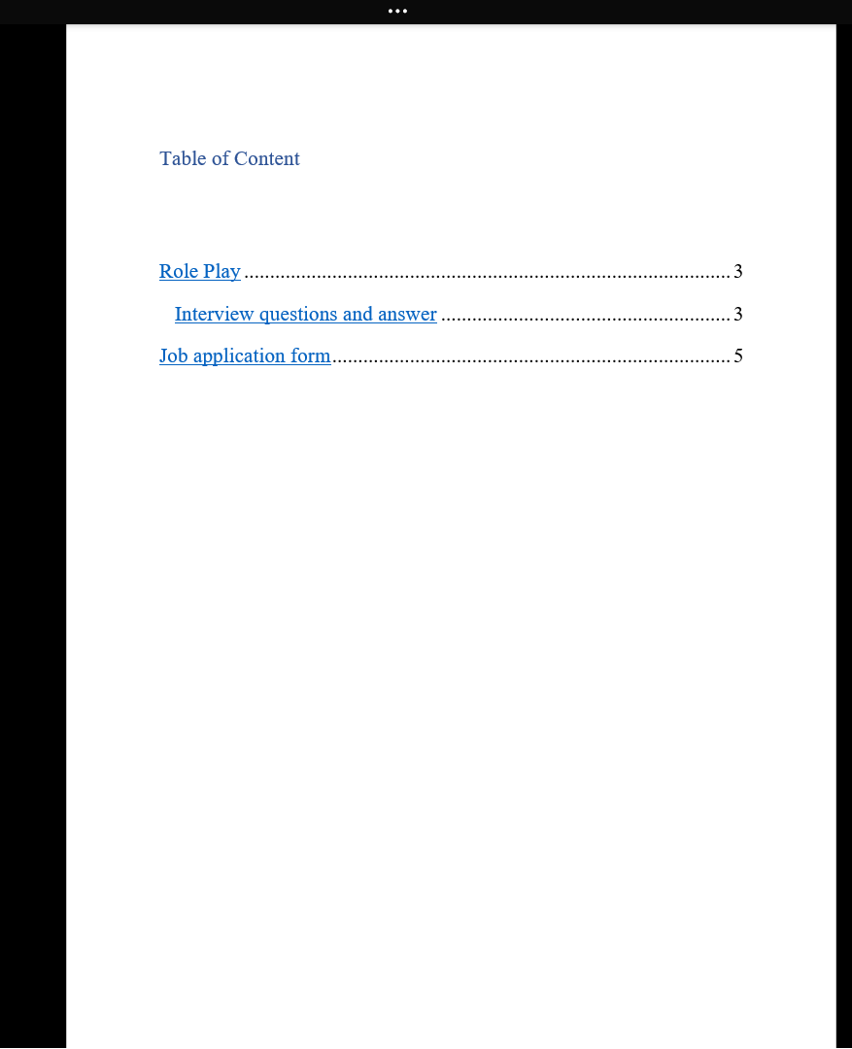
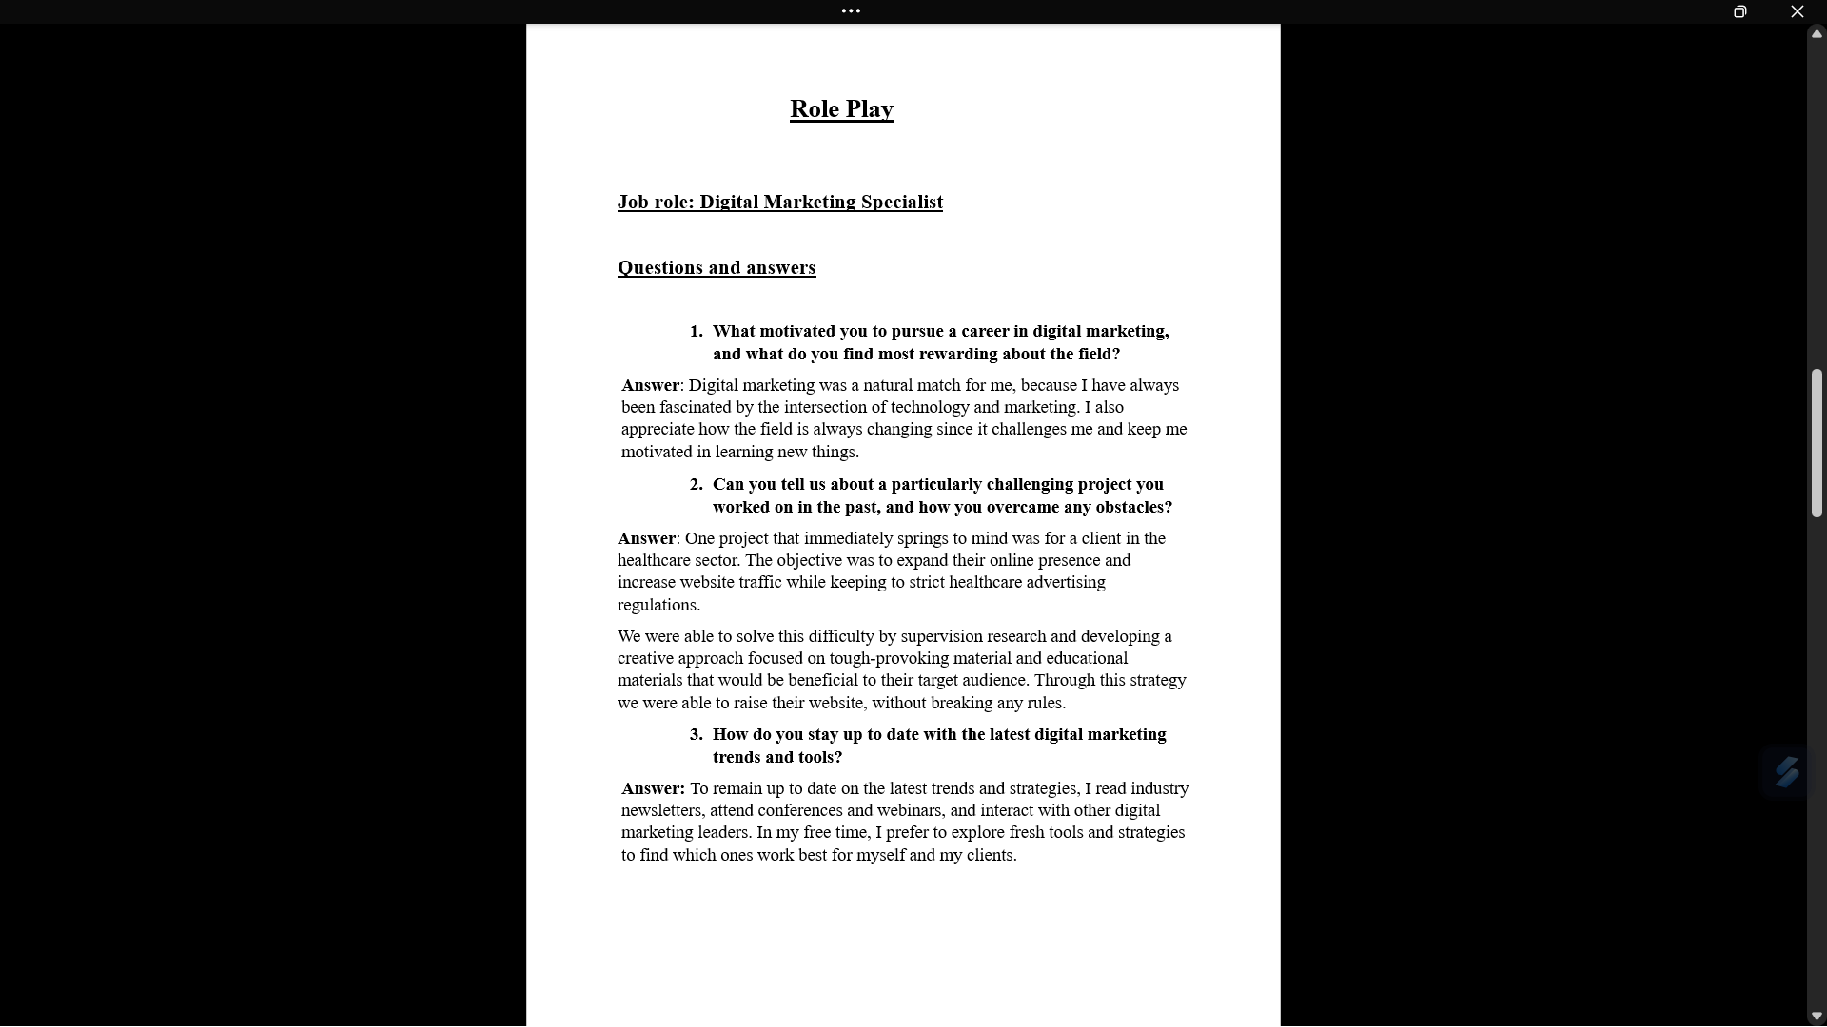
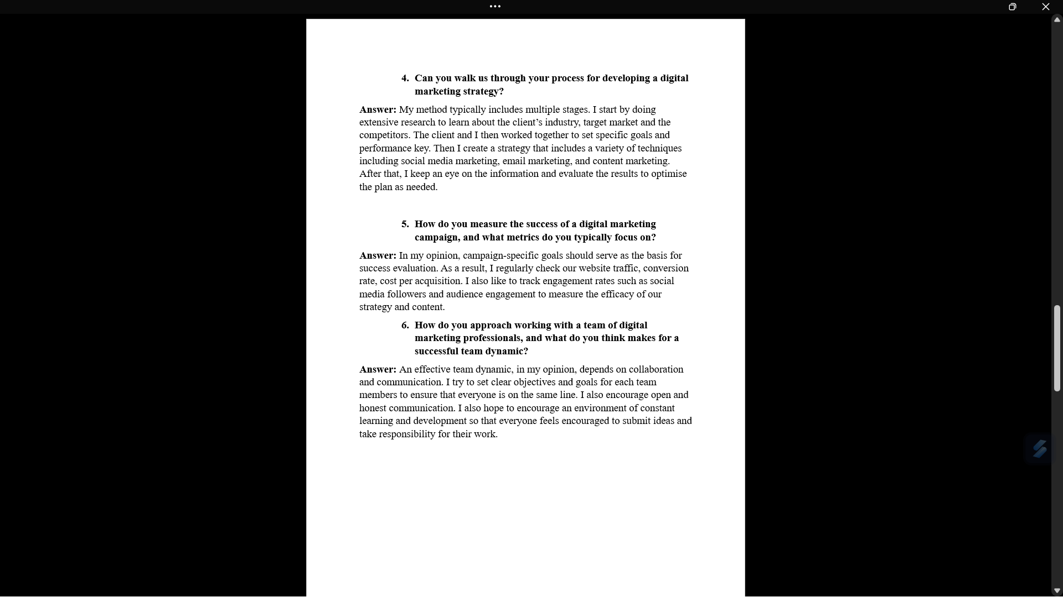

Job Application Form


