James Anthony Ofori-Poku (1808647)
Helen Leigh And Ciaran Robinson

DEVELOPMENT OF INSTRUMENT

DOCUMENTATION OF MAX PRO SYNTH 001 WITH MAX FOR LIVE
Introduction:
Developing an instrument is an interesting area of music technology that has helped to define the constant growth of the production of music over the years. With that being said, the aim of this coursework is to create an instrument which would be beneficial to the expression of musical ideas as well find convenient means for users to interact with them. With the development of my instrument, which I also consider as a project, this document helps to explain the various processes, approach, breakthroughs and setbacks I have encountered throughout the creation of my instrument. To discuss about the making of my synth instrument, we first have to look at what kind of synth I was interested in creating and the project plan that I came up with to have an overview of where it began and how it all came to its final stages.

What Is Kind Of Synth?
Researching about synthesis was one of the early steps taken to have an understanding of what I wanted to achieve with my instrument and thus, I came across a wide variety of synthesis that can be understood but can be difficult at times. The world of synthesis is complex, and it can be complicated to the extent of not knowing where to begin. The basis of synthesis can be defined as a method of producing sound from the ground up by the use of software and electronic hardware. There are different types of synthesis as well as their relative methods such as additive, subtractive, granular, wavetable and frequency modulation (i.e. FM) synthesis. There are also other types of synthesis which are not frequently used as much as the aforementioned. (O'Sullivan, 2012). Synthesis is mostly used in the field of music with the help of an electronic instrument known as a synthesizer which is used to create and play sounds with a keyboard. The keyboard has been a long-standing feature of synthesizers. Synthesizers are used in the production and recording of music as it has been for decades. Synthesizers can vary in the way they are built to be used and this leads to the some of the most well-known terms which are: monophonic and polyphonic. The difference between the two is: monophonic synthesizers can be referred to as the kind of synthesizers that allows for one key or note to be played at a time while polyphonic synthesizers, on the hand, are the kind of synthesizers which allows multiple keys or notes to be played at a time. It is with this difference that we can deduce the reason behind varying cost or expense between monophonic and polyphonic synthesizers on the market. (Guide, 2019). With my research done, I decided to create a monophonic additive synthesizer by the use of a software called Max For Live (i.e. specifically Max MSP).

What Is Additive Synthesis?
The principle or the theory of additive synthesis can be defined or stated as generating sounds by merging a series of sine waves together. In other words, additive synthesis is the process of combining sine waves sequentially at differing frequencies to generate any sound or timbre. (Rise, 2019). With additive synthesis, each sine wave added to another sine wave can be considered as an oscillator since the levels and their frequencies can be manipulated or modulated to obtain the preferred sound. In order to generate the sound, we are creating, each sine wave can be controlled individually with an envelope, which can be used to adjust the pitch and its levels. (Incorporated, 2018). The basis of additive synthesis also refers to the timbre or sound of musical instruments, which is acknowledged under the Fourier theory (i.e. this theory states that any intricate recurring waveform can be broken down to a group of sinusoids with varying frequencies, phases and amplitude) (Cassidy, 2002), to be composed of various harmonics. Additive synthesis is mostly used in electronic instruments and it also serves as the basis of harmonic organs.

What Is Max For Live And Max MSP?
Max For Live can be defined as a collection of sonic toolkits (i.e. audio effects, MIDI effects and instruments) and can be considered as an add-on to Ableton Live. Max For Live can also be defined as an extension of Ableton Live such that it enables experimental artists and producers alike, to create their very own plug-ins or micro software for music production, recording and live performance. The fundamental backbone of Max For Live happens to be Max (i.e. also referred to as Max MSP). (Rothwell, 2010). With Max, it is a visual programming language that can be used to develop complex multimedia and audio production tools. Max can also be referred to as a visually oriented programming environment that allows for the creation of interactive micro-programs or software for video, graphics and music needs. Max is written or developed in the C programming language and as such, the experience needed to use Max can range from a complete beginner to the advanced as it is in the form of visual programming rather than the written standard of coding. (Sweetwater, 2005). It is also useful for people with prior knowledge of any programming to have a quick start on using Max. Max is developed and maintained by a company called Cycling ’74 which is currently owned by Ableton. Max MSP can be divided into three distinct components, which are:
- Max, which deals with the various activities such as user interface, control and specifically, MIDI.
- MSP, which handles the audio and signal processing component.
- Jitter, which specializes in the manipulation of video as well as the rendering graphics.
The tools available for creating the effects and devices in Max are connected with each other by virtual patch cords which enable the transmission of signals as well as data in between objects in the Max programming environment. (Ghassaei, 2019).

The Project:
- Project Name: The 6-Oscillator Monophonic Synthesizer.
Project Image:
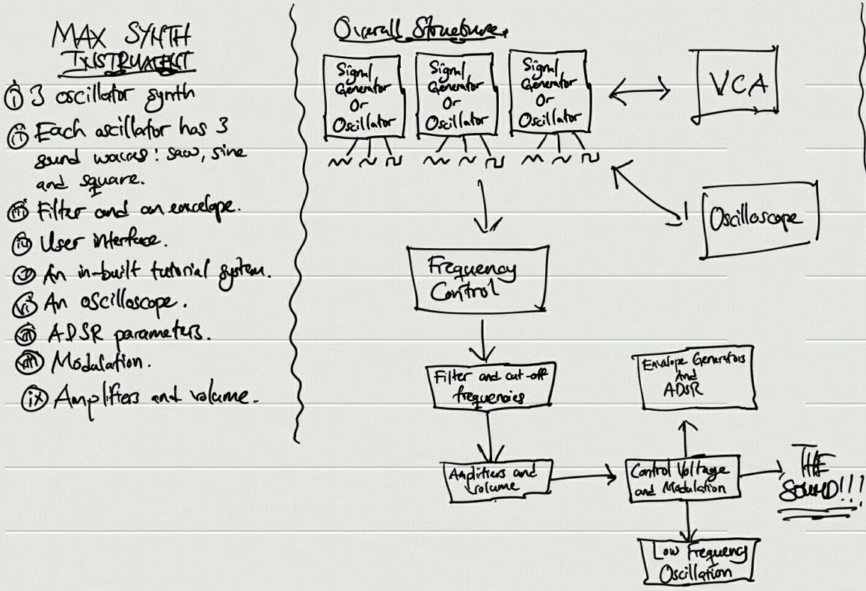
An early sketch of the 6-oscillator synth which details a quick note of its features as well as the individual components and how they would in conjunction with each other. The result being sound.

Overview:
- What does it do? It is a synthesizer plug-in for Ableton built using Max For Live (i.e. Max MSP). It is a 6-oscillator monophonic synthesizer that allows for the creation of sounds and if possible, emulates retro sounds. Each of the 6 oscillators has got 3 different sound waves which are: sine, square and saw. It will have an oscilloscope which will help beginners to learn about the basics of synthesis. Thus, to identify and understand the importance of sound design.
- Who is it for? It will be available specifically (i.e. portable with Ableton Live only) for Ableton users, professional musicians and beginners to synthesis.
- What are your influences? Yamaha DX7.
- Why am I influenced by the Yamaha DX7? It was commercially successful during the 1980s and was heavily featured in the decade’s massive hits. The algorithms that came along with it allowed for producers to programme the synth to their preference as well as store the presets that they created.
- Which tracks that have been composed with the Yamaha DX7? Kenny Loggins – Danger Zone, A-Ha – Take On Me, etc.

Process:
- Kit list: Max For Live.

- Project plan:
- More research on synthesis.
- Watch videos on synthesis and tutorials on Max For Live.
- Take notes of important things related to the project.
- Download and watch max for live tutorials.
- Make along with and practice with video.
- Document each synth, step and screenshot then analyse what to do next.

- How do I make an oscillator and then the synth as whole? (Step 1)
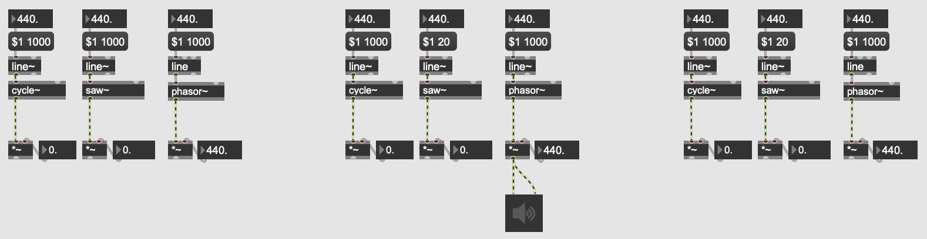

Number Boxes
Message Box

Linear Ramp Generator

Sound Waves

Virtual Patch Cords

The first attempt at creating an oscillator in the Max For Live environment. As seen above, the sound waves available in this oscillator are: sine (i.e. cycle), saw (i.e. saw tooth) and phasor (i.e. square).

The overview of the first synth created. This is a 3-oscillator synth.

Synth 1:
This oscillator, pictured above the overview, is one third of the synth. The image has been cropped to one oscillator to break it down into parts to be discussed. The first step of creating the oscillator began with setting-up number boxes (i.e. the top number boxes labelled with “440” is for pitch control while the bottom number box also labelled with “440” is for frequency control). The number boxes, in the Max environment, allows for the displaying of integer numbers as well as inputting and outputting the numbers. A message box is created to help display and transmit any message given with the capacity to control arguments. The object labelled “line~”, is a linear ramp generator and what it does, is to produce an envelope or a signal ramp. The line~ object is followed by the object “cycle~” which is Max’s interpretation of the sine wave. The same applies to the objects “saw~” and “phasor~” which are: saw-tooth and square respectively. The succeeding objects at the end of the oscillator are: a multiplier (i.e. “*~”) which multiplies two signals, a number box for frequency control and an audio output object known as “ezdac~”. The “ezdac~” object is an audio output and it also acts as an on/off button. As the first attempt of creating an oscillator for the synth, it worked, and it managed to produce sound. With an adjustment of the pitch and the frequency boxes, each of the soundwaves change in tone. From the image that shows the overview of the 3-oscillator synth, the arrangement of the oscillators is such there would have been an implementation of a multi-signal object which would have handled all the signals from the oscillators and then onwards to a collective frequency control patch. The setback of this synth was a lack of control, which is, each of the waves which is patched to the audio output object would be generated constantly unless turned off. Another setback was the difficulty of implementing my ideas further as this was an introductory attempt at creating the synth. As much as there was some minimal amount of success from this synth, I would deduce some useful methods of patching the objects on another approach to building another synth from scratch as well as gather some understanding of using Max MSP. This leads to the next synth in which I used as an overview to identify what I wanted to achieve.
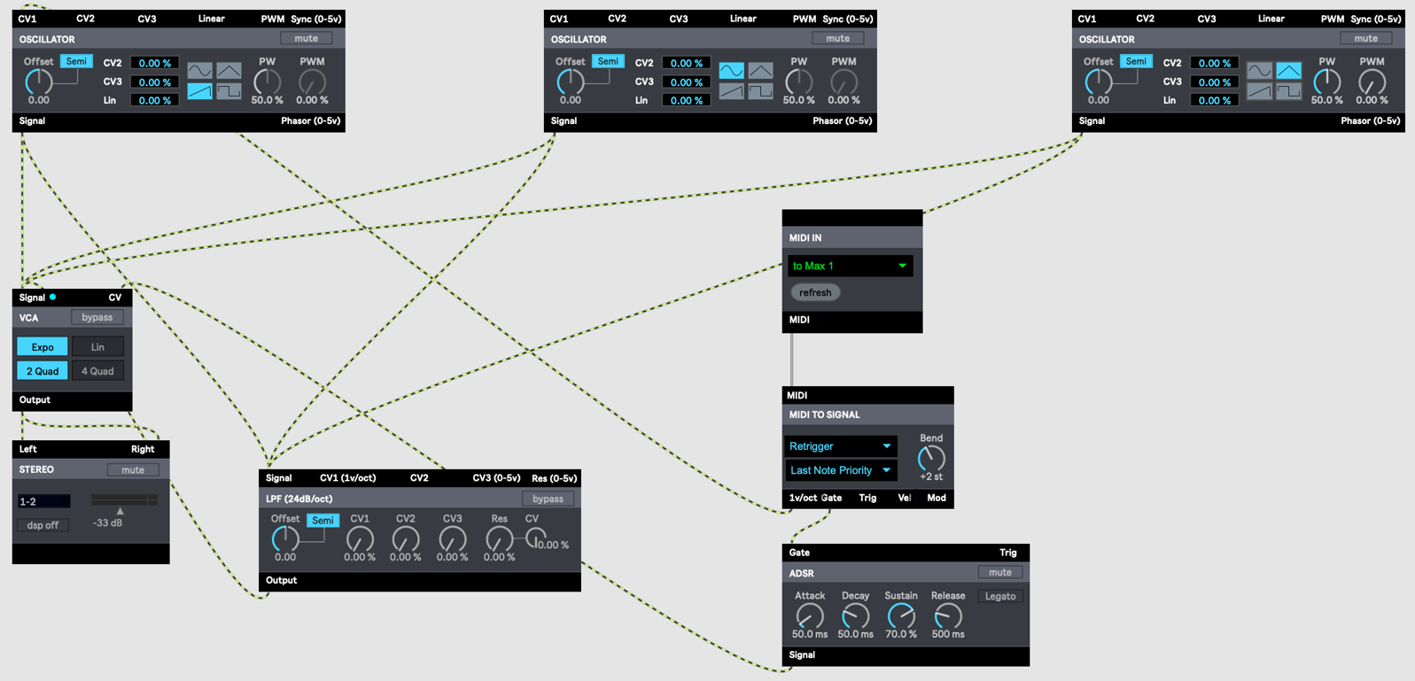
Synth 2:
An overview of the second synth I created along to experiment my ideas further. All the individual devices in the image above are a collection of tools made readily available from BEAP (i.e. Berklee Electro Acoustic Pedagogy).

This is the second attempt I took to creating the synth as seen in the image above, there is absence of objects, messages or number boxes. Instead, these are modules or ready-to-use parts that just need to be patched to create a simple to a complex modular synthesizer system. These modules, as mentioned earlier, are part of an extensive group of ready and easy-to-use tools in Max MSP called BEAP (i.e. Berklee Electro Acoustic Pedagogy). (Ableton, 2013). BEAP is a group of tools developed to reflect the operations of a Eurorack modular synthesizer and is easy to use and patch on the go. (Grosse, 2015). This is particularly useful for beginners who would prefer not to deal with the standard method of developing an instrument in the Max programming environment. The similarities between the Synth 1 and this synth is the 3 oscillators and in each of the oscillators, is an extra set of features which includes four waveforms, linear frequency modulation, pulse-width modulation (i.e. pulse-width modulation is referred to as a means of reducing or increasing the distance between the pulse of a waveform) features and sync. The waveforms available on each oscillator are: sine, triangle, saw-tooth and square wave. The parts labelled: “CV2” and “CV3” which are both attenuators for exponential frequency modulation input and “Lin” which is an attenuator for linear frequency modulation input. The “Offset” knob can be switched between semitone and Hz frequency modes. A pulse-width knob, which is useful to only the square waveform and the pulse-width modulation knob. There is also a voltage-control amplifier (i.e. VCA) which uses the level of an ongoing signal to handle another signal’s output level, a low-pass filter (i.e. LPF) module, a MIDI In module which transmits MIDI data from a device or port, a MIDI to Signal module which translates a message from BEAP into a signal, an ADSR (i.e. attack, decay, sustain and release) envelope and the Stereo output module. The way this synth works was by first patching the three oscillators to the VCA (i.e. specifically, the signal patch bay of the oscillators) and then, to the low-pass filter module which is also patched to the VCA to transmit signals. The MIDI In and MIDI to Signal modules are patched to each other as well as to the ADSR envelope. From the ADSR envelope, the VCA is patched to allow for MIDI devices to control or transmit data to play the synth. Finally, the VCA transmits signal to the Stereo output module which allows for the synth to be heard and controlled via the gain control. This synth was successful than Synth 1 because I had an understanding of how to patch the modules after the first synth, and the availability of the modules was also useful since there was no need to create and set up objects. Although this synth was a success, this was to help have an overview of what I wanted to create thus, I preferred to create a synth from scratch without the need to rely on ready-to-use modules.

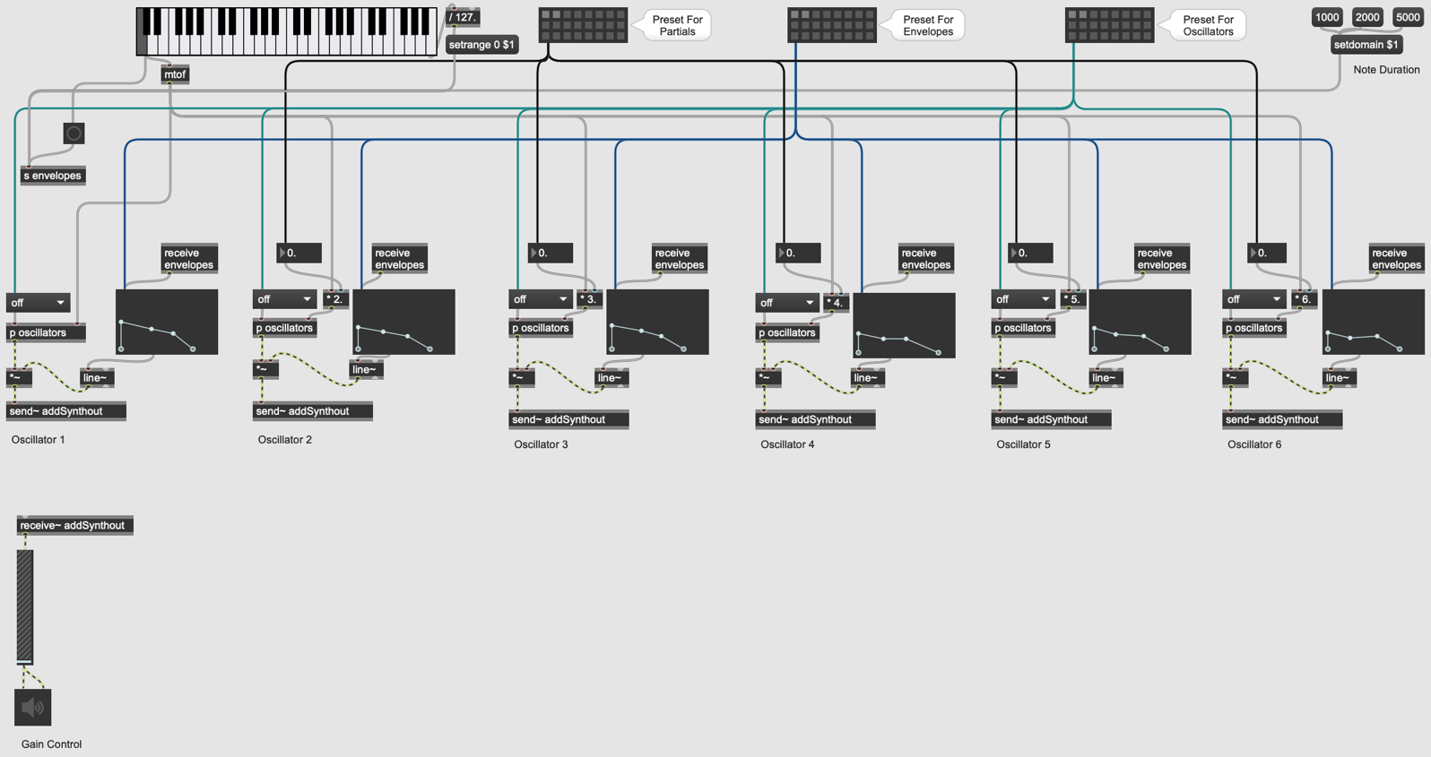
Synth 3:
An overview of the third synth which has got 6 oscillators, 6 envelopes, 5 frequency controls and etc. The image above, has got all the patch cables aligned and coloured to show the various connection. The image below is the finished synth, in presentation mode, which highlight the important components of the synth.

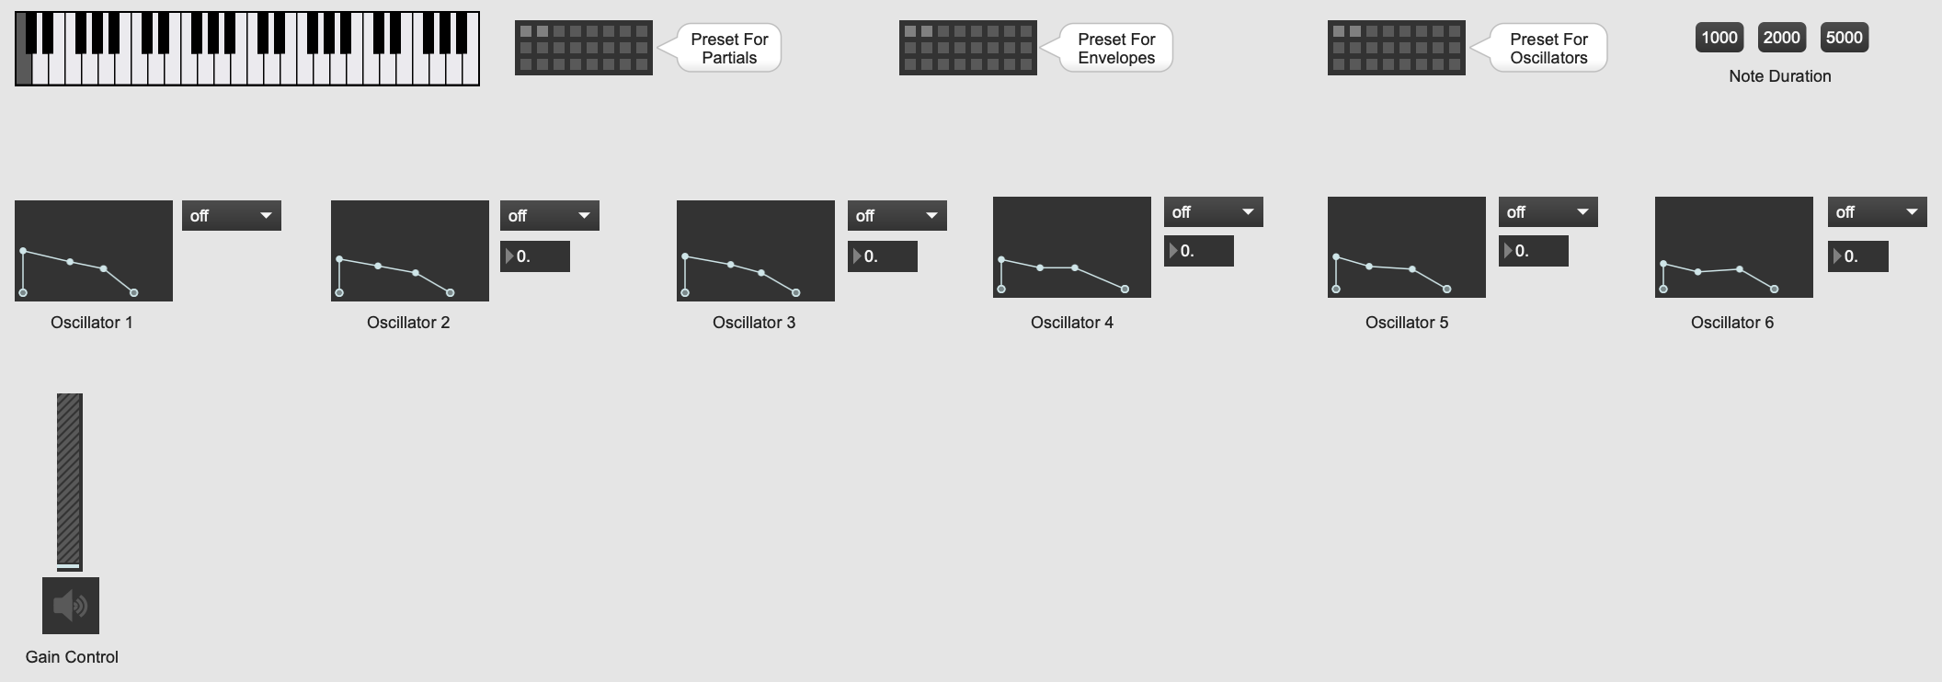
The final synth, Synth 3, takes from the previous synths that I have developed along the way up to this point. The initial stage of developing this synth, was to create a single oscillator with any of the three aforementioned waveforms, which are: saw, sine and square. The saw tooth waveform was the basis of establishing a signal flow and build upon the capabilities of the oscillator and the synth as a whole. The creation of this synth started with one oscillator, the gain control, a frequency control button (i.e. in the form of a number box), an envelope (i.e. “function” object), a button object, a linear ramp generator, a multiplier, a MIDI-note-number data to frequency converter which is the object, “mtof” (i.e. interpreted as a value of float in the form of Hz) and a keyboard (i.e. interpreted as “kslider”). The square waveform in this synthesizer is represented by the object “rect~”.
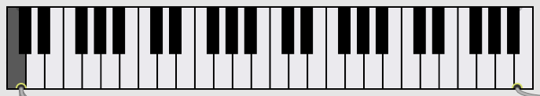
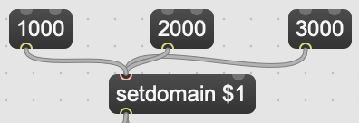

The keyboard (i.e. kslider object)
Note duration objects which consits of a set of number boxes.

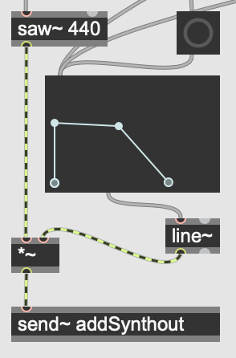
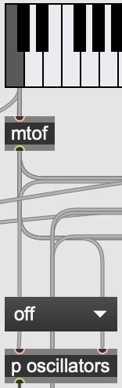

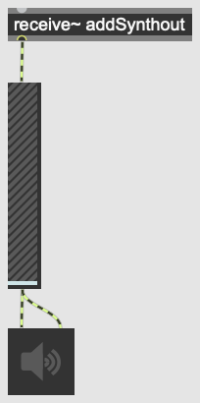

A group of objects that form a stereo device which include: a “receive~” object, the “gain~” object and the “ezdac~” object.
An oscillator with the saw-tooth waveform object, “saw~”, the linear ramp generator, a multiplier and a “send~” object with “addSynthout”.
The MIDI-note-number data to frequency (i.e. mtof) which allows the keyboard to transmit signals to the oscillator.

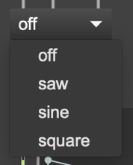
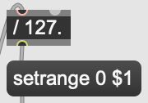

A velocity sensor which is patched to the kslider object.
The building blocks of the Synth 3.
The waveform menu system which is implemented to offer choice to users.

The 6 oscillators with saw-tooth waveform objects at the initial stage. The 5 multiplier objects change the tone of an oscillator by multiplying the incoming frequency of the keyboard octaves above depending on the number given.

Before explaining in detail how the synth increased in functionality, the “send~” and “receive~” objects the stereo output in addition to the gain control is one of the interesting things in the creation process because both objects do not require any patching to work. Instead, they both work correspondingly by remotely transmitting signals without the use of the patch cords. With one oscillator working by just the touch of any key on the “kslider” object, the building blocks of what would become the finished synth (i.e. the image right after the Synth 3 header) were individually added to one another so to fulfil an additional function. Each of these components work in conjunction with another (i.e. by patching) to accomplish minor operations of the synth which would eventually complete the instrument. Right after setting up the first oscillator, making 5 extra duplicates was a step further to generate different kinds of sounds from all six oscillator at once. The envelopes, which are present to each of the oscillators (i.e. as function objects in Max), are simply ADSR functions. The advantage of these envelopes is the option of adding or removing dots to manipulate how it operates according to however you choose. Triggering a key from the kslider object to all oscillators with the same waveform (i.e. as seen in the image above) would be loud thus, writing in different waveforms such as the square or sine wave would be interesting to listen to what sounds could be produced when played at the same time. Changing the waveforms on the duplicated oscillators yielded results as the sounds that were being generated were different. The results produced at this stage is before I added the octave multiplier objects (i.e. the objects labelled “* 2”, “* 3”, “* 4”, “* 5” and “* 6”) to the oscillators. What the octave multiplier objects did, was to multiply incoming frequencies (i.e. depending on the number given) from the MIDI-note-number data to frequency to produce a series of varying harmonics from the oscillators. This was particularly useful as it prevented an increased loudness in the event of having the same waveform across the oscillators. A major importance from the multiplier component was the possibilities of sounds that could be created or produced by changing the waveforms in each of the oscillators. With sound generated and controlled via the envelopes and the octave multipliers, the next step was to add a velocity sensor, which works in correlation to the kslider object, and a note duration function, which are a set of objects set-up and patched together. The velocity sensor was set-up with a pair of objects namely: a number box and a message box. While the number box is used to set the range or limit of velocity (i.e. written in as “/ 127” as seen in the building blocks images), the message box handles the incoming message or data, which is “/ 127”, and is then sent to kslider or the keyboard. The note duration function, on the other hand, are a set of message boxes which transmit numbers (i.e. 1000, 2000 and 5000 which represent seconds) to kslider via “setdomain $1”. The transmitted data to the message box “setdomain $1” is then sent as a fixed parameter to the keyboard and the result is a difference of duration or time of release when a note when is played. The next feature added to the synth was a menu system in which I would add in all the waveforms to a list and make it functional by clicking and selecting any of them (i.e. the waveforms) accordingly. What the menu system was implemented with (i.e. as shown in the images below), is the following objects: “selector~”, “saw~”, “cycle~”, “rect~” and “umenu” and combinatory option called encapsulation. The “selector~” object allowed for the allocation of signal inlets depending on the number entered at the end of the tilde sign (i.e. “~”) which in this case, was 3. With the waveform objects in place, patching them to the “selector~” object and the “umenu” object made it ready for encapsulation. Encapsulation is the method of condensing a set of objects into a sub-object as if everything was compiled into a container. When the encapsulation option is selected, the highlighted objects such as the “selector~” and waveform objects, a sub-object or sub-patch is created (i.e. appears) and the option of renaming is made available. In this case, “p oscillators” was the name chosen for the sub-object.
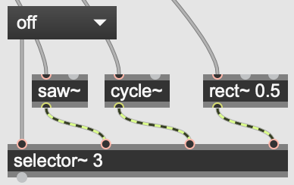
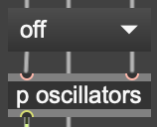

The result.
The waveforms, the umenu and selector objects after encapsulation.
The waveforms and the umenu objects patched to the selector object before encapsulation.

With the encapsulation of the waveforms to provide a feature of choice to the synth, an extra feature to add was a set of “preset” objects which would enable users to store and request for saved parameters. The saved parameters would be either set of oscillators, envelopes or multiplier objects (i.e. the partials). With regards to the synth, I created 3 “preset” objects in which each would be for oscillators, envelopes and the multiplier objects (i.e. as shown in the image below). To make them operable, patching each to their respective sources of parameters was the solution and the result was by holding the Shift Key over any of the preset slots and clicking on it to store a parameter being used at the time. To retrieve a stored preset, clicking on the stored slots recalls the saved parameter.
The preset objects with their respective sources to store their current states at the time of use.

Adding the preset objects brings the building of the synth almost to its final stages and the next step was to arrange the patch cords to make the synth presentable and ready for the user interface process. The Max programme offers the option to select a multiple number of patch cords and select the “Auto-Align” command which is available under the “Arrange” tab of the software. The final result of the synth is as the name states, which is, monophonic. The synth would be useful for playing and finding out some melodies on the go. The synth is pictured above this section, which is, right below the header of Synth 3. The setback of this synth was a major issue which had to deal with file format changes, save location and exporting it to Ableton Live. The process of doing the aforementioned is complicated thus, user or beta testing was not possible hence, leaving it to work in the Max environment instead.

- How would I export it as a plug-in from Max For Live? (Step 2)
  - If there was a way to figure out file format change and save location, the option to export the synth would not be a problem at all. The option of exporting a patch file or project file is available under the “File” tab of the Max programme.

- How would I install it as a plug-in on Ableton? (Step 4)
  - Uploading the patch codes to sites like GitHub or other code cloud storage sites to be made available for users of Ableton to download. The patch file should be in the .amxd format to be compatible with Ableton.

Instructions For Using Synth 3:
- The oscillators of the synth when opened are set to “off” by default (i.e. from the menu button) and to access the waveforms, click on the menu button to select a waveform of your choosing.
- To get a higher velocity from the keyboard, click on the high-ends of the keys and to get a lower velocity, click on the lower edges of the keys.
- To use the envelopes, click on any of the dots and drag to any position within the specified parameter (e.g. the attack area of the envelope).
- The note duration grants a varying release time of the keyboard thus, click on any of the numbers and play any of the keys to hear the result.
- The partials are in the integer and decimal format thus, there is the option of clicking and entering whole or decimal numbers and the other option of clicking and dragging up and down to increase or decrease the value.
- The gain control can also be adjusted to either high or low levels of loudness.
- To use the preset objects for storage, hold the Shift Key over any of the preset slots and clicking on it to store a parameter being used at the time. The slot with the stored parameter would be highlighted and a number would appear on the side. To recall stored presets, clicking on any of the stored slots to recall a saved parameter.

Analysis:
- Where would this project go next?
  - I would add extra features to the synth like an oscilloscope, a low and high-pass filter and a chord-trigger mode. It would be also be helpful to figure the file system of the Max program to make it ready for Ableton Live.

- How could you make money off of this?
  - If I could enhance the synth to a standard that has very interesting features just like some of the major synth software out there, I could make it available for the Ableton website shop. I could also have advertisers commercialise music production products via the synth and have that as my source of income.

- What have I learnt from the process of making an instrument?
  - It has been a very interesting yet difficult experience as a beginner to using the Max software. Although there is prior knowledge of programming, I have difficulty in understanding the logic of programming from the start but as I kept working on the instrument, understanding the fundamental aspects of the Max programming language brought some level of confidence on using the software. The potential of Max MSP is very fascinating to get learn about furthermore. My interest would be into developing micro-visual programs to integrate to a live performance set.

Bibliography
Ableton, 2013. Ableton. [Online]
Available at: https://www.ableton.com/en/blog/beap-powerful-modules-max-live/
[Accessed 3 April 2019].
Cassidy, S., 2002. COMP449: Speech Recognition. [Online]
Available at: http://web.science.mq.edu.au/~cassidy/comp449/html/index.html
[Accessed 2 April 2019].
Ghassaei, A., 2019. Instructables. [Online]
Available at: https://www.instructables.com/id/Intro-to-MaxMSP/
[Accessed 3 April 2019].
Grosse, D., 2015. Cycling '74. [Online]
Available at: https://cycling74.com/tutorials/a-few-minutes-with-beap-tutorial-series
[Accessed 3 April 2019].
Guide, D. P. R., 2019. Digital Piano Review Guide. [Online]
Available at: https://www.digitalpianoreviewguide.com/monophonic-vs-polyphonic-synth-whats-better/
[Accessed 2 April 2019].
Incorporated, A., 2018. Apple Incorporated. [Online]
Available at: https://support.apple.com/kb/PH27711?locale=en_US&viewlocale=en_US
[Accessed 3 April 2019].
O'Sullivan, S., 2012. Pro Audio Files. [Online]
Available at: https://theproaudiofiles.com/sound-synthesis-basics/
[Accessed 1 April 2019].
Rise, S., 2019. The Synthesizer Academy. [Online]
Available at: http://synthesizeracademy.com/additive-synthesis/
[Accessed 1 April 2019].
Rothwell, N., 2010. Sound On Sound. [Online]
Available at: https://www.soundonsound.com/reviews/max-live
[Accessed 1 April 2019].
Sweetwater, 2005. Sweetwater. [Online]
Available at: https://www.sweetwater.com/insync/max-msp/
[Accessed 3 April 2019].

