Human Development
Table of contents:
Part 1, word count 1061 - page 2
Part 2, word count 970 – page 5
Part 3, word count 955 – page 8
Reference list – page 12
Appendix- page 14

Part 1:
Maslow’s Hierarchy of needs
This infographic explores Maslow’s Hierarchy needs.

Physical Needs Maslow’s pyramid of Needs

These speak to basic physical needs like eating when hungry and drinking when thirsty. Maslow argues that several of these needs include our attempts to fulfil the body's need for homeostasis, which is to maintain consistent levels in many physiological systems (e.g., keeping the body temperature at 98.6 degrees).
"A Physiologist's View of Homeostasis," Harold Modell and associates
Maslow thought the most basic of our physiological needs were If one is poor in more than one, one will most likely try to meet these physiological needs first. When a child is truly hungry, for example, it is impossible to concentrate on anything except food. Still another example of a physiological need is the need for enough sleep (Hopper, 2024).
Maslow claims that the most basic human requirements are those of life like food, shelter, drink and air. Without this fundamental degree of survival, one cannot expect someone to think more profoundly or accomplish anything.
Maslow's paper states "a person who is lacking food, safety, love, and esteem would most likely hunger for food more strongly than for anything else." His theory holds that all else has to follow (Willingham, 2023).

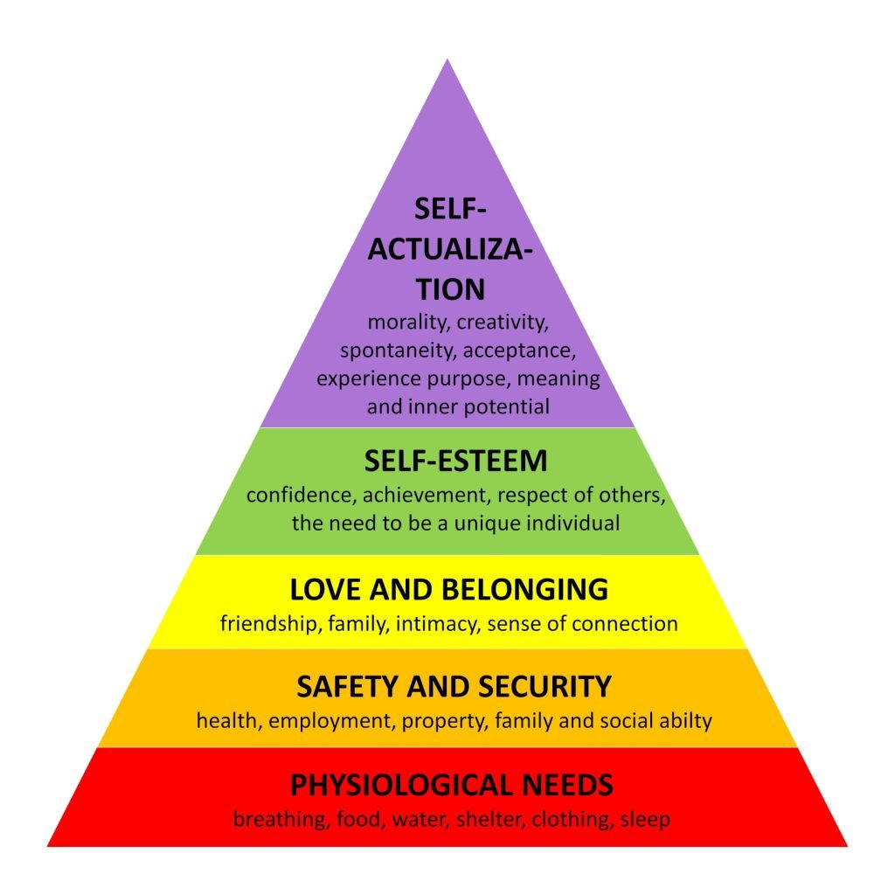
(Source: Simply Psychology, 2024)
Safety Needs Love and belonging
It is important to have a safe place once people's physical needs are met. Children want predictable and safe environments and often act fearfully or nervously when they are not given them. This shows that we need to feel safe from a very young age. Maslow said that adults in industrialised countries are more aware of their safety needs during disasters like war and natural disasters. These needs can also explain why we tend to stick with what we know or why we do things like buy insurance and put money into a savings account (Hopper, 2024). People can be safe because of the family and society (like the police, schools, companies, and medical care).
Some examples are property, well-being (like not getting hurt or having your home destroyed), law and order, emotional security, financial security (like having a job or getting social aid), and freedom from terrorism (Mcleod, 2024). Children need a safe surroundings, which may be given by suitable toys and playground equipment as well as by child-proofing sections meant to prevent mishaps. To keep predictable routines, they need consistency and regularity; so, they will experience dependability and security.
Emotional security is necessary for developing confident surroundings and trusting interactions with carers.
To guarantee their health and safety, teaching them basic hygienic practices including handwashing, to stop the spread of germs, is also vital (care learning, 2024).

Examples of belongingness are " comprise love, friendship, proximity, trust, acceptance, and the capacity for tenderness both given and received.
Children who stick to abusive parents may attest to how strongly this drive is felt in childhood and how often it trumps the need for safety (Mcleod, 2024). It is essential for people to feel loved and accepted by others to avoid feelings of sadness, loneliness and anxiety. Involvement in groups, including religious Love and belongingness needs," are human emotional needs for interpersonal connections, affiliation, connection, and group membership.
Needs for belongingness organisations, book clubs, sports teams, and other group activities, as well as interpersonal interactions with family, friends, and romantic partners, are significant (Cherry, 2024). The need for love and belonging is the next critical phase for a child's development and well-being after their bodily and safety/security requirements have been satisfied. Feeling loved and cared for is part of this need.
A child's family plays a significant role in their development and helps them satisfy their needs for affection and acceptance. What "family" means to every one of us is different. There is also a considerable requirement for youngsters to interact with one another (O’Hara-Leslie, 2024).

Self-esteem Self Actualization
Maslow's hierarchy of needs places the desire for respect and admiration at level four. The esteem needs start to become increasingly important in motivating behaviour after the needs at the bottom three levels are met.
At this point, winning other people's respect and admiration becomes more crucial than ever. Individuals must complete tasks to have their efforts acknowledged. Ego needs include the need for feelings of accomplishment and standing, as well as the need for self-esteem and personal worth.
People need to believe that they make a difference in the world and that other people value them. Participation in work-related activities, success in school, participation in sports or teams, and personal hobbies can all help meet the esteem needs. People who can meet their esteem demands by being recognised by others and having a positive sense of self-worth are more likely to have confidence in their skills.3 On the other hand, those who don't respect themselves or others may start to feel inadequate (Cherry, 2024). Maslow's Hierarchy puts self-actualization at the top, which is the highest level of human potential. People must first take care of their need for respect. In this way, self-esteem is how someone feels about themselves and how they relate to other people. At this stage, you have achieved something, you feel proud of yourself, and maybe even like you have some status in a certain area.
"Satisfaction of the self-esteem need leads to feelings of self-confidence, worth, strength, aptitude and adequacy of being useful and necessary in the world," Maslow said (Willingham, 2023).

This is Maslow's Hierarchy of Needs' last level. A person is said to have reached their full potential and met all of their basic necessities at this point. The desire for self-actualization can take many forms, including pursuing life goals, going back to school, and looking for pleasure. Individuals have different needs for self-actualization. While one person might want to become a millionaire or a humanitarian, another would want to be the finest parent. In essence, it is the quest for individual development (Pathak, 2021).
Adventure and novelty: Self-actualized people don't hesitate to attempt new things, new methods, and new concepts, or to rethink existing ideas in creative ways. Novelty gives them energy.
• Confidence: Self-actualized people don't rely too much on other people's praise since they are at ease with who they are.
• Non-prejudicial: Self-actualized people are tolerant and open to people from different backgrounds. They feel at ease with opinions and views that differ from their own.
•Empathic: Self-actualized people have empathy for all people.
•Overcoming polarities: Self-actualized people are neither nice nor bad, introverted nor outgoing, etc. They are not limited by polarity (Moses, 2007).

Part 2:
Concept of holistic child development
Early infancy is maybe the most important period of child development. It creates the foundation for their well-being and growth throughout maturity. (Queen Margaret university, 2023)
Holistic development, which stresses how many parts of a child's growth are connected, is very important in the early years. Also, according to (Unicef, 2023) scientific research shows that a person's early years define their entire life: Children's brains change minute by moment as they interact with their environment. The first few years of life saw more than a million brain connections created every second; this rate will never be duplicated. From (Unicef, 2023). "The quality of a child's early experiences makes a critical difference as their brain develops, providing either strong or weak foundations for learning, health and behaviour throughout life."
In early infancy, the term "holistic development" refers to a child's overall development including its social-emotional, cognitive, and biological growth. Every stage of a child's growth influences the others and recognises that they are complex people rather than only students.
Unlike conventional approaches to development that focus on specific areas of development, a comprehensive approach guarantees that all elements of a child's life are nourished all at once to support their general health and well-being (Queen Margaret university, 2023). The fundamental components of holistic development are,
Biological growth, Early childhood development depends critically on biological development—sometimes known as physical development. It covers children's overall health and welfare as well as their hand-eye coordination, development and enhancement of their fine and gross motor skills, etc.
Cognitive growth. The term "cognitive development" sums up a child's mental capacity including language, thinking, and problem-solving. It covers memory, attention, and the ability to understand and communicate ideas. It's also called intellectual growth.
Emotional and social growth. Aspects of a child's social-emotional development include their capacity to understand and regulate their emotions, create relationships, and interact with others. It comprises the child's development in social skills, empathy, self-worth, and self-expression (Queen Margaret university, 2023).
Holistic approaches to child development and education admit the interdependence of the mind, body, and spirit. Early childhood teachers and creche providers using a holistic approach take children's cognitive development into account together with their physical, social, emotional, and spiritual well-being.
Both planning and assessing a child's needs call for a thorough approach. Examining how the developmental domains interact with one another and how progress in one area could affect progress in another helps one to assess the child as unique and identify their achievements as well as shortcomings. For example, a child might utilise a spoon—physical—which encourages emotional self-worth and independence.
This approach helps early learning teachers and creche providers to plan future events for the child, therefore supporting their overall learning, development, and welfare (Scottish social services council, 2024). Teachers and carers help self-actualization by offering several experiences. This might include interactive story times that inspire imagination or hands-on learning whereby children can look in to challenges they are interested in. This will encourage overall development. Early years settings should be designed to support all levels of Maslow's hierarchy effectively by including nutritional programs that offer good meals and snacks. Daily timetables that enable children to feel safe, social interaction opportunities, including group activities that encourage interaction and collaboration, and skill building exercises including activities that enhance fine and gross motor abilities are part of a structured routine (care learning, 2024). Maslow’s' hierarchy of needs is very beneficial for nurturing children in their early years. Knowing every level helps educators and caretakers create better circumstances that support general growth. Early childhood addressing of basic needs prepares the stage for the lifetime welfare and education of the child. The journey in Early years towards self-actualization is a team effort of creating nurturing, inclusive and motivating events that inspire children to flourish (care learning, 2024). A number of specific techniques have the potential to be beneficial in assisting the overall development of young children. These include the following:
Assessment approaches that are effective in identifying children's strengths and the links between different learning areas and experiences, identifying the priorities of the local curriculum, particularly in situations where there is a strong relationship between parents and educators. There are a variety of approaches to curriculum planning, such as enquiries and investigations, that encompass and integrate a wide variety of various learning areas.
Pedagogies that are culturally relevant and curriculum that supports two cultures, intentional teaching, the pedagogy of play and inclusion-related practices and procedures (The education hub, 2020). When it comes to child development, the holistic approach is based on the concept of caring and growing the whole child. This indicates that it is not enough to just teach the necessary material in order for a child to be successful academically and pass various examinations. It is about having a holistic approach to the development of children encompassing all parts of the child's growth, including social development, emotional wellbeing, and all other factors that comprise the child as a whole. Providing our students with a safe setting for learning and a conscious space that is full of positive reinforcement allows us to give them greater freedom in discovering their own specific learning styles. Additionally, we are able to strengthen their confidence in confronting new and unfamiliar tasks, as well as their resilience in the face of failure (tuition, 2024). With the school’s active involvement and assistance, caregivers and community, a holistic approach seeks to educate the child in all aspects of their being, including all aspects of their physical, social, emotional, and academic development. A holistic approach acknowledges that all children, and especially those who are confronted with tremendous hardship, deserve a variety of information, skills, experiences, and basic values that will allow them to participate as valuable and ethical citizens and to realise their full potential in life (O’Malley, 2023).

.

Part 3:
Examples of early years practice

In part 3 we will be talking the importance of basic needs for children in early years settings, and the role we play as early years practitioners.
Importance of mealtimes: We know as practitioners working in the early years sector, that the Early Years Foundation Stage (EYFS) framework calls for caregivers to take all required steps to keep children healthy and safe. This means that providers need to be sure that the people who are in charge of making and handling food in their setting are qualified to do so. This entails cooking food in a hygienic manner, serving meals that are wholesome, well-balanced, and nourishing, and ensuring that food is prepared for infants and children of various ages—for instance, by mashing, pureeing, or cutting it into pieces that are the right size and shape to prevent choking hazards (Foundation years, 2021). Ensuring children have the correct balance of nutrients when they are fast growing depends on good diet. Our responsibility also includes ensuring children don't overindulge in food, which may lead to obesity or overweight.
Giving children a broad spectrum of tastes, textures, and foods will help to boost the range of meals they will consume. This can inspire later in life better eating habits. This is particularly crucial during this period of early development and growth.
This is a pivotal moment to help to lower health disparities all through a child's life. For a variety of circumstances, some children may not have access to wholesome food at home. Children's diet choices can be influenced by us, therefore perhaps influencing the food choice of their parents as well (GOV.UK, 2024).
Creating a safe and stable environment: To support children's emotional health, it's important to pay close attention to the places where they are cared for.
The actual environment of an early year’s setting can have a huge effect on the mental health of all the people who come in, including children, parents, and staff.
For children to feel at ease and safe while they're there, there needs to be a sense of order. This is especially important for youngsters whose homes aren't always in order, because the structured and ordered setting at the nursery can help them feel safe and healthy.
Settings that are neat, clean and keeps things in the same place so children can get to them easily give them a crucial sense of security and predictability.
A child who lives with uncertainty can feel better when they get to nursery and finds the bricks where they thought they would be. A messy and disorganised environment is at best confusing for kids because they must work hard to find things and at worst scary for the child (Hunter, 2024). Development of a child depends on feeling protected and respected. Children learn best, according to studies, when they are free from anxiety so they may participate completely and take intellectual risks.
Effective and meaningful learning is promoted in a safe atmosphere by which active engagement and the acceptance of challenges can grow. Making a child feel safe and secure is essential to help them to realise their full potential since this supportive environment not only improves their academic path but also their general well-being (Foundation years, 2024).
Building the child’s confidence and independence: Being independent has a lot of advantages; the main ones are those of confidence and self-esteem development.
Children should be empowered to be independent right from nursery and pre-school. It also prevents too depending too much on adults, parents, or even more confident friends.
Children should always be encouraged to begin with something simple and modest. Their self-discovery of doing things for themselves sets off a chain reaction soon. Children like that their actions have a result that motivates them to do more tasks for themselves.
The secret is to forget perfection as most would initially find difficulty with the tasks. As professionals, we avoid critiquing and instead provide encouraging follow-up like "you're getting there". This appreciation is crucial since it will inspire children to try again and maintain high confidence (School house, 2020). It is possible to boost the child's confidence with something as basic displaying Photographs of the children in the classroom. Additionally, you can have students paint self-portraits, design flags or puzzle pieces that symbolise their personalities and hobbies, and then put these things on display on the walls or them too see. Others include designing puzzle pieces.
Children receive a sense of acceptance, affection, and belonging as a result of this, which ultimately contributes to the upward slope of their self-confidence (Cullins, 2024).
Maslow concentrated on the positive rather than the negative features of human development, trying to find our maximum potential.
According to Maslow, some needs are more critical than others and people are driven to meet specific wants. Our survival drives our first and most fundamental need, so this will be what drives us first. After that need is satisfied, we will proceed to the next one and so on.
Applying Maslow's theory to our early years practice helps us to recognise the need of making sure children feel safe and secure, so it is imperative to provide that solid basis for learning and growth.
The Early Years Foundation Stage defines the requirements that early years providers have to satisfy to guarantee children learn and grow and stay safe and healthy. The safeguarding and welfare standards cover the actions caregivers are required to take to keep children safe and healthy and therefore satisfy their basic needs. The activities and experiences children engage in define their learning and development requirements, which also help them to choose the objectives they should be aiming for to satisfy their psychological and self-fulfilment demands (The education people, 2021).

Reference list

Care learning (2024). Supporting holistic growth. Available at: Examples Of Maslow’s Hierarchy Of Needs In Early Years - Care Learning (accessed 8/11/2024)
Care learning, (2024) Safety in children. Available at: ttps://carelearning.org.uk/early-years/models-theory/examples-of-maslows-hierarchy-of-needs-in-early-years/ (accessed 5/11/2024)
Cherry, (2024) Love and belonging. Available at: Maslow's Hierarchy of Needs (accessed 6/11/2024)
Cherry, (2024) Esteem needs. Available at: Maslow's Hierarchy of Needs (accessed 6/11/2024)
Care learning, (2024). Final thoughts. Available at: Examples Of Maslow’s Hierarchy Of Needs In Early Years - Care Learning (accessed 8/11/2024)
Cullins, A, (2024). Cultivate their sense of belonging by hanging their portraits or artwork around the home or classroom. Available at: Supporting Children's Independence - NurseriesHow to Build Confidence in Kids | Big Life Journal (accessed 25/11/2024)
Foundation years, (2021). Healthy eating and safe food preparation. Available at: Healthy eating and safe food preparation - Foundation Years (accessed 14/11/2024)
Gov.uk. (2024). Good food habits from birth. Available at: Help for early years providers : Nutrition (accessed 14/11/2024)
Hopper, (2024) What Is Maslow’s Hierarchy of Needs?. Available at: Maslow's Hierarchy of Needs Explained (accessed 5/11/2024)
Hopper, (2024) Safety. Available at: Maslow's Hierarchy of Needs Explained (accessed 5/11/2024)
Hunter, C. (2024). Examples of nurturing. Available at: Examples of nurturing – How to create a supportive environment in Early Years | Learning and Development | Teach Early Years (Accessed 14/11/2024)
Mcleod,S. (2024) Safety needs. Available at: Maslow's Hierarchy of Needs (accessed 5/11/2024)
Mcleod, PhD, (2024) Love and belonginess needs. Available at: Maslow's Hierarchy of Needs (accessed 6/11/2024)
Moses, (2007) Self-actualization. Available at: Self-Actualization - an overview | ScienceDirect Topics (accessed 6/11/2024)
O’Malley, E. (2023). Learning in schools and for life. Available at: Learning in school and for life: A holistic approach to child development | Blog | Global Partnership for Education (accessed 10/11/2024)
O’Hara-Leslie, E. (2024) Need for love and belonging. Available at: 4.2: Maslow’s Hierarchy of Needs Applied to Children - Medicine LibreTexts (Accessed 6/11/2024)
Pathak (2021) Self-actualization needs. Available at: How Maslow's Hierarchy of Needs applies to children %%sep%% %%sitename%% - HT School (accessed 6/11/2024)
Queen Margaret university, (2023) Understanding holistic development. Available at: Nurturing holistic development in early childhood - Blog (accessed 6/11/2024)
Queen Margaret university, (2023) The key areas of holistic development. Available at: ttps://online.qmu.ac.uk/blogs/nurturing-holistic-development-in-early-childhood/ (accessed 6/11/2014)
Scottish social services council, (2024) Introduction. Available at: Child development - Holistic view of child development and learning 1/8 (6/11/2024)
School house, (2024). The importance of feeling safe and valued. Available at: Why is it important for a child to feel safe? - Schoolhouse Day Care (accessed 14/11/2024) (accessed 14/11/2024)
Source: Simply Psychology, (2024). Available at: Maslow's Hierarchy of Needs (accessed 25/11/2024)
The education hub, (2020). Principle of holistic development. Available at: Principle of Holistic Development | Kotahitanga - THE EDUCATION HUB (accessed 10/11/2024)
Tuition, L.(2024). What is the ‘whole child’. Available at: What is holistic development and why is it the best approach for educating our children? (accessed 10/11/2024)
The education people, (2021). Exploring pedagogy. Available at: Exploring Pedagogy - Introducing Abraham Maslow (accessed 25/11/2024)
Willingham, A.J. (2023) Esteem Needs. Available at: Maslow’s hierarchy of needs: Examples and explanation | CNN (accessed 6/11/2014)
Willingham, AJ. (2023) Level 1: Physiological needs. Available at: Maslow’s hierarchy of needs: Examples and explanation | CNN (accessed 5/11/2024)

Appendix

I have not used AI

