5OS01 – Specialist Employment Law
TASK 1
  - Evaluate the aims and objectives of employment legislation
The role of employment law is to help provide working conditions that are free from bias for everyone. The main aim is to provide legal protection to employees and employers, and to regulate the employer and employee relationships (CIPD, n.d.).
The main three objectives when it comes to employment law would be to achieve social justice, this would look at making sure that the government has and promotes physical security, education, healthcare and employment. It allows each person to exercise their rights within society.
Employee protection makes sure that the rights are balanced and that the expectations of the job are fair. It looks at legislation such as regulations regarding hiring, to ensure that they are non-bias with regards to training requirements, contracts, such as temporary or fixed-term, and items such as redundancy procedures and notice periods.
Employee Rights Act 1996 looks at a wide range of legislation relating to law such as time off work, wages and flexible working to name a few. It looks at all workers and ensures that they are treated fairly by their employers, otherwise known as statutory rights.
The role of employment law is to help achieve all the above, from social justice to inclusion and fairness in the workplace. However, there are some pros and cons to having this in place which can be seen in the chart below.
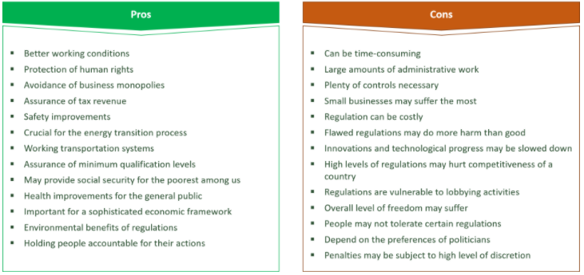
Just some examples of why my organisation is in favour of employment regulations, is that it allows us to have guidelines to which we work. It ensures that everyone is treated fairly. However, the pandemic has had an enormous impact on the labour market, and furlough allowed employers to dramatically change the size of their workforce. This has also had an impact within my current organisation as it has caused most employees to re-evaluate their work/life balance, and hospitality has been hit hard because of this. Anon, (n.d.). explains that labour shortages in hospitality are not necessarily a disaster for our economy and that we are all part of the same bumpy ride, as long as we pay attention to the fact that we are still living through the pandemic.

  - Examine the role played by the tribunal and courts system in enforcing employment law
There are 3 sources of employment law in the UK, and these consist of Common Law (Civil/Case Law), Statute Law and European Law. Common Law, this allows employees to be able to work under the contract of employment. It is created on a legal basis for the employer and employee relationship. It is known as the oldest source of law and is common to all.
Statute Law, this looks at employment protection legislations as early as the 1970’s, this includes legislation such as the Data Protection Act 1998, Equal Pay Act 1970, Employment Act 2002 etc.
The European Law is made by the European Union, however since leaving the EU, the UK now uses the domestic legislation, which is under the control of the UK’s parliaments and Assemblies. All information on this can be found and published on Legislation.gov.uk
The role of employment law within tribunals and court systems is to provide legal protection to employees and employers and aims to promote a productive and safe workplace. The tribunals look and deal with a lot of claims relating to their employment or the termination of this. It looks at how cases are settled before and during formal legal proceedings, all which ACAS also have to be informed of.
The role played by both the tribunal and court system, are very different but also link with each other. The employment tribunal is the first of the claims that you can go through. This is bound by the decisions made by the higher-level courts, such as the Court of Appeal, the Supreme Court and the European Court of Justice. The claims bought here are associated with reasons such as unfair dismissal, redundancy, wages and discrimination. Tribunals are generally less formal than the courts, and cannot provide legal advice, and evidence can be provided under affirmation or oath, and can be open to the public. The court system looks at the breach of common law and are not bound by previous decisions. The two diagrams below show the different structures between the tribunals system and the court system.
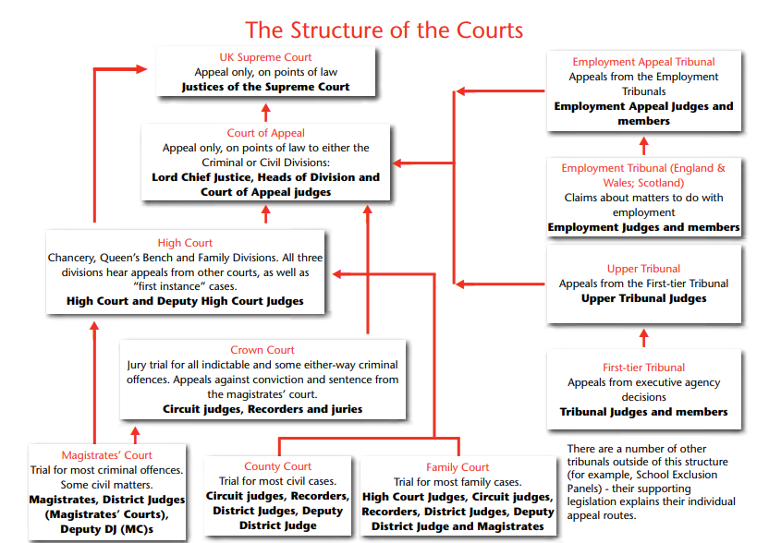

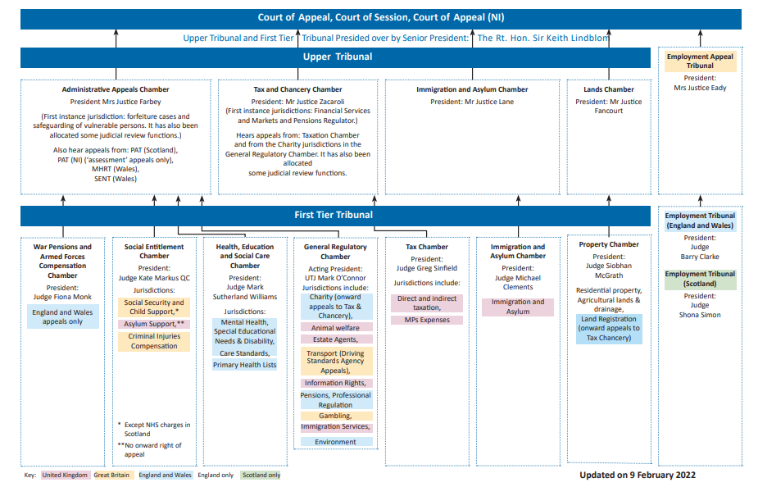

  - Explain how cases ae settled before and during formal legal procedures
Employers are encouraged to try reach a settlement before leading onto tribunals, this is normally done by negotiating directly with the individual/s and entering an agreement, however the employee will need legal advice to make any agreement legally binding, we also can look at agreeing to ACAS’ conciliated settlement, or by using a private mediator. In some cases, as an employer, you can also look at using a judicial mediation by an employment judge where a tribunal proceeding has been issued. (CIPD. (n.d.). Settlement and compromise agreements Q&As 2021) It is important to understand that these proceedings can be difficult to approach, and that there are rules to be followed.
ACAS has a role to play with regards to the early conciliation process, as his can provide an opportunity for the employer to settle the matter without the need to go to court. ACAS provide what is known as a COT3 which is a legally binding agreement, in which disputes are settled between the employer and the employee.
The process of these discussions is to first invite the individual/s to the meeting, after this it would be to hold the meeting and the employer may explain it concerns, which can range from performance, disciplinary proceeding or a breakdown of working relationships. It is important for the employer to provide as much information as possible so that there is a clear understanding of why the meeting is taking place. The third step would be to provide a written offer, depending on if the employee is happy to explore this route. Of which a letter will be drafted outlining the principal terms. The final step would be the settlement agreement. It is important for the employee to take individual legal advice. If the employee does not wish to explore settlement, if is vital that the negotiations should cease and that the underlying problem is resolved.
The reason that this process should be followed is to ensure that it is voluntary, and that it is done without prejudice, this means that there is no loss or waver of rights or privileges. It is also important to obtain independent legal advice as this can help you understand the strengths and weaknesses of your case, along with getting legal support throughout the process.
4.1 Explain the major statutory rights workers have in relation to pay
Under the Employment Rights Act 1996 the worker and the employer are afforded rights and responsibilities with regards to pay and the protection of the employee’s wages. It is vital that each induvidual employee is paid the right statutory wage as seen in the diagram below.
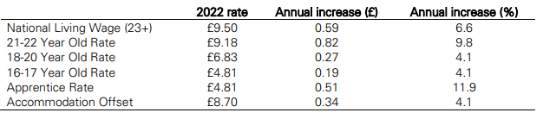
Each employee is also entitled to and is a statutory duty from the employer to provide a written statement, calculating the wages and the intervals in which the wages will be paid. This also must be itemised and set out with the gross wage of the employee and include any deductions. Employers will also need to be aware what minimum wage workers should get, as this would depend on their age and if they’re and apprentice. This all links with ensuring that employees are entitled to equal pay, this explains that by law men and women must get paid equal pay for doing ‘equal work’. Working time regulations ensure that there is a limit on how many hours one employee can work, this limit is normally 48 hours in one week, ensure that they are entitled to 5.6 weeks paid leave pre year and night workers should only work an average of 8 hours in a 24-hour period. sickness pay, and maternity and paternity pay. Also being introduced soon will be the right for parents to have neonatal leave, this looks like it may be equal pay with regards to maternity leave or may come under the unpaid/time off for dependant’s rights.
4.2 Explain the major statutory rights in leave and working time
As touched on slightly above, the working time legislation and are governed by the Working Times Regulations 1998. CIPD (2019) explains that the basic rights of an employee and their protections are a limit of an average of 48 hours a week over a 17-week period, this then requires a limit of an average of 8 hours worked within 24 hours. This also requires that there is an 11-hour rest period a day.
Annual leave entitlement allows a full-time employee 28 days, it is made up of a standard 20-day entitlement plus 8 days bank holidays. It is vital that when employees are on annual leave that they are paid their standard days rate of pay, this should apply if it is and what ever the working pattern. Calculating holiday pay (www.acas.org.uk. (n.d.). Calculating holiday pay) explains that this usually starts on a Sunday and ends on a Saturday. You should calculate your holiday pay from the last full week that you worked. For example, if you get paid £300 per week, you should then be paid £300 in holiday pay.
There are three different types of rest breaks that you are entitled to take at work. This is rest breaks at work, which means that you are entitled to one uninterrupted 20-minute rest break, if they work more than 6 hours in one day. Daily rest breaks, which I toughed in above. This means that the worker has the right to 11 hours rest in between working day. Finally weekly rest, this covers the workers rights to have either, 24 hours of uninterrupted without work each week, or 48 hours uninterrupted without work each week.
Another statutory right is provisions for night workers. This means that anyone who works at least 3 hours during the night period, is a night worker. The night period would be from 11pm – 6am. There are limits on what night workers can do, as they must not work for more than an average of 8 hours in a 24-hour period. This can be calculated over 17 weeks but cannot be any longer than a 52-week period. If both worker and employee agree to these terms.
4.3 Explain the main principles of maternity, paternity and adoption rights in the context of employment rights
Employees have the right to maternity, paternity and adoption leave from work. Maternity leave is taken either in a 9-month block of a 12-month block (however 9-12 months are unpaid). You can also cut your maternity leave short and return to work at any point. Within this time, you would be entitled to either statutory pay from your employer, or if this isn’t possible due to continuous service or the employee’s average weekly earnings are lower, there is an option to apply for maternity allowance. You are also entitled to take paid leave for any antenatal appointments that may come up during your working day (most employees will ask for proof of appointment for this to be allowed). During your maternity leave you are also allowed to do up to 10 KIT days these are Keeping in Touch Days to ease you back into the business when your maternity leave is coming to an end. The pay for this is usually calculated with your maternity pay in mind, and your employer will look at topping up your ‘maternity pay’ to your standard working days pay.
You are also entitled to share maternity leave with your partner, of which you can share up to 50 weeks of leave and up to 3 weeks of pay between you. You can choose to take this leave in blocks, by periods of weeks, take it all in one go, or you can choose to both be off work together. This is also an option if using a surrogate to have a baby, adopting a child, or fostering a child who you are planning to adopt. There are different criteria if you are adoptive parents or using a surrogate
4.4 Explain other employment rights relating to flexible working
The Flexible Working Regulations 2014 explains that to request flexible working you would need to be employed for at least 26 weeks, and this would have to be continuous. The employee has the right to fill in and submit the application, and any pervious flexible working arrangements would need to be made clear.
There are a variety of different types of flexible working, and different ways in which they can be done. Government Digital Service (2012) details them, from job sharing, working from home, part time, compressed hours, flexitime, Annualised hours, staggered hours and phased retirement (once they reach retirement age). It can also be requested that Sunday working, or religious reason should be considered if requested. These must be written requests and your employer has up to three months to decide. If the request is granted, the terms and conditions of your contract will also need to change. Flexible working requests can also be refused, if the employer believes that for example added cost would be damaging to the business, it will affect quality and performance and there is a lack of work to be done between the proposed working times. These are a few examples, however there are more reasons that an application can be rejected.

2.1 Evaluate the principles of discrimination law in recruitment, selection and employment
It is important that the principles of discrimination are looked at when going through the recruitment, selection and employment process. It is important to look at discrimination, and looking at the positives and the negatives, also looking at the genuine occupational requirements. Positive discrimination can have a large impact on the organisation overall. Positive action is a lawful way of improving diversity in the workforce, and you can run recruitment or promotion process which looks a scoring, if everyone in selection is of equal merit, you can pick and chose those who have protected characteristics to ensure more diversity and allow that to happen lawfully. Positive discrimination is unlawful as you can have an artificially low threshold so more people pass this selection process. It is in pace to address the diversity issues; however, this process needs to be done properly to ensure that it is lawful.
Furlong v Chief Constable of Cheshire Police (2019) looks at how positive action and positive discrimination can have a negative outcome on an organisation. In this case the claim was on the ground of direct discrimination based on sexual orientation, race and sex, as the organisation was looking to improve the amount of staff that were employed. They implemented 3 selection principles, people who identify as female, black minority/ethnic, LGBTQ or disabled, were automatically picked as part of the selection process, the second was anyone who speaks English as their second language, and thirdly anyone who already worked for the organisation. So, this filled the 85 job vacancies that were available. The selection principles that they used within this process was in fact positive discrimination. It was shown that the claimant would have in fact succeeded in the application and been appointed the role, had the respondent not applied positive action at the interview stage.
2.2 Discuss the legal requirements of equal pay
The principle of equal pay implies that the work is the same, substantially the same or of equal value. The defence for equal pay claims could be that the woman and her comparator are not doing equal work, the chosen comparator is not allowed by law, and the difference in pay is die to a genuine material factor, which is not linked to the sex of the jobholders. Below are some cases that are relevant to equal pay and are relevant to equal pay in the workplace.
Redcar and Cleveland Borough Council v Bainbridge and Surtees v Middlesbrough Borough Council (2008)
Wilson v North Cumbria Acute NHS Trust
Hayward v Cammell Laird Shipbuilders Ltd (1988)
It is important to implement equal pay reviews to ensure that the legal requirements are met. Pay reviews should be a part of the overall business structure, as it can identify and eliminate any pay gaps that may not be satisfactory.
There are to remedies that are available when bringing equal pay to a tribunal. This is declaration and compensation. A tribunal can make a declaration, this looks at the rights of the claimant and/or their employer and investigates the claim bought forward. The compensation if the claimant is successful, they will be entitled to, the same pay as their comparator, back pay to the date of the equality clause, up to a maximum of six years, and interest on back pay.
Word count: 2831

Bibliography
About Employment Law | CIPD (2019). About Employment Law | CIPD. [online] CIPD. Available at: https://www.cipd.co.uk/knowledge/fundamentals/emp-law/about.

www.acas.org.uk. (n.d.). Non-disclosure agreements | Acas. [online] Available at: https://www.acas.org.uk/non-disclosure-agreements.

Anon, (n.d.). Understanding the labour market: pandemic not pandemonium • Resolution Foundation. [online] Available at: https://www.resolutionfoundation.org/publications/understanding-the-labour-market/.

BBC Bitesize. (n.d.). What is equality and social justice? [online] Available at: https://www.bbc.co.uk/bitesize/topics/znbrpg8/articles/z42khbk.

CIPD (2019). Working Hours & Time Off Work | Factsheets | CIPD. [online] CIPD. Available at: https://www.cipd.co.uk/knowledge/fundamentals/emp-law/working-time/factsheet.

CIPD. (n.d.). Employment Regulation & the Labour Market UK | Guides. [online] Available at: https://www.cipd.co.uk/knowledge/work/trends/labour-market-regulations.

CIPD. (n.d.). Settlement and compromise agreements Q&As. [online] Available at: https://www.cipd.co.uk/knowledge/fundamentals/emp-law/dismissal/settlement-compromise-agreements-questions.

Courts and Tribunals Judiciary (2019). Structure of the courts & tribunal system. [online] Judiciary.uk. Available at: https://www.judiciary.uk/about-the-judiciary/the-justice-system/court-structure/.

EMPLOYMENT TRIBUNALS. (2018). [online] Available at: https://assets.publishing.service.gov.uk/media/5c66abfd40f0b61a1e93a27a/Mr_M_Furlong_v_The_Chief_Constable_of_Cheshire_Police_2405577.18_judgment_and_reasons.pdf.

Equal Pay Q&As | CIPD (2019). Equal Pay Q&As | CIPD. [online] CIPD. Available at: https://www.cipd.co.uk/knowledge/fundamentals/emp-law/equal-pay/questions.

Government Digital Service (2012). Flexible working. [online] GOV.UK. Available at: https://www.gov.uk/flexible-working/types-of-flexible-working.

GOV.UK. (n.d.). Mr M Furlong v The Chief Constable of Cheshire Police: 2405577/2018. [online] Available at: https://www.gov.uk/employment-tribunal-decisions/mr-m-furlong-v-the-chief-constable-of-cheshire-police-2405577-2018.

GOV.UK (2012). Rest Breaks at Work. [online] GOV.UK. Available at: https://www.gov.uk/rest-breaks-work.

Legislation.gov.uk (1996). Employment Rights Act 1996. [online] Legislation.gov.uk. Available at: https://www.legislation.gov.uk/ukpga/1996/18/contents.

Taylor, S. (2019). UK Court System & Employment Law | Factsheets. [online] CIPD. Available at: https://www.cipd.co.uk/knowledge/fundamentals/emp-law/about/uk-court-system-factsheet.

Working Time Guidance & Regulation | CIPD (2019). Working Time Guidance & Regulation | CIPD. [online] CIPD. Available at: https://www.cipd.co.uk/knowledge/fundamentals/emp-law/working-time.

www.acas.org.uk. (n.d.). Getting legal advice - Acas. [online] Available at: https://www.acas.org.uk/getting-legaladvice#:~:text=It%20can%20be%20useful%20to%20get%20independent%20advice [Accessed 18 Mar. 2022].

www.acas.org.uk. (n.d.). Calculating holiday pay | Acas. [online] Available at: https://www.acas.org.uk/checking-holiday-entitlement/calculating-holiday-pay.

‌

‌

‌

TASK 2 Email format
From: HR Officer
To: ABC Limited
Date: 26 March 2022

Subject: Closure of site
3.1 Discuss the legal implications of managing change
When closing a site, you need to consider a reasonable notice period to inform your employees that are affected by the closure. You may also want to investigate the contract and see if you have included a mobility clause into this, as this would outline reasonable adjustments with regards to relocation. It is important that you look at as many reasonable and best practices possible when looking to make a large and important change.
fairwork.gov.au. (n.d.) explains that there is a reasonable process for consultation and this avenue should be explored. It may be a beneficial approach to look at consultation and cooperation in the first instance. As you may be making better decisions when you have the employees’ input, it is easier to implement, as employees have been involved in the planning process, you will receive better performance during the period of change, and there will be less speculation with towards to misunderstanding, rumours and disputes, and this may also improve employee engagement and performance.
Kellogg Brown & Root (UK) Ltd. v (1) Fitton and (2) Ewer is a good case law to investigate as it looks at the clauses of the contracts, and the case that was made against the company. It is vital that you ensure that it is a reasonable enough request for the employees of your branch to relocate. In this case the Terms of Employment (information) Act, 1994 to 2014 explains that employees are entitled to receive at the outset of employment a statement of tier terms and conditions of employment, including specifying where the employees place of work will be. Reliance on a mobility clause or a lack of one, if bough to tribunal, claims can be bought under the unfair dismissal and redundancy payments legislation.
Proximity in ABC limited’ case to the new site could be disputed as it is vague to where what proximity the new site is located, as it states within 20 miles of each other. A better understanding of distance may allow further understanding by the employees. It is also possible that the employees may look at redundancy if the mobility clause is included and the employee is refusing to relocate as this can be seen as a reasonable reason for redundancy.
In this instance you would not need to follow the collective consultation route as you are not making 20 or more employees redundant, as it is possible, that all five, or less will choose to go down this road.
The next step would be to look and the requirements of individual redundancy consultation. Employees are entitled to a consultation if there is a risk of being made redundant. It is a point of sharing information not just with the individual, but everyone who may be affected. If there are between one and nineteen employees being made redundant there are no hard or fast rules to how the consultation should be carried out, just that it needs to be meaningful.
3.2 Explain the legal requirements relating to transfers and undertakings
It may be of interest to explore if your employees are governed by TUPE this is Transfer of Undertakings (Protection of Employment) Regulations 2006. I would recommend looking into the guidance on managing this possibility, when it comes to consultation and notification, dismissal, pensions, and require written information. It falls into two very broad categories, which are either a business transfer or a service provision change.
The two can be broken down into areas such as business transfers look at:
- Have most employees been transferred?
- Is there a high similarity between activities that have been conducted before and after the transfer?
- Have any assets such as buildings and/or movable properties been transferred?
These are some of the points that are most relevant to your case.
Service provision changes may also be looked at when it comes to TUPE. Are you going to be looking at this occurs when a client who engages a contractor to do work? This looks at either reassigning the contract to another or bringing the work in house.
It is important to understand that any employees that are transferring are entitled to carry on working for the new organisation with their existing terms and conditions of employment. You would also have to be mindful that the staff members being transferred, are also able to take their liabilities with them when it comes to statutory rights. This includes liabilities in tort, equal pay and discrimination claims, and unfair dismissal. This is also whereas previously discussed, meaningful consultation can be communicated and discussed with the employees at the earliest and most feasible time. Employers would require consulting properly and in a timely manner as it could be required to pay staff up to 13 weeks’ pay in compensation, if the process is not followed correctly.
Bibliography
ACAS (2014). Transfer of undertakings (TUPE) | Acas advice and guidance | Acas. Acas.org.uk. [online] Available at: https://www.acas.org.uk/index.aspx?articleid=1655.

Anon, (2020). Individual Redundancy Consultation (HR Help) | DavidsonMorris. [online] Available at: https://www.davidsonmorris.com/individual-redundancy-consultation/#:~:text=What%20is%20the%20individual%20consultation%20process%20for%20redundancy%3F[Accessed 26 Mar. 2022].

‌ CIPD (2020). TUPE (Transfer of Undertakings) | Factsheets | CIPD. [online] CIPD. Available at: https://www.cipd.co.uk/knowledge/fundamentals/emp-law/tupe/factsheet.

Gov.uk (2012). Employer relocation: your rights. [online] GOV.UK. Available at: https://www.gov.uk/employer-relocation-your-rights.

www.fairwork.gov.au. (n.d.). Consultation and cooperation in the workplace - Fair Work Ombudsman. [online] Available at: https://www.fairwork.gov.au/tools-and-resources/best-practice-guides/consultation-and-cooperation-in-the-workplace [Accessed 26 Mar. 2022].

‌ Digital, G. (n.d.). Insights - Destination anywhere? Reasonableness of Mobility Clauses in employment contracts. [online] www.rdj.ie. Available at: https://www.rdj.ie/insights/destination-anywhere---reasonableness-of-mobility-clauses-in-employmentcontracts#:~:text=Employers%20are%20required%20to%20act%20reasonably%20and%20responsibly%3A [Accessed 26 Mar. 2022].

‌

