Evaluating the Viability of Agriculture-Based Tourism in Sri Lanka
Abstract
Agri-tourism or agro-tourism has been gaining increasing popularity over the past several years as a means for farmers to diversify their income and also to fit into a larger scheme of rural development. Tourism, being an ever-ongoing contributor to the urban economy, puts greater pressure on agriculture to interface with tourism trends. Encouraging intersectoral linkages would, therefore, constitute a winning strategy for economic stability and an improvement to the quality of life of rural farming communities. Establishing linkages between economic sectors can prove to be mutually reinforcing, especially by encouraging financial diversification and providing a better quality of life for the rural agricultural population. This attempt was made to analyze the feasibility of agrotourism in Sri Lanka, while identifying opportunities and constraints relating to its development as a supplementary income for farmers. The whole range of agrotourism offers, including the recognition of varied agriculture across the country, the active participation and ownership attitude of farmers, a sufficient pool of skilled locals, and the natural beauty of rural environments associated with agricultural heritage and cultural traditions, may serve as opportunities for and may find the future of agrotourism in Sri Lanka.
The research examined the Nuwara Eliya District, relying heavily on empirical data obtained from interviews with key informants. Several challenges that restrict the development potential of agro-tourism were identified, encompassing both policy-related issues and those encountered at the operational level. Key barriers include insufficient institutional support, elevated input costs, limited market access, inadequate knowledge levels, weak infrastructure, a lack of training, and low entrepreneurial capacity. Agro-tourism has significant potential to enhance the livelihoods of villagers in rural regions. It is therefore possible to propose agro-tourism initiatives within the framework of national agricultural and market plans, as well as national tourism strategies, by utilizing locally available resources, clearly defined products, and fostering collaboration among various stakeholders.
Raising the farmers’ awareness is vital for the full utilization of the potential of agro-tourism. Farmers and stakeholders should be trained on handling and given necessary operational guidelines. Coordination between government ministries is fundamental to the enhancement of the tourism sector's farming linkages. Furthermore, research suggests that specific agro-tourism frameworks should be developed to align local contextual elements with globally recognised benchmarks. This dual strategy would ensure the quality and long-term viability of agro-tourism ventures while remaining consistent with worldwide best practices.
It is very much important to inform farmers about the better utilization of agro-tourism potential. It is recommended that farmers and stakeholders be trained on the handling process and provided with some operational guides. Better harmonization among ministries responsible for agriculture and tourism is required in order to strengthen the link between agriculture and tourism. Moreover, they recommend the need to develop context-based agro-tourism standards in line with international standards to guarantee the quality and sustainability of agro-tourism development.

Introduction
The tourism industry is one of the most prominent and rapidly growing economic sectors in the world, providing major benefits to host countries by presenting a variety of income-generating opportunities (Sofronov, 2018; Subash, 2015). Therefore, tourism development in underdeveloped nations has been generally recognized as a potential engine of economic growth, foreign currency gains, and job creation (Cooper et al., 2018). However, Community-based tourism (CBT) is viewed as a viable strategy for sustainable development and poverty reduction in rural areas, offering economic advantages and job opportunities to local populations (Okazaki, 2008; Prakoso et al., 2020). In many developing countries, rural people often benefit little from tourism, owing to little investment and promotional efforts orientated towards these areas (Radović et al., 2020; Ribeiro and Marques, 2002).
Sri Lanka is now in the initial phase of introducing agro-tourism as a new sector. Even if this concept is still fresh and insignificant in the country, it has ignited a lot of curiosity among the tourists who find it interesting. Additionally, in the same context, a number of developed countries have witnessed a significant change in their rural areas through the introduction of agro-tourism and thus they have simultaneously provided additional income for farmers. Likewise, a group of countries located in the Asia-Pacific region such as Thailand, Malaysia, India, Nepal, Bhutan, and Indonesia have gone through the process of implementing agro-tourism which has led to both social and economic benefits (Hamzah, 2012; Khanal et al., 2024; Pandey and Pandey, 2013). As afore-mentioned countries, agro-tourism has been the result of a carefully prepared plan that directly connects agricultural and rural development, and the most recent policies aimed at improving farmers' conditions are being enacted.
As noted by Ariyawardana (2021) the country is in the nascent stage of developing agro tourism , the implication is that Sri Lanka has all the fine elements to initiate and proliferate it. Being a nation with a long-standing agricultural economy where agriculture had been the mainstay, Sri Lanka has seen the industry of tourism as one of the main merchandises recently. After the termination of the three-decade long civil war, the country had become a more lucrative tourist destination which therefore had been enriched by nature's abundant gifts and distinct cultural influences. The nation has welcomed a substantial number of international tourists. In the year 2024, the visitor number in this lovely tourist destination crossed the 2 million marks for the first time write the highest number since 2019 (Digest, 2024; TTJ, 2024). With an impressive 38.07% year-on-year rise, this achievement marks the best annual performance since 2019. It is a strong sign of the recovery of the tourism sector, which has gone through a number of challenges in the last five years (De Silva, 2025). The Tourism Development Strategy (2011–2016) underlines the promotion of community-based tourism and suggests tourist villages as one of the actions to improve the value chains related to the rural economy (Fernando, 2017; Kpundeh, 2017; KumudumaliSH, 2020). This includes aspects such as the harvest, wildlife, agriculture, art, and religion. In such a backdrop, Sri Lanka is well-positioned to push the use of agro-tourism as a possible way to improve the socio-economic conditions of rural farming families, thus making the whole rural community more developed.
The main objective of this research is to understand the possible prospects and highlighted difficulties of developing agritourism in the farming communities of Sri Lanka, thus positioning it as a substitute income.
Sub Objectives
- To evaluate the existing situation of the agro-tourism sector in farming communities and to explore measures that might help in their economic prosperity.
- To identify the challenges and barriers confronted by farmers in the implementation and growth of agro-tourism in prevailing conditions.
Agro tourism
Agro-tourism acts as a multifaceted sustainability catalyst, promoting economic viability, socio-cultural preservation, and environmental conservation through integrated approaches. This unique type of rural enterprise retains fundamental ties to both agricultural communities and their surrounding ecosystems, enabling mutually beneficial interactions between human activity and natural systems. The agro-tourism sector demonstrates inherent synergies with both sociocultural preservation imperatives and ecological sustainability requirements, reflecting its dual orientation toward community well-being and environmental stewardship (Ariyawardana, 2021). Therefore, research on the conservation and preservation of natural and cultural heritage is crucial for the development of a sustainable agro-tourism sector. Public authorities ought to endorse targeted initiatives that enhance sustainability in this sector, specifically to elevate the knowledge and awareness of managers and users of agro-tourism facilities. The growth of sustainable agrotourism in Europe brings both advantages and disadvantages. A fundamental strength is its agricultural foundation, which serves as a catalyst for rural revitalisation while protecting natural landscapes and cultural traditions, strengthening local communities, and supporting regional economic growth.
Agro-tourism is a specific segment within the broader category of rural tourism, characterised by its unique focus (Tripathi and Tiwari, 2024). Rural tourism encompasses tourism activities situated in countryside environments, involving diverse experiences associated with rural life and landscapes. Agro-tourism represents a distinct category of rural tourism occurring on farms, where visitors engage directly with agricultural practices and experience farm life firsthand (Utama, 2023). He further claimed that agro-tourism contributes to rural economic diversification by creating employment opportunities in hospitality, food services (farm- to- table), and transportation sectors. In this context, tourists participate directly in rural activities organised by accommodation providers, encompassing agricultural practices, animal husbandry, and various farm-related operations.

Phillip S. et al. (2010) offer a comprehensive review of the theoretical and practical aspects of agro-tourism categorisation (Figure 4). This categorisation establishes a five-step classification in which agro-tourism is included.
1. Non-working farm- A property that was previously engaged in agricultural activities but is no longer participating in farming operations.
2. Operational farm with limited tourist interaction- A working farm that mainly functions as a backdrop for tourism, without involving tourists in agricultural practices.
3. Operational farm with indirect tourist engagement- An operational farm that integrates regional products and services into the tourist experience, facilitating indirect interaction with agricultural production.
4. Operational farm with direct engagement yet indirect tourist involvement- An operational farm that provides demonstrations or educational activities pertaining to agriculture and rural living, allowing tourists to observe without direct participation.
5. Operational farm with direct tourist engagement- An operational farm where tourists participate actively in various rural and agricultural activities conducted on the premises.

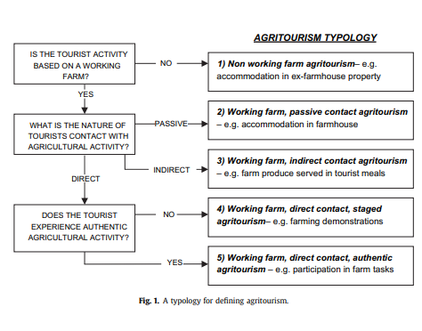

Figure 1. Agri- tourism typology

Agro-tourism involves the organisation and control of agricultural operations to provide tourism experiences. This strategy entails creating immersive services that reflect the cultural and agricultural wealth of rural communities. Such activities could include guided agricultural tours that demonstrate farming processes, Eno gastronomic encounters using local wine and products and agritourism hospitality services provide farmstay lodgings. Utama (2023) stated that Agro-tourism provides various economic, social, and environmental advantages. From an economic standpoint, it can produce supplementary income for farmers and rural communities, generate employment opportunities, and promote the development of local businesses. It aids in the preservation of cultural traditions, enhances community engagement, and offers significant educational experiences for visitors. These programs aggressively promote environmentally responsible agricultural practices, particularly organic farming and biodiversity conservation activities. They also promote increased public awareness of ecosystem preservation and wildlife habitat protection. As previously noted, agro-tourism enterprises provide a sustainable alternative to conventional mass tourist models, delivering multiple advantages that include economic prosperity, social empowerment, and environmental stewardship for host communities.
According to V and M.c (2023) argue that economic modernity has fueled the growth of agro-tourism, which is now a major topic in current discussions about rural development strategies, techniques, and programs. This transformation has allowed for a new assessment of the worth of rural resources. They further stated that this approach can provide important insights for farmers and policymakers to embrace wider perspectives on rural development. In several developing nations, policies actively promote agro-tourism as a means of increasing farmers' earnings and raising their knowledge of agriculture's importance and value (Karampela et al., 2021). The primary aim of agro-tourism is to increase farm revenue by providing visitors with organised recreational and educational opportunities. Agro-tourism offers mutual benefits to both the agricultural community and the visitors (for example see : Tripathi and Tiwari, 2024), agro-tourism generates profitable opportunities by combining agriculture with tourism, creating unique markets, services, and travel options that appeal to a wide range of regional audiences. Agro-tourism has been acknowledged as a successful entrepreneurial enterprise, allowing farmers to continue their traditional farming activities while increasing their household income(Chase, 2019). This presents an opportunity to promote the agricultural venue's "experience" through the efficient optimisation of resources. Wright and Annes (2016) posit that it offers a chance to market the "experience" of agricultural venues by effectively utilising resources productively and enhancing value through diverse activities associated with agriculture and the rural environment. Furthermore, value is enhanced through product diversification, the potential for increased profits via specialised production, packaging, and marketing, as well as by providing a range of services or experiences linked to a specific product or production method, including direct sales (Davis, 2006; United Nations Conference on Trade and Development, 2020, pp. 56–63). According to conference findings, direct-to-consumer sales tactics enable agricultural producers to bypass traditional distribution channels, allowing for improved profit margins by eliminating middleman expenditures. As illustrated in table 1. outlines essential categories of agro-tourism, emphasising significant activities and products linked to each category (Tripathi and Tiwari, 2024).

Table 1. Agro-Tourism Activities
Farm-centred experiences | Visitors may participate in various agricultural experiences, including guided farm tours, hands-on activities such as harvesting, planting, and gathering produce, hay waggon rides, horseback excursions, live farming demonstrations, fishing in stocked ponds, wine tasting, and cattle-riding activities.
Entertainment and Educational Activities | Visitors may engage in diverse recreational and educational activities, including the exploration of nature trails, wildlife observation, hiking, kayaking, and boating. Additional activities encompass visits to farm museums and heritage sites, as well as participation in fairs, festivals, and special events that honour food, crafts, nature, flowers, art, heritage, and cultural traditions.
Local Gastronomy and Lodging | Visitors can enjoy immersive experiences such as staying at farms or ranches, sampling unique dining options, or experiencing bed and breakfast accommodations. Agro-catering services and opportunities to taste fresh farm products in scenic picnic areas also enhance the experience. In addition, cooking workshops and live demonstrations provide hands-on learning about preparing meals with locally grown ingredients.
Marketing and retail of agricultural products | Farmers can promote their products through a variety of channels, including on-site sales (such as pick-your-own operations and farm stands) and off-site locations such as farmers' markets, agricultural fairs, and community events. Furthermore, the sale of processed or value-added items, whether direct or wholesale, provides additional opportunities to promote farm products.
Additional products and experiences | Engaging in the sale of locally crafted handicrafts, participating in community-based business activities, and partaking in photographs of wildlife experiences.

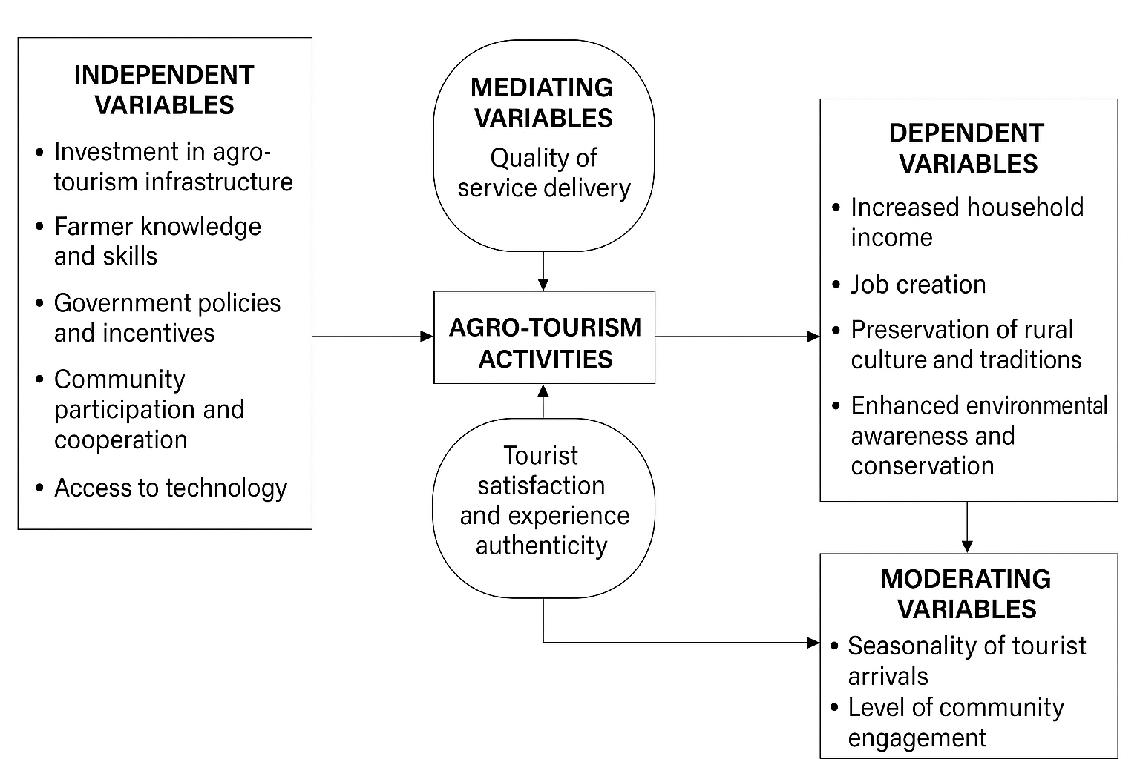
Conceptual Framework
Figure 2. Sustainable Agro-Tourism Experience Framework (SATEF)- Source: Authors’ elaboration.

The tourism sector's potential to alleviate poverty in developing countries is constrained by substantial revenue leakages, wherein a considerable portion of generated income fails to benefit the impoverished, as higher-income groups secure a significant share (Blake, 2017; Croes, 2017; Sandbrook, 2010). According to Anderson (2013) claims that conventional mass tourism provides negligible benefits to host towns because to extensive external procurement of materials and services, resulting in major income drain from local economies. As a result, specialized tourist models have arisen as viable alternatives aimed at mitigating negative socio-environmental impacts while maximising economic benefits for local residents.
Agro-tourism has become a significant alternative to mass tourism, providing economic, social, and environmental advantages to local communities and serving a vital function in rural development strategies and initiatives. It facilitates the re-evaluation of rural resource values amidst economic modernisation, fosters wider perspectives among farmers and policymakers (Karampela et al., 2021), and is increasingly advocated in developing nations to increase farmer incomes and raise awareness of agriculture's (Ariyawardana, 2021).
Agro-tourism seeks to enhance agricultural income by providing tourists with structured leisure and educational experiences through intentional development strategies. This model generates reciprocal benefits for both farmers and tourists through the development of innovative commercial opportunities, hospitality services, and destination experiences. It simultaneously promotes crop diversification, enhances the economic status of rural communities, generates revenue streams, and broadens distribution channels for local agricultural products (Barbieri and Streifeneder, 2019; Bevanda et al., 2018). Additionally, it enables farmers to remain engaged in agriculture and improve their families' quality of life through supplementary earnings (Tripathi and Tiwari, 2024).
Agro-tourism has been recognised as a form of entrepreneurial activity (Phelan, 2015). The approach facilitates the marketing of the agricultural venue's "experience" through the effective utilisation of resources. Value can be created by providing diverse agricultural and rural experiences, as well as expanding product lines and improving revenue prospects through targeted production methods, customised packaging, and effective marketing approaches. Value creation entails providing complementary services or immersive experiences related to core products or manufacturing processes, with direct-to-consumer sales channels serving as a crucial component. Curtis et al (2018), Aguglia et al (2009), and (Park et al., 2018) scholars argue that direct marketing techniques allow agricultural producers to bypass traditional distribution networks by selling directly to end consumers, potentially increasing profit margins. Furthermore, scholars have emphasised agro-tourism's dual significance as both a conservation strategy for farming assets and a means of maximising resource efficiency. This method promotes an interdependent dynamic between traditional agriculture and tourism sectors by sharing productive inputs such as land, labour, and financial resources.
Agro-tourism contributes to rural development by leveraging underutilised farm resources such as accommodation, meals, water, labour, and space for diverse agro-tourism activities (Khanal et al., 2024; Pandey and Pandey, 2013). This approach generates supplementary income for farmers and supports the implementation of agro-tourism promotion policies, especially in developing nations. Moreover, Enhancing the local tourism sector can serve as a strategic response to the adverse impacts of economic transition in small communities. It provides income-generating opportunities for economically disadvantaged populations through employment, entrepreneurship, and participation in supply chains. As noted by Ashley et al. (2007), tourism directly contributes to increased wages and business prospects. Furthermore, infrastructure improvements associated with tourism often facilitate broader economic linkages and stimulate the emergence of new enterprises as shown in the figure 5.

Key considerations in sustainable development
Sri Lanka is promoting community-based tourism and developing tourism villages, emphasising rural tourism to enhance socio-economic outcomes. It is crucial to analyse the definitions and features of rural tourism and agro-tourism, as well as to investigate their interrelations. A comprehensive understanding of these linkages can greatly enhance the socio-economic impact of tourism initiatives across the country.
The Brundtland Report, as articulated by the United Nations Commission on Environment and Development (UNCED), delineates three fundamental pillars of sustainable development: economic growth, environmental stewardship, and social equity (Purvis et al., 2019) aiming to achieve a balance among these elements. Figure 3 below demonstrates the application of sustainable development within the context of this paper.

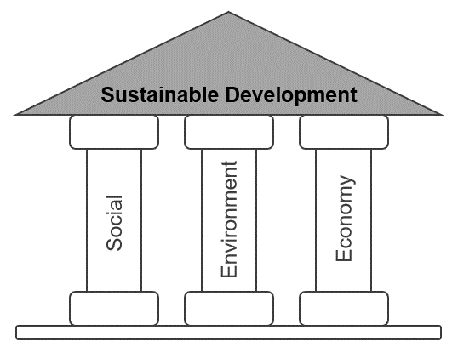

Figure 3. Pillars of Sustainable Development (Purvis et al., 2019)
Sustainable development is a core notion that guides contemporary international cooperation frameworks. In 2015, the United Nations General Assembly established the 2030 Agenda for Sustainable Development, which included 17 Sustainable Development Goals (SDGs). The worldwide framework went into effect in January 2016 (UN, 2015; UN, 2017). Over a fifteen-year period (2016-2030), worldwide efforts prioritised the widespread adoption of the SDGs by all member nations. These projects, in particular, emphasised three key objectives: (1) poverty and inequality reduction, (2) climate change mitigation, and (3) promoting inclusive society for all populations. The Sustainable Development Goals (SDGs) are an evolutionary step beyond the Millennium Development Goals (MDGs), broadening their framework with the ambitious goal of eradicating poverty in all of its forms worldwide (Wahyuningsih, 2018).
The supplementary objectives are intended to be applicable across all nations, regardless of their economic status, with the purpose of fostering prosperity and ensuring environmental protection. Addressing poverty requires alignment with economic growth strategies and the fulfilment of social needs, including education, employment opportunities, social support, and security, while also ensuring environmental protection is not overlooked. The aforementioned aims are designed for universal adoption across all nations, regardless of economic status, necessitating the engagement of essential stakeholders including governments, civil society, and the business sector. Furthermore, The United Nations Division for Sustainable Development (UN-DSD) has identified sustainable consumption and production as a top priority, with a focus on: (1) resource efficiency optimisation, (2) pollution prevention, and (3) the implementation of comprehensive life cycle assessment methodologies across all production systems (See; United Nations Conference on Trade and Development, 2020).
Considerations on Sustainable Development in Tourism
The fast rise of mass tourism in the 1970s sparked global alarm about its triple-bottom-line effects, which included economic distortions, cultural disruptions, and environmental damage. These concerns prompted greater academic and policy focus to establishing alternative tourist models that prioritise environmental principles.
Sustainable tourism is fundamentally linked to the increasing global focus on sustainable development and the foundational research conducted by the Brundtland Commission 1983 (Saarinen, 2021).
Sustainable tourism can be approached through multiple methodologies. The United Nations Environment Programme (UNEP) and the World Tourism Organisation (UNWTO) (2005) define it as follows:
- Sustainable tourism development necessitates making the best use of environmental resources while maintaining vital ecosystem functions and promoting the preservation of biological diversity and natural heritage.

- It points out the importance of respecting the socio-cultural authenticity of local communities, preserving their natural and cultural heritage, and promoting cultural understanding and tolerance.

- This approach ensures the sustainability of economic activities by enhancing the socio-economic welfare of all stakeholders. It includes the creation of secure employment opportunities, income generation, provision of social services for local communities, and efforts to alleviate poverty.

The World Tourism Organisation (UNWTO) describes sustainable tourism as a method that considers current and anticipated implications in three dimensions: economic viability, social equality, and environmental conservation. This paradigm meets the demands of a variety of stakeholders, including tourists, industry operators, natural ecosystems, and destination communities (Grandcourt, 2020). UNESCO describes sustainable tourism as a method that prioritises respect for both host populations and visitors while actively protecting cultural treasures and ecological systems (Rasdi et al., 2019; Sihombing et al., 2024).
Bramwell et al.(2017) and Bramwell (1993) present a basic sustainable tourism framework designed as an intentional intervention mechanism. This strategy addresses friction points and communication gaps caused by the dynamic interaction of tourist operators, guests, ecosystems, and local inhabitants. Their concept sees tourism development as an essential component of global sustainability goals, acknowledging the sector's reliance on three important pillars: ecological assets, cultural capital, and community resources. To obtain and retain high-value resource inputs across all operational domains, the tourist sector must actively engage with sustainable development imperatives via cross-sectoral collaborations (Choudhary, 2021; Jones and Comfort, 2020).
Sustainable tourism aims to reduce its ecological footprint while striking a balance between environmental preservation, socio-cultural integrity, and economic sustainability. Without effective governance measures, rural tourism destinations face negative repercussions from uncontrolled tourism development. The continued degradation of rural landscapes jeopardises their accessibility and utility for future generations. This demonstrates the vital relevance of implementing circular economy ideas in the tourism industry.

Methodology
The research utilised both the primary and secondary methods of data collection for the examination of the growth of agro-tourism at a given place in Sri Lanka. Primary data were gained through various qualitative methods most prominently the key informant interviews and focus group discussions, which were drawn as they had the capacity to obtain varied detailed insights from different stakeholders that were relevant to the context. The study was developed through the insights of a mixed group of participants from agriculture and tourism sectors. Participants were professionals from hospitality and tour operations, agricultural training and research experts, community members, and representatives from grassroots organisations mostly involved with farming communities. Key informant interviews served as a source of expert opinion, practical advice, and the provision of information relative to the opportunities and constraints unfolding from agro-tourism at the local level. The interviews were necessary to triangulate the data collected throughout the study.
A number of focus group discussions were executed to get the direct views of the farming community. The farmers were given the floor to talk about their existing capacity, available resources, and willingness to participate in the agro-tourism initiatives. Participants raised possible obstacles and informed their take on the current agro-tourism initiatives. Farmers recommended new activities and products for addition to agro-tourism which would be possible to them and their communities.
Alongside the primary data, the secondary information was collected by a thorough review of both published and unpublished documents. These were academic articles, reports of local institutions and grey literature sourced online. The primary stakeholders included the Ministry of Agriculture, the Ministry of Industrial Development, and the Ministry of Tourism, as well as the United Nations World Tourism Organisation (UNWTO).The materials offered exceptional context and policy advice which inventoried the results in a larger perspective of development and governance frameworks referring to agro-tourism.

Study area in Sri Lanka

Research has been carried out in the Nuwara Eliya District, which is located in the Central Province of Sri Lanka, as shown in Figures 1 and 2. chosen as the place for study due to its significance in tourism and agriculture. This district was specified based on two main reasons, as a center for eco- and cultural tourism which are closely connected to agro-tourism, and its high percentage of agricultural production in Sri Lanka, which includes a variety of farming activities. The site of research was chosen according to three main factors: the tourists' accessibility to the primary attractions, the cancellation of natural and artistic culture, and the wide variety of agricultural production. Data collection and analysis were centralized in the Ambewela area, located in the district, since it was considered the most suitable area according to the predetermined selection criteria.
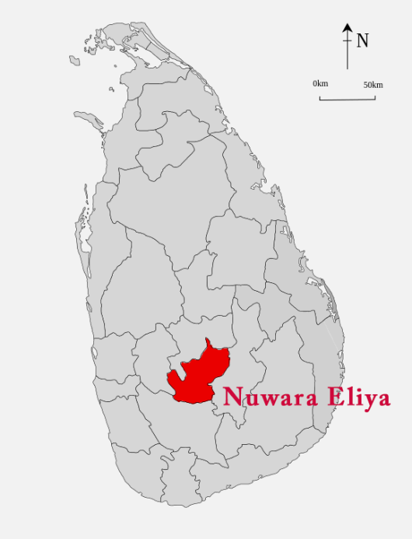

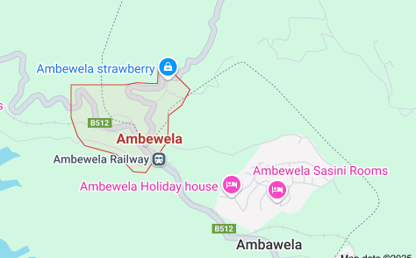

Figure 4. Nuwara Eliya District – Sri Lanka Figure 5. Ambewela map- (Google map,2025)
(Beyond, 2025)

Limitation of the study
The research emphasized two independent places that belong to the same district in Sri Lanka. The work used a qualitative method to get the perceptions and experiences of the locals about the agro-tourism in the places studied, instead of using numerical data as in other studies. The lack of access to certain financial data made it impossible to calculate the financial gains, thus limiting the analysis to a purely descriptive and interpretive format

Analysis
Participant ID | Sector | Role | Gender | Years of Experience | Notes
P01 | Agriculture | Agricultural Trainer | Male | 12 | Concentrate on the teaching of farmers and the agricultural policy.
P02 | Tourism | Tour Operator | Female | 8 | Partners with rural communities in the promotion of agritourism.
P03 | Community | Village Farmer | Male | 25 | Offered some ideas on cultural values and intergenerational knowledge.
P04 | Grassroots Organisation | Community Liaison Officer | Female | 7 | A firm supporter of women's active participation in the agritourism sector in a sustainable manner.
P05 | Hospitality | Hotel- Manager | Male | 15 | That is showing views on tourist satisfactions and local sourcing.
P06 | R&D | Agricultural Researcher | Female | 9 | Integrates tourism with sustainable farming as a main specialization.
P07 | Community | Youth Entrepreneur | Male | 5 | Different visions for the modernization of the country and the youth role in it have been suggested.
P08 | Tourism | Travel Itinerary Planner | Female | 6 | Emphasizes experiential and educational rural tours.
The Participant Profile included in Table 2. lists the demographic and contextual information of each individual involved in the study. This table is included to clarify the transparency and give a better view to the readers on the diversity, background, and relevance of the participants, thus, supporting the interpretation of the findings in the methodology and analysis sections.
Table 2. Participant Profile

The data's key themes are being discussed in Table 3, together with the participant cohort's characteristics. The enumeration of the themes in this form complies with the currently accepted methodological rules and gives a detailed picture of the degree of representation of themes in different groups of participants. In this way, the research is provided with additional analytical depth and the interpretive validity of the study is thus enriched.

Table3. Thematic Analysis of Qualitative Data
Theme | Description | Illustrative quotes | Participant Group(s) | Negative feedback
The Joint Efforts of Agriculture and Tourism. | The participants pointed out the symmetrical advantages of the phenomenon where farming techniques are attached to the tourism experience. | “People who are visiting in our place are very inquisitive about our food production; in fact, they can themselves have the practical exercise.” | Local farmers, Tour operators, Community members | A few agricultural producers expressed worries regarding their participation in tourism-related ventures, which they believe distracts them from their main agricultural activities.
Barriers to the Transfer of Knowledge | The problems connected with communicating agricultural practices to both tourism stakeholders and tourists were pointed out. | "Leisure travelers often find it challenging to follow the explanations of technical agronomy terminologies." | Specialists in agriculture, Staff of hospitality | In some cases, tour operators are not as knowledgeable about agriculture as they should be; thus, there is a possibility of them showing the wrong side of agriculture practices.
The empowerment of community through agri-tourism. | Agri-tourism was seen as a way to empower locals and revitalize the countryside. | "Our village has developed a sense of pride thanks to this project—we are now a tourist destination and we get an income." | Individuals from the community, Grassroots organisations. | Imagine if some people alone derive economic advantages from a certain situation while everyone else is left to deal with stress and exclusion in their community.
The requirement for capacity building is accentuated. | It was pointed out by a number of stakeholders that farmers are again again faced with the inadequate training in hospitality and tourism sector, and vice versa. | “There is an essential aspect for a farmer to learn it is in customer service which is also vital for a tour guide to know, about agricultural especially the process of crop and livestock production as well as the technology used.” | Pros in training, Hotel specialists, Community-based entities | Limited financial support, inaccessibility to rural training, and language difficulties are major obstacles to skill development.
Preservation of the Environment and Culture | The spotlight is on the preservation of local knowledge, ecosystems, and customary practices as a tourism resource. | "Tourists visit to see the natural beauty of things that we must take care of it and not only market it." | Local residents, Scientists in the field of Agriculture, Professionals in the Tourism sector. | Cultural dilution and environmental degradation are the potential risks resulting from the tourism activities which are poorly managed.

Discussion
Despite the region's established agricultural and tourism sectors, agro-tourism remains underutilised by local farmers. Only a small proportion of the agricultural community has participated in primitive agro-tourism activities, owing to a lack of awareness about the idea. This study's primary goal was to document and analyse tourism-related efforts conducted by farmers and local populations in the study area. The research findings show that agro-tourism development is greatly influenced by the area's specific natural circumstances, cultural history, and agricultural characteristics. The advancements of agro-tourism operations in the place of study were speedy and were notably influenced by the degree of tourism exposure, the types of tourists that come to the area, the existing cooperation with the tourism sector and the resources that are at the disposal of the farmers. Within the regions scrutinized in the Nuwara Eliya District, the main group of tourists targeted by these activities was the domestic tourists.
Due to the district's historical exposure to tourism activities, agro-tourism initiatives have been introduced in Ambewela which is situated in Nuwara Eliya District. There is a high degree of interest from international visitors in these types of rural tourist activities, said hotel operators based in Nuwara Eliya and Ella, which shows the possibility of growth and development in the near future. Tour operators and hoteliers have arranged village excursions that specifically highlight the ethnic culture, agricultural practices, and flora of the area's countryside to attract more international tourists. This kind of visit is characterized by the supervised marching in the village, which gives the visitors a realistic experience of the local people's life. After the guided tour, visitors could usually relax at the village lake while on the way to this endpoint along with the beautiful views of the agricultural fields and farms. Furthermore, engaged with the rural environment, tourists were given the chance to take part in traditional agricultural activities and to grow and savor the truly unique local cuisine. Specifically, foreign guests are welcomed to join the cooking of dishes and help in the process of preparing meals, which thus enhances their cultural immersion. Once in a while, some travelers would also take part in fishing at the village lake. Testimonies from visitors confirm that the stay was quite satisfactory, as they highly valued the experiences they had with the local people.
In summer, many tourists come to the local farms, and sometimes they get the chance to pick vegetables by themselves, which they consider as a special and unforgettable experience. Nevertheless, the actual observations made in the field demonstrate that such activities are not provided regularly or consistently.
Likewise, a few farmers involve tourists in the sale of their fruits and vegetables through roadside stalls, small retail outlets, or sometimes via intermediaries directly or indirectly. Increasingly, a few of them have also produced value-added strawberry jam as well. A similar number of ornamental plant growers promote the agro-tourism sector by selling flower pots in a small quantity. On the other hand, temporary accommodation facilities, which are also available to local tourists in summer, are offered by some residents. However, in general, these are not associated with farm-based activities.
Even though farmers could make earn a lot of money with the wide range of agro-tourism they can create, only a few were observed in the study area. Also, most of these activities had not yet been fully or widely integrated into the local farming. Currently, the offered agro-tourism experiences are:
- Guided visits to agriculture fields.
- Self-harvesting fruits and vegetables for tourists.
- Traditional cooking methods demonstrations along with dishes sampling.
- Authentic rural setting serving traditional meals.
- Village tours that facilitate local wildlife, picturesque landscapes, and agricultural practice exploration for visitors.
- Basic accommodation provided in village houses.
- Farmers can market their agricultural products through both direct and indirect sales channels. This includes selling fresh produce like seasonal fruits, processed value-added goods such as artisanal jams and preserves, as well as traditional handicrafts.
- Performances featuring local folk music and dance.

Challengers
Even if the farming community had the chance to broaden their scope and diversify through the growth of agro-tourism, the farmers found numerous barriers and limitations that hinder them from the full engagement in these activities. Although Ambewela is located in close vicinity of multiple tourist spots in the Nuwara-Eliya district, farmers' groups and reliable sources have recognized the ban on vending on the road as the prime hurdle to selling goods directly to the tourists. A fundamental hurdle to realising agro-tourism's full potential is the lack of linkages between agricultural producers and tourism stakeholders, which results in limited visitor participation in farm-based experiences. Another major hindrance to agro-tourism growth in rural communities is inadequate infrastructure, which includes subpar road networks, insufficient water supplies, and fragmented property holdings. To be more specific, land fragmentation has been the primary issues for both the farmers and the tourists, which lead to difficulties in the planning and management of the farm-based tourism experiences.
One of the main difficulties confronted by farmers in the course of their effort to develop agro-tourism is the lack of access to the initial capital funding necessitated for provision of quality services, especially so since most of them depend solely on the income generated from agriculture. The constraints of limited institutional assistance from government institutions make it more difficult to solve these problems and find ways to extend possibilities in the form of agro-tourism. Farmers and the key informants pointed out that the lack of basic structures particularly the sitting areas and appropriate accommodation for tourists is where they are and is that they want to be. The absence of these structures not only causes discomfort to the visitors but also contributes to the limited participation of the community at large in the agro-tourism initiatives. Farmers also spoke of a deficiency of learning and knowledge about the standards of quality that should be maintained by them and stressed upon the fact that not having training andassa ofīnàbility to take part in this activity as a promising venture.

Conclusion
It can be anticipated that agro-tourism farmers will have significant chances which are going to lead them to increase their income through the management of different activities that rely on resources available around. Still, the number of agro-tourism projects within the farming community is limited and not fully integrated with the main core of the agricultural operations it should belong to. Empirical evidence reveals that farmers having institutionalised linkages to tourist networks are better able to undertake long-term agro-tourism operations. This research emphasises the need of formalised tourism sector collaborations and institutional support mechanisms in promoting effective agrotourism development.
Agro-based tourism in farmers has several challenges starting from the problem in the policy to the obstacles at the grass root level. The low number of policies focused on targeted initiatives that directly encourage farmer involvement has negatively affected the development of agro-tourism as an effective rural development approach. Besides, the local barriers, which are dealt with on a day-to-day basis, have added to the problem that farmers cannot access agro-tourism opportunities.

Agro-tourism offers a great development opportunity by highlighting unique agricultural traditions, regional culinary history, handcrafted products, and rural hospitality services. Existing agriculture and tourism development programs at the national, regional, and municipal levels provide a solid foundation for agrotourism expansion. Agro-tourism participation can provide major socioeconomic benefits to rural communities when implemented strategically.

Reference
Aguglia, L., De Santis, F., Salvioni, C., 2009. Direct Selling: a Marketing Strategy to Shorten Distances between Production and Consumption. Unknown. https://doi.org/10.22004/AG.ECON.57657
Anderson, W., 2013. Leakages in the tourism systems: case of Zanzibar. Tour. Rev. 68, 62–76. https://doi.org/10.1108/16605371311310084
Ariyawardana, s.s.n., 2021. Sustainable tourism development in sri lanka: a sustainable approach towards agro-tourism in nuwara eliya.
Barbieri, C., Streifeneder, T., 2019. Agritourism Advances around the Globe: A Commentary from the Editors. Open Agric. 4, 712–714. https://doi.org/10.1515/opag-2019-0068
Bevanda, V., Štetić, S., The College of Tourism, Belgrade, Serbia, Economics Institute, Kralja Milana 16, 11000 Belgrade, Serbia, Pavić, L., Pažek, K., University of Maribor, Faculty of Agriculture and Life Sciences, Slovenia, Pavlovič, M., University of Maribor, Faculty of Agriculture and Life Sciences, Slovenia, 2018. Agritourism. Between agriculture and tourism. A review. Association of Economists and Managers of the Balkans in cooperation with the Faculty of Tourism and Hospitality, Ohrid, Macedonia, pp. 243–257. https://doi.org/10.31410/tmt.2018.243
Beyond, S.L. and, 2025. Sri Lanka Tours Packages for 2020 & 2021. Sri-Lanka Beyond. URL https://sri-lanka-and-beyond.com.au/tours/sea-and-safari-family-adventure-11-days/ (accessed 4.30.25).
Blake, A., 2017. Tourism and Poverty Alleviation: Tools and Policies.
Bramwell, B., Higham ,James, Lane ,Bernard, and Miller, G., 2017. Twenty-five years of sustainable tourism and the Journal of Sustainable Tourism: looking back and moving forward. J. Sustain. Tour. 25, 1–9. https://doi.org/10.1080/09669582.2017.1251689
Chase, L., 2019. Agritourism and Quality-of-Life for Farmers. Applying Quality of Life Research 337–352. https://doi.org/10.1007/978-3-319-91692-7_17
Choudhary, S., 2021. Sustainable Development Goal towards Tourism.
Cooper, C., Volo, S., Gartner, W., Scott, N., Nunkoo, R., Seetanah, B., 2018. Foreign Direct Investment and Tourism Development: A Theoretical and Empirical Review. SAGE Publications Ltd, 1 Oliver’s Yard, 55 City Road London EC1Y 1SP, pp. 556–566. https://doi.org/10.4135/9781526461452.n33
Croes, R., 2017. Tourism potential to benefit the poor: a social accounting matrix model applied to Ecuador.
Curtis, K.R., Allen, S., Slocum, S., 2018. Fresh Produce Direct Market Sales Considerations.
Davis, J.R., 2006. How Can the Poor Benefit from the Growing Markets for High Value Agricultural Products? SSRN Electron. J. https://doi.org/10.2139/ssrn.944027
De Silva, C., 2025. Tourist arrivals grow by 38% to 2 m in 2024 | Daily FT [WWW Document]. Dly. Financ. Times. URL https://www.ft.lk/front-page/Tourist-arrivals-grow-by-38-to-2-m-in-2024/44-771305 (accessed 4.23.25).
Digest, C., 2024. “Sri Lanka Welcomes 2 Million Tourists, Celebrating a Remarkable Recovery!” - Ceylon Digest [WWW Document]. URL https://www.ceylondigest.com/sri-lanka-welcomes-2-million-tourists-celebrating-a-remarkable-recovery/, https://www.ceylondigest.com/sri-lanka-welcomes-2-million-tourists-celebrating-a-remarkable-recovery/ (accessed 4.23.25).
Fernando, S., 2017. The Tourism-Led Development Strategy in Sri Lanka. J. Bus. Technol. 1. https://doi.org/10.4038/jbt.v1i1.81
Grandcourt, M.-A.E., 2020. The role of the United Nations World Tourism Organization (UNWTO) in tourism and sustainable development in Africa, in: Novelli, M., Adu-Ampong, E.A., Ribeiro, M.A. (Eds.), . Routledge, pp. 131–138. https://doi.org/10.4324/9781351022545-10
Hamzah, A., 2012. Socio-economic impact potential of agro tourism activities on Desa Wawasan Nelayan community living in Peninsular Malaysia. Afr. J. Agric. RESEEARCH 7. https://doi.org/10.5897/AJAR11.295
Jones, P., Comfort, D., 2020. The COVID-19 Crisis, Tourism and Sustainable Development. ATHENS J. Tour. 7, 75–86. https://doi.org/10.30958/ajt.7-2-1
Karampela, S., Andreopoulos, A., Koutsouris, A., 2021. “Agro”, “Agri”, or “Rural”: The Different Viewpoints of Tourism Research Combined with Sustainability and Sustainable Development. Sustainability 13, 9550. https://doi.org/10.3390/su13179550
Khanal, Aaditi, Khanal, Avishek, Basnet, F., Joshi, S., Giri, S., 2024. Agro-tourism in Nepal: Assessment of economic, cultural, and environmental impact. Humanit. J. 1, e2024007. https://doi.org/10.31893/humanitj.2024007
Kpundeh, S.E., 2017. Sri Lanka tourism - Strategic plan 2017-2020.
KumudumaliSH, T., 2020. Impact of COVID-19 on Tourism Industry: A Review.
Okazaki, E., 2008. A Community-Based Tourism Model: Its Conception and Use. J. Sustain. Tour. 16, 511–529. https://doi.org/10.1080/09669580802159594
Pandey, H., Pandey, P.R., 2013. Socio-Economic Development Through Agro- Tourism: A Case Study Of Bhaktapur, Nepal. J. Agric. Environ. 12, 59–66. https://doi.org/10.3126/aej.v12i0.7564
Park, T., Paudel, K., Sene, S., 2018. Sales impacts of direct marketing choices: treatment effects with multinomial selectivity. Eur. Rev. Agric. Econ. 45, 433–453. https://doi.org/10.1093/erae/jbx038
Phelan, C., 2015. Confronting mortality moments: death, dying and the consumption of dark tourism. Diffus.- UCLan J. Undergrad. Res.
Phillip, S., Hunter, C., Blackstock, K., 2010. A typology for defining agritourism. Tour. Manag. 31, 754–758. https://doi.org/10.1016/j.tourman.2009.08.001
Prakoso, A.A., Pradipto, E., Roychansyah, M.S., Nugraha, B.S., 2020. Community-based tourism: concepts, opportunities and challenges. J. Sustain. Tour. Entrep. 2, 95–107. https://doi.org/10.35912/joste.v2i2.563
Purvis, B., Mao, Y., Robinson, D., 2019. Three pillars of sustainability: in search of conceptual origins. Sustain. Sci. 14, 681–695. https://doi.org/10.1007/s11625-018-0627-5
Radović, G., Petrović, M.D., Demirović Bajrami, D., Radovanović, M., Vuković, N., 2020. Can Proper Funding Enhance Sustainable Tourism in Rural Settings? Evidence from a Developing Country. Sustainability 12, 7797. https://doi.org/10.3390/su12187797
Rasdi, L.M., Som, A.P.M., Usolludin, H.H., Nordin, N., 2019. Responsible tourism and quality of life: perspective of local community.
Ribeiro, M., Marques, C., 2002. Rural tourism and the development of less favoured areas—between rhetoric and practice. Int. J. Tour. Res. 4, 211–220. https://doi.org/10.1002/jtr.377
Saarinen, J., 2021. Is Being Responsible Sustainable in Tourism? Connections and Critical Differences. Sustainability 13, 6599. https://doi.org/10.3390/su13126599
Sandbrook, C.G., 2010. Putting leakage in its place: The significance of retained tourism revenue in the local context in Rural Uganda. J. Int. Dev. 22, 124–136. https://doi.org/10.1002/jid.1507
Sihombing, I.H.H., Suastini, N.M., Puja, I.B.P., 2024. Sustainable cultural tourism in the era of sustainable development. Int. J. Sustain. Compet. Tour. 3, 100–115. https://doi.org/10.34013/ijscot.v3i02.1601
Sofronov, B., 2018. The development of the travel and tourism industry in the world. Ann. Spiru Haret Univ. Econ. Ser. 18, 123–137. https://doi.org/10.26458/1847
Subash, T., 2015. Tourism in India: Potentials, Challenges and Opportunities.
Tripathi, V., Tiwari, Dr.M.V., 2024. Agro tourism: Approaches of Tourism by introducing agriculture tourism. Int. J. Agric. Ext. Soc. Dev. 7, 93–94. https://doi.org/10.33545/26180723.2024.v7.i5Sb.655
TTJ, 2024. Sri Lanka’s tourist arrivals surpass 2 million in 2024. Travel Trade J. URL https://traveltradejournal.com/sri-lankas-tourist-arrivals-surpass-2-million-in-2024/ (accessed 4.23.25).
United Nations Conference on Trade and Development, 2020. Harnessing Agricultural Trade for Sustainable Development: Guatemala 56–63. https://doi.org/10.18356/16b6bc15-en
Utama, I.G.B.R., 2023. Review Studies Key Element of Agrotourism Management. Pros. Semin. Nas. Forum Manaj. Indones. - E-ISSN 3026-4499 1, 169–180. https://doi.org/10.47747/snfmi.v1i.1497
V, L.S., M.c, D.S., 2023. Agri Tourism - A Panacea for Rural Development. IJFMR - Int. J. Multidiscip. Res. 5. https://doi.org/10.36948/ijfmr.2023.v05i06.10288
Wahyuningsih, W., 2018. Millenium develompent goals (mdgs) dan SUSTAINABLE development goals (sdgs) dalam kesejahteraan sosial, in: BISMA. p. 390. https://doi.org/10.19184/bisma.v11i3.6479
Wright, W., Annes, A., 2016. Farm Women and the Empowerment Potential in Value‐Added Agriculture. Rural Sociol. 81, 545–571. https://doi.org/10.1111/ruso.12105

