Construction Materials

Material Science and Building Services ACBA4006
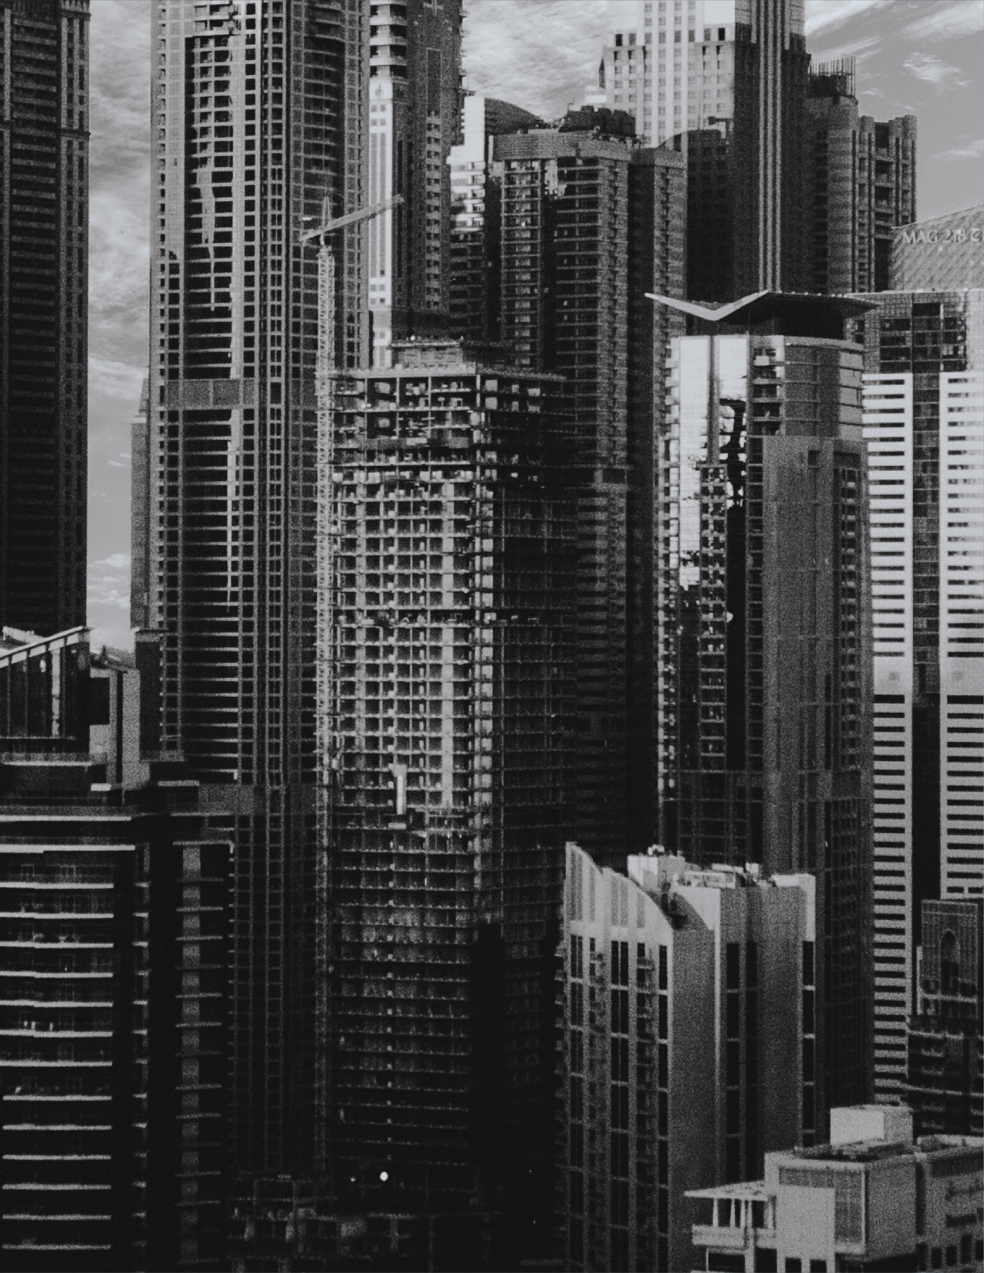
Kyle Davies
Contents
Contents __________________________________________________ 2

Introduction _______________________________________________ 3
Steel framed building – Burj Khalifa _____________________________ 4
- About the Project ___________________________________ 4

Consideration to Sustainability _________________________ 4

Concrete framed Building - Sesc Pompeia Factory Brazil ____________ 5
- About the Project ___________________________________ 5

Consideration to Sustainability _________________________ 5

Production Process of Steel ___________________________________ 6

Production Process of Concrete ________________________________ 7

Comparing and Contrasting ___________________________________ 8

Additional Graphs __________________________________ 9

References ________________________________________________10

Bibliography _______________________________________________ 11

Introduction

During recent years sustainability is shaping the way we built construction and we are thinking about the process and the waste and damage it does to our environment more than ever. During the stages of construction, pre-construction and after the project is complete all of these factors need to be considered to analysis the damage on the environment. The two main materials we use to construct a framed building are steel and concrete and both have their affects on the environment during its life cycle of the building. To understand the whole problem with the both materials being used in framed building we will need to look at two examples and their damage on the environment during the life cycle analyzing each material by comparing and contrasting each against varying factors. I will use photos and data to look at the factors. The factors that will need to be look at during this report are the following :

- Details of the two project’s during the design stage
- The potential impact of their construction
- Consideration to sustainability
- Analysis the materials used and their durability and climatic resistance to due to environmental conditions they exposed to on site
- Impact of material on the original production process
- Duration taken to construct the frames on the two different material types
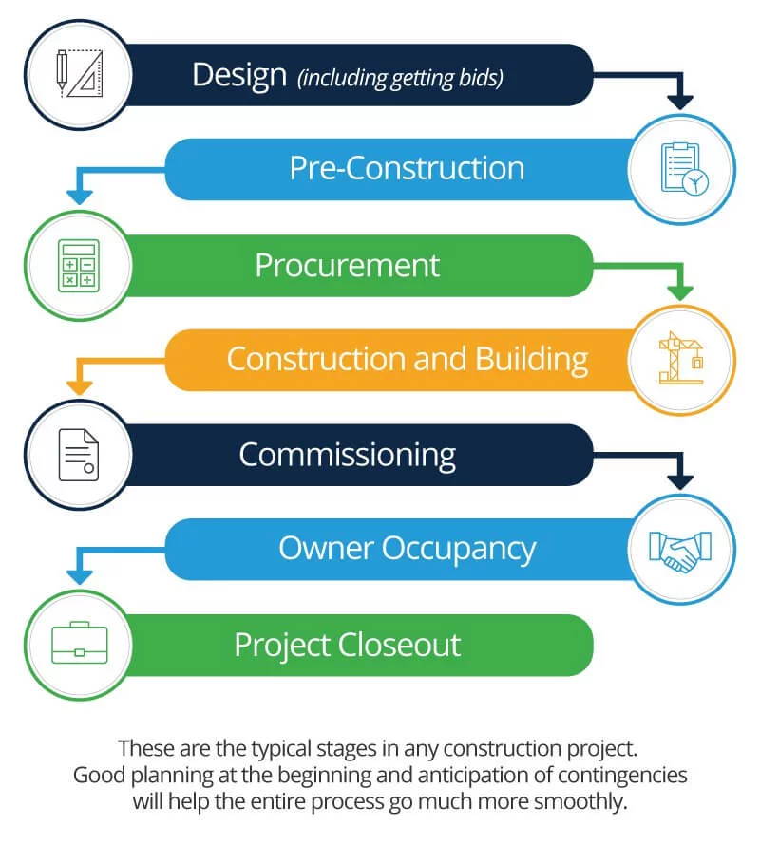

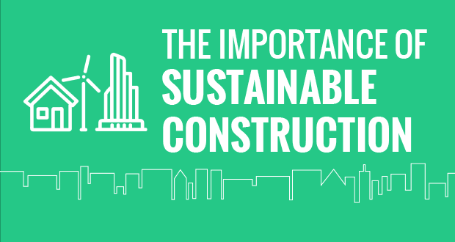
(Novotny, Rachel (2019, 19th April)

Ramos, Diana (2015, 14th November)

Steel framed building – Burj Khalifa

About the Project

The steel framed building that I will be looking at for this report is the Burj Khalifa. The building is quite unique steel framed structure. The planning of this building was different form other building due to extreme height they had to achieve. The construction of this building started in January 2004 and when it finish it become the ‘highest handmade structure in the world has ever seen’ (ConstructionWeekOnline (2010, 6th April ) and it took 1,325 days or 3.6 years to complete. The building is now full of artwork and expensive rooms for people to enjoy the building. During the design stage the architecture wanted the design to be very different from a normal high rise building and designed a ‘abstraction of the Hymenocallis flower’.(ConstructionWeekOnline (2010, 6th April ) The building needed to made and composed as three different parts around the Centre steel frame. When looking at the design and seeing what problems could occur they had a huge problem when it came to the wind and the high winding during the day and night. In Dubai the winds can get fast and can be dangerous at high height of the building. The solution for this was installing ‘over 40 wind tunnels conducted on Burj Khalifa to examine the effects the wind would have on the tower and its occupants’(ConstructionWeekOnline (2010, 6th April ) this would solve the problem with the wind climate of Dubai. The potential impact of this steel framed building being made is that the height and size of the building could cause it to fall over due to high winds at the greatest heights of the building.

Consideration to Sustainability
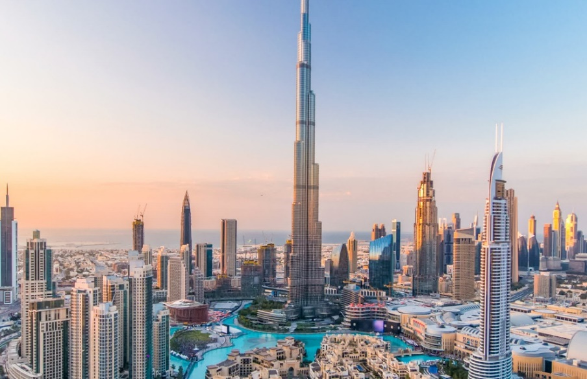
The sustainability of the Burj Khalifa is quite unique in itself. In the designing stage of the project the ‘managing director of developers Emaar’,(ConstructionWeekOnline (2010, 6th April ) Ahmad Al Matrooshi thought that this tall and amazing building should be a ‘benchmark an developments seeking sustainability in the region’. (ConstructionWeekOnline (2010, 6th April ) To do this he came up with an idea to install Solar Panels on the outside of the structure which ‘will heat 140,000 liters of water a day’(ConstructionWeekOnline (2010, 6th April ) according to the developer manager Ahmad Al Matrooshi. He goes on to say in a article that making the building sustainable and taking the measures is not an option and has to be done for the ‘sustainable growth’(ConstructionWeekOnline (2010, 6th April ) of the building, Solar panels was decided to be the best option for the building as the high climate would be the temperature could be taken advantage of and used to heat the water for the all the occupants within the building. Further into the article it stats that they installed ‘378 solar panels’(ConstructionWeekOnline (2010, 6th April ) and they were place on the roof to best get use of the sun light during the hours of light. The energy that would be created during those hours would vary but on average they would accumulate and save a total of ‘3,200 kilo watts of power per day’ .(ConstructionWeekOnline (2010, 6th April ).This shows that in the design stage some consideration to the sustainability of the project was thought about and put in the project as a main course of action.
(Getyourguide (2020, 14th January)

Concrete framed Building - Sesc Pompeia Factory Brazil

About the Project

The Sesc Pompeia Factory in Brazil is a very different type of building and took the concrete framework to a whole new level for the construction industry and the world. Nickname as the ‘Concrete Oasis’ (Smith, Louis (2015, 22nd August) the building was made in ‘the east zone of São Paulo’, (Smith, Louis (2015, 22nd August) and designed and created by an architect called Lina Bo Bardi, It was finally finished in 1982 and has been a tourist and local attraction ever since. The building was adapted from the old factory in the town, and was put up quickly and cheaply as possible. The rooms within the building are open spaces separated by small walls that do not go to the top of the building only around 2 or 3 meters high. This is a place for Art, Music and exhibitions and is a high part of the culture with classes being taught within the building and loads of study areas for people to enjoy and learn With costing little or no money at all for the community to enjoy that provide ‘education, health, leisure and culture services to the community at little or no cost. Alvarado, Paula (2012, 9th May).

Consideration to Sustainability
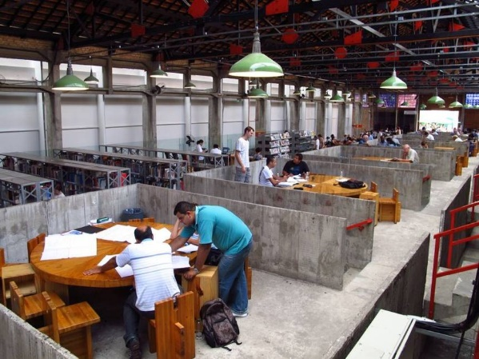
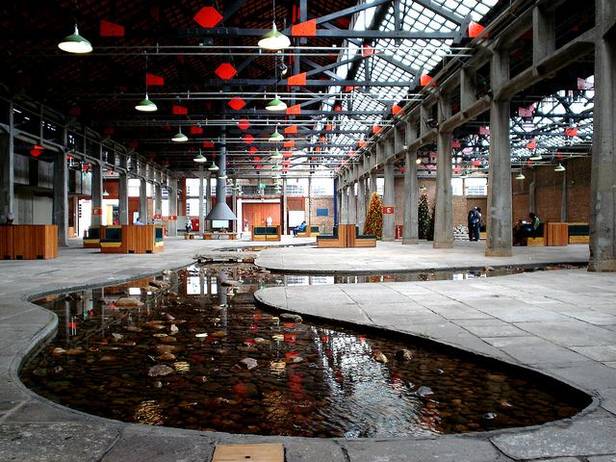
The building itself has many sustainable features that were thought about In the design stage of the project. The Architect Lina Bo Bardi included features in the building that would mean it wouldn’t need much ventilation systems or heating systems to run. Unique for its long concrete columns that go across to the different buildings, the designer understood that the factory’s main feature would be that the factory would be more or less the same it would have looked when the factory was up and running with a few changes to make the building an attraction for tourist and for people studying the arts and culture. The windows of the building instead of being complex and costly the architect just made holes in the walls were the windows would be place and installed a sliding mesh sheet that could be move back and forth for sunlight and cover from the weather. This means that the ventilation is good and has a natural flow into the building. Wasted electricity to generate lights this huge building would cost a massive amount but with the windows and large open areas the light of the day can pass though and be able to have natural lighting in the building. Ordinally the old factory was going to be demolished creating damage to the local environment but instead the architect kept the building and ‘enriched with things such as a shared hearth and a meandering, river-like length of water’.(Moore, Rowan (2012, 9th September). There is a total of three towers within the structure one mainly for water and the other two are sports center, cafes, and changing room, with also places to study. Flowing Rivers and Plants around the building is meant to symbolize nature and green sustainability. Minimum things were changed to the building to prevent it losing it historical look and this means the local environment was less damaged than you would expect from a building project. Although in both of the projects looked at for steel and concrete both have their effects on the environment in the making of the material, first we need to look at the production process of both concrete and steel.
Peng, Rui (2020, 14th January)
Alvarado, Paula (2012, 9th May)

Production Process of Steel

Frist it starts when you add coke into the blast furnace to Carbon Monoxide, this is done to reduce the iron oxide to iron. Iron needs to collect at the bottom of the furnace, the limestone creates something called ‘slag’, but at this stage the slag is in a liquid form with floats on top. The Slag will absorb all the impurities from the iron. Scarp is added the mixture to get different Quantities of Steel and oxygen is blown into the mixture forming the molten steel. See the diagram below for the first process.(Nantel, Allan (2019, November)
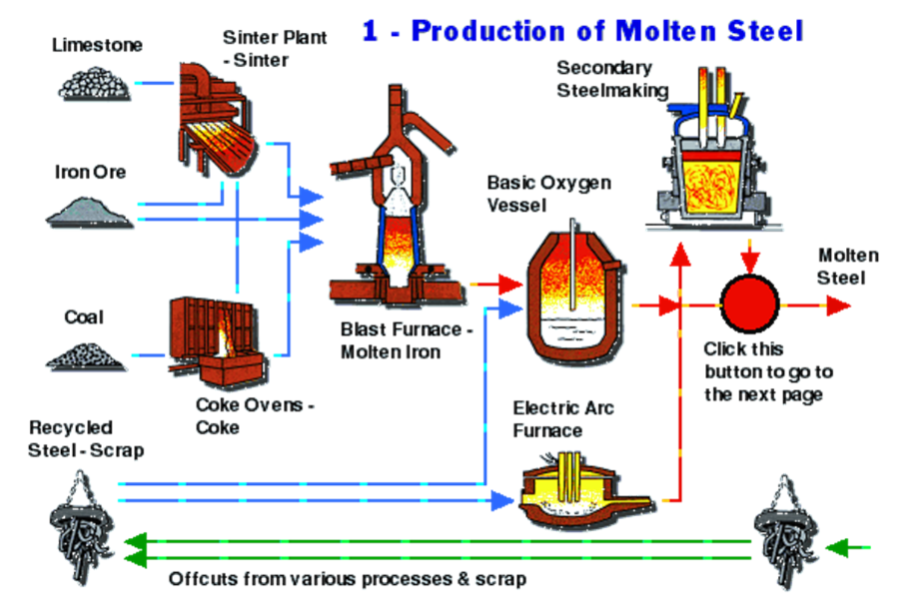

Iron is put into ladies and taken into the basic oxygen vessel

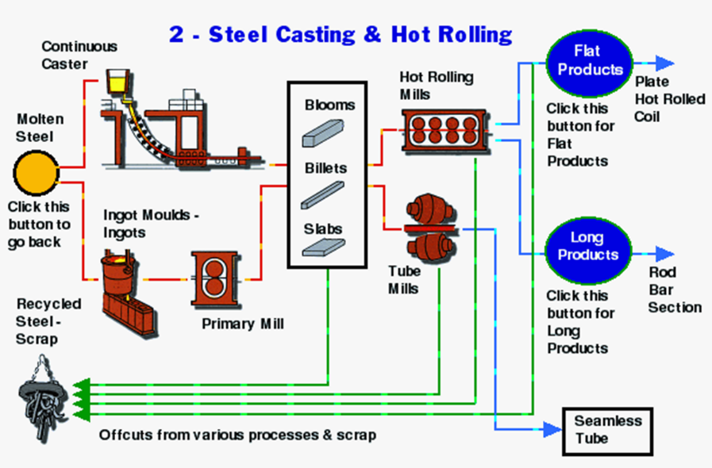
The next stage is steel production and this is where the steel is grated and hot rolled for manufacturing purposes. See diagram below:
Siddharth, Kalra (2015, 1st June)
The steel is shaped and strengthened for the different properties needed for example steel beams will be made for frames for building and designed to the specification required.

(Steel Manufacturing Process 2 (2020, 14th January)

Production Process of Concrete

The manufacturing process of concrete is far simpler than steel and therefore quicker to make. The process is still a complex one but there are the basic steps.

- Preparing Portland Cement - First it’s about preparing the Portland cement. ‘The limestone, silica, and alumina that make up Portland cement are dry’ (Howproductsaremade Forum (2020, 14th January) and is need to be broken down into a fine power and put together in the appropriate measurements, heated. It is heated to burn off the impurities like in the steel process. It needs to be burned to approx. ‘2,550 degrees Fahrenheit (1,400 degrees Celsius). (Howproductsaremade Forum (2020, 14th January) This is the temperature it needs to be to fuse the substance together and create a substance called ‘ clinker ‘. This is when cooled and out in into a ‘rotating drum filled with steel balls of different sizes’ (Howproductsaremade Forum (2020, 14th January). A substance called Gypsum is added during thing process in the rotating drum and creates a compound containing varying amount of chemicals such as ‘tricalcium silicate, dicalcium silicate, tricalcium aluminate, and tetracalcium aluminoferrite’(Howproductsaremade Forum (2020, 14th January)
- Mixing – The next stage is mixing and this is when all the gravels, sands and crushed stone is added to the mixture along with water and admixtures. Aggregates added to the mix. This is when mixed. Different curing times will depend on the admixtures added to the cement and they come in different types of concrete that can be ordered to the design of the material needed.
- Transported to site – this is when transport to site where it can be place and is ready to be used. Large machines and hand held pumps can be used to pump the concrete into the designated area.
- Curing time – the curing time of the concrete will depend on the different specification of concrete has been delivered. It is important that the concrete doesn’t cure too quick or too slow as you can get problems such as cracking and the breaking of the concrete. If the concrete doesn’t get the required strength as required the structure could collapse so testing must be done on the concrete before used. A sample should be made and kept to the designated curing time, for explain C25 concrete would take approx. 25 Days to reach full strength.
(Kylili, Angeliki (2015, October)
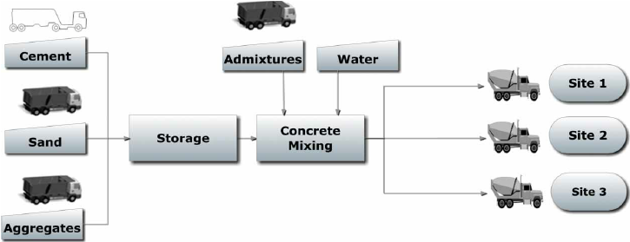
Comparing and Contrasting

Frame Type | Durability + Climate Resistance against environmental conditions | Impact the material production process has on the environment | Duration of frame to be constructed | Effects the Demolition has on the environment after its life cycle
Steel | This material is strong and long lasting. Stainless Steel is made to be protected against all weathers as the main source of damage for steel is rust. Stainless Steel won’t rust in the conditions on site. The Durability is increased when using stainless steel due to the properties. Stainless steel is made up of the following:  - 25% Old scrap such as end of life products  - 35% New Scarp which is returning from production  - 40% New raw materials added. (British Stainless Steel Association (2020, 14th January) | The production of steel has a huge damaging effect on the environment as we need to use fossil fuels to burn and heat the blast furnaces. The Blast furnaces produce harmful gases that are released in the air damaging local air and atmosphere in doing so. The waste raw material used in creating steel such as coal. The local environment is also polluted in the soil and the soil is damaged due to the expose of harmful gasses such as coke oven gas naphthalene, ammonium compounds, crude light oil, sulfur and coke dust are released from coke ovens. (Greenspec (2020, 14th January) Emissions to water and pollution nearby lakes and river can also be a problem on the environment. | Steel frames can be constructed quite quickly as they can be pre-fabricated with the manufacturer and delivered on site pre-fabricated and ready to construct. | Typically Steel can be recycled and re-use if not damaged. Although, Demolition of Steel frames after the life cycle could damage the soil strength if left un-treated.  There are two types of demolition one is using held tools and cranes to take down the structure and the other is Using explosives on the strong points of the building to make it collapse. This damages this local environment as the harmful dust and substances are blown around the area damaging local wildlife and plants.
Concrete | Similar to steel concrete is strong and typically long lasting if poured and measured correctly. But whereas steel, concrete is not acceptable to all types of weather. It deals well with cold weather but when it comes to hot weather the concrete could expand. Even in cold weather concrete is sometimes acceptable to explanation due to water getting in the cracks of the concrete. (See Diagram Below Concrete Temperature Distribution Graph)* | The production process of concrete is also damaging to the environment like steel. Making cement results in making a high level of CO2 which is damaging for the air. Burning of fossil fuels during the process of making concrete and using fossil fuels such as coal is used to gave the temperature of heating in the concrete manufacturing process. The burning of fossil fuels is bad for the environment because of the pollution it gives off. (See the diagram Below for the impacts of concrete on the environment)* | Concrete frames takes longer than steel frames to construct as concrete needs to be pumped into the designated areas whereas steel can put straight up. Concrete takes approx. 25 days to fully strengthen according to the Specification. | Concrete can be demolished quickly but releases harmful dust from the concrete itself can be inhaled and cause serious illness if not treated properly. The Environment will have similar effects to the steel and the soil strength will be damaged and the added admixtures to the concrete can make the ground and local water supplies toxic.

Concrete Temperature Distribution Graph
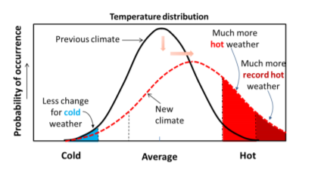

(Kaewunruen, Sakdirat (2018, 12th May)
Damaging impacts of concrete on the environment graph

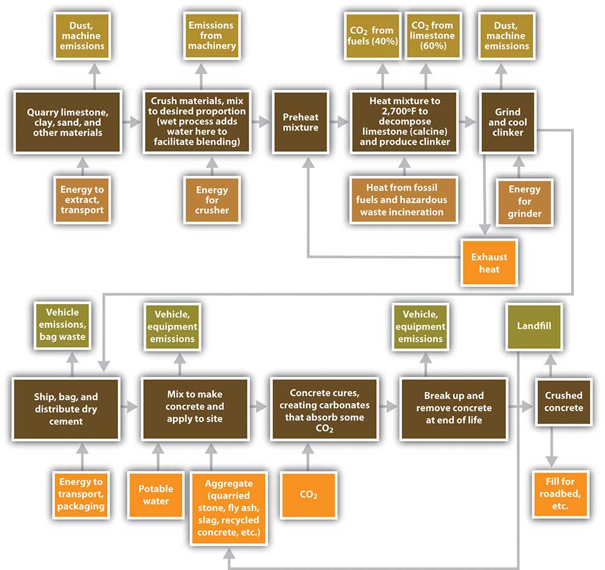

(Greenspec (2020, 14th January)
References

- (Novotny, Rachel (2019, 19th April). Picture saying ‘Importance of sustainable construction’ from an article. Retrieved from : https://esub.com/the-importance-of-sustainable-construction/
- Ramos, Diana (2015, 14th November). Picture of the Stages of a construction project from a article. Retrieved from : https://www.smartsheet.com/construction-project-management-101
- (Getyourguide (2020, 14th January) from a ticket website. Retrieved from: https://www.getyourguide.co.uk/burj-khalifa-l2703/
- Alvarado, Paula (2012, 9th May). Picture of the Sesc Pompeia building from a article. Retrieved from: https://www.treehugger.com/green-architecture/recycled-factory-thrives-social-center-supported-by-brazil-commerce-tax.html
- Peng, Rui (2020, 14th January). Picture of the Sesc Pompeia from Pinterest. Retrieved from: https://www.pinterest.co.uk/pin/317011261252441700/
- Siddharth, Kalra (2015, 1st June). Picture of the Production of Molten Steel from Quora. Retrieved from: https://www.quora.com/How-do-we-make-steel-in-steel-plants
- (Steel Manufacturing Process 2 (2020, 14th January). Picture of the steel casting and Hot Rolling process. Retrieved from: http://www.mepl-mmw.com/Steel-Manufacturing-Process2.php
- (Kylili, Angeliki (2015, October). Picture of the concrete manufacturing process from a article. Retrieved from: https://www.researchgate.net/figure/Concrete-manufacturing-process_fig5_283206129
- (Kaewunruen, Sakdirat (2018, 12th May) report. Retrieved from ‘Vulnerability of Structural concrete to Extreme Climate Variances’
- (Greenspec (2020, 14th January). Picture of ‘ The Environmental impacts of concrete ‘. Retrieved from: http://www.greenspec.co.uk/building-design/environmental-impacts-of-concrete/
- (ConstructionWeekOnline (2010, 6th April ). Retrieved from: https://www.constructionweekonline.com/article-7964-emaar-burj-a-benchmark-for-sustainability
- (Smith, Louis (2015, 22nd August). Article about the SESC Pompeia concrete Oasis. Retrieved from: https://www.brasilwire.com/sesc-pompeia-lina-bo-bardi/
- Alvarado, Paula (2012, 9th May). Article about ‘Recycled Factory Thrives As Social Center Supported by Brazil's Commerce Tax’. Retrieved from: https://www.treehugger.com/green-architecture/recycled-factory-thrives-social-center-supported-by-brazil-commerce-tax.html
- (Moore, Rowan (2012, 9th September). Article about Lina Bo Bardi: buildings shaped by love. Retrieved from: https://www.theguardian.com/artanddesign/2012/sep/09/lina-bo-bardi-together-review
- (Nantel, Allan (2019, November). Steel making process. Retrieved from: https://moodle.uwtsd.ac.uk/course/view.php?id=6448
- (Howproductsaremade Forum (2020, 14th January). Retrieved from: http://www.madehow.com/Volume-1/Concrete.html
- (British Stainless Steel Association (2020, 14th January). Retrieved from: https://www.bssa.org.uk/sectors.php?id=99
- (Greenspec (2020, 14th January). Retrieved from: http://www.greenspec.co.uk/building-design/steel-products-and-environmental-impact/

Bibliography/ Extra Research

- (Wikiarquitectura ( 2019, 21st December). Retrieved from: https://en.wikiarquitectura.com/building/sesc-pompeia-factory/
- (Pinterest (2019,21st December). Retrieved from: https://en.wikiarquitectura.com/building/sesc-pompeia-factory/#pompeia-planta-pistas
- (Handhome (2016, 16th August). Video on Youtube ‘ [46] Khu SESC Pompeia | Lina Bo Bardi ‘. Retrieved from: https://www.youtube.com/watch?v=x5n_NlGCiCI
- (Fam Properties Dubai (2016,17th December). Youtube Video ‘ How they build the world's tallest building Burj Khalifa - Construction Documentary’. Retrieved from: https://www.youtube.com/watch?v=12oynGTjYKs
- (Burj Khalifa( 2019, 28th December). Website explaining the facts and figures. Retrieved from: https://www.burjkhalifa.ae/en/the-tower/facts-figures/
- (The Constructor (2020, 2nd January ). Website on Foundations on Burj Khalifa. Retrieved from: https://theconstructor.org/structures/structural-details-burj-khalifa-concrete-grade-foundations/20512/

