

Analysis on HR department involvement in International M&A between Pembina Pipeline and TotalEnergies Se

Student name: Vasilka Sarandalieva
Student number:2113113
Module: Developing Relationships and Workplace Achievement
Modul code: BMSW5102
Lecture name: Zahra Mohammadnazari

Table of Contents
Abstract 2
Introduction 3
Pembina Pipeline Corporation 3
Total Energies Se 4
Section 1: Part 1 Cultural Analysis of Canada and France 5
1.1 Organisational culture and its impact 5
1.1.1 Power Distance 6
1.1.2 Individualism 6
1.1.3 Masculinity 7
1.1.4 Uncertainty Avoidance 7
1.1.5 Long Term Orientation 7
1.1.6 Indulgence 7
Section 1: Part 2 Institutional analysis of Canada and France 8
2.1 Institutional approach to International Human Resources Management (IHRM) 8
2.2 Impact on IHRM Practices 10
Section 2: Part 1 M&A Rationale and Integration Strategy 11
Section 2, Part 2 – Role of IHRM in implementing effective M&A 12
Conclusion and recommendations 13
References 14

Figure 1 Oil and gas sector image map 3
Figure 2 Brief Overview of Pembina Pipeline 4
Figure 3 Brief overview of TotalEnergies SE 5
Figure 4 Hofstede analysis for Canada and France 6
Figure 5 Neo-Institutional and PES analysis 9
Figure 6 Isomorphic pressure (DiMaggo and Powell,1983) 10
Figure 7 Acquisition Integration Approaches (Haspeslag and Jemison,1991) 11
Figure 8 HR Challenges in pre and post stage 12
Figure 9 HR Resolution for targeting possible challenges 13

Abstract

As part of HR team for international M&A deal between Pembina Pipeline and TotalEnergies SE, the purpose of this report is to help both companies reach rational cross-border decision. The report present a brief overview of both companies as established date, segment of operating, market share, number of employees , competitors, products, customers. An analysis on the HR department’s involvement in the different phases of the merger and acquisition. For purposes of this will be conduct Hofstede cultural analyse, in which a factor analysis structure shows how a society's culture impacts its members' values and their behaviour. In addition, Neo-Institutional framework incorporates institutional mandates to make an organization seem legitimate. In the following paragraphs will be perusing Canada and France institutional pillars and how the structure of these two societies varies in that context. Moreover, will be discussed isomorphic pressure and impact of IHRM practises in this cross-border process. Furthermore, rational and integration strategy.

Introduction

The oil and gas industry is a major contributor to the global economy. It encompasses activities such as exploration, production, refining, transport, storage and marketing of petroleum products. Oil and gas are used for a variety of purposes including fuel for transportation, heating, cooking and electricity generation (FigTree,2019). The industry also produces chemicals used in many everyday items from plastics to pharmaceuticals. The oil and gas industry is composed of several segments that include upstream (exploration & production), midstream (transportation & storage) and downstream (refining & marketing) (Darko,2014). Each segment has its own unique set of risks associated with it. The global demand for oil and gas continues to grow at an unprecedented rate due to population growth, urbanization and economic development around the world.
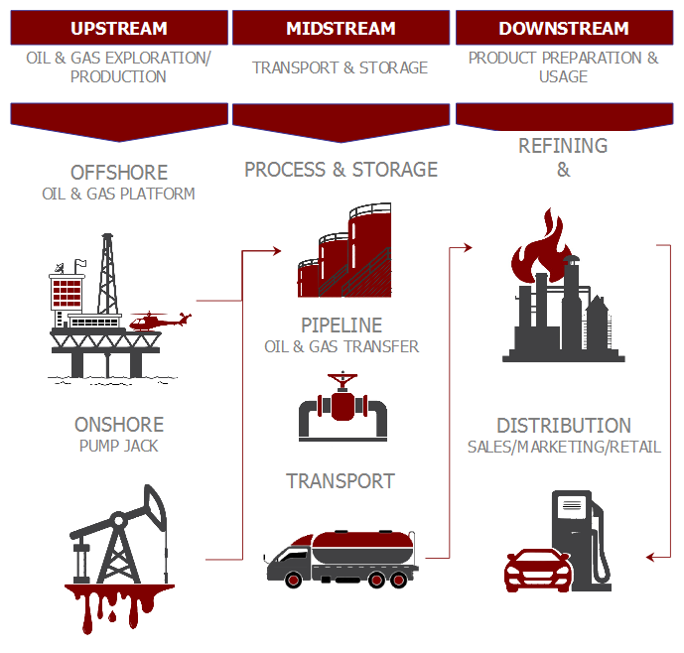
Figure 1 Oil and gas sector image map

Pembina Pipeline Corporation

The Pembina Pipeline Corporation has been providing customers with midstream and energy transportation services for more than 65 years. (Pembina,2020). The Pembina Pipeline Corp. offers midstream and transportation services. Pipelines, Facilities, Marketing and New Ventures, and Corporate make up its operating divisions. The Pipelines segment consists of conventional, oil sands, and transmission pipeline networks, as well as supporting infrastructure, storage, and spread operations for crude oil. The Facilities division includes the processing, fractionation, and supporting infrastructure needed to provide natural gas and NGL services to the company's clients. The Marketing and New Ventures division engages in value-added commodity marketing activities, such as purchasing and reselling goods and maximising storage possibilities. The business was established on September 29, 1954, and has its headquarters in Calgary, Canada (Forbes,2023).

Market share | Number of employees | Competitors | Product | Customers
$157.75 Billion | 100,000 | DCP Midstream LP  Canadian Utilities Ltd  Inter Pipeline Ltd  Frontera Energy Corp | Fuels, lubricants, bitumen, natural gas, special fluids and fuel additives, power and solar photovoltaic solutions | Private aviation  Home heating  Natural gas and power  Solar solutions  Service stations  Car wash
Figure 2 Brief Overview of Pembina Pipeline

Total Energies Se

The company was founded in 1924 with the goal of enabling France to play a significant role in the big oil and gas adventure, and it has always been motivated by a true pioneering spirit. Some of the world's most fruitful fields have been found by it (Totalenergies,2023). The integrated worldwide multi-energy corporation Total Energies SE, formerly known as Total SE, produces energy from renewable sources, oil and biofuels, natural gas and green gases, and other sources. Drilling, oil and gas production, processing, shipping, refining, petrochemical manufacture, storage, and distribution of petroleum products and speciality chemicals are all done by this company. It works in the field of renewable energy and engages in gas trading and power generating. Total Energies trades on multiple derivative markets, charters ships, and provides feedstock to chemical factories. The business provides consumer services to the manufacturing, transportation, automotive, aerospace, energy, and housing sectors. It conducts business in North and South America as well as Asia-Pacific, Africa, Europe, and the Middle East.

Market share | Number of employees | Competitors | Product | Customers
$19.27 Billion | 1260 | BP  Electricite de France  OQ Cheemicals  MOL Group  ENGIE  Shell | Ethylene and Oil Storage  Natural gas | Customers are confidential due to company policies
Figure 3 Brief overview of TotalEnergies SE

Section 1: Part 1 Cultural Analysis of Canada and France

1.1 Organisational culture and its impact

According to Schein (2010, p.18) organizational culture is defined as a set of shared fundamental beliefs learned as the group solved its problems of internal integration and external adaptation, which have been successful enough to be considered valid. Hence, new members must learn how to perceive, think, and feel when faced with these problems (Buchanan and Huczynski, 2010). One of the most comprehensive studies of how workplace values are influenced by culture has been conducted by Geert Hofstede in an effort to uncover how culture influences business behaviour. In examining IBM's employee value scores between 1967 and 1973, he analysed a large database. A further result of his study of cultures was the identification of four dimensions of culture that are influenced by national and regional cultural groupings (LI, 2015).
• Power distance
• Individualism
• Uncertainty avoidance
• Masculinity
In 1991, Hofstede identified fifth dimension: Long-Term Orientation (Hofstede, 2001). According to Michael Minkov’s analysis of World Values Survey data, sixth dimension called Indulgence versus Restraint, is added in the 2010 (Minkov, 2011).
A Hofstede analysis has been conducted for both Canada and France in order to aid the decision-making process for a cross-border merger and acquisition involving Pembina Pipeline and Total Energies SE. Figure 4, shows the results of conducted Hofstede analysis.
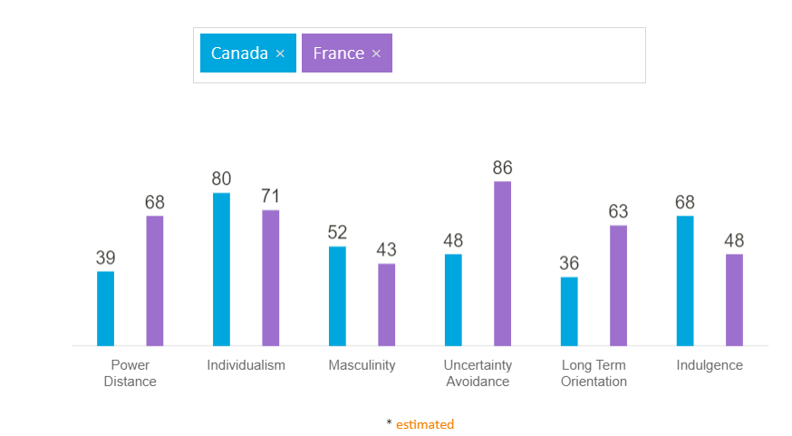
Figure 4 Hofstede analysis for Canada and France

Power Distance

A nation's "power distance" is the degree to which members of institutions and organizations with less power believe and accept that power is allocated unequally. Inequality in society is supported not just by the leaders, but also by the followers (Khatri,2009). As the results shows, in Canadian culture, leaders and followers share and consult freely. An emphasis is placed on equality, and the direct exchange of information is preferred. With bigger score, France accepts a fair amount of inadequacy, centralized power not only within companies and governments, but also geographically, with a long history of emotional dependence on parents and guardians.

Individualism

In individualistic societies, people are expected to only care about themselves and their immediate family (Tehrani and Yamini, 2022). Collectivism entails the trade of loyalty for care between members of a group. Canada scores highly on individualism. Family and self-care are important to everyone. Similarly, employees are expected to be self-reliant and provide more initiative from the organizational side. Despite not having a big difference in score from Canada, France demonstrates individualism as well.

Masculinity

In this dimension, high masculinity values ​​indicate that society is driven by performance and achievement (Salcedo and Gupta,2021). Both countries have low masculinity values and a good balance of work and personal life. Spending quality personal time.

Uncertainty Avoidance

Uncertainty Avoidance indicates how much members of a culture feel threatened by uncertain or ambiguous situations and have created institutions and beliefs to prevent them (LI,2015). As a culture, Canadians are very open-minded and accept various ideas, innovations in technology, tolerate all opinions, and exercise their freedom of speech. With very high score in this dimension, it is essential for the French to have rules and laws for everything, planned and structured to be charged, before all kinds of deals from different fields, the necessary information must be gathered.

Long Term Orientation

A normative society is determined by a score of 36 in this dimension at Canada. Normative thinking is a significant characteristic of such societies; people there are concerned with establishing absolute truths (Bukowski and Rudnicki,2019). Traditions are highly respected, saving for the future is relatively rare, and achieving quick results is often an objective. In contrast to Canada, France is characterized by a pragmatic society that believes truth is determined by many factors. Their persistence leads to success, savings, and investing. Adapt their traditions to the changing environment.

Indulgence

This aspect is defined as the extent to which people try to control their desires and impulses, based on how they were raised (Bukowski and Rudnicki,2019). A relatively weak control is called "Indulgence" and a relatively strong control is called "Restraint". Therefore, cultures can be described as indulgent or restrictive. A high score of 68 in this respect means that Canadian culture is classified as tolerant. People in societies with high passion scores often demonstrate a willingness to fulfil their urges and desires to enjoy life. They possess a positive attitude and tend to be optimistic. In addition, they value free time, doing what they want, and spending money as they see fit. France score a middle result where it concerns Indulgence versus Restraint. It is possible that the French are less relaxed and have less enjoyment of life than is widely believed based on this and their high score on Uncertainty Avoidance.

Section 1: Part 2 Institutional analysis of Canada and France

2.1 Institutional approach to International Human Resources Management (IHRM)

The Institutional Approach to International Human Resource Management (IHRM) is a theoretical perspective that examines the role organizations play in shaping IHRM practice (Edwards et al,2022). It focuses on the external environment, such as political, economic, social and cultural forces, influencing personnel decisions and practices (Huu,2022). This approach examines how the institutional systems of different countries shape HR policies and practices in terms of legal frameworks, labour markets and industrial relations. It also examines how multinational companies adapt their HR practices to the institutional contexts of different countries.
A Neo-Institutional framework incorporates institutional mandates to make an organization seem legitimate, increasing the likelihood of it surviving (Scott,2007). In the following paragraphs will be perusing Canada and France institutional pillars and how the structure of these two societies varies in that context. This analysis is comprised of three components; regulatory component, normative one and eventually cultural- cognitive component. Figure 5 Neo-institutional and PES analysis.
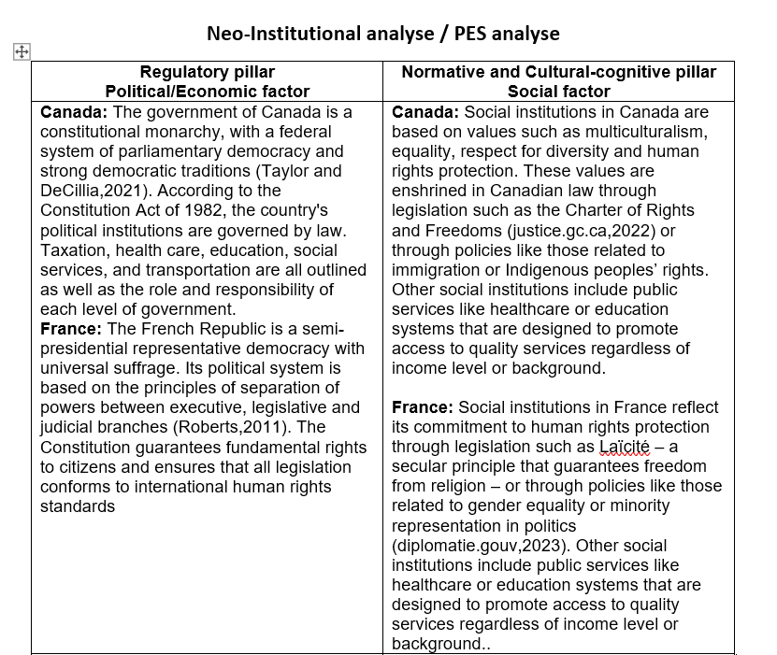
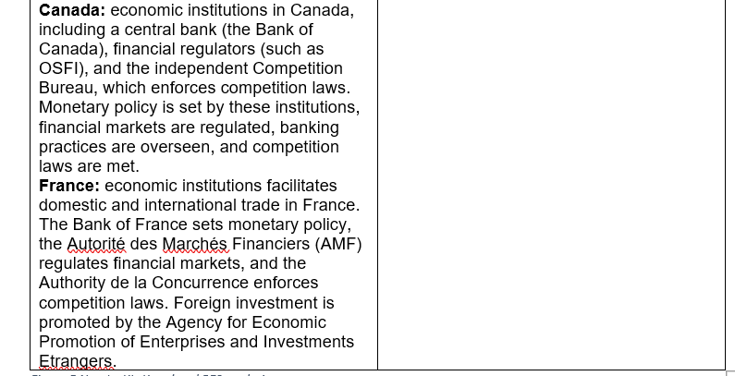
Figure 5 Neo-Institutional and PES analysis

Legislation and the policies of the government are considered coercive pressure in organizational theory, because organizations wishing to gain legitimacy as a result of compliance with the law must abide by the standards of practice laid out in that legislation. This is regardless of whether those standards are appropriate or effective (DiMaggio and Powell, 1983). Figure 6 shows the isomorphic pressure in cross-border M&A.

Figure 6 Isomorphic pressure (DiMaggo and Powell,1983)

2.2 Impact on IHRM Practices
Political, economic and social institutions for cross-border M&A, can have an impact on IHRM practices by influencing how employers recruit employees from different countries/regions/cultures; how they manage diversity within their workforce; how they develop compensation packages tailored towards different cultures/backgrounds; how they ensure compliance with local labour laws; etc.. By understanding these institutional frameworks it becomes easier for employers to make informed decisions about their IHRM strategies when operating across multiple countries/regions/cultures (Shen,2011).

Section 2: Part 1 M&A Rationale and Integration Strategy

Organizational growth has been fuelled by mergers and acquisitions (M&A) transactions for centuries. The frequency of M&A transactions has increased in modern business. M&A transactions show a steep increase, mainly for the purpose of acquiring technology (Rebner and Yeganeh, 2019). However, this is primarily driven reason for Pembina Pipeline to acquire Total Energies Se. Other acquisition rational reasons are:
- Geographical Diversification
- Cross-selling
- Synergies -“Value Creation”
- Opportunism
Haspeslagh and Jemison's acquisition integration approach model provides insight and guidance into choosing the most effective integration strategy. There are two significant criteria that companies should consider when planning for integration: Strategic Interdependence and Organisational Autonomy (Haspeslag and Jemison,1991). Figure 7 represent acquisition integration approaches.

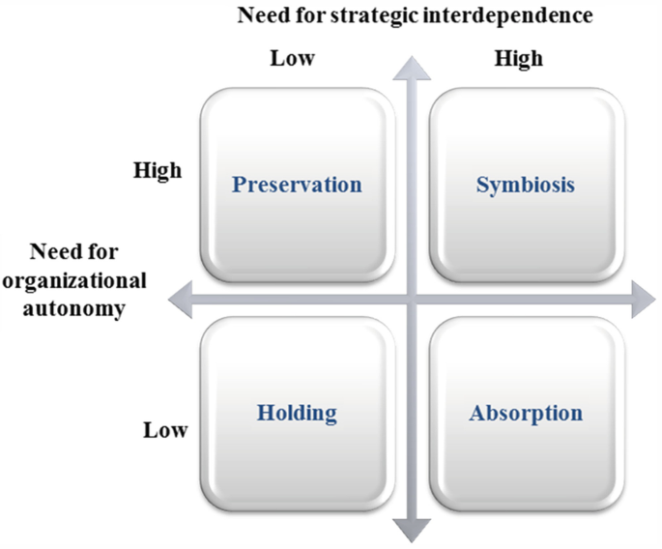
Figure 7 Acquisition Integration Approaches (Haspeslag and Jemison,1991)

The company’s acquisition is in holding stage, because integration causes some risks including management cost, financial risk, sharing of particular information. They do not integrate functions and departments in practice, so integration is not in their scope (Stevchevska-Srbinoska,2017). Furthermore, the strategic interdependence(low) and organizational autonomy (low) put the decision in holding stage of post integration.
In pre-acquisition integration both companies will be analysing strategic evaluation, financial evaluation, negotiation and planning for eventual implementation.

Section 2, Part 2 – Role of IHRM in implementing effective M&A

Acquisition success is primarily determined by an organization's ability to handle the decision-making and integration processes. An acquisition's potential value may be determined by strategic fit considerations, while its feasibility may be determined by organizational fit considerations. The actual value created however flows directly from the company's capacity to manage the acquisition process (Angwin and Meadows,2015). HR department plays a significant role in this process, as they are faced with challenges in the pre and post stages. Figure 8 represents some of the HR challenges in pre and post stage.

Figure 8 HR Challenges in pre and post stage
The key to avoiding challenges is to make sure that there is alignment in values from the get-go and identify any potential challenges. There is a need to develop a transition plan to ensure those misaligned values don't cause HR issues during the acquisition process. Figure 9 present some resolutions for targeting possible HR challenges in pre and post stage of acquiring.

Figure 9 HR Resolution for targeting possible challenges

Conclusion and recommendations

The cultural and institutional analysis of Canada and France reveals a number of differences between them, including differences in language, culture, values, uncertainty avoidance, legal systems and etc. These differences suggest that HRM practices should be adapted to fit the different country contexts rather than simply being implemented as-is across both countries. This is in line with the convergence-divergence debate which suggests that HRM practices should be tailored to fit the local context in order to maximize effectiveness. The acquisition of top managers is a complex process that presents many challenges. A merger or acquisition candidate needs to be evaluated and chosen carefully, and the appropriate price for an acquisition needs to be determined. M&A success is certainly impacted by these decisions. Managing the myriad organizational and HR concerns that surface throughout the M&A process, however, is as critical to success (Schweiger & Weber,1992). For successful cross-border M&A and fit on HR practices need to be align a transition plan to face possible challenges. Potential resolutions has been discussed earlier, which a refer as a recommendations for HR role in this process.

References

Angwin, D.N. and Meadows, M. (2015). New integration strategies for post-acquisition management. Long Range Planning, 48(4), pp.235-251.
Buchanan, D. A., & Huczynski, A. A. (2019). Organizational behaviour. Pearson UK.
Bukowski, A., & Rudnicki, S. (2019). Not only individualism: The effects of long-term orientation and other cultural variables on national innovation success. Cross-Cultural Research, 53(2), 119-162.
Dabiriyan Tehrani, H., & Yamini, S. (2022). Gender differences concerning the horizontal and vertical individualism and collectivism: A meta-analysis. Psychological Studies, 67(1), 11-27.
Darko, E. (2014) Overseas Development Institute. Short guide summarising the oil and gas industry lifecycle for a non-technical audience[online]. Available from https://assets.publishing.service.gov.uk/media/57a089efed915d3cfd0004d4/Short_guide_summarising_the_oil_and_gas_industry_lifecycle-43.pdf [ Access: 14/02/2023]
DiMaggio, P.J. , & Powell, W.W. (1983). The iron cage revisited: Institutional isomorphism and collective rationality in organizational fields. American Sociological Review, 48, 147-160.
Edwards, T., Almond, P., Murray, G., & Tregaskis, O. (2022). International human resource management in multinational companies: Global norm making within strategic action fields. Human Resource Management Journal, 32(3), 683-697.
Farndale, E., Horak, S., Phillips, J., & Beamond, M. (2019). Facing complexity, crisis, and risk: Opportunities and challenges in international human resource management. Thunderbird International Busines
Forbes. (2023). Forbes Media LLC. Pembina Pipeline Calgary, Canada[online]. Available from https://www.forbes.com/companies/pembina-pipeline/?sh=79212ac22532 [ Access: 14/02/2023]
France Diplomacy. (2023). Secularism and Religious Freedom[online]. Available from https://www.diplomatie.gouv.fr/en/coming-to-france/france-facts/secularism-and-religious-freedom-in-france-63815/article/secularism-and-religious-freedom-in-france [Access:17/02/2023]
GlobalData, Plc. (2023). Companies. TotalEnergies SE: Overview[online]. Available from https://www.globaldata.com/company-profile/total-se/ [Access:14/02/2023]
Government of Canada. (2022). The Canadian Charter of Rights and Freedoms[online]. Available from https://www.justice.gc.ca/eng/csj-sjc/rfc-dlc/ccrf-ccdl/ [Access:12/02/2023]
Haspeslagh, P. and Jemison, D.B. (1991). Managing acquisitions: Creating value through corporate renewal. New York: The Free Press
Hofstede, G. H., & Hofstede, G. (2001). Culture's consequences: Comparing values, behaviours, institutions and organizations across nations. sage.
Huu, N. D. (2022). Information Systems In International Human Resource Management (Ihrm)-An Overview. Webology (ISSN: 1735-188X), 19(2).
Khatri, N. (2009). Consequences of power distance orientation in organisations. Vision, 13(1), 1-9.
Mari, S., Gil de Zuniga, H., Suerdem, A., Hanke, K., Brown, G., Vilar, R., & Bilewicz, M. (2022). Conspiracy theories and institutional trust: examining the role of uncertainty avoidance and active social media use. Political Psychology, 43(2), 277-296.
Minkov, M. (2011). CULTURAL DIFFERENCES IN A GLOBALIZING WORLD. FOREWORD BY GEERT HOFSTEDE. Emerald Group Publishing Limited, (2011)
Rebner, S. and Yeganeh, B. (2019). Mindful mergers & acquisitions. OD Practitioner, 51(1), pp.11-16.
Robert, E. (2011). Semi-presidentialism: An increasingly common constitutional choice. Semi-presidentialism and democracy, pp.1-20.
Salcedo, E., & Gupta, M. (2021). The effects of individual-level espoused national cultural values on the willingness to use Bitcoin-like blockchain currencies. International Journal of Information Management, 60, 102388.
Schein, E. (2010). Organizational culture and leadership. 4th ed. John Wiley & Sons.
Schweiger, D. M., & Weber, Y. (1992). Strategies for managing human resources during mergers and acquisitions: An empirical investigation. Human Resource Planning: Solutions to Key Business Issues Selected Articles, 101-118.
Scott, W. R. (2001). Institutions and organizations. 2nd ed. Thousand Oaks, CA: Sage.
Shen, J. (2011). Developing the concept of socially responsible international human resource management. The International Journal of human resource management, 22(06), 1351-1363. s Review, 61(3), 465-470.
Stevchevska-Srbinoska, D. (2017) Post-merger Integration Approaches: Case Analysis of the One. Vip Macedonia Merger. (2017) Asian Journal of Finance & Accounting 8(2):228 DOI:10.5296/ajfa.v8i2.10288
Taylor, G. and DeCillia, B. (2021). Canada: A strong foundation with an uncertain future.
TotalEnergies. (2023). Our company. TotalEnergies, a pioneering spirit[online]. Available from https://totalenergies.com/group/identity/history [Access:14/02/2023]
Tree, F. (2019). Energy. A Brief Introductory Guide to the Oil and Gas Industry Segments[online]. Available from https://www.figtreecapitalventures.com/blog/a-brief-introductory-guide-to-the-oil-and-gas-industry-segments/ [ Access: 14/02/2023]

