

Daniela Veselova Vasileva
2235335
BABM
LCBB5000, Data handling and business intelligence
Dr. Molly Jack

Employing business intelligence to improve retail decision-making and educational results: a data-driven approach

Contents
Introduction 3
Task 1 – sales transactions in excel file. 3
Identifying cancellations and analysis: 3
Most frequently purchased products 5
The sales trend over the months 7
Quantity of products per customer in each transaction. 8
The most profitable segment customers. 11
Recommendations and strategies for the business to gain more profit. 13
Task 2 – student score in excel file and csv file. 14
How many students are male and female? 14
Number of students qualifies and does not qualify for reduced/free lunch 15
Mean and median of students who qualifies and does not qualify for reduced or free lunch in SSPS file. 19
K – means clustering. 22
Advantages and disadvantage of using SPSS and Excel. 23
Conclusion 24
References 26

Introduction
In today's dynamic and competitive retail sector, business intelligence (BI) plays a critical role in guiding strategic decisions. Information collected through data analysis is a vital asset that allows firms to increase operational efficiency, identify market trends, and improve customer satisfaction. This essay examines sales transaction data for a US-based e-commerce business, focussing on order cancellations, sales trends, product popularity, consumer purchasing behaviour, and profitability sectors. This study uses Microsoft Excel for data processing, analysis, and visualisation in order to deliver practical insights and strategic recommendations for improving corporate performance and profitability.
The analysis evaluates several aspects of the dataset, such as order cancellations, monthly sales patterns, frequently bought products, client transaction behaviour, and the most profitable customer segments. Furthermore, this essay investigates potential causes of order cancellations and proposes strategic strategies to reduce such events, hence improving overall customer happiness and corporate profitability.
This essay underlines the relevance of business intelligence (BI) in retail decision-making and explains how data-driven strategies may encourage long-term business growth in a competitive market context.
In the second part of the essay, it will be analysed the data from SSPS and Excel tables for school scores about qualifications or not about reduced or free launches. There will be considered gender, pre-tests and post-tests.

Task 1 – sales transactions in excel file.

Identifying cancellations and analysis:
Customer happiness and product quality are key factors in cancellations. According to Bhowmick and Seetharaman (2023), poor product quality can result in greater return rates and cancellations.
Cancellations are transactions with negative quantities. We have 11 cancellation transactions (with C before the transaction number).
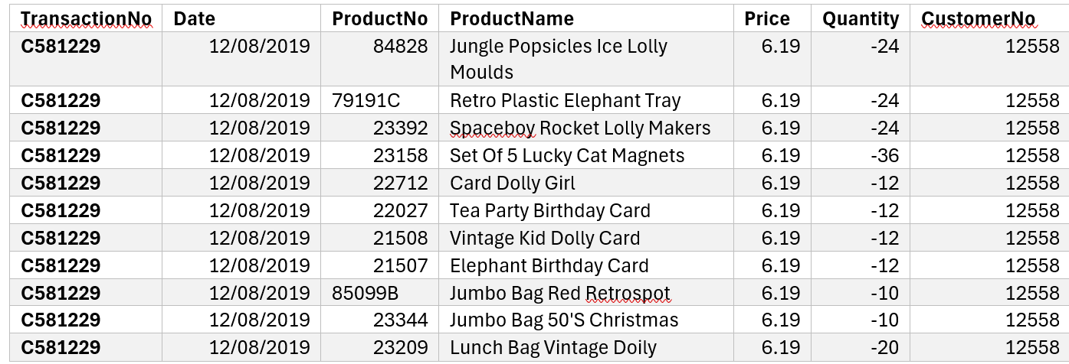
There could be some potential reason for cancellation which I present as follow:
- Customer satisfaction and product quality issues: The customer (Customer No: 12558) may have returned and cancelled products due to quality or condition issues upon delivery. The repeated cancellations of several items could indicate dissatisfaction with multiple products.
- Customer requirements changed: The customer may have changed their mind about the order, realising they no longer wanted the items or ordered too much. This is reinforced by the enormous quantity of cancellations. (Spagnuolo, 2023)
- Incorrect order placement: The consumer may have ordered incorrect items or quantities and looked for a cancellation to fix the error. This is particularly common with big orders, where oversight is more likely. (Spagnuolo, 2023)
- Bulk order cancellations: If a customer discovers erroneous numbers or items after making an order, they may cancel it and repurchase with the proper quantities.
- Stock availability and backorders: Customers may cancel orders due to backordered items or shipping delays.
- Duplicate orders: The consumer may have mistakenly placed multiple orders and cancelled one. This occurs when orders are placed quickly without first verifying previous orders (Procurify, 2022).
I did a breakdown of all cancellation for US customers as follow:
Cancellations of high-quantity items, such as "Set Of 5 Lucky Cat Magnets" (-36), "Spaceboy Rocket Lolly Makers" (-24), and "Jungle Popsicles Ice Lolly Moulds" (-24), may be due to bulk order problems or demand fluctuations.
Cancellation of similar items, such as birthday cards and bags, may indicate a change in event plans or dissatisfaction with a product range.
All cancellations are associated with a single client (client No: 12558). This indicates that the faults are specific to this customer's order or situation, rather than systemic concerns affecting several consumers.
Here are some recommendations regarding the mentioned above findings:
Stay connected with Customer No. 12558 to find out the precise reasons for their cancellations. This feedback can provide useful information about potential product or service improvements.
Improve order verification to ensure bulk purchasers check and confirm their orders before finalising them. This may lessen the number of cancellations due to order errors. Effective inventory management is critical for handling large orders (Munyaka and Yadavalli, 2022). According to Cruz-Jesus, Pinheiro, and Oliveira (2019) and SPS Commerce (2023) emphasise the importance of optimising stock levels in preventing order errors and cancellations. Implementing personalised marketing strategies can significantly enhance customer retention (Chuang, Oliva and Heim, 2019).
Implement a thorough quality assurance approach to improve product quality and satisfaction. High-quality checks before shipping can help to prevent returns and cancellations.
Providing improved customer service to help bulk purchasers place and manage their orders will help prevent cancellations due to ordering problems or changes in order requirements.
Based on the data, cancellations are related with one client and a variety of products, implying issues including order errors to changes in customer preferences or dissatisfaction with product quality. By addressing these issues with focused solutions, the company may reduce the risk of future cancellations while increasing overall customer satisfaction (Bhowmick and Seetharaman, 2023).

Most frequently purchased products

In dataset I identified the net quantity sold for a product is the total quantity minus cancelled quantities. Here is the data with settled quantities.
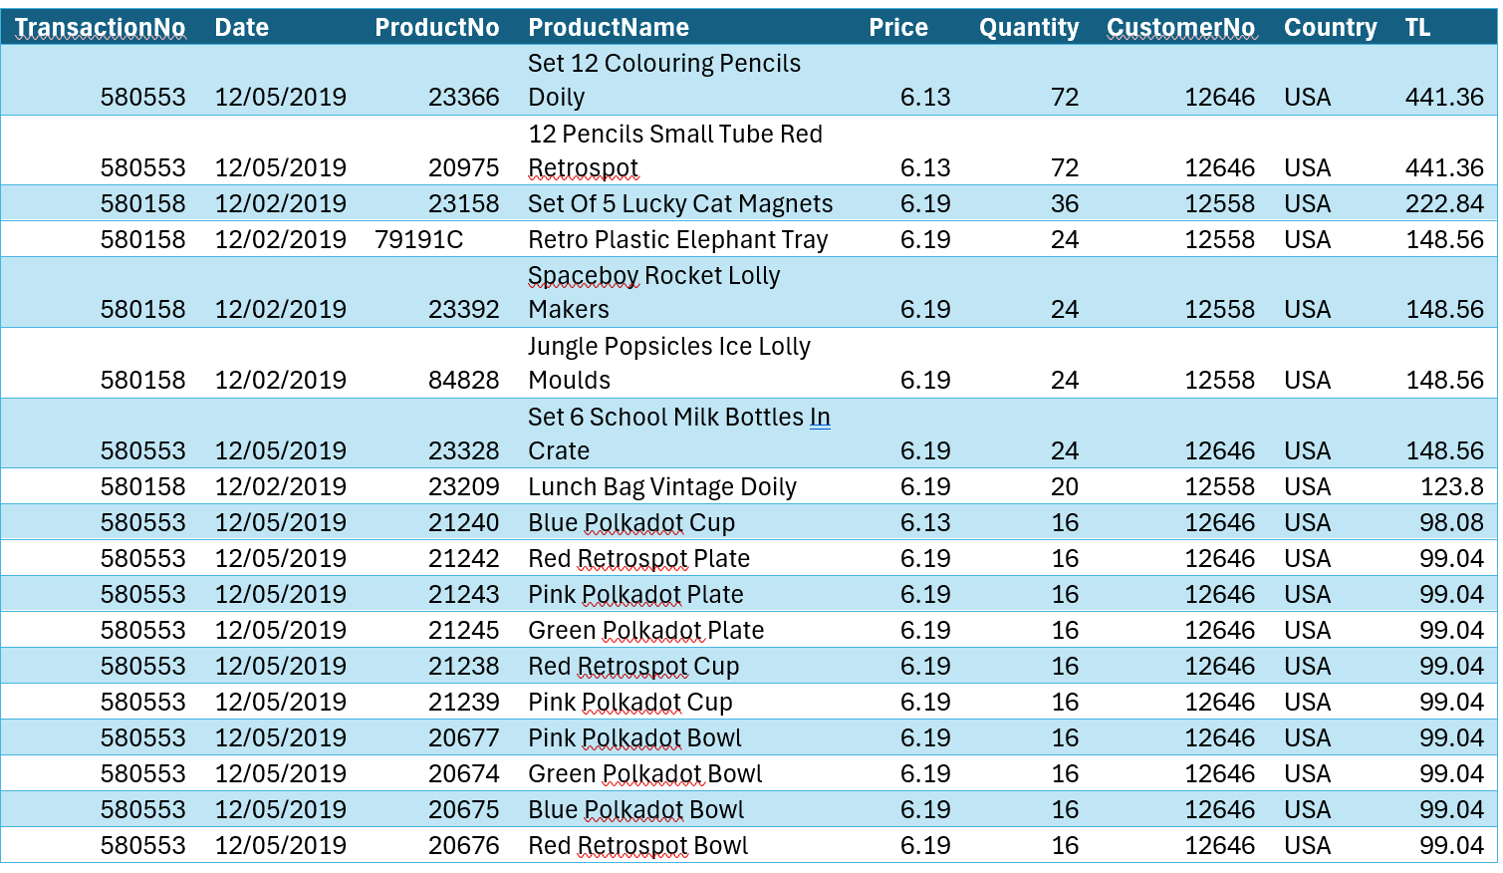
Based on the net quantity sold, these are the most frequently purchased products:
1. Set 12 Colouring Pencils Doily: 72 units
12 Pencils Small Tube Red Retrospot: 72 units
2. Set 6 School Milk Bottles in Crate: 24 units
Retro Plastic Elephant Tray: 24 units
Spaceboy Rocket Lolly Makers: 24 units
Jungle Popsicles Ice Lolly Moulds: 24 units
3. Multiple Polkadot items (bowls, plates, cups): each sold 16 units
The most popular goods are "Set 12 Colouring Pencils Doily" and "12 Pencils Small Tube Red Retrospot," each selling 72 units. Several more products, like "Set 6 School Milk Bottles in Crate" and various polkadot items, sold well.
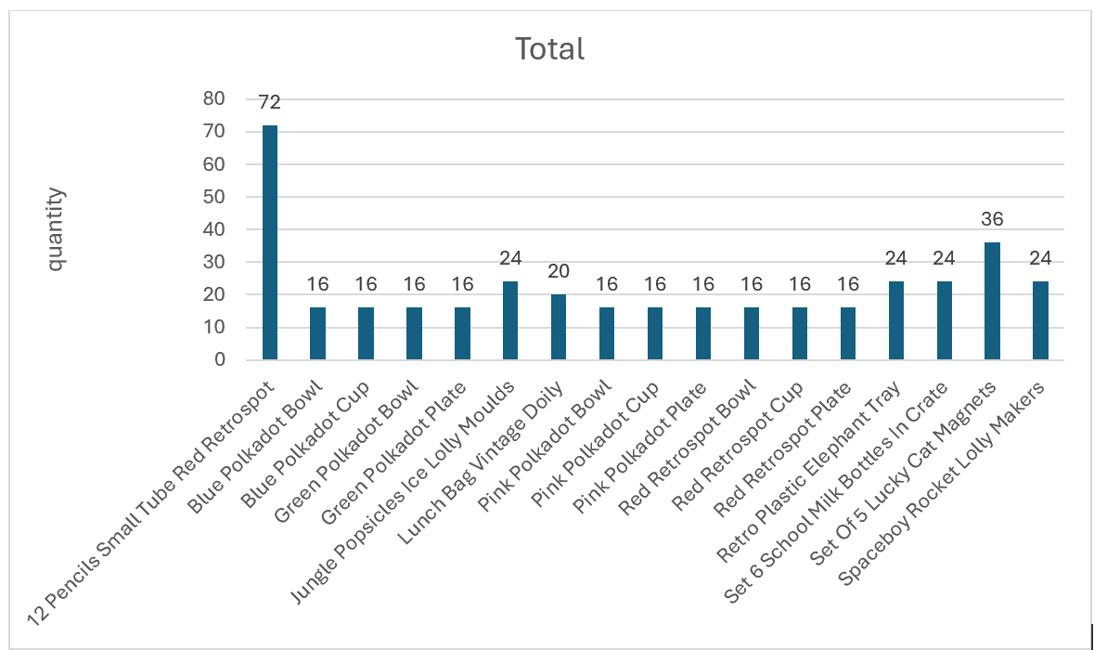

The sales trend over the months

In the report has been used the provided dataset to calculate monthly total sales based on quantity. I was assuming that the prise is in USD, as the chosen country is USA.

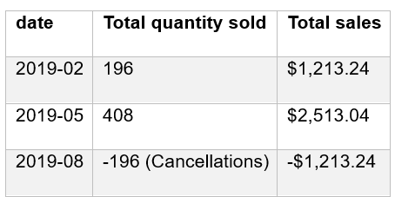
Analysis of Sales Trend
- February 2019: Total quantity sold: 196.
Total sales: $1,213.24.
- May 2019: Total quantity sold: 408.
Total sales: $2,513.04.
- August 2019: Total quantity sold: -196 (due to cancellations).
Total sales: -$1,213.24.

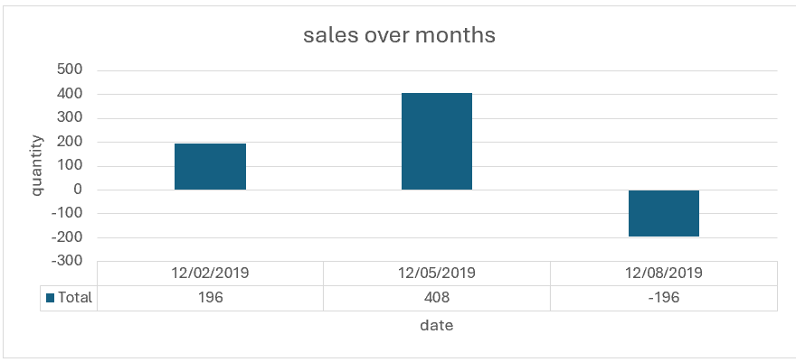
Here are some thoughts and recommendations:
The sales performance in May 2019: sales and quantity sold were highest, indicating a peak in activity. February 2019 sales are moderate. August 2019 shows a negative trend due to many cancellations, affecting overall sales negatively.
High cancellations in August 2019 may indicate consumer dissatisfaction product returns, or quantity problems. There is a likelihood of holidays in August, and goods are no longer required. Further investigation is required to discover specific causes.
The sales trend across three months (February, May, and August 2019) shows varied sales performance, with a peak in May and a high cancellation rate in August. Identifying the reasons for the August cancellations may help increase future sales success. Furthermore, focussing on successful May strategies may help replicate this peak performance in months to come.

Quantity of products per customer in each transaction.
Here is the data summarised by each transaction followed by chart:
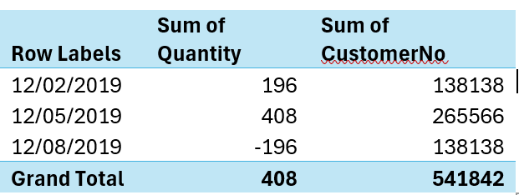
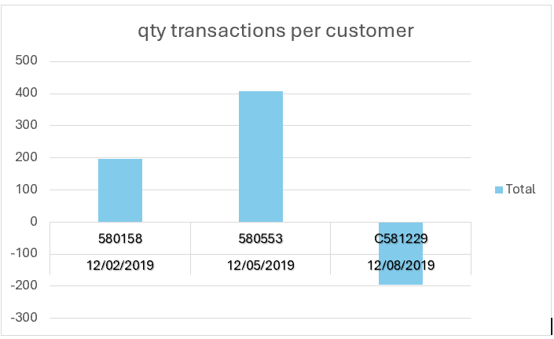

This is a detailed breakdown of the transactions:

Transaction 580158 (12/2/2019), total quantity purchased.

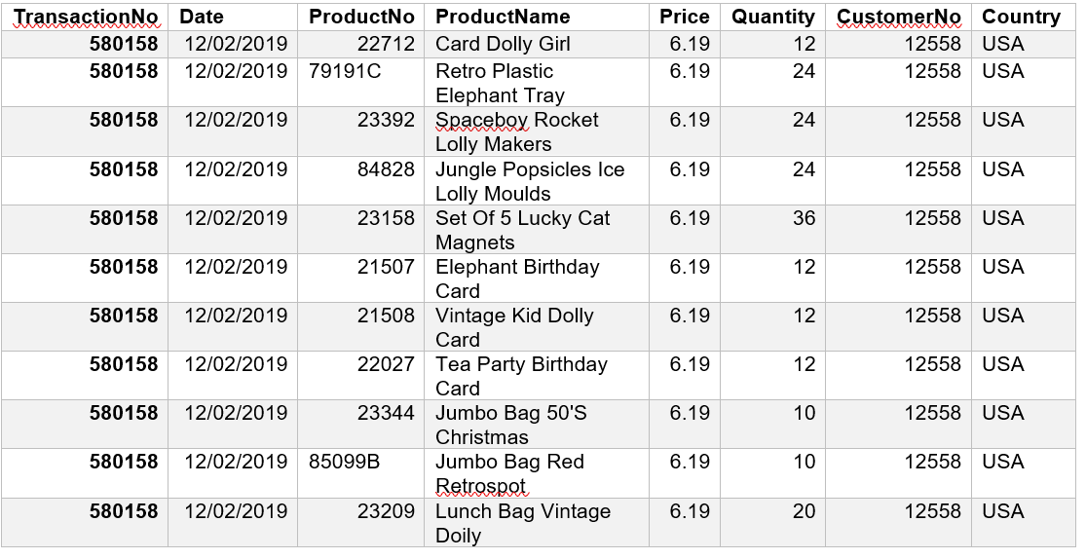

Total: 196

Transaction 580553 (12/5/2019), total quantity purchased.
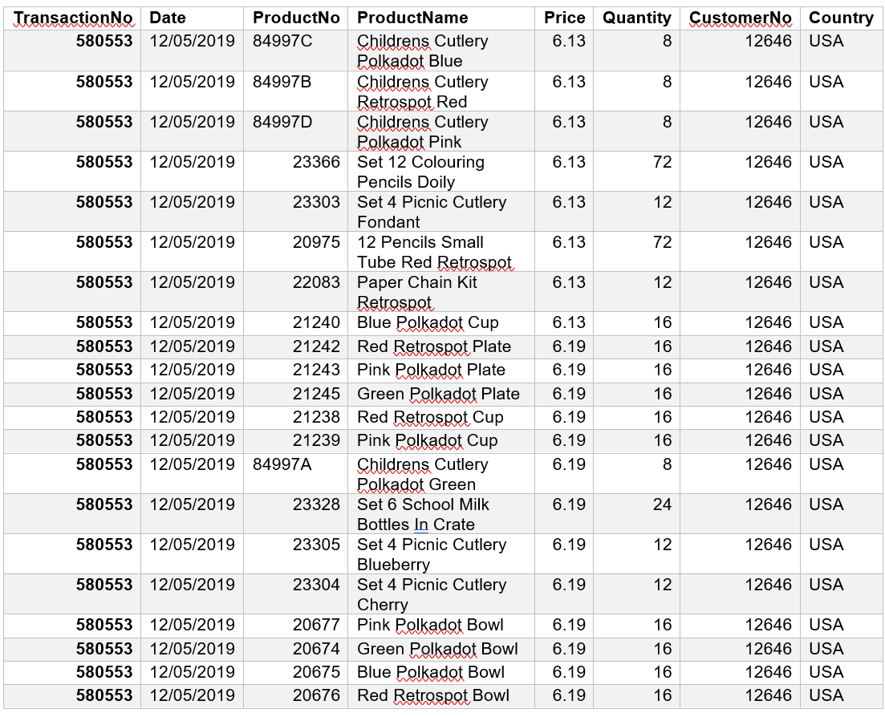
Total: 408

Transaction C581229 (12/8/2019), total quantity purchased.
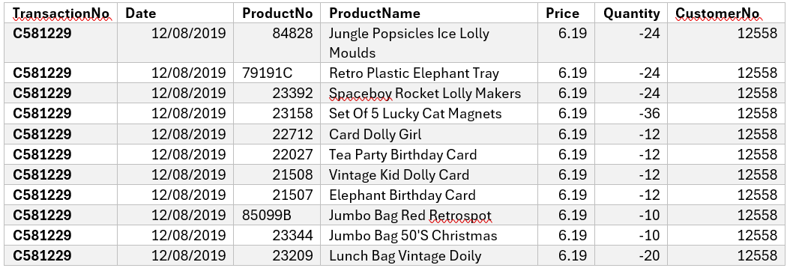
Total: -196

The most profitable segment customers.
The analysis is going to see total sales for each customer, including both positive purchases and negative (cancellations). The total sales for customer 12558, are as follow:
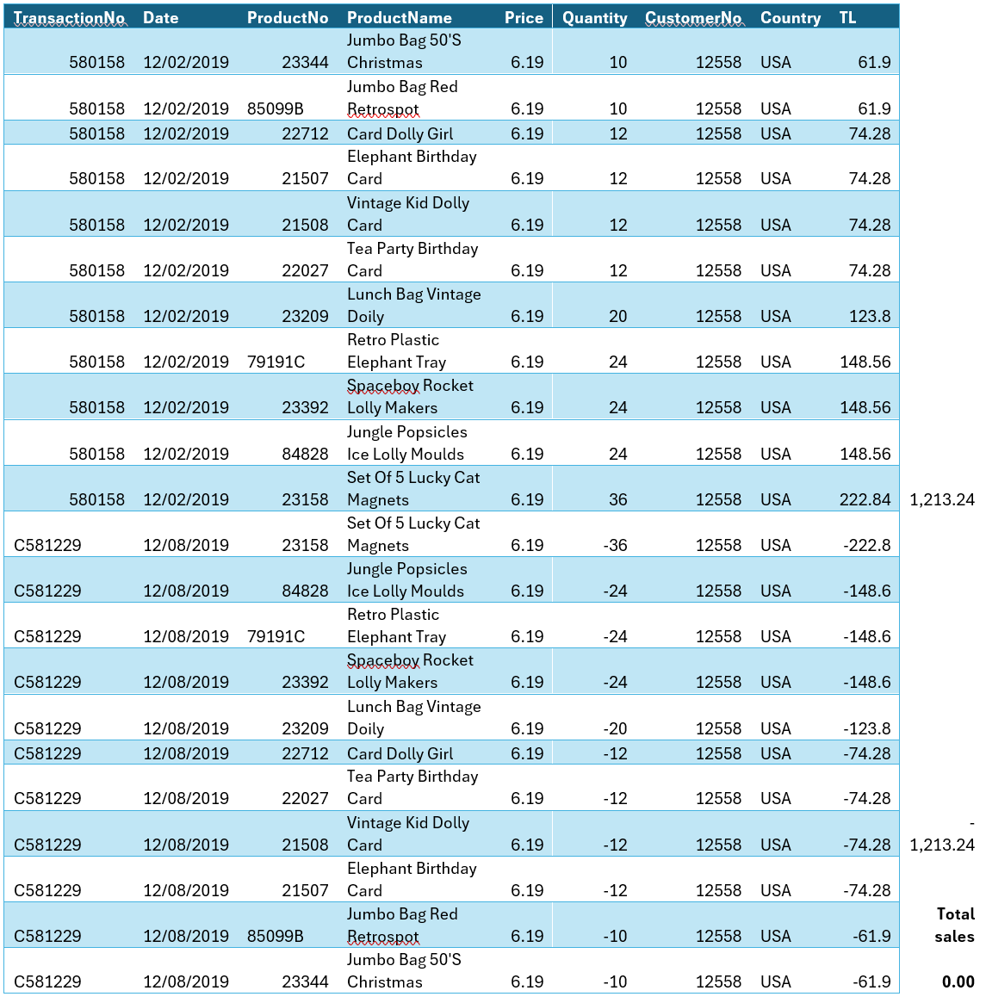

Second customer 12646 total sales are as follow:
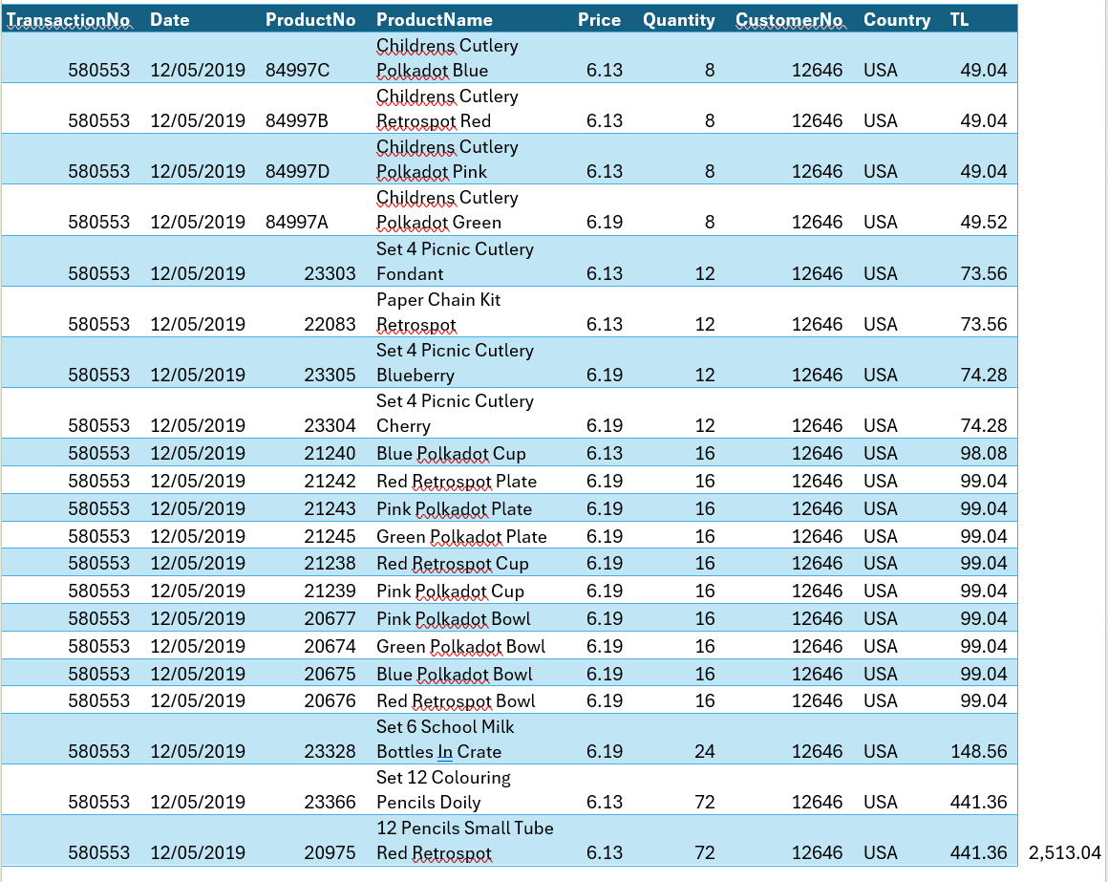

Analysis of the most profitable customer segment:
Customer 12646 is the most profitable customer segment, generating $2,513.04. This shows that customer 12646 made big purchases with no cancellations that affected their overall sales negatively.
As a conclusion I can say that customer 12646 has been recognised as the most profitable customer segment based on total sales calculations. This consumer made several purchases in high quantities and high-value items, which contributed significantly to total sales. In comparison, customer 12558 had an equal number of sales and cancellations, resulting in a net total sale of $0.00.

Recommendations and strategies for the business to gain more profit.

According to Kotler et al. (2020), here are some strategic advice to help the company generate more profits:
Customer retention and loyalty programs, focused on high-value customers (Customer 12646). Implement loyalty programs to reward frequent and high-value consumers, such as Customer 12646. To encourage repeat purchases, consider offering points, discounts, or exclusive deals. Use data analytics to personalise offers and suggestions based on historical purchase behaviour, leading to increased customer satisfaction and loyalty.
Regarding the cancellations, company must be focused to understand and reduce cancellations (Customer 12558). The company may implement a feedback tool to understand the causes for cancellations. Send follow-up emails or surveys to clients who cancel orders to collect feedback. Similarly, to improve product descriptions by providing accurate and complete product descriptions, photos, and specifications to prevent cancellations.
By enhanced customer support, the company can improve client support during and after the purchasing process. Provide real-time chat support to address client complaints quickly (Bhowmick and Seetharaman, 2023).
Inventory management should be focused on high-demand products (Petrucci and Manganaro, 2023). Optimise stock by analysing sales trends to ensure high-demand products are always available. Use inventory management software to forecast future demand and change inventory levels accordingly is also required (SPS Commerce, 2023). The company should increase average orders value by bundling frequently purchased products (Chuang, Oliva and Heim, 2019). For example, pair the "Childrens Cutlery Polkadot" sets with matching plates and bowls.
Regarding the marketing and promotions, the focus should be on leveraging data insights. Targeted marketing campaigns must use the sales data to find popular products and develop customised marketing efforts, highlight best-sellers such as "Set 12 Colouring Pencils Doily" and "12 Pencils Small Tube Red Retrospot". Use seasonal promotions or sales events during peak purchase seasons to increase sales and previous data to determine the optimal dates for these campaigns are required (Kotler et al., 2020).
Other recommendation is to improve online presence. The focus should be on improving the customer experience. For this purpose, optimization of the website for user-friendliness, speed, and mobile responsiveness are important. A pleasant shopping experience helps lower cart abandonment items. The company must think to invest in content marketing methods like blogs, tutorials, and videos to increase direct traffic to your website (ApnTech Team, 2024).
Implementation of the plan:
1. Short-term (1-3 months) - Launch client feedback and loyalty programs. Optimise product descriptions and provide better customer support. Conduct targeted marketing initiatives, including seasonal promotions.
2. Medium-term (3-6 months) - Implement stock optimisation and bundling solutions.
Introduce new product versions and gather client feedback for future innovation. Optimise website for improved user experience.
3. Long-term (6-12 months): Expand product offerings depending on customer preferences and market developments. Enhance content marketing to increase brand loyalty and direct traffic.

Task 2 – student score in excel file and csv file.
The second section of the essay seeks to analyse 2133 school students with pre-test and post-test results, gender, and whether they are or not qualify for reduced or free lunch. As a first step will be counting of how many are males and females and providing information in excel chart and in SSPS chart.

How many students are male and female?
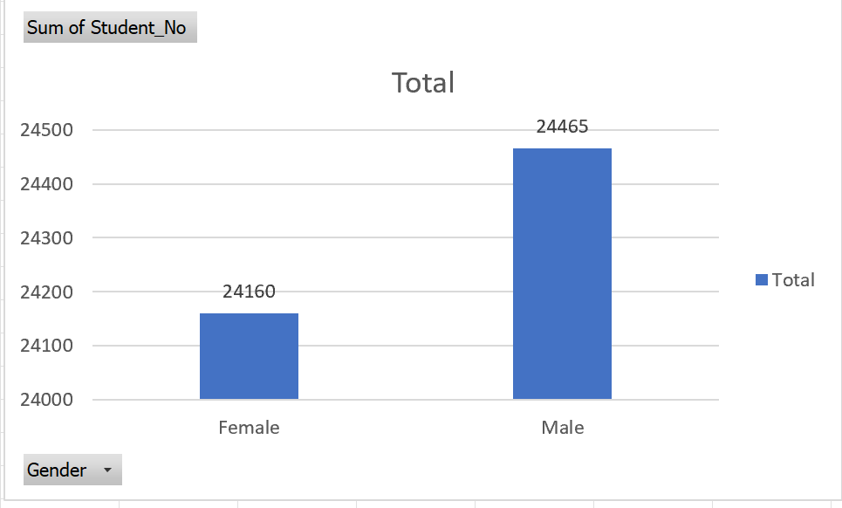

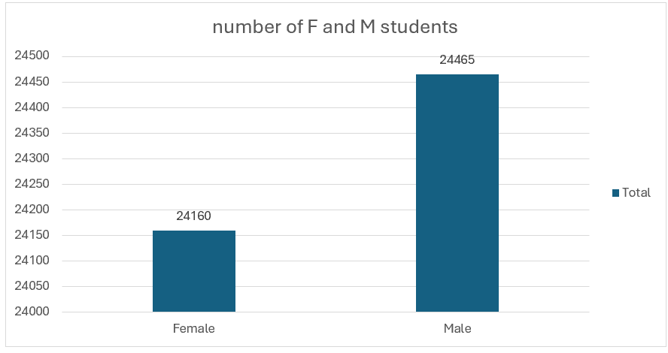

Number of students qualifies and does not qualify for reduced/free lunch
Following analysis is regarding how many students are or not qualify for lunches, binding with their gender:
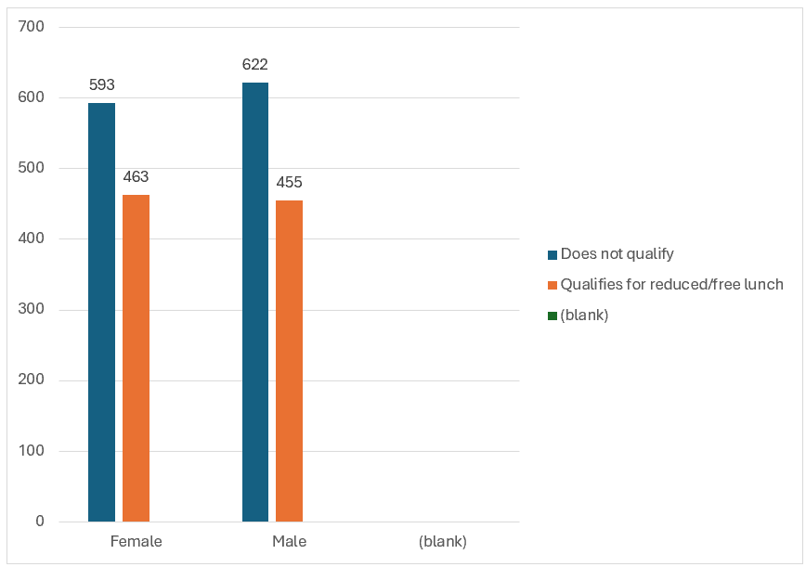
The ratio between males and females as follow:
Females who do not eligible for reduced or free lunch: 593. Females who qualify for reduced or free lunch: 463.
Total females = 593 + 463 = 1,056
Percentage not qualified:
593 × 100 ≈ 56.15 %
1056
Males who do not qualified for reduced or free lunch: 622. Males who qualify for reduced or free lunch: 455.
Total males = 622 + 455 = 1,077
Percentage who does not qualify:
622 × 100 ≈ 57.74 %
1077

Therefore, most of both males and females are do not qualify for reduced or free lunch, with males slightly more likely to not qualify than females.
To identify if students are eligible for reduced or free lunch, the report should look into the relationship between school type, gender, and pre- and post-test scores. This is going to assess whether and how these factors affect eligibility for reduced or free lunch programs.
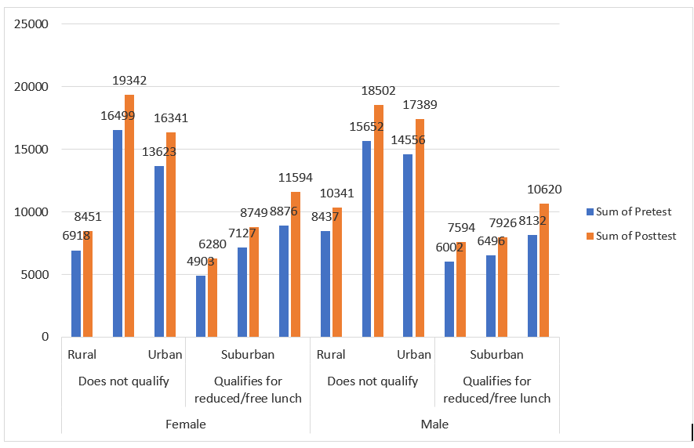
To identify children’s eligibility for reduced or free meal programs, we must evaluate the relationship between school type (rural, urban, or suburban), gender, and pre- and post-test scores. Here's a full analysis based on the data shown in the chart:
- Pre-test and post-test scores by school type and gender.
Female students residing in rural areas do not qualify.
Pre-Test Total: 8,451.
Post-Test Total: 6,918.
For rural female students who do not qualify for reduced or free lunch, post-test scores are significantly lower than pre-test scores.
Urban (does not qualify)
Pre-Test Total: 16,499
Post-Test Sum: 19,342.
Urban female students who do not qualify demonstrate a significant improvement in post-test scores, indicating a favourable learning outcome.
Suburban (qualified for reduced or free lunch):
Pre-Test Total: 6,280.
Post-Test Total: 4,908
Suburban female students who qualify for reduced or free lunch had lower post-test results, indicating possible difficulties in maintaining academic achievement.

Male students in rural areas do not qualify.
Pre-Test Total: 15,652.
Post-Test Sum: 18,502.
Rural males who do not qualify for reduced or free lunch indicate significant improvement in post-test scores, which could be linked to successful educational interventions or assistance.
Urban (does not qualify)
Pre-Test Total: 14,556.
Post-Test Total: 17,389.
Even urban boys who do not qualify had higher post-test scores, indicating that the urban school environment has a positive impact on academic performance.
Suburban (qualified for reduced or free lunch):
Pre-Test Total: 7,594.
Post-Test Total: 6,002.
Post-test scores for suburban male students who qualify for reduced/free lunch are decreasing, indicating that these children may be experiencing issues that are affecting their academic outcomes.
There is a relationship between school type and academic performance. Urban students, both male and female, who do not qualify for reduced/free lunch often improve on post-test scores, implying that urban schools may provide more resources or learning environments to assist children do better. In contrast, students from suburban regions who qualify for reduced/free lunch tend to have lower post-test results, regardless of gender, which may indicate a need for specialised academic support or interventions in these locations.
Based on the findings, boys who do not qualify for reduced/free lunch make more progress in post-test scores than females, particularly in rural and urban settings. This suggests that males may benefit more from educational opportunities available to people who do not qualify for lunch programs.
Students that qualify for reduced or free lunch, particularly in suburban regions, appear to struggle more with academic achievement, as evidenced by lowering post-test results. This might suggest that economic issues affecting eligibility for reduced/free lunch may also affect academic achievement, needing further assistance for these students.

To examine the correlation between students who do not qualify for reduced or free lunch and their gender, as well as their pre-test and post-test scores, the following analysis can be conducted with the provided data in excel file. Also, chart visualization is provided.
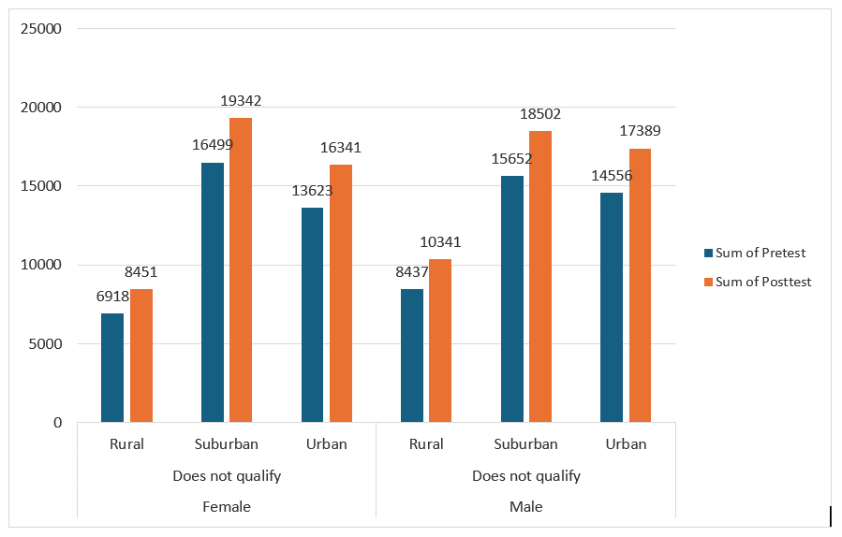
Post-test scores are lower than pre-test scores, showing that rural students who do not qualify for reduced or free lunch may face problems that influence their academic performance over time. Suburban female students have significantly higher post-test scores, suggesting that these pupils may benefit from their environment or resources, resulting in better academic performance. Urban female students also have higher post-test results, which may represent the benefits of urban educational settings.
Rural boys who do not qualify show an increase in post-test scores, demonstrating good learning progression despite not being eligible for reduced/free meals. Suburban male students show the greatest improvement in post-test scores, implying that suburban surroundings may provide major academic benefits to males who do not qualify for reduced or free meals. Urban male students also show significant improvement, supporting the theory that urban educational environments create greater post-test performance.
In summary, male students in all school categories (rural, suburban, and urban) show significantly higher post-test results than females. This could indicate that males are get more from the educational environments available in these locations.

Mean and median of students who qualifies and does not qualify for reduced or free lunch in SSPS file.
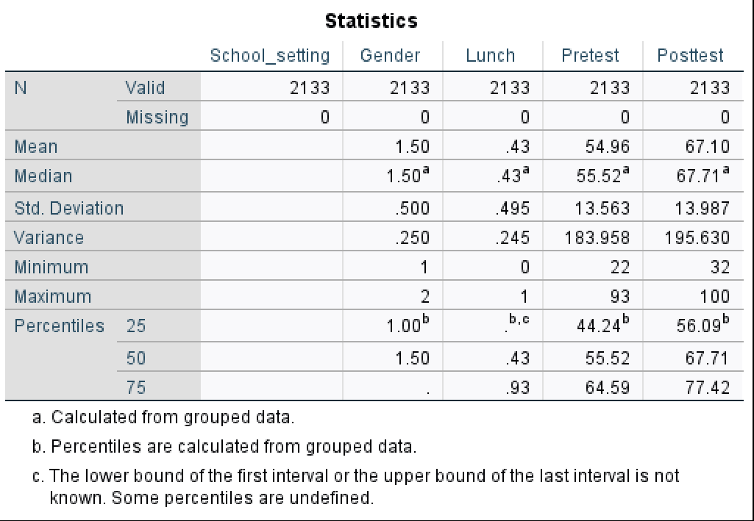

Pre-test scores:
Mean 54.96 and median 55.52
The pre-test results are balanced between the mean and median, indicating that most students have comparable baseline knowledge or skills prior to any instruction.
Post-test scores:
Mean 67.10 and median 67.71
Both the mean and median post-test scores increased, indicating that student performance improved overall following the intervention. The near mean and median values suggest that the post-test scores are distributed symmetrically.

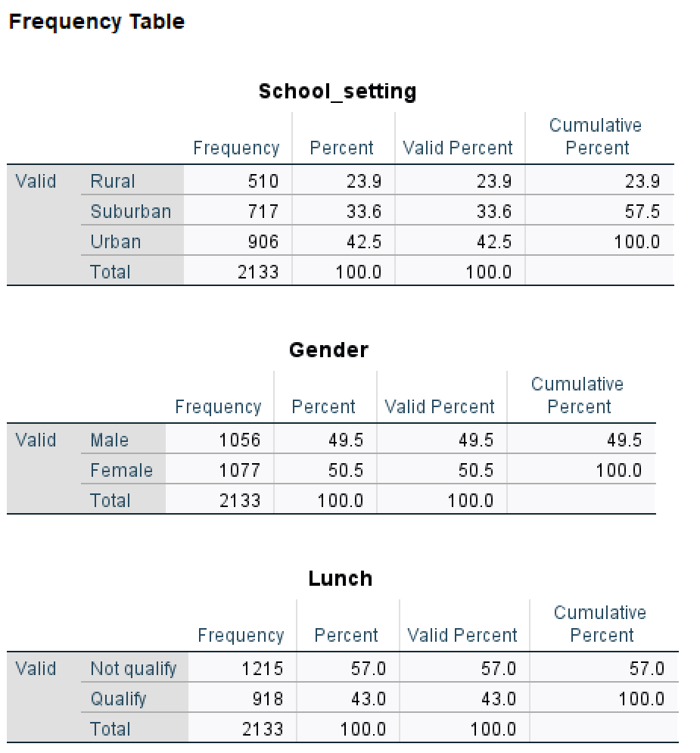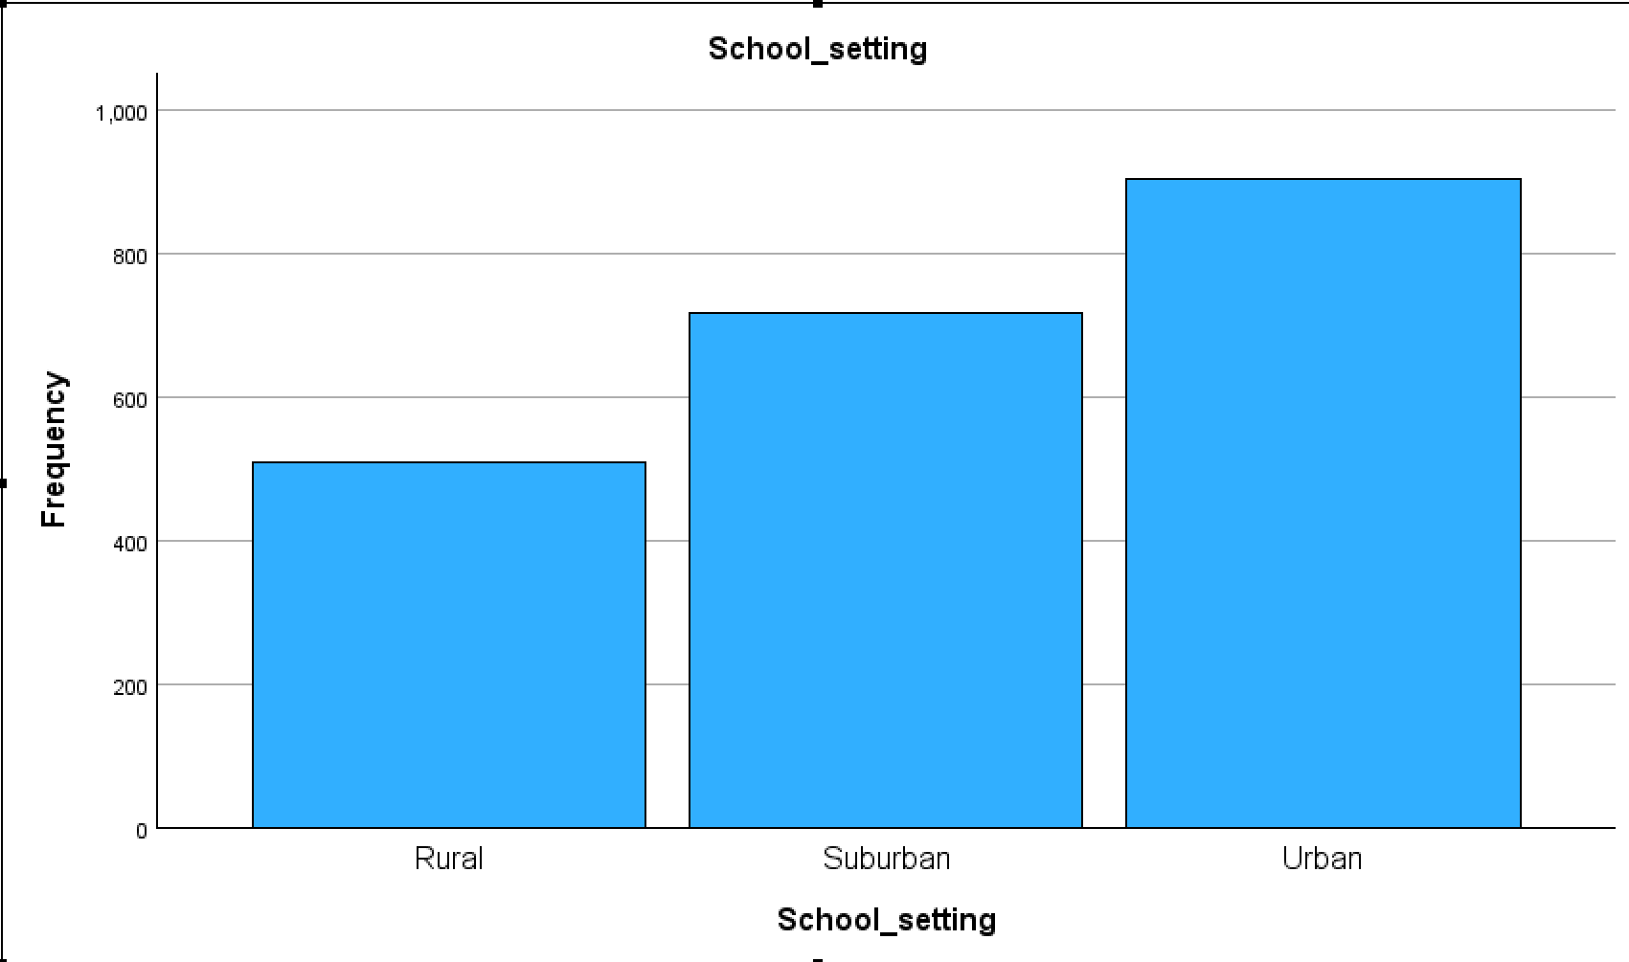

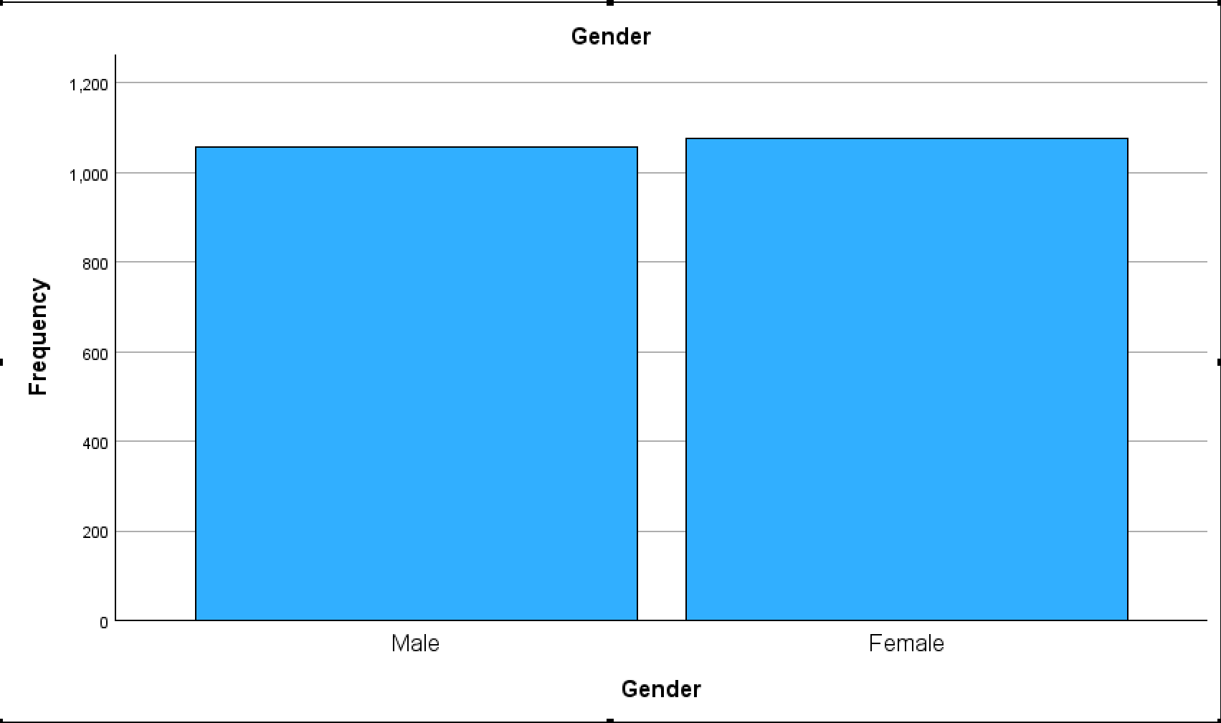
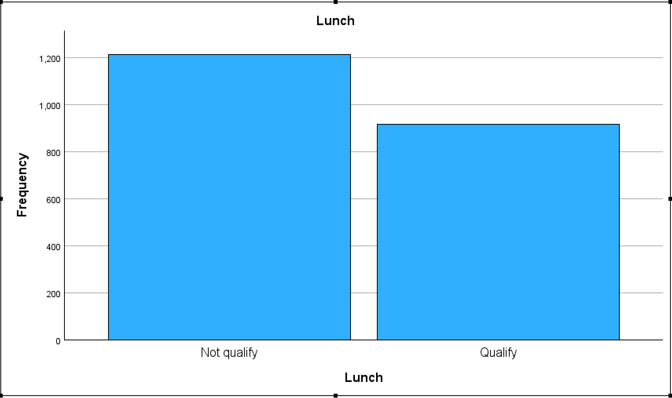

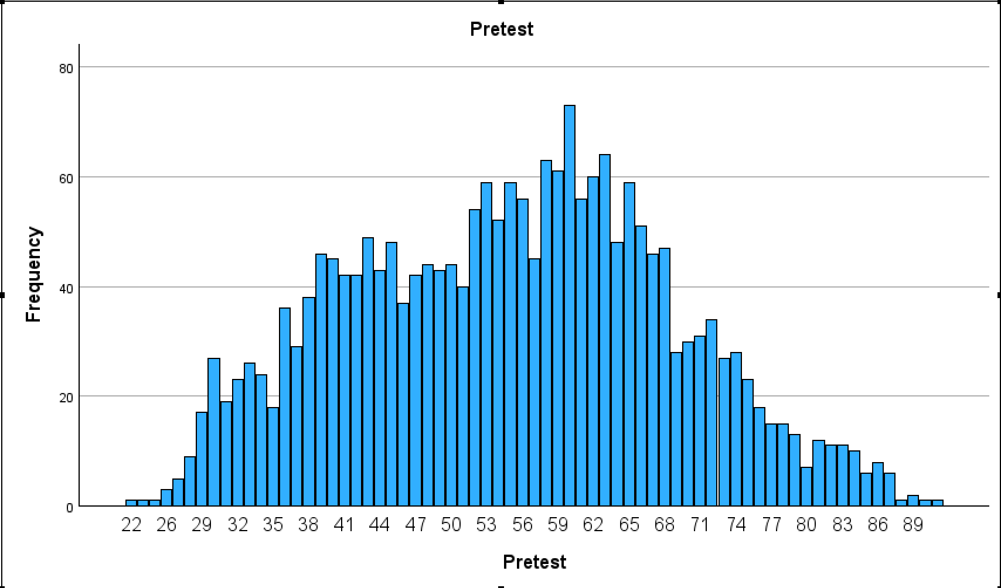
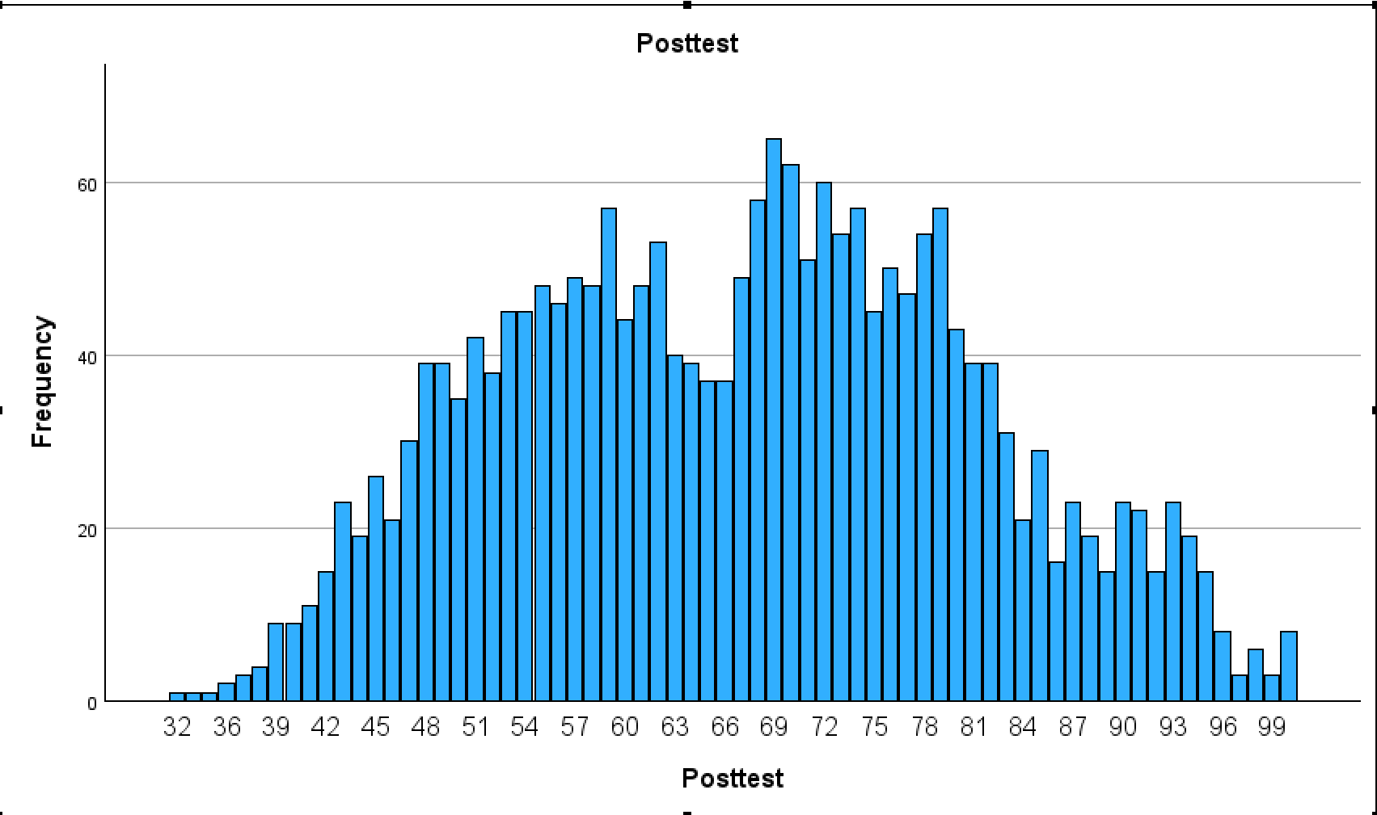

K – means clustering.
According to Kavlakoglu and Winland (2024), K-Means clustering analysis is an unsupervised learning approach for data clustering that assigns unidentified data points to groups or clusters. “The k-means clustering algorithm is an example of an exclusive or “hard” clustering method” (Kavlakoglu and Winland, 2024).
The presented data shows the results of a K-Means clustering analysis with pre-test and post-test scores. A full examination of the result is provided below, with a focus on the initial and final cluster centres, iteration history, and case distribution among clusters.
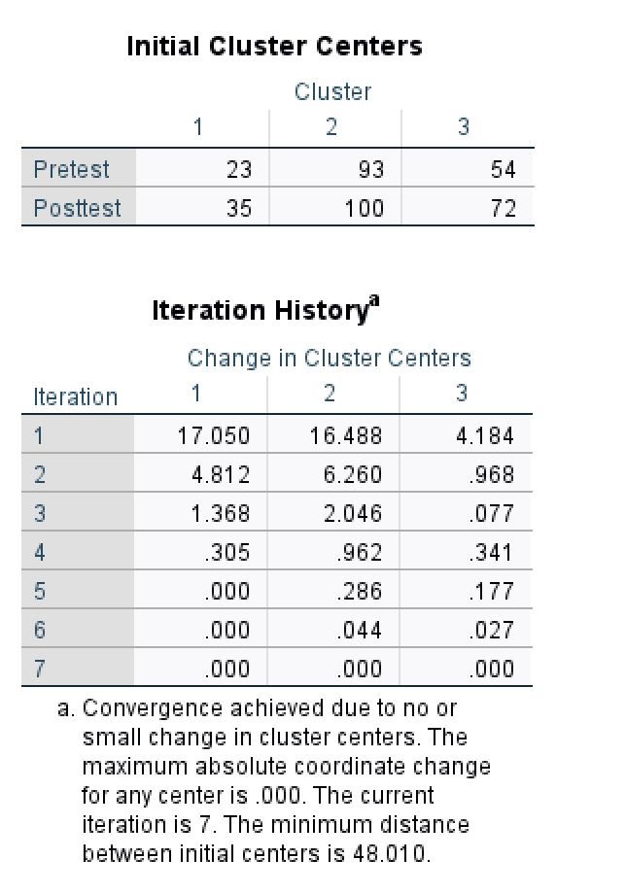

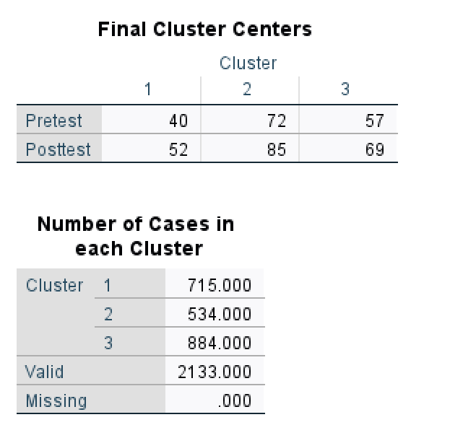

The K-Means Clustering analysis divides students into three groups based on their pre-test and post-test scores. This segmentation can be used to tailor interventions, set suitable challenges, and improve educational outcomes. For example, students in Cluster 1 may require more basic support, whereas those in Cluster 2 may benefit from advanced learning possibilities. Cluster 3 indicates the middle ground, in which differentiated education may be most effective.

Advantages and disadvantage of using SPSS and Excel.

According to Alchemer (2021), SPSS is an effective tool for statistical analysis, especially in research and academic environments where advanced statistical techniques are required. However, it may be less intuitive and expensive than Excel.
According to Puneet (2024), Excel is a very adaptable and user-friendly tool for general data analysis, visualisation, and administration, making it appropriate for a wide range of professional and personal needs. However, it is limited in its ability to do advanced statistical analysis.
Both tools have advantages and are frequently used at the same time depending on the unique objectives of the analysis. For example, data may be cleaned and processed in Excel before being imported into SPSS for in-depth statistical analysis.

According to Alchemer (2021) and Puneet (2024), there are some advantages and disadvantages shown in the table:
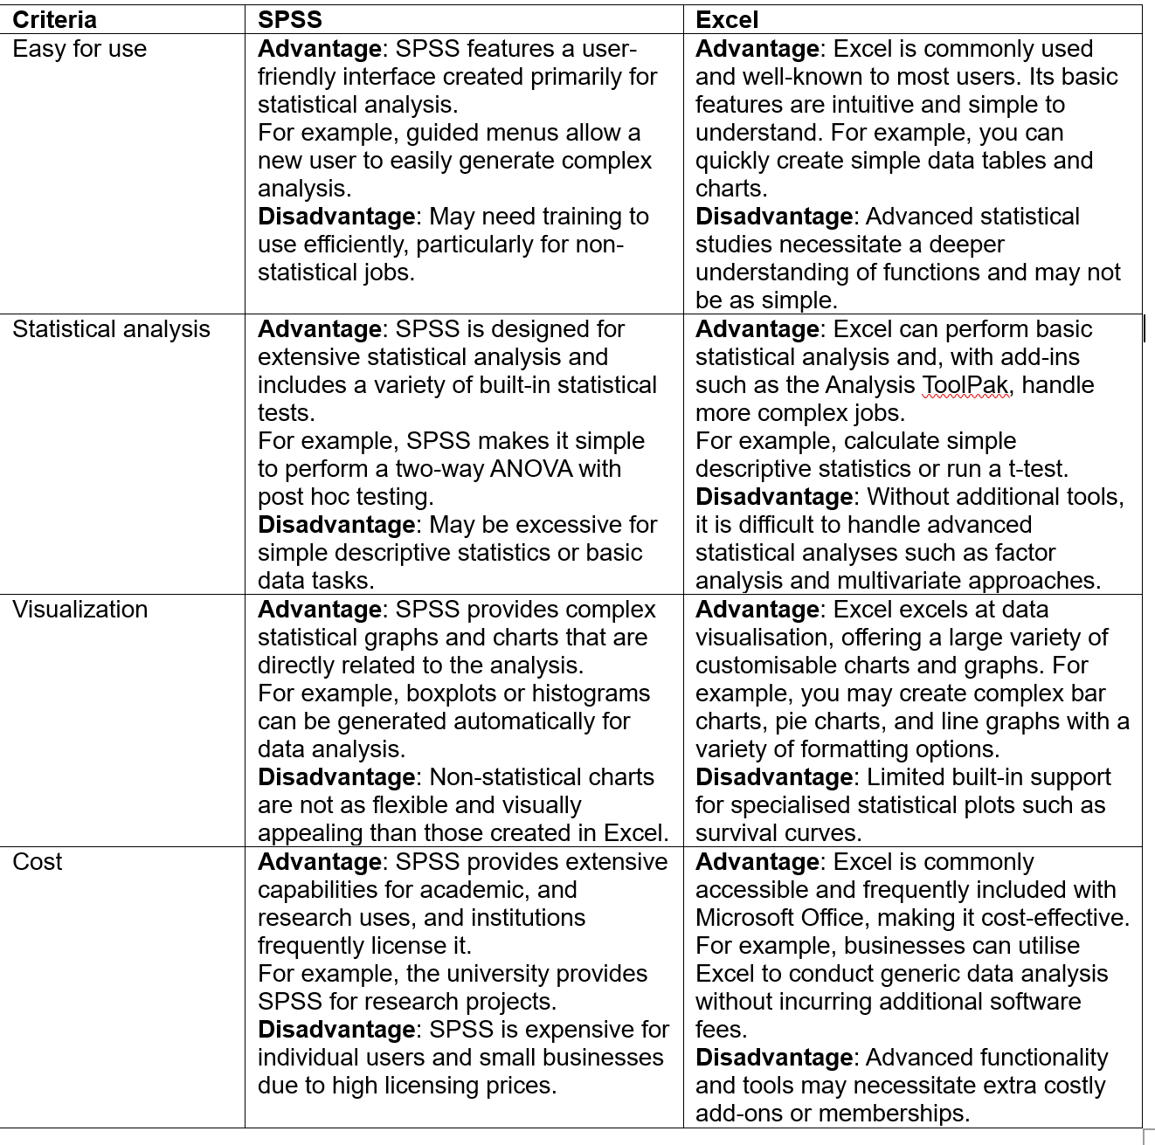

Conclusion
This essay showed Business Intelligence (BI)'s revolutionary influence in improving retail decision-making and educational outcomes. A detailed examination of sales data and student performance measures reveals the importance of a data-driven approach to improve operational efficiency, customer satisfaction, and academic achievement.
In the first task of the essay (retail sector) analysing sales transactions revealed significant trends in customer behaviour, product popularity, and sales patterns. The main issues discovered by the study include order cancellations and customer segmentation, both of which are crucial for optimising inventory management and targeting high-value consumers. Strategic solutions, such as personalised marketing and loyalty programs, were made to deal with these difficulties and increase overall profitability.
In the second part of that essay, which is in the field of education, analysis of student data using BI tools such as SPSS and Excel revealed information about the impact of school type, gender, and socioeconomic status on academic performance. The use of K-Means clustering enables the identification of unique student groups, allowing for more targeted educational activities that meet student needs and improve learning results.

References
- Alchemer (2021). What is SPSS and How Does it Benefit Survey Data Analysis? [online] Alchemer. Available at: https://www.alchemer.com/resources/blog/what-is-spss/.
- ApnTech Team (2024). 10 Proven Strategies to Enhance Your Online Customer Experience. [online] apntech.io. Available at: https://apntech.io/improve-online-customer-experience/ [Accessed 15 Aug. 2024].
- Bhowmick, A. and Seetharaman , Dr.A. (2023). Impact of product quality on customer satisfaction: A Systematic Literature Review. Impact of product quality on customer satisfaction: A Systematic Literature Review. [online] doi:https://doi.org/10.1145/3603421.3603434.
- Chuang, H.H., Oliva, R. and Heim, G.R. (2019). Examining the Link between Retailer Inventory Leanness and Operational Efficiency: Moderating Roles of Firm Size and Demand Uncertainty. Production and Operations Management, 28(9), pp.2338–2364. doi:https://doi.org/10.1111/poms.13055.
- Cruz-Jesus, F., Pinheiro, A. and Oliveira, T. (2019). Understanding CRM adoption stages: empirical analysis building on the TOE framework. Computers in Industry, 109, pp.1–13. doi:https://doi.org/10.1016/j.compind.2019.03.007.
- Kavlakoglu, E. and Winland, V. (2024). What is k-means clustering? | IBM. [online] www.ibm.com. Available at: https://www.ibm.com/topics/k-means-clustering [Accessed 11 Aug. 2024].
- Kotler, P., Armstrong, G., Harris, L.C. and He, H. (2020). Principles of Marketing. Eight European Edition ed. Pearson UK.
- Munyaka, J.-C.B. and Yadavalli, S.V. (2022). INVENTORY MANAGEMENT CONCEPTS AND IMPLEMENTATIONS: A SYSTEMATIC REVIEW. South African Journal of Industrial Engineering, [online] 32(2), pp.15–36. doi:https://doi.org/10.7166/33-2-2527.
- Petrucci, D. and Manganaro, L. (2023). Supply chain orchestration graduates from theory to leading practice. [online] Supply Chain Dive. Available at: https://www.supplychaindive.com/spons/supply-chain-orchestration-graduates-from-theory-to-leading-practice/650105/.
- Procurify (2022). 10 Common Procurement Mistakes and How to Solve Them - Procurify. [online] www.procurify.com. Available at: https://www.procurify.com/blog/10-common-procurement-mistakes-and-how-to-solve-them/ [Accessed 8 Aug. 2024].
- Puneet (2024). Top 10 Benefits of Microsoft Excel – Why YOU Should Learn it in 2024. [online] Excel Champs. Available at: https://excelchamps.com/benefits-of-microsoft-excel/#3_All_the_tools_for_data_analysis [Accessed 11 Aug. 2024].
- Spagnuolo, D. (2023). Rethinking Shopify order cancellations: A data-informed approach. [online] Cleverific.com. Available at: https://cleverific.com/blog/top-customer-order-cancellations-reasons-on-shopify [Accessed 11 Aug. 2024].
- SPS Commerce (2023). 3 key holiday strategies for suppliers: Are you ready? [online] Supply Chain Dive. Available at: https://www.supplychaindive.com/spons/3-key-holiday-strategies-for-suppliers-are-you-ready/699336/ [Accessed 11 Aug. 2024].
- Tutorials Point (2024). Data Mining - Terminologies. [online] Tutorialspoint.com. Available at: https://www.tutorialspoint.com/data_mining/dm_terminologies.htm [Accessed 8 Aug. 2024].
- Wikitechy (2024). Clustering in Data Mining | Data Mining Tutorial - wikitechy. [online] Wikitechy.com. Available at: https://www.wikitechy.com/tutorial/data-mining/clustering-in-data-mining#:~:text=What%20is%20Clustering%20in%20Data%20Mining%20%3F%201 [Accessed 8 Aug. 2024].

