Picture Analysis – Interpreting Archaeology

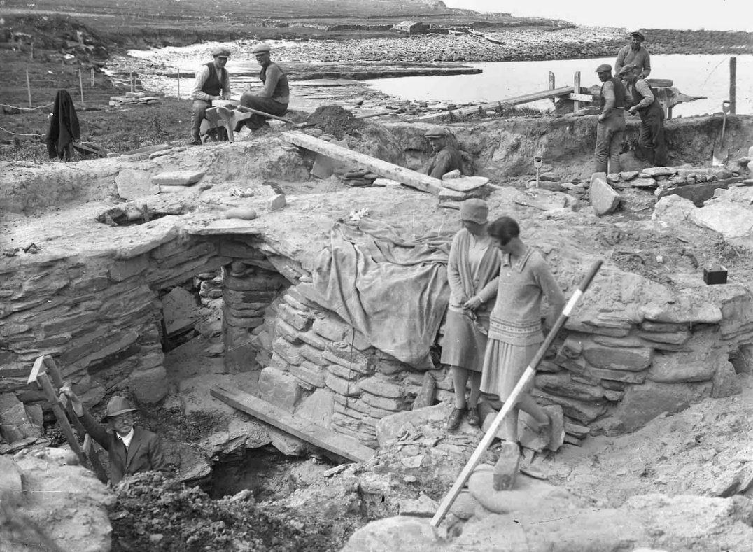
This black and white photograph captured at Skara Brae, Scotland during the 1920’s presents to us an excavation directed by Vere Gordon Childe.

Firstly, to make analysis simpler I divided the image into quarters and started with the bottom left. I chose to use Bourdieu’s theory of practice for analysing this image as you can see reference to different human capitals and examples of habitus {Costa & Murphy, 2015}. Here we can see Gordon Childe posed in the foreground on a ladder coming out of a hole. The symbolic and cultural capital of this is significant as we know he is head of this dig and as the archaeologist he holds the most knowledge. His clothing clearly indicates he was not digging much himself, yet on the ladder he maintains power and prestige here because of his intellectual status. Economic capital is apparent here as he is well dressed and educated, therefore likely funding this dig and the workmen. This links into doxa as Childes enforces his positions through different capitals.
Expanding on Bourdieu, I realised that this dig site would classify as a field under the theory of Habitus, a field being a place where social agents interact {Bourdieu, 1986}. Following this point, I looked at the top two corners of the photograph. Where we can see six workmen looking towards the camera, strangely they don’t appear to be doing anything at the time of the photograph besides socialising, positioned with presumably their tools. Adding to the unnaturalness of the picture, presenting (to me) this notion Childe is working harder; realistically the men in the background would have dug the hole, he’s climbing out. One thing I like here is the worker on his own behind the plank in the centre looking at the camera with a quizzical smile as if to say are you really taking a picture of this, indicating it is a tableau rather than candid shot. Another noteworthy point about these men is what they’re wearing. Flat caps - commonly associated with working class men in northern England. This fashion for men in the 1920’s holds symbolic capital with viewers immediately seeing their position as workers and note their position in the background.
Finally, the bottom right hand corner we see two women dressed nicely, standing on looking at Childe. They strike me as culturally situated actors in this photograph, placed there to produce and reproduce ideas of women and archaeology {Steel, 2019}. Ideas that say women can be present at digs but outside the dirty work, whilst also maintaining a certain standard of presentability. The women here are examples for praxis- another term of Bourdieu’s- as their position buys into the societal ideals for women at the time {Bourdieu, 1986}. The woman on the left is seen holding a trowel however it appears holding it is uncomfortable and unnatural for her from its awkward placement. I noticed a photography technique here with the measuring pole alongside the woman on the right, used as a leading line to direct your eye from her to Childe’s. The fact the women are placed before the workmen as well I think captures attention and indicates high social and economic capital.
This picture can be used to interpret archaeology, but only when done with caution as we’re seeing select information, whereas it’s useful for the empirical aspects like excavation standards.

References
Bourdieu, P. (1986) The forms of capital. In J. Richardson (Ed.) Handbook of Theory and Research for the Sociology of Education (New York, Greenwood) pp 241-258.
Costa, C. and Murphy, M. (2015). Bourdieu, habitus and social research. Basingstoke: Palgrave Macmillan.
Steel, L. (2019). Social Archaeology – HPAR5010. [PowerPoint] University of Wales Trinity St David. Pp 6-11. Available online: https://moodle.uwtsd.ac.uk/mod/folder/view.php?id=79978

