

Table of content

Introduction
Inquiry of Context
Aim and Objectives
Inquiry of Questions
Inquiry of Rationale

Literature Review
Introduction
Concept of VLE
Positive and Negative Factors of VLE
Strategies to Overcome the problems
Summary
Method of Research
Introduction
Method for searching
Inquiry of Design
Inquiry of Philosophy
Inquiry of Approach
Inquiry of Choice
Inquiry of Strategy
Sampling
Data Collection, Analysis
Ethical Considerations
Overview

Outcome, Analysis and Discussion
Primary data analysis
Secondary data analysis
Summary of the findings

Conclusion
Recommendations
References
Appendix 1: Questionnaire
Appendix 2: Survey Results

Introduction
VLE (Virtual Learning Environment) does not offer a wide range of digital tools and resources for online learning. Where students get an interactive and collaborative learning experience. This report will discuss the impact of VLA on student learning. Also, the analysis of how technology can be used to facilitate collaboration and communication between students and teachers. The research aim is to find impacts the use of VLE, to evaluate the advantages and disadvantages and to suggest strategies for the efficient use of VLE. Questions in this research are:
What factors influence the use of VLE?
What are the advantages and disadvantages of VLE?
What strategies can be suggested for effective use of VLE?

Inquiry of Context
Virtual Learning Environment (VLE) it has gained increasing attention in recent years, as the use of technology in education has grown rapidly. VLE research investigates the impact of technology on the learning process, including topics such as student engagement, knowledge acquisition and retention, and the impact of different types of technology on learning outcomes. It also looks at how technology can be used to facilitate collaboration and communication among students and teachers. VLE research is particularly important in the current COVID-19 pandemic, as many schools and universities have shifted to online learning platforms. As such, understanding the effectiveness and impact of VLEs is essential in developing effective strategies for teaching and learning (Oyelude, 2018).
Aim
- To examine the VLE on student learning at UWTSD.
Objectives
- To improve communication and collaboration between students and educators: VLEs can be used to foster communication and collaboration between students and educators, providing an online platform for conversations, project collaboration, and peer-to-peer support.
- To reduce the cost of education: VLEs can be used to reduce the cost of education by eliminating the need for physical space, transportation, and other related costs.
- To increase access to education: VLEs can be used to increase access to education by nourishing access to educational resources, materials, activities, and communication to any student with an internet connection

Inquiry of Questions
- How does using a VLE impact student engagement and academic performance?
- How does using a VLE increase instructor effectiveness?
- What are the benefits and challenges of using a VLE in the classroom?
- How can using a VLE improve the quality of student learning?

Inquiry of Rationale
The reason for researching a VLE is to understand how to improve the learning outcomes of students. In particular, the research tries to understand how a VLE helps in the development of collaboration and communication between students and teachers, but also the effects of using the VLE on student performance (Ryan and Poole, 2019). By understanding the VLE impact on student learning, educators can make informed decisions about the best use of this technology in the classroom (Times high school, 2020).
Literature Review
Introduction
VLE is a platform that provides students with access to educational materials, personalized interactions with instructors, and collaboration with peers. It is becoming increasingly important as a tool to support and enhance teaching and learning practices. VLEs have the potential to improve student engagement, increase the availability of resources, foster a sense of community, and reduce the cost of education (Debois, 2022). They also enable students to learn at their own pace, which can help to reduce stress and anxiety. Additionally, VLEs can provide real-time feedback and support for instructors, as well as promote collaboration between students.
Concept of VLE
VLE stands for Virtual Learning Environment and is a platform that facilitates online learning. It is a type of e-learning system that enables students and instructors to interact virtually, in real-time or asynchronously, using a combination of audio, video, and text-based communication tools (Racheva, 2022). VLEs are used to provide an online learning experience, including activities, assessments, multimedia elements, and other learning resources. VLEs can be used for both synchronous and asynchronous learning, as well as for the individual, group, and class-based learning (Clark, 2021).
Positive and Negative Factors of VLE
Positive Factors: VLEs provide a platform to easily access learning materials and resources, allowing students to have an interactive learning experience. They also make it easier to learn from home and can help reduce costs associated with traditional learning materials such as textbooks. VLEs also allow instructors to provide feedback on student work in a timely manner and track student progress (Karumbaiah et al., 2022).
Negative Factors: VLEs may be difficult for some students to use and can be overwhelming for those who lack technical skills or experience. Additionally, VLEs can be a distraction from learning if students are not properly supervised or monitored. Furthermore, VLEs can lead to issues of privacy and security, as student data is stored online (Bahera, 2019).
Strategies to Overcome the problems
- Introducing incentives: Introducing incentives such as rewards and recognition for completing the VLE can help to motivate students to use the VLE.
- Making the VLE more user-friendly: Making the VLE more user-friendly with clear instructions and easy navigation can help to make the VLE more accessible to all students.
- Conducting regular training sessions: Conducting regular training sessions to help familiarize the students with the VLE can help to make it more accessible.
- Creating a VLE support team: Creating a VLE support team to provide support and answer any queries that the students have can help to reduce the problems associated with VLEs (Tsay et al., 2020).
- Improving technical support: Improving technical support and providing more resources to help students with any technical issues can help to increase the use of VLEs (Mubarak et al., 2022).
Summary
VLEs are important for providing access to learning resources, providing flexibility in learning, improving communication, and enhancing interaction between students and teachers. Factors such as content, navigation, aesthetics, and accessibility are important for successful VLEs.
Method of Research
Introduction
The research used will study the impact of a VLA which will depend on the research question and the desired result. Generally, qualitative and quantitative research approaches can be used to study VLEs. Qualitative studies often include interviews, focus groups, and field observations to gain insight into the user experience with VLEs. Quantitative studies can include surveys and experiments to measure the impact of the VLE on learning outcomes.
Method for searching
- Inquiry of Design
Descriptive design is a method in which data is collected through observation and surveys to draw conclusions about a particular population. In this case, descriptive design is used to study the impact of VLE on a predetermined population. This design involves the collection of data about participants' use of the VLE, their experience with the platform, and their overall opinion of the VLE. These data can then be used to determine the impact of VLE on participants and to draw conclusions about the effectiveness of the technology (Leino et al., 2021).
- Inquiry of Philosophy
Positivism is a research philosophy that views reality as objective and measurable. It assumes that facts can be discovered through scientific methods, such as observation and experimentation. In the context of a Virtual Learning Environment (VLE), positivism suggests that its impact can be accurately measured and understood through empirical data. This data can then be used to make decisions about how to best use the VLE to improve student learning outcomes (Lund and wang, 2019).
- Inquiry of Approach
Deductive research starts with a theoretical framework and works to develop a hypothesis. It involves taking information that has already been collected and analysing it to determine if it supports the hypothesis. In the case of VLE impact, the researcher would start with a theoretical framework about the potential impact of using VLE and then collect existing data from related studies to see if the data supports the hypothesis. If it does, the researcher would conclude that the VLE has a positive impact (David, 2021).
- Inquiry of Choice
Mixed research is a combination of qualitative and quantitative data and methods. This is used to better understand the impact of VLE. Qualitative methods are used to understand user experiences and opinions, while quantitative methods are used to measure the effectiveness of VLEs. Mixed research supports a comprehensive and thoroughly understanding of the impact of VLE (Awoyemi, Akinlubi, & Awoyemi, 2020).
- Inquiry of Strategy
This research strategy involves surveying students who have been exposed to a VLE. Questions will be asked about their experience and perception of the VLE, as well as the impact it has had on their learning. This survey will provide a detailed understanding of the effectiveness of the VLE, allowing for the necessary changes and improvements to be made. The survey will be administered to a diverse sample of students who have experienced a VLE, providing an accurate representation of the impact the VLE has had (Estriegana et al, 2021).
- Sampling
Sampling is a technique of selecting a group of humans from a population of interest. In this case, simple random sampling is used to study the impact of a Virtual Learning Environment (VLE). This involves randomly selecting a group of individuals from the population of people who are using the VLE. This group is then studied to learn more about the impact of the VLE on learning outcomes (Singh and Devi, 2018). This method is effective because it eliminates bias and provides an accurate representation of the population.
- Data Collection and Analysis
This is a process of collecting information to analyse and make decisions. Secondary data collection involves obtaining data from existing sources, while primary data collection involves collecting new data. In the case of a VLE, secondary data collection would involve collecting existing research and data from surveys, interviews, and reports. Primary data collection would involve conducting surveys and interviews with users of the VLE to determine the impact it has had on their learning. Data analysis involves interpreting the gathered information to draw conclusions (Hamutoglu et al., 2020).
Ethical Considerations
For researching the impact of a VLE include ensuring that participants' privacy is respected, that informed consent is obtained from all participants, and that data is collected and stored securely. Additionally, researchers must be mindful of any potential digital divides between participants, ensuring that all participants have access to the VLE and that the research does not disadvantage any individuals or groups (Research-methodology, 2022).
Overview
The research methodology for the impact of VLEs on learning consisted of surveys, interviews, and observations to analyse the effectiveness of VLEs on student learning.

Outcome, Analysis and Discussion
Primary data analysis

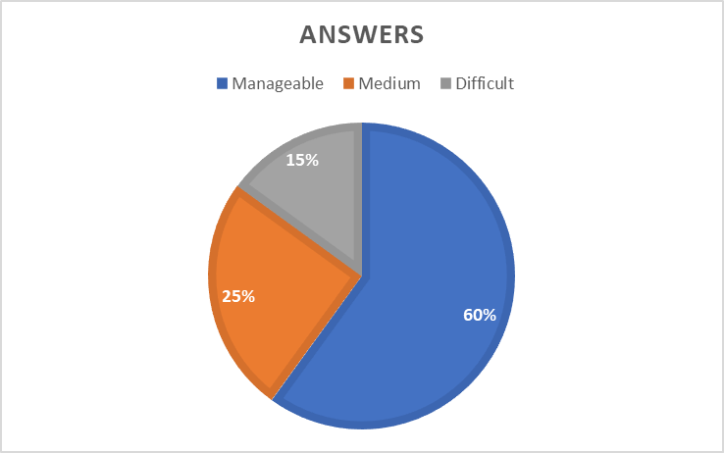

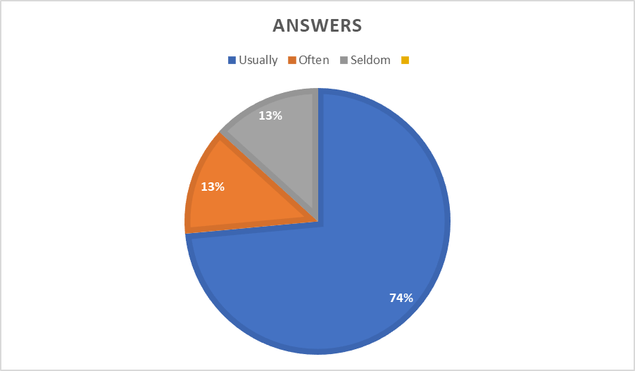

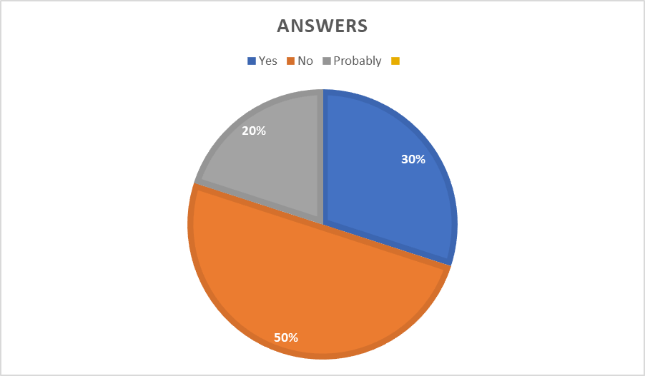

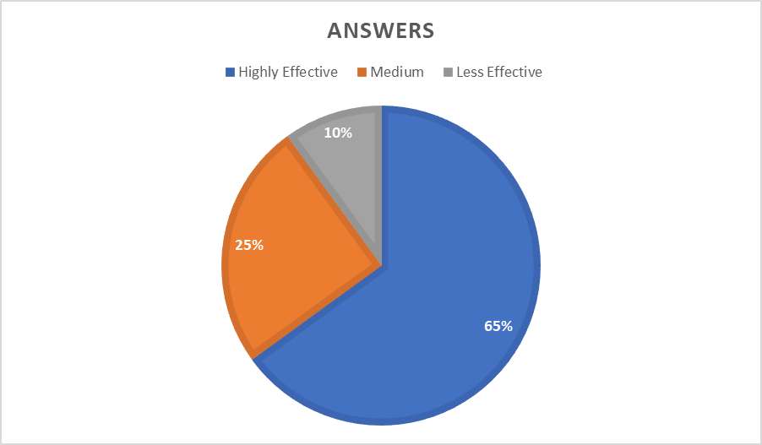

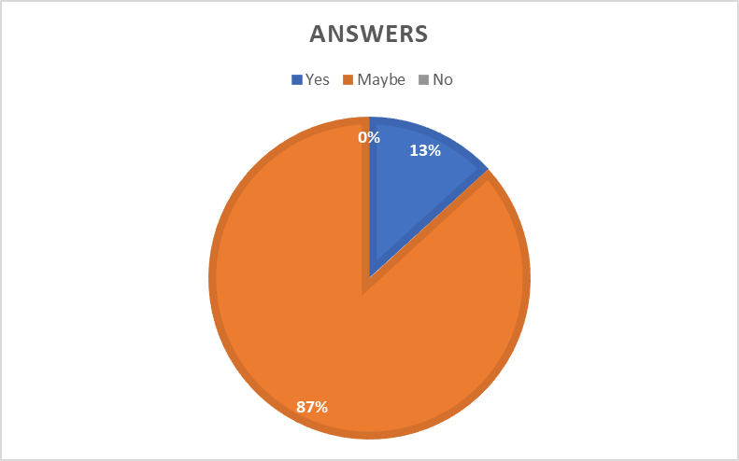

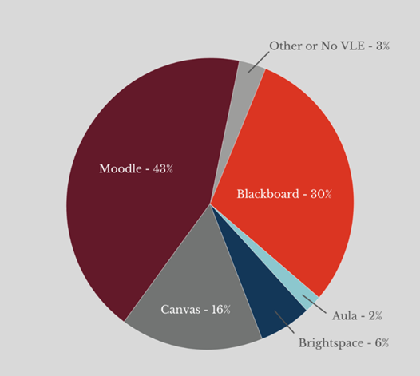
The use of Virtual Learning Environments (VLEs) has been highly beneficial for universities in the UK and the utilization of Moodle has been on the rise. Surveys on VLE usage show that students have been satisfied with the process. Data from the graph reveals that 43% of universities have adopted Moodle, making it the most popular platform. The University of Wales Trinity Saint David (UWTSD) can use this platform to enhance student learning.
The summary of findings
The research found that implementing a VLE had a positive impact on learning. Students reported increased engagement and motivation as well as improved academic performance. In addition, teachers reported improved communication with students and increased collaboration (Tudor et al., 2018). Finally, researchers concluded that VLEs are an effective tool for teaching and learning (Peng et al., 2019).
Conclusion
The research conducted on the impact of a Virtual Learning Environment (VLE) suggests that VLEs can be beneficial in providing students with an increased level of engagement and motivation in their learning. VLEs can also help to reduce barriers to learning, such as physical access to resources, and can provide a safe environment for collaborative learning. However, there is still room for improvement in the design and implementation of VLEs in order to maximize their effectiveness.
Recommendations
1. Determine how virtual learning environments (VLEs) affect students' ability to learn. VLE the impact on students' achievement, enthusiasm, and contentment might be investigated.
2. Research the effectiveness of VLEs for different age groups and learning styles.
3. Explore how VLEs can be used to promote collaborative learning and foster student-teacher interactions.
4. Investigate the ability of VLEs to support students with special needs (Oyelude, 2018).
5. Examine the role of VLEs in providing access to educational resources and materials.

References
- Awoyemi, R. A., Akinlubi, I. S., and Awoyemi, R. O., 2020. Innovation Attribute as Predictors of Social Media Adoption in Library Services.International Journal of Applied Technologies in Library and Information Management, 6(1), 43–55.
- Bahera, M., 2019. The Impact of Emerging ICTs in the School Curriculum: Implications for Teachers and Students.Journal of Data and Network Science, 6(2), 253–268.
- Clark, D., 2021. Topic: Digital learning in the UK. Statista. Available at: https://www.statista.com/topics/8518/digital-learning-in-the-uk/#dossierKeyfigures [Accessed 10th December 2022].
- David, J., 2021. Differences between deductive and inductive approaches to research. how and what. Available at: https://howandwhat.net/differences-deductive-inductive/ [Accessed 8th December 2022].
- Debois, S., 2022. 10 advantages and disadvantages of questionnaires. Pointerpro. Available at: https://pointerpro.com/blog/questionnaire-pros-and-cons/ [Accessed 11th December 2022].
- Hamutoglu, N.B., Gemikonakli, O., Duman, I., Kirksekiz, A. and Kiyici, M., 2020. Evaluating student's experiences using a virtual learning environment: satisfaction and preferences. Educational Technology Research and Development, 68(1), pp.437-462.
- Karumbaiah, S., Baker, R., Tao, Y. and Liu, Z., 2022, March. How does Students’ Effect in Virtual Learning Relate to Their Outcomes? A Systematic Review Challenging the Positive-Negative Dichotomy. In LAK22: 12th International Learning Analytics and Knowledge Conference (pp. 24-33).
- Leino, R.K., Gardner, M.R., Cartwright, T. and Döring, A.K., 2021. Engagement in a virtual learning environment predicts academic achievement in research methods modules: A longitudinal study combining behavioural and self-reported data. Scholarship of Teaching and Learning in Psychology.
- Lund, B. D., and Wang, T., 2019. Effect of Virtual Reality on Learning Motivation and Academic Performance.Kansas Library Association College Proceedings, 9(1), 1–7.
- Mubarak, A.A., Cao, H. and Zhang, W., 2022. Prediction of students’ early dropout based on their interaction logs in the online learning environment. Interactive Learning Environments, 30(8), pp.1414-1433.
- Oyelude, A. A., 2018. Virtual reality (VR) and augmented reality (AR) in libraries and museums.Library Hi Tech News, 35(5), 1–4. 10.1108/LHTN-04-2018-0023
- Peng, H.H., Lin, Y.T. and Wu, T.L., 2019, December. The effects of virtual learning environment on high school students’ English learning performance and attitude. In International Conference on Innovative Technologies and Learning (pp. 815-824). Springer, Cham.
- Racheva, V., 2022. Virtual classroom six tips to improve your learner's attention. VEDAMO. Available at: https://www.vedamo.com/knowledge/improve-learners-attention-in-virtual-classroom/ [Accessed 11th December 2022].
- Research-methodology, 2022. Ethical considerations - research methodology. Research-methodology. Available at: https://research-methodology.net/research-methodology/ethical-considerations/ [Accessed 9th December 2022].
- Ryan, E. and Poole, C., 2019. Impact of virtual learning environment on students’ satisfaction, engagement, recall, and retention. Journal of medical imaging and radiation sciences, 50(3), pp.408-415.
- Singh, I., Devi, M., 2018. Virtual Learning Environment: Issues and Challenges before LIS Schools.International Journal on New Trends in Education, 4(3), 65–78.
- Times higher education, 2020. The COVID-19 pandemic forces UK universities to reimagine their campuses. Times Higher Education (THE). Available at: https://www.timeshighereducation.com/hub/coursera/p/covid-19-pandemic-forces-uk-universities-reimagine-their-campuses [Accessed 10th December 2022].
- Tsay, C.H.H., Kofinas, A.K., Trivedi, S.K. and Yang, Y., 2020. Overcoming the novelty effect in online gamified learning systems: An empirical evaluation of student engagement and performance. Journal of Computer Assisted Learning, 36(2), pp.128-146.
- Tudor, A, Minocha S., Collins, M., Tilling, S., 2018. Mobile virtual reality for environmental education.Journal of Virtual Studies, 9(2), 25–36.

Appendix 1: Questionnaire
1. What was your experience with Moodle in terms of ease of use?
● Manageable
● Medium
● Difficult
2. How frequently do you access Moodle?
● Usually
● Often
● Seldom
3. Do you believe that Moodle should be modified in some way?
● Yes
● No
● Probably
4. What impact does VLE have on student learning?
● Highly effective
● Medium
● less effective
5. Would you suggest using Moodle for other individuals from other Universities?
● Yes
● No
● Maybe



