

Problem at the Workplace
Dissatisfied Food Delivery Drivers

With Balendran Kandasamy
By Yordan Petrov (2120805)
Problem Solving and Decision Making (BMSW4004_LON)



01.03.2023
Contents
INTRODUCTION 3
The workplace Problem 3
ANALYSING THE INFORMATION 4
ROOT CAUSE ANALYSIS (RCA) 4
APPLYING SITUATIONAL ANALYSIS MODELS 5
RANGE OF ALTERNATIVE SOLUTIONS 8
EVALUATION OF ALTERNATIVE SOLUTIONS 8
IMPLEMENTING THE SOLUTION 9
Communication plan with stakeholders 11
MONITORING AND REVIEW TECHNIQUES 13
CONCLUSION 14
References 15
APPENDIX 16
Appendix 1: Task 1 Presentation - Dissatisfied Food Delivery Driver 16
Appendix 2: Task 1 – Role Play Scenario 20
Appendix 3: Fishbone Diagram - Dissatisfied Food Delivery Driver 22
Appendix 4: ADKAR Gap Model 22

INTRODUCTION

Ensuring innovation and a creative approach to new challenges is crucial in leadership success. Being able to communicate and share your ideas takes no less skill. Decision Making and Problem-Solving Strategies will help you to learn key techniques and models to confidently make the right decisions. (Adair, 2013)
We were tasked to develop a role play scenario for the Problem Solving and Decision Making module at the University of Wales Trinity Saint David (Appendix 2). There we presented a complex workplace problem stemming from the role play issue, offered solutions, and communicated and applied the best one (Appendix 1). This report contains a more detailed soliton and implementation plan are offered to the workplace issue with a food delivery driver who is being dissatisfied at the workplace, along with other critical aspects to implementing the best solution.

The workplace Problem

The nature of the problem is that a food delivery driver is not satisfied and unhappy at work. He is facing unhappy customers due to orders being late during weekends, stress as well as little to no tips.
This complex issue could have a great impact on several important aspects of this business:
- Drivers are dissatisfied with the job.
- Drivers are under extreme pressure.
- Customers are unhappy.
- Late delivery or no delivery.
- Poor food quality upon late delivery
- Wasting food and time.
- Losing profit.
- Loosing quality workers
- Ruining the good name of the brand.

ANALYSING THE INFORMATION

ROOT CAUSE ANALYSIS (RCA)
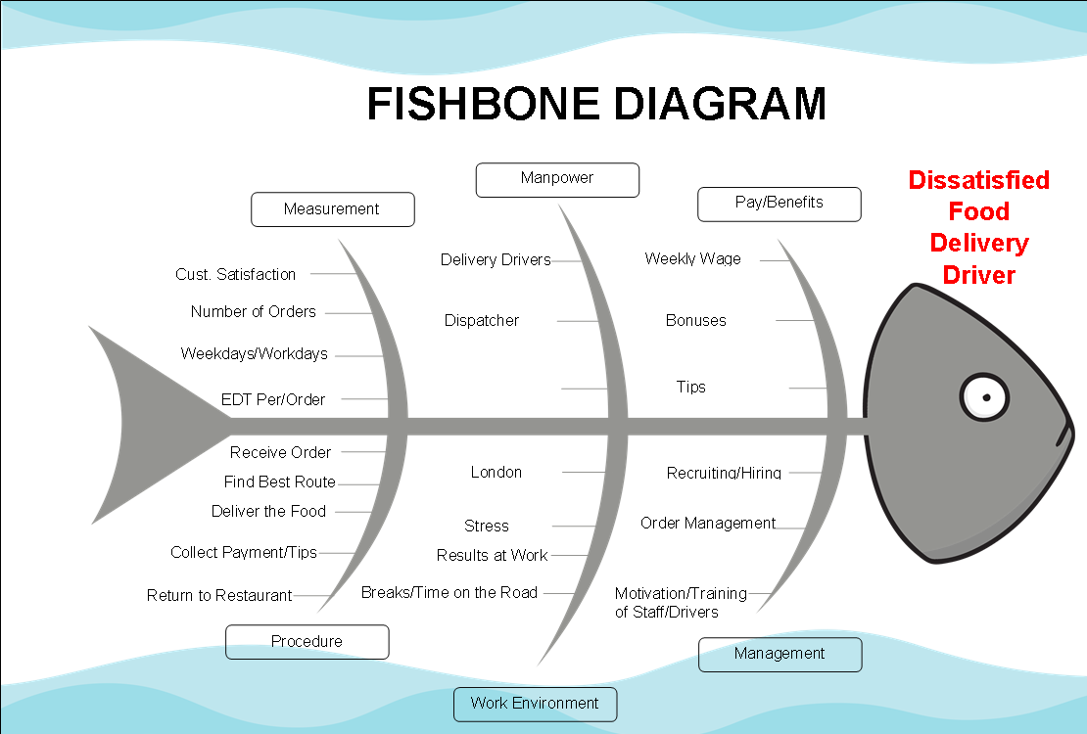
To identify the possible root causes we need to analyze the causes and effects of the complex problem. Here is a fishbone diagram to visualize cause-and-effect links (Appendix 3).

Here are the major categories that could be related to the dissatisfaction of the driver:
- Pay/Benefits – the satisfaction at work is directly linked to the income and benefits.
- Manpower – if there are not enough workers or issues and miscommunication are taking place, major issues can occur.
- Measurement – all the factors we can measure – how satisfied customers are, what number of orders are being delivered, how long is the estimated delivery time per order and what time of the week it is.
- Procedure – all the tasks involved in the driver’s delivery process.
- Work environment – location, stress, not enough breaks can create employees’ dissatisfaction.
- Management – the factors that management is directly responsible for.
All the above categories and their related factors can lead to employees being unhappy at the workplace.

“Experienced meaningfulness, experienced responsibility, and knowledge of results are the key psychological states that lead to worker outcomes of high intrinsic work motivation, high satisfaction with personal growth, and high work effectiveness.” (Abe, 2021)

At the interview, the driver mentioned that he is unable to handle all the orders coming through on the weekends and he is very unhappy with the results of that. (Appendix 2). Few of the categories listed above can lead to this, such as:

- Overwhelming number of orders during weekends but not during the weekdays.

- Not enough deliver drivers on the weekends due to poor recruitment or unattractive pay and work conditions/environment.

- Inexperienced or not properly trained drivers and dispatchers.

- Communication or other issues between dispatchers and drivers.

- Increased traffic in the area during weekends.

APPLYING SITUATIONAL ANALYSIS MODELS

It is crucial to gather as much information and data that is directly related to the problem to be able to weigh the options. Doing this will help better understand what needs to be done, to solve the problem. It will also help create ideas for a possible solution (Gray, 2022).

The takeaway is a part of a successful organization that is popular across the nation and offers a desirable cuisine. There are many customers in the area for both – sit in, or takeaway. Many orders come in for delivery as well.
On the other hand, the business is extremely busy and hard to manage across the departments and poor access to suitable staff in the area makes it a challenge for the executive management to operate.

Next in this section SWOT analysis tool is applied to identify the strengths of the organization followed by PESTLE analysis.

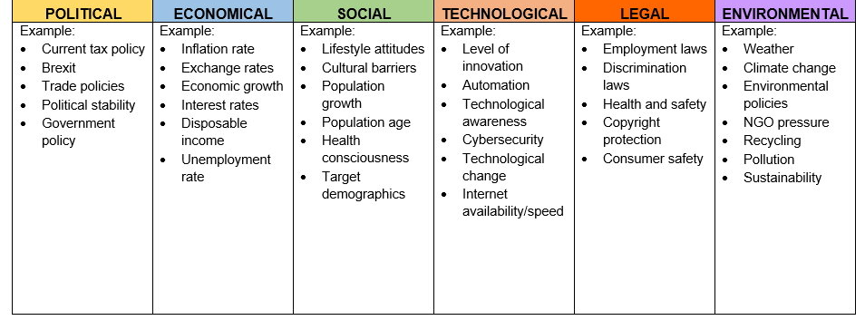
SWOT ANALISYS

- Poor access to staff.

- Lots of Customers
- Great Area for Delivery

- Difficult to manage.

- Great Food
- Popular Brand
- Part of big organization with multiple takeaways across UK

PESTLE ANALISYS
Health and safety

Consumer safety

Food safety

Discrimination
Inflation

Low wages

Unemployment rate
Brexit

Post COVID restrictions

Recycling

Pollution

Traffic
Work-life balance

Demography

Intercultural relations

Post COVID consumer behavior
Internet

Technology

Why use PESTLE? “This concept is used as a tool by companies to track the environment they’re operating in or are planning to launch a new project/product/service, etc.” (pestleanalysis.com, 2022)

Many external factors are related to the takeaway and the organization. The two most relevant to the complex problem at hand are Political and Technological. While Brexit had a very negative impact on access to staff, the internet, in combination with some other circumstances (post COVID) lead to a large increase in the takeaway and delivery orders.

As explained in a recent article “drivers are cancelling in droves. Wait times for food delivery are ballooning out and driver shortages are leading to food waste”. and continue “Our five years of research reveals an industry facing pushback from both workers and customers. Many workers we spoke to sought to leave”. (Bissell, 2022 )

The information available points to an external issue, the delivery industry is struggling and there is no one to fill the void. That in combination with the increase in delivery orders will continue to apply pressure to the business and everyone involved in the food delivery industry, especially the drivers.

Customers experience the negative impact as well. As a customer puts it “It’s kind of lost the sense of quality and customer service that they used to have that I really enjoyed […] it got to the point where, say I’d order twice in one week, both orders would come, and they’d be cold. Basically inedible. The drivers would literally have no idea where they’re going.” (Bissell, 2022 )

RANGE OF ALTERNATIVE SOLUTIONS

There are three solutions we can apply to solve the complex problem and related issues of the dissatisfied food delivery driver:

• Solution 1: Hire Extra Drivers – more drivers will deliver the orders quicker, but this is related to recruiting and training process and strongly depends on external factors. There are many uncertainties connected with this solution.

• Solution 2: Outsource Delivery Process – by hiring a third party delivery company and lifting the weight of managing the delivery aspects of the business, making it completely external. It will have positives for the other departments and management. This is not as much dependent on external factors, such as access to staff, training, and planning. Overall, more expensive than the other solutions to apply but simplifying the internal operations, saving time and workforce capacity.

• Solution 3: Improve the Delivery Process, Benefits and Training – by better training and increasing the delivery drivers’ job satisfaction and providing better equipment certainly will solve the issue. Better delivery timing and more satisfying pay, better suited vehicles, and equipment, things will completely change for the drivers.

EVALUATION OF ALTERNATIVE SOLUTIONS

“Evaluating alternative solutions involves analysis, discussion, and review. Iterative cycles of analysis are sometimes necessary.” (wibas.com, 2022)

“A decision matrix evaluates and prioritizes a list of options and is a decision-making tool. The team first establishes a list of weighted criteria and then evaluates each option against those criteria.” (asq.org, 2023) As a result, the highest scoring option would be most advantageous. In this case we are comparing four of the most important factors, which are equally valuable:
- Cost – indicates how much it would cost to implement. A higher score means cheaper.
- Time – indicates the timeframe to apply. A higher score means a shorter timeframe.
- CSAT – customer satisfaction expected during/after solution is applied. A higher score means a better CSAT.
- Management Difficulty – how taxing on the management it would be to apply. Less score means more difficult.

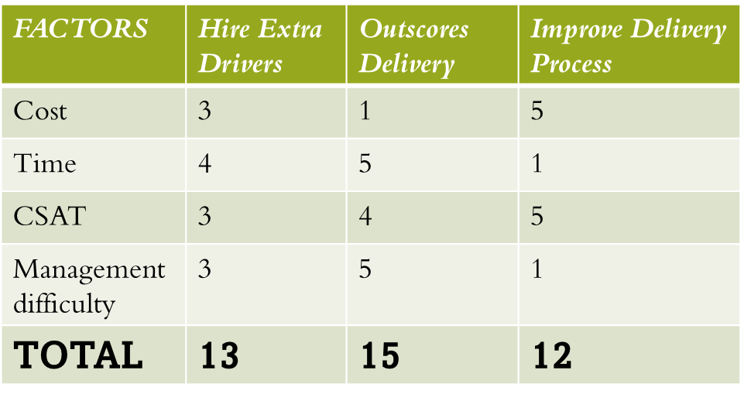
DECISION MATRIX

Clearly the results show that Decision 2 would be most suitable. This is due to it being timesaving, improving CSAT and ease to manage, at the cost of extra costs.

IMPLEMENTING THE SOLUTION

“Implementing change and understanding its general effects on organizational
members, it is obvious that the process used to plan and enact an organizational
change is as important as the state of existing content and contextual factors.” (Armenakis & Bedeian, 1999)

To successfully apply the solution, a good implementation plan is critical. There are several tasks involved:

- Data Collection and Organizing – by gathering the data available so far. and the data that will come in as the implementation is in progress, we can create charts to compare factors such as CSAT and EDT.
- Collecting, Storing, Analyzing and Monitor – this is the continues process related to new data coming in, using it to monitor the process and adjust.
- Create Budget – calculate the expenses for the project and delegate an appropriate budget.
- Hire a Delivery Company – choose a third party delivery partner.
- Relieve Drivers – As the delivery partner takes over drivers must be let off. This is a very difficult process, and it would be best if done gradually. An option here is to train drivers for another position.

Proper planning and timeframes are necessary for each of the tasks involved in the implementation plan. Also, milestones must be set. A Gannt Chart visualizes the timescale and milestones next.

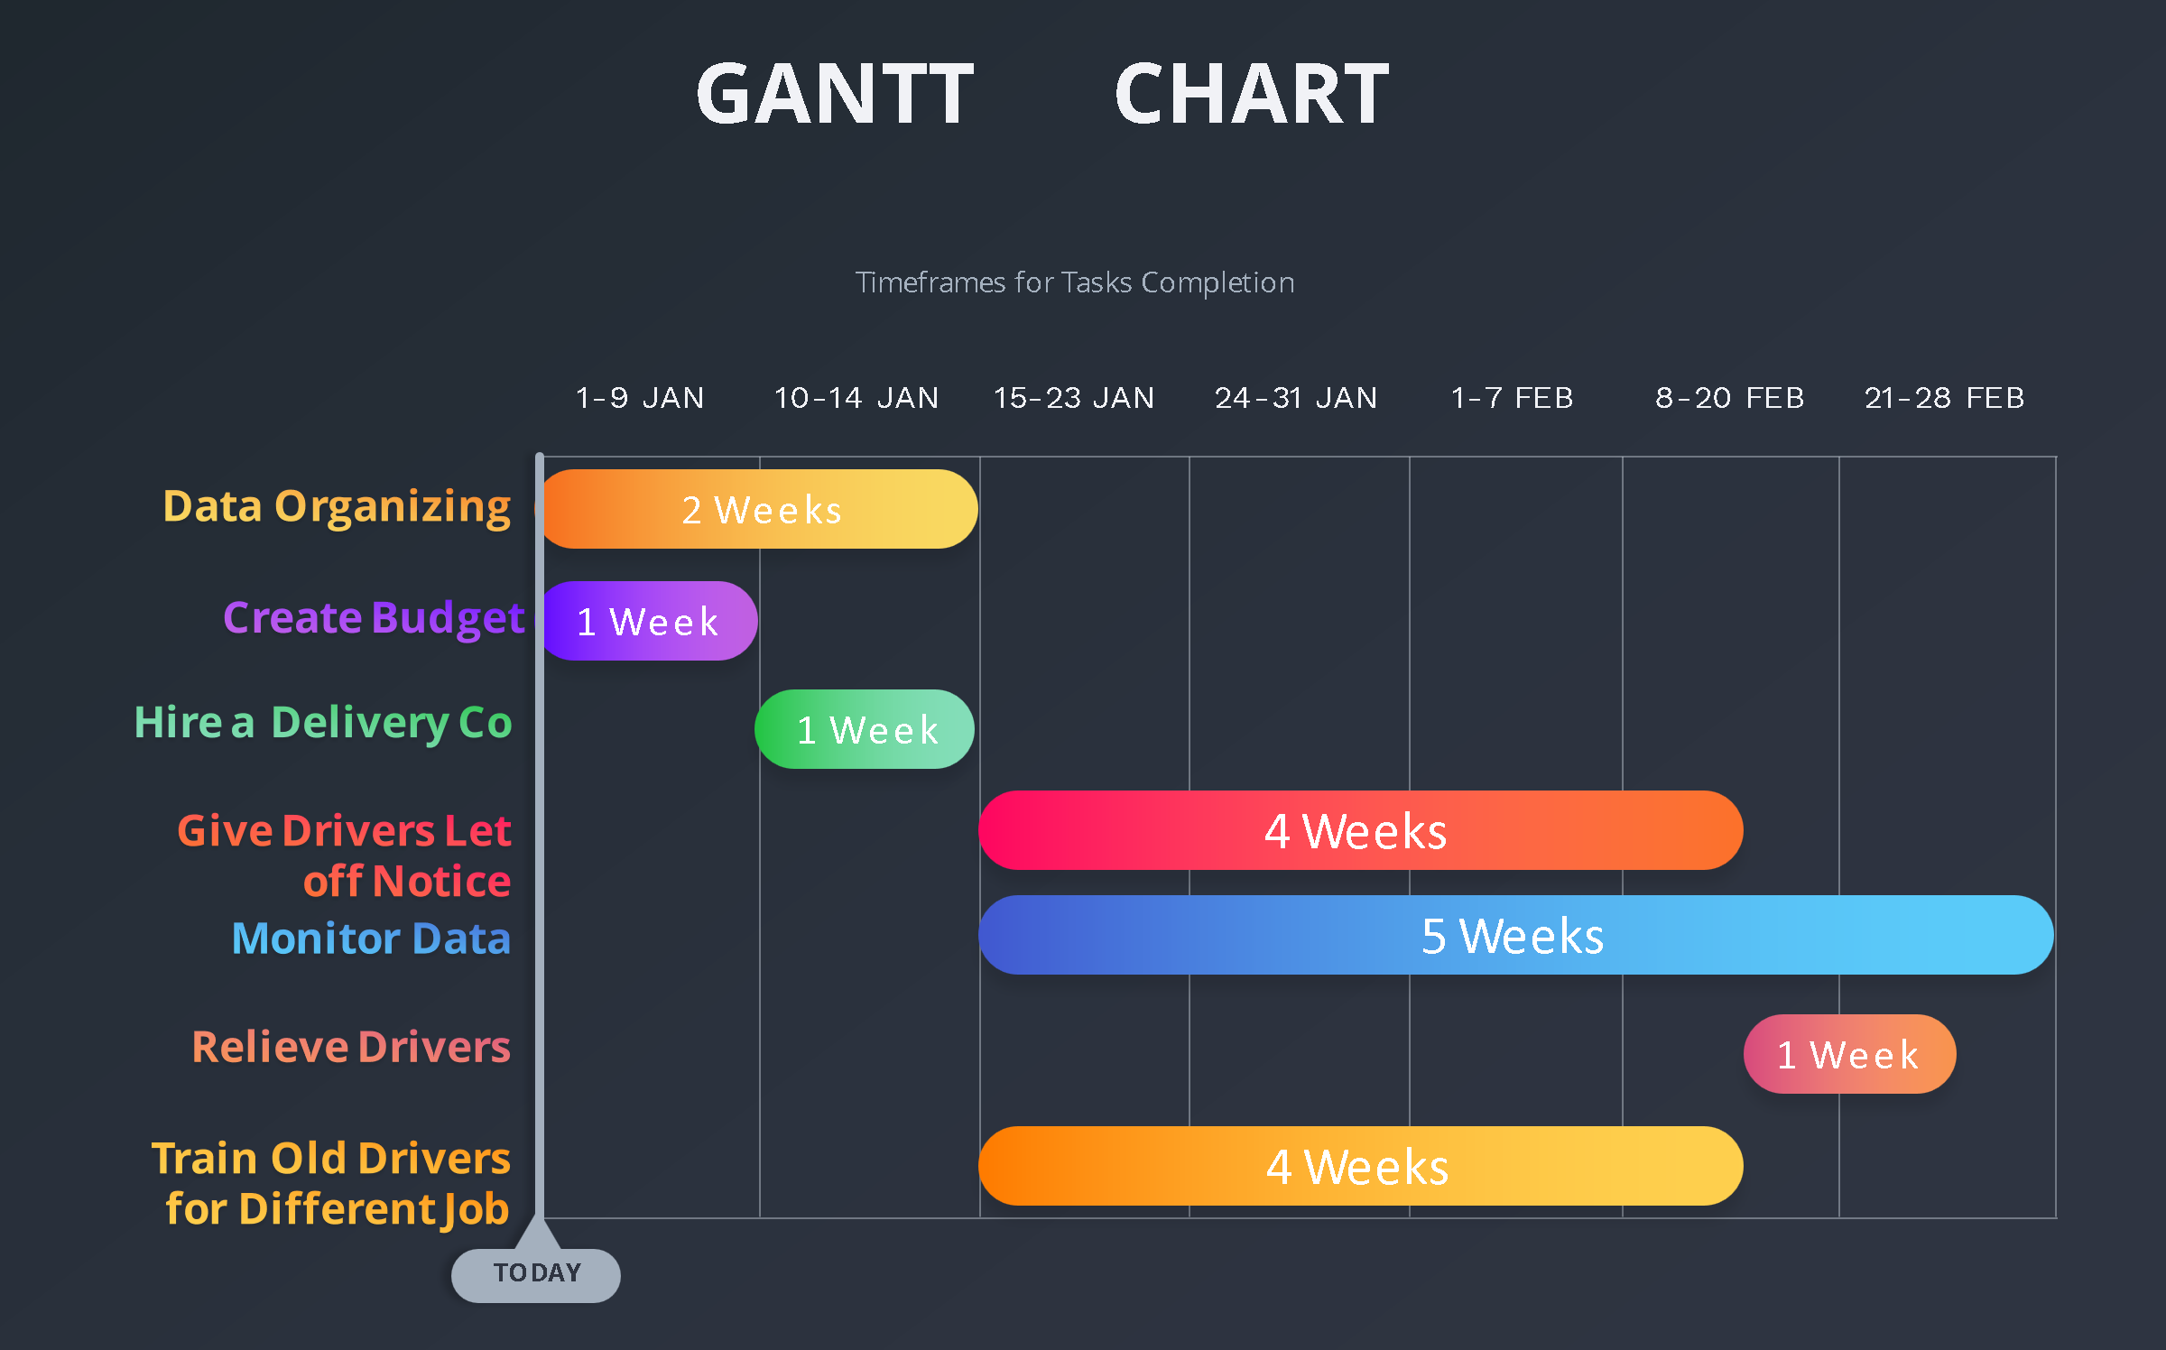
GANNT CHART

Communication plan with stakeholders
Consideration and good communication with the stakeholders greatly contributes to a successful execution of the implementation plan. The importance of stakeholders is well recognized but simply put “Business can be understood as a set of value creating relationships among groups that have a stake in the activities that make up the business.” (Freeman, 2017)

There are many categories of stakeholders, and they are present in any field of business, whether they themselves realize it or not.
“The relationship can be direct or indirect, voluntary or involuntary, external ( outside ) or internal ( inside ), critical ( core, necessary or non-trivial ) or distal ( fringe ), primary, secondary, tertiary, formal ( ofﬁcial ) or informal, perfect or imperfect, implicit or explicit, legal ( contractual or arm’s length ), economic ( ﬁnancial ), operational, social or moral ( normative ), legitimate, derivative or residual, market or non-market, joint and mutual.” (MIles, 2017)

There are three steps in this section that we adhere to and create a plan
:
- Identify - recognize related stakeholders to a business. Here is a list of stakeholders to the takeaway restaurant:

- Customers. Those who order food from your restaurant through the online ordering system.
- Delivery Partners. Those who deliver food to customers.
- Restaurant Owners
- Franchise Holders
- Employees
- Suppliers
- Regulatory bodies. Government institutions that have a health and safety function.
- Community Groups
- Shareholders

- Categorize Stakeholders – according to their Influence or Power and Interest with the business. A Power/Interest matrix is applied here to help with that:

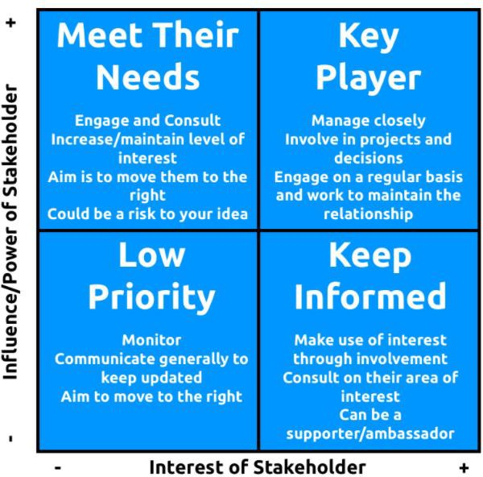
POWER/INTEREST MATRIX

Community Groups

Delivery Partners
Employees

Restaurant Owners
Franchise Holders
Regulatory Bodies

Customers
Suppliers
Shareholders

- Create a Stakeholder Engagement Plan – to prioritize and set regular communication links and communication frequency, according to stakeholders’ power and interest. Here is the plan:

Stakeholder Communication Plan
Stakeholder | Power/Interest | Key interests & Issues | Communication Vehicle | Frequency
Customers | High/Low | Good Service | Feedback, Reviews, Tips | Daily
Suppliers | High/Low | Frequent Orders | Phone, Internet | Weekly/Daily
Shareholders | High/Low | High Profits | E-mail | Every 3 Months
Restaurant Owners | High/High | Profits, Quality Service, CSAT | Direct Contact, Phone, E-mail | Daily
Franchise Holders | High/High | Profits, Quality Service, CSAT | Direct Contact, Phone, E-mail | Weekly
Delivery Partner | Low/High | Delivery Orders, CSAT | Direct Contact, App, Phone | Daily
Regulatory Bodies | High/High | Safety Hazards | Direct Contact, E-mails, Mail | When required
Community Groups | Low/Low | Environmental | Direct Contact, Announcements, Meetings | When required

MONITORING AND REVIEW TECHNIQUES
When milestones are set and the timeline is clear It is vital that management monitors, evaluates and regulates the process involved during and after this change.

- Milestones –standards and various milestones are set in reasonable timeframes regarding certain important factors and performance. For example, if a target is set for estimated delivery times (EDTs) to reach a certain point after 1 month.
- Monitoring – certain outputs from the data linked to the quality of service must be closely observed, such as CSAT and EDT.
- Evaluating – customers review and factors like CSAT and EDT are evaluated to show if the results are positive. They can indicate if there is a need for adjustments.
- Regulate – to regulate and adjust the strategy, based on accurate information provided regularly. Management can give feedback and directions to correct the procedures according to standards and performance, to ensure effective execution.

One and all are on the same course, it is important that the management takes the needed steps to communicate, support, educate and reinforce staff throughout the development and implementation. A great tool to use for that aim is an ADKAR Gap Model (Appendix 4).

CONCLUSION

The complexity of problems in the workplace requires a no less complex solution. Picking the right one is critical and only the first step to solving a problem. Change is always uncertain and a difficult process. Successful implementation of the plan by identifying different factors and information, monitoring, and taking the actions necessary is a hard task. What we can do is make it more manageable.

References
Abe, E. N., 2021. Future of Work, Work-Family Satisfaction, and Employee Well-Being in the Fourth Industrial Revolution. 1st ed. Hershey PA: IGI Global.
Adair, J. E., 2013. Decision Making and Problem Solving. 2nd ed. London: Kogan Page.
Armenakis, A. A. & Bedeian, A. G., 1999. Organizational Change: A Review of Theory and Research in the 1990s. Journal of Management, XXV(3), p. 293–315.
asq.org, 2023. Decision Matrix. [Online]
Available at: https://asq.org/quality-resources/decision-matrix
[Accessed 03 Jan 2023].
Bissell, D., 2022 . Guilt, shame, dissatisfaction: workers and customers on the gig economy (and how to make it better). [Online]
Available at: https://theconversation.com/guilt-shame-dissatisfaction-workers-and-customers-on-the-gig-economy-and-how-to-make-it-better-185502
[Accessed 03 January 2023].
Freeman, R. E., 2017. Research in Progress R. Edward Freeman Five Challenges to Stakeholder Theory: A Report on Research in Progress. In: D. M. Wasieleski & J. Weber, eds. Stakeholder Management. Pittsburgh, PA: Emerald Publishing Limited, pp. 1-20.
Gray, K. D., 2022. 5 Steps to Good Decision Making. [Online]
Available at: https://www.corporatewellnessmagazine.com/article/5-steps-to-good-decision-making
[Accessed 03 Jan 2023].
MIles, S., 2017. Stakeholder Theory Classiﬁcation, Deﬁnitions and Essential Contestability. In: D. M. Wasieleski & J. Weber, eds. Stakeholder Management. Pittsburgh, PA: Emerald Publishing Limited, pp. 21-47.
pestleanalysis.com, 2022. WhatI s Pestle Analysis. [Online]
Available at: https://pestleanalysis.com/what-is-pestle-analysis/
[Accessed 03 Jan 2023].
wibas.com, 2022. https://www.wibas.com/cmmi/darsp-15-evaluate-alternatives-solutions. [Online]
Available at: https://www.wibas.com/cmmi/darsp-15-evaluate-alternatives-solutions
[Accessed 03 Jan 2023].

APPENDIX

Appendix 1: Task 1 Presentation - Dissatisfied Food Delivery Driver
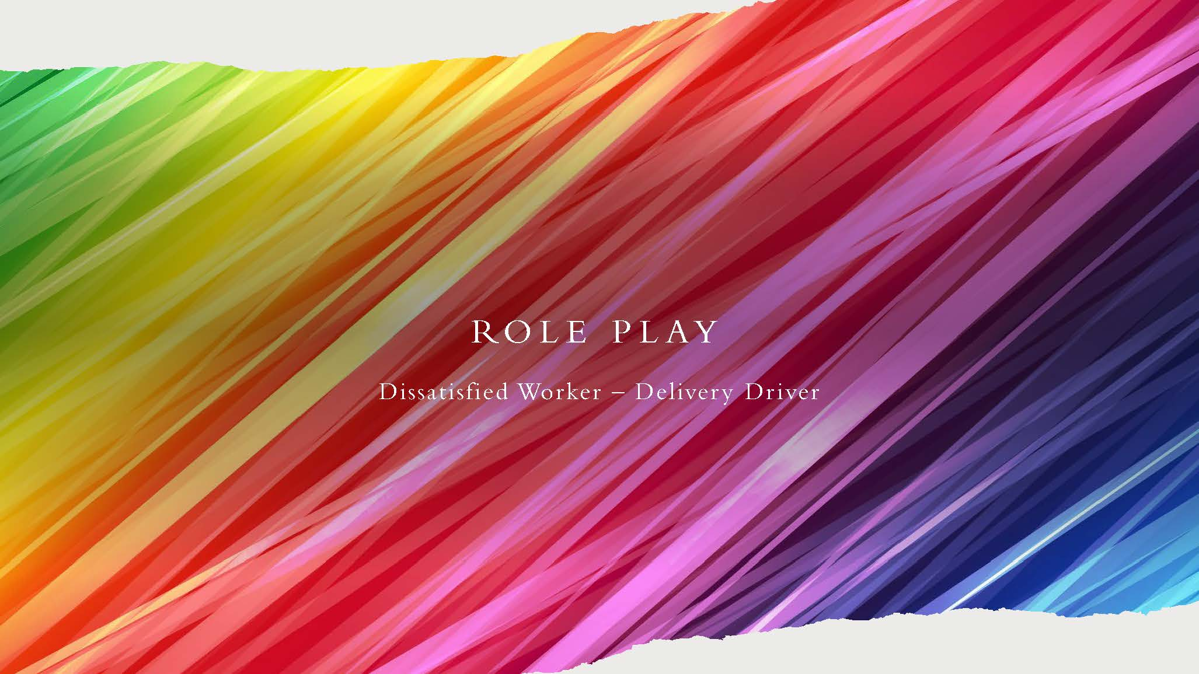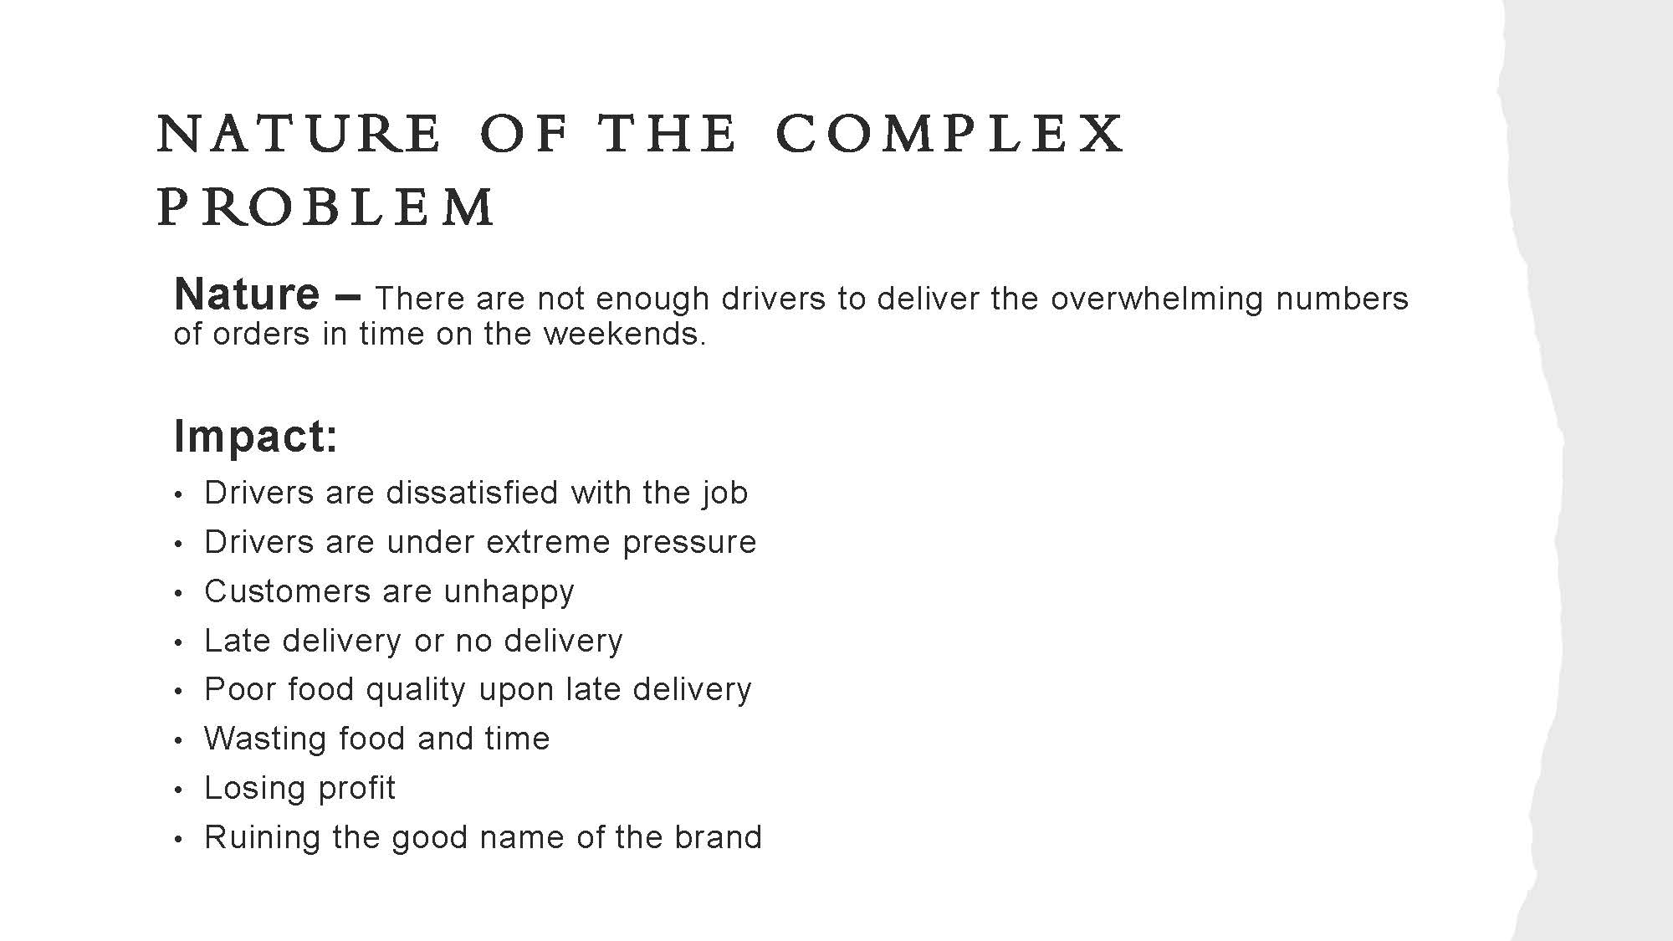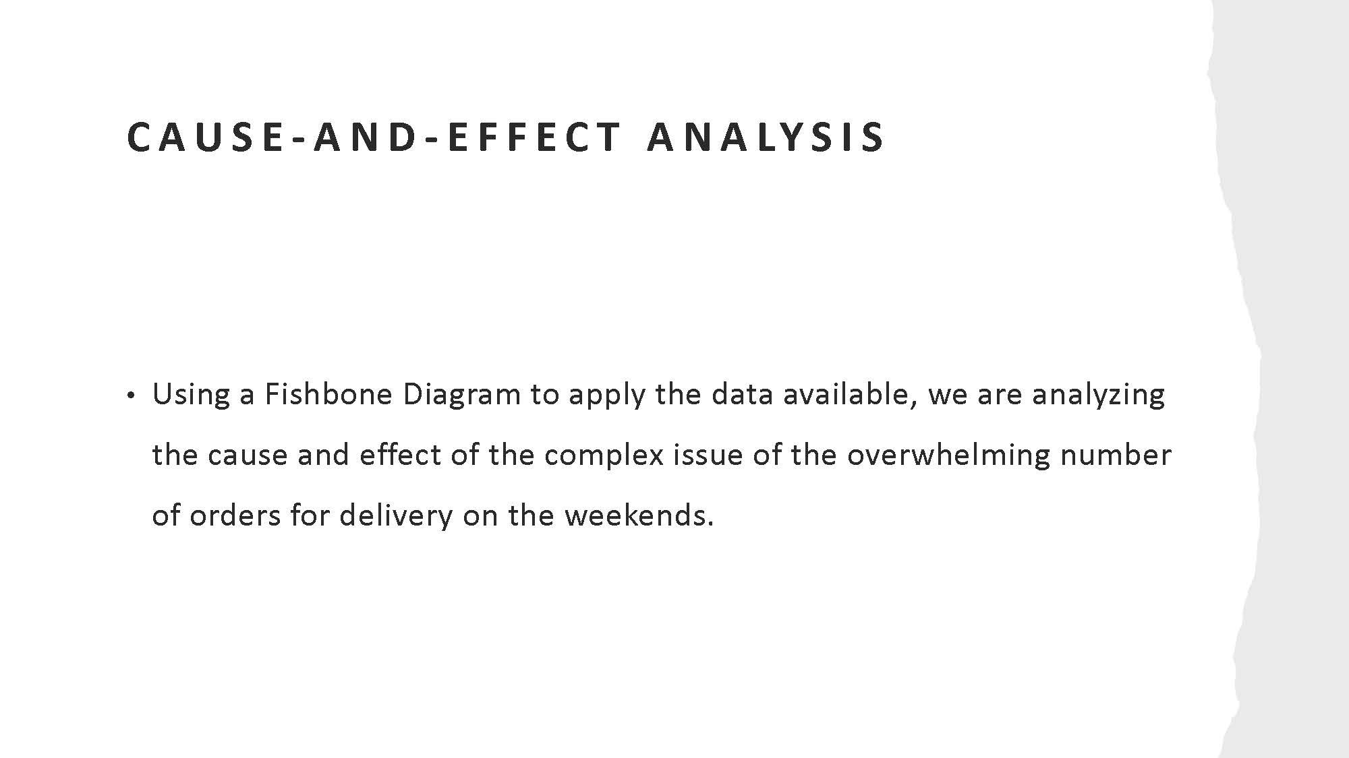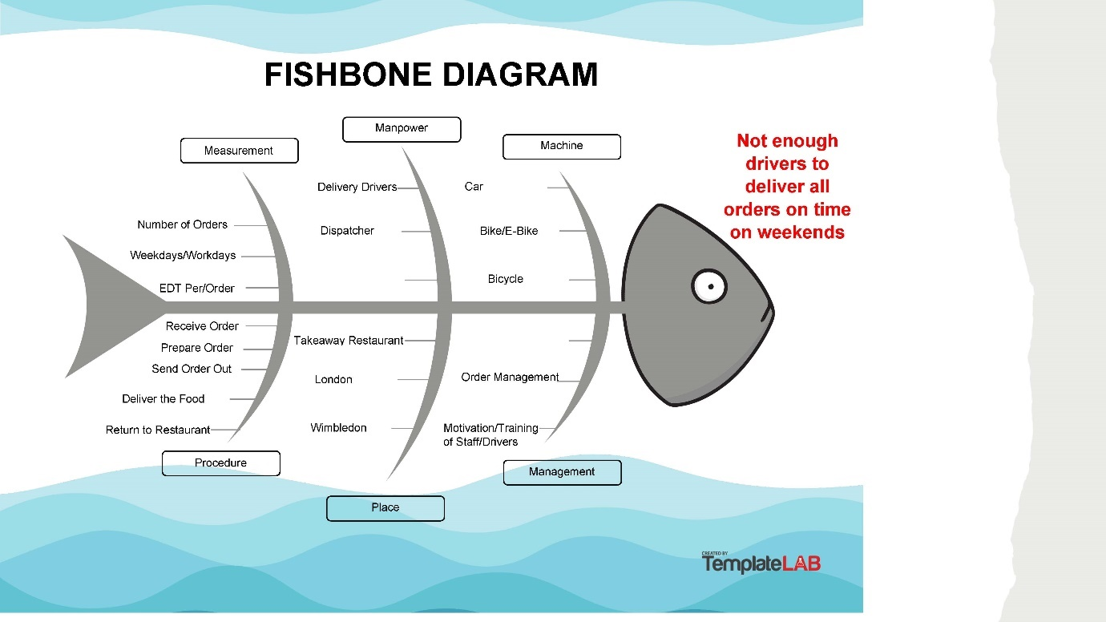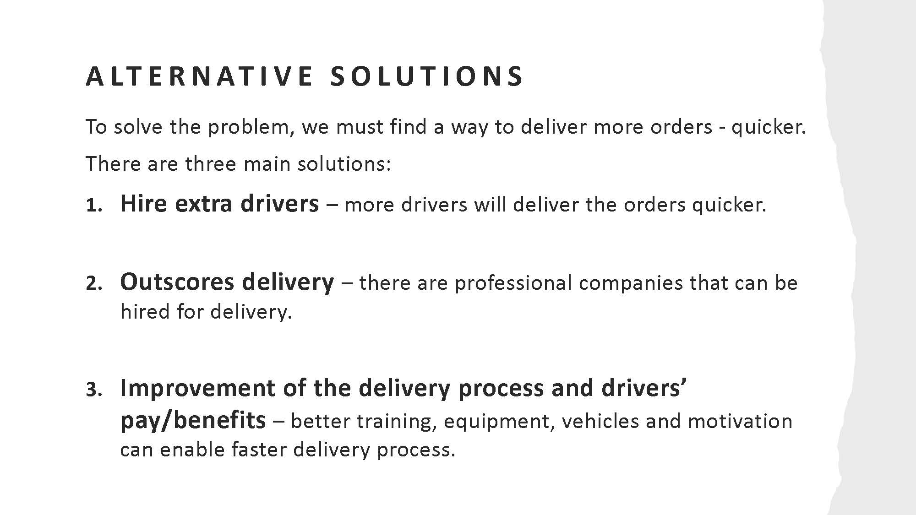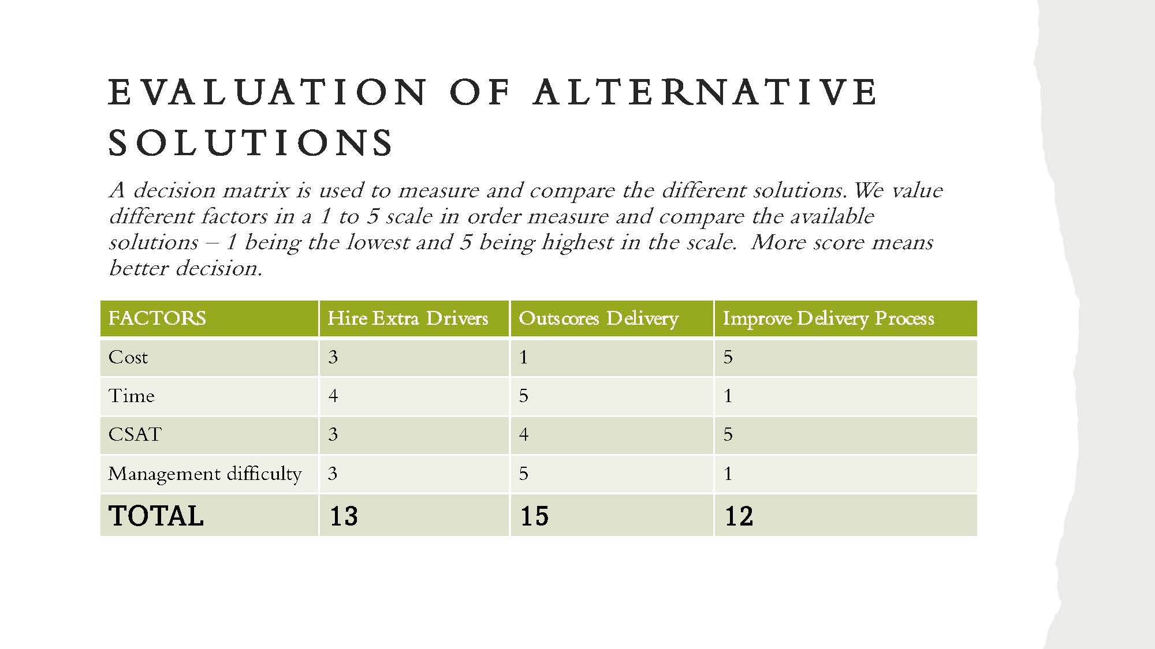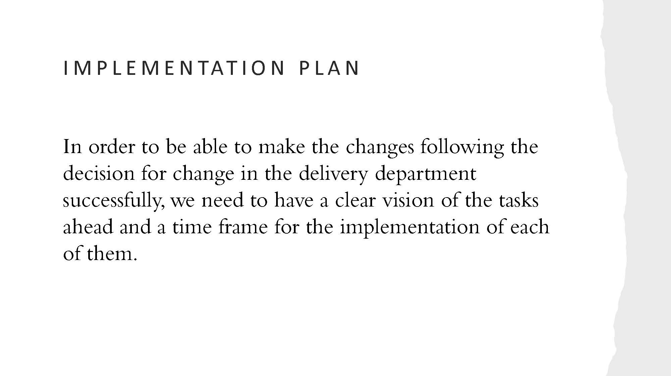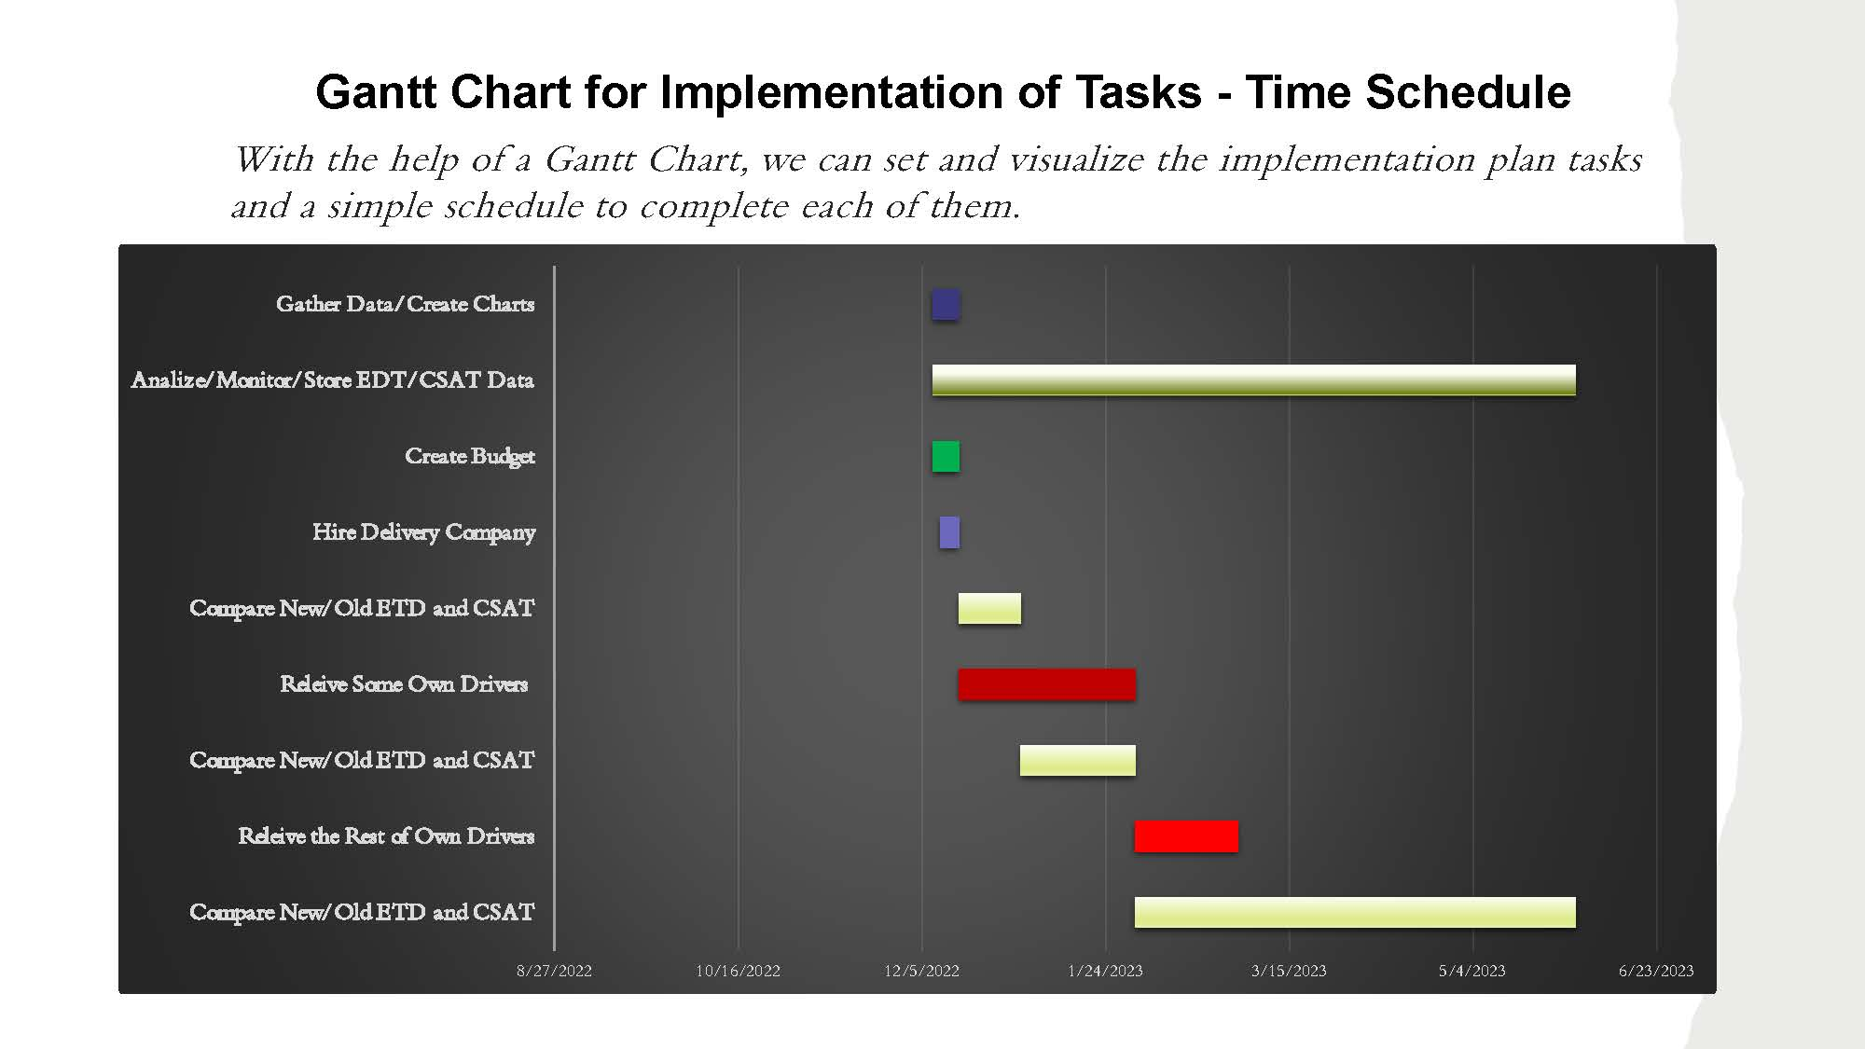

Appendix 2: Task 1 – Role Play Scenario
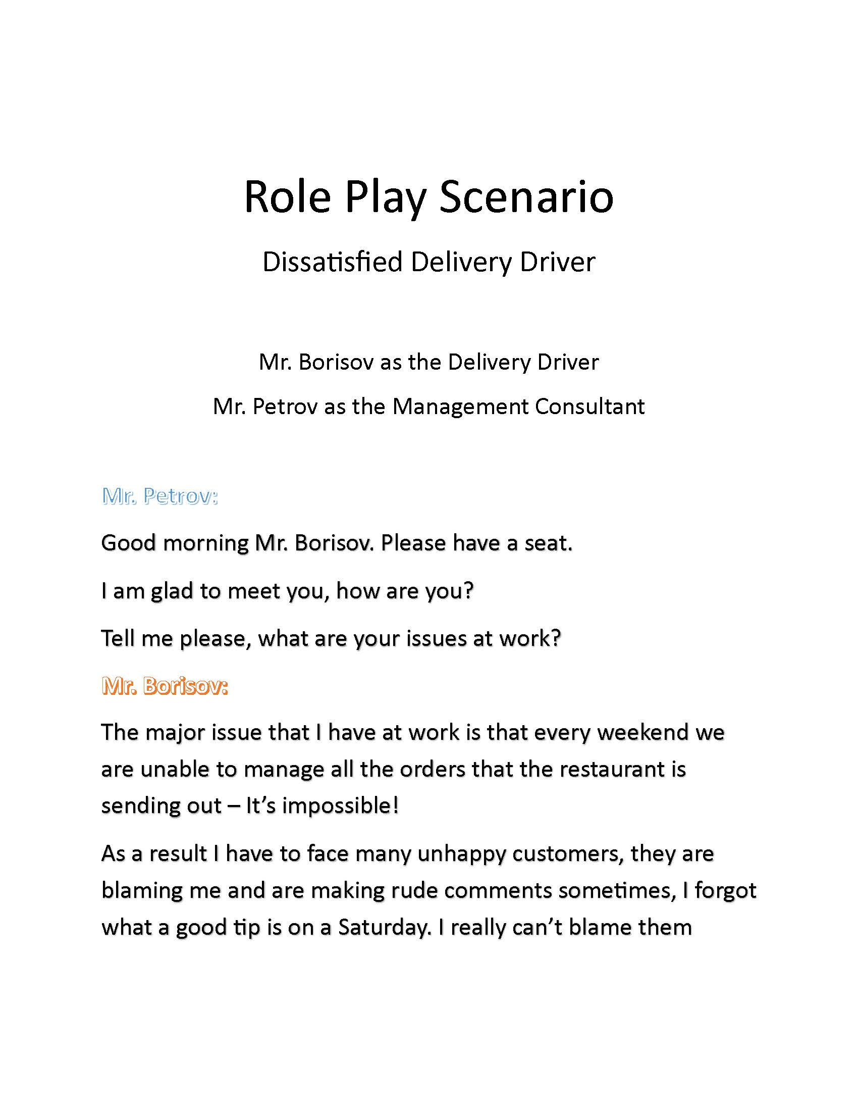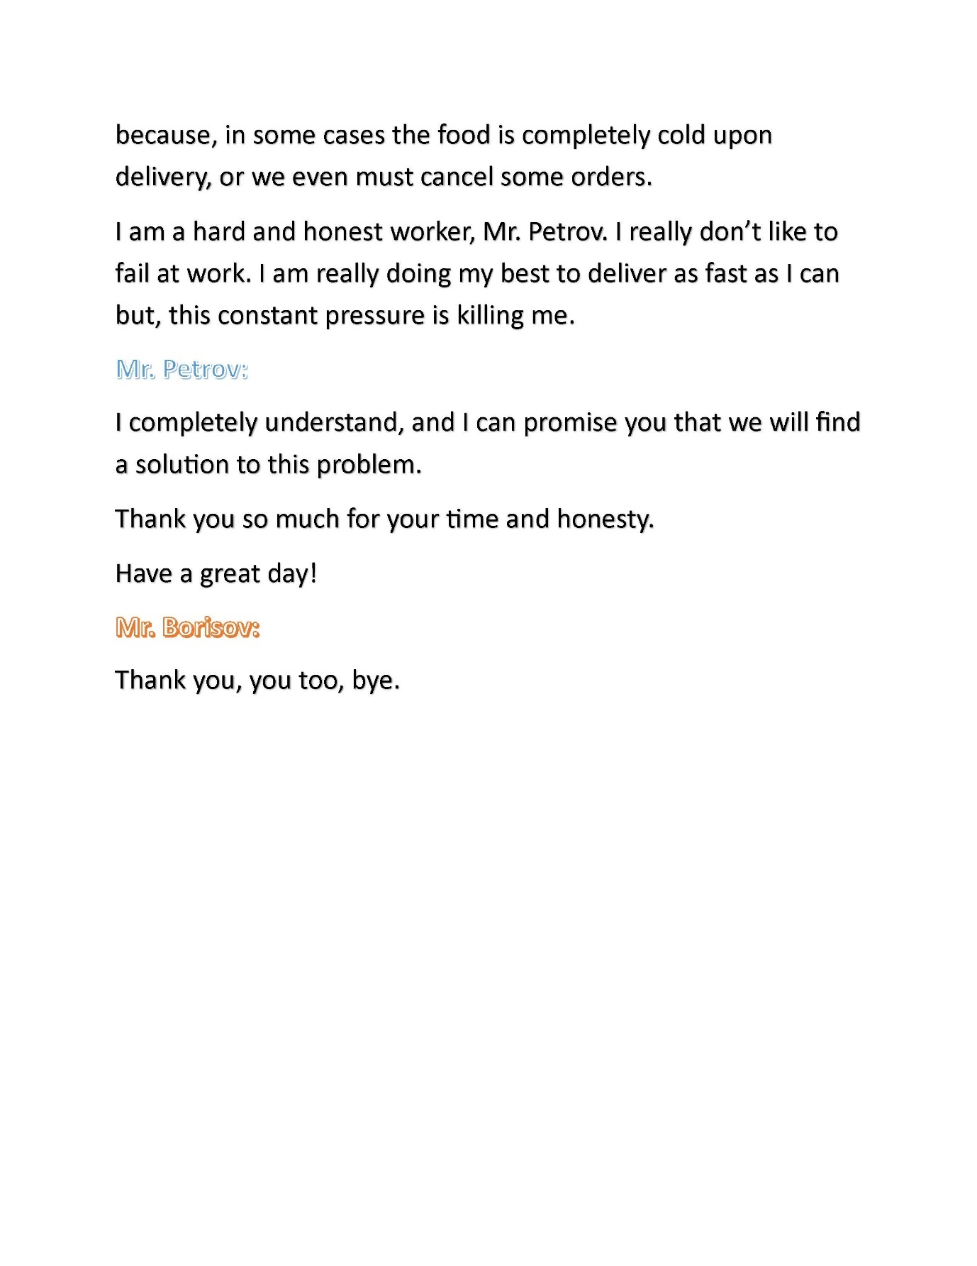

Appendix 3: Fishbone Diagram - Dissatisfied Food Delivery Driver

Appendix 4: ADKAR Gap Model

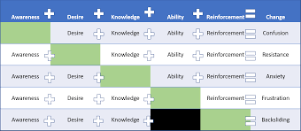
ADKAR GAP MODEL

