How Might Conflict Be Identified in the Pre-Archaelogical Record
Student Number:1600787

Humans and their ancestors have always had a great capacity for violence. The 20th century is the best example for this, filled with the deadliest conflicts ever fought in human history. The pre-archaeological record is also no exception to this. The case has been made that there has been an attempt to pacify the past and to make the invention of warfare and conflict a “new” idea. This notion, however, has been challenged by the prominent anthropologist Lawrence Keeley who, in his book War Before Civilization 1996, demonstrates to us that conflict was a factor in pre-history. However, Keeley has received much criticism due to his almost extreme views on conflict, and the way he is seen as attempting to interpret conflict when there is no conflict to be found. Humanity continues to show a countless capacity for violent tendencies. This school of thought seems to be supported by discoveries of items like arrowheads and the innumerable flint axes that have survived into the modern period.
Being able to recognise the features of conflict in the archaeological record, which is what this essay shall be focused on, is not easy as there is no written evidence of conflict only the remains of the people and the tools that they have left behind. This makes the task of identifying conflict in the Pre Archaeological record even more challenging as weapons that are crafted out of stone and bones are the only ones to survive for archaeologists to recover and have only been in use for the past 40,000 years (Keely, 1998:60), therefore if anyone was killed before this time with a wooden weapon, the wood wouldn’t survive and the cause of death may remain a mystery.
In many ways, the best examples that indicate conflict in archaeological finds are those that are found from skeletal remains. From remains found at different locations around the world, we can see that conflict has always been part of human history.
As Lawrence Keeley, writes in a cross-cultural survey, an overwhelming 90-95% of all human societies have at some point been at war (Keeley, 1998:47). One such site is Sima de Los Huesos, Atapuerca, Spain where the remains of 32 individuals were recovered and date to 250,000 BC (Arsuaga et al, 1997). As well as being a site with six of the bodies killed Atapuerca also shows the earliest evidence of cannibalism (Fernandez-Jalvo et al, 1999) due to the cut marks on the bones which are identical to animals. In this instance, it is unclear whether cannibalism was largely practised as a method to honour the dead by keeping the deceased with them or whether it was due to times of hardship where early man was forced into consuming his kin. Examples of victim’s remains being discovered with the killing tool still embedded include the site at Grimaldi, Italy, where a child’s remains, dating back to the Aurignacian, (the earliest time period humans occupied Italy) were excavated (Keely, 1998: 61) and the discovery? Of what is thought to have been a massacre at Telheim in Germany dated to 5500 BCE. The aforementioned examples provide us with clear evidence that there was conflict in the Pre-Archaeological record and help us to identify it.
However, Berger and Trinkaus (1995), argue that during this time period the lifestyle of a Neanderthal was far more trauma centred and as a result, it led to a high number of injuries being sustained from animals such as woolly rhinos and mammoths. Therefore, analysis of skeletal remains when attempting to identify human remains in the archaeological record to look for signs of conflict does become more difficult due to the possible causes of death for instance some blunt force blow to head may look like it came from a mammoth but may have been the result of human agency to identify when we take into account the hunter-gatherer lifestyle that was led. When we also factor in additional trauma, such as those taken from the human agency of violence, it is sometimes harder in a sense to know if someone was killed via human causes or by an animal. An example of this is referenced again by Keeley (1998: 60). Skulls that were found on South African Australopithecine were thought to have been killed by a paired spear but later analysis revealed that they were in fact killed by a leopard that hunted early man.
While there is certainly more trauma within the lifestyle of the Neolithic, there are evidently locations where there have been undeniable killings taking place and to this extent, the remains of those killed may offer us similar killing blows to the ones animals may deliver. Without the presence of writing or the presence of more sophisticated artwork, it is unclear how useful skeletal remains are, in some instances, at helping us to identify conflict within the prehistory time period. While cave art is nothing new to archaeologists there are very few examples like the one found in Morella la Vella, Spain as shown in Figure 1 below. While we will never know the exact meaning behind the depictions shown here, what is clear is that the cave drawing shows us people fighting one another. To this end, we may be looking at some of the earliest use of tactics that have been recorded. However, this does not mean that it is clear as to what these tactics are, as shown we can only see seven figures all converging on a central point. This may, however, indicate that there is a leader of sorts, to which Keeley, (1998: 68) would agree with this viewpoint that this is an early depiction of warfare.

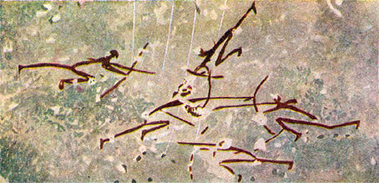
Figure 1 (conflict pre 12,000 BC, 2018) Figure 2 12,000 BCE (Sharan Art-Tadart, 2018)
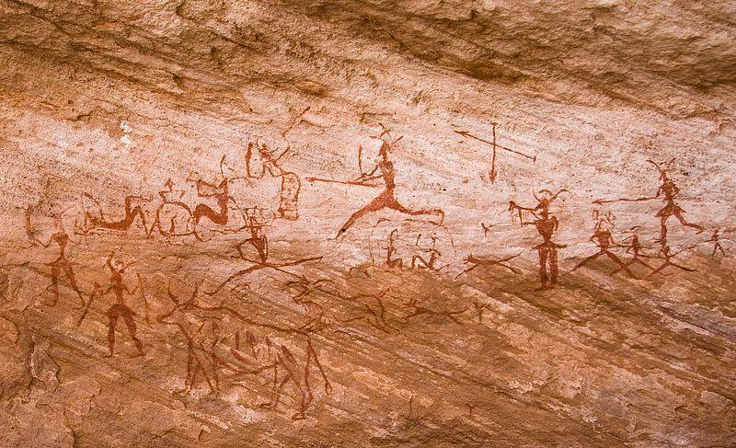

Figure 2 also depicts a scene reminiscent of warfare, the central figure is larger which may suggest that they were some sort of leader in this war scene. Showing the figurines using what appear to be spears, possibly a raid or an attack of some sort due to the presence of the cattle-like animal and the crossed spears. To our eyes, these do look like scenes depicting warfare, thus we have interpreted them as such, these drawings were done with the intention of having meaning (Leroi-Gourhan, 1964: 8- 82; Freeman, 2009). Human depictions at the time of the Palaeolithic also show no portrait styles. The simplicity of their portrayal could point to a number of reasons, one being technical and the other being that due to the difference and diversity of human species at this time they may have chosen not to include things such as facial features. Therefore, conflict in terms of a xenophobic view may have played a role in this in terms of people knowing the associated groups that lived relative to that area, as humans had adopted a sedentary lifestyle around 12000 BC which is roughly when Figure 2 was created.
Keeley (1998) writes that the strategies and tactics used in war are largely dependent on the social and political organisation. Arguing that societies who exist in a non-state mean that it is unlikely they will develop specialised military units, further proving as to why there is no distinction as to looks within the depictions shown above.

Figure 3
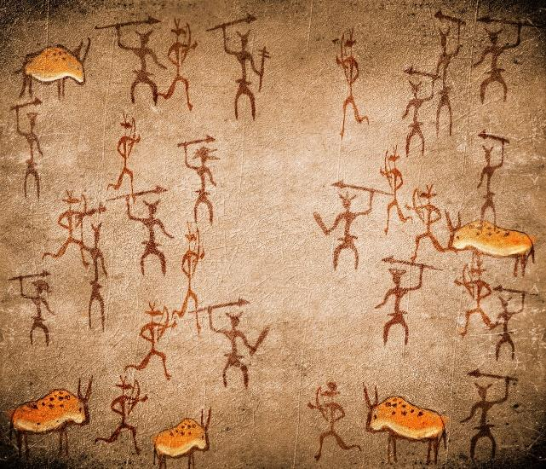
Figure 3 shows a cave painting from Lascaux, France which again depicts what looks like a prehistoric battle scene with a mixture of spear and bow type weaponry. While we do not know the meaning behind this and the other cave art depictions, when it comes to looking at the depictions through the lenses of one of the three different theories as to why humans go to war as proposed by Wilson (1970: 119), “we are inclined to partition other people into friends and aliens, in the same sense that birds are inclined to learn territorial songs and to navigate by the polar constellations. We tend to fear deeply the actions of strangers and to solve conflicts by aggression.”
Wilson argues that humans go to war as a result of territorial disputes, and to further this a study conducted on pre-industrial societies by Carol and Melvin Ember (Ember and Ember, 1990: 255) indicated that the societies that most often went to war were those recovering from a natural disaster and the example given in this instance was a drought. To this extent and given the location of some of the paintings, the drought combined with the desired expansion for territory.
One example that Keeley gives is of the Maricopa from Arizona, who go to war when there are water shortages (1999: 192). This would be a modern example of people going to war as a result of natural disaster and fits in with Wilson’s (1970) theory on the origin of warfare. One site from the Palaeolithic that supports this theory was discovered by Wendorf and is located in Sudan. The site in question dated to 12,000 BCE held the remains of fifty-nine people, all of whom had evidence to support they were murdered. 24 still had chert weaponry embedded into the bones (Wendorf, 1968). The people are believed to have been killed as a result of the environmental pressure according to Wendorf, but no further study was undertaken, thus, Figure 3 could very well be a scene that depicts a raid happening and the art’s purpose here is to serve as a warning against the neighbouring groups. Given the examples provided both prehistoric and modern it is evident that the theory of territory as a driver for conflict gains more credibility due to the harsh conditions that early man would have had to endure, thus indirectly providing us with evidence of conflict in the Pre-Archaeological Record.
Keeley argues that a new frontier, wherever it may be, will always be less peaceful and more susceptible to war (1999:179). In this instance whereby humans in the Paleolithic and Mesolithic were not yet fully sedentary, they would have more than likely been more war-like in their approach to the other. He argues that a new frontier wherever it may be, will always be less peaceful and more susceptible to war (Keeley 1999:179). In this instance whereby humans in the Palaeolithic and Mesolithic were not yet fully sedentary, then they would have more than likely been more warlike in their approach to the other. And the evidence for this frontier being violent in Palaeolithic times is a site at cardinal France, where settlers seemingly came to conflict with Mesolithic hunters (Keeley, 1998: 182) around 7,000 BCE. He writes “Archaeologists found a few skulls with cut marks from decapitation these skulls differed in physical type from that of the cardinal farmers. But resembled the Mesolithic foragers farther to the north (1999: 198)” thus showing that the two groups came into conflict with one another. However, counter to this a study conducted by Elizabeth Cashdan in 2001, found that there was no correlation between ethnocentrism and xenophobia thus counteracts Keeley's point of the farmers killing Mesolithic foragers out of fear of the unknown. While we will never know what exactly led to the clash between Mesolithic and Palaeolithic farmers there was still conflict present that we can use to identify conflict in the pre archaeological record
Based on the evidence proposed throughout this essay, it clearly demonstrates that there was conflict within the Pre-Archaeological Record. From the few sites aforementioned combined with the gruesome discoveries that were made there, it is clear that there was indeed conflict throughout this time period for whatever reason. The ability to identify conflict within this time period though without use of the written word and given the time span makes it significantly more difficult to determine what is and is not evidence of human violence, as some injuries such as blunt force trauma would show up in the skeletal remains. The hunting methods would also show this, if the individual were to sustain injury due to the hunter gatherer lifestyle. Regardless of this, the infamous sites mentioned above such as the Atapuerca, not only have violent death involved, but is linked to cannibalism. However, this may have occurred after death and under extreme circumstances, so the agency of killing another human may have been removed, thus limiting what we could contextualise as violence. Moreover, the notion of art in a modern sense is new with some cultures not distinguishing between art and writing such as the Egyptians. Therefore, it would be wrong in many instances to apply what we understand as art and as a narrative to look at these ancient drawings as the meaning might be completely misconstrued.
The site discovered by Wendorf in 1968 while seemingly supports the view of conflict in the pre-archaeological record. Does, however, leave it very much open to speculation as there was no further test to be carried out on the bodies to see if Wendorf’s hypothesis was correct, thus leaving the true cause of their death a mystery even though it seems to support Keeley’s views on why some groups go to war over resources. However according to the survey conducted by Elizabeth Cashdan, ethnocentrism does not seem to be a factor here in these early conflicts. While there may be different theories and ways to interpret the findings of archaeologists sites such as the one discovered by Wendorf and the depictions of cave art do show us that there was conflict that we can interpret in the pre archaeological record.

Bibliography
Arsuaga, J. L. et al (1997). Sima de los Huesos (Sierra de Atapuerca, Spain): the site. Journal of Human Evolution, 33: 109-27.
Berger, T. and Trinkaus, E (1995). Patterns of Trauma among the Neandertals. Journal of Archaeological Science, 22(6), pp.841-852.
Keeley, L. (1996). War before civilization. New York: Oxford University Press.
Freeman, L. (2009). Anthropology without informants. Boulder, Colo: University Press of Colorado.

Leroi-Gourhan, A. 1964. Les Réligions de la préhistoire. Paris, Presses Universitaires de France.
Thorpe, I (2003). Anthropology, archaeology, and the origin of warfare. World Archaeology, 35(1), pp.145-165.
Wendorf, F (1968). Site 117: a Nubian Final Palaeolithic graveyard near Jebel Sahaba, Sudan. In The Prehistory of Nubia, Vol. 2 (ed. F. Wendorf). Dallas, TX: Southern Methodist University Press, pp. 954-1040.

List of figures
Figure 1: conflict pre 12,000 BC. (2018). [image] Available at: http://www.goldenageproject.org.uk/487.php [Accessed 24 Mar. 2018].
Figure 2: Sharan Art-Tadart. (2018). [image] Available at: https://whc.unesco.org/en/list/287 [Accessed 24 Mar. 2018].

Figure 3:
https://commons.wikimedia.org/wiki/File:Libya_4924_Pictograms_Tadrart_Acacus_Luca_Galuzzi_2007.jpgL, Gazzuli 7.4.07

