

LOCATION: Swansea | LLEOLIAD: abertawe
LEVEL 7 | LEFEL 7

MODULE CODE: ACCA7029
Enterprise Core Networking

ANSWER PAPER

Peng Xu
2006614

1.
a.ISP
When a site (POP) establishes a connection with just one single ISP then the connection is called Single-Homed Network. Under this topology, the set-up uses a static/dynamic routes provided by the ISP which is then connected to the edge router of the POP.
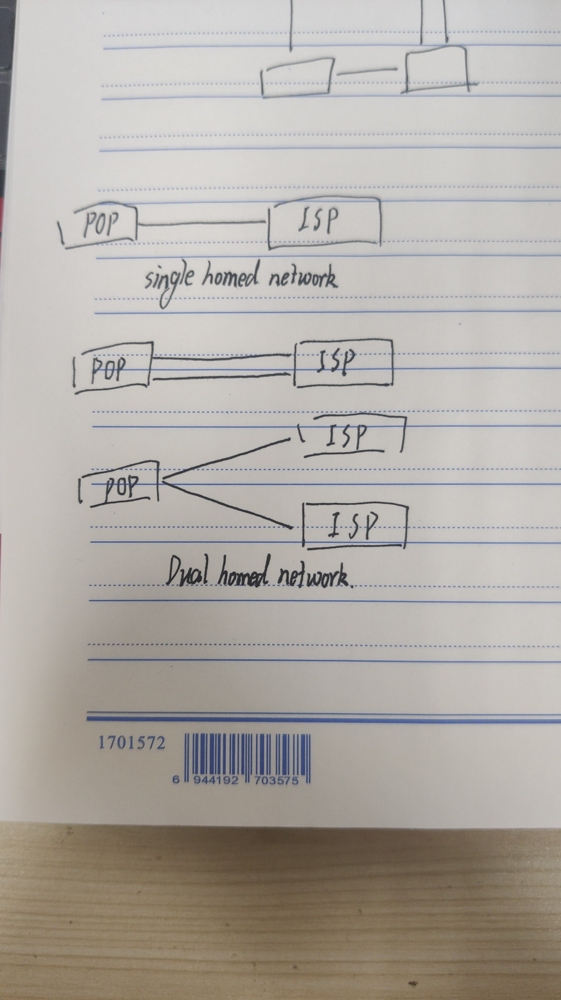
The only advantage of this type of setup is that it is highly cost effective. However, it is not safe as it does not provide any redundancy or backup. Any breakage in the link will cause disruption in the whole connection. This is fine for a site that does not depend heavily on Internet.

Dual-Homed Network
In a Dual-Homed Network connection, a site has two or more connection to the same ISP. Now this can be connected to either one or two edge routers (ISP or POP) where one link is primary and the other is secondary or backup. The other way a POP can use this topology is to load balance the traffic using both the links. This type of network also offers redundancy at the host side.
Let's see how this connection looks like

Multi-Homed Network
Multi-Homed Network connection is when the POP is connected to more than one ISP at the same time. This type of Network topology offer several benefits including redundancy and backup in case of failure (any one ISP). In such scenario where one of the ISP goes down, the system switches all the traffic to the other active ISP without any network downtime. Another huge benefit is that the POP can decide the best network path to route the traffic and offering high efficiency. One can take Multi-Homing a step further and offer Dual-Multihomed, where there are two connections to multiple ISPs. This topology offers the most redundancy.

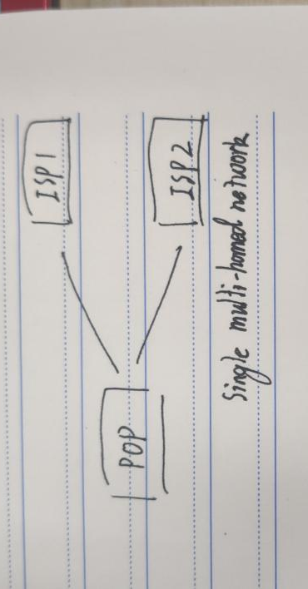
The importance of Multi-Homed Network
In comparison to Single and Dual Homed Network, a Multi-Homed offers much more features and advantages that can benefit a host as well as the client. Redundancy/Reliability and Performance are the two major factors a client looks for before choosing a service provider. Having Multi-Homed network offers high level of both Efficiency and Reliability for business. Therefore, to maintain the same level of network quality worldwide a host must partner with multiple carriers.
Multi-Homing at Psychz Networks
Psychz Networks is truly a Multi-Homed Network offering seamless service to our clients 24/7. We have a fault tolerant network with redundancies at every level. We have multiple upstream connections to internet offering services from some of the leaving service providers from across the globe including Hurricane, China Unicom, Nlayer, Tinet, NTT, Comcast, PCCW and more. And because we’re a multi-homed network provider with all of these redundancies in place we are able to offer our customers the ability to choose from the providers they like or from the one that can meet their requirement. To learn more about our network please.

b.RSTP

RSTP is standard, described in IEEE 802.1w. It is an evolution of STP that provides faster convergence of STP.

RSTP defines the following port roles :​

- Root​
The root port is the switch port on every nonroot bridge that is the chosen path to the root bridge. ​
There can be only one root port on every switch. ​
The root port is considered as part of active topology. ​
It forwards, sends, and receives BPDUs (data messages).​

- Designated​
Each switch has at least one switch port as the designated port for the segment. ​
In active topology, the switch with the designated port receives frames on the segment that are destined for the root bridge. ​
There can be only one designated port per segment.
RSTP defines the following port roles :​

- Alternate​
The alternate port is a switch port that offers an alternate path toward the root bridge. ​
It assumes a discarding state in an active topology. ​
The alternate port makes a transition to a designated port if the current designated path fails.​

- Disabled​
A disabled port has no role within the operation of spanning tree.​

- Backup​

The backup port is an additional switch port on the designated switch with a redundant link to the shared segment for which the switch is designated. ​
The backup port has the discarding state in active topology.

RP is the shortest port from this SW to root. Each SW has one and only one RP, which is used to receive BPDUs from root-bridge.
1. Each non-root SW is on the nearest port to root
2. Each non-root SW has and only one RP
3. The definition of RP is based on the switch

Segment:
•P2P link, direct link, full duplex link;
•It can be simply understood as one end link of the switch interconnection

DP forwards BPDUs. If there is a DP on a SW, then this SW is called a designated switch
definition:
1. There is one and only one DP on each segment, and there must be one DP
2. Leave the segment to the nearest port of root

AP is a replacement port, which means that when the RP fails, it is quickly called RP; it is a backup for the root port; it will become the root port in the future
BP is the backup port, which means that when the DP fails, it is quickly called DP; it is a backup for the designated port; it will become the designated port in the future.

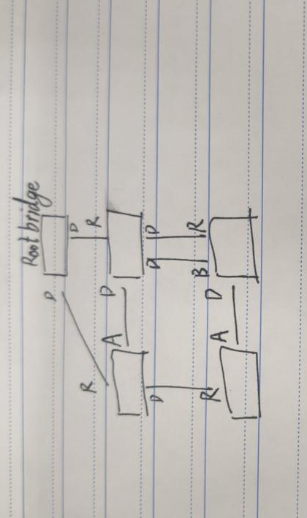

2.
a.Routed port
A routing port is like a physical interface on a router, but it does not have to be connected to the router, it can also be connected to a manageable site. The routing port will not be associated with a specific VLAN like the access port. The routing port on the switch is just like the actual router interface, except that it does not support VLAN sub-interfaces, but it can also be configured with Layer 3 routing protocols.
The routing port is only a Layer 3 interface and does not support Layer 2 protocols such as VTP, DTP (Dynamic Trunk Protocol) and STP (Spanning-Tree Protocol). To configure a routing port is to convert the interface to layer 3 mode through the "no switchport" interface configuration command. It can also be seen from the command name that it converts the port to a non-layer 2 switch port. Then use the interface configuration command "ip address ip_address" to assign an IP address to the port, enable the routing function, and configure the routing protocol features through the "ip routing" and "router protocol" global configuration commands.

#Create a virtual interface address, the addresses of vlan2 and vlan3 are respectively used as the gateways of PC1 and PC2
[H3C]interface vlan 1
[H3C-Vlan-interface1]ip address 192.168.1.254 24
[H3C]interface vlan 2
[H3C-Vlan-interface2]ip address 192.168.2.1 24
[H3C]interface vlan 3
[H3C-Vlan-interface3]ip address 192.168.3.1 24
#Dividing the interface connecting PC1 and PC2 into the corresponding vlan
[H3C]interface GigabitEthernet 1/0/2
[H3C-GigabitEthernet1/0/2] port access vlan 2
[H3C-GigabitEthernet1/0/2]interface GigabitEthernet 1/0/3
[H3C-GigabitEthernet1/0/3] port access vlan 3

b.OSPF
OSPF contains five types of data packets.
①HELLO
OSPF packet number 1
Used to discover, maintain (Neighbors) relationship, and DR and BDR election
②Database description: DBD
OSPF packet number 2
This data packet is generated during the exchange of the link state database and has three main functions:
The master-slave relationship in the process of election and exchange of link state databases
Determine the initial sequence number in the process of exchanging the link state database
Exchange all LSA packet headers
③ Link-state request: LSR
OSPF packet number 3
Used to request the details of LSA packets that are not found in this router or are outdated during the DBD exchange process
④Link-state update: LSU
OSPF packet number 4
It is used to flood multiple LSAs and also used to respond to received link state updates.
⑤Link-state acknowledgment: LSAck
Data packet number 5
It is used to confirm the received LSA. If the status of the router sending the confirmation is DR or BDR, the confirmation packet will be sent to the multicast address 224.0.0.5 of the OSPF router
If the status of the router sending the confirmation is not DR or BDR, the confirmation will be sent to the OSPF router multicast address 224.0.0.6

c.EIGRP

Fast convergence

EIGRP uses DUAL to achieve rapid convergence. A router running EIGRP stores its neighbors’ routing tables so that it can quickly adapt to changes in the network. If no appropriate route or backup route exists in the local routing table, EIGRP queries its neighbors to discover an alternative route. These queries are propagated until an alternative route is found, or it is determined that no alternative route exists.
​
Partial updates

EIGRP sends partial triggered updates instead of periodic updates. These updates are sent only when the path or the metric for a route changes; they contain information about only that changed link rather than the entire routing table. Propagation of these partial updates is automatically bounded so that only those routers that require the information are updated. As a result, EIGRP consumes significantly less bandwidth than IGRP. This behavior is also different than link-state protocol operation, which sends a change update to all routers within an area. ​

Multiple network layer support

EIGRP supports IP version 4 (IPv4), IP version 6 (IPv6), AppleTalk, and Novell NetWare Internetwork Packet Exchange (IPX) using protocol-dependent modules that are responsible for protocol requirements specific to the network layer. EIGRP’s rapid convergence and sophisticated metric offer superior performance and stability when implemented in IP, IPv6, IPX, and AppleTalk networks.

Successor​

A successor is a neighboring router that has a least-cost path to a destination (the lowest FD) that is guaranteed not to be part of a routing loop.​Successor routes are offered to the routing table to be used for forwarding packets. ​Multiple successors can exist if they have the same FD. ​

Feasible successor (FS)​

A feasible successor is a neighbor that is closer to the destination, but it is not the least-cost path.A feasible successor ensures a loop-free topology because it must have an AD less than the FD of the current successor route.Feasible successors are selected at the same time as successors but are kept in the topology table as backups to the successor routes. ​

The topology table can maintain multiple feasible successors for a destination.

3.
Campus network frame design

1.Design requirements

①Establish the backbone network of the campus network and realize the entire campus network coverage through wireless;
②Solve the problem of access to campus network in comprehensive office buildings, teaching buildings, and student dormitories, and meet the Internet needs of teachers, students and employees;
③Realize the basic application services of the campus network, such as WEB service, DNS service, mail service, FTP service;
④Improve and strengthen the authority and policy management for users to access resources on and off campus, and manage traffic, bandwidth and logs to improve the campus The manageability of the network;
⑤Aiming at the traffic attacks in some computer rooms, causing intermittent network disconnection, strengthen the security strategy of the campus network and effectively improve the security of the school network;
⑥Deploy wireless Internet access, expand a single area of ​​the wireless signal mountain to a large area, try to make the main places of the school can achieve wireless Internet access, and it is convenient to query information and handle some teaching tasks;
⑦The network design should adopt the international mainstream technology and have good backward expansion capabilities (such as TPV6 access);
⑧In order to ensure the fault tolerance of the entire network system, redundant link 3 is used in the design to avoid timely completion of the switch when the equipment or line fails, and to ensure that the network will not be interrupted;
⑨Due to the distributed deployment of network equipment, in order to facilitate management, use a suitable network management protocol to monitor the core equipment of the campus network and enhance the stability of the network.

2.Network architecture analysis

Star-shaped structures are mostly used in modern network structured cabling projects, which are mainly used on the same floor and are generated by connecting the computers in each room with hubs or switches. It has simple construction, high scalability, low cost, and good manageability. Advantages: The hierarchical wiring of the campus network mainly adopts a tree structure; the hub or switch of each layer is connected to the switch of the exit of the building, and the switches of each building are connected to the communication network of the campus.
A three-tier structure is used to design the campus network for the university. Choose 10 Gigabit Ethernet as the high-speed backbone connecting multiple campuses of the university; choose Gigabit Ethernet as the backbone between the floors of each campus to form the convergence layer of the university campus network; choose 100 M Ethernet LAN as the basic access form, The high performance and high reliability of the overall network must be considered in the equipment selection and structural design of the network center.
To carry out the overall design of the campus network, we must first conduct object research and demand investigation, clarify the nature of the school, the characteristics of the reform and development, and the needs and conditions of system construction, and accurately describe the school’s information environment; in the application of demand analysis On this basis, determine the type of school Intranet service, and then determine the specific goals of system construction, and conduct system analysis and design according to the application requirements construction goals and the distribution characteristics of the main buildings of the school.
Switches interconnect each campus network
The reasons for choosing 10 Gigabit switches to interconnect various campus networks instead of high-speed routers are:
1. The Ethernet technology system adopted by each campus network has good compatibility.
2. The university will carry out multimedia applications such as teaching video observations and remote lectures on campus networks, and it is necessary to provide high-speed information channels. The 10 Gigabit switch is a three-layer switch, a switch with routing function, and can have better performance in a campus network environment.
3. The price factor. If high-speed routers are used to cover tens of kilometers, SDH technology is usually used at the bottom layer, which increases the price of related equipment by 2 to 3 times. Although the high-speed router has better isolation for each campus, it is of little use in the campus network.
The backbone network is connected by a public IP address
The number of IP addresses that the campus network has obtained from CERNET cannot meet the demand. It can only be used for publishing information and contacting the Internet or conducting network scientific research. Therefore, the main body of the campus network IP address is the private network address converted by NAT. . Using a private network address is not conducive to academic exchanges with other universities, but it is also a last resort method; on the other hand, it may make the campus network less harassed by hackers.

3.Principles of Campus Network Design
1.The principle of advancement: use advanced and mature network communication technology for networking, support multimedia applications such as data, voice, and video images, use switching-based technology to replace traditional routing-based technology, and ensure network technology and network products Basically meet the demand within a few years.
2. The principle of openness: The construction of campus network should follow international standards and adopt standard protocols and standard interfaces supported by most manufacturers, so as to provide convenience and possibility for the interconnection of heterogeneous machines and heterogeneous operating systems.
3. Principle of manageability: An important content of network construction is network management, and network construction must ensure the manageability of network operations. With excellent network management, the operating speed of the network will be greatly improved, and network fault diagnosis can be performed quickly and easily.
4. Security principle: The central task of information system security is to ensure the smooth flow of information networks, to ensure that authorized entities obtain information safely through the network, and to ensure that the information is complete and reliable. Every aspect of the network system may cause security and reliability problems.
5. Flexibility and scalability: When choosing a network topology, you also need to consider future development. Since the equipment in the network is not static, such as adding or deleting a workstation, updating some equipment, or changing equipment Location, so the selected network topology should be able to be easily configured to meet new needs.
6. Stability and reliability: Reliability is very important to a network topology. Node failures or transmission media failures often occur in a local area network. A highly reliable network topology can cause these failures to affect the entire network. In addition to the least possible impact, it should also have good fault diagnosis and fault isolation functions.
7. High bandwidth: Due to the particularity of the campus network network application, it has relatively high performance requirements for the entire network system. Among them, the network rate requires the main information point 100M to be switched to the desktop, and the terminals in the campus network have a fast switching function. In order to support the transmission capabilities of data, voice, video and multimedia, the technology must reach the current international advanced level. It is necessary to adopt the most advanced network technology to adapt to the transmission of large amounts of data and multimedia information, not only to meet current business needs, but also to fully consider future development. For this reason, high-bandwidth advanced technology should be selected.
8. QoS guarantee: With more and more multimedia applications in the network, such applications have higher requirements for service quality. This network system should be able to guarantee QoS to support such applications.
9. IP Multicast: Since the campus network contains many multimedia application communications, there will be a lot of broadcast information, which takes up a lot of bandwidth resources. Therefore, the network system should be able to support IP Multicast, which can reduce unnecessary broadcasts in the network and save the bandwidth of the backbone.
10. A network that conforms to the development trend of IP: In any current network that provides services, IP support services are the most common, and IP technology itself is undergoing development and changes, such as IpV6, IP QoS, IP Over SONET, etc. With the emergence of emerging technologies, campus networks must keep up with the pace of IP development, that is, they must choose network vendors that are in the leading position of IP development.

4.Three-tier network structure design
- Core layer design of backbone network
The campus network is divided into public network and private network. Through the firewall, connect to the part of the demilitarized zone where various application servers are placed, and connect to the CERNET through the router.
The core layer in the three-layer campus network structure is located in the public network part, and Cisco’s 10-Gigabit switch Cat6509 can be used.Leasing the bare core of optical fiber from a telecommunications company, and connecting the 10 Gigabit switches in the two parks at a 10 Gigabit rate.
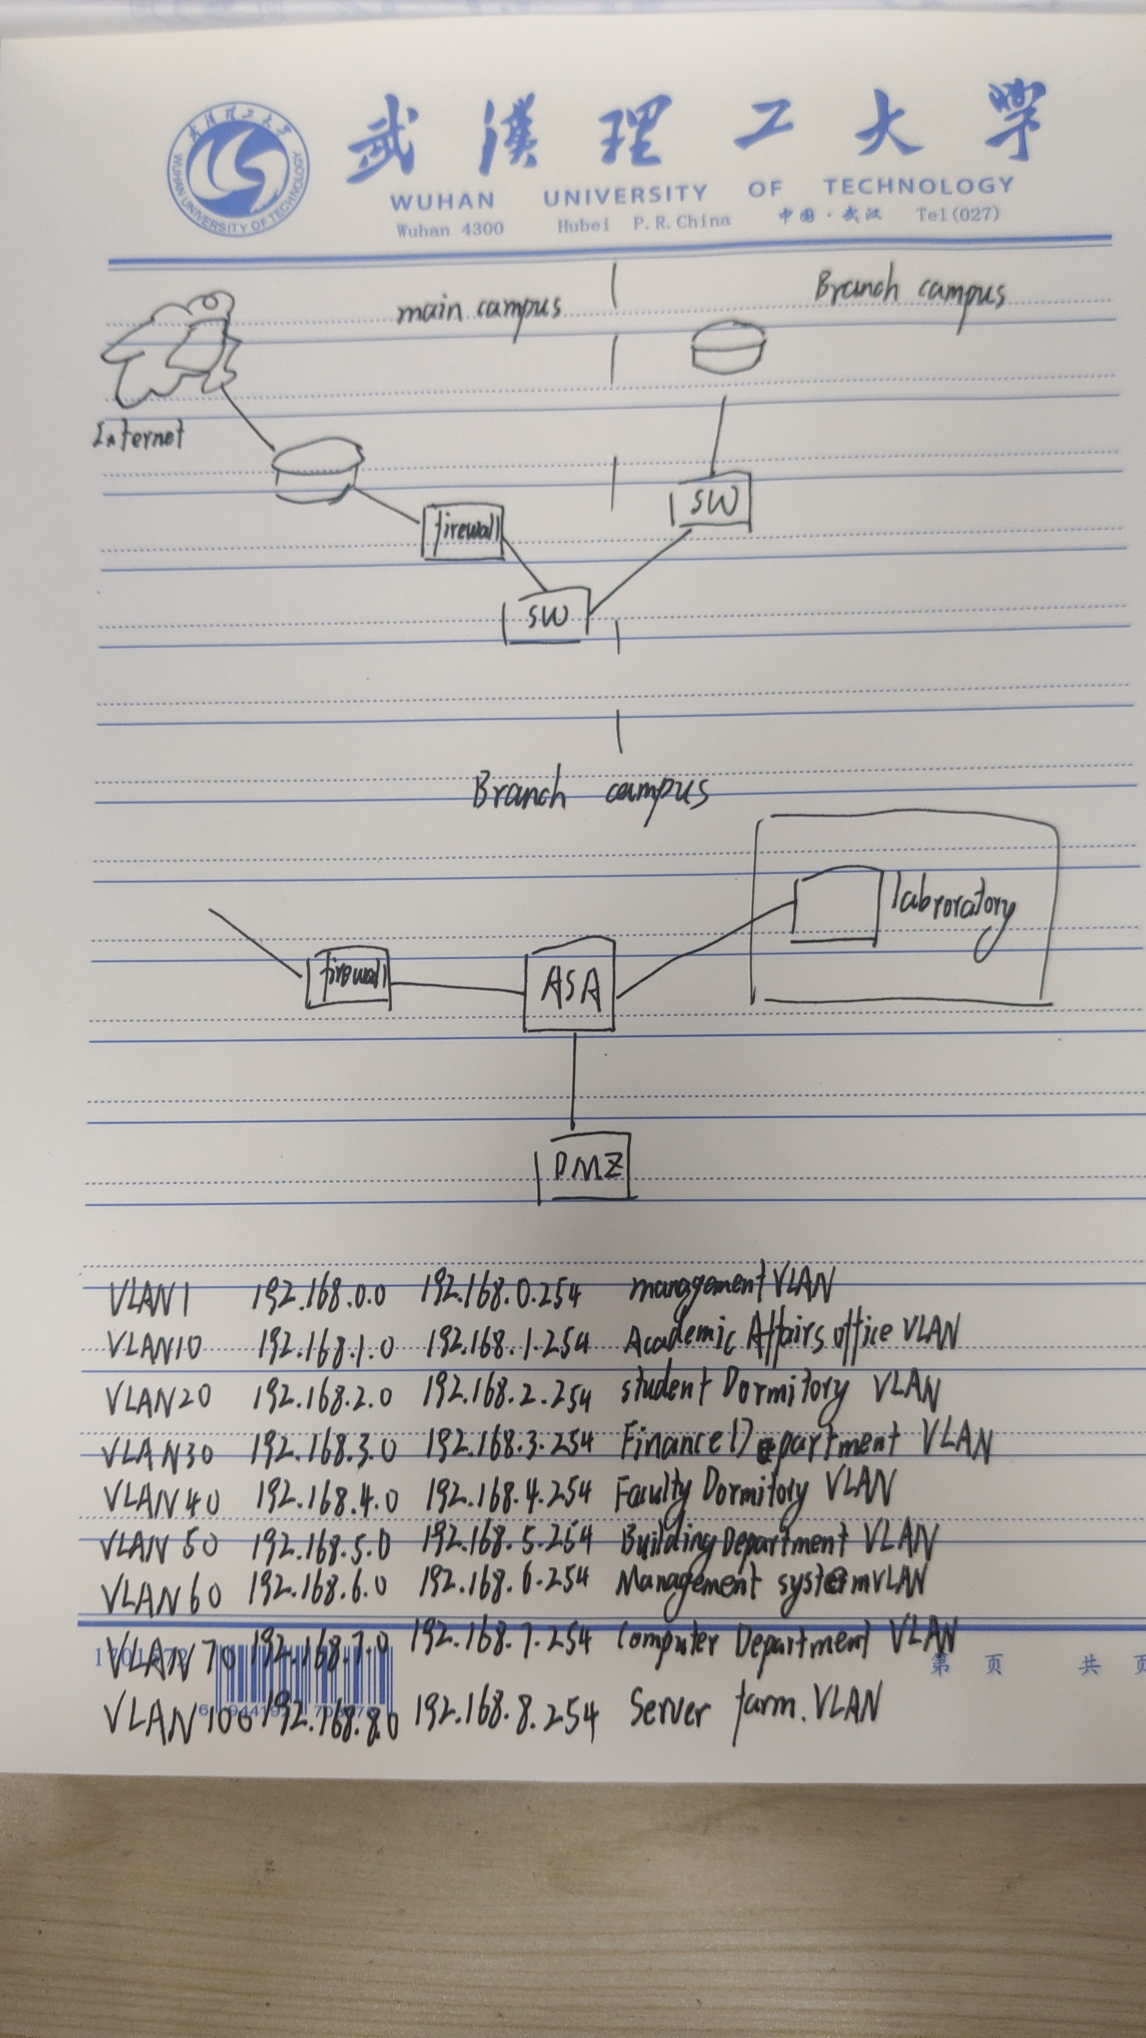
- Convergence layer design of branch campus
Convergence layer equipment not only shares part of the pressure on core equipment, but also improves network security. This implementation plan is designed from the perspective of the stability, security and ease of maintenance of the network operation to meet customer needs. The campus network can basically maintain the original two-layer network architecture, and use dedicated IP address blocks in its own campus network. The floors are connected by Gigabit optical fibers, and they are converged to the Gigabit main switch and connected to the university's Gigabit switch through the firewall. .
Since the number of PCs in the new laboratory building is about 1600, considering the teaching area, management area, and data service area in the park, it is recommended to divide it into several subnets, or it can be divided into multiple VLANs to isolate broadcast traffic and improve Network work efficiency and improve security.
The backbone network of the branch campus can use 3COM's Switch 4007 switch and the Gigabit fiber optic cable connected with 3C16980 to form the backbone of the college campus network, and down to 100M Ethernet as the access network to connect to the user's PC.
The two-story network topology of the branch campus laboratory building is shown in the following figure:
5.IP planning and VLAN
- Principles of IP address allocation
The quality of IP address planning not only affects the efficiency of the network routing protocol algorithm, but also affects the performance and stability of the network, as well as the expansion and management of the network. It will also directly affect the development of related new services and the further sustainability of network applications. Sexual development.
The allocation principles of IP addresses are as follows:
1. Assign a Class C address to the point-to-point IP address interconnected by the three-layer switch equipment to provide sufficient scalability.
2. Considering the scale of future network expansion, the management IP address of the Layer 2 switch equipment is assigned a Class C IP address.
3. Consider allocating several private address segments of class C for the school campus network.
The IP acquisition method for server clusters and office buildings is manual allocation, and the others are acquired through DHCP. All Internet access methods use NAT.
VLAN division
VLAN technology allows the physical LAN of a network to be logically divided into different broadcast domains. The broadcast and unicast traffic within a VLAN is restricted within the VLAN and will not be forwarded to other VLANs. This helps to control traffic, simplify network management, and improve network security.
VLAN is a protocol proposed to solve the broadcast problem and security of Ethernet. It adds a VLAN header on the basis of Ethernet frames, and uses VLAN ID to divide users into smaller working groups, restricting different working groups. The second-tier visits of users. The advantage of a virtual local area network is that it can limit the broadcast range. It is a relatively mature enterprise networking specification. In this case, we can use the characteristics of small networks. We can further monitor the network. Even if an IP conflict occurs, it is easy to know where it happened. Which department.

6. Equipment selection
- Core switch equipment selection
The backbone of the network is usually referred to as the core layer. The main purpose of the core layer is to provide high-speed forwarding and communication, providing oil painting, and a reliable backbone transmission structure. Therefore, the core layer switch should have higher reliability, performance and throughput.
Ruijie Networks RG-S9620 switch has become an ideal choice for enterprise network core switches. It is suitable for building high-speed, safe and reliable 10 Gigabit networks for governments, schools, and enterprises. Its backplane bandwidth is 9.6T, and its packet forwarding rate: L2: 3571Mpps, L3: 3571Mpps, expansion slots: 20 (4 for management and exchange matrix)

- Physical link layer configuration principles
The physical/link layer configuration follows the following principles:
1. The physical ports interconnected by network devices should be bound to the port speed and full-duplex mode;
2. It is recommended that all Vlans do not penetrate the core layer, and all Vlans will be terminated on the aggregation layer switch;
3. This implementation plan recommends not to enable STP Spanning Tree Protocol. Since all VLANs have been terminated at the aggregation layer switch, there is no loop on the second layer, so there is no need to enable it; if you enable the Spanning Tree Protocol based on each Vlan , There will be a lot of broadcast messages, which will affect the performance of the core switch and the network convergence time;
4. All interconnection ports between the core layer and aggregation layer switches are set to Trunk mode, but currently only the interconnection Vlan is allowed to pass, in order to cope with the situation that Vlan will pass through the core layer in the future;
5. The interconnection port between the aggregation switch and the access switch is set to Trunk mode.
Network Security and Management
7.cyber security
The security threats of campus networks mainly come from two major areas, one comes from inside the network, and the other comes from outside the network. The threats from the network are mainly virus attacks and hacking attacks. According to statistics, about 40% of the attacks that threaten the security of the campus network are from the inside of the network. How to prevent attacks from the inside is a point that the campus network security protection system needs to focus on.
Analysis of threats to network security
Threats to computer network security include:
1. "Hacker" attacks;
2. Computer virus;
3. Denial of Service Attack (Denial of Service Attack).

8. Network security precautions
A variety of information security is realized without changing the original network structure, and the campus internal network security is guaranteed. The Rising series products of China's network security software are adopted.
1. Rising antivirus software online version
2. Super virus killing
3. Intelligent active defense
4. Enhanced network-wide vulnerability management
5. Powerful network management capabilities are the basic deployment, control, execution, upgrade, reporting and logging, and secondary development of network security.
6. Compatible with multiple platforms
7. Integrated intelligent service system

9. Firewall settings
- Firewall technology

A firewall refers to a system or a group of systems set up between different networks or network security domains. It is used to strengthen network access control between different networks or network security domains. It can control the flow of information in and out of the network according to the network access principle. It has strong anti-attack ability.

The campus network is connected through a router. This router is called a border router. In order to protect the campus network from external attacks, a firewall must be installed on the border router to achieve the purpose of controlling and protecting the entire network.

- Firewall Design

(1) The firewall design strategy is based on a specific firewall and defines the rules for completing the service access strategy. There are usually two basic design strategies:
① Allow any service unless explicitly prohibited;

② Any service is prohibited unless expressly permitted.

The first type is safe but not easy to use, and the second type is easy to use but not safe. The second type of design strategy is usually adopted. And most firewalls take a compromise between the two.

(2) The security strategy of the firewall:
① All data packets from inside to outside and from outside to inside must pass through the firewall;
② Only data packets permitted by the security policy can pass through the firewall;
③ The firewall itself must have the function of preventing intrusion;
④ All services are forbidden by default, except for necessary services are allowed.

(3) The design of firewall:
① Ensure the security of the campus intranet host, and prohibit extranet users from connecting to the intranet;
② Only provide limited services such as HTTP, SMTP and POP to external users;
③Provide all Internet services to internal accounting users, but-the law passes through the proxy server;
④ It is required to have the functions of preventing IP address spoofing and IP address embezzlement;
⑤ It is required to have accounting and auditing functions, which can effectively record all activities of the campus network.

10. Denial of service prevention
The prevention of network device denial of service attacks is mainly to prevent TCP SYN flooding attacks, Smurf attacks, etc.; the method of preventing TCP SYN for network devices is mainly to configure the network device TCP SYN threshold, if more than this threshold, discard the excess TCP SYN data packet; anti-Smurf attack is mainly to configure network devices not to forward ICMP echo requests (directed broadcast) and set the threshold of ICMP packets to avoid becoming a forwarder and victim of a Smurf attack.

11. Access control
Access to the internet from the intranet is allowed, and all ports are open.
Allow access requests from the public network to the DMZ (demilitarized) zone: WEB server only opens port 80, mail server only opens port 25 and 110.
Access requests from the public network to the internal area are prohibited, and all ports are closed.
Allow access to the DMZ (demilitarized) zone from the intranet, all ports are open
Access to the internet from the DMZ (demilitarized) zone is allowed, and all ports are open.
Access to the intranet from the DMZ (demilitarized) zone is prohibited, and all ports are closed.

12. Integrated wiring design
Compared with traditional wiring, integrated wiring has many advantages, which cannot be compared with traditional wiring. Its characteristics are mainly manifested in its practicability, functionality, advancement, flexibility, convenience, reliability, scalability, openness, standardization, economy and life cycle. And it also brings a lot of convenience to people in terms of design, construction and maintenance.

- Composition and design of structured integrated wiring system
The integrated wiring system is an open wiring system that can support almost all data, voice equipment and various communication protocols. At the same time, because PDS fully considers the development of communication technology, there are sufficient technical reserves in the design to fully meet The long-term needs of users, the application range is very wide. Moreover, the structured integrated wiring system has a high degree of flexibility. The location of various equipment changes, and the change of the local area network does not require rewiring, as long as proper wiring adjustments are made in the wiring room to meet the needs. Structured integrated wiring is generally divided into six subsystems.

- Work area subsystem and its network design
The work area subsystem is composed of equipment connected by RJ-45 jumpers and information sockets. The information point consists of a standard RJ45 socket. The number of information points should be determined according to the actual functions and requirements of the work area, and an appropriate number of redundancy should be reserved. For example: 2 to 3 information points can be configured for each office point in an office area, and 3 to 5 dedicated information points should be configured for this office area for workgroup servers, network printers, fax machines, video conferences, etc. . If the office area is a business application, the bandwidth of the information point is 100M to meet the requirements; if the office area is a technology development application, each information point should be a switched 100M or even an optical fiber information point.

The terminal equipment in the work area (such as telephones, fax machines) is directly connected to each information socket in the work area by using Anpu’s Super Category 5 twisted pair, or an adapter (such as ISDN terminal equipment), balance/ The unbalanced converter is connected to the information socket for conversion.

- Wiring subsystem and its network design
The wiring subsystem starts from the information socket in the work area to the distribution frame of the management room subsystem. The cable selection of the wiring subsystem should be determined according to the type, capacity, bandwidth, and transmission rate of specific information points in the building. The recommended twisted-pair cable and optical fiber models used in the wiring subsystem are: AMP's Super Category 5 or Category 6 unshielded twisted pair, TCL indoor single-mode or multi-mode fiber.

In the twisted-pair horizontal wiring link, the maximum length of the horizontal cable is 90m. If 100Ω UTP twisted pair is used as the cable of the wiring subsystem, different types of cables can be used according to the different types of information points. The solution chooses AMP's Super Category 5 unshielded twisted pair cable.

- Trunk subsystem and its network design
The trunk subsystem is responsible for connecting the management subsystem to the equipment room subsystem. The main cables that can be used in the trunk subsystem are: HAY Category 3 large logarithmic cable; AMP's Super Category 5 or Category 6 twisted-pair cable; TCL indoor single-mode or multi-mode fiber. The program chooses the Super Category 6 twisted-pair cable from Anpu.

The vertical trunk line subsystem consists of cables connecting the main equipment room to the wiring closets on each floor. Its function is mainly to connect each layered distribution frame with the main distribution frame. The backbone cable is used to provide communication channels between floors, so that the entire wiring system forms an organic whole. The Topology structure of the vertical trunk line subsystem adopts a hierarchical star topology structure, and the wiring closet on each floor needs to be connected to the main equipment room of the building with a vertical trunk cable. When 25 pairs of large-pair cables are used in the vertical backbone, each 25-pair large-pair cable is an indivisible unit for a certain floor. The connection between the vertical backbone cable and the horizontal system cable needs to be realized by jumpers in the floor management room.

- Subsystem between equipment and its network design
The equipment room subsystem consists of cables, connectors and related supporting hardware. Use BIX jumper patch panels to connect to switches; use optical fiber termination frames to connect hosts and network devices. The main equipment in the equipment room includes digital program-controlled switches, computer network equipment, servers, building automation equipment hosts, and so on. They can be put together or set separately. In larger integrated wiring, computer equipment, digital program-controlled switches, and building automation equipment hosts can be separately set up in computer rooms, and hardware equipment closely related to integrated wiring can be placed in the equipment room, and the computer network equipment room can be placed in the remote equipment room. Far location.

The equipment room subsystem is a centralized equipment area that connects the public equipment of the system, such as local area network (LAN), mainframe, building automation and security systems, and connects to the management subsystem through the vertical backbone subsystem.

- Management subsystem and its network design
The management subsystem is composed of cross-connection, interconnection and I/O. Management refers to the requirements for marking and recording the wiring equipment, cables and other facilities in the equipment room, telecommunications room, and work area according to a predetermined pattern. The jumper adopts Category 5 unshielded twisted pair, RJ45 connector. The management room is the wiring room of the floor. The management subsystem provides a means for the interconnection of other subsystems. It is a device that connects the vertical trunk line subsystem and the horizontal trunk line subsystem. The management subsystem is composed of cross-connection, interconnection and input/output, which realizes wiring management and provides means for connecting other subsystems. Including patch panels, jumper equipment and optical patch panels and other components. When designing the management subsystem, it is necessary to understand the basic design principles of the circuit and reasonably configure the components of each subsystem. Anpu’s integrated wiring solution has a complete set of scientific and easy-to-manage products for management subsystems.

- Building group subsystem and its network design
The building group subsystem is to realize the interconnection between the buildings and provide the hardware required for the communication facilities between the building groups. The means of wired communication can be used between the building groups, as well as the means of microwave communication and radio communication. The transmission medium adopts outdoor six-core multimode fiber.

The principle of medium selection for the building group subsystem: The building is within two kilometers between the building, the transmission medium is outdoor optical fiber, it can be buried underground or overhead (above 4M), and the power line needs to be avoided. Pay attention to the bending radius of the optical fiber. System construction key points: including routing starting point and ending point; cable length, entrance location, media type, required labor cost and material cost calculation. The space where the building group subsystem is located also has requirements for doors and windows, ceilings, power supply, lighting, and grounding.

References

[1]. Xu Zhenming. Networking Project. Xi'an University of Science and Technology Press. 2007

[2]. Edited by Xie Xiren. Computer Network Seventh Edition. Electronic Industry Press. 2017.1

[3]. Edited by Yang Weidong. Network System Integration and Engineering Design. Published by Science Press. 2002.4

[4]. Zhang Haifan, edited by Mu Yongmin. Introduction to Software Engineering Sixth Edition. Tsinghua University Press. 2013

[5] Si Taozhi, Yang Yinchun, Yu Lijun. Network Engineering 2nd Edition. People's Posts and Telecommunications Press. 2008

