-STUDENT NAME: PETER NGUTY ACHA | STUDENT NUMBER: 2018019
PROGRAMME | BSc HEALTH AND SOCIAL CARE
MODULE | CHANGEMAKERS CREATIVITY AND VALUE CREATION
MODULE CODE | BMHP5014_BIRM
LECTURER | ROBERT NARTOWSKI
ASIGNMENT TITLE | E-PORTFOLIO EVIDENCE OF LEARNING COMPRISING OF 2 SEPERATE ARTEFACT ITEMS

Introduction
It has been proven that one stands the risk of developing different types of cancer from smoking tobacco or being exposed to tobacco smoke. In my e-portfolio I am going to develop a campaign plan to make people understand the effect of smoking on the human body, and subsequently will be writing an elevator pitch which I will be presenting to an audience at the (DUDLEY CITY TOWN HALL), detailing the scope and profoundness of the effect of smoking on the human body. This will be supported with research details reports, and accredited images. In the pitch I will make clear my goals and why I started this campaign. I will also through my pitch urge them to join me in my campaign.

MY CAMPAIGN IS ALL ABOUT RAISING AWARENESS ABOUT THE EFFECT OF SMOKING ON THE HUMAN BODY
(THE POSTER I AM GOING TO USE FOR MY CAMPAIGN)

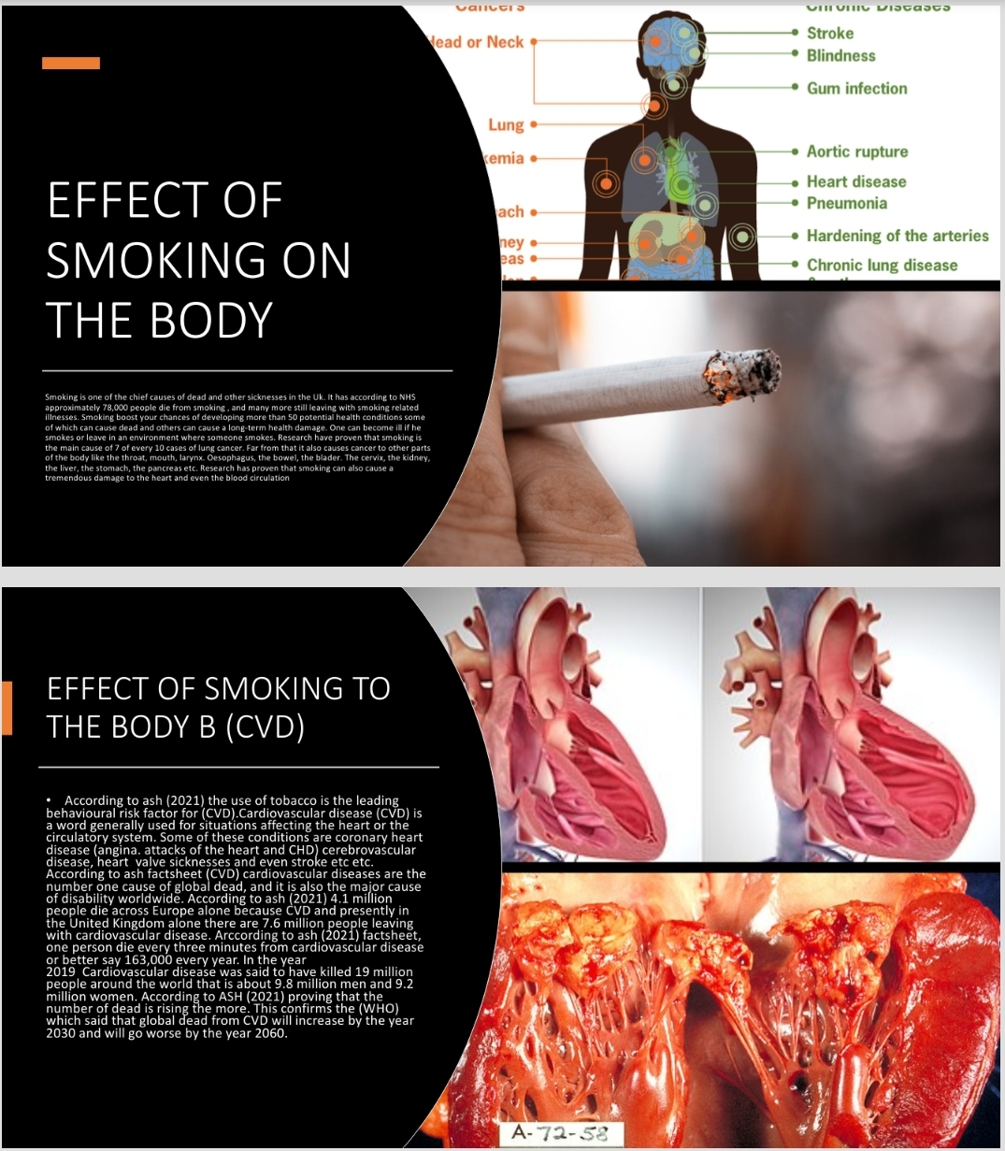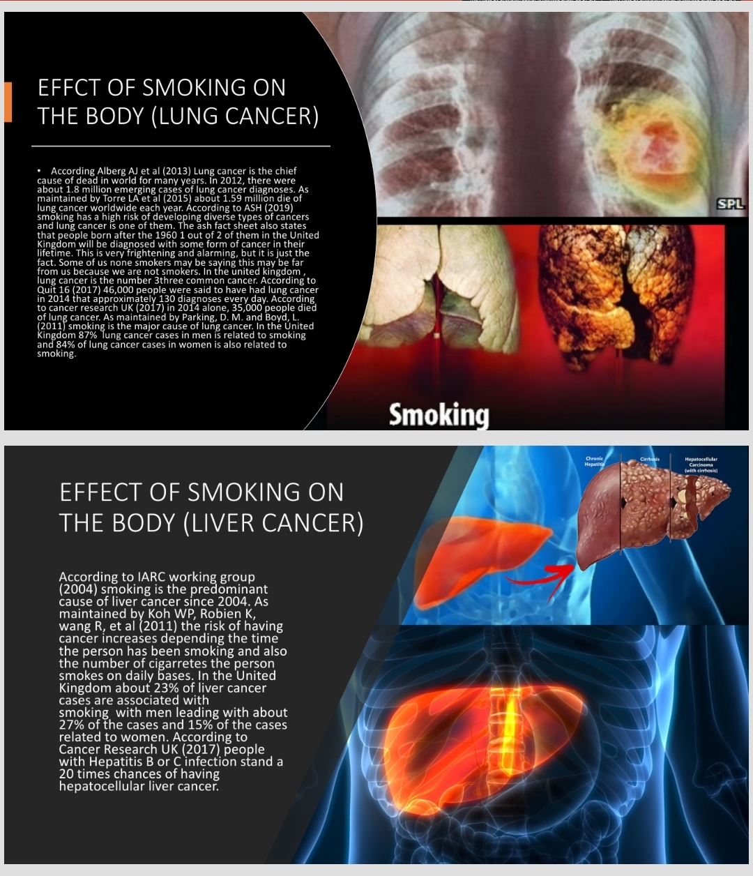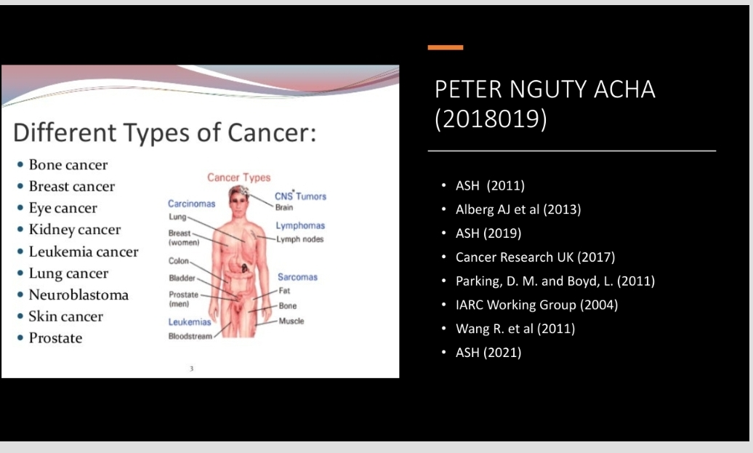

MY CAMPAIGN PLAN
To carry out a campaign of this magnitude, I will not deny the fact that I cannot do it all alone to achieve an excellent result. I will urge people to join as volunteers by making the purpose of my campaign clear and what I intend to achieve to them.
To start my campaign, I have outlined some steps I will be following: -
- I would make my cause clear to my audience with statics and research findings and research reports regarding the problem.
- I will do my campaign differently from the other campaigns that have already been done on the same problem.
- I most have it clear in mind what I really want to achieve and to gear my campaign towards that goal.
- I will now plan my campaign.
- I will also through my campaign speech urge many to join me.
In the second phase of the campaign, I will also be outlining some things that will be needed to start and carry out the campaign.
- Permission from the local authorities and to make my mission known to them.
- Finance
- Logistics
- Digital skills and social media experts

- Why do I need permission from the local authorities to carry out my campaign?
Since the main campaign ground is going to be in city council hall, I will need the council’s permission to be able to use the hall and secondly Since the campaign is expected to draw many crowds, I will be needing health and security officials to be present in case need be.
- Finance: - As a matter of fact I am going to need money to carry out nearly everything we are going to be doing during the cause of our campaign and enough funding has already been achieved through free will donations.
I have planned to print 2000 posters on A4, A3, and A2 papers respectively. The smaller posters will be given to attendees as handouts and the bigger posters will be posted in hospitals entrances, schools, frequently visited areas, parks, care homes, hospices etc.
- Logistics: - I am going to need transportation to take me and my volunteers from one place to another after the city hall campaign to post the posters on selected places.
- Social media experts: - I would need social media experts to also lunch my campaign through social media plat forms like Facebook, Tic Tok, WhatsApp, YouTube, Instagram, smart Chat, Tweeter etc.
My campaign is going to be centred on: -
- Create awareness of the eminent health harm caused by smoking and second-hand smoke exposure
- Encourage people who smoke to quit and make them to know the helps that are available if they decide to quit.
- Urge people who decide not to quit smoking not to smoke around others and encourage those who do not smoke to protect themselves, others and their loved ones from second-hand smoke exposure.
I will make sure I incorporate all the above messages and information in my poster. Why I have decided to use poster to convey my messages is because the audience and the population will be able to perceive the message without much explanation. Secondly since many people find it had to dedicate time in reading, the poster will still help them to understand the message. The other reason also is that the message will still be circulating and will even reach to those who couldn’t make it to the campaign ground.

MY ELAVATOR PITCH ABOUT THE EFFECT OF SMOKING ON THE BODY
Hi, my name is Peter Nguty Acha, and I was born in Cameroon a small country in central Africa.
Today I am here to talk to you about the effect of smoking on the human body. (That is the danger of smoking on the human body)
Now, I have a question for all of us.
My question goes does, how many of us have lost someone or know someone who have lost someone or about to lose someone from a smoking related disease?
Nearly everyone here including me.
Right?
Research have proven that smoking is one of the chief causes of cancer and other smoking related disease such CVD.
As we all know there are diverse types of cancers cause by smoking.
When I lost my senior brother in 2013 from a smoking related disease, I took it upon myself to start this campaign by making people know the effect smoking have on the human body.
Frankly speaking I never knew the gravity of damage smoking could cause on the body until the one closest to me died from this phenomenon.
Many of us might be saying I do not smoke neither do any of my relatives. Fine.
The fact is that the United Kingdom government spends billions of pounds each year for the treatment of Deases caused by smoking and of which this money could be used to improve the quality of lives of its citizens.
Millions die every day around the world, millions are diagnosed every day around the world because of different types of smoking related diseases.
The most frightening truth is that as we speak now someone somewhere is being diagnosed of a smoking related disease and someone somewhere will die from it.
We cannot change the past, but we can change the future by joining this campaign to sensitize the population about the danger in smoking and its effect on the human body.
The truth is that if all of us join this campaign in anyway or by any form, lives could be saved, less people would be sick because of smoking related diseases and less people will die from it. I did not just want to get involved in this cause without knowing the scope and profoundness of this phenomenon, and because of this I had to hold to talks with some important organisations in and out of the UK such as Cancer Research UK, British Heart Foundation, Cancer research Specialists and some other researchers around the world and this was what I found: -

According to Cancer Research UK (2017) there is a high risk of developing cancer from smoking tobacco. The most striking truth is that even people around where the smoking is taking place could also face the same high risk of developing cancer. They also revealed that 1 in 2 people born in the United King after the year 1960 may have any form of cancer in their lifetime and 1 in 4 will die from the disease. According to Banks et al (2015) every two out of three long-term smokers may die from a smoking related disease.
The good news is that according to Cancer Research UK (2017) smoking is the single largest preventable risk factor for cancer. As maintained by Quit 16 (2017) smoke from tobacco has been responsible for one fifth of (64,500) of all emerging cancer cases per year and responsible 27% of the total cancer casualties in the United Kingdom. As maintained by Cancer Research UK (2017) 19% of all cancer cases reported in the United Kingdom are related to exposure to tobacco smoke. According to World Health Organization (2017) Smoking tobacco is responsible for every one in five cancer deaths (22%) around the globe.
After going through all these research results, I decided to go further to find out more about those parts of the human body which studies have also proven that could be affected by smoking related diseases, and the results were more frightening.
According to Secretan B et al (2009) smoking is the cause of at least a minimum of 16 types of cancer, of which include nose cancer, mouth cancer, voice box cancer, throat cancer, gullet cancer, lung cancer, liver cancer, pancreas cancer, kidney cancer, stomach cancer etc.
For many years now we have known lung cancer as the most common cancer that could be caused by smoking.
- IMMAGE 1 shows the picture of a lung affected by cancer
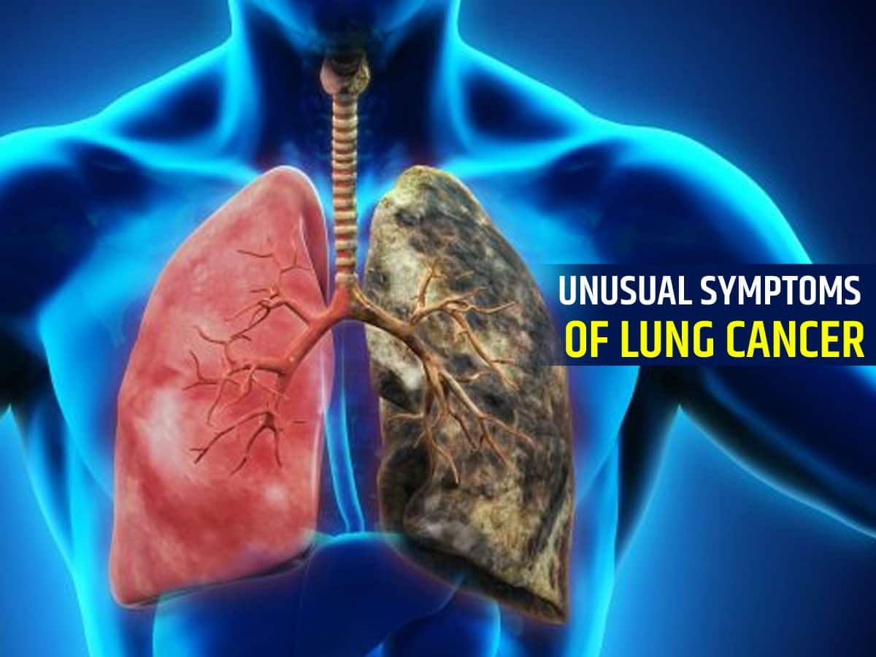

According to Alberg AJ et al (2013) lung cancer has been the most known cancer in the world for many years. As maintained by the International Agency for the Research on Cancer (2017) about 1.83 million people in 2012 had suffered from lung cancer, and according to Cancer Research UK 1.59 million deaths.
As maintained by Quit 16 (2017) lung cancer is the number three most common cancer in the United Kingdom. In 2014, 46.403 people were said to have had lung cancer an estimate of about 130 cases every day. According to Cancer Research UK 35,895 people died of the disease in 2014. According to Parkin, D. M. and Boyd, L. (2010) lung cancer has the largest number of cases caused by smoking tobacco in the United Kingdom with an alarming 87% of lung cancer cases being men and 84% of the cases are women.

IMMAGE 2 LIVER CANCER
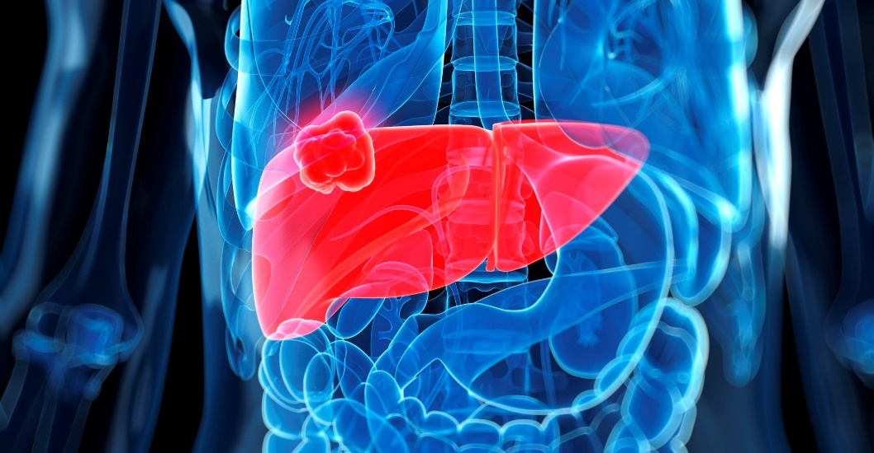

It has always been argued that smoking does not cause liver cancer. According to Lee YC et al (2009) since 2004, studies have proven that smoking can cause liver cancer. According to IARC Working Group (2004) said that there are enough proves to conclude that tobacco smoking can cause liver cancer.
According to Koh WP, Robien K, Wang R, et al (2011) the risk of having cancer increases with the time someone has been smoking or the number of cigarettes someone smokes. The liver cancer is one of the most dangerous types of cancer because according to Shire AM et al (2012) by the time it is discovered, the cancer would be in an advance stage, leaving very small chances of treatment. According to Cancer Research UK (2017) in the United Kingdom, approximately a quarter of 23% of liver cancer are associated to smoking, with 27% men and 15% women.

According to Cancer Research UK (2019) liver cancer have soared by 50% in the last decade. This implies that enough is not being done to reduce the number of people being infected. These are some of the frightening reports that justifies my cause.
THE IMMAGE BELLOWS SHOW A KIDNEY INFECTED BY CANCER

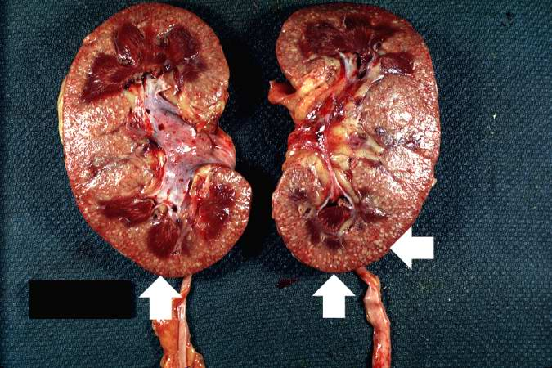

According to Cancer Research UK (2017) kidney cancer accounts for 4% of all cancers in men and approximately 3% in women in the United Kingdom. As maintained by Florou AM et al (2014) There is sufficient evidence to show that kidney cancer has mostly been found to be common in smokers than non-smokers and there is sufficient evidence to show that smoking is a risk factor for the for the three main types of kidney cancer. According to Cumberbatch MG et al (2016) a smoker has 33% chances of having kidney cancer than a non-smoker. According to Cancer Research UK it is estimated that 29% of kidney cancer cases which are found in men and 15% in women in the United King could be due to smoking.

Ladies and gentle, with these prove I have just presented to you, everyone here will agree with me beyond no doubt that smoking is the number one cause of some preventable cancers and other smoking related diseases such cardiovascular diseases (CVD). It will not be right if we just seat and watch people die, people get sick from this disease of which a vast number of the cases could be prevented if they were informed about the dangers repeatedly.
For this reason, I have decided to lunch this campaign and I am calling upon everyone here to join me in any way or by any form to make it a complete reality. We cannot change the past, but we can start now to change the situation, and I assure all of us here that many lives will be saved.
Thank you for coming.

Reference list
- Alberg AJ et al. Epidemiology of lung cancer: Diagnosis and management of lung cancer, 3rd ed: American college of chest Physicians evidence-based clinical practical guidelines. Chest May 2013; 143(5 supplement): e 1 S-e29S
- Alsamarrai A et al. Factors that affect risk for pancreatic disease in the general population: a systematic review and meta-analysis of prospective cohort studies. Clinical Gastroenterology Hepatology October 2014; 12(10): 1635-1644
- Banks et al. Tobacco smoking and all-cause mortality in large Australian cohort study: findings from a mature epidemic with current low smoking prevalence. BMC Medicine 2015; 13: 38
- Cancer Research UK. Cancer mortality statistics. [ Accessed March 2017]
- Cumberbatch MG et al. The role of tobacco smoke in bladder and kidney carcinogenesis: A comparison of exposures and meta-analysis of incidence and mortality rates. European Eurology September 2016; 70(3): 458-466
- International Agency for the Research on Cancer. Lung cancer estimated incidence, mortality and prevalence worldwide in 2012. [Accessed March 2017]
- Florou AN et al. Clinical significance of smoking cessation in subjects with cancer: a 30-year review. Respiratory Care December 2014; 59(12): 1924- 1936
- Koh WP, Robien K, Wang R, et al. Smoking as an independent risk factor for hepatocellular carcinoma: the Singapore Chinese Health Study. British Journal of cancer October 2011; 105(9): 1430-1435
- Lee YC et al. Meta-analysis of epidemiologic studies on cigarette smoking and liver cancer. International Journal of Epidemiology. December 2009; 38(6): 1497-1511
- Parkin, D. M. and Boyd, L. Tobacco-attributable cancer burden in the UK in 2010. British Journal of Cancer 2011; 105(S2): S6-S 13
- Peto R et al. Smoking, smoking cessation, and lung cancer in the UK since 1950: combination of national statistics with two case-control studies. The BMJ, 2000; 321: 323-329
- Quit 16. Which cancers are caused by smoking? [ Accessed March 2017
- Secretan B et al. A review of human carcinogens-Part E: tobacco, areca nut, alcohol, coal smoke, and salted fish. Lancet Oncology November 2009; 10(11): 1033- 1034
- Shire AM et al. Prevention of hepatocellular carcinoma: progress and challenges. Minerva Gastroenterogica e Dietologica March 2012; 58(1): 49-64
- Torre LA et al. Global cancer statistics. 2012. CA: A Cancer Journal for Clinicians March/April 2015; 65(2): 87-108
- IARC Working Group on the Evaluation of Carcinogenic Risks to Human. IARC Monographs on the evaluation of carcinogenic risks to humans: Tobacco smoke and involuntary smoking. IARC Press 2004; 83
- Richard Boland CR, Goel A. Clearing the air on smoking and colorectal cancer. Journal of the National Cancer Institute July 2010; 102(14): 996-997

