2026
Data Security & Compliance
Assignment
Josh Longhurst (2205415)

Contents
Task 1 - Securing the Modern Enterprise: From Zero Trust to AI Governance 2
Abstract 2
1.1 Introduction 2
2.1 Shared Responsibility Model 3
2.2 Cloud Delivery Services 3
2.3 Cloud Service Providers Security 4
3.1 Misconfigurations 4
3.2 Identity Attacks 4
3.3 Third Party Risks 4
3.4 Nation State Threats 5
3.5 API Exploitation 6
4.1 Cloud Security 6
4.2 Why CSPM is essential & Capabilities 6
4.3 Limitations of CSPM 7
5.1 Zero Trust for Cloud 7
5.2 Identity first security method 7
5.3 Networking 7
5.4 Encryption 7
5.5 SIEM integration 7
5.6 Governance 8
6.1 AI 8
7.1 Conclusion 8
Task 2 - Work-Based Project: Chief Information Security Officer (CISO) Proposal 8
Abstract 8
Introduction 8
The proposed security organisational chart – Including Management areas of Digital Services 9
Role Justification 10
Policy Framework 10
Compliance Strategy 11
Phase 1 (Month(s) 1-3) – Foundation Phase 11
Phase 2 (Month(s) 4-6) – Operations 11
Phase 3 (Month(s) 7-12) – Continued Compliance 11
Technical Standards and Architecture 11
NIST CSF 2.0 11
Zero Trust Diagram 12
Architecture Justification 12
Risk Register 13
Incident Response and Business Continuity 13
Ransomware Response Playbook 14
Governance and Strategic Roadmap 15
12 Month strategy Roadmap 15
Outlined KPI’s 16
Technical KPI’s 16
Summary 16
Key 17
References 18
Table of Figures 20

Task 1 - Securing the Modern Enterprise: From Zero Trust to AI Governance
Securing Cloud and Hybrid Environments: Strategies for mitigating risks in AWS, Azure, or GCP, including Cloud Security Posture Management (CSPM).

Abstract
This research paper outlines the security challenges and strategies associated in modern cloud and hybrid environments. It will dive deep into risks and leading causes of breaches as well as looking into strategies to ensure risks and vulnerabilities are managed and mitigated. The paper will also dive into real-world case studies from around the world. The insights from task 1 will drive the proposal and inform recommendations in task 2.

1.1 Introduction
The swift adoption of Could and Hybrid Infrastructure has transformed how complex enterprise IT systems are created, managed, maintained, scaled and the cost efficiency to organisation. It has also had a major effect on IT teams and staff, where now everyone needs to be able to understand a range of aspects of information technology.
Cloud has dominated the enterprise IT model for a number of years, statistics show over 94% of organisations have adopted cloud services with 70% operating the cloud services in a hybrid model. [1] [2]
Whilst the shift has changed the way we work such as allowing flexibility, it has improved company operational times as companies can now employ from all over the globe rather than fixed locations. The movement was driven by the need for rapid deployment as global availability requirements increased in times such as COVID, where staff moved to working from home and have now since migrated to hybrid working solutions. [3]
However, the shift in enterprise technology and its implementation has introduced a new set of security challenges. Cloud environments run on shared responsibility models and complex identity structures unlike traditional on-prem services. Misconfigurations, improper management of permissions and insecure API’s have become the leading cause of cloud breaches. [4]

2.1 Shared Responsibility Model
Cloud infrastructure operates on as previously mentioned a shared responsibility model. The providers of the cloud service secures the underlying infrastructure, while its clientele secures configurations, identity and data that is running through the cloud service. Research into Cloud environments show customer side failures for breaches rather than provider vulnerabilities. [5]

2.2 Cloud Delivery Services
In cloud computing there are three different forms of cloud service delivery; IaaS, PaaS and SaaS.
IaaS or Infrastructure-as-a-Service is a delivery model that the Cloud Service Provider (CSP) manages the IT Infrastructure this includes the networking, storage, servers and any other vital components to deliver its service to the customer using internet connections. Whilst the customer then manages and supports the operating systems, databases, data, applications, endpoints and accounts. IaaS assigns the customers the greatest responsibility of protection and security. Examples of CSP’s that provide the IaaS delivery method are Amazon Web Services (AWS) and/or Microsoft Azure. IaaS is the most common method of delivery used in IT departments for deployment of virtualised environments. [5]
PaaS or Platform-as-a-Service is a delivery service model that like in IaaS the CSP manages the IT infrastructure but also the platform and tools for application development, this is where customers access these areas via an internet connection. In PaaS the responsibility of protection lies with the customers to secure data, endpoints, applications and accounts. Examples of PaaS is AWS Elastic Beanstalk and/or Azure App Services. [5]
SaaS or Software-as-a-Service is a delivery method where the CSP manages every service provided except from the developing and deploying of application code. The CSP handles recourse allocation and server provisioning scale resources up or down based on workload. The customer has the responsibility of securing all data, endpoints and accounts. SaaS is the main cloud delivery service that is handled by end users without realising. Microsoft 365 is an example of SaaS along with Google Workspace and Microsoft Azure. SaaS generates the most revenue amongst the 3 delivery methods and often accounts for over 50% of total public cloud spending. [6] [5]

2.3 Cloud Service Providers Security
Cloud Service Providers all provide different security models and methods to secure the service.
AWS emphasises identity & access management, network VPC’s and services such as security hub which is a centralised security management and compliance system. [7]
While Microsoft Azure integrates Active Directory, Defender, Sentinel SIEM, firewalls and policy governance. The security framework is built on a Zero Trust model and defence strategies. [8] [9]

3.1 Misconfigurations
Misconfigurations is the biggest cloud security issue. Common security issues include overly permissive identity and access management roles, no logging, and unrestricted firewall inbound rules.
An example of this is the very well-known Capital One AWS breach in 2019 where a misconfigured web application firewall allowed an attacker in to exploit metadata services in AWS and allowed access to millions of customer records. [10]

3.2 Identity Attacks
Cloud services work based off identity services. The identity services work through credentials, tokens and MFA which then allows end users to access cloud services such as Microsoft 365 for example. In IT departments examples include access to administrative tools and actions in the cloud service.
A highly cited example of an identity attack in the Uber Attacks in 2022 which saw an attacker using MFA fatigue to compromise an employee’s VPN credentials allowing for the attack surface to grow and gaining access to internal IT systems. MFA fatigue is also known as MFA bombing where attackers spam the end users MFA device with endless alerts in the hope the end user will approve requests intentionally to stop consistent alerts or in the hope the end user accidentally accepts. It starts with a simple phishing email where the start of the breach occurs by the attacker taking your credentials via phishing emails and then attempting to sign into the cloud services. [11]

3.3 Third Party Risks
Hybrid infrastructure depends on third party integrations and CI/CD pipelines and open-source components. A single compromised integration can spread vulnerabilities across and entire organisations digital environments. Risks can come from various areas such as Dependency vulnerabilities, third-party DevOps, compromised CI/CD pipelines, Security gaps, Malicious code injections, Insider threats and Governance failures.
The MOVEit 2023 case study used a zero-day vulnerability in which a widely used file transfer tool was compromised and lead to multiple data breaches across the global in many enterprises, governments and other organisations. The incident led to highlighting to IT professionals of the high risk from the supply chain. [12]
The graphic to the below shows the affected organisations across the world [13]
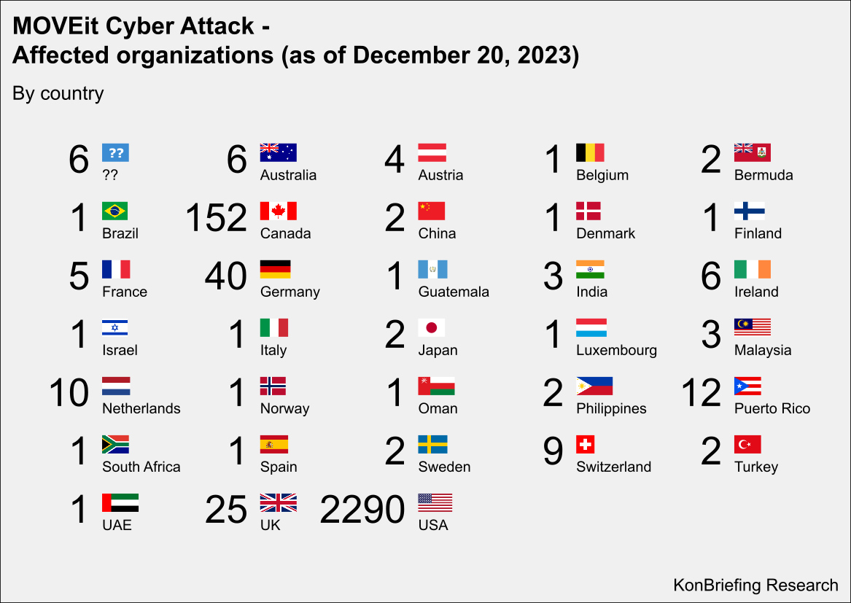
Graphic 1 - MOVEit Cyber Attack Victims [13]

3.4 Nation State Threats
As the world enters a very fragile state and world leaders publicly disagreeing on a range of matters, warfare is highly on the radar both from physical combat and digital warfare. Often carried out my states across the globe to disrupt and carry out strategic defensive and offensive operations. It works by disrupting computer networks or even shutting down IT systems with prime objectives to infiltrate, sabotage, disrupt infrastructure while bypassing physical battlefields.
The 2024 Microsoft Midnight Blizzard is a key example of this where Russian state-link actors compromised Microsoft corporate emails by exploiting OAuth token weaknesses. The incident highlighted the strategic value of cloud identity comprise. [14]
The below chart shows a timeline of the Microsoft Attack [15]
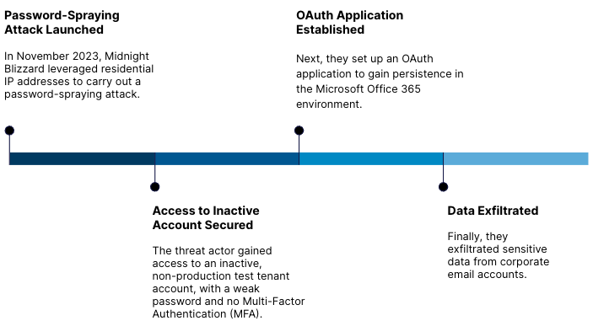
Graphic 2 - Microsoft Breach Timeline from Obsidian [15]

3.5 API Exploitation
Cloud APIs are extremely powerful in cloud architecture, but they are also very vulnerable. Research shows insecure API’s are part of the top 3 cloud threats. This is where attackers exploit weak authentication and excessive permissions.
Volkswagen is a prime example of this type of attack where a grey hat hacker, a hacker who disclosed to the company. The vulnerability was found when APIs in the My Volkswagen App when owners registered a vehicle to brute force thousands of 4-digit code combinations to gain unauthorised access to vehicles digital profiles. [16]

4.1 Cloud Security
CSPM or Cloud Security Posture Management denotes a set of automated tools and/or processes that analyse cloud environments for any misconfigurations, compliance issues and can identify risky endpoints or accounts. The need for CSPM has increased massively as organisation rely critical BAU systems into cloud environments. [17]

4.2 Why CSPM is essential & Capabilities
CSPM is an essential part of cloud security, especially as thousands of configurations occur in enterprise cloud and hybrid environments where manual auditing is impossible. CSPM provides capabilities such as continuous compliance monitoring against benchmarks such as ISO 27017, misconfiguration discovery such as API’s and storage buckets, identity analysis such as excessive permissions, automatic remediation and integration with SIEM systems such as Sentinel. [18] [19]

4.3 Limitations of CSPM
Whilst CSMP has a lot of capabilities and it implements higher security it does have limitations with the riskiest limitation being alert fatigue which could cause missed real attack alerts. It also brings other limitations such as narrow focus within the infrastructure, limited application layer attack detection and runtime threat investigations. [18] [20]

5.1 Zero Trust for Cloud
Zero trust is a method in which nobody is trusted, inside or out the network. In Cloud and Hybrid environments this usually refers to strong identity verification, least privilege access and micro-segmentation. It often has an effect to all users, especially IT staff where digital teams now have implemented Privileged Identity Management and Just In Time which usually means staff need to login with a specific specialised account and then request higher privileges the system will then grant or deny the user based on the reasoning for the request and if the user has been permitted the access to request the specific area they are requesting. It also allows for logging movements and clicks, so there will always be a timeline of who, when and what accessed. Frameworks such as NIST 800-207 cover Zero trust. [21]

5.2 Identity first security method
Identity is one of the biggest reasons for attacks. Whilst no solution will fully protect against identity-based attacks, there are systems and methods that can be implemented to assist in the protection. An example of a systems and method already enforced is MFA, where users setup a second device to receive codes to or to provide codes to input into the device requesting MFA. It works by verifying your identity using usually 2 types of evidence from categories such as something you have such as a smartphone, something you know such as a security question or something you are such as biometrics. [22]

5.3 Networking
Hybrid environments require network segmentation across on-prem and cloud networks which often include the use of VPC segmentation and/or Firewall policies setup in line with Zero trust architecture. [23] [24]

5.4 Encryption
All major cloud providers offer Key Management Services that allow you to securely generate, manage and control the cryptographic keys used to protect the data held within the cloud. These KMS systems are integrated into the cloud platforms making easy to encrypt data without third part services or products. [25]

5.5 SIEM integration
Cloud logs must be feed into SIEM systems to allow for detection and to resolve using automatic response which is known as SOAR. An example of this is Microsoft Sentinel which collects security data to detect, investigate and respond to threats. [26]

5.6 Governance
Governance is a set of rules, policies and processes which an organisation is directed, controlled and/or accountable. Frameworks include NIST 2.0, ISO 27017, CIS, ENISA. Effective cloud governance requires establishing clear policies and assigning ownership for resources and enforcing configurations across the cloud infrastructure. Misconfigurations are a leading cause into cloud breaches by attackers, which highlights the importance of correct configurations and governance policies. [27]

6.1 AI
Security has changed over recent years with the introduction of AI driven security features and advanced threat hunting and detection. Machine Learning can detect unusual identity behaviour, misconfigurations and lateral movement. Microsoft has many AI features from Microsoft Security Copilot, AI within Purview and AI Security built into Entra. [28]
Self-healing is a feature in security and cloud environments to automatically input fixes to misconfiguration without human intervention, to ensure maximum security. A featured used in Azure. [29]

7.1 Conclusion
Cloud and hybrid environments offer operational advantages but introduce a range of complex security challenges. Current threat landscapes include misconfigurations, identity attacks, supply-chain compromise. CSPM has become a critical control for monitoring, compliance and attack path reduction but alone is insufficient. Effective cloud security requires a universal approach combining zero trust, governance, DevSecOps and cloud-native controls. As cloud and hybrid adoption excels the need to for proactive, automated, IAM driven security targets accelerates and is essential in protecting large enterprise cloud and hybrid environments.

Task 2 - Work-Based Project: Chief Information Security Officer (CISO) Proposal

Abstract
This proposal defines the strategic design and implementation plan to ensure information security is paramount for Aegis FinTech as they look to move into the EU markets. The proposal will be aligned with findings from Task 1 and will include organisational charts, policies and processes, risk register, technical and executive KPI’s and incident response.

Introduction
As Aegis FinTech Innovations enters a new phase of growth and prepare for Series B funding which will also allow us to expand into the European Union. The proposal will outline design and implementation for our new Information Security Unit which will be called ISU. The proposal has been built on my findings after researching Securing Cloud and Hybrid Environments, which identified the significant vulnerabilities and risks we are facing as we grow. All recommendations are based on evidence, operational goals, and legal requirements such as GDPR.
This proposal establishes a security plans, policy frameworks, compliance strategies, technical architecture, risk management, playbook creation and a 12-month roadmap aligned to Zero Trust strategies and security controls.

The proposed security organisational chart – Including Management areas of Digital Services
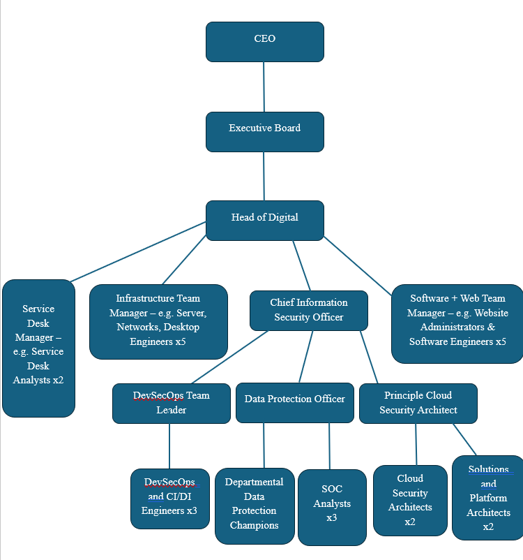
Figure 1 - Proposed Org chart

Role Justification
In the above proposed organisational chart, leading from the top down we will have our CEO and then Executive Board. We will then introduce a Head of Digital who will oversee all of Digital Services and its operations.
Leading on we will have our team of senior managers within Digital. These being the Service Desk Manager, Infrastructure Manager, Software & Web Team Manager and the Chief Information Security Officer. They will all work together and during a major incident will form the Major Incident Team. They will be responsible for leading teams of different engineers, analysts and Architects (dependant on the role).
We will then introduce a DevSecOps Team leader to lead a small team of three DevOpsEngineers. The role will involve reporting findings to the CISO and will also be present in the Major Incident team while the engineers continue to work hard during said Major Incidents. DevSecOps Engineeers will be responsible for IAC scanning, CI/DI security and automated remediation. They will also work extremely closely to the Principle Cloud Security Architect and their team.
Alongside the DevSecOps Leader, a new role will be created for the data protection officer who will oversee Departmental Data Protection Champions, the person will also lead legal, regulatory and compliance for the organisation ensuring we comply with regulations. They will also oversee SOC analysts monitoring our onsite security as well as our cloud-based security due to us following a hybrid environment. They will also be present in the major incident team with the DevSecOps Team leader.
Finally, we will introduce a Cloud Team. The team will be managed by the Principle Cloud Security Architect who will report all cloud projects to senior management and will also be present in major incidents with the Data Protection officer and DevSecOps Team Leader. They will oversee a team of two Cloud security architects and 2 solutions and platform architects. They will work together ensuring platforms and solutions are to up to date but also fit the requirements of the company as we grow. The security architects will be responsible for ensuring our cloud security is kept up to date and deliver projects to upgrade our cloud security. This will be completed alongside DevSecOps Engineers.

Policy Framework
Acceptable Use Policy governs the use of AI and cloud platforms for employees. It prohibits uploading sensitive financial information into AI systems and use of only approved cloud services. My research in task one into securing cloud and hybrid architecture identified insecure API’s and misconfigured SaaS integrations being major risks. This policy enforces strict access control, logging and CSPM monitoring.
Hybrid and Remote Access policy defines the security requirements for employees working remotely. This includes Zero Trust, MFA, device posture checks and encrypted connections. My research in task one highlighted identity-based attacks such as MFA fatigue which hit uber in 2022. The policy mandates resistant MFA and session monitoring.
Third-party and cloud vendor policy establishes formal vendor processes including security questions, penetration-testing evidence and relevant certifications. During task one I discovered supply-chain compromise as a threat, MOVEit 2023 is an example of this. The policy requires CSPM scanning of connected SaaS, Contract obligations for breaches and verified encryption, IAM controls, logging and monitoring.

Compliance Strategy

Phase 1 (Month(s) 1-3) – Foundation Phase
- Appoint Data Protection Officer
- Employ Skeleton IT security and cloud team
- Conduct Article 30 records of processing
- Implement AI analytics
- Deploy encryption controls
- Deploy up to date policies
- Establish ICT governance structure
- Asset inventory management
- Implement MFA across the organisation

Phase 2 (Month(s) 4-6) – Operations
- Continue hiring of IT teams
- Implementation of DSR workflows
- Establish Breach Notification processes
- Conduct third-party data processing audits
- 6-month report of resilience, security and data protection
- Integrate SOC and SIEM
- DORA based incident reporting workflows

Phase 3 (Month(s) 7-12) – Continued Compliance
- Annual GDPR audit
- Mandatory Staff training
- GDPR controls implemented into CSPM and SIEM
- Review internal policies and procedures
- Conduct threat-led pen-testing
- Backup and recovery procedures

Technical Standards and Architecture

NIST CSF 2.0
NIST CSF 2.0 is aligned with cloud security and zero trust principles within hybrid environments. In Task 1 I concluded that IAM and CSPM are essential in securing infrastructure. NIST CSF supports both through its Identity, Protect, Detect, Respond and Recover framework.

Zero Trust Diagram
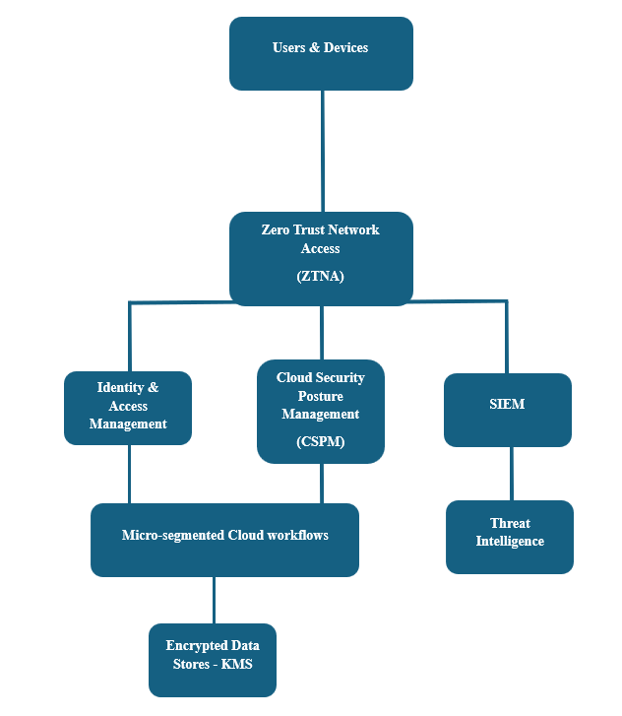
2 - Zero Trust Technical Diagram

Architecture Justification
ZTNA: Least privileged, never trust, always verify. Counters against identity attacks such as Uber in 2022.
CSPM: Mitigates misconfiguration vulnerabilities and allowing unauthorised external access.
SIEM: rapid threat detection and automated response.
Micro-segmented Cloud Workflows: Reduces lateral movement and enforces least privilege access, restricting movement, reducing blast radius in a breach. An example attack as set out in task 1 was the Midnight Blizzard in 2024.
KMS: Key Management Service is a managed service that allows for creation and control of cryptographic keys. KMS is a common component in cloud services and provides functionality for secure storage of encryption keys and digital signature algorithms.

Risk Register
Threat | Impact | Likelihood | Justification from Task 1 | Mitigation
Cloud Misconfiguration | Critical | High | Identified as a top risk in Cloud as over 80% of environment contain critical misconfigurations | CSPM, IaC scanning and automated response
Identity Compromise | High | High | Uber 2022 attack where MFA fatigue was used to gain access | Zero trust architecture, phishing resistant MFA
Supply-Chain Compromise | Critical | Medium | MOVEit 2023 Global breach | Vendor Assessments, continuous monitoring

Incident Response and Business Continuity
As part of improving Aegis FinTech’s resilience. I have developed a comprehensive ransomware response playbook aligning with industry practices and threat intelligence findings from Task 1. Modern attack groups are increasingly exploiting or trying to exploit cloud and hybrid environments such as cloud misconfigurations, identity & access management weaknesses and supply-chain vulnerabilities. These type of attacks have been demonstrated in a number of recent attacks such as the MOVEit breach in 2023, and MFA fatigue attack on Uber in 2022.
Our playbook responses begins with rapid detection, containment and automated responses until our SOC and relevant parties can investigate further. This will work by introducing a SIEM and where behavioural indicators are raised for abnormal encryption activity, privilege escalation or suspicious API’s will be automatically raised immediately with the SOC team and relevant staff. Once detected, comprised devices will be isolated through Zero Trust network access controls to prevent lateral movement inside of the network, which is often used by attackers as discovered in Task 1.
Following containment of the attack, a communication phase begins. The communication phase ensures all internal and external communications are coordinated. It also sets out who will be notified in the 1st instance before moving forward with further communication to staff and public.
Staff to be notified in 1st instance:
- CEO
- CFO
- DPO
- Head of Legal
This enables regulatory compliance to GDPR articles 33 and 34 which mandates timely reporting of a breach. Pre-approved communication templates will be created and used to inform customers, partners, stakeholders and regulators. This will ensure clarity and consistency in moments of high pressure and time sensitive situations.
Next the recovery phase starts, this will focus on eradication and restoration of services and infrastructure from backups stored in segregated cloud environments. These backups are protected using write once policies, preventing tampering and up to date secure backups to be deployed to restore the service. The use of write-once backups directly addresses ransomware trends by attackers of corrupting and/or encrypting backups, which was highlighted in reports in task 1.
Finally, a structured formal review process with initiate ensuring lessons learned are constructed for continuous improvement. The review will analyse root causes, review and update CSPM policies, refine IAM user privileges, enhance device security and improve detection and response. Regular sessions will be held face to face to validate readiness and staff familiarity with responses and procedures. We will also conduct regular simulations where senior management, executives and relevant stakeholders will be tested to ensure the organisation is prepared to the best possible level.

Ransomware Response Playbook
Below is our outlined playbook

Phase 1 – Detect and Contain
- SOC escalates ransomware indicators, patterns with file encryption and malicious traffic
- Zero Trust Network Access isolates all devices affected by the ransomware
- SIEM triggers automated playbooks

Phase 2 – Communication
- Notify the cyber security steering group
- Notify regulators
- Prepare customer communications and public notification

Phase 3 – Recovery
- Restore systems from immutable backup solutions
- Validate integrity using hash
- Initiate digital forensic analysis

Phase 4 – review incident
- Update CSPM policies
- Refine IAM privileges
- Enhance device security
- Improve detection and response
- Conduct regular face to face meetings, training sessions, simulations and tabletop exercises

Governance and Strategic Roadmap
To ensure strong strategic alignment, establishing a cyber security steering group will serve as the central governance group for all security related queries, issues and engagement campaigns at Aegis FinTech.
The steering group will be chaired by the CEO but will be joined by the CFO, Head of Digital, Head of Legal, Data Protection Officer and Chief Information Security Officer. Whilst the group will heavily involve staff from technical digital teams by introducing non-technical staff, we will be able to ensure our response is best suited and decisions are evaluated not only from technical aspects but also financial, legal, regulatory, operational viewpoints.
The group will meet monthly to review processes, risk posture, and discuss next steps in security improvements and investment. The group will also look into and monitor our GDPR and DORA compliance and continue to monitor the organisations security statistics. This governance structure will reflect the importance of accountability, regulatory scrutiny and heightened security measures as the organisation looks to expand into the EU.
This will also accompany the 12-month strategic roadmap and prioritise initiatives based on the findings of task 1 research into cloud and hybrid security. As outlined above we will focus on ensuring meeting the targets in each phase (phases 1 - 3). Each phase indicates the importance of security and the need for proactive, automated responses and controls in cloud and hybrid environments, also set out in my task 1 research. Throughout the roadmap we will track progress using a blend of technical and executive KPI’s, such as reduction on misconfigurations, CSPM policies, detection and recover time improvements and vendor compliance. The governance model and roadmap we have set out ensures that the organisation Aegis FinTech’s security posture evolves using structed, measurable, research and evidence driven data which follows and aligns with regulatory expectations and requirements and real-world threats.

12 Month strategy Roadmap

1st Quarter
- Deploy CSPM to address the misconfiguration risk
- Apply Zero Trust Network Access to the organisation to address the identity compromise
- Establish a SOC and SIEM
- Conduct GDPR mapping
- Implement MFA on all users
- Change control processes implemented

2nd Quarter
- Implement DORA reporting workflows on incidents
- Initiate Vendor risk management analysis and programme
- Implement CIEM for identity governance
- Conduct a Data Protection Impact Assessment for AI

3rd Quarter
- Deploy micro segmentation to support our Zero Trust Network Access
- Integrate IaC scanning into CI/CD pipelines
- Initiate threat penetration testing

4th Quarter
- Carry out Full DORA resilience testing
- Immutable backup validation
- Conduct Annual GDPR audit and report
- Review and improve CSPM policies
- Review and publish full year review of services, achievements and improvements
- Conduct end of year meeting with the Cyber Security Steering Group

Outlined KPI’s

Executive KPI’s
- Reduction in could misconfigurations
- Vendor Compliance
- GDPR and DORA audit pass rate and improvements where necessary
- Incident report time

Technical KPI’s
- Mean Time to Detect (MTTD)
- Mean Time to Respond (MTTR)
- CSPM pass rates
- IAM Privilege reduction
- CI/CD pipeline security scan pass rate

Summary
The proposal establishes a resilient and modern regulation-aligned Information Security processes, procedures and units for Aegis FinTech Innovations LTD. Every recommendation provided in the proposal is directly advised from findings in my Task 1 research into cloud and hybrid security. The strategy is constructed on evidence-based and real-world threats that could harm or destroy the organisation. Implementing Zero Trust, CSPM, strong IAM, MFA and a compliance roadmap, Aegis FinTech will be strongly positioned to expand into the EU and will hold confidence in their infrastructure, IT and cloud systems and data being protected and safe from emerging cyber threats.

Key
- MTTD – Mean Time to Detect
- MTTR – Mean Time to Respond
- CSPM – Cloud Security Posture Management
- IAM – Identity Access Management
- ZTNA – Zero Trust Network Access
- CEO – Chief Executive Officer
- CFO - Chief Financial Officer
- DPO – Data Protection Officer
- IaC – Infrastructure as Code
- CIEM – Cloud Infrastructure Entitlement Management
- SIEM – Security Information and Event Management
- SOAR – Security Orchestration, Automation and Response
- KMS – Key Management Service
- NIST CFS 2.0 – National Institute of Standards and Technology Cyber Security Framework 2.0
- DORA – Digital Operational Resilience Act
- GDPR – General Data Protection Regulation
- MFA – multi-factor authentication
- AI – Artificial Intelligence
- ML – Machine Learning
- SOC – Security Operations Centre
- CI – Continuous Integration
- CD – Continuous Deployment
- KPI – Key Performance Indicators
- API – Application Programming Interface
- AWS – Amazon Web Services
- GCP – Google Cloud Platform
- EU – European Union
- IT/ICT – Information Technology/Information Communications Technology
- DSR – Data Subject Request
- SaaS – Software as a Service
- IaaS – Infrastructure as a Service
- PaaS – Platform as a Service
- CSP – Cloud Service Provider
- DevSecOps – Development, Security, Operations
- DevOps – Software Development, IT Operations
- CIS – Centre for Internet Security
- ENISA – EU Agency for Cyber Security
- ISO – international Organisation for Standardisation
- VPC – Virtual Private Cloud
- VPN – Virtual Private Network
- COVID – Coronavirus

References

[1] | A. Porter, “2023 Cloud Migration Trends: Data Takes Flight,” Big ID, 09 06 2023. [Online]. Available: https://bigid.com/blog/cloud-migration-trends-and-statistics-2023/. [Accessed 14 06 2026].
[2] | Techbound, Techbound Technology, 17 02 2026. [Online]. Available: https://tecbound.com/cloud-computing-business-operations/. [Accessed 09 06 2026].
[3] | Google Cloud, “Advantages and disadvantages of cloud computing,” Google, [Online]. Available: https://cloud.google.com/learn/advantages-of-cloud-computing. [Accessed 14 06 2026].
[4] | IBM, “X FORCE Cloud Threat Landscape Report,” IBM, 2024.
[5] | T. Stansfield, “What is the shared responsibility model?,” Orca, 2024.
[6] | C. C. Market, 06 2026. [Online]. Available: https://www.grandviewresearch.com/industry-analysis/cloud-computing-industry. [Accessed 14 06 2026].
[7] | AWS, “AWS Security Hub CSPM Fetaures,” AWS, [Online]. Available: https://aws.amazon.com/security-hub/cspm/features/. [Accessed 14 06 2026].
[8] | “Innovate with cloud security capabilities,” Microsoft, [Online]. Available: https://azure.microsoft.com/en-us/explore/security. [Accessed 14 06 2026].
[9] | “Introduction to Azure Security,” Microsoft, [Online]. Available: https://learn.microsoft.com/en-us/azure/security/fundamentals/overview. [Accessed 14 06 2026].
[10] | L. Danielson, “Capital One Data Breach,” Huntress, 21 11 2025. [Online]. Available: https://www.huntress.com/threat-library/data-breach/capital-one-data-breach. [Accessed 14 06 2026].
[11] | M. Burgess, “Uber Data Breach,” Huntress, 31 10 2025. [Online]. Available: https://www.huntress.com/threat-library/data-breach/uber-data-breach. [Accessed 2026 06 14].
[12] | “MOVEit Vulnerability and Data Extortion Incident,” National Cyber Security Centre, [Online]. Available: https://www.ncsc.gov.uk/information/moveit-vulnerability. [Accessed 14 06 2026].
[13] | “MOVEit Hack Victim List,” Kon Briefing, [Online]. Available: https://konbriefing.com/en-topics/cyber-attacks-moveit-victim-list.html. [Accessed 23 06 2026].
[14] | MSRC, “Microsoft Actions following Attack by Nation Sate actor Midnight Blizzard,” Microsoft, 09 01 2024. [Online]. Available: https://www.microsoft.com/en-us/msrc/blog/2024/01/microsoft-actions-following-attack-by-nation-state-actor-midnight-blizzard. [Accessed 14 06 2026].
[15] | “Behind the Breach: Microsoft Breach by Russian Hakcers,” Obsidian, 05 11 2025. [Online]. Available: https://www.obsidiansecurity.com/blog/microsoft-breach-russian-hackers-midnight-blizzard. [Accessed 23 06 2026].
[16] | Z. Gorgiev, “2025 top 5 API incidents,” Equixly, 2025. [Online]. Available: https://equixly.com/blog/2025/09/08/2025-top-5-api-incidents/. [Accessed 14 06 2026].
[17] | “What is Cloud Security Posture Management (CSPM),” Microsoft Learn, [Online]. Available: https://learn.microsoft.com/en-us/azure/defender-for-cloud/concept-cloud-security-posture-management. [Accessed 16 06 2026].
[18] | “Cloud Security Posture Management,” ORCA, [Online]. Available: https://orca.security/platform/cloud-security-posture-management-cspm/. [Accessed 16 06 2026].
[19] | “ISO-27017,” ComplyNexus, [Online]. Available: https://complynexus.com/iso-27017/. [Accessed 16 06 2026].
[20] | R. Sherman, “What CSPMs can't do for your cloud security,” Mitiga, 09 02 2024. [Online]. Available: https://www.mitiga.io/blog/what-cspms-cant-do-for-your-cloud-security. [Accessed 16 06 2026].
[21] | “CyberArk,” Palo, [Online]. Available: https://www.cyberark.com/what-is/nist-sp-800-207-cybersecurity-framework/. [Accessed 16 06 2026].
[22] | “What is Multifactor Authentication,” Microsoft, [Online]. Available: https://support.microsoft.com/en-us/security/what-is-multifactor-authentication. [Accessed 16 06 2026].
[23] | Davebhargavi, “Implementing Network Segmentation,” Medium, 17 11 2025. [Online]. Available: https://medium.com/@davebhargavi507/implementing-network-segmentation-micro-segmentation-on-aws-using-vpc-lattice-security-95ea4a6d866f. [Accessed 16 06 2026].
[24] | “Network Segmentation (VPCs),” Maturity Model, [Online]. Available: https://maturitymodel.security.aws.dev/en/2.-foundational/vpcs/. [Accessed 16 06 2026].
[25] | D. Shackleford, “How to choose a cloud key management service,” TechTarget, 21 05 2025. [Online]. Available: https://www.techtarget.com/searchsecurity/tip/How-to-choose-a-cloud-key-management-service. [Accessed 16 06 2026].
[26] | “What is Microsoft Sentinel security information and event management (SIEM)?,” Microsoft Learn, [Online]. Available: https://learn.microsoft.com/en-us/azure/sentinel/overview?tabs=defender-portal. [Accessed 23 06 2026].
[27] | B. Buckman, “13 Cybersecurity Frameworks for 2026,” Huntress, 14 05 2026. [Online]. Available: https://www.huntress.com/blog/cybersecurity-frameworks. [Accessed 23 06 2026].
[28] | Microsoft, “Microsoft Security Copilot,” Microsoft, [Online]. Available: https://www.microsoft.com/en-us/security/business/ai-machine-learning/microsoft-security-copilot. [Accessed 07 07 2026].
[29] | “Design for self-healing,” Microsoft, [Online]. Available: https://learn.microsoft.com/en-us/azure/architecture/guide/design-principles/self-healing. [Accessed 07 07 2026].

Table of Figures
Graphic 1 - MOVEit Cyber Attack Victims [13] 5
Graphic 2 - Microsoft Breach Timeline from Obsidian [15] 6

Figure 1 - Proposed Org chart 9
2 - Zero Trust Technical Diagram 12

