Process Workbook
HPTD4003
Rhys Cannon (2005848)
(BA) Filmmaking

Principals of Design – Task 1 - Observing a pot of boiling water
- Using the smallest pot to save energy and water
- Starting from cold tap water
- Highest heat setting
- I now appreciate why it’s better to boil from a kettle first
- 3 mins to start steaming
- Tempted to have a face sauna with a towel
- Tiny bubbles, visible chemical reaction
- Starting to make boiling noise
- Bigger bubbles
- About 7 mins to boil
- Poached an egg

Task 2 - Design Criteria of chosen product
“Form follows function” – Louis Sullivan
The shape and look of an object is a direct result of what it is intended for.
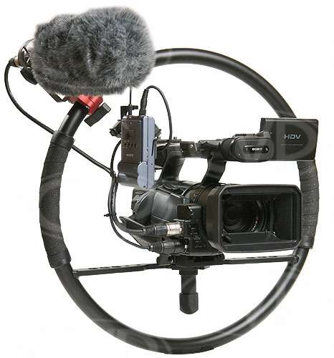
Mike Figgis’ “Fig Rig”
- Design goal – Camera stabilizer for limited space, long takes and action shots
- User perception – Practical, professional, industry standard
- Physical attributes – Sturdy, compact, lightweight
- Functional attributes – Adaptable, dynamic, plenty of room for attachments
- Constraints – Dock must be secure and allow for certain cameras, lightweight material required

Task 3 - Analyse the statement: “Design is a collaborative, not an individual activity.”
It can be both depending on the project.
I can feasibly design a painting/house sign/image on Photoshop by myself. Or work on pre-production, i.e. the script or storyboard to a film.
It is possible, but impractical, to design every aspect of a large project, particularly if you are less skilled and insightful in some areas than others.

Task 4 – Notes on poems
Dream Within a Dream – Edgar Allen Poe
- Inception
- Mourning a loss
- Died before their time, tragic
- Couldn’t save them from death
- Inevitable that they died
- Death is the sea and we are all grains of sand
The Road Not Taken – Robert Frost
- Pastoral, romantic
- Woods representing life in every sense; growth and journey
- Lamenting over choices made/not made in past but embracing the path he is on now
Fast Rode the Knight – Stephen Crane
- Focusing on the knight first, taking all the glory and credit for his endeavors
- It was the horse that brought him there and it has been forgotten
- ‘War Horse’
- Tribute to forgotten heroes
- Purple Poppy Appeal

Task 5 – Responding to Images
1.
- Hopeful imagery
- Springtime, new beginnings
- Feels familiar, like home
2.
- Tides of change
- Scene of devastation

3.
- Sail looks unsettling
- ‘Jeepers Creepers’
- Sailors’ superstition
4.
- Monet
- Celebration of colour
- Poplar trees
5.
- London burning, or just industrial era
- Train steam
- Smog covering sun
- Seems like noice is vibrating the water
6.
- Calmer colours
- More peaceful than previous image
7.
- Industry hazing over nature

Task 6 – Responding to stage and screen
1.
- ‘The Shining’ inspired?
2.
- Film Noir
- ‘An Inspector Calls’?
- Murder mystery
3.
- Colour co-ordinated
- Focus on Mise-en-scene
4.
- Macbeth witches? Or Greek tragedy chorus?
- Telling of an omen
- Considered decision on lighting and wide hats
5.
- ‘Casablanca’?
- 50’s sci-fi?
6.
- Chaotic
- Trapped in a cage or doll house
7.
- Bladerunner
- Juxtaposition between futuristic setting and old media format
- Holding onto old ways
- Overload of info and media

Task 7 – Responding to chosen Atmospheres
1.
- Italy – Portifino
- Idyllic
- Ideal retirement destination
2 – Deadpool 2.
- Foreboding
- Kid isn’t threatening looking compared to background
3 – Joker.
- Triumphant
- Joy
- Contrast in colours
4 – Old family photo.
- Happy friends
- Motley crew
- Old people reminiscing
5 – Shutter Island.
- Tragic
- Bright colour contrast
- Busy mise-en-scene

6 – Phantom of the Opera.
- Elaborate
- River Styx
- Candles stand out from blues
7 – Cinderella Pantomime.
- Garish colours
- Childish
8 – Rainy painting.
- Blurred vision
- Water in eyes
- Lots of texture
9 – Infinity War.
- Studying
- 1000 yard stare
- Memories
10 - ???.
- Reminder of the passing of time
11 - ???.
- Busy city or harbour town
12 – Clever orang-utan
- Having fun
- Smart and initiative
- Showing up humans
13 – Dr Sleep.
- Separate life from the rest of the world
- Isolated

14 – Two Towers.
- Grand, sweeping plains
- Sense of wonder of the rest of the world
- Like being on a stranded island
- Safe and fortified but isolated
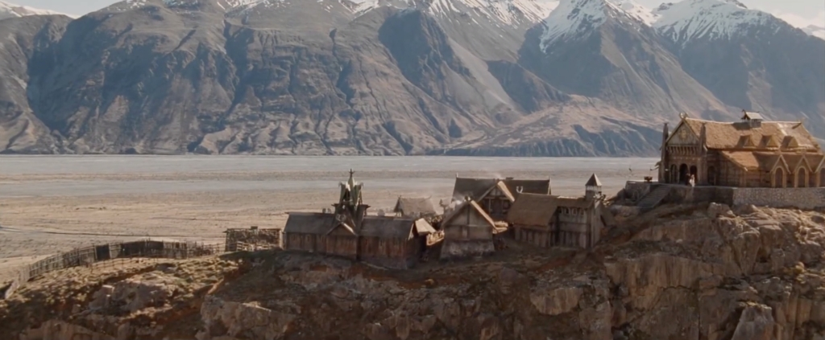
- Full 360 view

Task 8 – Analysis of chosen movie trailer – The Batman 2021
I would be most interested in the pre-production of this movie (story boarding and shot listing); the cinematography is the key way of setting the scenes and showing exposition as it is a comic-book movie.
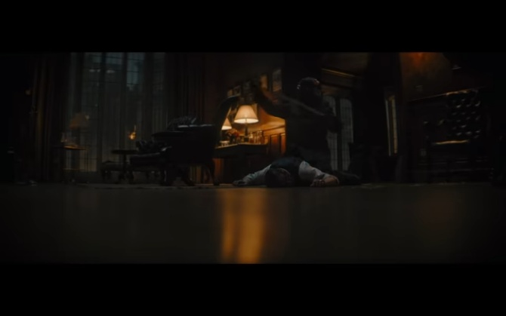 | - 0:10 Inciting moment  - Foreboding music and abrupt sounds  - Use of mystery and horror to engage attention
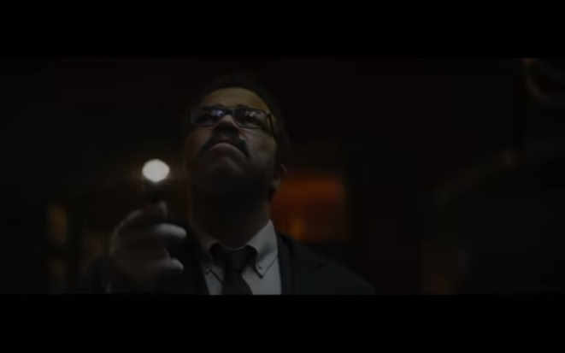 | - 0:26 Exposition  - Reveals what’s going on and setting
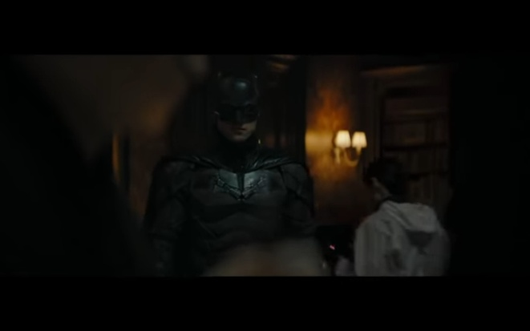 | - 0:52 Beginning of rising action  - Reveal of most recognisable/important character  - Establishes that this is a Batman movie
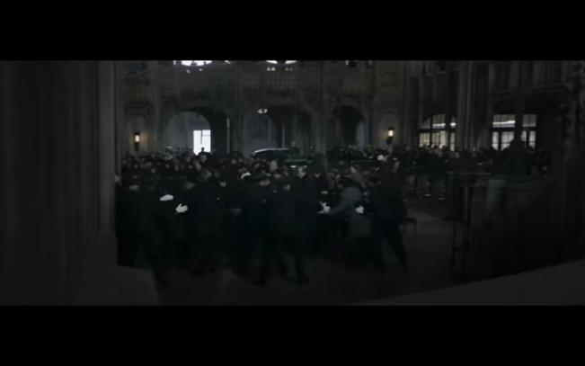 | - 1:00 Continued rising action  - Tenser exposition as action escalates
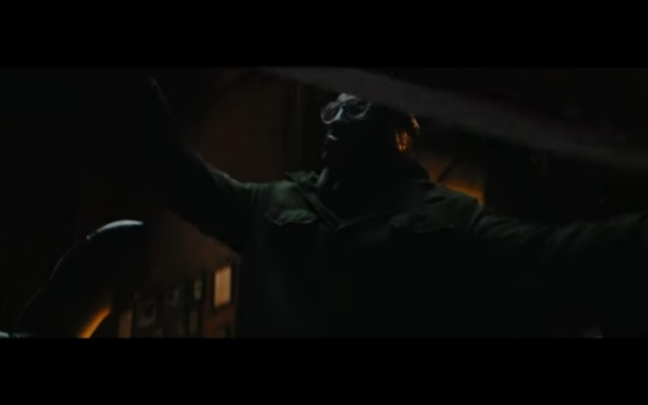 | - 1:20 Crisis  - Riddler making himself known  - Final piece of exposition
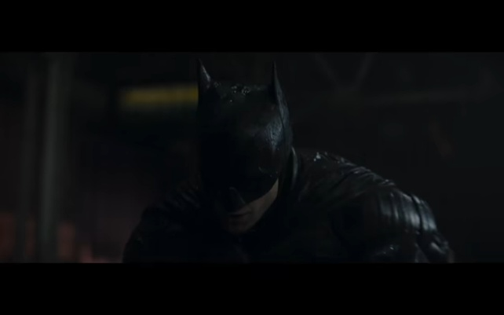 | - 1:34 Climax  - Hooker shot  - Makes you watch again  - Serves same purpose as tagline
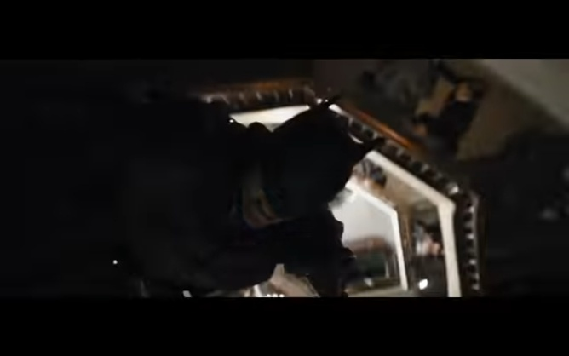 | - 1:47 Continued rising of action  - Held peak of action  - Holds attention
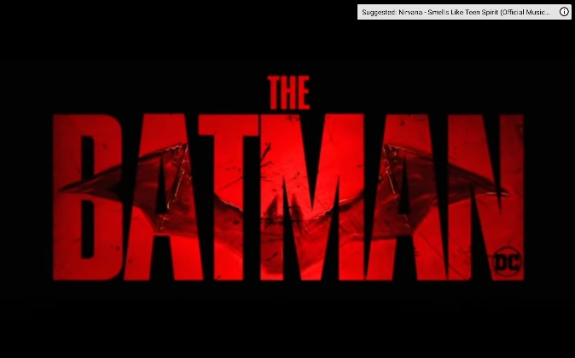 | - 1:56 Falling action  - Conclusion
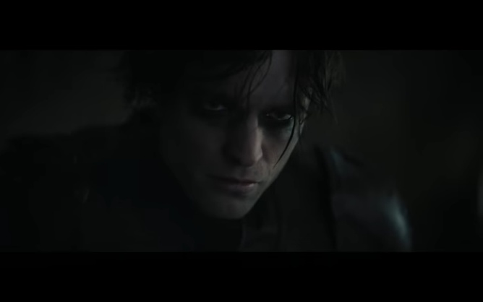 | - 2:06 Resolution  - Sums up what’s in store

This sequence mostly follows Laurel's Dramatic Arc: Exposition, Inciting Moment, Rising Action, Crisis, Climax, Falling Action, Resolution

The Trial of the Chicago 7
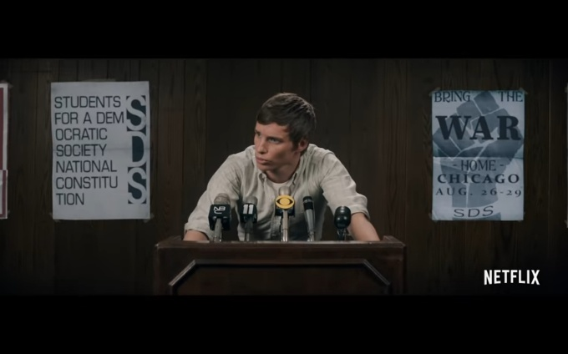 | - 0:00 – Immediate inciting moment  - Threatening opening line  - Grabs attention
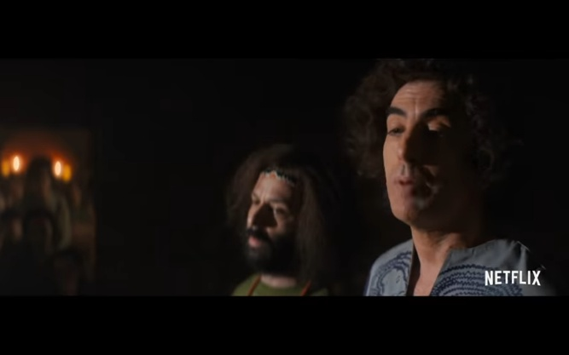 | - 0:08 – 0:25 – Exposition  - Overload of exposition and information  - Historical docu-drama of real events and people
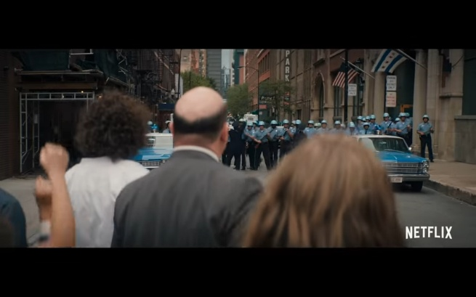 | - 0:25 – Start of rising action  - Change of atmosphere highlighted with music and exclamations in dialogue
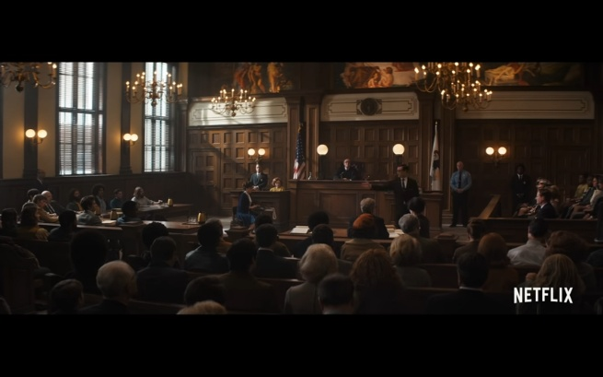 | - 0:39 – Continued action and exposition  - Holds attention with action and dialogue whilst relaying information
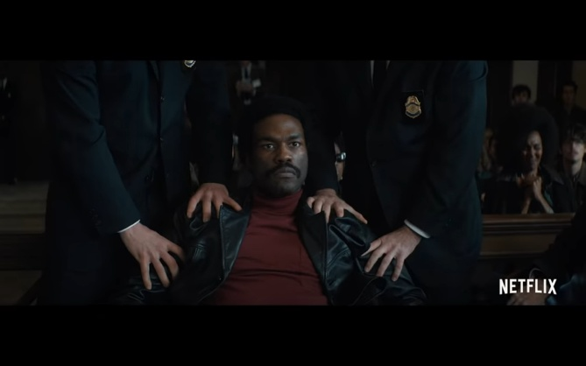 | - 1:35 – Crisis  - Protagonists being held back by all the obstacles and how they’re treated
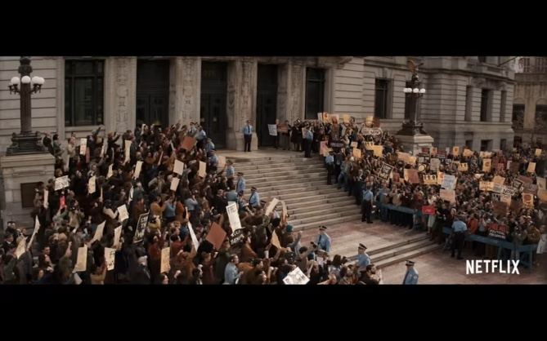 | - 1:55 – Climax  - Highlighted by uplifting music  - More positive atmosphere of the heroes fighting back
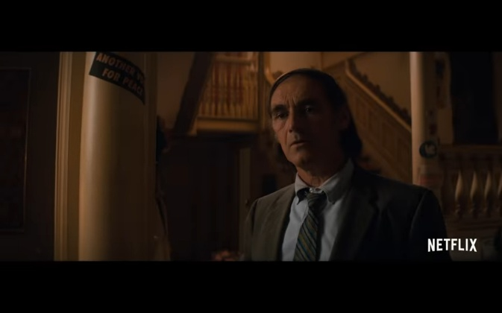 | - 2:25 – Falling action  - Less tense atmosphere  - Humbling moment for protagonist
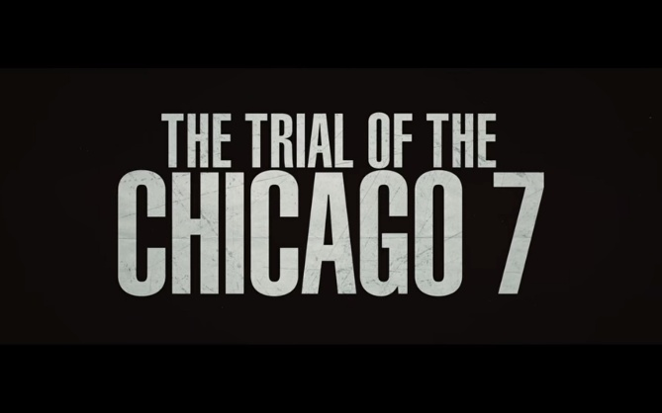 | - 2:33 – Resolution  - Summarises film’s story with the title  - People who were alive at the time will recognise the case name.

Again, similar dramatic arc style but more dialogue heavy than action compared to Batman. Focus on an accurate account of historical event whilst remaining an entertaining movie to hold attention.
Task 9 – Identifying the roles within a movie’s Art Department
The Art Department is headed by the production designer, who works directly with the director and the director of photography to discuss the overall look of the entire production. The Art Department is divided into four sub-departments:
Lead by the Art Director the artists consist of set designers, graphic artists and illustrators who all work with the director and production designer to discuss and design the overall look of movie set.
They then pass the designs onto the Construction Department, lead by the construction co-ordinator, who consist of carpenters, labourers and craftspeople.
The Sets Department, lead by the set decorator, then fill the set with furniture and decorations or anything that needs to be bought and sourced elsewhere. Quite often a greensman is needed to fill the set with real and/or artificial plants, and if a large amount is required this becomes its own sub-department.
The Properties Department, lead by the prop master, focus on items that the actors and extras interact with rather than just set dressing. Quite often these are items that need to be sourced rather than crafted, and may also require the actors to undergo training to use such as with weapons.
The Costume Department and Hair and Makeup Department are large enough to qualify as sub-departments as they have their own hierarchies; the assistants deal with the day to day tasks and supervise what is given to supporting actors and extras, whereas the head designers they work for focus on the look of everything and work directly with the lead actors.
Outside of the Art Department is the Special Effects (SFX) Department who work on practical effects during filming and production of the film. Lead by the special effects supervisor this consists of pyrotechnicians, model builders, sculptors and miniature crafters, who all build things that are captured in the camera and are very often temporary structures.
The Visual Effects Department work on the post-production side of a project. The visual effects producer has the same hierarchy as the production designer in that they work directly with the director and director of photography to discuss how shots are edited. The department consists of digital artists, animators, rotoscope artists and programmers who add or fix things that wasn’t captured in camera.

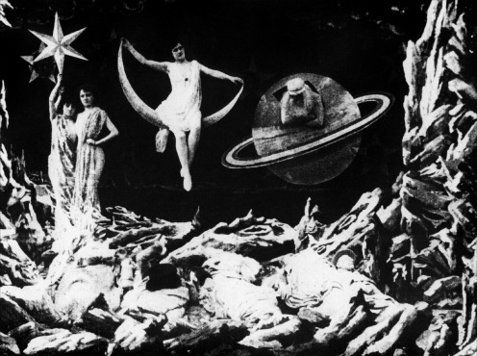
Much like the theatre and the stage, the evolution of films changes and adapts to new art mediums and technologies that expand the possibilities in what can be achieved to tell a story.
Le Voyage dans la Lune (1902)

The Cabinet of Dr Caligari (1920)

North by Northwest (1959)

For a Few Dollars More (1965)

Star Wars: A New Hope (1977)

The Mandolorian (2019-2020)
Whilst film very much began it’s life from theatre roots, it evolved far more rapidly over the course of just one century as opposed to many centuries, and continues to do so.
Silent movies relied entirely on what was seen on screen without any sound, so acting was highly expressive, and the sets and visuals were made to be a spectacle for the audience.
As technology progressed and sound was introduced, acting became more realistic and the visuals were toned down, until colour film was developed. Then there was a return to what could be achieved visually as technology continued to advance.
As an example, the visual effects company Industrial Light & Magic who were responsible for the effects throughout the Star Wars franchise, began with cruder technology compared to today. Relying on miniatures and film reel manipulation to achieve the ground-breaking effects for it’s time, they set a precedent for modern cinema in the latter half of the twentieth century.
Today they are producing the likes of The Mandolorian TV series; using “Stagecraft” projected LED screens displaying 3D generated backgrounds that can be altered in real time, match to the positions of the cameras, and also create ambient lighting that casts itself onto the actors and sets built in the foregrounds.
This new technology surpasses the decades-long use of green/blue screens and is an example of how rapidly movie are evolving.
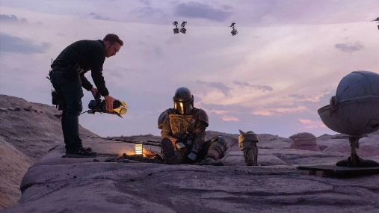
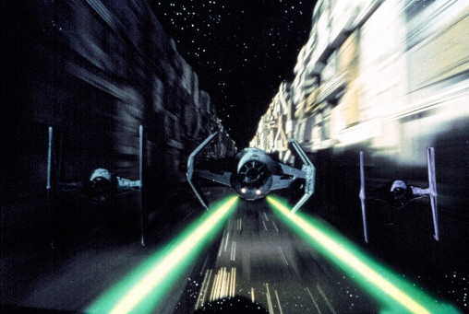
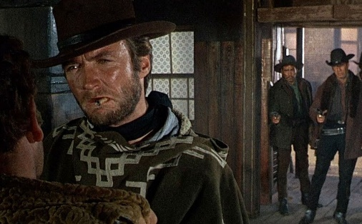
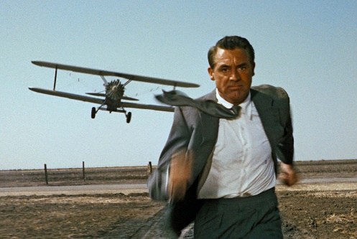
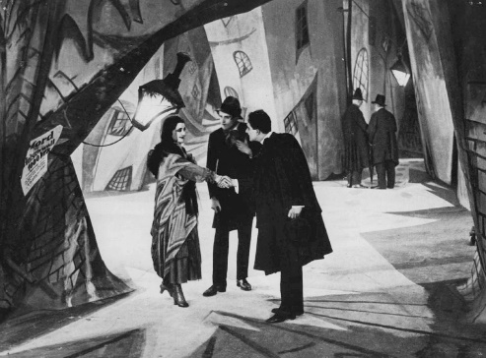

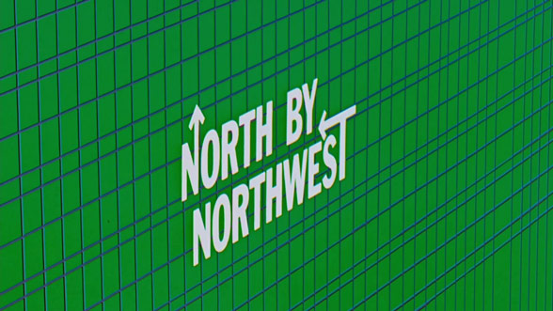
Title Sequence for Hitchcock’s North By Northwest (1959)
The opening title sequence for this movie was designed by the graphic designer Saul Bass and was one of the first to make use of “kinetic typography”, consisting of words and letters that move in dynamic ways to suit the theme of the film.
Saul Bass was famous for his bright, colourful designs that were usually torn shapes pieced together to form an image. This was no doubt why Hitchcock chose Bass as it fits the theme and plot of the movie; fast-paced action, busy city settings, chatotic misdirection and mistaken identity. All of which induces paranoia and mystery in this spy-thriller.
The advantage of using “kinetic typography” is that it can be fully tailored and choreographed, and in this case it fits to the rhythm and beat to the music score. As it transitions from the graphic drawing of the building into the city life footage the credits continue to appear and disappear in quick motions that suit the bustling movements around them.

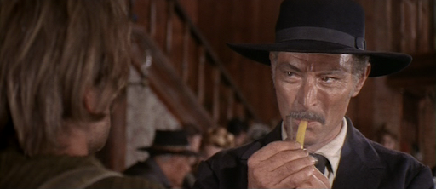
Designing for Sergio Leone’s For a Few Dollars More (1965)
Focusing on this particular scene from the film, I would follow the classic format of designing a western; building “skeleton” wooden buildings (structures with just a shell and no interior) along a flat desert landscape, and have the art department source historically accurate costumes and props.
This scene is primarily an interior scene but has a view of an exterior through a window. I would designate a few structures to be used for interior scenes (saloon, sheriff’s office, bank etc) and fill them with more set construction, set dressing, props and lighting so that filming can be done inside and also have views of the exterior through windows.
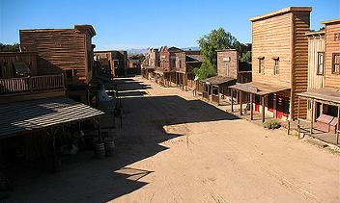
Task 10 – Story Telling and Condensed Imagery in Song Lyrics
Pinball Wizard from the album Tommy by The Who, 1969
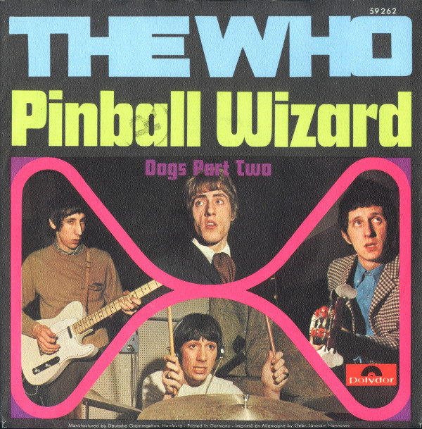
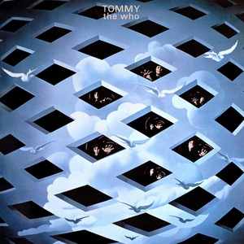
First verse:
Ever since I was a young boy
I played the silver ball
From Soho down to Brighton
I must have played them all
But I ain't seen nothing like him
In any amusement hall
That deaf, dumb and blind kid
Sure plays a mean pinball.

A ‘concept album’ is an album whose tracks hold a larger purpose or meaning collectively than they do individually. Typically achieved through a single central narrative or theme, which can be instrumental, compositional or lyrical.
Other examples include Green Day’s American Idiot, My Chemical Romance’s Black Parade, and Pink Floyd’s The Wall.
Whilst there have been other albums before Tommy that followed a concept album structure, it was the first studio album to be billed as a rock opera. The Who wanted to progress beyond the standard three minute pop single format.¹
The narrative focuses on the life and events occurring around Tommy, the deaf dumb and blind kid, and his journey becoming a master pinball player.
The album was a success as a whole but also achieved hit standalone tracks, such as Pinball Wizard.
The lyrics of the opening verse set the scene and introduces the central character of Tommy. Like many stories, the narrative is told from a first person perspective of a secondary character observing the main character. Examples of this way of storytelling include the Sherlock Holmes cases, The Great Gatsby, and Fight Club.

The imagery of the song suggests places like bright, colourful and garish London/Brighton amusement halls, which can also date the setting during a time when such places were more popular.
This particular song gave the idea for the theme and story of the rest of the concept album, and subsequently, the film adaptation of the same name in 1975, followed by the stage musical in 1992.
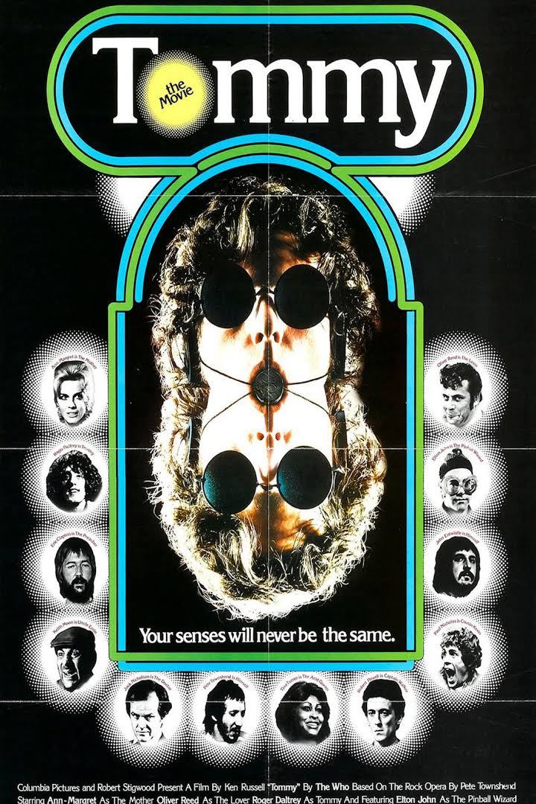
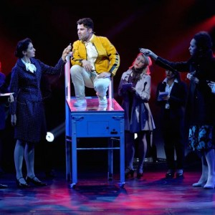

“The package I hope is going to be called "Deaf, Dumb and Blind Boy." It's a story about a kid that's born deaf, dumb and blind and what happens to him throughout his life ... But what it's really all about is the fact that ... he's seeing things basically as vibrations which we translate as music. That's really what we want to do: create this feeling that when you listen to the music you can actually become aware of the boy, and aware of what he is all about, because we are creating him as we play.”
Pete Townsend speaking to Jann Wenner, 1968
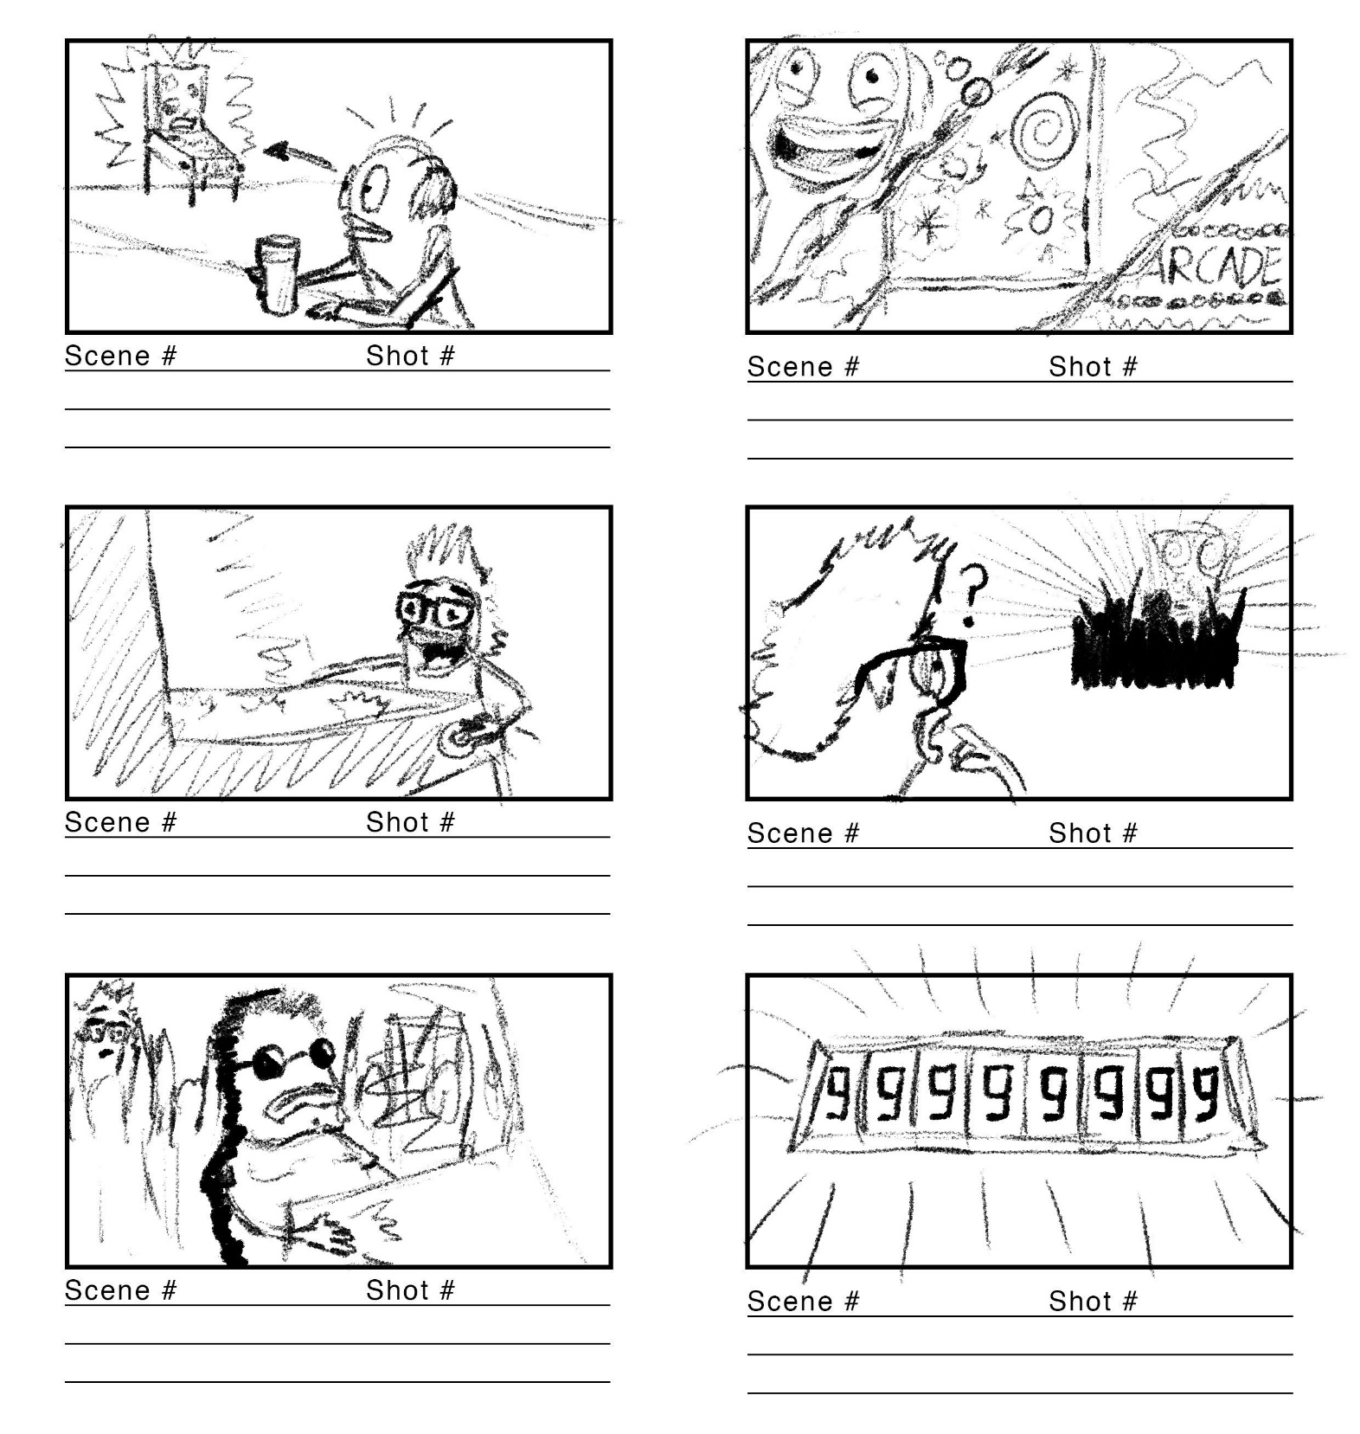
Storyboard 1 – more literal interpretation based on first treatment of lyrics
The score counters reach max score
Reveal of the deaf dumb and blind kid surrounded by his disciples as he plays
Spots a commotion of kids crowding and cheering around another machine
Flashback to being a kid playing pinball in a 60s Brighton arcade
Old man starts to remember being back at the arcade as a child
Old man spots a pinball machine in a seedy English pub

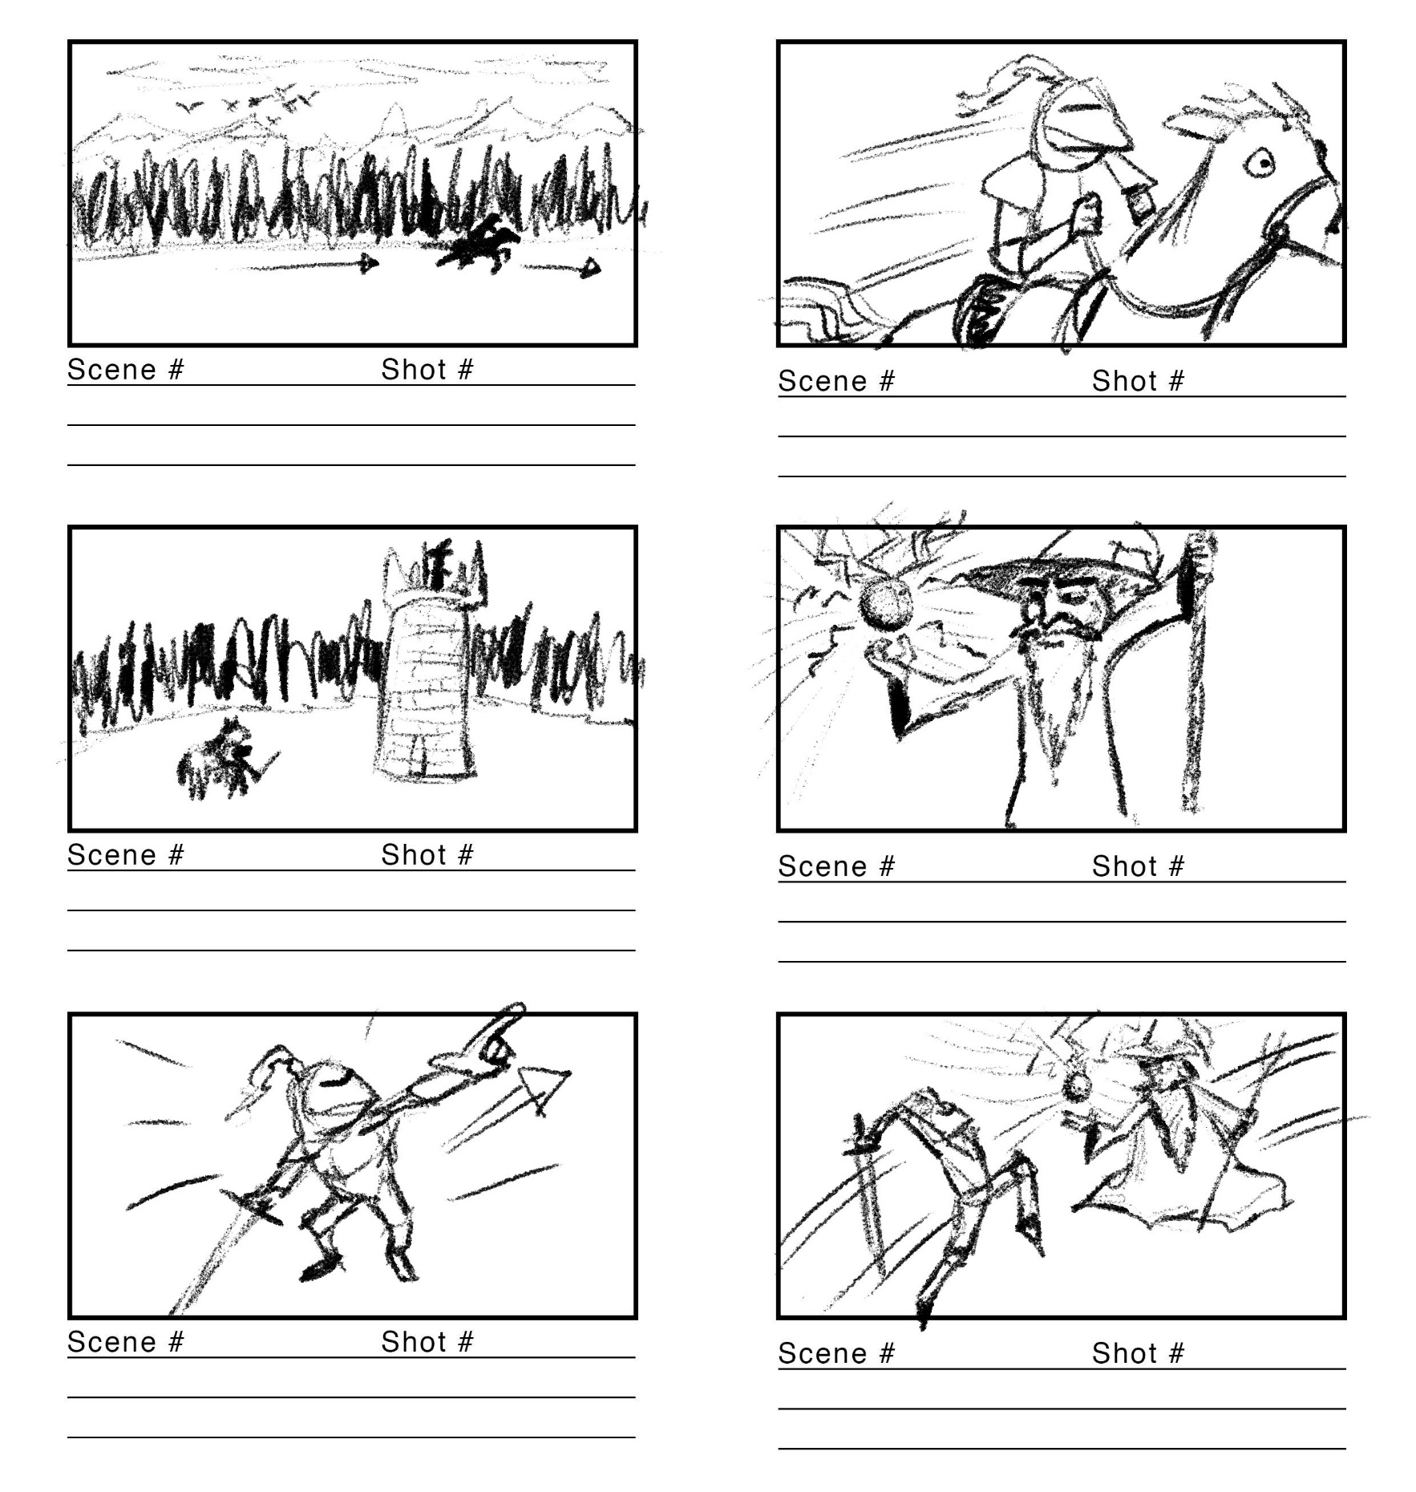
Storyboard 2 – “opposite” interpretation
Action shot of Knight and wizard lunging at each other
Knight challenges the wizard
Reveal of literal “pinball wizard" wielding a mystical silver ball
Arrival at wizard’s tower
“Hero” shot of Knight on his horse
Medieval fantasy setting with a Knight riding across the plains

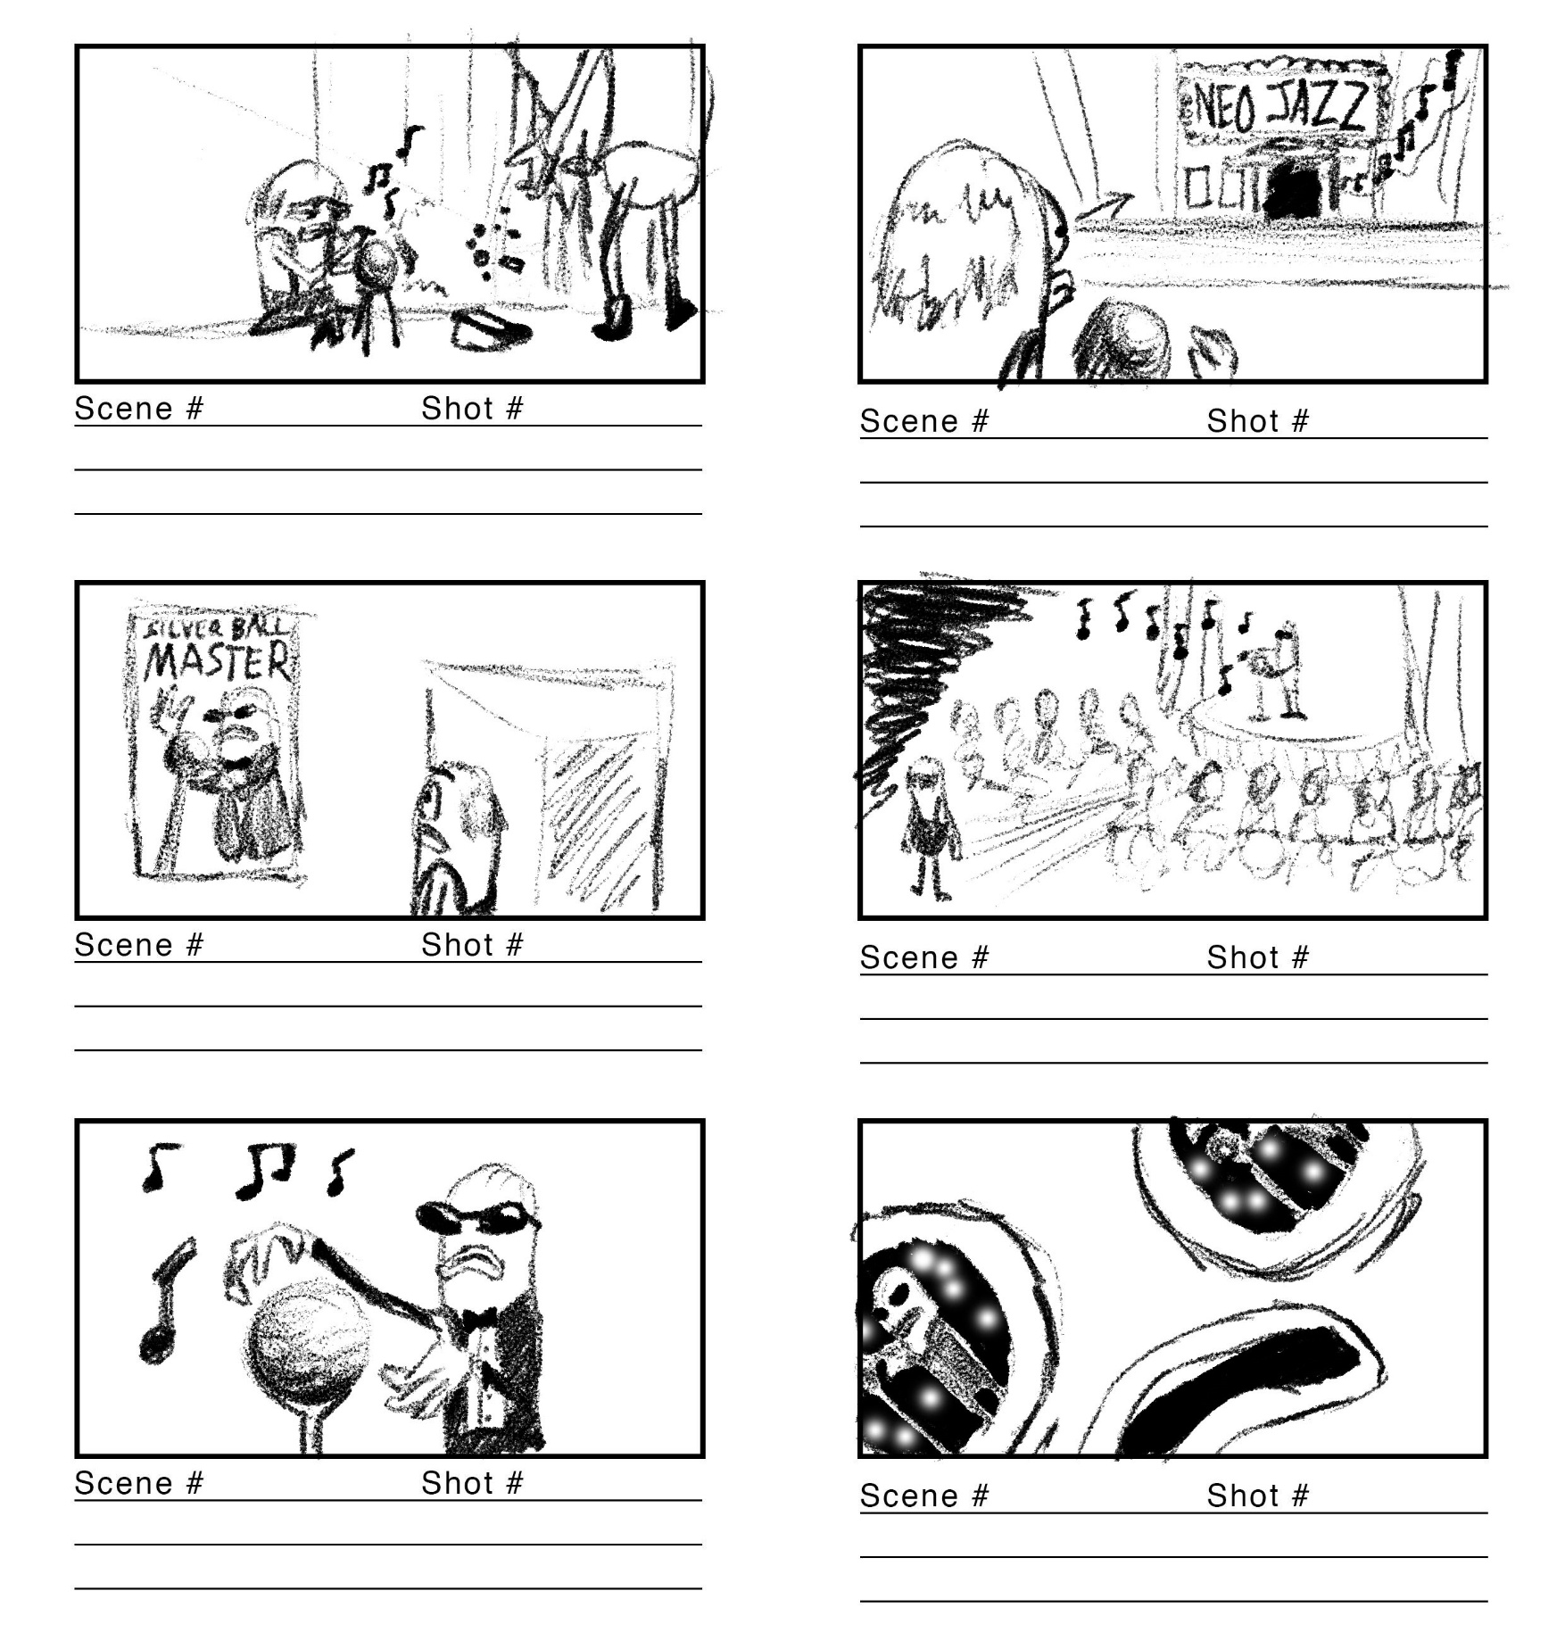
Storyboard 3 – “hybrid” of previous two
Busker is amazed by the skill of the silver ball master
Reveal of deaf dumb and blind man playing a fancier silver ball instrument
Busker enters jazz club and sees a large audience watching the silver ball master
Busker spots a poster of the music act going on inside
Hypnotic music emanating from jazz club across the road
Futuristic City setting with a busker playing a silver ball instrument

I enjoyed designing these as they were an insight into how concepts for projects are put together, and how different people can have different interpretations of a given stimulus.
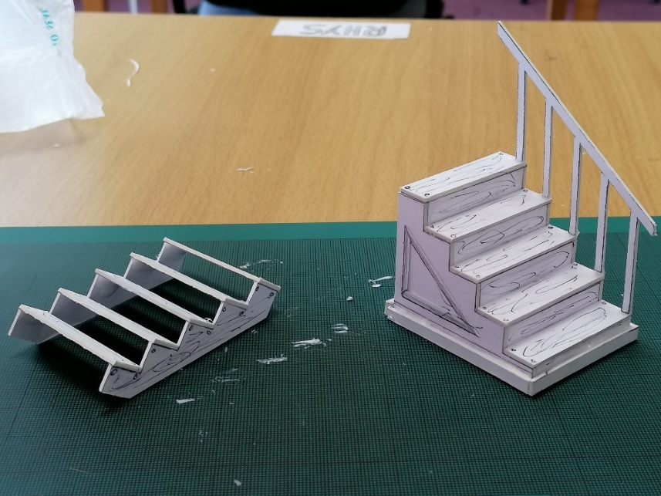
Task 11 – Scale model making for sets
Pre-measured 1:25 scale stage stairs
- Considerably easiest task in terms of piecing together
- Difficult to keep edges neat all over

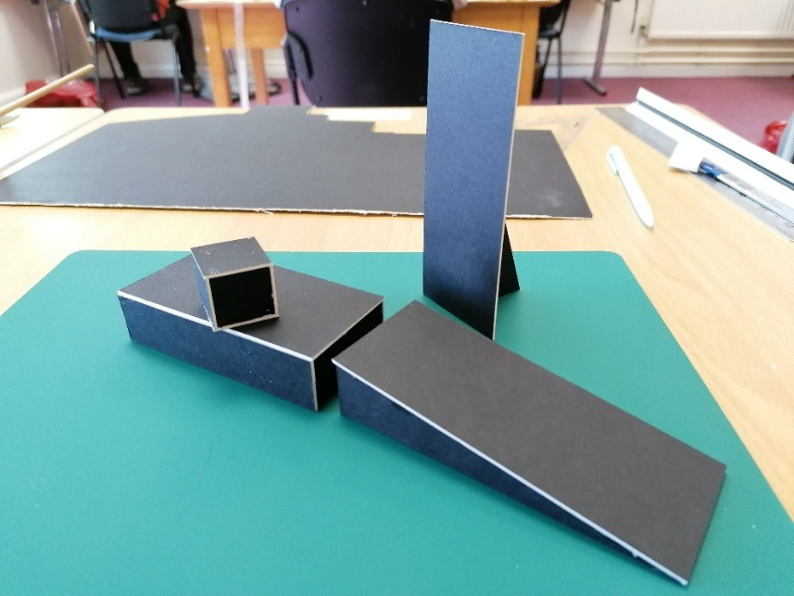
Creating set pieces from given 1:25 measurements
- Best task to help with learning to measure in scales

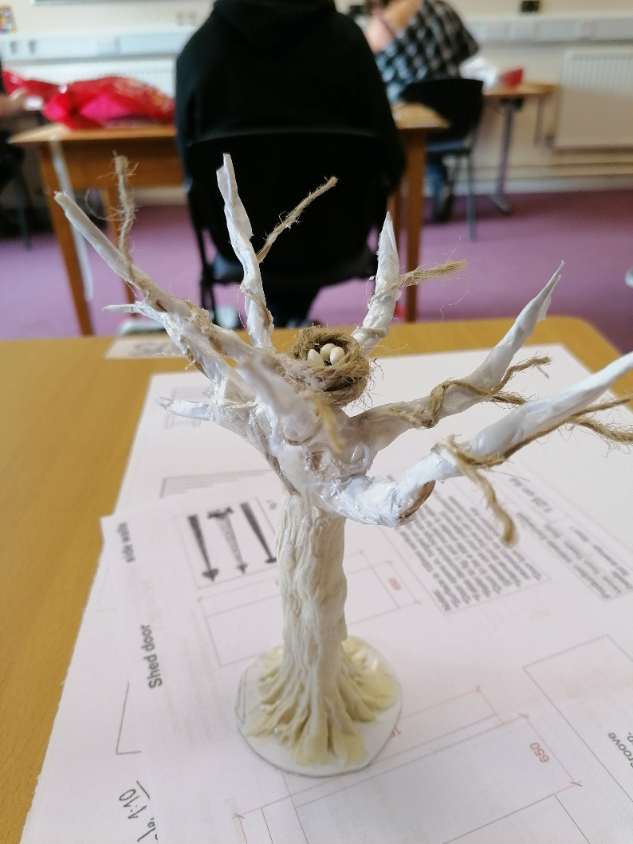
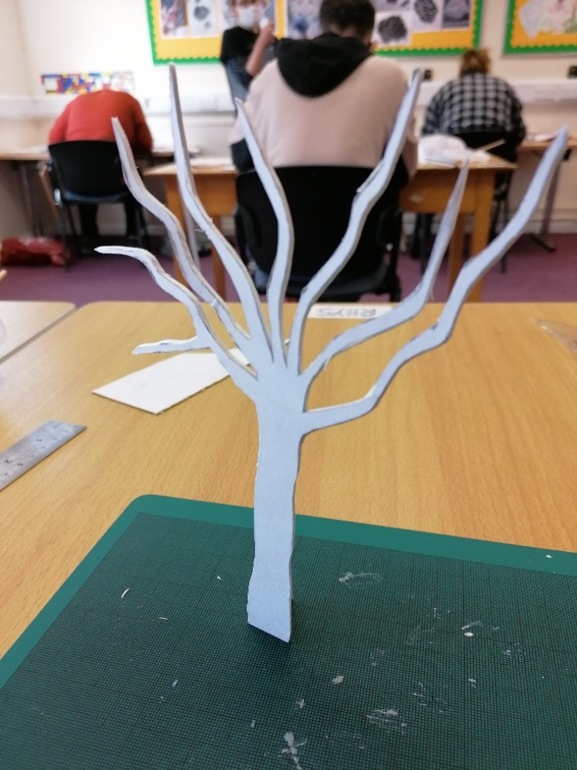
Creating 3D tree in 1:25 scale
- Most fun model
- Started from pre drawn 2D tree
- Cut from mount board then began bending branches to add third dimension
- Built up trunk using plasticine
- Wrapped tissue paper around branches to add organic shape and thin ends
- Unravelled string then coiled around large branches to create smaller ones
- Birds nest made by wrapping tightly around little finger, then sealing shape with PVA glue. Like how birds make nests with their spit
- Sealed everything with PVA glue
- Would have added more small branches and twigs if doing again

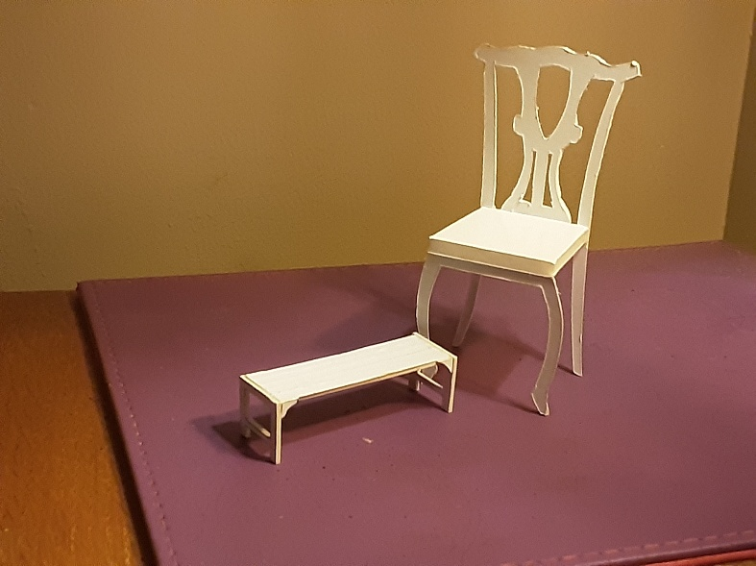
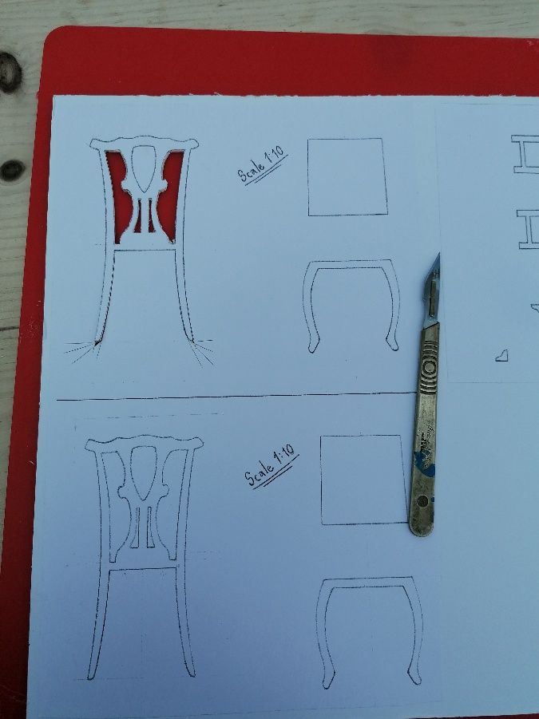
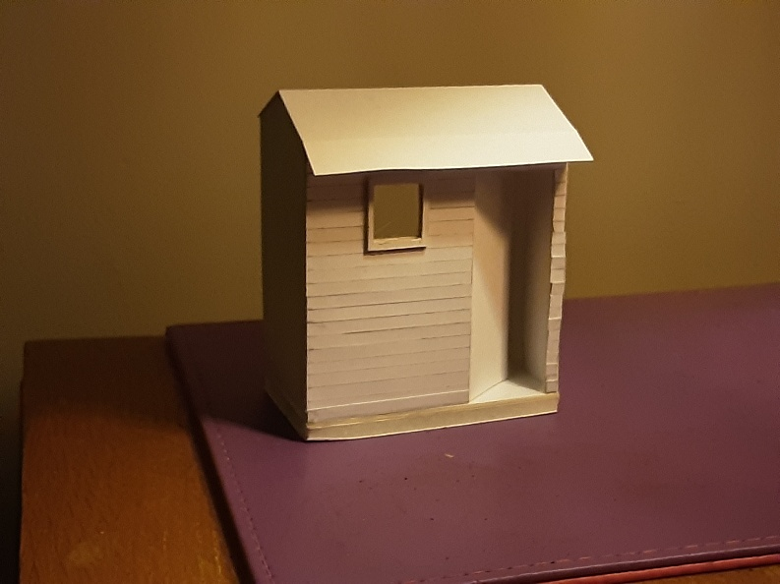
Creating chair in 1:10 scale
- 1:10 more used for creating film sets and scenes
- Most different model with ornate designs on chair back
- Would have designed it differently to allow front legs to glue to front of seat, with addition of corner supports

Creating garden shed in 1:25 scale
- Most dynamic model with functions to allow stage entrance and scene changes
- Added cling film window pane and exterior frame
- Would have added door detail and cut the exterior panels differently

Having had previous sessions entirely online this was a very enjoyable break from that; creating physical and tangible things. It goes to show that not everything in design can be conveyed just in 2D formats, it helps to have 3D objects in front of you to visualize ideas to others.

Task 12 – Breakdown sheet of scene from given movie script, notes for production and prelude to storyboard
BREAKDOWN SHEET #1
Page Count: 71 Date:_____________________________
Production Company:
Production Title: MY WEEK WITH MARILYN
Scene #:80
Scene Name: PINEWOOD STUDIOS. OLIVIER’S DRESSING ROOM. INT DAY
Description: Olivier practises his lines and vents about Marilyn
CAST  OLIVIER  MILTON  COLIN | STUNTS | EXTRAS/ATMOSPHERE
CAST  OLIVIER  MILTON  COLIN | EXTRAS/SILENT | EXTRAS/ATMOSPHERE
SPECIAL EFFECTS  INTIERIOR ROOM LIGHTING  DRESSING MIRROR LIGHTS  CIGARETTE SMOKE HAZE | PROPS  CHAIRS  CIGARETTES AND CIGARETTE PACKETS  MATCHES OR LIGHTERS  WHISKEY, GLASSES AND DECANTER  MILTON’S BAG  PILL BOTTLES | VEHICLES/ANIMALS
WARDROBE  50'S SMART CASUAL ATTIRE  COSTUMES FOR MOVIE CHARACTERS | MAKEUP/HAIR  WELL KEMPT TRIMMED MEN’S HAIRCUTS  BASIC FOUNDATION  MOVIE MAKEUP FOR OLIVIER | SOUND EFFECTS/MUSIC  MUFFLED BACKGROUND STUDIO ACTIVITY FROM OUTSIDE ROOM  HUM FROM LIGHTS
SPECIAL EQUIPMENT  FAKE CIGARETTES? | PRODUCTION NOTES  SET DRESSING FOR DRESSING ROOM: COSTUMES ON CLOTHES RAIL, CLUTTER OF MAKEUP AND SCRIPT PAGES ON DESK, DRESSING MIRROR FOR OLIVIER

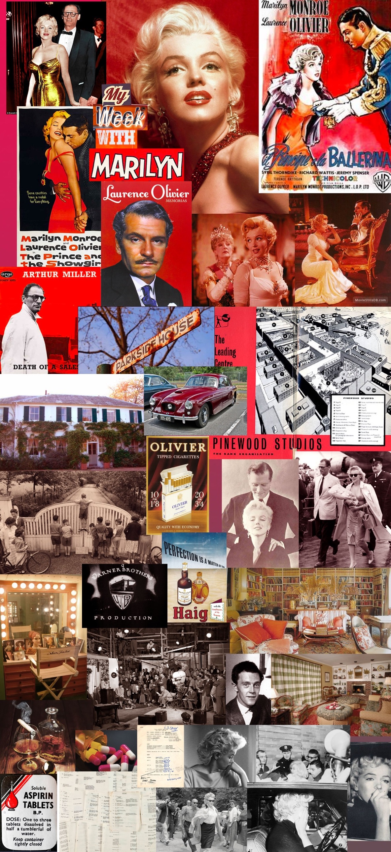
Task 12 – Mood Board for given film
For this mood board I was aiming for an over-arching summary of My Week With Marilyn containing all of its elements, in the shape of a linear flow of the narrative from beginning to end.
The top being the first half of the film; its colours are the most vibrant and glamorous, the atmosphere is upbeat and positive. As it continues it becomes desaturated and eventually colourless, the images are more cluttered and chaotic, and are representing the obstacles and problems Marilyn deals with throughout the story.

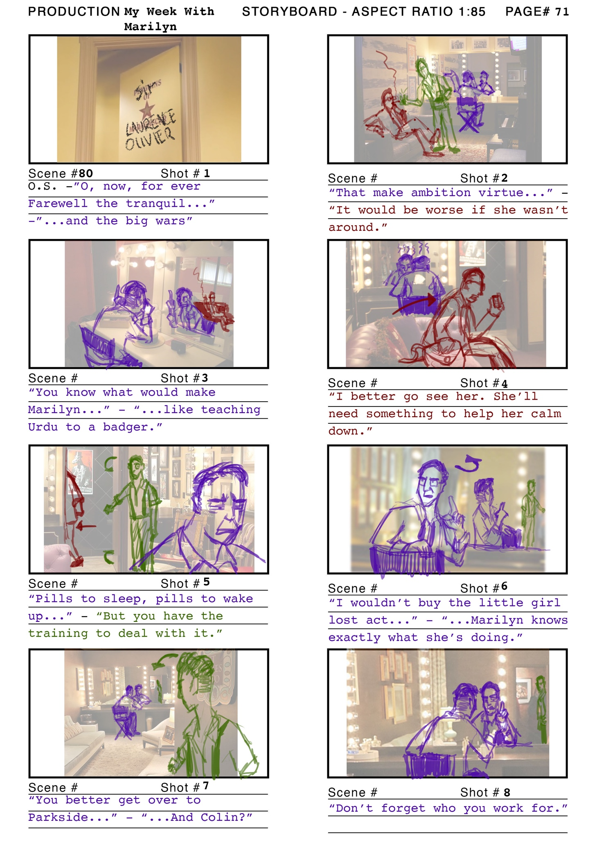
Task 14 – Story Board for given film
Each shot is around 30 seconds or less as it is a short scene. The length is determined by the first and last lines of dialogue spoken separated by an ellipsis, as shown in the notes below. Each character is drawn in different colours that match their lines.
The images used for the background were helpful for creating perspective, and I found that using the ‘related images’ feature on Google allows you to find images of the same scene but form different angles.
Shot 1. Brief detail on Olivier’s dressing room door star as we hear his Shakespeare reciting off screen.
Shot 2. Slow zoom in on Olivier in his mirror whilst Miller sits behind him, and Colin lights his cigarette and pours them both whiskey.
Shot 3. Medium shot on Olivier, whilst keeping Miller in shot through the reflection in the mirror.
Shot 4. Brief detail on Miller’s bag as he takes out a pill bottle to look at, then medium shot as he stands up to leave the room, Olivier skulking in the background.
Shot 5. Close up of Olivier looking into his mirror away from Colin in the background getting the door for Miller, switching focus as they exchange dialogue.
Shot 6. Pause, followed by medium shot of Olivier turning back to scold Colin, keeping in shot his reflection looking back at Colin in the background.
Shot 7. Wide shot with Colin in foreground leaving the room, pausing to listen to Olivier in the background.
Shot 8. Zoom cut from same camera position on Olivier for emphasis on last line, keeping Colin’s reflection in the background.

I particularly enjoyed this task as it is part of the designing aspect in filmmaking, something I feel I am most skilled at. This and many other aspects of pre-production is usually done collaboratively, and I believe some of the best ideas and designs are formed from multiple minds.
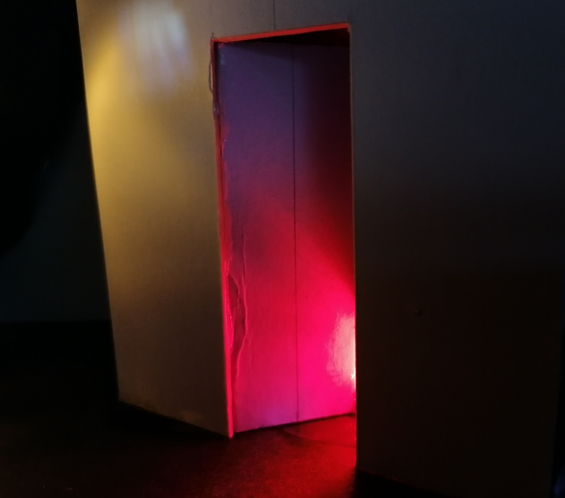
Task 15 – Visual response to given stimulus
Our given stimulus was the first script page for Damien – Omen II, and the task was to create an image that reflects the theme and the mood of the scene.
Initially I took the task too literally and began designing a complete set for the scene; a café with a city backdrop under a sunset through a window. Whereas the image needed to be more abstract, using close ups of objects and different sources of light.
Our result was something that would suggest the overall theme of the scene; we used a scale model doorway, red gel taped behind it, black card to make a bright torch and some dim electric tea-lights.
We positioned the torch behind the doorway and red gel to create an ominous glare coming from the room, also acting as a “key light”. The tea-lights were poked through the card to shine on the wall acting as “fill lights”.
We were extremely pleased with the results as the photo taken created the illusion of this being a to-scale doorway in a horror movie. The different sources of light created contrasting colours bouncing off the white doorway.
I further understood the purpose of this task after doing it; it serves the same purpose of a mood board and a scale model set when it comes to the overall design process to a project, and should be presented alongside everything else to convey intentions for lighting, colour schemes, textures, theme and emotions evoked when looking at it.
After watching the first scene to Damien – Omen II it seemed to be visually very different to the description in the script. This may have been a decision made later on in pre-production or perhaps during filming.
Screenshots from Damien – Omen II, 1978 courtesy of IMDB.com
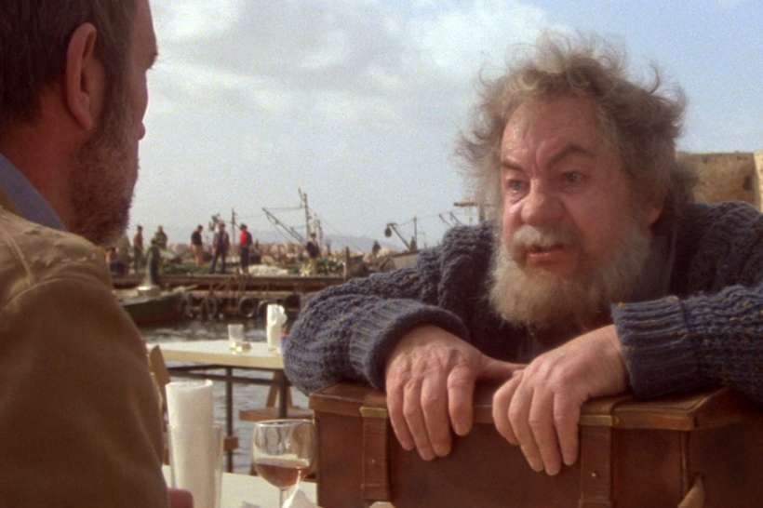
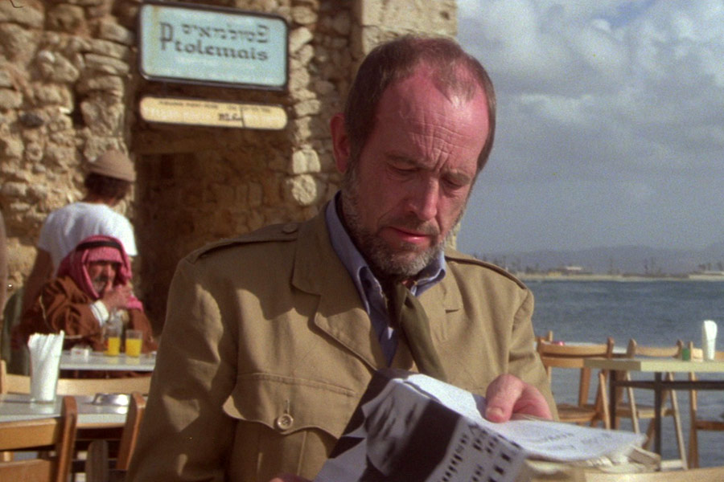
Task 16 – Final Project
Our group’s Creative Response to given stimulus: Robot Boy – poem from Tim Burton’s The Meloncholy Death of Oyster Boy & Other Stories, 1997

- Commitment
At the start of the Steps of Design, we simply read through the poem together aloud and absorbed it. Then we discussed what we thought about it individually and broke down the poem; its plot, the characters, the theme and subtexts.
One of our observations was that there was more than one perspective within the story; Mr Smith, Mrs Smith, Robot Boy, and the reader. From this, we committed to the idea of telling this story from multiple points of view and in a non-linear flow.
- Analysis
In this story the roles of Protagonist and Antagonist are subjective and interchangeable depending on how you perceive the characters. Some of us argued the antagonist was Mr Smith for being a poor husband, some thought it was Mrs Smith for having an affair, some thought it was the Microwave-Blender for leading Mrs Smith astray, and some even thought it to be Robot Boy for coming into existence and ruining the lives of Mr and Mrs Smith.
All characters would perceive themselves to be innocent in this blame game, and from this we came to the idea of telling this story from all points of view.
From analysing the plot we boiled it down to a simplified version; “a long-awaited child becomes unwanted”, or “unhappy wife has an affair and has an illegitimate son.” Looking past the humorous and fairy-tale-like imagery it becomes a stereotypical drama/tragedy plot.
- Research
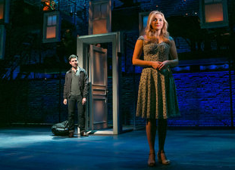
The first source of inspiration we came up with was the musical The Last Five Years by Jason Robert Brown. The story is the five year relationship and marriage between Cathy and Jamie, Cathy’s perspective is played out in reverse-chronological order (starting the show at the end of their relationship) whilst Jamie’s is in chronological order (starting after their first date). The characters do not interact with each other except at the mid-point of the show where their stories intersect.
Another aspect of this style of story-telling is “parallel action”, in which dialogue and events are played out simultaneously, the viewer can witness everything going on but the characters only see their own perspectives.
Second Stage revival of The Last Five Years, 2013 Off-Broadway
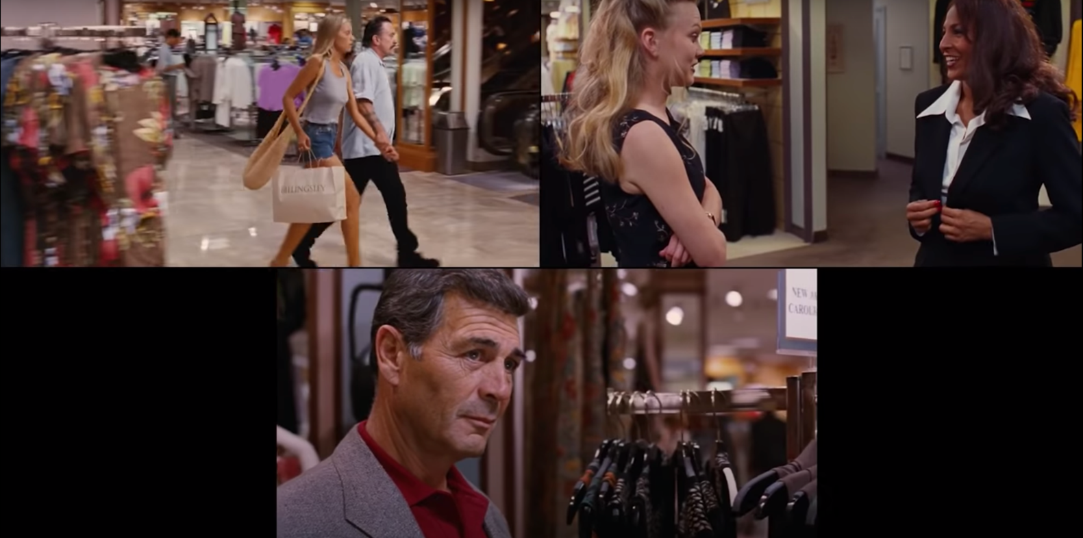
Jackie Brown – Quentin Tarantino, 1997
A great example of parallel action in film is Quentin Tarantino’s Jackie Brown, which features scenes that are played multiple times from different character’s point of view. If all shots were synchronised together like the above image then the scene is played out with everything in view. The audience witnesses everything whilst the characters only see things in their perspective.
- Incubation
We all compared these ideas and our own interpretations of the Robot Boy poem, and we agreed on making a collage of images as our creative response. It would be a visual telling of the story in the poem, with different photographs of events occurring from different characters’ perspectives. We would display the images on the wall with frames to suggest they are wholesome family portraits, except that they are positioned in a non linear way leading to a main middle picture.

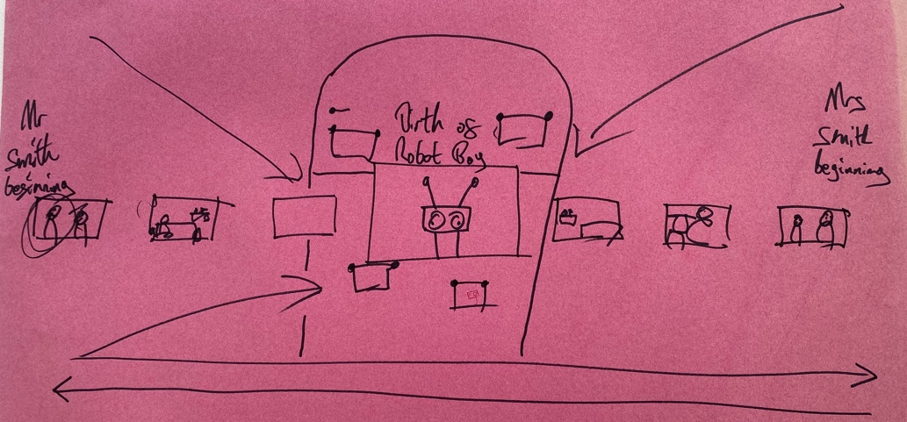
Rough sketch of our collage idea, focusing on structuring the narrative
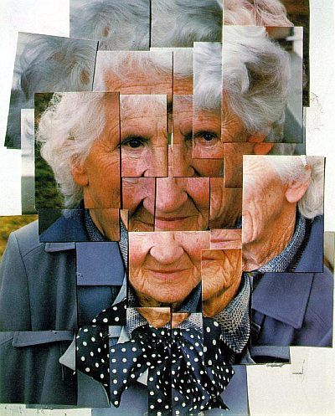
Returning to research, we each gave ourselves different aspects of this project to look into; Tim Burton himself, other stories told in non-linear narrative structures, the aesthetic of old fashioned family portraits, and working with photo collages.

I found the best example of story telling with photos is David Hockney’s work with collages, or his “Joiner” series. He took multiple photographs of the same subject at different angles and pieced them together to create new images.

Mother 1 Yorkshire Moors, 1985

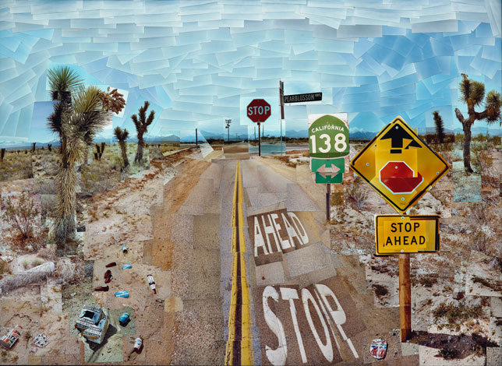

Pearblossom Highway 1, 1986

“Using varying numbers of Polaroid snaps or photolab-prints of a single subject, Hockney arranged a patchwork to make a composite image. One of his first photomontages was of his mother. Because these photographs are taken from different perspectives and at slightly different times, the result is work that has an affinity with Cubism, which was one of Hockney’s major aims – discussing the way human vision works.” Khanh Hmoong, 1983

I wanted to follow the idea of challenging the way human vision works; in that our eyes often follow things in a linear, left-to-right direction. This can be limiting and restrictive if there is more to see in a story, and experimenting with how we follow a story can allow us to view a bigger picture from many perspectives.
- Selection
We pieced together our research to decide on how to approach this project; we would take photos of ourselves playing as the characters of Mr & Mrs Smith, the Doctor, and the Microwave Blender. We decided that the central images would be the ones seen from Robot Boy’s perspective so would not feature in the photos, rather he would be physically present in the middle of all these images as if he is telling this story to us.
- Implementation
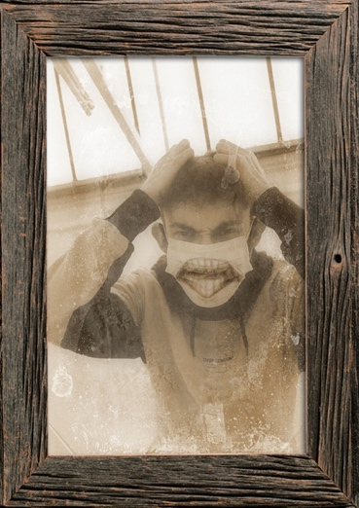
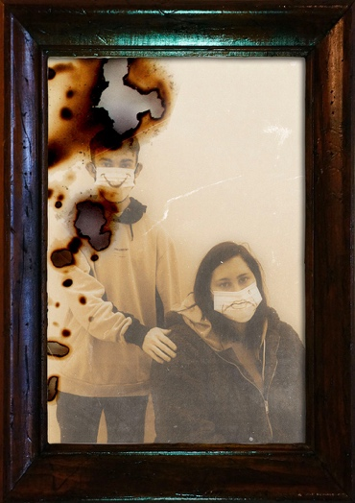
We staged a rough set within the room we were in and used a few found objects as props. We posed ourselves enacting relevant moments in the Robot Boy story from different characters’ perspectives. We positioned the pictures on the wall like family photos, all leading towards the middle main pictures. In the centre was a “Robot Boy” pieced together from an assortment of objects, telling his story.
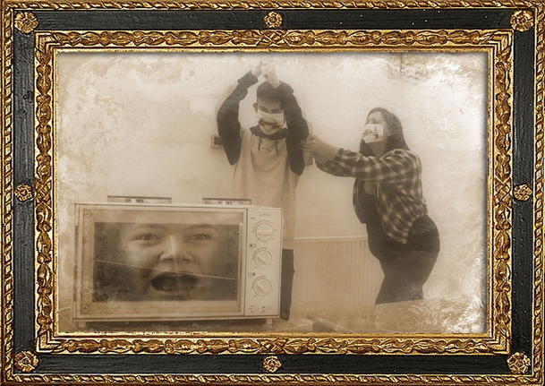
We wanted the viewers to be the “fourth perspective” who is able to view all events in the story witnessed by different characters and decide
for themselves who is the protagonists and antagonists.
- Evaluation (before presentation)
I feel we managed to achieve what we wanted to put across to the audience; a visual telling of a written story in the form of a collage, laid out in a way that tells all characters’ perspectives.
I think with more time and resources I would have enjoyed creating something more tangible to tell the story. We had drafted ideas that required more craft work and may have been beyond our capabilities; such as making a hand-held slideshow device or a Zoetrope containing all of our images. Items like these would be more interactive and similarly challenges how we perceive images.
However these would require others to touch and pass them around, which would create social distancing problems. So our current approach allows us to be able to keep everyone distanced whilst still engaging with the story.
In a pitching scenario I would still include this, alongside other mediums of design such as a mood board and pieces of scale models for a set, as it would further help to convey the ideas of how we would tell this story.

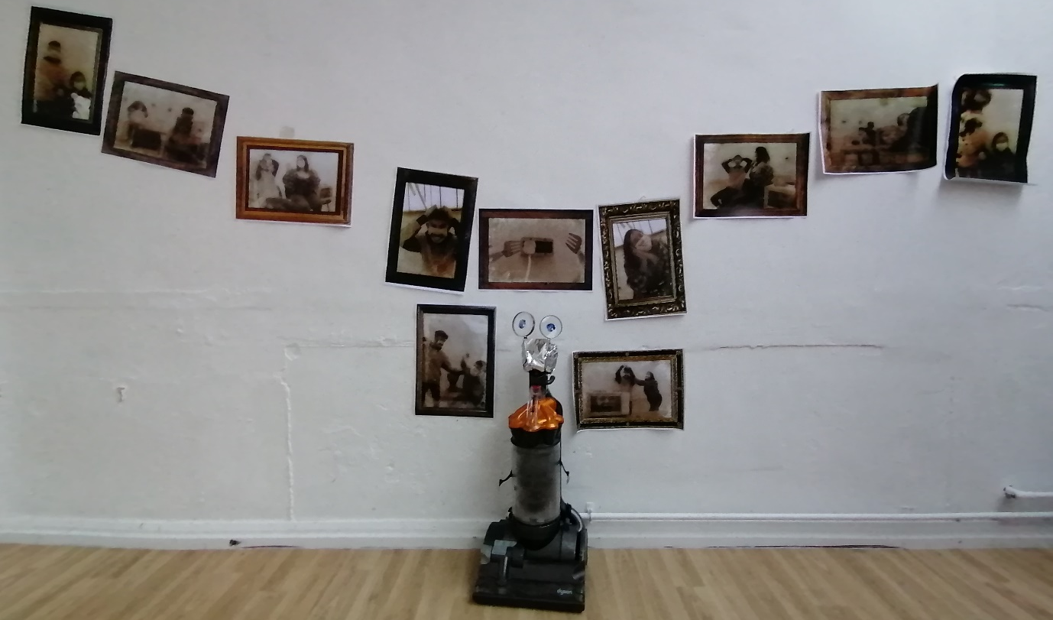
Final presentation for project: photo collage forming a non-linear storyboard
Myself and the rest of my group all thought the presentation was very well received, and that everyone fully understood the ideas we were putting across.
Despite not having fully rehearsed how we would speak to everyone and spending more time on research and implementing the project, we still managed to speak cohesively about what we designated each other to talk about; I opened the talk with how we began structuring the narrative, we then each talked about our individual research tasks, and the rest flowed naturally from there.
I really appreciated the feedback everyone had to give and it was good to see everyone understood the project. Others agreed on my thoughts about using this approach to pitch a design for a project that has a non-linear narrative, and is something that challenges how we perceive and read a story.

Marsh. D – ‘Before I Get Old: The Story of The Who’, 2015, Plexus Publishing Ltd.
‘David Hockney – Joiner Photographs’ – Don Featherstone, 1983, Arthaus Magik

