BLOGS AND POSTURE
KHUSHI NAIK

"Tracking Mental Health with the Moodfit App: A Useful Tool for Managing Depression"
In the UK, depression is one of the leading causes of mental health issues, affecting around 1 in 6 people at any given time (Chen et al, 2022). It can lead to a range of physical, emotional, and psychological symptoms, making daily life more difficult. With rising awareness about mental health, many are turning to digital solutions to manage and monitor their well-being (Heissel et al, 2023). One such tool is the Moodfit app, designed to track various aspects of mental health and offer insights to help individuals cope with depression and anxiety.

About the Moodfit App

Moodfit is a versatile mental health app that helps users track their moods, thoughts, sleep patterns, and other key mental health indicators (May, 2023). The app offers a combination of tools like mood tracking, journaling, and mindfulness exercises, aimed at helping users understand their mental state and work towards improvement (May, 2023). It's suitable for anyone dealing with stress, anxiety, or depression, providing both self-care exercises and professional guidance (Wintermeyer, 2021).

Features of Moodfit:
- Mood Tracking: Allows users to track their emotions daily, helping to identify patterns and triggers (Wintermeyer, 2021)
- Cognitive Behavioral Therapy (CBT) Tools: Offers exercises based on CBT techniques to challenge negative thoughts and improve mental health (Talactac, 2021).
- Sleep and Activity Tracking: Integrates with fitness trackers to monitor physical health, which is often linked to mental well-being (Wintermeyer, 2021)
- Mindfulness Exercises: Includes guided meditation and breathing exercises to reduce stress and anxiety (Talactac, 2021).
- Progress Reports: Provide insights into mood patterns and suggest coping strategies based on the data collected (Talactac, 2021).
Advantages:
- Comprehensive tracking: Moodfit integrates various aspects of mental health, from mood to sleep patterns, which can help users understand their emotional triggers and overall well-being (Balaskas et al, 2021).
- Personalised insights: The app provides tailored recommendations, such as mindfulness exercises and lifestyle adjustments, to improve mental health (Talactac, 2021).
- Accessible and user-friendly: It’s easy to use, making it a good fit for both beginners and experienced users of mental health apps (Balaskas et al, 2021).
Disadvantages:
- Limited professional support: While Moodfit offers a range of tools, it doesn’t provide direct access to licensed mental health professionals or therapists (Balaskas et al, 2021).
- Subscription-based features: Some advanced features are locked behind a paywall, limiting access for those who cannot afford the premium version (Balaskas et al, 2021).
- Data privacy concerns: Like most health apps, there are concerns about how user data is stored and shared, especially when dealing with sensitive mental health information (Balaskas et al, 2021).
Rectifying the Challenges:
To address these challenges, Moodfit could:
- Integrate a referral system for users to easily connect with licensed therapists or mental health professionals (Balaskas et al, 2021).
- Offer more free features or provide a more affordable subscription model for people who need it the most (Balaskas et al, 2021).
- Improve transparency around data privacy by offering clearer information about how user data is protected and used (Balaskas et al, 2021).

"The Top Features of Medisafe: A Medication Reminder App for Chronic Disease Management"
Chronic diseases such as diabetes, hypertension, asthma, and arthritis are long-term health conditions that require continuous management. In the UK, where chronic diseases are on the rise, effective disease management is crucial to improving patients' quality of life and reducing healthcare costs (Lorig et al, 2020). According to the National Health Service (NHS, 2024), over 15 million people in the UK live with a long-term condition. Managing these diseases requires consistent medication adherence, lifestyle changes, and regular check-ups, which is where digital tools like Medisafe come in (Arefin, 2024).
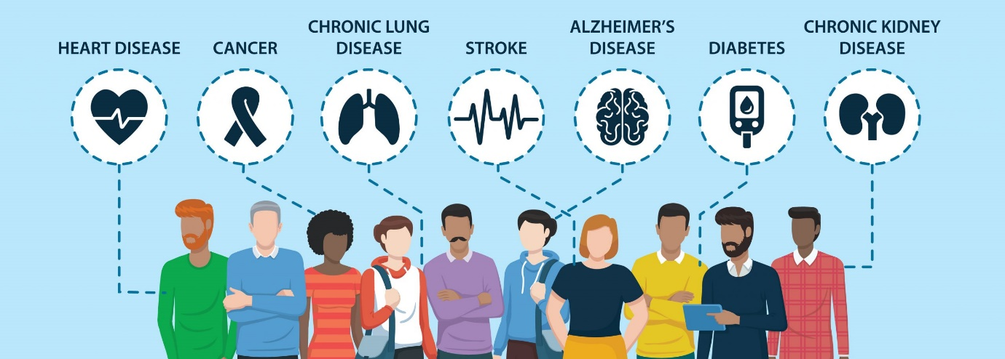
About the Medisafe App:
Medisafe is a medication reminder app designed to help users manage their medications effectively. Available on both iOS and Android, Medisafe provides personalized medication reminders, tracks doses, and offers a variety of features to make chronic disease management easier (Park et al, 2017). It is particularly useful for individuals who struggle with remembering to take their medication regularly, a common issue among those managing chronic conditions (Park et al, 2017).

Features of Medisafe:
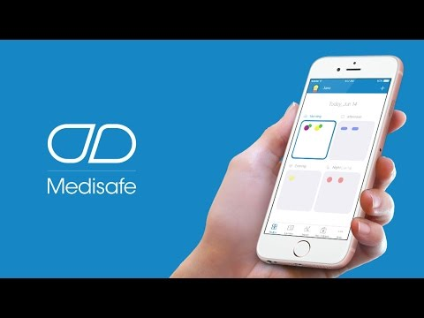
- Input prescribed medications, and dosage instructions, and set up reminders for timely doses (Chew et al, 2020).
- Alerts for potential drug interactions, ensuring safe treatment (Peng et al, 2020).
- Track key health metrics like blood pressure, blood sugar, and weight for chronic disease management (Peng et al, 2020).
- Share medication schedules with family or caregivers for added support (Peng et al, 2020).
- Reminders to refill prescriptions, preventing medication gaps (Chew et al, 2020).
Advantages of Medisafe:
- Improved Medication Adherence: By sending regular reminders, Medisafe helps ensure that users take their medications on time, which is critical for effective disease management (Chew et al, 2020).
- Ease of Use: The app's simple interface makes it accessible to users of all ages, including older adults who may not be tech-savvy (Peng et al, 2020).
- Data Sharing: The ability to share medication data with family or healthcare providers fosters better communication and support (Chew et al, 2020).
Disadvantages of Medisafe:
- Dependence on Technology: Some users, especially those who are not comfortable with smartphones, may struggle to use the app effectively (Peng et al, 2020).
- Limited Free Features: While Medisafe offers a free version, some features, like advanced tracking and reports, require a paid subscription (Faisal et al, 2021).
- Privacy Concerns: Storing personal health information on an app raises privacy and security concerns, especially if sensitive data is not adequately protected (Faisal et al, 2021).
Rectifying the Challenges: To address the challenges, Medisafe could improve its user onboarding process to make it easier for less tech-savvy individuals to set up and use the app (Peng et al, 2020). Additionally, enhancing the security protocols for data protection would help alleviate privacy concerns (Faisal et al, 2021). Medisafe can also consider offering more features in its free version to cater to a broader audience, especially those who cannot afford the premium subscription (Faisal et al, 2021).

References
Arefin, S., (2024). Chronic disease management through an ai-powered application. Journal of Service Science and Management, 17(4), pp.305-320.
Balaskas, A., Schueller, S.M., Cox, A.L. and Doherty, G., (2021). The functionality of mobile apps for anxiety: systematic search and analysis of engagement and tailoring features. JMIR mHealth and uHealth, 9(10), p.e26712.
Chen, T. and Lucock, M., (2022). The mental health of university students during the COVID-19 pandemic: An online survey in the UK. PloS one, 17(1), p.e0262562.
Chew, S., Lai, P.S.M. and Ng, C.J., (2020). Usability and utility of a mobile app to improve medication adherence among ambulatory care patients in Malaysia: qualitative study. JMIR mHealth and uHealth, 8(1), p.e15146.
Faisal, S., Ivo, J. and Patel, T., (2021). A review of features and characteristics of smart medication adherence products. Canadian Pharmacists Journal/Revue des Pharmaciens du Canada, 154(5), pp.312-323.
Heissel, A., Heinen, D., Brokmeier, L.L., Skarabis, N., Kangas, M., Vancampfort, D., Stubbs, B., Firth, J., Ward, P.B., Rosenbaum, S. and Hallgren, M., (2023). Exercise as medicine for depressive symptoms? A systematic review and meta-analysis with meta-regression. British journal of sports medicine, 57(16), pp.1049-1057.
NHS, (2024) https://www.england.nhs.uk/aac/what-we-do/how-can-the-aac-help-me/test-beds/long-term-conditions-early-intervention-programme/
Park, D.Y., Goering, E.M., Head, K.J. and Ellis, R.J.B., (2017). Implications for training on smartphone medication reminder app use by adults with chronic conditions: pilot study applying the technology acceptance model. JMIR formative research, 1(1), p.e8027.
Peng, Y., Wang, H., Fang, Q., Xie, L., Shu, L., Sun, W. and Liu, Q., (2020). Effectiveness of mobile applications on medication adherence in adults with chronic diseases: a systematic review and meta-analysis. Journal of managed care & specialty pharmacy, 26(4), pp.550-561.
Talactac, L.I.C., (2021). Evaluation of Mobile-Based Applications for Reactive Depression Secondary to Traumatic Brain Injury (Doctoral dissertation, Alliant International University).
Wintermeyer, S.A., (2021). Positive psychology apps: a systematic review of the quality and characteristics of a selection of current free-of-charge positive psychological apps aiming to enhance resilience available in the Google Play Store (Master's thesis, University of Twente).

