Healthy and Unhealthy Food and Snacks

1- A detailed lesson plan

Curriculum for Wales 2022

Lesson/Session Plan
Age: 4 to 5  Nursery age (in the day nursery). | No. of learners: 12 |  |  |  |  | ALN/Meeting learners’ needs:  Using picture cards, with children whose English is not their first language. This will help the children to gain understanding and support of what is happening in the lesson.  Link can be made to the Additional Learning Needs and Education Tribunal (Wales) ACT. The Act states that it is important that every individual Is treated with regards their needs and meets their needs (Welsh Government , 2018).
Additional Adults: 4 |  | Responsibilities of additional adults for this session: is to keep the children safe when walking to the local shop as well as supporting them throughout the lesson.
Learning objective(s):  - To understand about healthy and unhealthy foods and snacks.  - To develop the importance of physical activity  - To build in their knowledge where fruits grow or come from.  This can be linked to the ‘Well-being’ within the Foundation Phase (2015). As it provides the children with an opportunity to understand the importance of exercise like walking as well as ‘the right types of food and drink are important for healthy bodies’ (Welsh Government , 2015, p. 11). |  |  |  | Success criteria:  - Children should be able to gain an understanding between healthy and unhealthy foods and snacks.  - Discuss and demonstrate their understanding of why physical activity is important for their health.  - Children should be able to explain where the fruit that they are going use come from or where and grows.  Success criteria can be connected to the Health and Well-being within the Curriculum for Wales under developing physical health and well-being has lifelong benefits, description of learning (progression step 1). At the end of the lesson children should be able to ‘make connections between [their] diet and physical health’ (Curriculum for Wales, 2019, p. 1).
Links to previous learning:
Children were introduced to the Eatwell plate. In order to consolidate this knowledge, we are going to make our own healthy snacks.

Curriculum coverage (AoLE/Strand/Descriptions of learning)
- Well-being- learning about the importance of exercise like walking and eating healthy foods and snacks.
- Education for Sustainable Development and Global Citizenship- learning about where do bananas grow.
- Digital Competence – access, to the iPads to watch the video.
- Knowledge and Understanding of the World – developing awareness of healthy and unhealthy food and snacks. Where do the bananas and strawberries grow How to keep fit and healthy.
- Mathematical Development – counting and naming different shapes
- Physical development – developing an understanding on stay active by walking as well as using their fine motor skills.
- Welsh Language Development – counting, naming fruits in Welsh.
- Language, Literacy and Communication Skills – learning new vocabularies and also communicating with their friends while undertaking snap and pairs activity, which is about healthy and unhealthy foods and snacks.
All of the above areas of learning are essentials within both Foundation Phase Framework within the Welsh Government (2015) document as well as Curriculum for Wales (Welsh Government , 2019). Therefore, they had been used within the lesson plan.

Thinking Skills  At the beginning of the lesson children will be asked simple questions about whether they know where the fruit comes from. They will be questioned throughout the lesson and to make sure that they are involved in the lesson. |  |  | Literacy (LNF)  Children will be able to develop their communication skills by talking to their peers and teachers, they can be involved by asking questions from the teachers. Successfully undertaking and  being involved within the activity, as well as following the instructions, shows that children were listening and concentrating on what they have been asked to do.  The connection can be made to Mathematical Development within the (Welsh Government , 2015) curriculum. Where children can use maths through oral, counting and naming the shapes.  This can be connected to the Languages, Literacy and Communication within the Curriculum for Wales (2019, p. 1) under expressing ourselves through languages is key to communication description of learning (progression step 2) ‘I can speak clearly, varying expression and gestures to communicate my ideas’.
Numeracy (LNF)  Count how many pieces of fruit that have used in their fruit kebab. As well as naming different shapes that fruit is cut in to, therefore, they will be familiarised with different shapes. |  |  | Digital Competence (DCF)  Children will use an iPad to watch different stories with regards to the lesson.  Using an iPad can be linked to the Digital Competence Framework (DCF), (2018).
Y Cwricwlwm Cymreig (the Welsh Dimension)  Within this activity children will be introduced to the basic Welsh vocabularies as well as to the numbers from 1 to 10. They will be encouraged to count in Welsh such as, 1 – un, 2 – dau, 3 – tri, 4 – pedwar, 5 – pump, 6 – chwech, 7 – saith, 8 – wyth, 9 – naw, 10 – deg. As well as naming the fruit and shapes in Welsh for example, mefus is strawberry and banana is banana.  Here, a link can be made to Welsh Language Development within the Foundation Phase Framework (Welsh Government , 2015) document. Where children can learn new vocabularies as well as counting in Welsh. |  |  | Global Dimension  The discussion can be drawn to where does the fruit that we are going to use for the fruit kebab come from, where does it grow. Asking the children if they know where a banana grows? And having a discussion that bananas grow in the tropical regions like India, China, Africa as well as from south and central America. Bananas are mostly grown in the hot countries around the world.  This can also be linked to the Knowledge and Understanding of the World within the (Welsh Assenbly Government, 2008) document. The connection is made by talking about the bananas that they do not grown in the UK, and we get them from other countries around the world.  Global Dimension can be linked to Education for Sustainable Development and Global Citizenship Welsh Assembly Government (ESDGC), (2008).

Time | Session activities, organisation, and management | Assessment for Learning (strategies and opportunities)
 | Introduction
Explaining that we are going to learn about healthy and unhealthy food and snacks as well as walking to the local shop to buy the ingredients to make a healthy snack, fruit kebab.

Involve the children by asking them whether it is going to be a good idea to walk to the local shop and buy the ingredients needed for the fruit kebab and, how walking is one of the good activities which help our body to stay healthy. Also, ask the children if they know anything about healthy and unhealthy food and snack.

Ask the children how many pieces of fruit and vegetable should they eat a day? Read the children the story “I Can Eat a Rainbow” by Olena Rose.
- Do you feel safe and confident walking to the local shop?
- Do you know how many pieces of fruits and vegetables should you eat every day?
- Can you identify which foods and snacks are healthy and unhealthy?
- Using varieties of questions throughout the lesson?
- In order to check children’s understating at the end of the lesson thumbs up and thumbs down strategy will be used.
- Questioning and verbal feedback.

 |  |  | Assessment for learning is considered one of the best strategies in which is the ‘process of identifying what the learner has or has not achieved in order for teachers to plan the next steps in the teaching or learning’ (Elmwood Infant School, 2019, p. 1).
 | Main activities |  | Resources and Key Vocabulary
 | (Physical activity by walking), taking children to local shop – 25 minutes  - Let the children know that we are going to the local shop when they enter to the classroom, and they need to keep their shoes and coats on. Together write a list of what we need to get from the shop, bananas, strawberries and kebab sticks.  - Ask the children to line up and hold-a-ring on the walking rope to go to the local shop and buy the ingredients for the fruit kebab that we are going to make. Start walking to the shop, on the way to the shop talk to the children if they know where does the fruit that we are going to buy comes from? Whether they grow in hot or cold countries?  Here, the link can be made to Physical Development (2008), as children will use their gross motor skills by walking to the local shop.  - Also, talk to the children about the importance of walking and exercise for our bodies, and how by walking we can stay healthy.  - Once we are at the shop, we will ask the children to help us in finding the ingredients and resources that we need to get.  Book reading - 10 minutes  - Once we are back from the shop two teachers will stay with the children, while the other two staff prepare the ingredients to make fruit kebab. Children will be asked to sit down on the floor and a teacher will read the story of “I Can Eat a Rainbow”, and the other teacher will help to involve the children within the story. Through reading this book children will be able to identify healthy and unhealthy food and snacks that they should and should not eat.  - Children will also have a chance to explore more stories with regards to healthy and unhealthy food/snacks in reading area.  Making the fruit kebabs- 10 minutes  - pre-cut the fruits in different shapes using the small shapes cutters.  Children will use their fine motor skills by pushing the fruit onto the stick, therefore, the link can be made to Physical Development (2008).  - Children will be asked to sit around the table, while the staff member explains to them, they have to be careful when using the kebab sticks and that they should not poke their friends with the stick. Ask the children to push the bananas and strawberries onto the stick carefully, also support will be given to the children who cannot push the fruit into the stick. Once they finish ask them to count in both English and Welsh.  - While they are making their fruit kebab a staff member will be getting the Snap and pairs activity ready and once, they are finished a staff member will take them to undertake the other activity.  Healthy and unhealthy food and snacks (Snap and pairs activity) - 10 minutes  - Split the children into two groups and ask them to sit around the table. Children will be given 14 cards per group, and they will be asked to figure out which foods, snacks and drinks are healthy and unhealthy. Also, identifying which country are the foods/snacks from?  This can be linked to the ‘Knowledge and Understating of the World’ within the foundation phase 2008. As children will be able to learn and differentiate between healthy and unhealthy foods/snacks.  - Additional information will be provided on the resources part, an iPad will be used to watch a story online, which will help and support the children to undertake this activity. The video identifies varieties of foods and snacks which are heathy as well as unhealthy. |  | Key vocabulary
- Healthy food/snacks
- Unhealthy food/snacks
- Fruit kebab
- Bananas
- Strawberries
- Being careful

Resources
- Books
- Healthy and unhealthy food and snacks cards
- Small shapes cutter
- Kebab sticks
- Pen/paper
- iPads
- Hold-a-ring walking rope
 |  |  | Reading a story will enable the children to learn varieties of vocabularies.
 | Plenary- 5 minutes
Children will be asked to explain what they have learned throughout the lesson, with regards to healthy and unhealthy food, how walking is good for their body. Then, after they explain, the teacher will ask them questions.

It is important to consider the plenary within the lesson plan as it supports both the teachers and pupils to ‘identify and clarify what has been learned, often by referring back to the lesson objectives, in order to help then to plan for successive learning and teaching that builds on the learning [that] has taken place’ (Department for Education, 2004, p. 5).

2- Resources
Snap and pairs activity
Lesson objectives
- Encourage children to think about healthy and unhealthy food and snacks
- Children will gain the knowledge and understanding of healthy food and snacks
- Encourage children to work together by each of them have a portion of cards with them and laying the cards until they find the matching cards
- Improve children’s communication as well as social skills
- To encourage the children to take turns.
Equipment
- Link to the YouTube video of a story of healthy and unhealthy food, this will support the children with an understating as well as prepare them to undertake the activity
- Two sets of 14 cards of healthy and unhealthy foods, snacks and drinks
- iPad to watch the story
- YouTube link of healthy and unhealthy food story: https://youtube.com/watch?v=SBPcTpHBWTs&feature=share (Hazim, 2021, p. 1).

Activity plan
The preparation by the teachers for this activity:
- Put the children into two groups 6 members in each group
- Place the 14 cards of healthy and unhealthy foods, snacks and drinks on the table for each of the group
- Put the story on the iPads ready for the children to watch when they are ready

The activity includes:
Healthy and unhealthy food, snacks and drinks
Healthy
- Water
- Corns
- Natural yogurt
- Apples
- Veggie stick and hummus
- Plate of colourful fruit
- Veggie toast
Unhealthy
- Chocolate
- Fizzy drinks
- Different types of candys
- Pizza
- Beef burger
- Chips
- Chicken nuggets

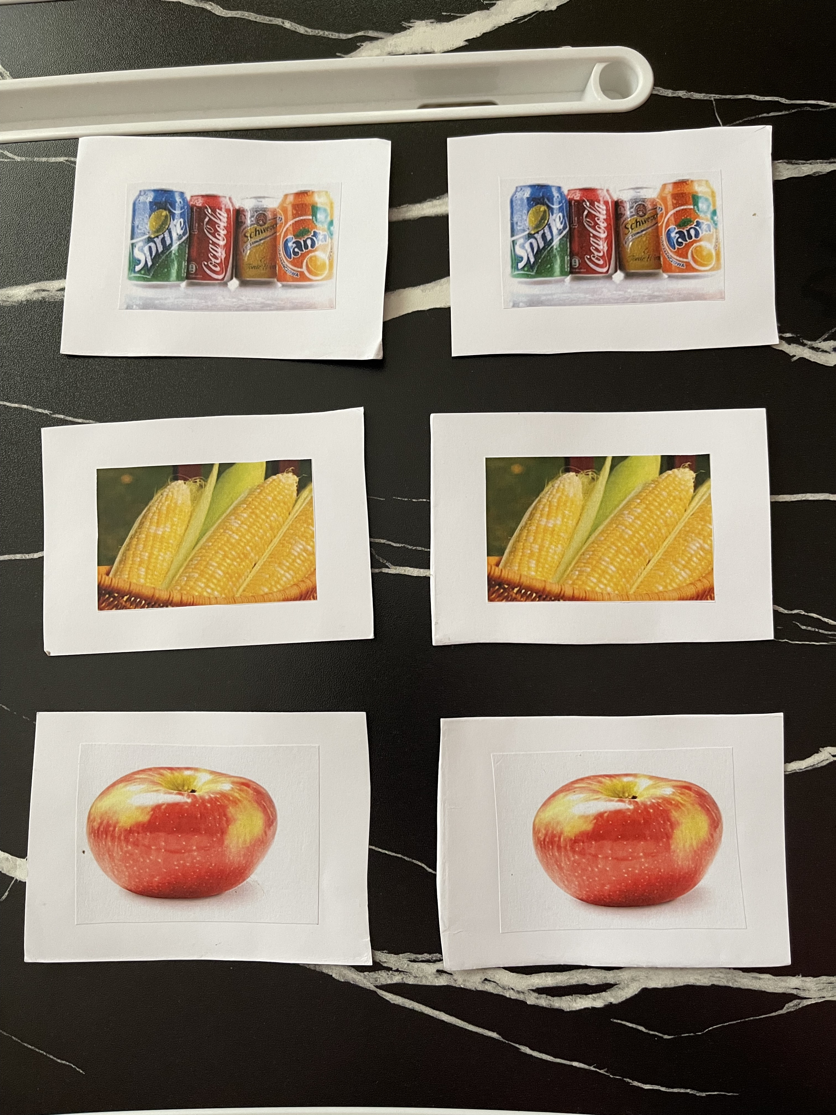
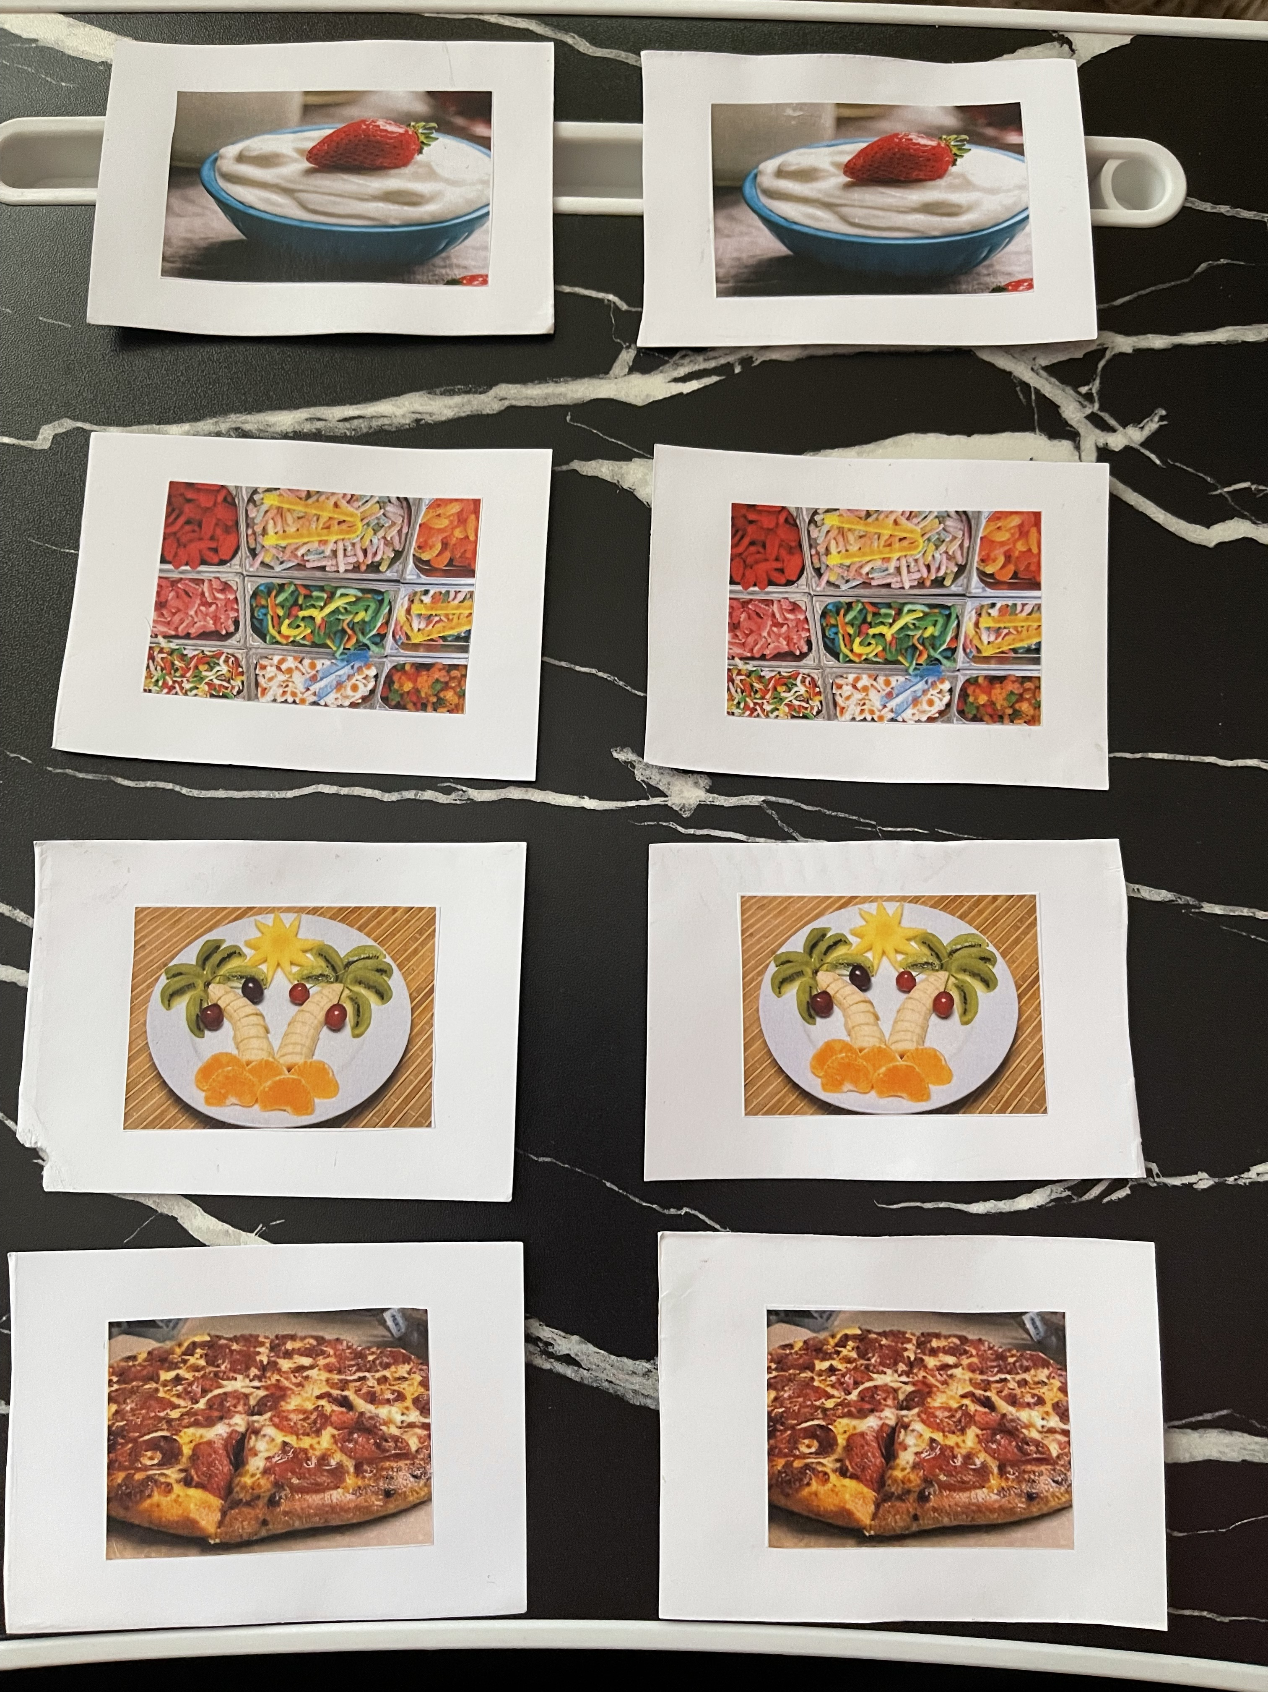
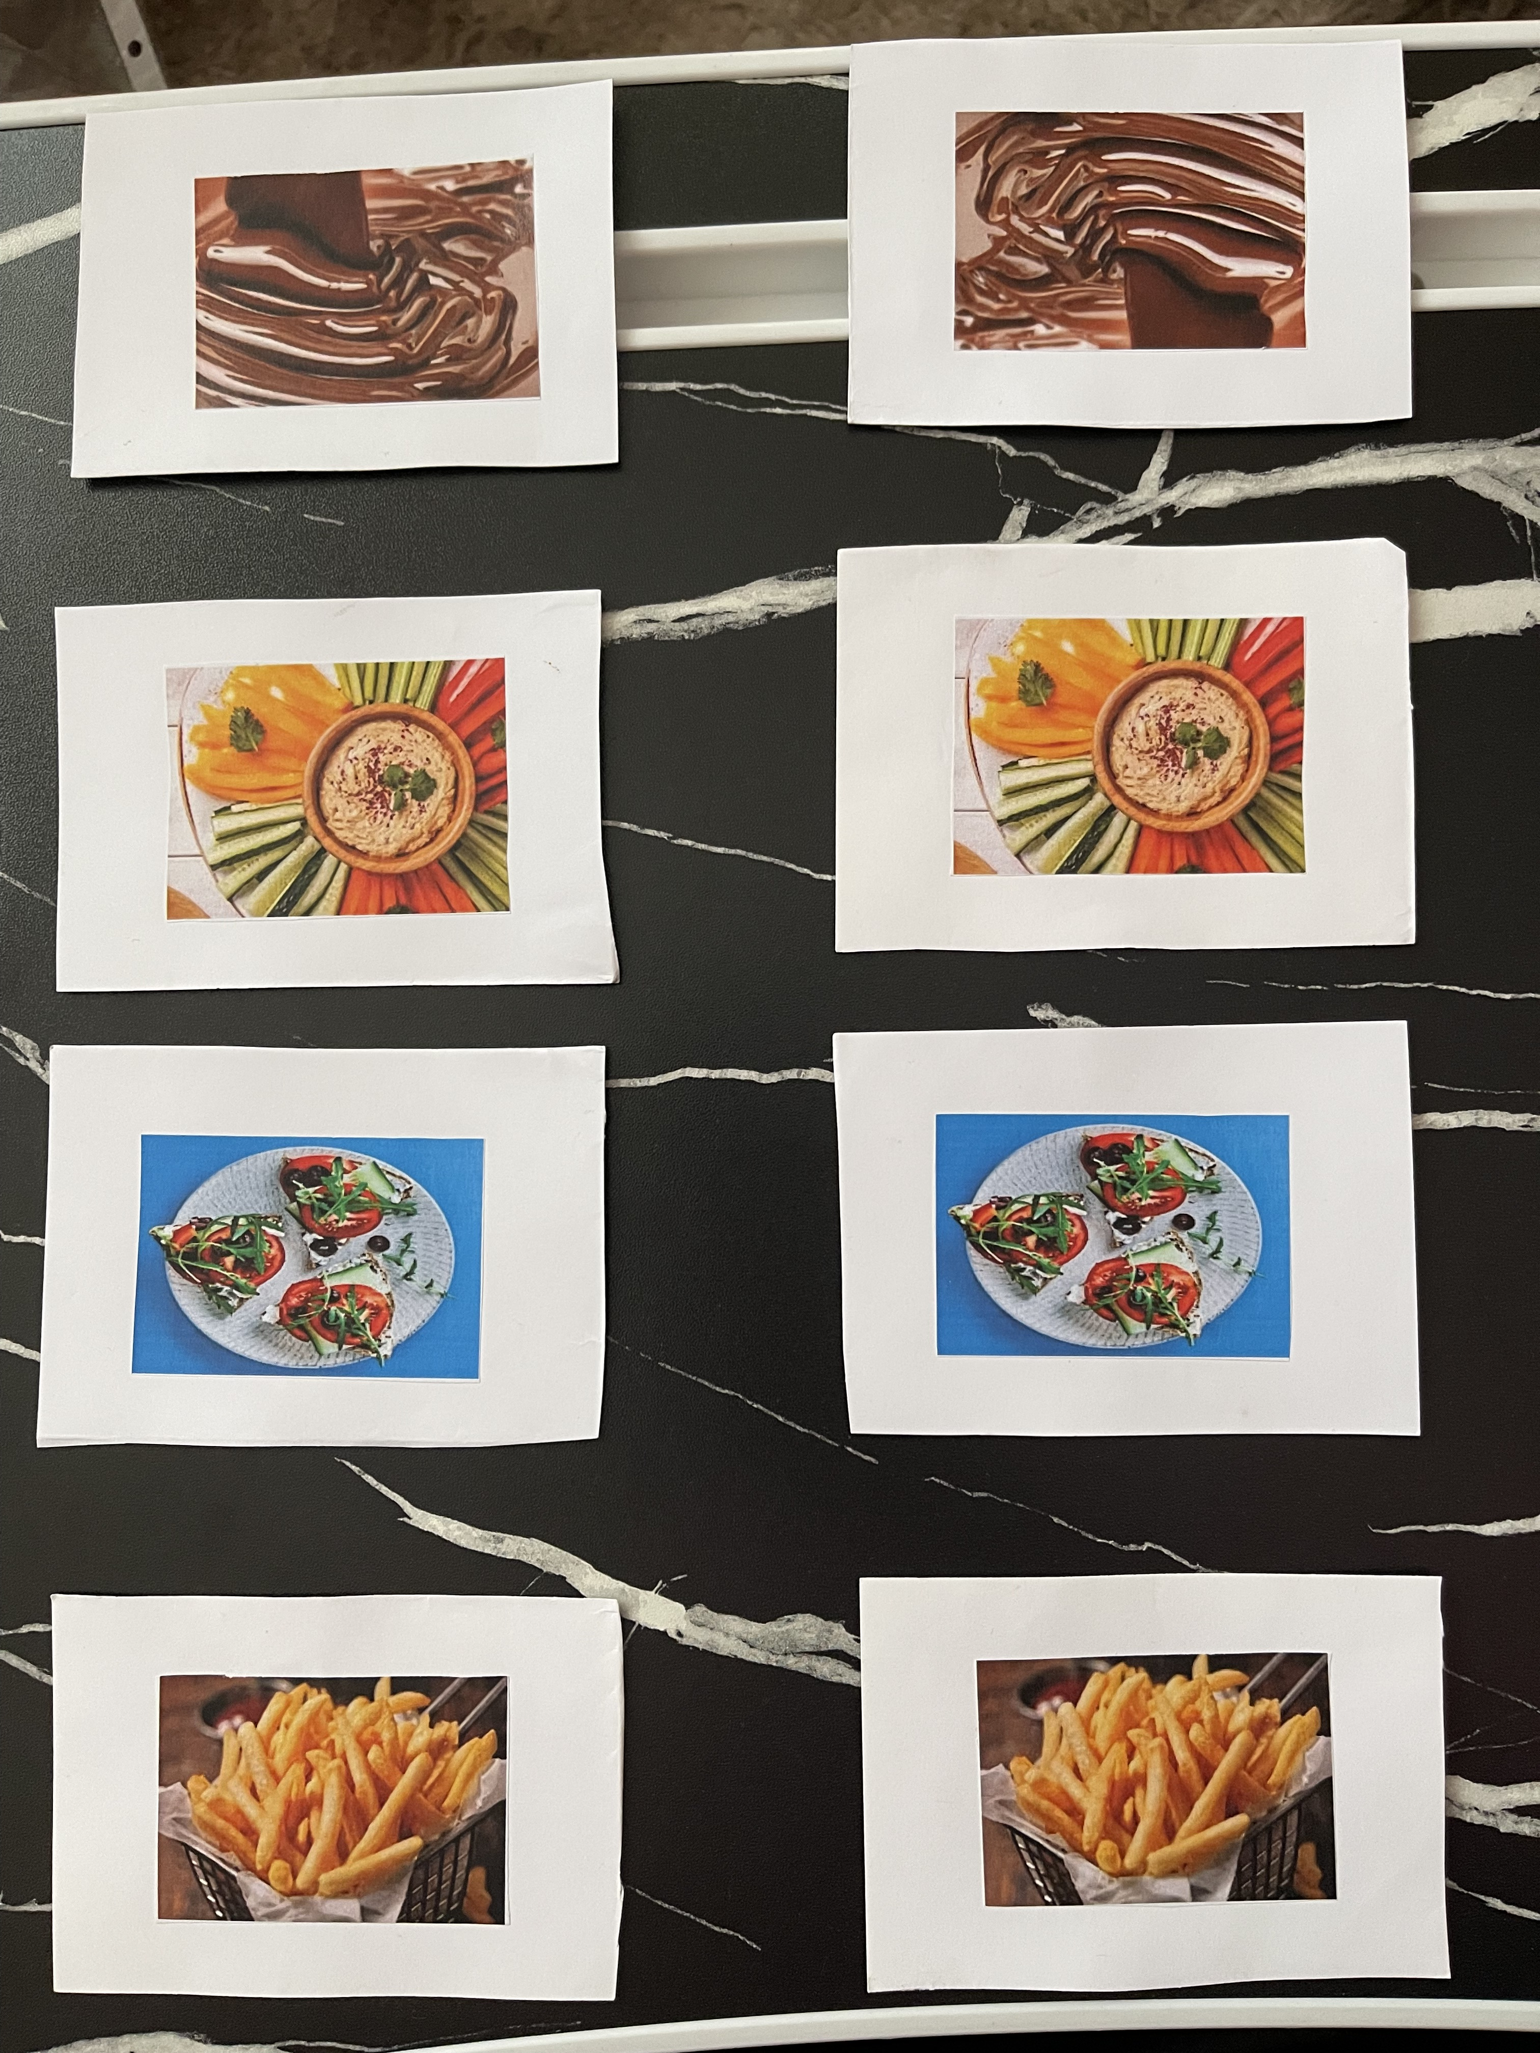
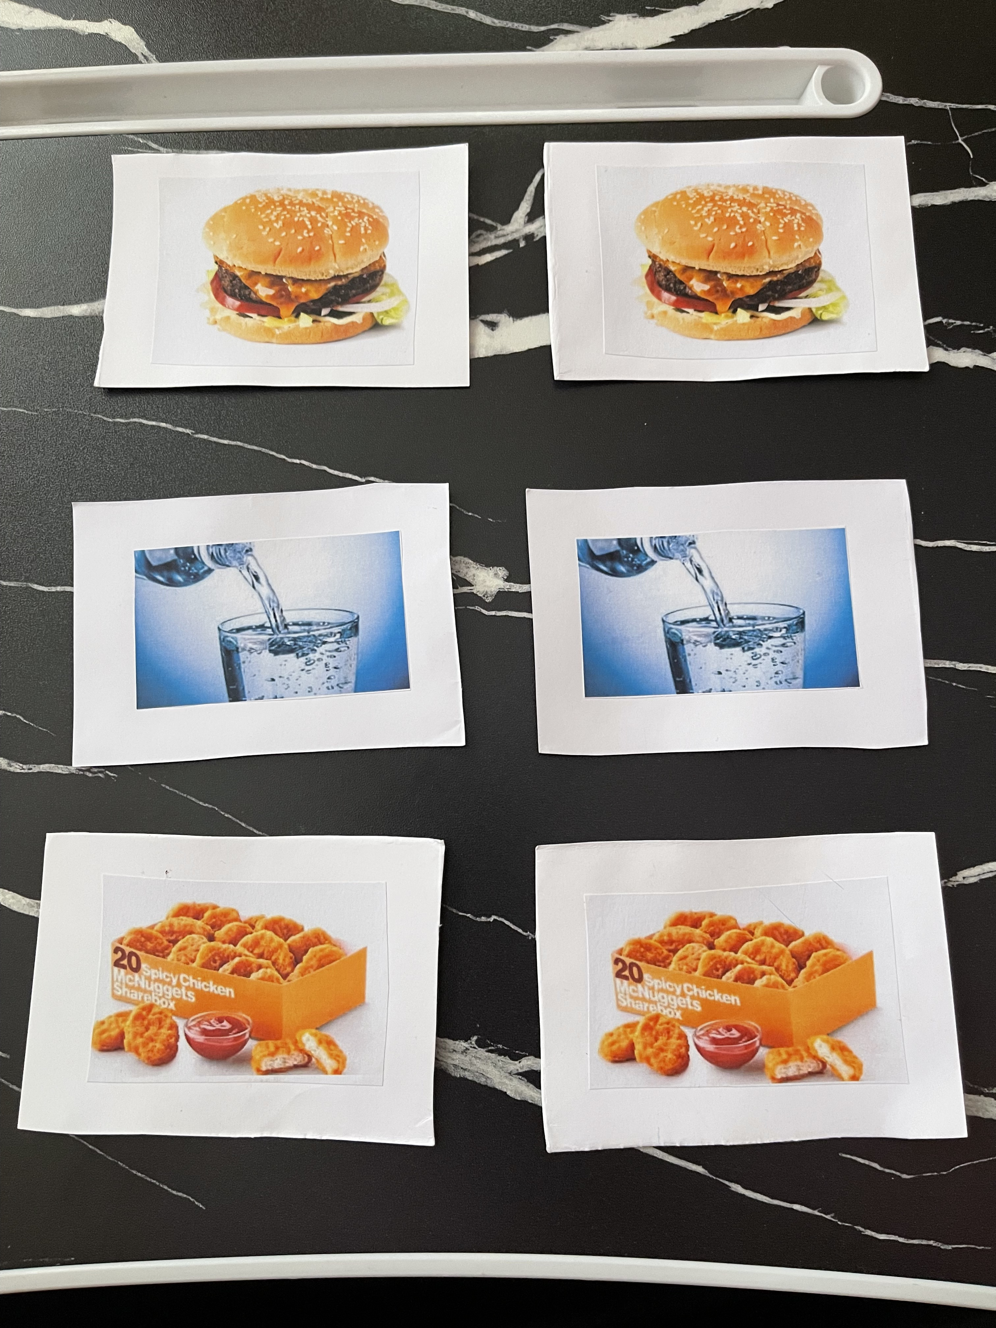
3. Rationale for plan and resource

The main aim of the following account is to explain and justify the lesson plan and resource within the lesson plan. With regards to justification a reference is made to Bloom’s Taxonomy theory (1956) where he made a reference to the foundation of lesson planning (Leonard, 2002). The justification will also link to the professional best practice within the lesson plan.
To begin, the rational for choosing this particular topic is that research shows that almost 1 in 5 children in the UK are overweight or obese by the time they go to primary settings (McMurray, 2020). The lesson plan is aiming at promoting physical activity and healthy eating for children aged 4-5 years old at a nursery setting. The link will be made to the Foundation Phase Framework, Curriculum for Wales as well as theory of the best practice. Firstly, a lesson plan is defined ‘as a source or tool that guides teachers through their working learning process’ (Trigueros, 2015, p. 1).

The first activity of the lesson plan involves a physical activity by walking to the local shop, this can be linked to both the Foundation Phase Framework within Welsh Goverment (2015) as well as Curriculum For Wales (2019). By walking to the local shop children are able to ‘develop gross motor skills’ (Welsh Government, 2015, p. 44). Research shows that physical activity has many positive benefits on children’s health and wellbeing and according to Archer (2014, p. 2) physical activity helps and improves children’s ‘self-esteem and psychological well-being, and reduces stress, anxiety and depression’.

Digital competence as one of the main features of the lesson plan is highlighted to be important. According to Welsh Government (2018, p. 5) DCF is fundamentally important, and therefore, all educational settings should provide ‘learners with high-level digital skills to ensure [that] young people are digitally competent, and evolve into enterprising, creative and critical thinkers’. Therefore, DCF is used within the lesson planning for the children which enables the children to use the iPad to watch videos to support them to complete the snap and pairs activity. Research by Agir (2015 , p. 176) shows that using digital devices like ipads and computers ‘in lessons increase [learners] motivation and their willingness to participate in class, and such tools help them to learn more effectively’. However, research has indicated that many learners uses digital devices and that they ‘can become unnecessary distractions in the classroom’ (Shirley, 2018, p. 117). Therefore, research highlights that rather than learners spending time on screen or using digital devices, they should socilase and take part in daily physical activties as ‘technology use is associated with increased risk of obesity in children’ and also it resulted in ‘decreased physical activity’ (Alotaibi, et al., 2020, p. 489). On the other hand, Sadik (cited in Shirley, 2018, p. 122) points out that ‘teachers should look at the use of iPads as a improvement and learning experience’ and how it enhances learners learning as well as the impact that technology will have in their future as digital competency.

It is important to consider that it was following the Formative Assessment review by Black and Wiliam (1998) Assessment for Learning (AfL) has been embedded in educational settings (Black, et al., 2004). AfL is defined as ‘the process of seeking and interpreting evidence for use by learners and their teachers to decide where the learners are in their learning, where they need to go and how best to get there’ (Asessment Reform Group 1999 citted in Frederickson & Cline, 2015, p. 178). It is clear here, that the information is very important for both the teachers as well as learners as it ‘provides information about the learning process that teachers can use for instructional decisions and students can use in improving their performance’ (Wiliam, 2011, p. 8). Therefore, it identifies ‘the current or actual level of development of the learner and the next level’ through Vygotsky's zone of proximal development (ZPD) (Shabani, et al., 2010, p. 238). This provides the teacher with the information to meets the learners’ needs. At the same time the ‘learners progress, they can take on more responsibility for their own learning and self-assessment’ (Ceri, 2008, p. 21).

AfL is considered within the planning to be able to effectively plan different activities and with a set of questions which meets the learners needs. The oral feedback will provided for the children and this allows the teachers to have good knowledge and understanding of the individual learning, the way which they can improve and ‘not just on their mistakes, also contributes to the development of autonomous thinking and learning’ (Flórez & Sammons, 2013, p. 6). However, according to Browne (2016, p. 10) AfL ‘does not appear to be working’ all the time. One of the reasons behind this might be that the teachers do not provide clear and effective feedbacks to the learners.

Research shows that during reading storybooks to children they will ‘learn to recognise letters’ and ‘being aware of sounds, children also need to recognise the role that alphabet letters play and that letters have different sounds’ (Duursma, et al., 2008, p. 554). It also widens children’s vocabularies and helps them to develop their thinking and imaginations skills (Government of South Australia, 2020). Therefore, it is important to mention that by reading stories to or with children, they develop knowledge and understanding of not only new vocabularies but also learn how to be patient and listen to the story until it finishes (Koralek, 2022).

One of the other important features of the planning is Additional Learning Needs (ALN) /Meeting learners’ needs. According to Welsh Government (2021, p. 28) people with ALN have ‘learning difficulty or disability (whether the learning difficulty or disability arises from a medical condition or otherwise)’. This fits into the best practice because in the nursery there are few children who cannot speak or have the understanding of the English language. Therefore, picture cards are used to explain to the children what they going to do and what is happening. However, what is extremely important is that every child must be included and valued as well as ‘treated equitably regardless of the severity of their need’ (Welsh Government, 2018, p. 100).

Cross-curricular links are considered another essential part of the plan, Digital Competence, Literacy as well as Numeracy are mandatory within Curriculum for Wales. ‘It will be the responsibility of all practitioners, across all curriculum areas, to develop and ensure progression in these skills’ (Welsh Government , 2019, p. 1). On the other hand, Welsh educationalists were very disappointed with the results of PISA test from 2018 as Wales did not do well with the core subject, for instance, the ‘average PISA reading score for Wales in 2018 was 483. This has remained stable since 2006 (481)’ (Welsh Government , 2019, p. 2). Therefore, it vitally important to highlight Literacy and Numeracy within the planning in order to improve their outcomes.

Furthermore, working in a group is identified to be very beneficial as by working collaboratively, every individual will be able to support, learn from each other and share new ideas (Burke, 2011). As the part of the planning, one of the activities is required for the children to work together to identify healthy and unhealthy foods and snacks. This will allow the children to communicate, exchange ideas, learn from each other and solve any problems (Chiriac, 2014). However, there are a number of negative effects of working in a group including ‘insufﬁcient communication, unclear roles, and problems with one group member’ (Chiriac, 2014, p. 6).

To conclude, this account has successfully explained and justified the lesson plan and resources. The links have been made to Bloom’s Taxonomy theory (1956) and to the Foundation Phase Framework, Curriculum for Wales, Assessment for Learning and to the professional best practice within the lesson plan. It has also explored different features of the lesson plans.

References

Agir, A., 2015 . iPad at School: A Holistic Evaluation of the Opinions of Students, Teachers and Parents Concerning iPad Usage. International Journal of Education, 7(3), pp. 175-193.
Alotaibi, T. et al., 2020. The Relationship between Technology Use and Physical Activity among Typically-Developing Children. Healthcare (Basel), 8(4), pp. 488-494.
Archer, T., 2014. Health Benefits of Physical Exercise for Children and Adolescents. Journal of Novel Physiotherapies, 4(2), pp. 1-4.
Black, P. et al., 2004. Working inside the Black Box: Assessment for Learning in the Classroom. Phi Delta Kappan, 86(1), pp. 2-94.
Browne, E., 2016. Evidence on formative classroom assessment for learning, Brighton: UK: Institute of Development Studies.
Burke, A., 2011. Group Work: How to Use Groups Effectively. The Journal of Effective Teaching, 11(2), pp. 87-95.
Ceri, 2008. Assessment for Learning Formative Assessment. [Online]
Available at: https://www.oecd.org/site/educeri21st/40600533.pdf
[Accessed 21 January 2023].
Chiriac, E. H., 2014. Group work as an incentive for learning – students’ experiences of group work. Frontiers in Psychology, 5(558), pp. 1-10.
Curriculum for Wales, 2019. AREA OF LEARNING AND EXPERIENCE Health and Well-being. [Online]
Available at: https://hwb.gov.wales/curriculum-for-wales/health-and-well-being/descriptions-of-learning/
[Accessed 21 January 2023].
Curriculum For Wales, 2019. AREA OF LEARNING AND EXPERIENCE: Health and Well-being. [Online]
Available at: https://hwb.gov.wales/curriculum-for-wales/health-and-well-being/descriptions-of-learning/
[Accessed 21 January 2023 ].
Curriculum for Wales, 2019. AREA OF LEARNING AND EXPERIENCE: Languages, Literacy and Communication. [Online]
Available at: https://hwb.gov.wales/curriculum-for-wales/languages-literacy-and-communication/descriptions-of-learning/
[Accessed 12 January 2023].
Department for Education, 2004. Supporting ITT providers: the effective use of plenaries. [Online]
Available at: https://dera.ioe.ac.uk/7555/1/nso/pdf/97316e2ce1d4226cd555caf75f280cb6.pdf
[Accessed 19 January 2023].
Digital Competence Framework (DCF), 2018. Digital Competence Framework: Your questions answered. [Online]
Available at: https://hwb.gov.wales/api/storage/85f69bca-0134-426d-bff1-c46b4c1d067b/digital-competence-framework-your-
[Accessed 18 January 2023].
Donaldson, G., 2015. Successful Futures Independent Review of Curriculum and Assessment Arrangements in Wales. [Online]
Available at: https://www.gov.wales/sites/default/files/publications/2018-03/successful-futures.pdf
[Accessed 18 January 2023].
Duursma, E., Augustyn, M. & Zuckerman, B., 2008. Reading aloud to children: The evidence. Archives of Disease in Childhood , 93(7), pp. 554-557.
Elmwood Infant School, 2019. Assessment for Learning Policy. [Online]
Available at: https://www.elmwood-inf.croydon.sch.uk/wp-content/uploads/AFL-policy-Jan-2019-revised-FINAL.pdf
[Accessed 21 January 2023].
Flórez, M. T. & Sammons, P., 2013. Assessment for learning: effects and impact. [Online]
Available at: https://www.educationdevelopmenttrust.com/EducationDevelopmentTrust/files/5a/5a6d6203-ec49-4d33-9c5d-42c188184807.pdf
[Accessed 21 January 2023].
Frederickson, N. & Cline, T., 2015. Special Educational Needs, Inclusion and Diversity. 3 ed. Berkshire: Open University Press .
Government of South Australia, 2020. Why stories are important. [Online]
Available at: https://parenting.sa.gov.au/pegs/PEG57-Why-stories-are-important.pdf
[Accessed 21 January 2023].
Hazim, C., 2021. Healthy and unhealthy food story. [Online]
Available at: https://www.youtube.com/watch?v=SBPcTpHBWTs
[Accessed 21 January 2023].
Koralek, D., 2022. Reading Aloud with Children of All Ages. [Online]
Available at: https://www.rif.org/sites/default/files/images/2022/06/14/Support_Materials/ReadingAloud.pdf
[Accessed 21 January 2023 ].
Leonard, D. C., 2002. Learning Throries A to Z. Westport : Greenwood Press.
McMurray, S., 2020. Physical Activity and the Wellbeing of Children and Young People. [Online]
Available at: http://www.niassembly.gov.uk/globalassets/documents/raise/publications/2017-2022/2021/education/4021.pdf
[Accessed 21 January 2023].
Physical Development, 2008 . Physical Development. [Online]
Available at: https://hwb.gov.wales/storage/9b5ebf42-d636-4232-9452-e186c21b7eae/physical-development.pdf
[Accessed 18 January 2023].
Shabani, K., Khatib, M. & Ebadi, S., 2010. Vygotsky's Zone of Proximal Development: Instructional Implications and Teachers' Professional Development. English Language Teaching, 3(4), pp. 237-248.
Shirley, Y., 2018. Ipads versus Books. Creative Education, Volume 9, pp. 115-139.
Trigueros, R., 2015. LESSON PLAN LESSON PLAN. English Language Teaching, pp. 1-31.
Welsh Assembly Government , 2008. Education for Sustainable Development and Global Citizenship: A Common Understanding for Schools. [Online]
Available at: https://hwb.gov.wales/storage/eaf467e6-30fe-45c9-93ef-cb30f31f1c90/common-understanding-for-school.pdf
[Accessed 21 January 2023].
Welsh Assenbly Government, 2008. Knowledge and Understanding of the World. [Online]
Available at: https://www.gov.wales/sites/default/files/publications/2018-02/knowledge-and-understandin-of-the-world.pdf
[Accessed 20 January 2023].
Welsh Government , 2015. Foundation Phase Framework. [Online]
Available at: https://hwb.gov.wales/storage/d5d8e39c-b534-40cb-a3f5-7e2e126d8077/foundation-phase-framework.pdf
[Accessed 18 January 2023].
Welsh Government , 2018. ADDITIONAL LEARNING NEEDS AND EDUCATION TRIBUNAL (WALES) ACT. [Online]
Available at: https://www.gov.wales/sites/default/files/publications/2018-02/additional-learning-needs-and-education-tribunal-wales-act-2018-explanatory-memorandum.pdf
[Accessed 21 January 2023].
Welsh Government , 2018. Digital Competence Framework Your questions answered. [Online]
Available at: https://hwb.gov.wales/storage/85f69bca-0134-426d-bff1-c46b4c1d067b/digital-competence-framework-your
[Accessed 21 January 2023].
Welsh Government , 2019. Achievement of 15 year olds (Program for International Student Assessment) PISA national report: 2018. [Online]
Available at: https://www.gov.wales/achievement-15-year-olds-program-international-student-assessment-pisa-national-report-2018
[Accessed 21 January 2023].
Welsh Government , 2019. Cross-curricular skills frameworks. [Online]
Available at: https://hwb.gov.wales/curriculum-for-wales/cross-curricular-skills-frameworks
[Accessed 21 January 2023].
Welsh Government , 2021. The Additional Learning Needs Code for Wales 2021. [Online]
Available at: https://www.gov.wales/sites/default/files/publications/2021-03/the-additional-learning-needs-code-for-wales-2021.pdf
[Accessed 21 January 2023].
Welsh Government, 2015. Foundation Phase Framework. [Online]
Available at: https://hwb.gov.wales/storage/d5d8e39c-b534-40cb-a3f5-7e2e126d8077/foundation-phase-framework.pdf
[Accessed 21 January 2023].
Welsh Government, 2018. ADDITIONAL LEARNING NEEDS AND EDUCATION TRIBUNAL (WALES) ACT. [Online]
Available at: https://www.gov.wales/sites/default/files/publications/2018-04/additional-learning-needs-and-education-tribunal-wales-act-2018-explanatory-memorandum.pdf
[Accessed 21 January 2023].
Wiliam, D., 2011. What is assessment for learning?. Studies in Educational Evaluation, Volume 37, pp. 3-14.

