OVERVIEW OF VIRTUAL LEARNING ENVIRONMENT
Name: Maria Grigoran
Student id: – 1915295
Professor: Fernando Suneeth
Table of content.
Introduction………………………………………………………………….3
Overview……………………………………………………………………..3
Aims and objectives …………………………………………………………4
Background and research……………………………………………..5 to 19
Discussion…………………………………………………………………..20
Conclusion……………………………………………………………20 to 21
References…………………………………………………………………..21

Introduction
The Virtual Learning Environment refers to a precise context that helps to understand a proper learning environment that represents a web-based platform which is not only helpful for giving an effective external extension of the library but also an authoring environment. The study will encompass the primary purpose and the necessity of implementing Virtual Learning Environment in the UK institutions.

Overview of the Virtual Learning Environment
What is the Virtual Learning Environment?
Virtual learning environment can be considered as a design space that helps in improving the learning and teaching environment for the students. In the context of the United Kingdom the use and application of VLE can be found with greater importance.
When This Concept was introduced?
The concept of VLE has hit the educational system of the United Kingdom in the second half of the 1990s (Azevedo and Gašević, 2019). Initially maximum educational platforms have become web based and taken over by VLE, though these take ups have not become universal.
Who is Using This Technology?
Virtual Learning Environment has been found with immense popularity in the educational context of the United Kingdom. Students across the country and 80% colleges have made their active intervention in adopting the Virtual Learning Environment (UK Higher Education Institutions income 2017 | Statista, 2020). Most educational institutions in the UK and Turkey have adopted VLE for higher studies.
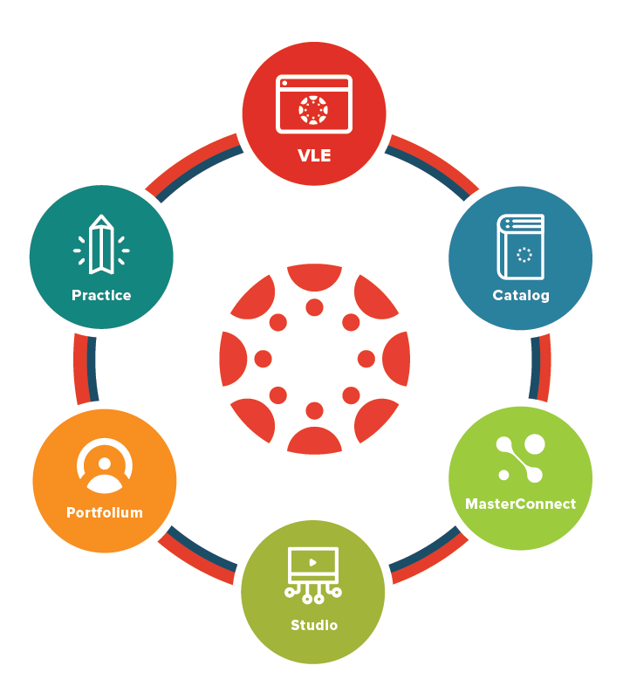
Figure 1: VLE Canvas
(Source: Bogusevschi et al. 2020)
Why is it important to research this topic?
The research process will be developed based on the importance of VLE in the educational context of the UK. By aligning with technological advancement, it becomes necessary to improve the educational infrastructure for the future betterment of the students. It not only makes the educational process flexible but also makes it simpler.

Aims and Objectives
The primary aim of the study is to introduce the significance of VLE in front of the UK students. The new phenomenon in education can be brought with the incarnation of VLE and it empowers and encourages the students to have digital support from the extension of their educational library.
Several objectives can be illustrated here in order to contemplate with the research. The following objectives are as follows,
- To identify the importance of VLE for improving the educational performance of the students
- To enhance the educational opportunities for the students
- To assist the teachers and students by giving digital platform for occupying effective knowledge and information
- To illustrate several risk factors that may take place while implementing Virtual Learning Environment in the educational platform
- To recognize effective strategies to deal with uncertainties

Research Questions
Apart from the primary aim and objectives of the research there are several research questions that need to be illustrated here in order to bring transparency in the chosen theme. The research questions are,
- What is the significance of VLE in the educational platform of UK institutions?
- How VLE could influence the services?
- How the use of VLE could be helpful for the advanced teaching method?
- Which risk factors may take place in the institutions after the implication of VLE?
- What can be the effective strategies for dealing with such uncertainties?

Background
Literature Review
Different services that are given by VLE
According to Bogusevschi et al. (2020), Virtual Learning Environment consists of several services such as planning lessons, managing the administrative works, tracking individual performance of the students, maintaining activity logs, improving the level of engagement and providing additional materials through digital platforms to the students for supporting their educational journey. These services are being provided by VLE to improve the educational functions and working procedures of the teachers in the institutions.
Different Benefits that are being derived by Students and Teachers
Different benefits can be gathered after the implementation of VLE in gathering academic success by developing positive teacher and student relationships and avoiding behaviour problems. According to Pererva et al. (2020), with the help of VLE, teachers could easily plan the lessons for the students that help the students to practice the lessons and could easily increase grades.
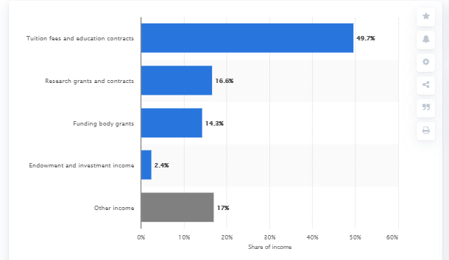
Figure 2: Distribution of Higher Education Institutions' income in UK
(Source: UK Higher Education Institutions income 2017 | Statista, 2020)
Challenges that are being faced by the teachers and the students
As stated by Hassan et al. (2019), several challenges may take place while implementing VLE within the educational context. It becomes troublesome to adopt new technologies for the students and the teachers too. Lack of knowledge in handling digital devices and libraries can create hassle for the teachers.
Technologies required for VLE
Different technologies are necessary for VLE such as assistive technologies, multimedia and presentation technologies along with social networking tools.
Legislation associated with the implementation of VLE and Future Opportunity
In order to implement the Virtual Learning Environment, it would be necessary for the educational institutions to incorporate Online Educational Regulations that ensure learner's authentication while conducting online process of gathering information. It conjures up an effective artificial environment which can easily replace the contemporary and traditional method of teaching. Thus, it would help the institutional authorities to gain future possibilities by VLE.
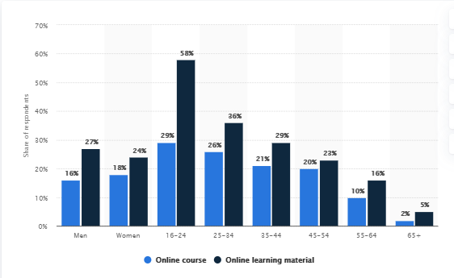
Figure 3: Share of Individuals in Online Learning Material
(Source: Online learning in Great Britain 2019 | Statista, 2020)

Research Method
Research Approach
As per the chosen theme it can be illustrated that the researcher would use Inductive Research approach in order to generate generalized knowledge based on specific information.
Research Design
Similarly, the use of research design will be appropriate in this research context. Based on the chosen theme it can be stated that the qualitative descriptive research design will be used.
Data Collection Method
Collection of data is equally important for completing any research therefore the researcher would use both primary and secondary data collection methods. Different articles and journals will be used for collecting secondary data.
Data Analysis Method
For analysing data, quantitative and qualitative both data analysis methods will be used by the researcher.
Sampling
During Pandemic it might be difficult to collect data by conducting surveys by visiting places (Almarzooq et al. 2020). Therefore, nonprobability sampling will be used that will assist in conducting phonetic interviews.
Based on personal questionnaire, we can conclude that students can have different approach to the virtual learning environment, and the application in field of certain aspects of VLE.
Based on 12 questions, the respondents had different points of view regarding virtual learning.
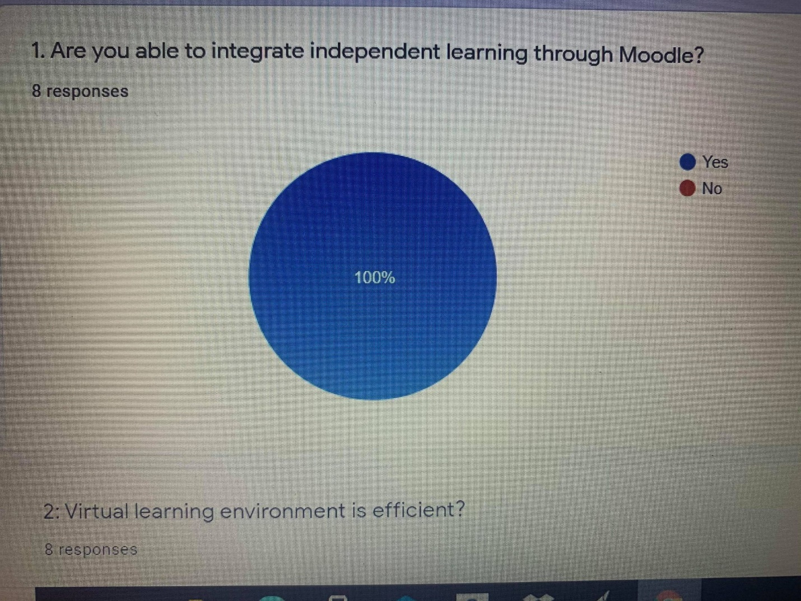

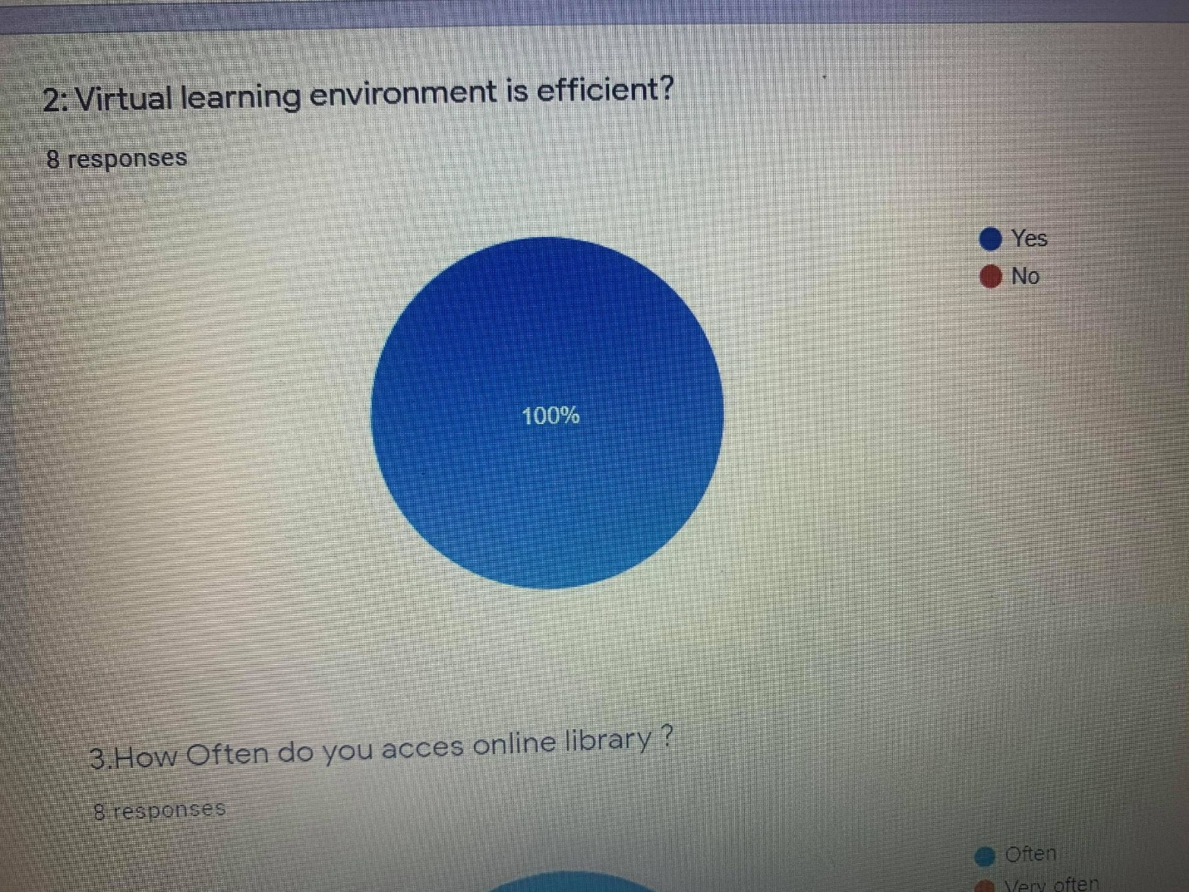
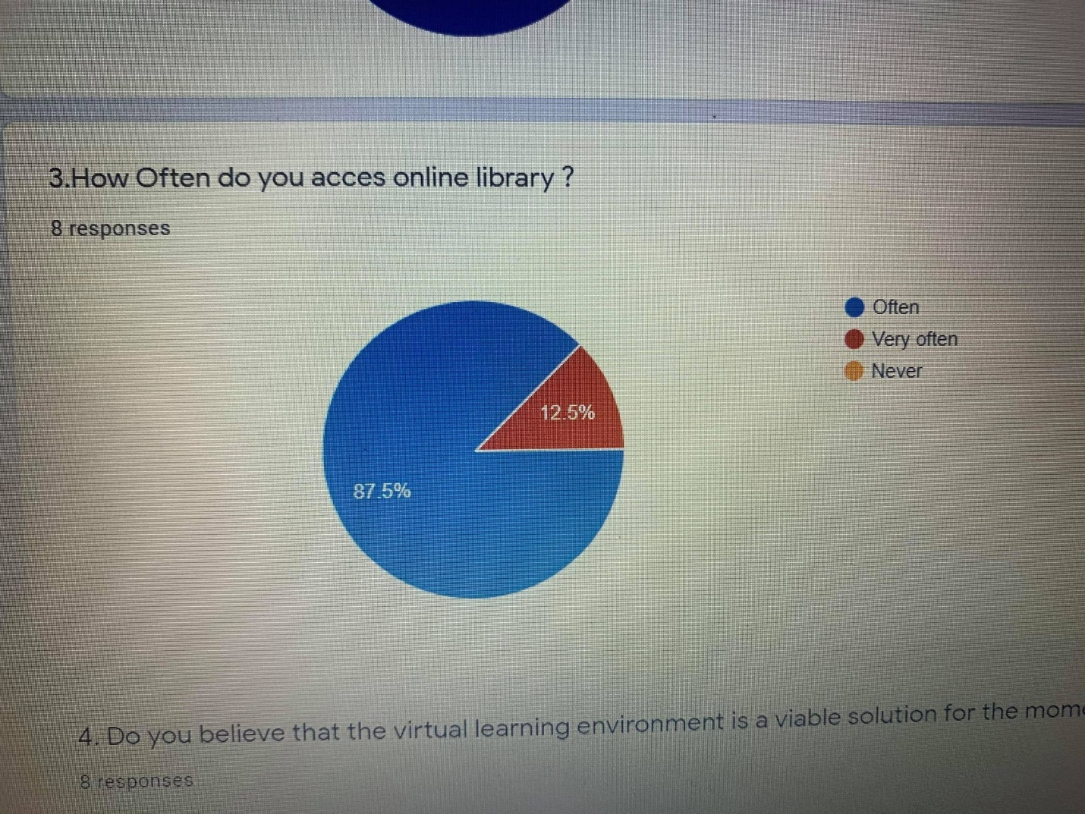
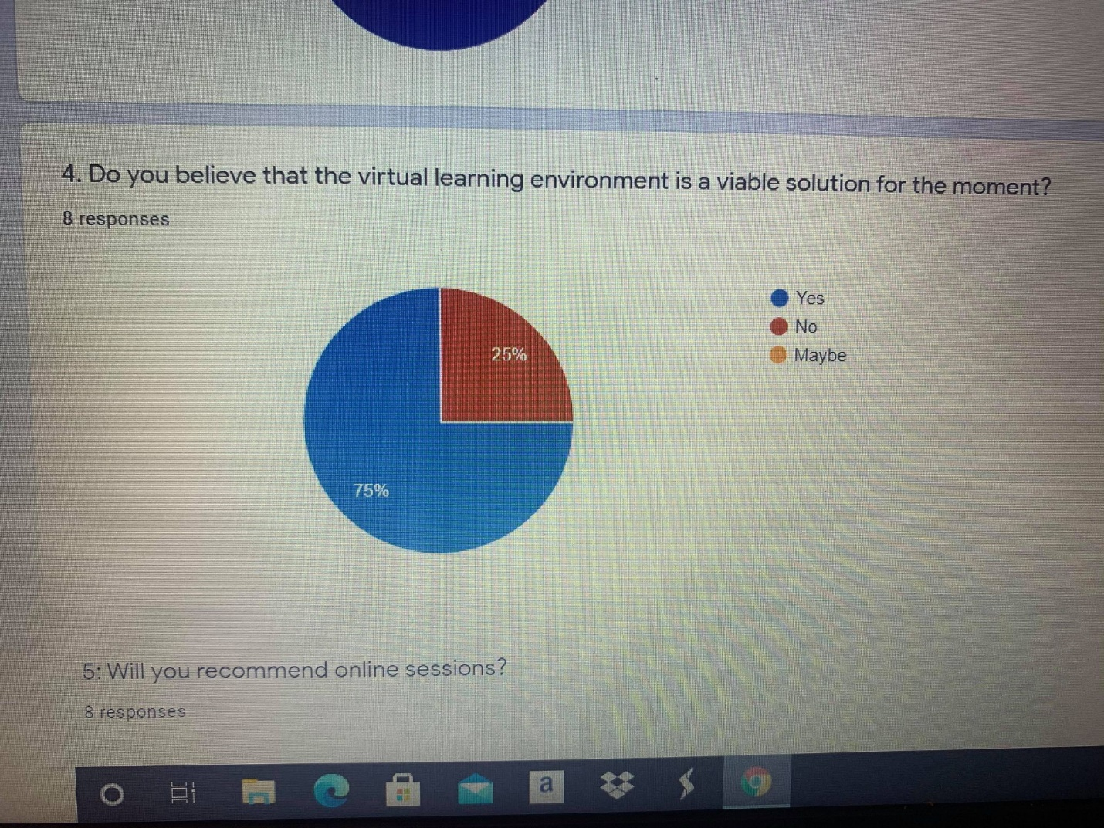
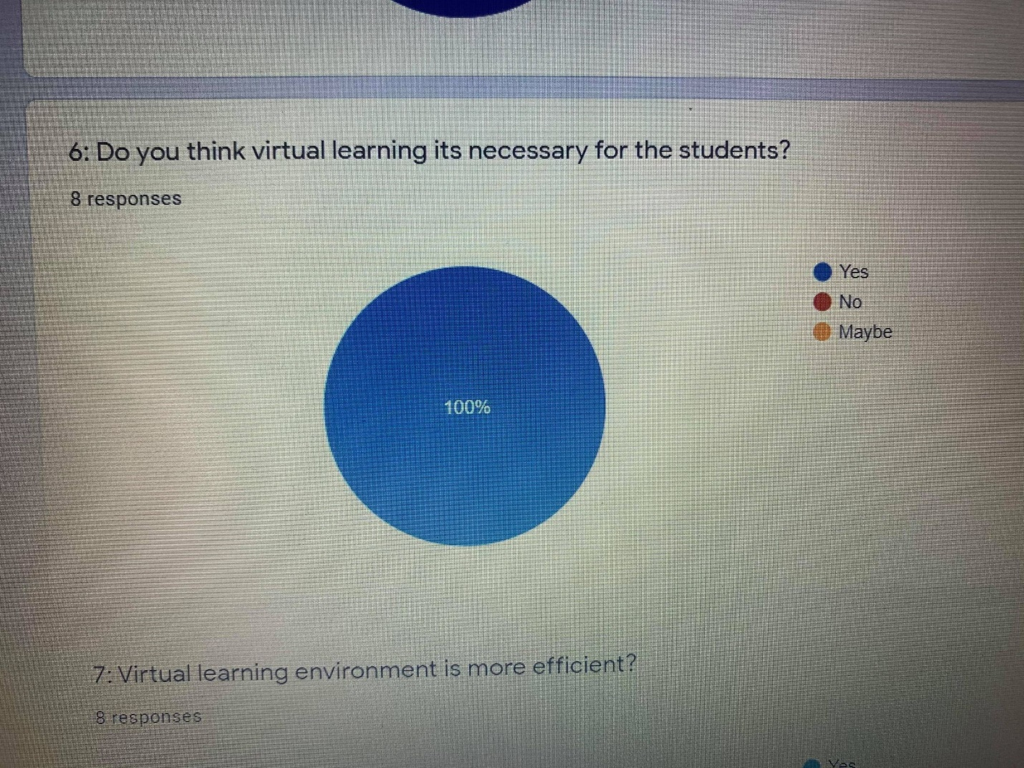
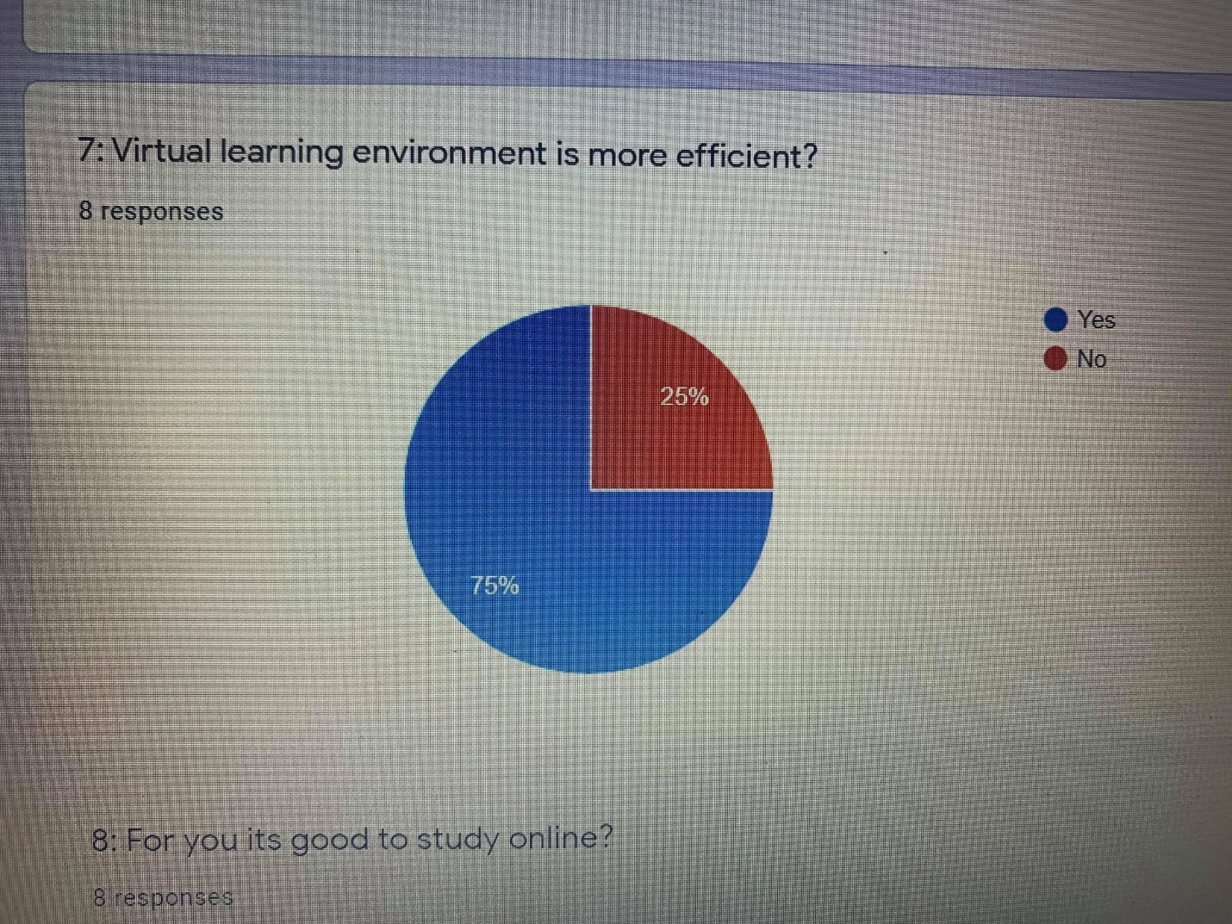
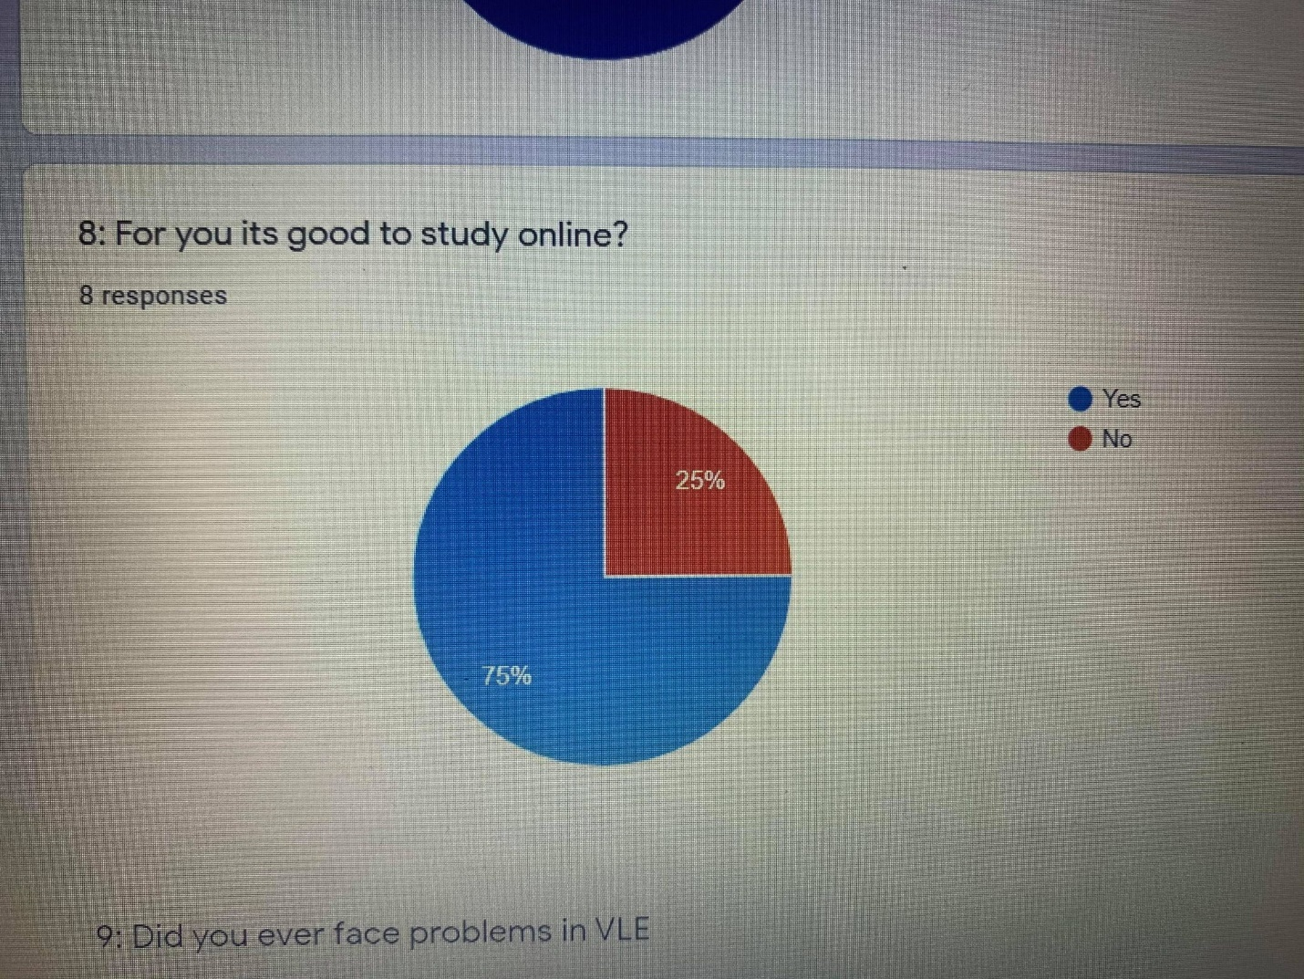

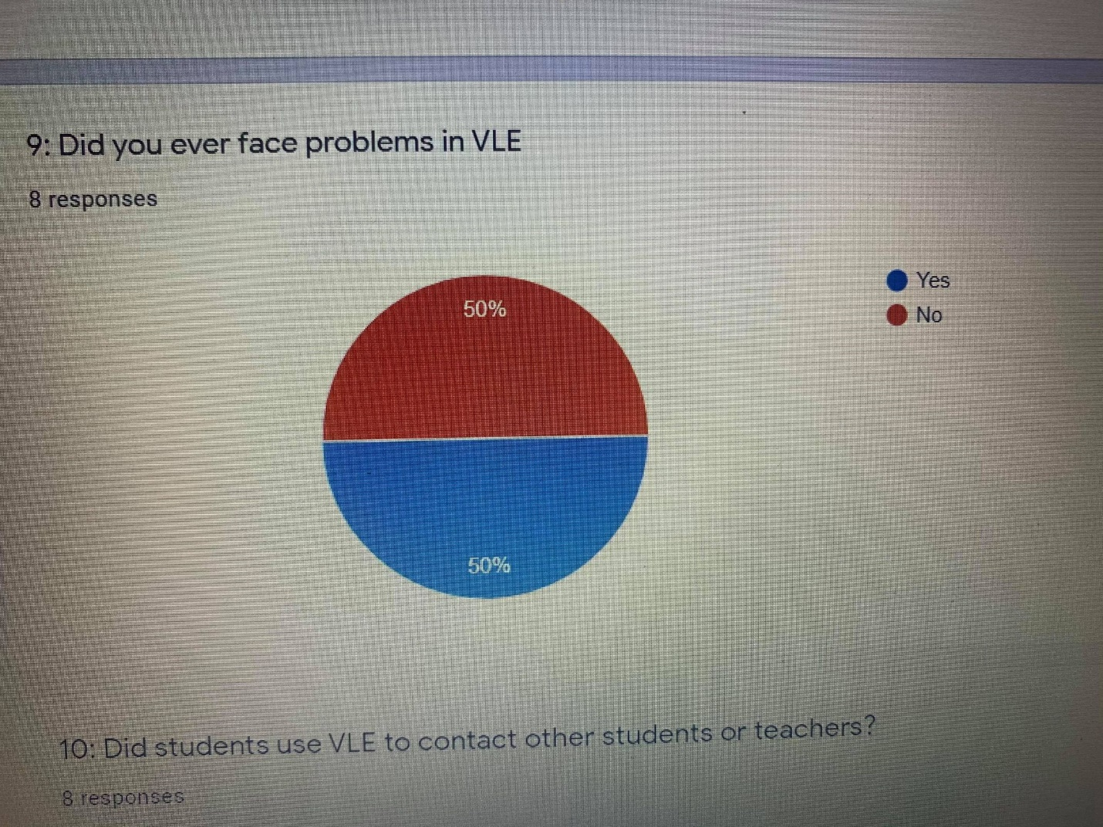
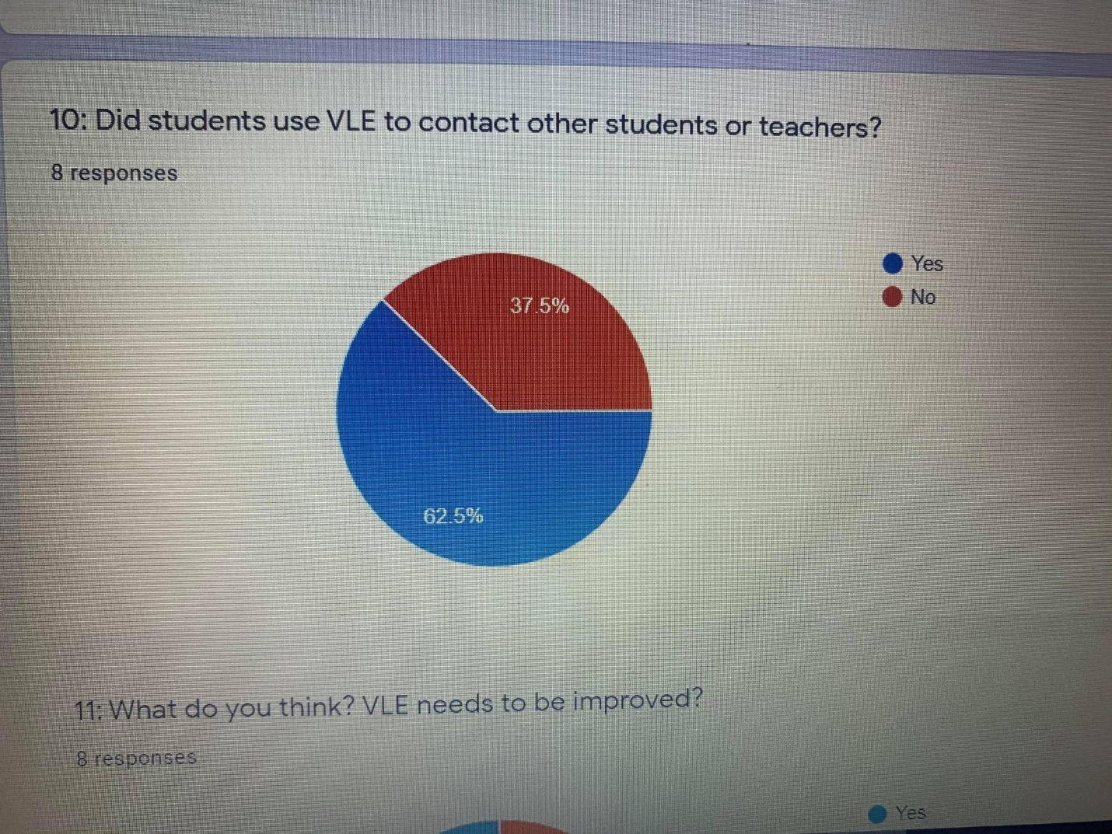
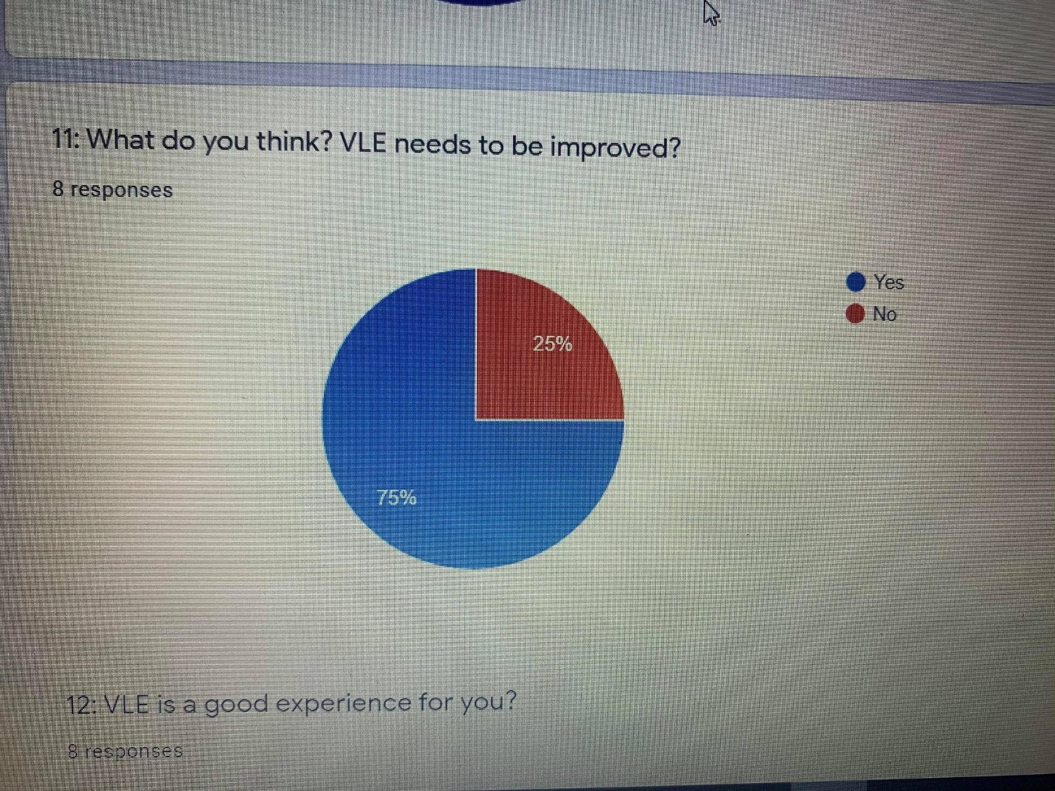
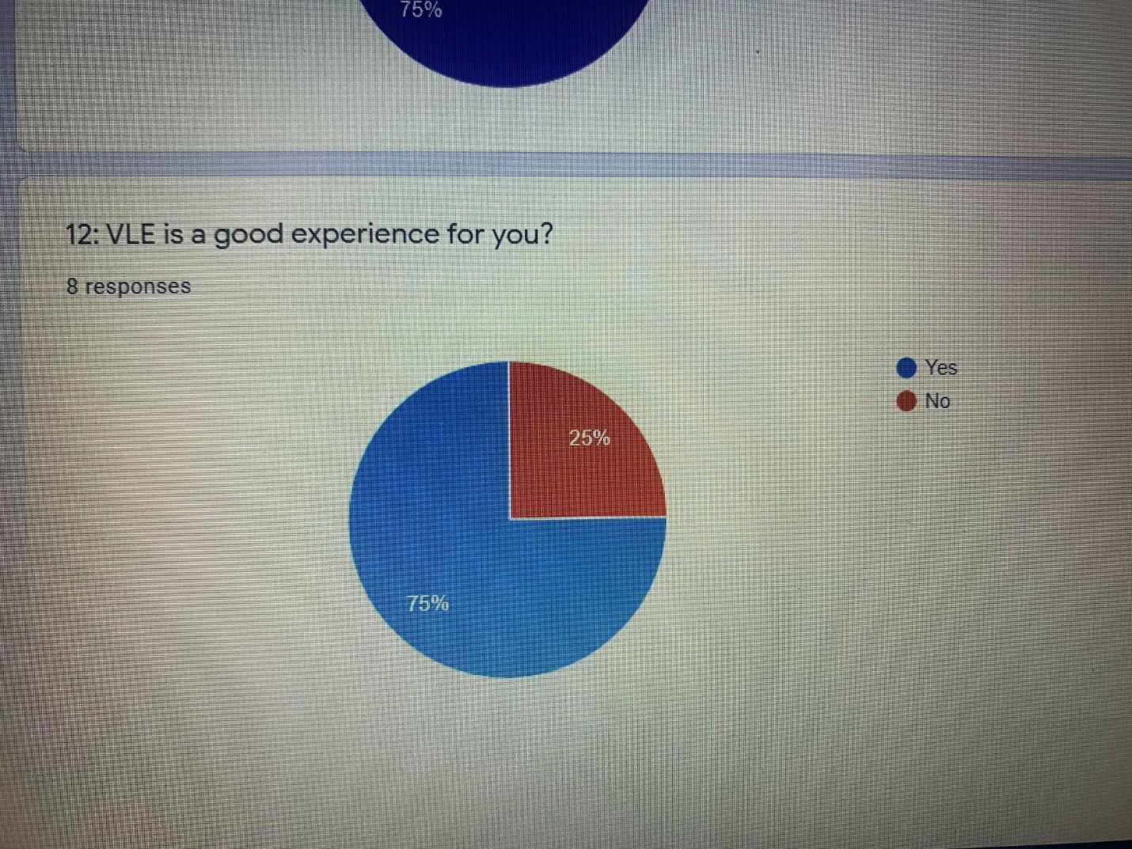

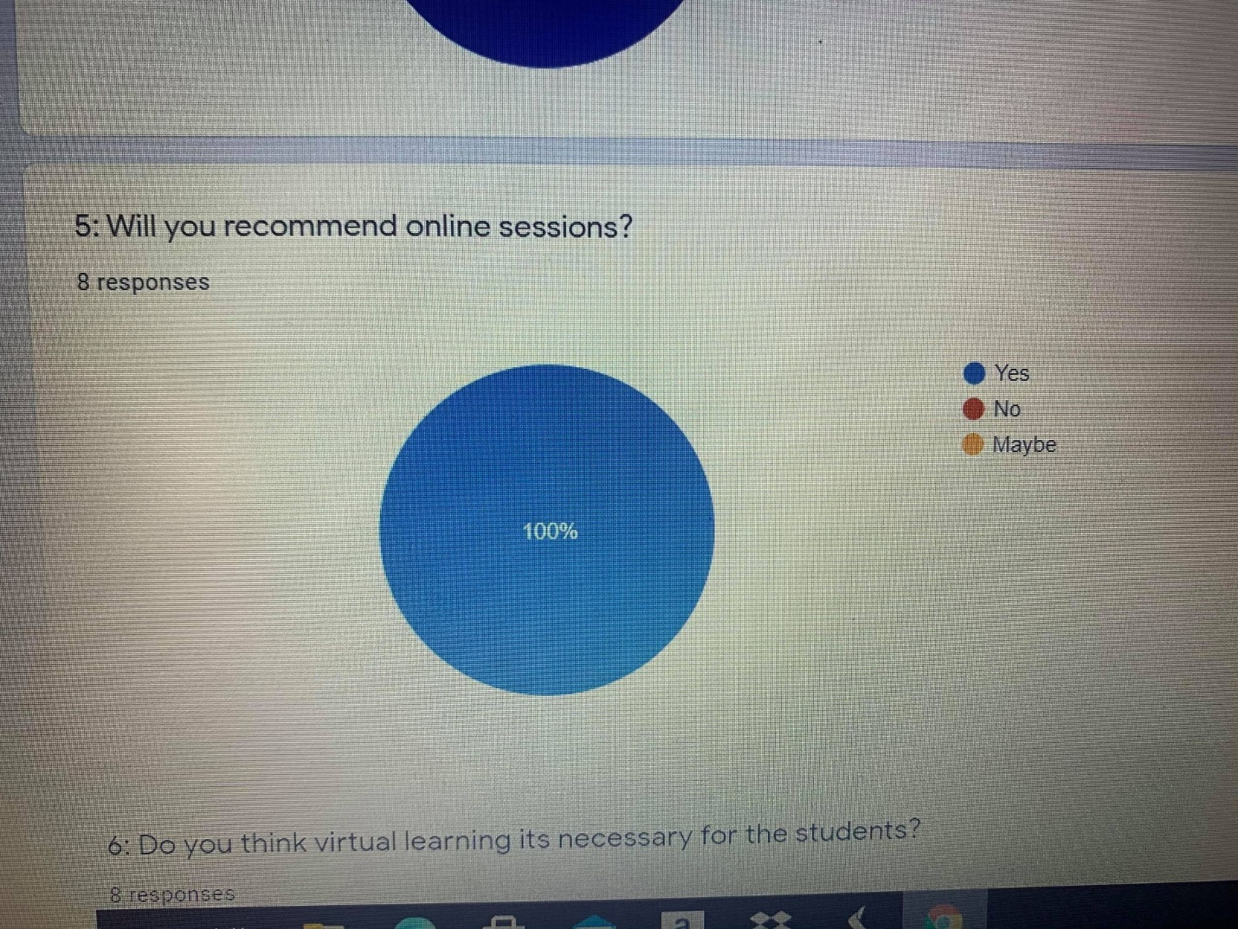
Based on received feedback, we can discuss the interest of students, and break down their preferences furthermore, in a detailed table of options set based on their responses.
Q1 | Q2 | Q3 | Q4 | Q5 | Q6 | Q7 | Q8 | Q9 | Q10 | Q11 | Q12
Yes-8 | Yes-8 | Yes-7 | Yes-6 | Yes-8 | Yes-8 | Yes-6 | Yes-6 | Yes-4 | Yes-5 | Yes-6 | Yes-6
No-0 | No-0 | No-1 | No-2 | No-0 | No-0 | No-2 | No-2 | No-4 | No-3 | No-2 | No-2
 |  |  | Maybe-0 | Maybe-0

Therefore, most of the respondents are highly appreciating the virtual learning environment and are considering the experience is mutual beneficial for students and interactions with teachers and the digital learning system as a fully functional entity for studies.

Discussion.
Based on in-class experience, studied literature and the survey given responses, we can considerate that the VLE, represents a useful medium, an extension for overall learning experience. Studies are indicating a high attachment from students and tutors.
Developments inside the domain, acceded expectations, teachers can prepare classes, take attendance and give feedback during classes, and can make recommendations based on the library, giving options for each category of classes on each chosen profile of studies.
Furthermore, the interconnected library ensures a complete extend for documentation, including articles, books, journals etc. and gives a bigger purpose to the digital resources during collage.
As a bad fact, certain domains could not be included in the digital platform, specialities such as medical field, and main practical specialities need to continue on in-class activity, so the extension of services that can be applied on the digital library and virtual learning environment is limited to a certain degree for specialized groups of students. Furthermore, the e-learning experience and development can be improved, certain browsers do not fully support extensions that allows chosen libraries to be available on their platform, and the development does not cover specialised extensions for different operating systems.
Conclusion.
To conclude, as an overall experience, based on experience and research we can conclude that Virtual Learning Environment, can become a main assistant in the learning process.
Furthermore, as the platform will become more advanced, and the implementation will become more refined, e-learning can replace actual in-class activities concluding in a more safe environment for students and tutors, and implementation can be expanded from collages to primary school, separating more in-field specialities from general schooling.
As a definitive experience, from my experience, few developments need to be put together, and more titles need to be made available on the platforms, in a complete version.
Based on personal experience, titles that are incomplete published is available through campus, and ISBN number and publisher is available, but they can be set on a pay per view system, that can ensure a better option when there are not available in campus libraries, or students need the content only for a limited amount of time, or for certain chapters.
So, on the plus side the virtual learning represents an important development, and a suitable replacement for in-class experience for both tutors and students.

References
Almarzooq, Z., Lopes, M. and Kochar, A., 2020. Virtual learning during the COVID-19 pandemic: a disruptive technology in graduate medical education.
Azevedo, R. and Gašević, D., 2019. Analyzing multimodal multichannel data about self-regulated learning with advanced learning technologies: Issues and challenges.
Bogusevschi, D., Muntean, C. and Muntean, G.M., 2020. Teaching and Learning Physics using 3D Virtual Learning Environment: A Case Study of Combined Virtual Reality and Virtual Laboratory in Secondary School. Journal of Computers in Mathematics and Science Teaching, 39(1), pp.5-18.
Hassan, S.U., Waheed, H., Aljohani, N.R., Ali, M., Ventura, S. and Herrera, F., 2019. Virtual learning environment to predict withdrawal by leveraging deep learning. International Journal of Intelligent Systems, 34(8), pp.1935-1952.
Pererva, V., Lavrentieva, O., Lakomova, O., Zavalniuk, O. and Tolmachev, S., 2020. The technique of the use of Virtual Learning Environment in the process of organizing the future teachers' terminological work by specialty.
Statista. 2020. Online Learning In Great Britain 2019 | Statista. [online] Available at: <https://www.statista.com/statistics/882117/online-learning-in-the-uk-by-demographic/> [Accessed 1 September 2020].
Statista. 2020. UK Higher Education Institutions Income 2017 | Statista. [online] Available at: <https://www.statista.com/statistics/538075/breakdown-of-higher-education-institutions-income-in-united-kingdom-uk/> [Accessed 1 September 2020].

