Supporting Paper

BMHP5001

Lecturer: Mark Gallagher

Musammat Khaleda Begum
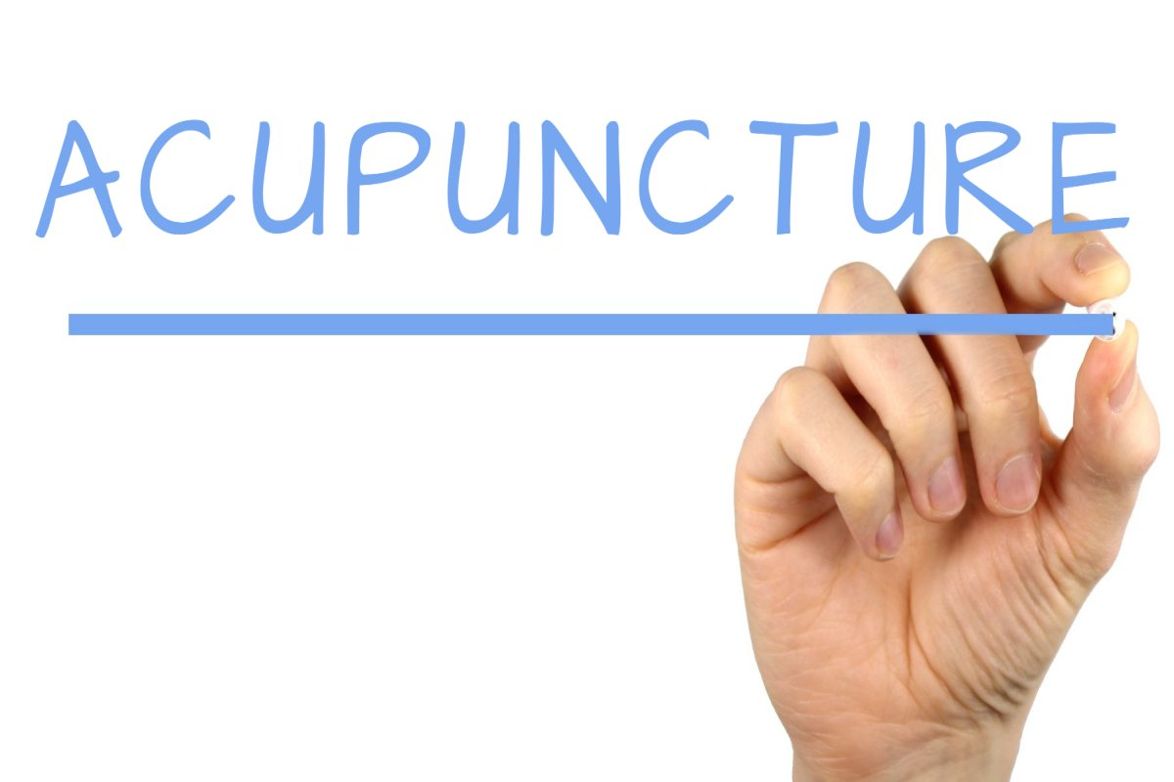1714938

Contents

Introduction………………………………………………………………………………………………2
Complementary therapy……………………………………………………………………………………………………2
Acupuncture……………………………………………………………………………………………..2
Overview of the history of acupuncture…………………………………………………………..2,3
Effects of Acupuncture 3
Comparison and contraindication………………………………………………………….………3.
Uses of Acupuncture……………………………………………………………………….…………4
Conclusion………………………………………………………………………………………………5.
References…………………………………………………………………………………………….…5

Introduction:
This paper is going to support the presentation I did. I am going to support the topics we wrote on the presentation slide by giving some more brief on each points. There were four people in our group. All our group members worked hard to make the presentation look good and easy to understand for our audience. Our group members are myself Musammat Khaleda Begum, Dolu Miah, Fulban Bibi, Saniatul.

Complementary therapy:
Complementary therapy was presented by Dolu. He had done it very efficiently and tried to make it as clear as possible. I am now going to talk about it in my own word.
Complementary therapies is a form of medical treatment that are used along with our mainstream medicine (Bupa UK, 2020). There is a debate on wether it is or not an alternative to the conventional treatment. In most cases it is definitely alternative to painkillers.
According to Evans et al, (2012) cancer patient often approach complementary therapy to help them maintain a healthy progress.

Acupuncture:
On the presentation slide Dolu wrote what is Acupuncture and I did the definition of acupuncture. Here for my supporting paper I am combining both into an introduction of acupuncture.
In Latin acupuncture means needle. An acupuncturist would insert many extremely fine needles at a time into specific parts of the body in order to kill pain.
According to Ling (2014) before the invention of conventional medicine Chinese medicine was popular as a cure of cancer.
English word acupuncture was discovered in the seventeenth century which means a treatment for pain in which thin needle are inserted just under the surface of the skin. It was a technique the Chinese had been using for more than two thousands years. Even in today’s world acupuncture is in use routinely in china as an anastatic during surgery.

Overview of the history of acupuncture:

Acupuncture is One of the oldest Chinese medical treatment in existence. Teaching of Taoism is the root of acupuncture which promotes Harmony between human and world around them and balance between yin and yang. Acupuncture was originated in china two thousand and five hundred years ago and in the nineteenth century it was introduced to the west.
Acupuncture was invented by Dutch physician William Ten Thyne who was also a botanist. Acupuncture was first introduced to the western medicine by him. Havang Di was called the father of acupuncture as the treatment was very popular during his period and ruling in china.
In 1970s acupuncture was first introduced to the United States by Henry A. Kissinger who travelled to china and there he fell ill. He was given the treatment and he introduced it to the US.
Korea and Japan was the first two countries to receive the knowledge of acupuncture. The French are considered the first western civilisation to adopt the treatment.
America and Britain developed their interest in the 19th century.

Effects of Acupuncture:

Lower Back Pain
According to a report of Annals of Internal Medicine in 2017, researchers found acupuncture helps ease pain immediately compared with no acupuncture. But the evidence of its effectiveness is very little.

Migraines
In a review of Cochrane Database of Systematic reviewa in researchers discovered that including acupuncture to the treatment of migraine symptoms might reduce the frequency of migraine.

Tension Headaches
Having a series of six session of acupuncture can help people with severe tension headache. Acupuncture showed positive effect on reducing headache frequency compared to other treatments..

Knee Pain
A report shows that acupuncture develops physical function in order to fight knee pain due to osteoarthritis. The down side of this is it only provides relief from pain for a very short period.

Side effects of Acupuncture:
Even though acupuncture is know for pain relief, from the needling it can leave a new pain. There are some other side effects of acupuncture that makes the treatment less reliable. Some of them are given down below
- Acupuncture can leave skin rashes and bruises behind.
- The treatment can cause bleeding and pain.
- Some evidence shows acupuncture treatment can develop dizziness, nausea and fainting on patients.
Another side effect that can a high risk for patient is infection. Because of so many needle being inserted at the same time it can cause infection.
(Arno kroner,2020)

Comparison and Contraindication:
Comparison: Acupuncture are proven to be used for many disease but mainly acupuncture is known for the pain relief. There are so many different methods of treatment for pain relief.
- Pain killer tablets are easy to access but acupuncture is not very easy to access. In most cases patient only go for acupuncture when the doctor refer them to.
- Painkiller tablets are inexpensive where acupuncture can be very expensive.
- Where painkillers only helps ease the pain temporarily , acupuncture can help stimulate blood circulation and ease pain at the same time.
- Pain killer are used knowing it can be effective for a short time but people uses acupuncture in the hope to get a permanent result.
Contraindication:
They state that absolute contraindications to be:
- used with patient with movement disability.
- risk of lymphoedma.
- spinal cord compression.
And relative contraindications to include:
- Acute stroke
- Patients with cancer
- Areas of poor skin condition
- Diabetic patients
- Patients with epilepsy
- Hemophilia or other clotting disorders (Acupuncture contraindications, 2020)

Uses of Acupuncture:
On the presentation Saniatul spoke about the uses of acupuncture. She presented a very clear research on the uses of acupuncture. It was something simple and easy to understand. I am now going to give a little brief on the uses of acupuncture to support my presentation slides.
Acupuncture is mainly a pain relief treatment even though there are evidence that shows acupuncture can be used for some critical conditions as well. But the effectiveness on critical conditions are not clear. Some of the uses of acupuncture are given below.
- Neck pain
- Osteoarthritis
- Headache
- Lower back pain
- Knee pain
- Joint pain
- Postoperative pain
- Insomnia
- Migraines
- Nausea
- Sciatica
- Sinus congestion
- Stress and anxiety
- Tinnitus
- Weight loss

Conclusion:
Acupuncture is one of the oldest medical treatment in the existence. Even though there are debates on how effective it is. It was a very good subject for us to work on. I learned a lot of information about this treatment by all the research I had to do in order to make the presentation slides.

References:
- Bupa.co.uk. 2020. Complementary Therapies | Health Information https://www.bupa.co.uk/health-information/complementary-therapies/complementary-therapies.(Accessed 29 June 2020)
- Physiopedia. 2020. Acupuncture Contraindications.https://www.physio-pedia.com/Acupuncture_contraindications [Accessed 1 July 2020].
- Verywell Health. 2020. What Is Acupuncture? What Are The Benefits.www.verywellhealth.com/acupuncture-health-uses-88407 [Accessed 2 July 2020].
- NCCIH (2016b). Acupuncture: In Depth. [online] NCCIH. Available at: https://www.nccih.nih.gov/health/acupuncture-in-depth. Accessed 5 Jun. 2020.
- Medicalnewstoday.com. 2020. Acupuncture: How It Works, Uses, Benefits, And Risks.www.medicalnewstoday.com/articles/156488> [Accessed 2 July 2020].

