Research Activity

You are a student with a passion for the outdoors and outdoor adventure activities. You feel that outdoor activities can improve people’s health. Being outdoors makes you feel good but do others feel the same? Is there any evidence that that there are health improvements from engaging in outdoor activities? After giving this much thought you are interested in finding out if your instinct is right.
You are ready to engage in inquiry and research.
So were do you start, well you start by writing out the question you want to find an answer to, so that is the starting point.
So you get started, you write the question down in about ten different ways and finally after a gulp of air and a scratch to the head you decide this is how you feel the question is best stated.
Here is the question you have arrived at.

How do you think outdoor activities can be used as a focus for improving people’s general health and wellbeing?

- What type of research paradigm best describes this question?
Qualitative
- Where will you search for information to address this question? (List all)
I will search for articles in the library and google scholar. I will also send out questionnaires to see how the public feel
- How easy / difficult is it to find sources to help answer the question?
Conducting research in the general public is a good source and easily accessible so if all else fails its still relatively easy
- What did you do to make the process less difficult?
I broke down “health and wellbeing” into smaller key questions like “how does the outdoors effect your mental health” and “how does the outdoors effect your aerobic Health”
- How did you arrange the materials you found? Did you have a system
I arranged the folders into the answers to my smaller key questions as stated above
- Pick five search results.
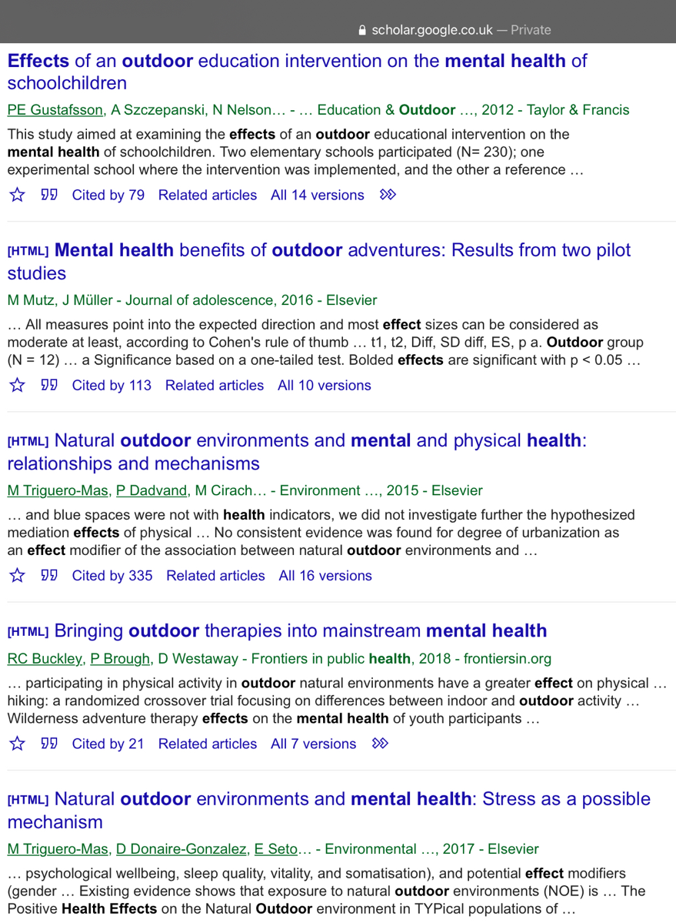

The next stage is the literature review process.
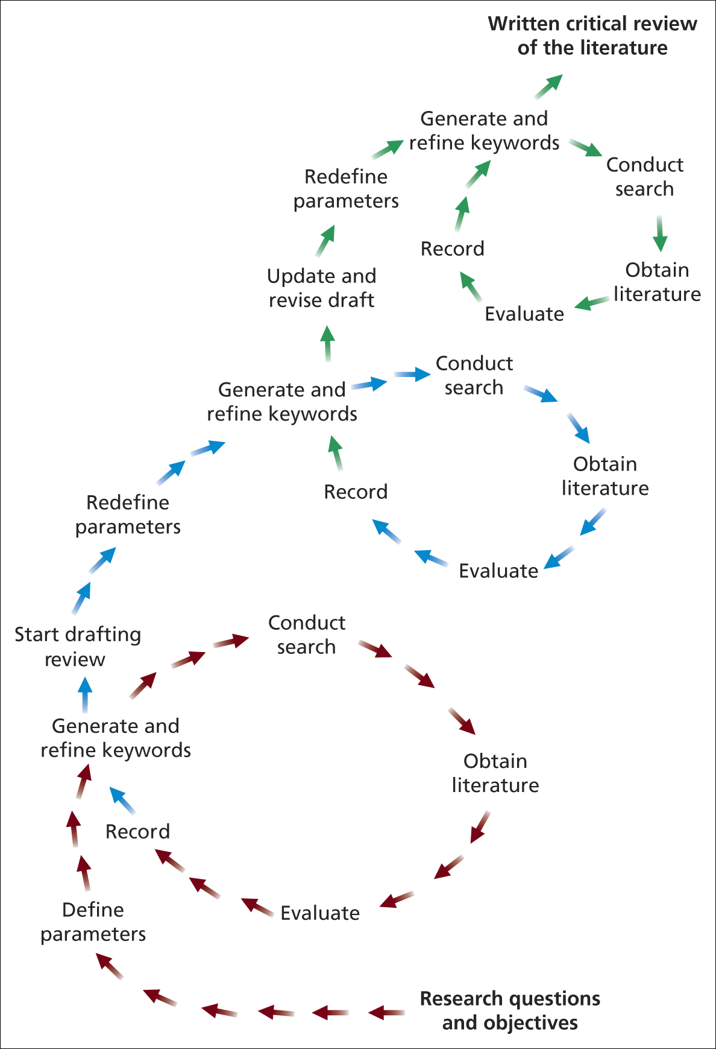
Figure 1 The literature review process Saunders et al., 2009

- The process suggests you need to evaluate those search results, but how do you do that?
Check when they were written, if they are peer reviewed, where they are published and relevancy.
- How would you evaluate those five search results? Are there any guidelines / checklists you would follow to decide what you are looking for in those papers?
If the title has the key words “outdoors”, “health” and “effect” in it and if its published in a respected journal or website. Read the abstract and make sure the article is relevant.
- Now you have your evaluation checklist ready then read the three research sources and report on your checklist.
All 3 research sources met the checklist. The first result is 2012 so is almost too old
- Make a summary of what are the key findings from the papers. Report these.
The outdoors benefits the health of a person in many ways but it benefits the mental health more so than any other parts of “well being”
- Did the sources provide useful findings and what are these findings?
They did point out that socially privileged children are more sheltered from the outdoors so can reap a larger mental health benefit than those who come from a socially disadvantaged area who would spend more of their time in the outdoor environment
- Did the sources you found indicate a need for further research?
I think researching the effect on my local area would be interesting and the results would be more tangible to me

