Cover Page

Academic and industry skills

By Alicia Hiles

Executive summary
The purpose of this report is to analyse and discuss all skills that are required for jobs in tourism industry. The report will identify the key skills that are needed to become a cabin crew member.

Table of contents
Cover Page | P1
Executive Summary | P2
Table of Contents | P3
Introduction | P4
Main Body | P5-6
Conclusion | P7
Appendix | P8-
Bibliography

Introduction
A report will be presented identifying the skills needed for the travel and tourism industry. There will be an analysis and a discussion about specific key skills and many relevant job advertisements will be looked at. A report will be produced with a maximum of 1000 words. A discussion will be included on each skill informing the reader why its important to have the type of skill.

Main body
All types of jobs require different skills but the basic skills are usually essential which will be presented below:
- Communication
Communicating is one of the most used and important skills. It is used in usually in all types or industries whether its talking to customers, consumers or even managers. Effective communication is a combined set of 4 including: engaged listening, nonverbal communication, managing stress in the moment, declaring you in a respectful way. This is very important in the tourism industry as most customers will rely on you whether it’s a travel agent, air hostess or even a rep.

- Team working skills
This is one of the most important basic skills for jobs as most roles require people to work together. Each individual is different and are all good at different things which means that if a person struggles with something then there’ll usually be another person that can help or take over. Managers will seek different qualities and when putting teams together can even consider Belbin Team Roles.

- Planning and organising
It is said that being organised is essential to getting tasks done. It’s usually required to have good organising skills and planning so that goals can be met and them employers can succeed within the work they undertake.

- Time management
Time management is essential when it comes to jobs as individuals have to manage their time to turn up on time and even when it comes to deadlines and everything has to be done by a certain time. The NHS state that “Good time management at work means doing high-quality work, not high quantity.”

- Numeracy skills
Numeracy skills are used on a daily basis and even in the tourism industry which is why it’s essential for all applicants to have some knowledge of using numbers and solving problem. Humphries (2012) stated "It is simply inexcusable for anyone to say: 'I can't do maths.'”.

- Good IT skills
Having IT skills is usually essential now as most jobs rely on technology and the internet. In the tourism industry mostly all jobs require to use technology to booking the holidays either online or to being on the aircraft.

- Flexibility
Most jobs like for the applicant to be flexible so that they can work when they are required to and it’s an advantage to be flexible as that what most companies are looking for. In the tourism industry its essential to be flexible in most jobs, for example cabin crew need to be flexible as flights are taking off all throughout the 24 hours meaning that workers have to be there looking after guests.

Tourism
There are many jobs and careers within the tourism industry which include: retail travel, tour operations, airports, airlines, accommodation, visitor attractions and cruising. If applying for a job role like this then it’s important to read the job advertisement as individuals may decide that it’s not for them.
Cabin Crew
Air cabin crew members must deliver excellent customer service to passengers while ensuring their comfort and safety during all flight. It is stated by TUI that you have to flexible as “customers want to go on holiday 365 days a year and we need a flexible team to be part of this journey” in which if you are not willing to work the hours that they require then there no point applying. Cabin crew members are all required to work with one another to ensure that the passengers are safe and get all the beverages they want when on board. Time management is a must when becoming a cabin crew member as no one can be late because it will affect everyone. Also during the landing time and the departure time each one of the cabin crew have to do a search on board to ensure no hazards. Basic numeracy skills are required as when on board food and beverages are sold in which case they are dealing with money. To consider becoming a part of a cabin crew team then the requirements that are needed are specified below:
- Aged 18
- Hold a valid UK/EU passport and a valid UK National Insurance Number
- Eligible to live and work in the UK
- Fluent in English (both spoken and written)
- Able to reach to a height of 6’2
- Able to swim 25 metres unassisted
- Fit and able to obtain an EASA Aero-Medical Certificate
- Able to provide a supportable five-year history with references
- Willing to cover any visible tattoos and remove any body piercings
- Uniformed colleagues to have natural hair colour
- Live within 90 minutes of the based airport
- A confident communicator

Conclusion
To conclude this report, the basic needs are usually required for all jobs in which case individuals must have experience or knowledge of the skills. When applying for a job it’s important that the requirements are taken in as the job may not be right for the individual. To become a cabin crew member then all the above skills are required as the job will entail communicating, working as a team, planning and organising, time management, flexibility, numeracy and IT.

Appendix
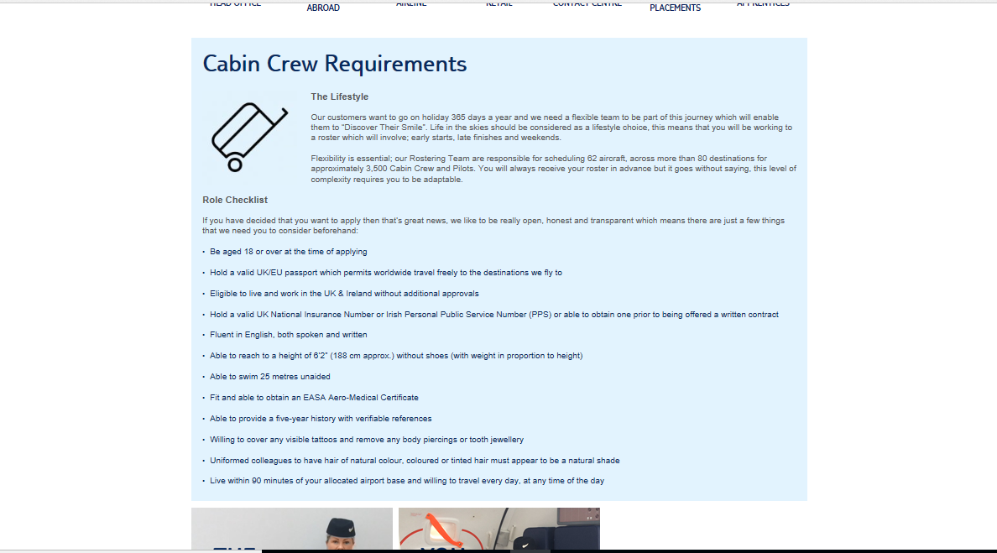

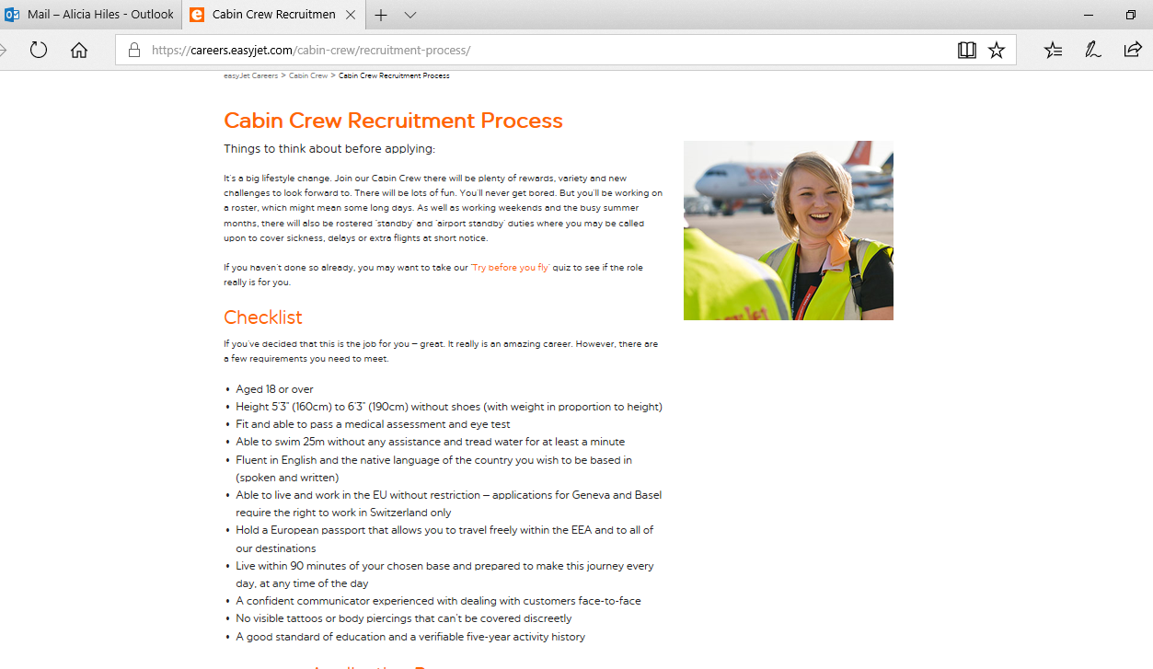

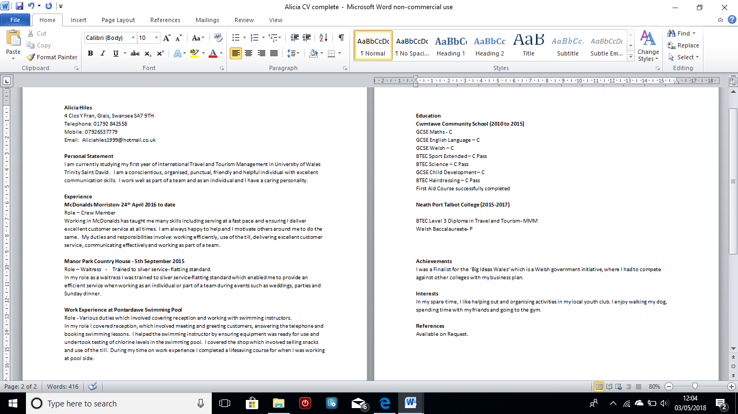

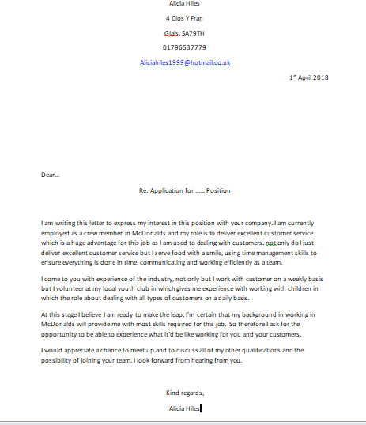

Bibliography
Burns, J.(2012), Poor numeracy 'blights the economy and ruins lives’. http://www.bbc.co.uk/news/education-17224600 (accessed 1st may 2018)
Costa, G. (2013). Cabin CREW - Assessment Day - Interview Revealed [online]. Available: https://books.google.co.uk/books?id=LBLpBgAAQBAJ&printsec=frontcover&source=gbs_ge_summary_r&cad=0#v=onepage&q&f=false ( Accessed 1st May 2018)
EasyJet. (2018) Cabin Crew Recruitment Process. https://careers.easyjet.com/cabin-crew/recruitment-process/ (accessed 1st May 2018)
Helpguide.org. (2017), Effective Communication. https://www.helpguide.org/articles/relationships-communication/effective-communication.htm (accessed 1st may 2018)
Lafata, K. (2012), Success at Work: Why You Should Be a Flexible Employee. https://www.levo.com/posts/success-at-work (accessed 1st May 2018)
Meredith, R. (2004), Management teams. 2nd ed. London: Routledge
NHS. (2018), Easy time-management tips. https://www.nhs.uk/conditions/stress-anxiety-depression/time-management-tips/ (accessed 1st May 2018)
Porges, Stephen W. (2011). The Polyvagal Theory: Neurophysiological Foundations of Emotions, Attachment, Communication, and Self-regulation. New York: W. W. Norton & Company.
Skills you need. (2016), Effective team working skills. https://www.skillsyouneed.com/ips/team-working.html (accessed 1st May 2018)
TUI. (2018), Cabin Crew Requirements. https://tuijobsuk.co.uk/work-at-tui-travel/tui-airways/cabin-crew/cabin-crew-requirements/ (accessed 1st May 2018)
University of Kent. (2017), What are the top ten skills that employers want?. https://www.kent.ac.uk/careers/sk/top-ten-skills.htm (accessed: 1st may 2018)

