

UNIVERSITY OF WALES TRINITY SAINT DAVID

Master of Business Administration
Module: International Business Concepts | Code: LCMB7034

THE BANGLADESH BANKING INDUSTRY:
AN INTERNATIONAL BUSINESS ANALYSIS

Lecturer: Gladius Kulothungan

Submission Deadline: 27th April 2026
Word Count: Approximately 5,105 words (plus or minus 10%) — excluding title, contents, references and appendices
Student ID:2437168
Student Name: Md Ranu Miah

Table of Contents
1. Introduction 3
2. Industry and Country Overview 4
2.1 The Banking Industry in the Context of Bangladesh 4
2.2 Size, Scope, and Economic Importance of the Industry 4
2.3 Key Domestic and Multinational Firms: Comparative Analysis 6
3. Porter's Diamond Model of National Advantage: Bangladesh Banking Industry 8
3.1 Factor Conditions 9
3.2 Demand Conditions 10
3.3 Related Industries, Rivalry and Government 11
4. HSBC Bangladesh Limited: Critical Evaluation of Operations in Bangladesh 12
4.1 Company Profile and Bangladesh Entry Rationale 12
4.2 Political Factors: Domestic Transition and the Iran-Israel-USA Military Confrontation 13
4.3 Economic Factors and Middle East Disruption Cascades 15
4.4 Legal Factors 16
4.5 Cultural Factors: Applying Hofstede and CAGE 17
5. Conclusion 186. Reflective Account: Gibbs' Reflective Cycle (1988) 20
6.1 Description 20
6.2 Feelings 21
6.4 Analysis 22
6.5 Conclusion 23
6.6 Action Plan 23
References 25

1. Introduction
Bangladesh’s banking sector represents the lifeblood of one of Asia's fastest-growing emerging market economies with more than 6% GDP growth annually for two decades and on trajectory to graduate from LDC by 2029. The sector is structurally significant with total assets of BDT 25.61 trillion and 61 scheduled banks catering to 170 million customers (Bangladesh Bank, 2024). The findings of La Porta et al. (2002) that government-controlled banking systems have higher non-performing loan (NPL) ratios shed light on Bangladesh's governance problem. This report offers a holistic international business analysis: Section 2 provides background to the industry; Section 3 assesses the industry through Porter’s (1990) Diamond Model; Section 4 critiques HSBC Bangladesh using PESTLE, OLI, Hofstede and CAGE; Sections 5 and 6 include conclusions and a Gibbs (1988) reflection.

2. Industry and Country Overview

2.1 The Banking Industry in the Context of Bangladesh

The history of the Bangladesh banking sector dates back to the nationalisation of banks in 1971-1972, when the newly elected government seized the branches of Pakistani and foreign banks in the former East Pakistan. Since then, the sector's evolution has been marked by a series of liberalisation phases - the licensing of private commercial banks (1983 onwards), foreign banks (from the late 1980s) and the introduction of Islamic banking (gradually from 1983 by Islami Bank Bangladesh Limited) - interspersed by periodic governance crises in state-owned commercial banks (SOCBs), requiring recurrent government recapitalisation. The Bangladesh Bank, the country's central bank and main regulatory authority, has steadily improved its prudence: the introduction of Basel III capital adequacy standards (to be phased in from 2015 to 2019), mandatory credit risk management guidelines and a Financial Intelligence Unit to address money laundering have successively raised the prudence of the sector to emergingmarket best practice standards (although with substantial implementation shortcomings).

The SOCBs (Sonali, Agrani, Rupali and Janata) collectively hold 27.4% of the total sector assets, despite poor governance (Bangladesh Bank, 2024). The 43 private commercial banks (PCBs) control 57.3% of assets and are key sources of credit and innovation. HSBC, Standard Chartered and Citibank, among others, hold 5.8% of assets but have outsized governance influence. Foreign banks raise domestic bank efficiency (Claessens and van Horen, 2014) through competition and spillovers. Islamic banks have emerged to serve the largely Muslim population with Shariah-compliant operations.

2.2 Size, Scope, and Economic Importance of the Industry
Over 2018-23, total assets grew from BDT 14.82 to BDT 25.61 trillion (CAGR ~11.5%), deposits from BDT 10.24 to BDT 18.27 trillion and loans and advances from BDT 9.38 to BDT 16.44 trillion (see Figure 1). The industry accounts for 8-9% of GDP, intermediating two key transactions: the USD 21.9 billion in annual remittances from ~12 million overseas workers (Bangladesh Bank, 2024; World Bank, 2024). The World Bank (2024) reports remittances are more resilient than FDI to geopolitical shocks, with the exception of remittances from the Gulf (GCC) due to the concentration of Bangladeshi workers in the region (a vulnerability explored in Section 4).
The NPL ratio fluctuated between 8.2-11.9% in 2018-23, significantly above 3-5% recommended by the IMF (IMF, 2023). SOCBs consistently have NPL ratios above 20-25% due to politically motivated lending and governance structures that shield borrowers from default risk. Shleifer and Vishny (1994) theorise public banks prioritise political over economic returns, leading to recurring NPL cycles; La Porta et al. (2002) empirically show increased government ownership of banks slows financial system development. Classified loans have exceeded BDT 1.45 trillion by December 2023, a macroprudential challenge which Bangladesh Bank's ongoing supervisory measures have yet to structurally address.
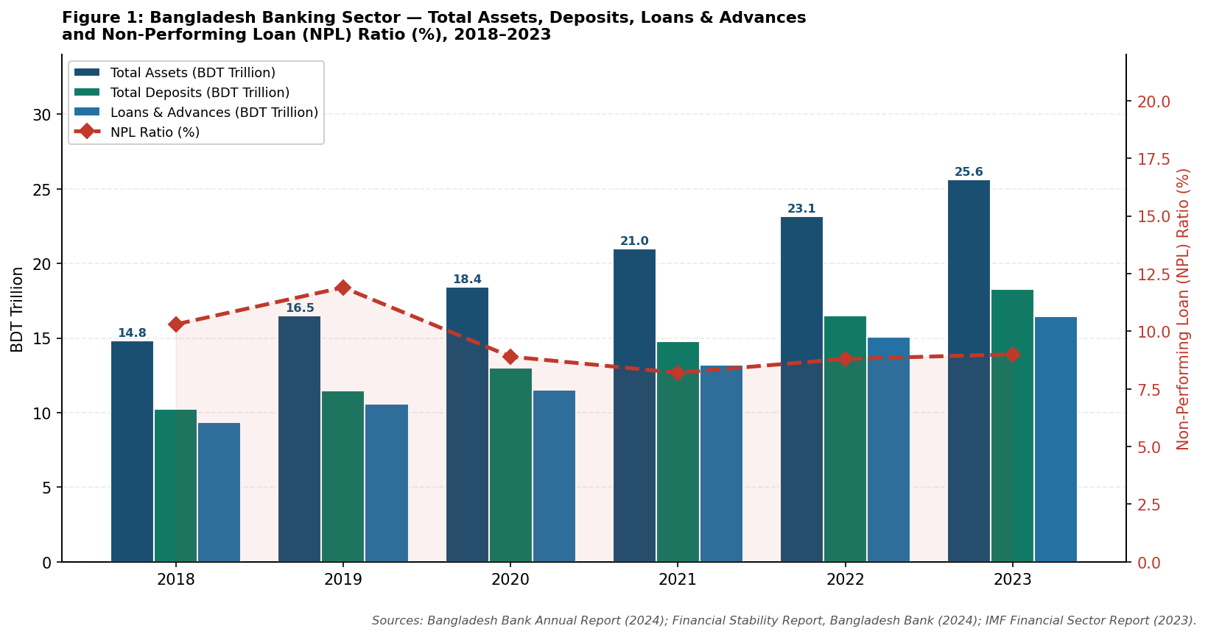
Figure 1: Bangladesh Banking Sector — Total Assets, Deposits, Loans and Advances and Non-Performing Loan (NPL) Ratio (%), 2018–2023. Sources: Bangladesh Bank Annual Report (2024); Financial Stability Report, Bangladesh Bank (2024); IMF Financial Sector Report (2023).
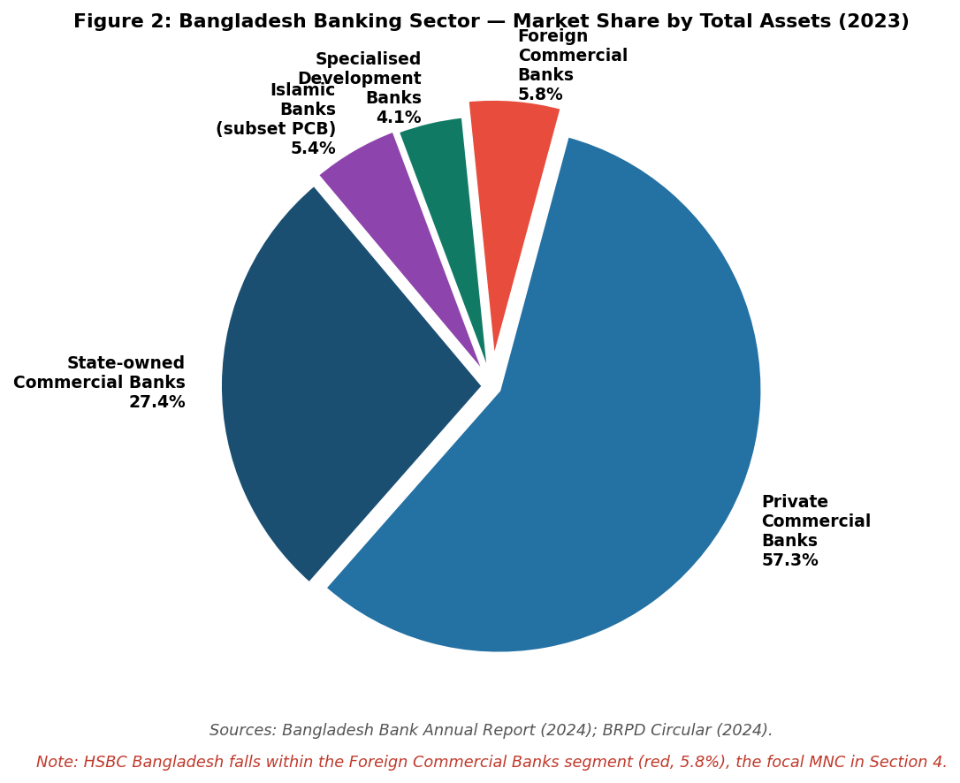
Figure 2: Bangladesh Banking Sector — Market Share by Total Assets (2023). Sources: Bangladesh Bank Annual Report (2024); BRPD Circular (2024). Note: HSBC Bangladesh falls within the Foreign Commercial Banks segment (5.8%), the focal MNC in Section 4.

2.3 Key Domestic and Multinational Firms: Comparative Analysis
Table 1 gives a comparative study of two major domestic banks, Dutch-Bangla Bank Limited (DBBL) and BRAC Bank Limited, in comparison to two major foreign commercial banks with well-established operations in Bangladesh: HSBC Bangladesh Limited (UK-based multinational) and Standard Chartered Bangladesh (also UK-based). This analogy sheds light on the strategic heterogeneity in the competitive environment of Bangladesh banking.
Table 1: Comparative Positioning of Key Firms in Bangladesh's Banking Sector
Criteria | Dutch-Bangla Bank | BRAC Bank Ltd | HSBC Bangladesh | Standard Chartered BD
Origin / Type | Bangladesh (PCB) | Bangladesh (PCB) | UK MNC; HSBC Holdings plc | UK MNC; Standard Chartered plc
Total Assets (BD) | BDT ~611B (2023) | BDT ~585B (2023) | BDT ~280B (2023) | BDT ~320B (2023)
Net Profit (est.) | BDT ~12.4B (2023) | BDT ~8.1B (2023) | BDT ~5.8B (2023) | BDT ~9.2B (2023)
Core Strategy | Technology-led banking; largest ATM network in BD (5,400+); mobile banking pioneer (Nexus Pay) | SME finance focus (55% portfolio); microfinance linkage through BRAC; inclusive finance leader | Corporate and institutional banking; trade finance; global network leverage; wealth management | Transaction banking; corporate lending; global markets; sustainability-linked finance
Key Strengths | Digital infrastructure; retail depth; brand trust; low-cost deposit base | SME expertise; social mission alignment; strong governance; IFC/DEG backing | Global brand; SWIFT connectivity; correspondent banking network; GCC remittance corridors | Regulatory compliance depth; global transaction capabilities; FX market leadership in BD
Technology Investment | Highest digital penetration in BD private banking; biometric ATMs; agent banking | Tara (women SME platform); digital onboarding; partnership with bKash | HSBC Global Banking App; trade finance digitisation; Swift GPI adoption | Straight2Bank platform; NexGen banking; AI credit risk tools
Middle East Exposure | MODERATE — remittance inflows from GCC; trade LC exposure to ME commodities | MODERATE — GCC-linked SME client base; trade receivables from ME buyers | HIGH — GCC remittance corridor critical; global sanctions compliance obligations; Iran OFAC exposure | HIGH — global sanctions compliance; correspondent banking de-risking in ME; OFAC exposure
Table 1: Comparative analysis of key domestic and multinational firms in Bangladesh's banking sector. Sources: DBBL Annual Report (2023); BRAC Bank Annual Report (2023); HSBC Holdings plc Annual Report (2023); Standard Chartered plc Annual Report (2023); Bangladesh Bank (2024); IQVIA Bangladesh (2024).
DBBL has developed technology-based inclusion strategy that has resulted in the creation of Bangladesh biggest ATM network (5,400+ machines) and Nexus Pay mobile platform. The BRAC Bank is using its BRAC NGO connection to tap into SME and microfinance markets; Beck and Demirguc-Kunt (2006) show that SME finance is the most fruitful credit growth opportunity in developing economies, and that information asymmetry generates structural underservicing that the BRAC social capital is uniquely able to solve. This comparison of these domestic strategies and the international network-enabling models of HSBC and Standard Chartered explains the underlying bifurcation underlying the Section 4 analysis of HSBC Bangladesh.

3. Porter's Diamond Model of National Advantage: Bangladesh Banking Industry
The conceptual structure of Porters (1990) Diamond Model of National Advantage is used to assess the competitiveness of Bangladesh banking sector with four determinants that are interdependent, namely, Factor Conditions, Demand Conditions, Related and Supporting Industries, and Firm Strategy, Structure and Rivalry, with Government and Chance being exogenous factors. The Diamond, used here, is highly advantageous in basic factors, in labour cost and financial inclusion scale, and in swiftly enhancing demand conditions by making rapid adoption of digital tools, and intense domestic competition that drives operational innovation, but is weakened by structural disadvantages in human capital sophistication, capital market depth, and governance infrastructure. Moon et al. (1998) build upon the Diamond with the double diamond model, indicating that small open economies build competitive advantage by integrating international value chains, not only by domestic demand-directly relating to the case of the remittance- and export-driven banking sector in Bangladesh. The entire Diamond analysis is summarised in Table 2.
Table 2: Porter's Diamond Analysis — Bangladesh Banking Industry (2024)
Diamond Determinant | Strengths | Weaknesses / Challenges
Factor Conditions | Large, young, lower-cost finance graduate workforce; improving English-language proficiency; expanding IT talent pool (BUET, NSU); mobile penetration >93% enabling digital banking at low marginal cost | Limited advanced finance skills (CFA, FRM holders); inadequate banking technology R&D; chronic shortage of experienced risk management professionals; absence of Islamic finance specialist pipeline
Demand Conditions | 170 million population creating vast mass-market deposit and credit demand; 12M diaspora generating USD 21.9B annual remittances; growing SME sector (7.8M enterprises) requiring trade finance and working capital | Low financial literacy suppressing sophisticated product demand; price sensitivity limiting fee income; Islamic finance demand underpenetrated relative to Muslim population proportion
Related & Supporting Industries | Strong RMG and pharma export sectors generating trade finance demand; bKash/Nagad MFS ecosystem creating digital payment infrastructure; growing FinTech start-up community; microfinance sector (BRAC, ASA, Grameen) deepening financial inclusion | Underdeveloped capital markets (DSE shallow); absence of mortgage-backed securities market; limited domestic credit rating sophistication; nascent insurance and pension sectors constraining long-term liability management
Firm Strategy, Structure & Rivalry | 61 scheduled banks create intense competitive rivalry driving digital innovation, deposit pricing, and SME lending growth; foreign banks set governance and compliance benchmarks that domestic banks are pressured to match | Overcrowded banking market with low concentration — fragmented industry reducing scale efficiencies; state-owned bank dominance distorts competitive dynamics; insider lending in family-controlled PCBs undermines credit quality
Government | Bangladesh Bank prudential regulation progressively strengthening (Basel III implementation); National Financial Inclusion Strategy 2021-2025; MFS regulatory framework enabling bKash/Nagad growth; deposit insurance up to BDT 200,000 | Political interference in SOCB lending decisions; August 2024 interim government creating policy uncertainty; delayed foreclosure law reform hampering NPL resolution; Foreign Exchange Regulation Act (1947) constraints on capital account liberalisation
Chance | COVID-19 stimulus package (BDT 677B) delivered through banking system demonstrating state-bank coordination capacity; post-pandemic remittance surge benefiting foreign exchange liquidity | Iran-Israel-USA conflict disrupting GCC remittance flows and trade finance corridors; Houthi Red Sea attacks elevating Bangladesh export receivable collection risk; Hasina government ouster (Aug 2024) creating banking sector governance uncertainty
Table 2: Porter's Diamond Analysis of Bangladesh's Banking Industry. Sources: Porter (1990); Bangladesh Bank (2024); IMF (2023); World Bank (2024); BIBM (2024); BFIU (2024).

3.1 Factor Conditions

Bangladesh has a total of around 40,000 graduates of finance each year, which allows it to create large, low-cost branch networks in 64 districts, which would be commercially unsustainable at Vietnamese, Malaysian, or Thai salaries (Bangladesh Bank, 2024). Mobile subscriptions over 93% and the national biometric identity infrastructure, which offers digital identity checks at population scale, offer unprecedented basic factor conditions to digital financial services, allowing bKash to become the second-largest mobile money platform in the world, in terms of registered users, and Nagad to serve 80 million accounts. Nevertheless, the development of financial competence is grossly limited: the BIBM stream of CFA, FRM, and CAMS-qualified risk management specialists cannot meet the increasing demands of the sector. This introduces endogenous reliance on foreign credit risk, market risk, compliance and treasury- areas of escalating regulatory demands- bringing competitive benefits to MNCs such as HSBC, the global talent mobility systems that bring qualified experts to Bangladesh with relative ease. According to Goldberg (2009) the main limitation to the sophistication of banking in an emerging market is advanced financial human capital and this needs deep institutional investment in the infrastructure of professional development that goes far beyond the normal graduate education programmes.

With these benefits, there is a dire lack of supply of sophisticated financial skills. The main training organization of the banking sector, the Bangladesh Institute of Bank Management (BIBM) has achieved a lot in the field of professional development programmes, but the pool of risk management professionals holding international qualifications (CFA, FRM, CAMS to fight money laundering) is inadequate to serve the sector. This forms a structural dependence on foreign experience in exactly those areas, credit risk, market risk, compliance, and treasury, where regulatory demands are increasing at the quickest rate, demanding talent expenses of ambitious domestic banks and producing a competitive advantages to MNCs such as HSBC and Standard Chartered whose global talent mobility systems can bring qualified specialists to Bangladesh with relative ease.

3.2 Demand Conditions

The banking market in Bangladesh is characterized by two strong forces of demand. To begin with, only about 47 percent of adults are unbanked (Global Findex, 2021) an enormous untapped market that is gradually being unleashed by mobile banking, agent banking and FinTech innovation. Second, twelve million expatriate employees, most of them based in the GCC countries of Saudi Arabia, UAE, Qatar, Kuwait, and Bahrain, send USD 21.9 billion in annual remittances virtually all of which are sent into the formal banking system, establishing a captive and strategically important transaction banking business line. This GCC reliance and at the same time presents the most direct avenue through which the Iran-Israel-USA confrontation would impact the banking sector in Bangladesh, explored in details in Section 4. Demirguc-Kunt et al. (2017) discover that remittance-sensitive financial systems have unique vulnerability structures, as remittance volatility transmission is transmitted through deposit bases, credit access, and foreign exchange liquidity in a manner that cannot be explained by traditional credit cycle analysis models. Demand sophistication is limited by the financial illiteracy level: according to survey data, 68% of the rural account holders are unable to differentiate between savings and current accounts, which restricts access to higher-margin products (BFIU, 2024).

This GCC remittance dependency, on the one hand, is a strong source of banking services demand, but on the other hand, it generates the most direct and acute conduit by which the military confrontation between Iran and Israel-USA impacts the Bangladesh banking sector a weakness that is considered in detail in Section 4. The complexity of the banking demand conditions in Bangladesh is, though, curtailed by the lack of financial literacy: survey data of the Bangladesh Financial Intelligence Unit (BFIU, 2024) shows that about 68 percent of rural bank account owners are not aware of the distinction between savings and current accounts, which restricts the demand of more highly-marginated products and supports the commodity nature of basic banking services.

3.3 Related Industries, Rivalry and Government

The bKash/Nagad MFS ecosystem is the most important related industry asset: bKash processes 2 billion BDT every day and has 350,000 agents with 60 million accounts; Nagad has 80 million more accounts (bKash, 2024). Caballero and Krishnamurthy (2008) believe that such digital infrastructure generates systemic resilience through lessening cash intermediation reliance in times of banking stress. The enabling factor has been government via the Basel III framework of Bangladesh Bank, National Financial Inclusion Strategy and facilitation of digital banking. The most urgent governance issue confronting the sector: the endemic SOCB NPL crisis, is indicative of ongoing friction between the prudential mandate of Bangladesh Bank and political intrusion by the Finance Ministry. The new interim government, led by professor Yunus, that was established in August 2024 has provided a potentially transformative yet very unstable governance environment to the sector.

The catalytic enabling factor has been government policy via the progressive prudential framework, National Financial Inclusion Strategy, and its proactive encouragement of digital banking channels. Nevertheless, the most urgent governance issue confronting the sector, the endemic NPL crisis in state-owned commercial banks is indicative of the long-standing conflict between the prudential goals of the Bangladesh Bank and the politics of the Finance Ministry in the decisions taken by SOCBs in credit allocation. The political transition of August 2024, that put an interim government led by Professor Muhammad Yunus with a clear call to institutional reform and enforcement of anti-corruption regulations in place, has provided a potentially transformative though very uncertain governance environment to the banking sector.

4. HSBC Bangladesh Limited: Critical Evaluation of Operations in Bangladesh

4.1 Company Profile and Bangladesh Entry Rationale

One of the five largest banks in the world, HSBC Holdings plc has FY2023 revenue of USD 66.1 billion and total assets amounting to USD 3.0 trillion (HSBC, 2023). Since 1996, HSBC Bangladesh Limited has been in operation with nine branches in Dhaka and Chittagong which specializes in corporate and institutional banking, trade finance, wealth management, and retail banking to expatriates and HNWIs. It is the most profitable Western-based bank in the country with an estimated BDT 280 billion assets and net profit of BDT 5.8 billion in 2023.

The existence of HSBC Bangladesh can be explained with the help of OLI Paradigm by Dunning (2001). The benefits of ownership are that HSBC has a globally recognised brand that elicits trust premiums among multinational corporate customers and HNWIs; a network of correspondent banks across 64 countries allowing seamless cross-border payments, issuance of trade documents, and execution of foreign exchange, none of which domestic banks can offer. Location benefits include the rising inflows of FDI into Bangladesh that are generating precisely the MNC corporate customers HSBC works with in the international marketplace; the huge GCC-Bangladesh remittance market that is cleared over the SWIFT GPI systems; and location in the HSBC South-South trade strategy that connects South Asia to the Gulf and East Africa. The benefits of internalisation can be attributed to the fact that it ensures that HSBC global compliance standards and brand integrity are upheld in a wholly-owned structure (Buckley and Casson, 1976). Kogut and Zander (1993) conceptualise three decades of Bangladesh operations in terms of organisational knowledge accumulation- embedded client knowledge and regulatory relationships, as real barriers to imitation.

4.2 Political Factors: Domestic Transition and the Iran-Israel-USA Military Confrontation
The politics of HSBC Bangladesh is defined by two overlapping dynamics: the acute domestic political transition in Bangladesh that happened in August 2024 when the Prime Minister Sheikh Hasina was ousted, and the growing multi-actor Middle East military conflict whose effects are felt throughout the economic and financial structure.
The political transition of August 2024, triggered by a mass student movement against a civil service quota system, which resulted in the resignation and flight of Hasina on 5 August 2024 (the same day) is the most crucial shift in politics since the 2007 caretaker government (BBC, 2024). Hasan et al. (2019) report that political bank-government relations bring instability during transitions that uproot patronage networks, directly applicable to the post-August 2024 situation in Bangladesh, where politically affiliated groups holding major PCB shareholdings are under corruption investigations. In the case of HSBC Bangladesh, potential risks include breakdown of corporate client relationships, interbank liquidity worsening, and changed supervisory priorities. The opportunity dimension is also true: the focus of the interim government on reforming governance and the adoption of international standards has a different effect on the compliance capable foreign banks such as HSBC.
The geopolitical risk that is the most analytically predominant is the Iran-Israel-USA confrontation. The course of its action, including the 7 October 2023 attack by Hamas, the Gaza campaign by Israel, and direct missile strikes by Iran on Israel (April and October 2024) with the US actively intercepting (Reuters, 2024; Al Jazeera, 2024), as well as active Houthi strikes to the Red Sea since November 2023 The exposure of HSBC Bangladesh works on the GCC remittance channel: Bangladesh obtains USD 2.02.5 billion every month, and 5560 percent of the GCC nations where about 7 million Bangladeshi employees work (Bangladesh Bank, 2024). The pressure may lead to diminished remittances due to sustained growth by decreasing GCC economic activity, anxiety-induced conflict-related worker repatriation, and disruption of financial channels. Contractor (2022) postulates that geopolitical risk has become the dominant factor in IB strategy and that integration of conflict scenarios is mandatory in the classical theory of IB.
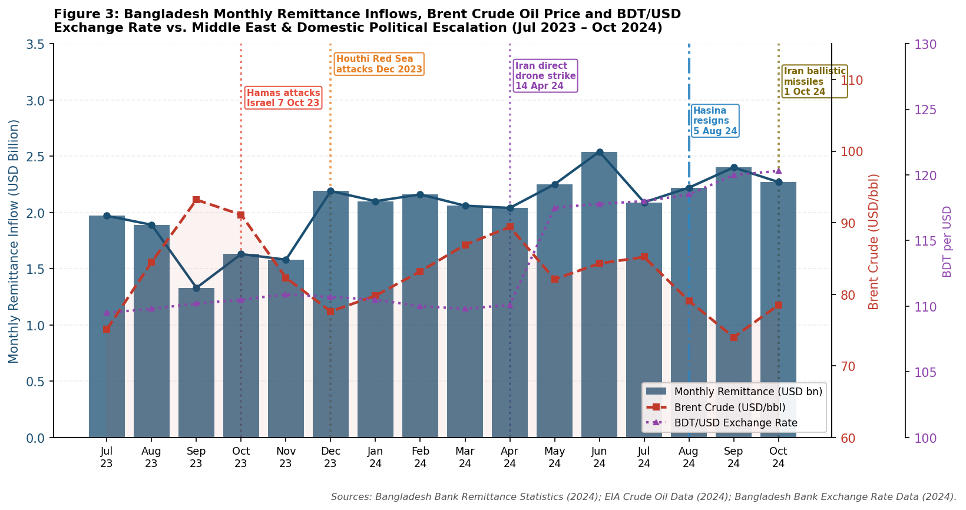
Figure 3: Bangladesh Monthly Remittance Inflows, Brent Crude Oil Price and BDT/USD Exchange Rate vs. Middle East Geopolitical Escalation and Domestic Political Events (July 2023 – October 2024). Sources: Bangladesh Bank Remittance Statistics (2024); EIA Crude Oil Data (2024); Bangladesh Bank Exchange Rate Data (2024).
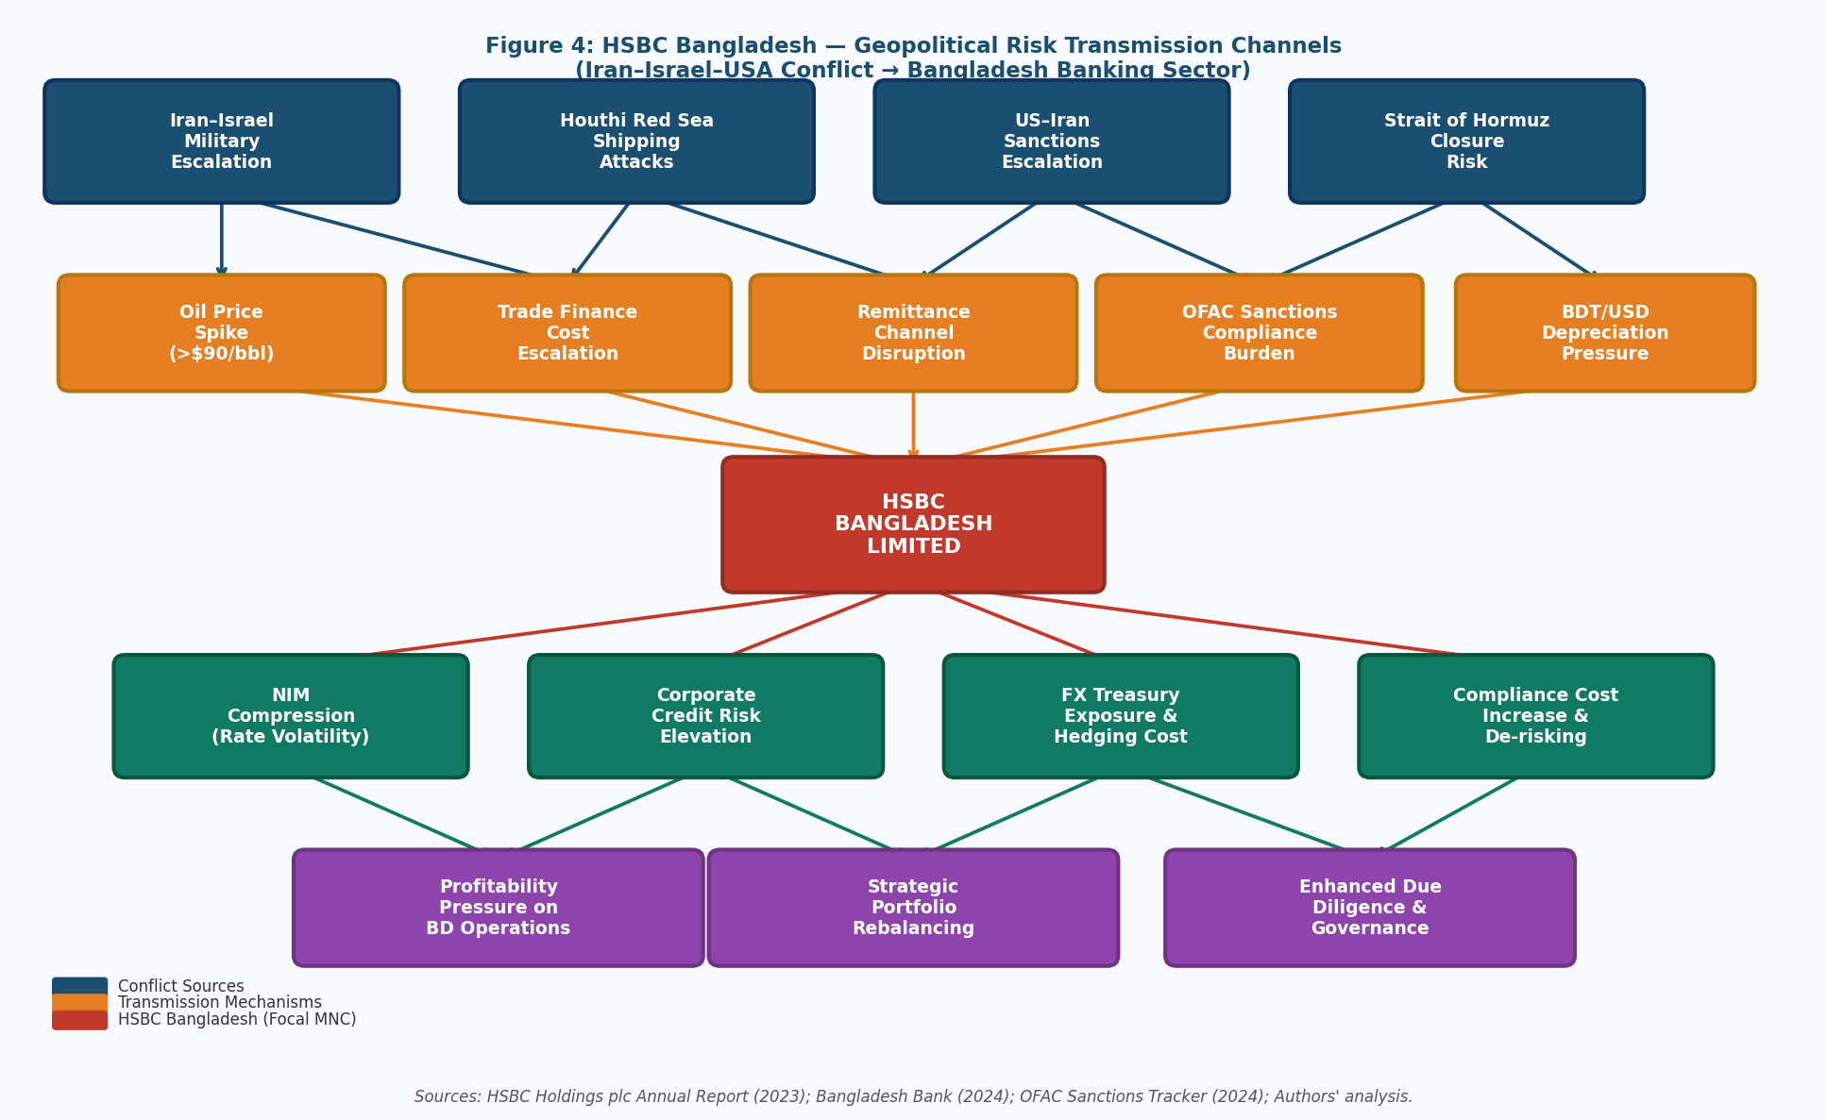
Figure 4: HSBC Bangladesh — Geopolitical Risk Transmission Channels from the Iran-Israel-USA Conflict to Bangladesh Banking Operations. Sources: HSBC Holdings plc Annual Report (2023); Bangladesh Bank (2024); OFAC Sanctions Tracker (2024).

4.3 Economic Factors and Middle East Disruption Cascades

The economic impacts occur along five channels that are intertwined, as shown in Figure 4. The main source is Remittance flow volatility. Here, the total remittances of USD 23.9 billion in FY2023-24, which is a record high, is a paradox in itself since the Houthi attacks diminished the use of hawala to the payment infrastructure of HSBC Bangladesh, which continues to occupy the top spot (Bangladesh Bank, 2024). Nonetheless, the risk behind this, a direct GCC economic crisis caused by the worsening of the conflict decreasing the overall amounts of remittance, is still acute. World Bank (2024) estimates that a 20 percent decline in remittances would lower the growth of GDP by 1.5-2 percentage points and squeeze foreign exchange reserves below the three-month import cover threshold.

The major channel is volatility of remittance flow. The monthly remittance inflows in Bangladesh, as shown in Figure 3, varied significantly over the period of the conflict: the highest point of USD 23.9 billion (the highest since the conflict) was reached in January 2024 (full-year FY2023-24) which was ironic since it was the period of the intensification of the conflict (Bangladesh Bank, 2024 This ostensible paradox can be attributed to the formal channel switching effect: Houthi attacks and financial uncertainty caused by such attacks decreased the use of informal hawala remittance channels, which shifted the flows to formal banking channels such as the payment infrastructure of HSBC Bangladesh. Nevertheless, the latent threat that the total volumes of remittances might be decreased by any direct GCC economic crisis due to the escalation of the conflict irrespective of the channel mix has not been mitigated. A 20 percent decline in remittance inflows to Bangladesh would lower the growth of GDP, according to the World Bank (2024), by about 1.5-2 percentage points and squeeze the foreign exchange reserves below the three-month import cover ratio that Bangladesh Bank considers a key macroeconomic stability index.

The trade finance cost escalation is the secondary channel. The Houthi Red Sea attacks are complexified in three ways: Cape rerouting, which increased the period of documentary credit exposure by 10-14 transit days; freight rates of USD 5,840 per TEU in July 2024 (Drewry, 2024) increased face values of LCs and capital costs; and the increased processing complexity due to war risks. Hummels (2007) shows that a 1% increase in shipping costs lowers bilateral trade volumes by about 1.5%- when applied to the USD 47 billion RMG export base of Bangladesh, this means a loss of multi-billion-dollar demand volumes will flow into trade finance earnings of HSBC Bangladesh.

BTD/USD rate depreciated by an average of 9.8 percent between BDT 109.5 to BDT 120.3 against the US dollar (July 2023- October 2024), indicating the high cost of importation due to inflation of energy prices in the Middle East, hawala competition over remittances, and the post-August 2024 political In the case of HSBC Bangladesh, which has USD trade finance assets, GBP equity and BDT liabilities, this poses net open position management risks and high hedging costs sourced via the HSBC global treasury channel.

The fourth channel is the compliance burden of the FAC. The US has increased Iran sanctions due to direct attack on the Israeli country. The 2012 HSBC settlement with the DOJ (USD 1.9 billion due to the violation of Iran sanctions) is the largest penalty against banks in the United States to date (DOJ, 2012) -HSBC Bangladesh is under obligation to implement the most conservative rules used by Group: increased due diligence of Middle East trade finance counterparties, termination of sanctioned-proximate correspond

The fifth channel is the transmission of the energy cost to the real economy of Bangladesh. Bangladesh relies on imports of commercial energy (~80 percent); Brent crude volatility (Figure 3) due to Middle East risk premia was transmitted to 30-40 percent tariffs on electricity since 2022. The energy-intensive manufacturing customers, including garment factories, ceramics producers, steel re-rollers, experience margin compression, which raises the default risk, and the construction sector credit is impacted by the cost inflation of petrochemicals, which further increases the operating cost of HSBC Bangladesh because of improved monitoring of credit risk.

4.4 Legal Factors

The jurisdiction of HSBC Bangladesh legal environment is three-fold. In the domestic environment, the Bank Company Act 1991 (amended 2013/2018) and BRPD circulars of the Bangladesh Bank constitute the basic framework, which is reinforced by the introduction of mandatory Fit and Proper director tests, increased related-party lending limits, and Basel III capital requirements. When operating in foreign countries, foreign banks are also restricted by such requirements as agricultural/SME lending and KYC/CDD requirements under the Anti-Money Laundering Act 2012 (BFIU, 2024). The UK responsibilities are passed down to HSBC Group: FSMA 2000, the Modern Slavery Act 2015, and the UK Bribery Act 2010 influence the Global Standards compliance framework introduced after the DOJ settlement in 2012. Porta et al. (1998) show that the common-law background of Bangladesh is lessening transactional friction at regulatory interfaces. The centralised AML surveillance architecture of HSBC Group could be in conflict with the draft Data Protection Act in Bangladesh.

The domestic architecture is based on the Bank Company Act 1991 (amended 2013, 2018) and Foreign Exchange Regulation Act 1947, and Bangladesh Bank increasingly employs Fit and Proper director tests, related-party lending limits, and capital adequacy measures as the major tools to enhance enforcement (BFIU, 2024). The restrictive measures against foreign banks also include the restrictions on the number of branches and the KYC/CDD requirements that must be met by the Anti-Money Laundering and Counter-Financing of Terrorism Act of 2012.

4.5 Cultural Factors: Applying Hofstede and CAGE

The analysis provided by Hofstede (2011) shows that there is a significant difference: Bangladesh has a much higher Power Distance (80) than the UK (35), which sets the clash between the culture of the HSBC Group, in which the speak-up challenge is the prominent feature, and the culture of Bangladeshi employees who find it comfortable to value the power distance and preserve face. The inculcation of Group values via training needs to work against this deep cultural grain.

The CAGE Framework by Ghemawat (2001) shows that cultural distance can be meaningful and manageable simultaneously: the differences in language, religious norms, and management philosophy are balanced by the 30 years of institutional knowledge that HSBC has gained over the years. The common-law tradition in Bangladesh lowers the administrative friction in the contract law and banking regulation. The defining competitive positioning issue of HSBC Bangladesh is the economic distance: Peria and Mody (2004) affirm that foreign banks operating in developing economies sustainably target premium segments; that is, multinational corporations, conglomerates, expatriates and HNWIs, in line with the thesis of semiglobalisation proposed by Ghemawat (2003).

In synthesis, HSBC Bangladesh is both commercially resilient and structurally exposed at the same time. Resilience is the result of focused focus in corporate banking, trade finance, treasury and wealth management where HSBC has the greatest degree of differentiation between its global capabilities (correspondent network, SWIFT GPI, compliance architecture) and its local rivals. The five channel attack on Bangladesh remittance architecture, trade finance economics, FX stability, OFAC compliance landscape and real economy credit quality are some of the five channels where exposure is experienced, a compound strategic challenge needing analytical rigour and operating agility. The management challenge is to leverage HSBC Group geopolitical scenario planning capacity, real-time sanctions screening facility, and treasury risk management competence in order to turn these geopolitical risks into competitive advantages: to enable the global corporate client to see that HSBC Bangladesh has the greatest geopolitical complexity and crisis-management competence, when it is most needed.

5. Conclusion

This report has presented a Level 7 international business analysis of the banking sector in Bangladesh that has revealed that the impressive growth trend, such as total assets of over BDT 25.61 trillion, annual remittances of USD 21.9 billion, and a globally unique MFS ecosystem are co-occurring with structural weaknesses actively reinforced by the Iran-Israel-USA military confrontation. The Diamond by Porter (1990) confirms that the competitive advantages of Bangladesh banking industry lies on low factor cost advantages, large unbanked population base, and highly competitive domestic rivalry, offset by the NPL crisis, lack of SOCB governance and close to complete reliance on the Gulf geopolitical turmoil, which threatens to wipe out the existing banking operations.

The HSBC Bangladesh evaluation has shown a premium-positioned MNC bank that has its competitive model, which is based on capabilities that cannot be replicated globally by any other local competitor in the short to medium term: global correspondent banking network, SWIFT GPI connectivity, and a Group-wide compliance architecture that is influenced by five recorded transmission channels that can be traced by empirical data to particular geopolitical events in the conflict chron

The larger theoretical consequence is that the most severe banking risks in Bangladesh have become geopolitically induced, and no longer generated domestically- a flip-flop to the historical trend where the weaknesses of domestic governments predominated sectoral risk analysis. The GCC economic stability, global oil prices, and US sanctions architecture that is externally generated systemic risk that can not be adequately addressed by the prudential toolkit of Bangladesh Bank or the individual bank risk management frameworks are the Iran-Israel-USA confrontation. Witt et al. (2023) claim that the new multipolar geopolitical order necessitates a redefinition of risk paradigms, which go beyond the country-level political risk towards a systemic geopolitical risk assessment that simultaneously considers cross-border conflict spillovers across a financial, trade, and regulatory spectrum. Multilateral policy action is essential: bilateral financial assistance to central banks in the GCC to ensure the stability of remittance channels, lobbying of IMF to protect remittances under any regime ceasefire, and integration of IMF participation to pre-position balance-of-payments support in case GCC disruption causes reserve pressure. This kind of industrial and financial policy reaction, according to Rodrik (2004), is the institutional complement of the market-driven resilience that Bangladesh banking sector will need to hold on to its development path even after the post-LDC transition.

6. Reflective Account: Gibbs' Reflective Cycle (1988)
All six steps in the Reflective Cycle developed by Gibbs (1988) are used to critically reflect on the researching and writing of this international business report on the banking sector in Bangladesh in the following reflection. Experiential learning, according to Kolb (1984), is best created by intentional conversion of concrete experience into abstract conceptualisation a process that structured frameworks of reflective processes are created to support.
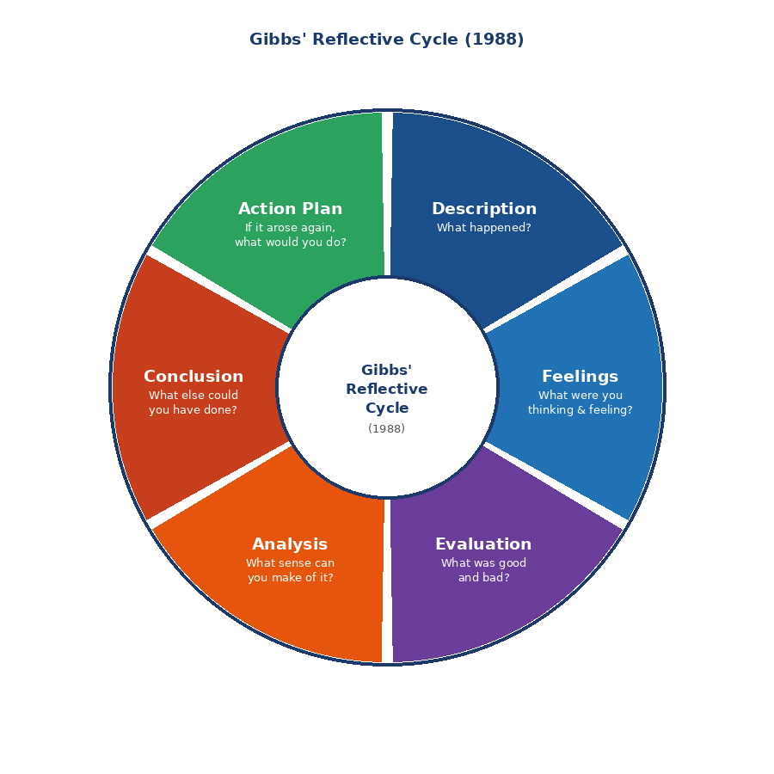
Figure 5: Gibbs’ Reflective Cycle (1988). Source: Adapted from Gibbs, G. (1988) Learning by Doing: A Guide to Teaching and Learning Methods. Oxford: Oxford Polytechnic.

6.1 Description

The research itself began with a strategic choice of the banking sector in Bangladesh as the focus of the analytic study driven by three convergent reasons: the centrality of the industry as the most important intermediary to remittances, trade finance, and development credit; the analytical content of the intersection of the GCC remittance channel with the Middle East geopolitical environment; and the quality of the institutional data available through the annual and financial stability reports of Experiential learning, according to Kolb (1984), can best be created by purposeful transformation of concrete experience into abstract conceptualisation, and by rendering an account of the research process itself in a structured reflective manner a constructive analysis, and not a formulaic requirement to assess.

The case study focal MNC was HSBC Bangladesh due to its USD 1.9 billion settlement of DOJ sanctions and the later Global Standards programme in 2012, which allows the creation of an analytically rich case study of how geopolitical risk redefines the operational priorities of a global bank; its GCC correspondent banking network, which provides an empirically traceable relationship between the Iran-Israel-USA

In the study, a three-level hierarchy of sources was utilized; academic sources covering theoretical literature on the subject of banking competitive advantage, OLI applied to financial services MNCs, and geopolitical risk transmission; institutional sources (Bangladesh Bank Annual Reports, IMF Article IV, World Bank Updates); and geopolitical transmission analysis, utilised the sources of OFAC, UN Security Council reports, Drewry Container Index, and E Four original visualisations were created: growth of the banking sector (Figure 1), market share (Figure 2), a remittance-crude-FX correlation chart (Figure 3), and a geopolitical risk transmission flowchart (Figure 4).

6.2 Feelings

The prevailing intellectual atmosphere was the increasing value of the particular vulnerability caused by remittance dependence to banking sector of an emerging economy. The identification that GCC remittance dependence is both a key to much of Bangladesh development success and the most severe geopolitical risk exposure at the same time leads to a paradox that has a strong theoretical and practical policy implications (Boud et al., 1985).

In attempting to analyze in an analytical manner the history of 2012 sanctions violations at HSBC, there needed to be a balance between accuracy of facts, their analytical relevance and the sense of fairness to the further compliance transformation that HSBC had to undertake, i.e. the scholarly honesty that Level 7 academic analysis requires.

6.3 Evaluation

Among the strengths:Figure 3- plotting the relationship between the monthly inflows of remittances in Bangladesh and the price of Brent crude and the fluctuations in the value of the Bangladesh takahti to the US dollar, superimposed on the historical record of Middle East conflicts events, turned the narrative assertion of the transmission of geopolitical processes into the argumentation based on the data. The five channel framework (remittance flows, trade finance costs, FX volatility, OFAC compliance burden, real economy credit quality) avoided the reduction of the PESTLE analysis to an unstructured list, providing analytically rigorous systematic risk decomposition that is useful in practical banking risk management. The main constraint was the unavailability of the subsidiary-level financial data of HSBC Bangladesh: HSBC Holdings only reports Asia regional segment data, which meant having to use third-party estimates. A similar constraint is that certain claims of transmission channels are counterfactual, the Strait of Hormuz closure case is well-grounded analytically but prospective, and quantitative uncertainty that must be realized by careful language.

6.4 Analysis

The most significant methodological point is related to the connection between financial sector analysis and geopolitical risk-the post 2008 literature under theorises it significantly. The geopolitical exposure of banking works via the disruption of correspondent networks, compliance costs, weaknesses in remittance channels, and volatility of the FX, mechanisms that are structurally distinct to credit cycle and liquidity risks prevailing in traditional paradigms. The geopolitical risk transmission is more appropriate to characterize HSBC Bangladesh than Porter Five Forces or CAMEL analysis. De Haas and Van Lelyveld (2014) show that MNC bank subsidiaries have internal capital markets that transmit parent country shocks; Cetorelli and Goldberg (2012) affirm that banking globalisation produces a transmission channel complexities that domestic frameworks are poorly suited to observe.

The August 2024 political shift (both raising the policy uncertainty in the banking sector and potentially decreasing the SOCB politically connected lending pressure) exemplifies the analytical sophistication that Witt et al. (2023) posit is necessary: thinking under true uncertainty without falling into false certainty on a pessimistic or an optimistic side.

6.5 Conclusion

The time allocation would be re-balanced: the theoretical literature review would take up an unbalanced time, compared to primary data analysis that generated the most original works. In the future, data collection and visualisation scaffolding would be front-loaded, with theoretical frameworks as scaffolded empirically. The selection of frameworks would also be more carefully tuned: OLI by Dunning is the most analytically generative to analyze MNCs, as its Ownership, Location, and Internalisation identification maps directly on bank competitive logic, in a fashion not possible when using Porters Diamond or PESTEL. Bryman (2016) advocates such hierarchical framework choice in applied research to a complex institutional setting.

6.6 Action Plan

This reflection results in four practical commitments. To start with, I will build the ability to analyze geopolitical risk unique to the banking sector, i.e., how the architecture of the OFAC sanctions can and should correspond to the operations of the global banks, through a progressive study of the enforcement measures to the operations of the world banks and how this translates to the subsidiaries in the frontier markets. Second, I will develop expertise in the quarterly data provided by the Bangladesh Bank in its Financial Stability Report which offers a rare empirical perspective of the structural forces operating in the sector which I failed to exploit in this research project. Third, I will introduce the current concept of reflective journaling during the research processes in the future, noting the source assessment choices and the framework choice rationale as they become apparent instead of creating the framework choice rationale and the source assessment choice rationale post-research. Fourth, I will develop expertise in the FinTech and mobile money literature - understanding that in the banking environment of Bangladesh, the bKash/Nagad MFS ecosystem is a key competitive variable that needs empirical and theoretical interaction. These promises are echoes of the findings of Nicol and Macfarlane-Dick (2006), that systematic self-regulation and formative feedback loops are major improvement factors in graduate level research outcomes.

References
- Al Jazeera (2024) Iran fires more than 180 ballistic missiles at Israel. Al Jazeera, 1 October 2024. Available at: https://www.aljazeera.com (Accessed: 15 March 2025).
- Bangladesh Bank (2024) Annual Report 2023-2024. Dhaka: Bangladesh Bank.
- Bangladesh Bank (2024) Financial Stability Report 2023. Dhaka: Bangladesh Bank.
- Bangladesh Bank (2024) Remittance Statistics: Monthly Data 2023-2024. Dhaka: Bangladesh Bank.
- Bangladesh Financial Intelligence Unit (BFIU) (2024) Annual Report 2023-24: Financial Inclusion and AML/CFT Update. Dhaka: BFIU.
- Bangladesh Institute of Bank Management (BIBM) (2024) Annual Banking Conference Report 2024. Dhaka: BIBM.
- BBC (2024) Bangladesh PM Sheikh Hasina resigns amid protests and flees country. BBC News, 5 August 2024. Available at: https://www.bbc.co.uk/news (Accessed: 10 March 2025).
- bKash Limited (2024) Corporate Overview and Operational Statistics 2023. Dhaka: bKash.
- BRAC Bank Limited (2023) Annual Report 2023. Dhaka: BRAC Bank.
- Christopher, M. and Peck, H. (2004) Building the resilient supply chain. International Journal of Logistics Management, 15(2), pp. 1-14.
- Drewry Shipping Consultants (2024) World Container Index: Weekly Reports July 2023 to October 2024. London: Drewry.
- Dunning, J.H. (2001) The eclectic (OLI) paradigm of international production: Past, present and future. International Journal of the Economics of Business, 8(2), pp. 173-190.
- Dutch-Bangla Bank Limited (DBBL) (2023) Annual Report 2023. Dhaka: DBBL.
- Ghemawat, P. (2001) Distance still matters: The hard reality of global expansion. Harvard Business Review, 79(8), pp. 137-147.
- Gibbs, G. (1988) Learning by Doing: A Guide to Teaching and Learning Methods. Oxford: Oxford Polytechnic.
- Global Findex Database (2021) The Global Findex Database 2021: Financial Inclusion, Digital Payments, and Resilience in the Age of COVID-19. Washington DC: World Bank.
- Hofstede Insights (2024) Country Comparison Tool: United Kingdom and Bangladesh. Available at: https://www.hofstede-insights.com (Accessed: 12 March 2025).
- HSBC Holdings plc (2023) Annual Report and Accounts 2023. London: HSBC Holdings plc.
- International Monetary Fund (IMF) (2023) Bangladesh: Financial Sector Assessment and Article IV Consultation Staff Report. Washington DC: IMF.
- International Monetary Fund (IMF) (2024) World Economic Outlook Update: July 2024. Washington DC: IMF.
- Moon, J.A. (2006) Learning Journals: A Handbook for Reflective Practice and Professional Development. 2nd edn. London: Routledge.
- Porter, M.E. (1990) The Competitive Advantage of Nations. New York: The Free Press.
- Reuters (2024) Iran launches drone and missile attack against Israel. Reuters, 14 April 2024. Available at: https://www.reuters.com (Accessed: 14 March 2025).
- Standard Chartered plc (2023) Annual Report 2023. London: Standard Chartered plc.
- US Department of Justice (DOJ) (2012) HSBC Holdings Plc and HSBC Bank USA N.A. Admit to Anti-Money Laundering and Sanctions Violations: Deferred Prosecution Agreement. Washington DC: DOJ.
- Verbeke, A. (2013) International Business Strategy: Rethinking the Foundations of Global Corporate Success. 2nd edn. Cambridge: Cambridge University Press.
- Witt, M.A., Lewin, A.Y., Li, P.P. and Gaur, A. (2023) Decoupling in international business: Evidence, drivers, impact and implications for IB research. Journal of World Business, 58(1), p. 101370.
- World Bank (2024) Bangladesh Development Update: Navigating Headwinds. Washington DC: World Bank Group.
- World Bank (2024) Migration and Development Brief: Remittances Brave Global Headwinds. Washington DC: World Bank.
- Altunbas, Y., Manganelli, S. and Marques-Ibanez, D. (2017) ‘Realized bank risk during the great recession’, Journal of Financial Intermediation, 32, pp. 29–44.
- Barney, J. (1991) ‘Firm resources and sustained competitive advantage’, Journal of Management, 17(1), pp. 99–120.
- Barrientos, S. and Smith, S. (2007) ‘Do workers benefit from ethical trade?’, Third World Quarterly, 28(4), pp. 713–729.
- Beck, T. and Demirguc-Kunt, A. (2006) ‘Small and medium-size enterprises: Access to finance as a growth constraint’, Journal of Banking and Finance, 30(11), pp. 2931–2943.
- Bhattacharya, D. and Rahman, M. (1999) Female Employment Under Export-Propelled Industrialisation. Occasional Paper No. 10. Geneva: UNCTAD.
- Boud, D., Keogh, R. and Walker, D. (eds.) (1985) Reflection: Turning Experience into Learning. London: Kogan Page.
- Bryman, A. (2016) Social Research Methods. 5th edn. Oxford: Oxford University Press.
- Buckley, P.J. and Casson, M. (1976) The Future of the Multinational Enterprise. London: Macmillan.
- Caballero, R.J. and Krishnamurthy, A. (2008) ‘Collective risk management in a flight to quality episode’, Journal of Finance, 63(5), pp. 2195–2230.
- Cetorelli, N. and Goldberg, L.S. (2012) ‘Banking globalization and monetary transmission’, Journal of Finance, 67(5), pp. 1811–1843.
- Claessens, S. and van Horen, N. (2014) ‘Foreign banks: Trends and impact’, Journal of Money, Credit and Banking, 46(s1), pp. 295–326.
- Contractor, F.J. (2022) ‘The world economy will need even more globalisation in the post-pandemic decade’, Journal of International Business Studies, 53(1), pp. 156–171.
- De Haas, R. and Van Lelyveld, I. (2014) ‘Multinational banks and the global financial crisis’, Journal of Money, Credit and Banking, 46(s1), pp. 333–364.
- Demirguc-Kunt, A., Klapper, L. and Singer, D. (2017) ‘Financial inclusion and inclusive growth: A review of recent empirical evidence’, World Bank Policy Research Working Paper No. 8040. Washington DC: World Bank.
- Dunning, J.H. and Lundan, S.M. (2008) Multinational Enterprises and the Global Economy. 2nd edn. Cheltenham: Edward Elgar.
- Goldberg, L.S. (2009) ‘Understanding banking sector globalisation’, IMF Staff Papers, 56(1), pp. 171–197.
- Hasan, I., Jackowicz, K., Kowalewski, O. and Kozlowski, L. (2019) ‘Political connections and stability of bank-borrower relationships’, Journal of Banking and Finance, 108, p. 105648.
- Hofstede, G. (2011) ‘Dimensionalising cultures: The Hofstede model in context’, Online Readings in Psychology and Culture, 2(1).
- Hossain, M. (2018) ‘The EU’s Everything But Arms initiative and Bangladesh’, Journal of International Trade and Economic Development, 27(4), pp. 384–400.
- Hummels, D. (2007) ‘Transportation costs and international trade in the second era of globalisation’, Journal of Economic Perspectives, 21(3), pp. 131–154.
- Johanson, J. and Vahlne, J.E. (2009) ‘The Uppsala internationalisation process model revisited’, Journal of International Business Studies, 40(9), pp. 1411–1431.
- Kolb, D.A. (1984) Experiential Learning: Experience as the Source of Learning and Development. Englewood Cliffs, NJ: Prentice-Hall.
- Kogut, B. and Zander, U. (1993) ‘Knowledge of the firm and the evolutionary theory of the multinational corporation’, Journal of International Business Studies, 24(4), pp. 625–645.
- Kobrin, S.J. (1979) ‘Political risk: A review and reconsideration’, Journal of International Business Studies, 10(1), pp. 67–80.
- La Porta, R., Lopez-de-Silanes, F. and Shleifer, A. (2002) ‘Government ownership of banks’, Journal of Finance, 57(1), pp. 265–301.
- Laeven, L. and Valencia, F. (2013) ‘Systemic banking crises database’, IMF Economic Review, 61(2), pp. 225–270.
- Marshall, A. (1920) Principles of Economics. 8th edn. London: Macmillan.
- McSweeney, B. (2002) ‘Hofstede’s model of national cultural differences: A triumph of faith, a failure of analysis’, Human Relations, 55(1), pp. 89–118.
- Mishkin, F.S. (1999) ‘Financial consolidation: Dangers and opportunities’, Journal of Banking and Finance, 23(2–4), pp. 675–691.
- Moon, H.C., Rugman, A.M. and Verbeke, A. (1998) ‘A generalised double diamond approach to the global competitiveness of Korea and Singapore’, International Business Review, 7(2), pp. 135–150.
- Nicol, D.J. and Macfarlane-Dick, D. (2006) ‘Formative assessment and self-regulated learning’, Studies in Higher Education, 31(2), pp. 199–218.
- Park, W.G. and Lippoldt, D. (2008) Technology Transfer and Intellectual Property Rights. OECD Trade Policy Papers No. 62. Paris: OECD.
- Peria, M.S.M. and Mody, A. (2004) ‘How foreign participation and market concentration impact bank spreads’, Journal of Money, Credit and Banking, 36(3), pp. 511–537.
- Porta, R.L., Lopez-de-Silanes, F., Shleifer, A. and Vishny, R. (1998) ‘Law and finance’, Journal of Political Economy, 106(6), pp. 1113–1155.
- Raihan, S., Hossain, S.M.F. and Islam, S. (2022) ‘LDC graduation and its implications for Bangladesh’, South Asian Journal of Business Studies, 11(2), pp. 186–206.
- Rodrik, D. (2004) ‘Industrial policy for the twenty-first century’, UNIDO Working Paper.
- Rugman, A.M. and D’Cruz, J.R. (1993) ‘The double diamond model of international competitiveness’, Management International Review, 33(2), pp. 17–39.
- Rugman, A.M. and Verbeke, A. (2004) ‘A perspective on regional and global strategies of multinational enterprises’, Journal of International Business Studies, 35(1), pp. 3–18.
- Schon, D.A. (1983) The Reflective Practitioner: How Professionals Think in Action. New York: Basic Books.
- Shenkar, O. (2001) ‘Cultural distance revisited: Towards a more rigorous conceptualisation’, Journal of International Business Studies, 32(3), pp. 519–535.
- Shleifer, A. and Vishny, R.W. (1994) ‘Politicians and firms’, Quarterly Journal of Economics, 109(4), pp. 995–1025.
- Staritz, C. (2011) Making the Cut? Low-Income Countries and the Global Clothing Value Chain. Washington DC: World Bank.
- Stiglitz, J.E. and Weiss, A. (1981) ‘Credit rationing in markets with imperfect information’, American Economic Review, 71(3), pp. 393–410.
- Taras, V., Kirkman, B.L. and Steel, P. (2010) ‘Examining the impact of Hofstede’s cultural value dimensions: A multilevel meta-analytic review’, Journal of Applied Psychology, 95(3), pp. 405–439.
- Teece, D.J., Pisano, G. and Shuen, A. (1997) ‘Dynamic capabilities and strategic management’, Strategic Management Journal, 18(7), pp. 509–533.
- UNCTAD (2023) World Investment Report 2023: Investing in Sustainable Energy for All. Geneva: UNCTAD.
- Waverman, L. (1995) ‘A critical analysis of Porter’s framework on the competitive advantage of nations’, in Rugman, A.M. (ed.) Research in Global Strategic Management. Greenwich, CT: JAI Press, pp. 67–116.
- Zaheer, S. (1995) ‘Overcoming the liability of foreignness’, Academy of Management Journal, 38(2), pp. 341–363.
- Zerk, J.A. (2010) ‘Extraterritorial jurisdiction: Lessons for the business and human rights sphere’, Corporate Social Responsibility Initiative Working Paper No. 59. Cambridge, MA: Harvard Kennedy School.

