Professional Career Development in Health and Social Care (LCHS 4009)

ASSIGNMENT 2

Personal Development Portfolio

Name of Student: Khrystyna Yastremska

I.D. Number: 2509328

Name of Tutor: Cristopher Mafuva

Table of Contents
Introduction 3
Task 1 of 4 CV 4
Task 2 of 4 Personal Statement 6
Task 3 of 4 SWOT Analysis & Personal Development Plan 8
Task 4 of 4 Reflective Account Using Gibbs' Reflective Cycle 10

Introduction
A professional portfolio is the career portfolio used to collect the evidence of the individual's credentials, skills, experiences, and reflections to showcase their preparation for a career of interest. A portfolio is a valuable means of demonstrating professional competence, self-awareness and ongoing development in the context of health and social care work. It helps the person develop a realistic assessment of their strengths and where he or she needs to improve, as well as specific, realistic goals for further development. This portfolio is working to demonstrate the authors suitability for a specific job in the health and social care settings and includes a CV, a personal statement, SWOT, a personal development plan as well as an account of their previous assessment performance in relation to reflection.

Job Advertisement
Job Title: Senior Care Assistant
Job Employer: Montrose Care Home (B&M), Langley Road, Montrose, East Kilburn, WD17 4PE
Salary Range: About £25k - £35k Per Annum
Closing Date: 30th September 2026
Summary: This is an opportunity for a Senior Care Assistant to work at the Montrose Care Home in Watford with the Home Manager, Deputy Manager and Assistant Manager and be responsible for the well-being of the people who are living at the home. As an important part of the role, it will involve the mentoring of junior staff, ensuring that records are kept up to date and compliant with CQC standards and that residents are safe.

Essential Requirements: NVQ Level 2 minimum (preferably working towards NVQ level 3), mentoring of staff, good communication skills.
Source: hertfordshireonline.co.uk
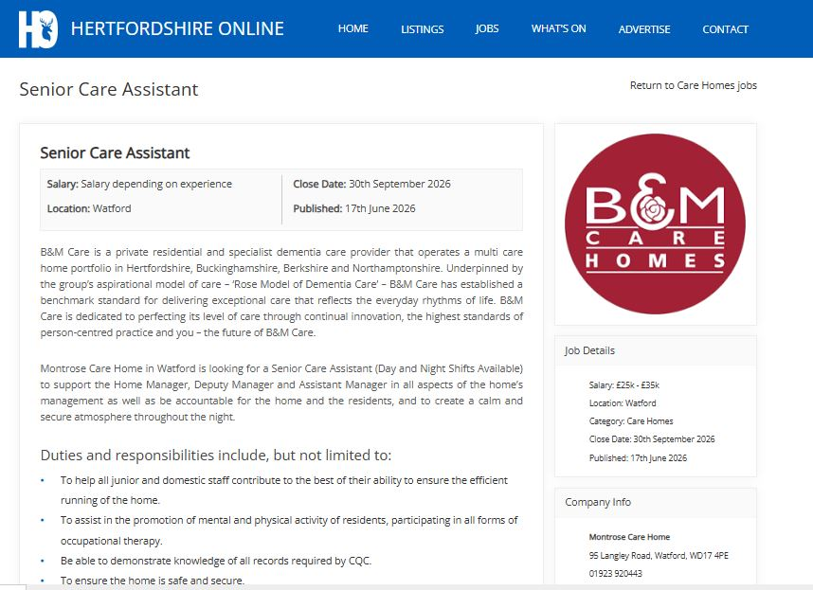

Task 1 of 4 CV

KHRYSTYNA YASTREMSKA
Watford, Hertfordshire | astremskahristina@gmail.com | 07392737722
Professional Summary
Healthcare worker with a caring and reliable attitude to work who has 4 years’ experience working in the UK Health and Social Care sector with person centred approach of providing care to the aging and vulnerable population. Familiar with supporting older people and vulnerable individuals with regard to their well-being, personal care, mobility and long-term health needs/responsibilities. Keeping up to date with patients’ welfare, escalating concerns to appropriate levels, maintaining clinical notes accurately and recalling and collaborating between multi-discipline teams. The experience gained in clinical work in Ukraine, as a nurse, was supplemented with experience gained in patient care, monitoring of patients in the state of health and clinical assistance. Student of Higher Education Certificate in Health and Social Care to enhance team working and career development. This experience and skill set support a role as a Senior Care Assistant, especially with the areas of responsibility of supporting vulnerable people, keeping records and assisting them to live independently.
Key Skills
- Personal Care activities of daily living support.
- Dementia care and vulnerable adult support
- Patient observation and escalation of concerns
- Clinical documentation and record keeping
- Infection prevention and control
- Medication in support and basic nursing care

Experience
- The Chase Care Home — Senior Care Assistant (2023-Present)
- Provide person-centred care to older people and people with reduced mobility and complex care needs, such as those with dementia.
- Support vulnerable adults to carry out daily living functions, personal care and wellbeing, encourage independence and dignity.
- Check on well-being of residents physically and emotionally, make notes and notify senior members of any concerns.

- Healthcare Care Assistant — The Chase Care Home (2022-2023)
- To support personal care, hygiene, nutrition and hydration of residents, to assist nursing staff to deliver safe and dignified care.
- Provide support to complete documentation of care, to make basic observations and report on changes; to maintain standards of infection control.

- Staff Nurse (Outpatient/Office-Based) — Medical Unit.26, State Criminal-Executive Service of Ukraine (2018-2022)
- Conducted nursing care that involved probing, cleaning and treating wounds, dressing and monitoring symptoms.
- Also performed medicine administration and recording of medication history, doctors and health care workers.

- Disinfection Specialist — Correctional Facility State Penitentiary Service of Ukraine (2016-2018)
- Disinfect, decontaminate and cleaned a high-risk environment, assisted infection control measures with safe handling of equipment and hazardous materials.

Education
- CertHE Health and Social Care (Level 4) — University of Wales, London (2025-2026, ongoing)
- IAO Level 2 Diploma in Care — Innovate Awarding (2023-2024)
- Bachelor’s in medicine related to Registered Nurse at Chortkiv State Medical College (2005 – 2007)
- Medical Assistant at Feldsher Degree College at Chortkiv State Medical College (2002-2005)
Hobbies & Interests
- Planting, Reading & Swimming
References
- Available upon request

Task 2 of 4 Personal Statement
I am seeking a Senior Care Assistant role as it is a position which is suitable for my experience of supporting vulnerable people and providing person centered care. Practical experience of working in a care setting with the extension and support of older people and those with health and support needs. My work in healthcare has enhanced my communication, protection, records and working with clients who are vulnerable to find independence in their lives to make a difference in their quality of life.
My current role is a Senior Care Assistant position at The Chase Care Home, Watford, which perfectly fits my clinical background and dementia care experience. I have practical experience across care homes, out of home and secure settings and have dedicated many years to healthcare. My career goal is to continue working in health and social care, eventually either as a Senior Care Assistant or a Dementia Care Support Worker, using my clinical skills, tenderness and dedication to person-centered care to enhance the lives of the elderly and those with care needs.
In Ukraine, I highly valued my opportunity to specialize as a Feldsher (Medical Assistant), and qualified as a Registered Nurse, equipping me with solid clinical evaluation, medication management, and patient monitoring skills. During the early days of my job search I have also had the opportunity to work as a Dis-infection Specialist inside a correctional facility resulting in a very strict understanding of infection prevention, safe handling back then and there is no doubt that there is strict protocol to be followed when it comes to hygiene (University of Edinburgh, 2026). Then I was a Staff Nurse in an outpatient medical unit where I performed nursing actions such as wound care, giving injections and checking on the patients with chronic diseases, medical records were maintained, and coordinated with the doctors and multi-disciplinary teams.
Continued my clinical practice on this basis in residential care settings since moving to the UK. I have worked with elderly residents as a Health Care Assistant, and more recently a Senior Care Assistant at The Chase Care Home giving care for their personal needs, mobility, continence needs and dementia related issues. I have built a great ability to observe residents' physical and emotional needs; to act on these observations at the right time; and to keep records of residents, according to organisational emphasis and confidentiality. As a senior, I have also had the opportunity of giving back and mentoring younger members of staff, ensuring safe and caring practice throughout the team. Alongside my work experience, I am also studying for a Certificate of Higher Education in Health and Social Care, which is helping to reinforce and help with my theoretical understanding of issues around care principles, reflective practice and professional development.
I have great strengths in being compassionate, reliable and resilient that are needed when helping people with complex health and emotional needs. I have good communication and teamworking abilities, I work well within multi-agency teams and have good organisational skills, maintain precise records and follow safe care procedures. My work experience also provides me with a solid foundation in infection control, drug assistance, and minimal nursing.
My experience in the front line, clinical training and attention to continuous improvements in my knowledge and technique would be valuable for an employer who are looking for a dependable, skilled, caring healthcare worker (Skills for Care, 2026). I am sure that I have the background needed to contribute not only to a health and social care team but to continue to build in the health and social care sector.

Task 3 of 4 SWOT Analysis & Personal Development Plan

- SWOT Analysis
As a Senior Care Assistant in the health and social care field my personal strengths, weaknesses, opportunities and threats are highlighted below through a SWOT analysis.

Strengths
I have more than 4 years of hands-on experience in care and clinical support in UK residential care settings. As I have previously been a Registered Nurse, I have a solid foundation of patient assessment, medication support as well as basic nursing care that many assistants without a clinical background may lack. I have a caring, responsible and ability to support individuals suspected to have dementia and/or impaired mobility and/or complex or ever-changing health needs. I also possess good organisational skills with the ability to keep accurate records, with excellent communication skills on multidisciplinary teams.

Weaknesses
I have a wide range of practical experience, but my qualifications in the health and social care system of the UK are still in development as I'm pursuing my Certificate of Higher Education. Also, as English is not my first language, I can sometimes struggle with writing documentation and formal communication, but in speaking I am pretty good amongst the residents and my colleagues. I have supervisory or management level responsibilities but only informal mentoring of young staff.

Opportunities
Learning outcomes from my Certificate of Higher Education course on Health and Social Care will build on my theory base and provide opportunities to progress to more advanced or specialist positions such as care co-ordination or dementia care specialist. Due to the clinical work, I am doing, the UK's health and social care sector also provides a wealth of opportunities for ongoing professional development (CPD) including specialised training programs in dementia care, safeguarding and leadership.

Threats
However, the health and social care industry continues to experience issues such as staffing shortages and excessive workloads, which may contribute to reducing the health and safety of workers and create risk of burnout. Furthermore, changing regulatory and compliance standards also signal a need for ongoing learning to stay current and if an individual hasn't acquired the knowledge that could have an impact on their career trajectory (University of Edinburgh, 2026). More practitioners are seeking advanced qualifications and the competition for senior, or specialist positions is growing.

Personal Development Plan (PDP)
I have considered three important learning targets for my future pathway, what activities I will engage in and how I will track progress towards them in my role.

Goal | Development Actions | Timeframe | Monitoring & Evaluation
1. Complete my Certificate of Higher Education in Health and Social Care | Ensure attendance, good quality of assignments and utilising theory into practice for the day to day | Year 1 | Monitor progress through module marks and feedback to reflect on use in work each term
2. Gain specialist knowledge in dementia care | Attend approved dementia training and sit in on some dementia specialist nursing training in my workplace. | Year 1–2 | Get a recognised certificate, review feedback from supervisor on enhanced practice and self-assess confidence every 3 months
3. Develop leadership and supervisory skills | Accept greater mentoring opportunities with younger staff, ask for team leadership or senior mentoring opportunities, and undertake formal supervision training | Year 2 | Conduct formal performance evaluation; keep a diary of leadership experiences; ask for feedback from management annually

I will review my performance regularly by reflecting on myself, checking with my manager in supervision meetings and in my employer's formal performance management process. If necessary, adjust my objectives and time scale in response to feedback given, ensuring development is in line with my own occupational aims and the changing requirements of the health and social care field.

Task 4 of 4 Reflective Account Using Gibbs' Reflective Cycle

Description
In Component 1, of the module LCHS4009, I prepared a presentation on key skills and knowledge needed to work effectively as a team in the health and social care sector. During the presentation I had to study the theory, put it into practice and explain the theory clearly to my fellow students and lecturer within a given period (Gibbs, 1988). I created slides with the important content areas, practiced my presentation beforehand and spoke it, after which I spent some time answering the group's questions and verbally giving feedback from my lecturer.

Feelings
Before the show, I felt some nervousness and excitement. The area where I would be most closely testing my English was expressing detailed information clearly and fluently in public, as I find this complication to be one of the most challenging for second language learners (The Access Group, 2026). I felt like I was okay during the presentation discussing context that was congruent to my clinical experience, and I felt self-conscious during the presentation at moments when the questions were surprise. I felt relieved and accomplished after, but yet knew I could improve on things.

Evaluation
On reflection, there were several positive aspects of my performance. Specifically, the verbal feedback from my lecturer said that my research of the content was comprehensive, and that I showed a great depth of knowledge and understanding of the health and social care principles, which my clinical experience has confirmed. I was also praised for keeping my cool and remaining professional throughout. The feedback, however, also outlined points that need to be improved for example with attention to pacing, with my speed of delivery in places where I was nervous, and regarding the eye movement and engagement with the audience, which was less consistent when I used the notes to fix on, and when I depended on them more heavily.

Analysis
In the light of this feedback, I see that my subject knowledge is a strong point but that my presentation skills are something that needs to be improved. I might have been anxious about the way that I spoke and ended up rushing through my ideas because I wasn't letting my audience catch my main ideas. The focusing of eyes down may have influenced having audience engagement have been limited and my delivery seemed less confident than what I knew than it was (The Access Group, 2026). This is in keeping with well established guidelines of good communications; that clarity, timing and genuine interest in the language spoken, are as important as the accuracy of what is being said in professional presentations. It helps me develop the awareness that like clinical skills, presentation skills can only be learnt with purposeful practice and is not only about the subject matter.

Conclusion
In summary, this experience has been very educationally enriching. It has taught me that good technical or clinical practice is not enough audience appropriation and style are just as valued. I know how nervous I get around fluency in language impacts my pacing and non-verbal expression, and that this can be a place to apply practice as well as content preparation.

Action Plan
In the near future, I plan to make more presentations that I will record to analyse pace and body language. Apart from this, I plan to work on minimising the use of written notes instead by using a very small card with a prompt instead to get more eye contact and interaction from the audience. Furthermore, I would like to continue to present in academic and work-based environments to develop and increase my confidence and fluency in this valuable professional skill that will gradually improve over time.

References
Gibbs, G. 1988. Learning by Doing: A Guide to Teaching and Learning Methods. Oxford: Further Education Unit, Oxford Polytechnic. Available at: https://www.ed.ac.uk/reflection/reflectors-toolkit/reflecting-on-experience/gibbs-reflective-cycle
Skills for Care 2026. Leadership Programmes and CPD. Available at: https://www.skillsforcare.org.uk/Support-for-leaders-and-managers/Developing-leaders-and-managers/Leadership-programmes-and-CPD.aspx
The Access Group 2026. What is CPD in Health and Social Care? Available at: https://www.theaccessgroup.com/en-gb/digital-learning/elearning-courses/health-social-care-courses/what-is-cpd-in-health-and-social-care/
University of Edinburgh 2026. Gibbs' Reflective Cycle | Reflection Toolkit. Available at: https://reflection.ed.ac.uk/reflectors-toolkit/reflecting-on-experience/gibbs-reflective-cycle

