

Student name: Cynthia Yemi Edward Igbinigie
Student ID:2524363
Module name: Introduction to Health and Social Care
Module code:LCHS4003
Lecturer name: Jolly Nwankwo

Table of Contents
Element 1 3
Element 2 5
Introduction 5
Origins and historical context 5
Current functioning and critical evaluation 6
Significance in enhancing quality 6
Conclusion 6
References 8

Element 1
Major challenges
Community antenatal midwifery services face significant pressures:
Staffing shortages are a primary issue with the Royal college of Midwives estimating a shortfall of around 2,500 midwives in England. This leads to heavier workloads, reducing community, and difficulties meeting demands, especially in deprived areas (RCM, 2023; Nuffield Trust, 2023).
Health inequalities represent another key challenge. Ethnic minority and deprived communities often experience poorer access and outcomes due to language barriers and systemic issues (Gov.uk, 2025; CQC, 2025).
Addressing these requires sustained investments in workforce and equitable models (NHS England, 2023).


This image illustrates a community antenatal appointment, highlighting the supportive relationship between midwife and expectant mother. Regular check-ups, such as blood pressure monitoring and discussions and wellbeing, help identify issues early and build trust (NHS, 2026).
Community antenatal midwifery service

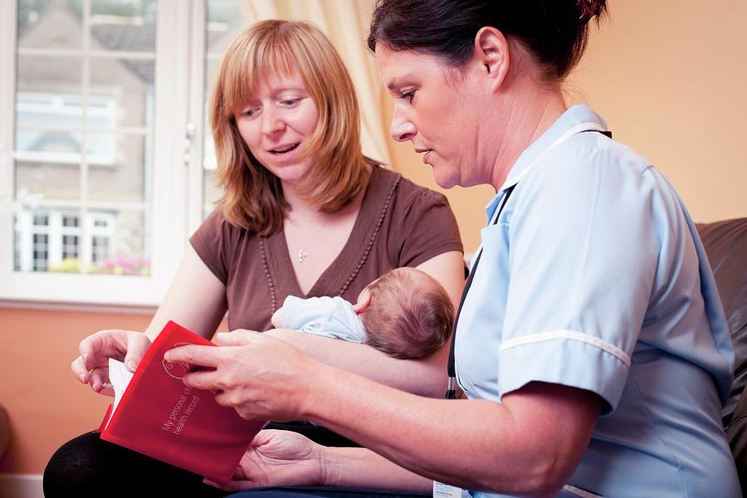this image captures a community midwife providing postnatal support, reviewing the personal health record with a new mother and her baby. It shows the continued role of midwifery care beyond pregnancy, offering guidance, reassurance, and continuity in the early weeks after birth (NHS, 2026).
Current functioning
Today, community antenatal midwifery services from the cornerstone of NHS pregnancy care. Women can self-refer as soon as they know they are pregnant, with the first booking appointments ideally by 10 weeks. Midwives provide scheduled appointments covering health checks, ultrasound scans, screening tests, and lifestyle advice (NHS, 2026).
Care is delivered in accessible community settings often with continuity from the same midwife or small team. This model promotes informed choice, reduces hospital visits, and improves outcomes through strong relationships and partnerships working (NHS England, 2023).

Brief History
The origins of community antenatal midwifery in the UK trace back to the early 20th century, with the Midwives Act 1902 establishing formal regulation and training. Before the NHS, care was often provided by local authority district midwives or independently. The founding of the NHS in 1948 integrated these services into a national system, offering free care at the point of need under a tripartite structure (Taylor, 2022).
In the 1970, reorganisation shifted more focus to hospitals following the Peel Report (1970), which advocated for increased medical involvement. However, community midwifery persisted, evolving through polices like Changing Childbirth (1993) and Better Births (2016), which promoted community of carer and personalised care. Today, these services reflect a balance between community-based support and integration with specialist care, shaped by efforts to improve safety and equity (NHS England, 2016).
This historical development shows how midwifery has moved from fragmented local provision to a more structed, evidence-based NHS model. It is interesting to note how reports like the Morecambe Bay investigation later reinforced the need for better teamwork and community focus to prevent tragedies. Reflecting on this history highlights how far services have come while still facing ongoing pressures to maintain that community ethos (Kirkup, 2015).
Introduction
Community antennal midwifery service from a vital part of the UK’s National Health Service (NHS), providing essential care to pregnant women and their families before birth. These services focus on monitoring the health of the mother and baby, offering advice, screening tests, and support to promote positive pregnancy outcomes. Midwives are usually the main point of contact for low-risk pregnancies, delivering personalised, woman-centred care in community settings like clinics, GP surgeries, or even home visits (NHS, 2026).
This approach aligns with the NHS’s commitment to safe accessible maternity care, emphasising prevention, education, and early intervention. These services are key to reducing inequalities and supporting families during a transformative life stage. They empower women with information and choices, contributing to better maternal and neonatal health across the UK.
What stands out is how these services go beyond medical checks by building trusting relationships that help women feel heard and supported, especially first-time mums or those from diverse backgrounds. In reading on the topic, this relational aspect is often highlighted as making a real difference to emotional wellbeing during pregnancy (NHS England, 2016).

Element 2: Domiciliary care services within the community

Introduction
domiciliary care services, often called home care, provide important support to people in their own homes. These services help individuals maintain their independence by assisting with personal care, medication, household chores, and social interaction. There mainly support older adults, people with disabilities, and those recovering from illness (NHS, 2026). In the UK, domiciliary care is a key part of the adult social care system, involving close partnership between local authorities, the NHS, and private providers.

Origins and historical context
The origins of domiciliary care in the UK go back to early community-based support. Before the 20th century, families and charities mostly looked after vulnerable people, with some help from poor Law relief. The founding of the NHS in 1948 created a clearer divide between health and social care, leaving social care mainly to local authorities.
A big change came in the late 20th century. The Griffiths Report (1988) and the NHS and community care Act 1990 strongly encouraged “care in the community” instead of keeping people in large institutions. This shift was influenced by rising costs of residential care, a desire for more personal independence, and the wider move towards deinstitutionalisation. Later, the Care Act 2014 built on this by focusing on wellbeing, personalisation, and better integration between health and social care (Department of Health and Social Care, 2025; Taylor, 2022).

Current functioning and critical evaluation
Today, domiciliary care works through a mixed system where local authorities assess people’s needs under the Care Act and commission services from independent providers. Care is usually based on personalised plans, and direct payments allow service users more choice and control.
However, there are some serious issues. Workforce shortages are a major problem, with staff turnover caused by low pay, zero-hours contracts, and heavy workloads (Skills for Care, 2025). Many care visits are very short often just 15 to 30 minutes which makes it difficult to provide proper, continuous support. Although integration with the NHS have improved through schemes like the Better Care Fund, there is still too much fragmentation, leading to delayed hospital discharges (NHS England, 2023; CQC, 2025). From what I have read, these problems affect the overall quality and reliability of care, especially as the population ages. This highlights the need for stronger partnership working between health and social care services, as poor coordination can negatively impact service users’ experiences.

Significance in enhancing quality
Despite these challenges, domiciliary care makes a real difference to people’s lives. By supporting individuals in their own homes, it helps them keep their dignity, independence, and sense of belonging. Many service users say they feel happier and less lonely than they would in a residential setting.
Good domiciliary care also helps people leave hospital safely, prevents unnecessary admissions, and supports reablement. This leads to better health results and reduces pressure on families. In our ageing society with rising demand, domiciliary care is essential for preventing loneliness and supporting independent living while respecting individual preferences and promoting social inclusion (Nuffield Trust, 2023; NHS, 2026). It also allows service users to stay connected to their local community and maintain daily routines that are important to their identity and wellbeing. Furthermore, it gives families peace of mind knowing their loved ones are supported in a familiar and comfortable environment.

Conclusion
Overall, domiciliary care has developed from informal community roots into a more personalised and integrated service, shaped by important policies over the years. While it faces ongoing challenges around staffing and funding, its ability to improve quality of life for service users in clear. Greater investment in staff pay, training, and better health-social care partnerships will be crucial to make sure these services reach their full potential across the UK.

References
CQC (2025) State of Care 2024/25. Available at: https://www.cqc.org.uk/publications/major-report/state-care/2024-2025 (Accessed: 23 June 2026).
Department of Health and Social Care (2025) Care and Support Statutory Guidance. Available at: https://www.gov.uk/government/publications/care-act-statutory-guidance (Accessed: 23 June 2026).
Gov.uk (2025) Confidence in maternity care services: engagement with ethnic minority women and maternity staff. Available at: https://www.gov.uk/government/publications/confidence-in-maternity-care-services-engagement-with-ethnic-minority-women-and-maternity-staff/confidence-in-maternity-care-services-engagement-with-ethnic-minority-women-and-maternity-staff (Accessed: 26 June 2026).
NHS (2026) Your antenatal care and appointments. Available at: https://www.nhs.uk/pregnancy/your-pregnancy-care/your-antenatal-care-and-appointments/ (Accessed: 26 June 2026).
NHS (2026) Care and support at home. Available at: https://www.nhs.uk/conditions/social-care-and-support-guide/care-services-equipment-and-care-homes/care-and-support-at-home/ (Accessed: 28 June 2026).
NHS England (2016) Better Births: Improving outcomes of maternity services in England. Available at: https://www.england.nhs.uk/wp-content/uploads/2016/02/national-maternity-review-report.pdf (Accessed: 28 June 2026).
NHS England (2023) Three-year delivery plan for maternity and neonatal services. Available at: https://www.england.nhs.uk/publication/three-year-delivery-plan-for-maternity-and-neonatal-services/ (Accessed: 28 June 2026).
Nuffield Trust (2023) Inequalities in midwifery continuity of care during pregnancy. Available at: https://www.nuffieldtrust.org.uk/news-item/inequalities-in-midwifery-continuity-of-care-during-pregnancy (Accessed: 30 June 2026).
Royal College of Midwives (RCM) (2023) State of Maternity Services Report. Available at: https://www.rcm.org.uk/media/6915/england-soms-2023.pdf (Accessed: 30 June 2026).
Skills for Care (2025) Summary of domiciliary care services 2025. Available at: https://www.skillsforcare.org.uk/Adult-Social-Care-Workforce-Data/workforce-intelligence/resources/Reports/National/Summary-of-domiciliary-care-services-2025.pdf (Accessed: 08 July 2026).
Taylor, B. (2022) Transformational Change in maternity services in England. Available at: https://pmc.ncbi.nlm.nih.gov/articles/PMC8753811/ (Accessed: 01 July 2026).

