Module Title: Food and Beverage Operation
BMIH4002
Assignment Title: Assignment 2 Menu Engineering

Student name: Larisa Afloarei
Student ID number: 2243427

- Restaurant Concept
- Menu Design
Content

Restaurant Concept
“In the demanding world of the restaurant industry, success is not solely reliant on exceptional food and service. Behind the scenes, strategic decisions greatly impact a restaurant's bottom line, and at the forefront of these is the art of menu engineering.” (Kumar, 2023). As a new restaurant in the Trinity Hotel chain the aim of our restaurant is to connect with the quests and offer them a calm and enjoyable experience. “Success in the restaurant industry is, in part, determined by boundary spanning service providers' ability to manage their emotions with the goal of providing excellent service while simultaneously authentically displaying the proper emotions to connect with the guest.” (Moreo, 2019).
The restaurant is situated in the hotel reception proximity. The destination is suitable for any period of the year from spring booming to summer lights, autumn changing colours and winter tale. As winter is approaching out establishment will bring in an atmosphere of enchantment. The Christmas season ignites crackling log fires and festive carols within a friendly relaxing ambient. “We help provide the ambiance, the gentle buzz of conversation around the room”. (Johnston, R. , 2012).
The restaurant menu for the period is adding to the seasonal warmth feeling.
According to Dixon, Miscuraca, and Koutroumanis, (2018), in today’s world, individuals prefer the sourcing and serving of fresh and natural ingredients. Our menu is based on sustainability as most of the products are delivered from nearby farms and local producers. The menu is aligned to food safety regulations and are a direct reflection of our chef dedication and experience.
Our primary clients are represented by the hotel quests, looking for a local, traditional experience as well as families, corporate employees, friends, that would like to celebrate their special events in a remarkable atmosphere. For dining out, our establishment is perfect for couples or families aiming for tranquillity and peace.
“A special occasion is one of the most common reasons for eating out. Such family events as birthdays and anniversaries, special dates (Christmas, New Year’s, Valentine’s Day and Halloween) or a special event (a christening or passing examinations) are all reasons for celebration and eating out. Equally, people may decide to go to a restaurant for no other reason than to dine socially with friends.”(Davis, 2018). Our restaurant is ready for each reason and our menus are created based on the dine out reason.

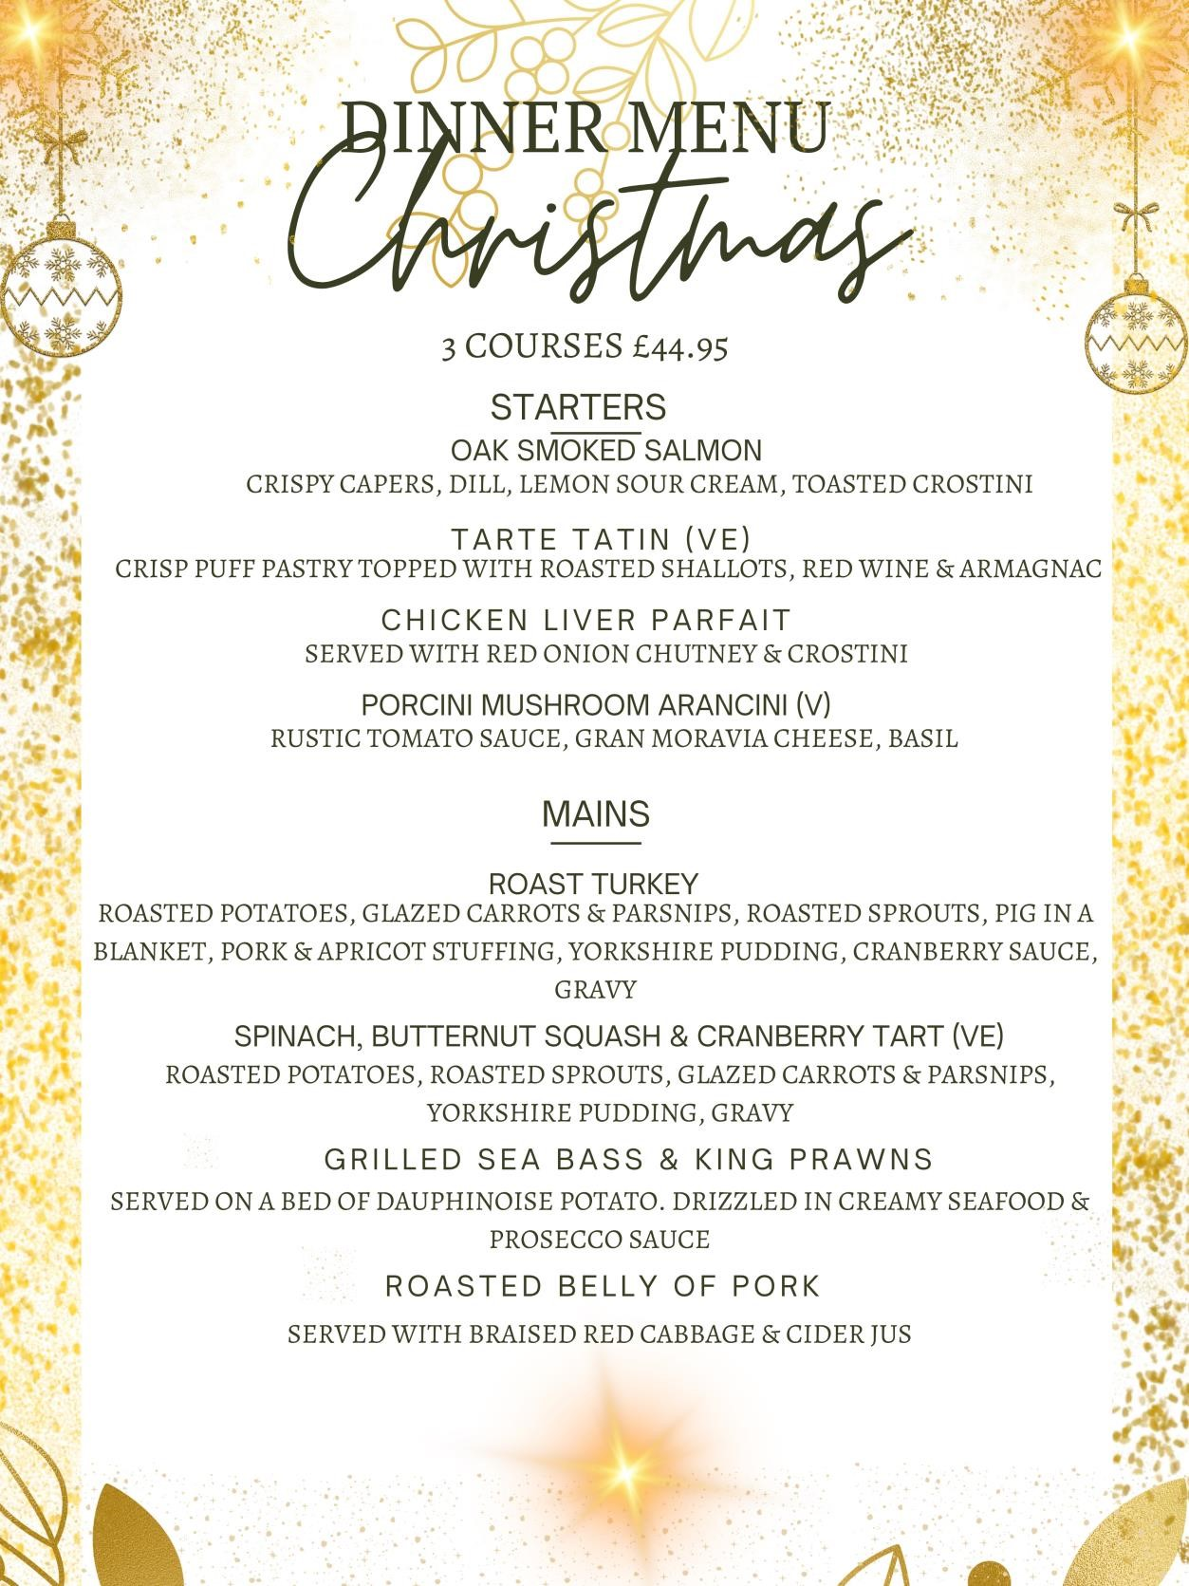

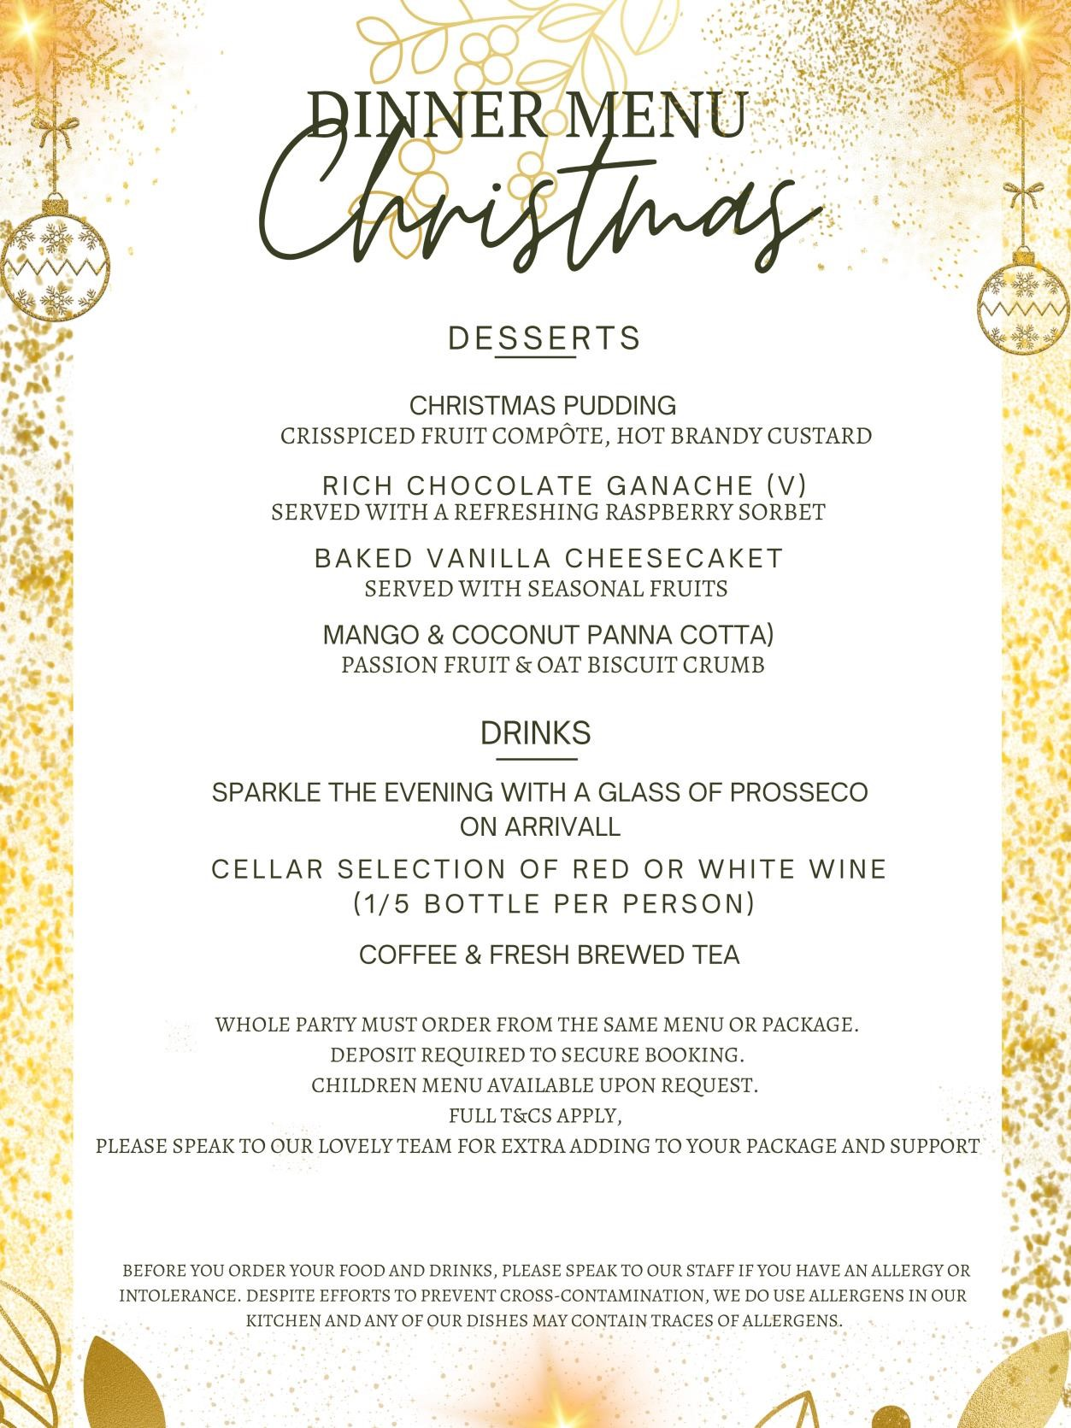

References:

https://modernrestaurantmanagement.com/engineered-for-success-boosting-profitsthrough-intelligent-menu-planning/ Accessed on 28/10/2023
Moreo, A. et al. (2019) ‘How emotional displays and service quality impact satisfaction and loyalty: A gendered look’, Journal of Foodservice Business Research, 22(6), pp. 563–581. doi:10.1080/15378020.2019.1663105.
Brown, D. R., TotalBoox and TBX (2013) The Restaurant Manager’s Handbook :
How to Set Up, Operate,and Manage a Financially Successful Food Service
Operation. 4th Edition. Atlantic Publishing Group*
Davis, B et al. (2018) Food and Beverage Management. 6 edn London: Routledge.**
Johnston, R. (2012) Service operations management : improving service delivery.
4th ed. Harlow, England:Pearson.*
Dixon, D.P., Miscuraca, J.A. and Koutroumanis, D.A., (2018). Looking strategically to the future of restaurants: casual dining or fast casual?. Entrepreneurship Education and Pedagogy, 1(1), pp.102-117.
Delanoy, N. and Kasztelnik, K. (2020). Business Open Big Data Analytics to Support Innovative Leadership Decision in Canada. essuir.sumdu.edu.ua.
Motarjemi, Y and Lelieveld, H (2014) Food safety management : a practical guide for the food industry. Illustrated edition. Amsterdam: Academic Press.*
Foskett, D. et al. (2021) The Theory of Hospitality and Catering. 14th Edition. London: Hodder
Education Group.*
Walker, J (2017) Introduction to Hospitality. Harlow: Pearson Education Limited.* Wood, R. (2013) Key Concepts in Hospitality Management. London: Sage*

